WEEK-9 [ B Vasudeva, 2520090136]
BOOKFLOW LIBRARY SYSTEM
Transactional Microservice using Spring Boot, Spring Data JPA and PostgreSQL
To develop a transactional BookFlow Library microservice using Spring Boot, Spring Data JPA and PostgreSQL for managing book inventory and borrowing orders, with FastAPI Gateway integration.
Database – bookflow creation in Postgresql
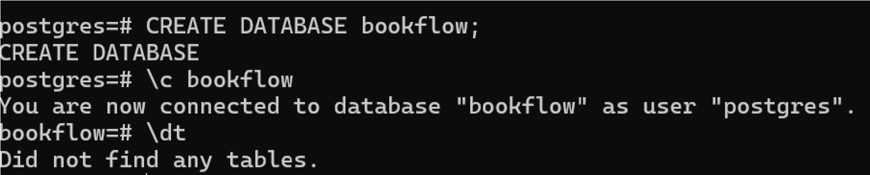
Tables Inserted
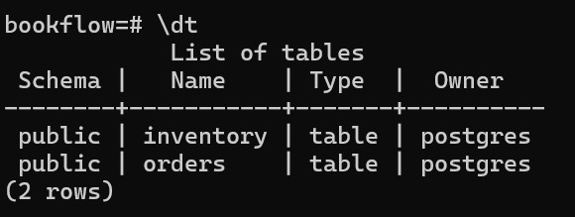
Initial Inventory Data in PostgreSQL
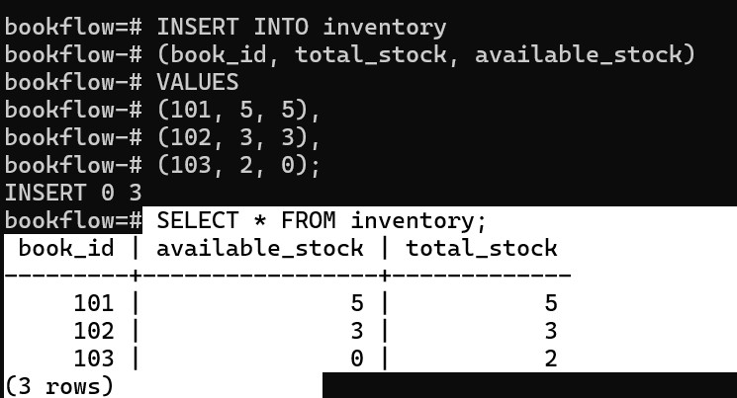

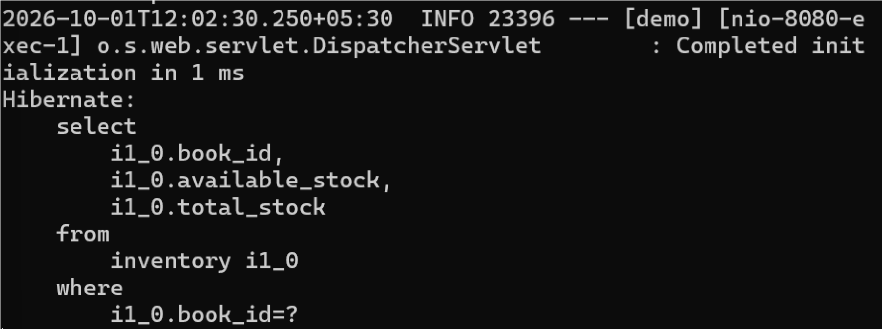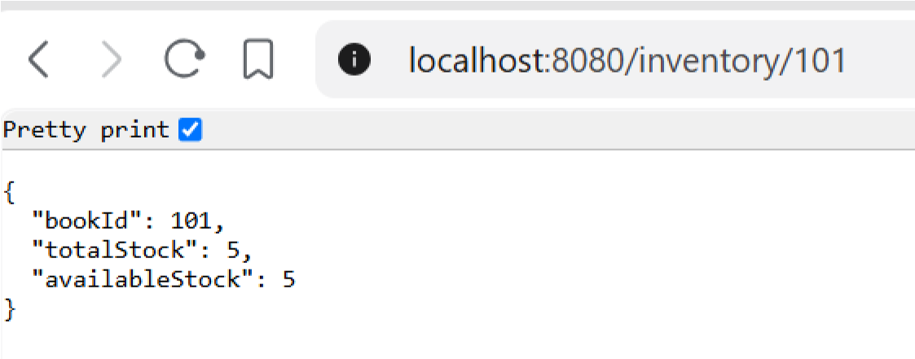
GET Inventory for Book 101

Successful Book Borrowing
—

POST
/orders

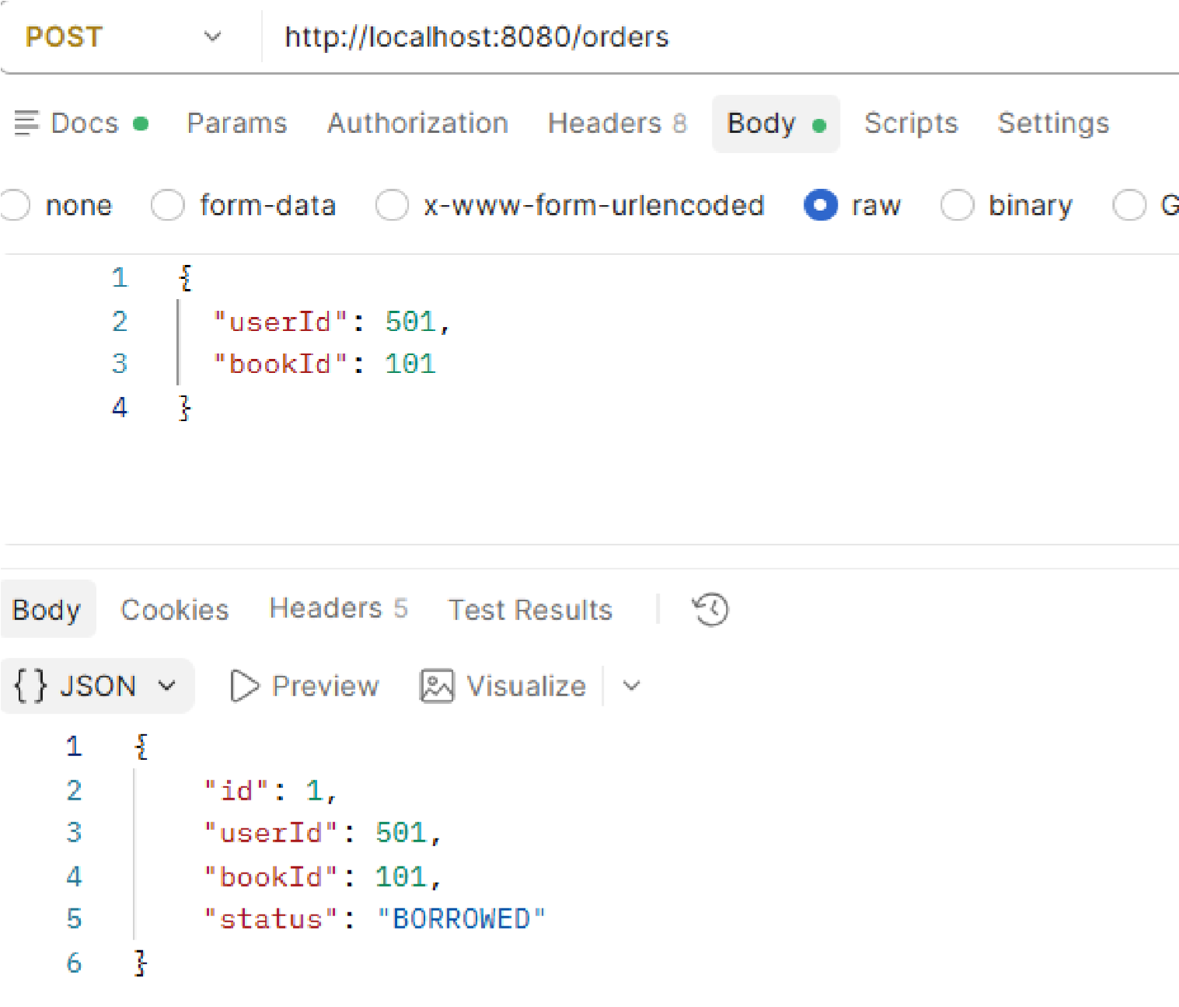
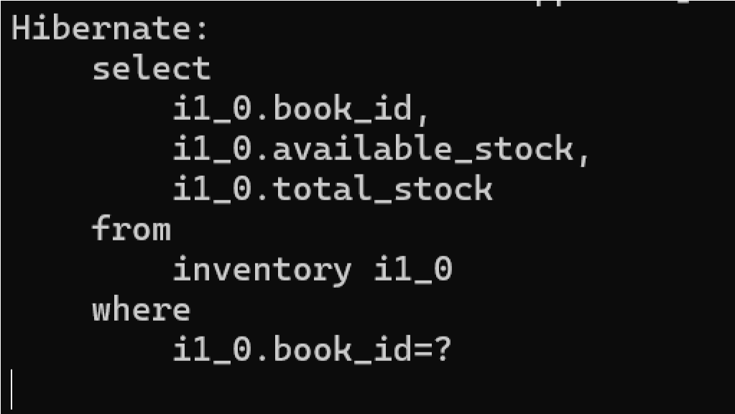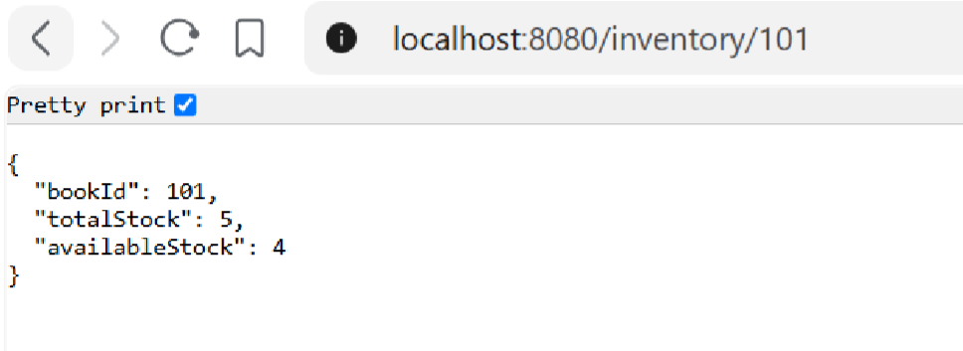
GET
/inventory/101

—

Inventory After Book Borrowing

PostgreSQL Database
—

Inventory and Order Records After Borrowing

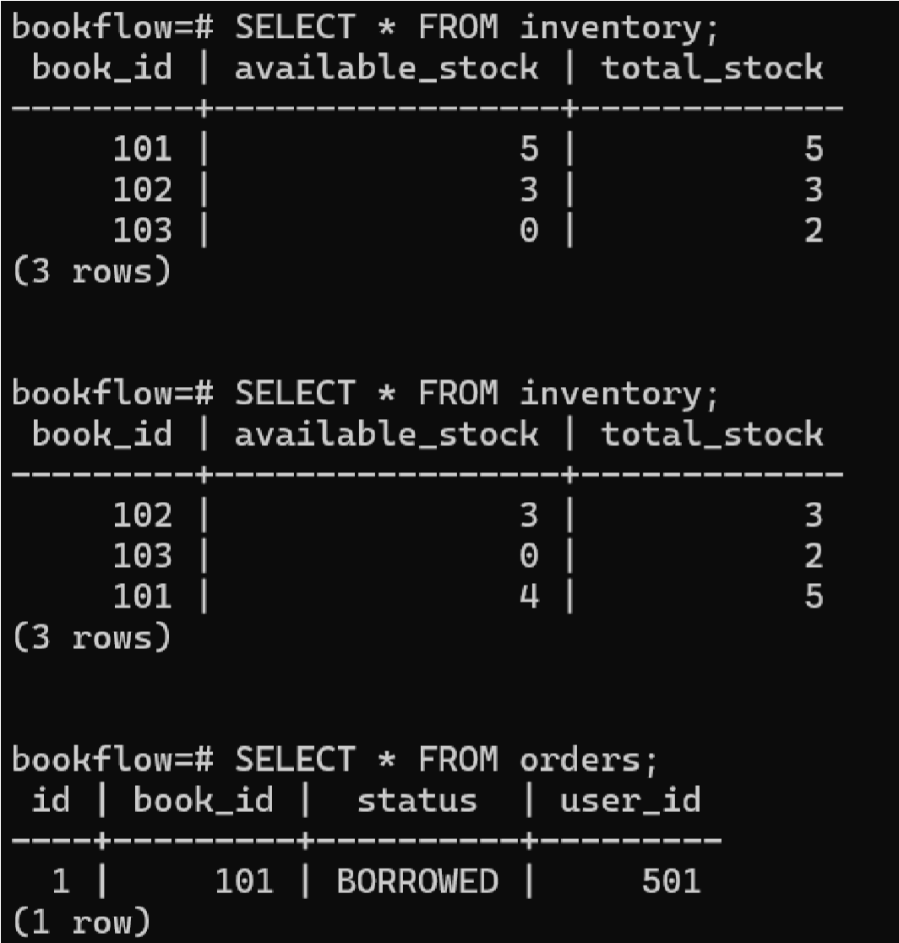

POST /orders — Out-of-Stock Book Returns 409 Conflict
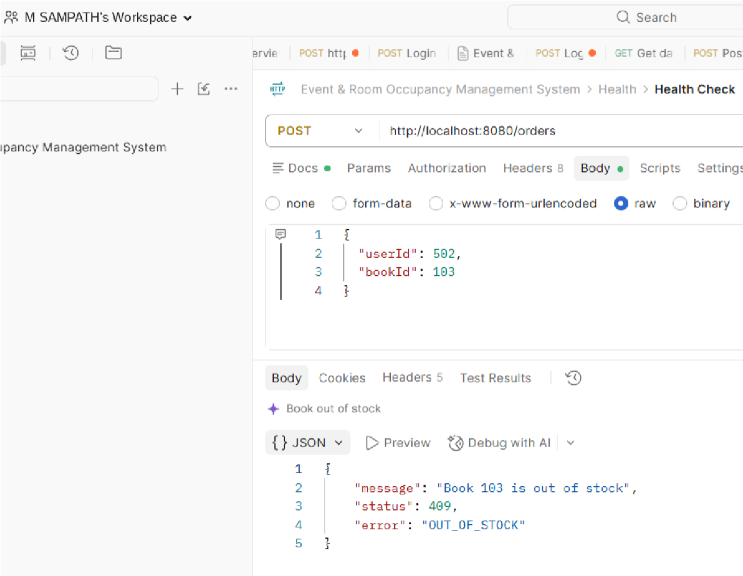
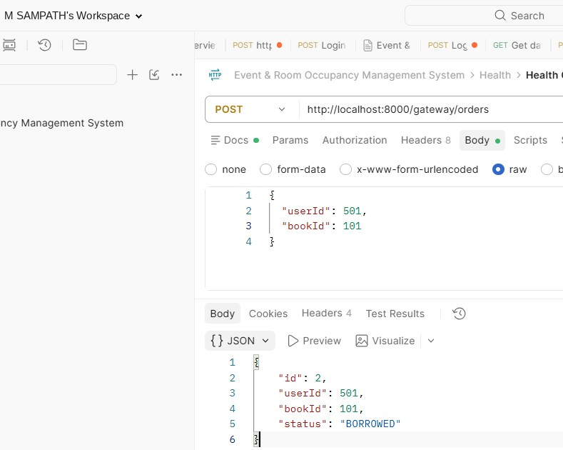
FastAPI Gateway
—

/gateway/orders

Successfully Forwards Request to Spring Boot

PostgreSQL — Final Inventory and Order Records
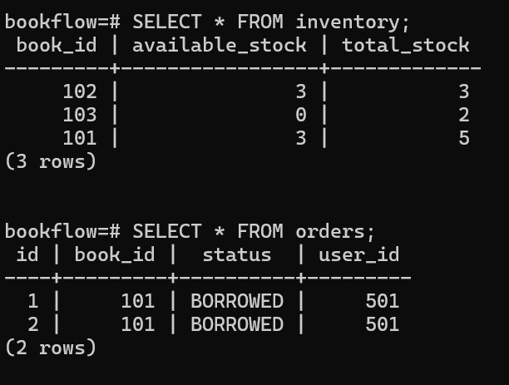
Folder Structure: bookflow-transaction/
│
├── pom.xml
│
└── src/
└── main/
├── java/
│ └── com/
│ └── bookflow/
│ └── transaction/
│
│ ├── BookflowTransactionApplication.java
│ │
│ ├── controller/
│ │ ├── OrderController.java
│ │ └── InventoryController.java
│ │
│ ├── entity/
│ │ ├── Inventory.java
│ │ └── Order.java
│ │
│ ├── repository/
│ │ ├── InventoryRepository.java
│ │ └── OrderRepository.java
│ │
│ ├── service/
│ │ ├── InventoryService.java
│ │ └── OrderService.java
│ │
│ ├── dto/
│ │ └── OrderRequest.java
│ │
│ └── exception/
│ ├── BookOutOfStockException.java
│ └── GlobalExceptionHandler.java
│
└── resources/ └── application.yml
Codes:
• _{pom.xml}

<?xml version="1.0" encoding="UTF-8"?> <project xmlns="http://maven.apache.org/POM/4.0.0" xmlns:xsi="http://www.w3.org/2001/XMLSchema-instance" xsi:schemaLocation="http://maven.apache.org/POM/4.0.0 https://maven.apache.org/xsd/maven-4.0.0.xsd">

<modelVersion>4.0.0</modelVersion>

<parent>
<groupId>org.springframework.boot</groupId>
<artifactId>spring-boot-starter-parent</artifactId>
<version>3.5.5</version>
<relativePath/>
</parent>

<groupId>com.bookflow</groupId>
<artifactId>bookflow-transaction</artifactId>
<version>0.0.1-SNAPSHOT</version>
<name>bookflow-transaction</name>
<description>BookFlow Transactional Microservice</description>
<properties>
<java.version>17</java.version>
</properties>

<dependencies>

<dependency>
<groupId>org.springframework.boot</groupId>
<artifactId>spring-boot-starter-web</artifactId>
</dependency>

<dependency>
<groupId>org.springframework.boot</groupId>
<artifactId>spring-boot-starter-data-jpa</artifactId>
</dependency>

<dependency>
<groupId>org.postgresql</groupId>
<artifactId>postgresql</artifactId>
<scope>runtime</scope>
</dependency>

<dependency>
<groupId>org.springframework.boot</groupId>
<artifactId>spring-boot-starter-validation</artifactId>
</dependency>

<dependency>
<groupId>org.springframework.boot</groupId>
<artifactId>spring-boot-starter-test</artifactId>
<scope>test</scope>
</dependency>

</dependencies>

<build>
<plugins>
<plugin>

<groupId>org.springframework.boot</groupId>
<artifactId>spring-boot-maven-plugin</artifactId>
<configuration>
<mainClass>com.bookflow.transaction.BookflowTransactionApplication< /ma inClass>
</configuration>
</plugin>
</plugins>
</build>

</project>

• _{application.yml}

spring: datasource:
url: jdbc:postgresql://localhost:5432/bookflow username: postgres password: UR_PASSWORD
jpa: hibernate:
ddl-auto: update show-sql: true properties: hibernate:
format_sql: true
server: port: 8080

- BookflowTransactionApplication.java

package com.bookflow.transaction;

import org.springframework.boot.SpringApplication; import org.springframework.boot.autoconfigure.SpringBootApplication;
@SpringBootApplication public class BookflowTransactionApplication {

public static void main(String[] args) {
SpringApplication.run(BookflowTransactionApplication.class, args);
} }

- _{Inventory.java}

package com.bookflow.transaction.entity;
import jakarta.persistence.Entity; import jakarta.persistence.Id; import jakarta.persistence.Table; import jakarta.validation.constraints.Min;

@Entity
@Table(name = "inventory") public class Inventory {
@Id private Long bookId;

@Min(value = 0, message = "Total stock cannot be negative") private Integer totalStock;

@Min(value = 0, message = "Available stock cannot be negative") private Integer availableStock;
public Inventory() {
} public Inventory(Long bookId, Integer totalStock, Integer availableStock)
{ this.bookId = bookId; this.totalStock = totalStock; this.availableStock = availableStock;
}
public Long getBookId() { return bookId;
} public void setBookId(Long bookId) { this.bookId = bookId;
} public Integer getTotalStock() { return totalStock;
} public void setTotalStock(Integer totalStock) { this.totalStock = totalStock;
}

public Integer getAvailableStock() { return availableStock;
} public void setAvailableStock(Integer availableStock) { this.availableStock = availableStock;
} }

• _{Order.java}

package com.bookflow.transaction.entity;
import jakarta.persistence.Entity; import jakarta.persistence.GeneratedValue; import jakarta.persistence.GenerationType; import jakarta.persistence.Id; import jakarta.persistence.Table;

@Entity
@Table(name = "orders") public class Order {

@Id
@GeneratedValue(strategy = GenerationType.IDENTITY) private Long id;
private Long userId; private Long bookId; private String status;

public Order() {
}
public Order(Long userId, Long bookId, String status) { this.userId = userId; this.bookId = bookId; this.status = status;
}
public Long getId() { return id;
} public void setId(Long id) { this.id = id;
}

public Long getUserId() {
return userId;
} public void setUserId(Long userId) { this.userId = userId;
} public Long getBookId() { return bookId;
} public void setBookId(Long bookId) { this.bookId = bookId;
} public String getStatus() { return status;
} public void setStatus(String status) { this.status = status;
} }

- InventoryRepository.java

package com.bookflow.transaction.repository;

import com.bookflow.transaction.entity.Inventory;
import org.springframework.data.jpa.repository.JpaRepository;
public interface InventoryRepository extends JpaRepository<Inventory, Long> { }

- _{OrderRepository.java}

package com.bookflow.transaction.repository;

import com.bookflow.transaction.entity.Order; import org.springframework.data.jpa.repository.JpaRepository;
public interface OrderRepository extends JpaRepository<Order, Long> {
}

- _{OrderRequest.java}

package com.bookflow.transaction.dto;
import jakarta.validation.constraints.NotNull;
public class OrderRequest {

@NotNull
private Long userId;

@NotNull
private Long bookId;
public Long getUserId() { return userId;
} public void setUserId(Long userId) { this.userId = userId;
} public Long getBookId() { return bookId;
} public void setBookId(Long bookId) { this.bookId = bookId;
} }

• _{InventoryService.java}

package com.bookflow.transaction.service;

import com.bookflow.transaction.entity.Inventory; import com.bookflow.transaction.repository.InventoryRepository; import org.springframework.stereotype.Service;
@Service public class InventoryService {

private final InventoryRepository inventoryRepository;
public InventoryService(InventoryRepository inventoryRepository) { this.inventoryRepository = inventoryRepository;
}

public Inventory getInventory(Long bookId) {
return inventoryRepository.findById(bookId)
.orElseThrow(() -> new RuntimeException("Book not found"));
}
}

• _{OrderService.java}

package com.bookflow.transaction.service;
import com.bookflow.transaction.dto.OrderRequest; import com.bookflow.transaction.entity.Inventory; import com.bookflow.transaction.entity.Order; import com.bookflow.transaction.exception.BookOutOfStockException; import com.bookflow.transaction.repository.InventoryRepository; import com.bookflow.transaction.repository.OrderRepository; import org.springframework.stereotype.Service; import org.springframework.transaction.annotation.Transactional;
@Service public class OrderService {
private final InventoryRepository inventoryRepository; private final OrderRepository orderRepository;

public OrderService(
InventoryRepository inventoryRepository, OrderRepository orderRepository) { this.inventoryRepository = inventoryRepository; this.orderRepository = orderRepository;
}

@Transactional
public Order borrowBook(OrderRequest request) {

Inventory inventory = inventoryRepository.findById(request.getBookId())
.orElseThrow(() -> new RuntimeException("Book not found"));
if (inventory.getAvailableStock() <= 0) { throw new BookOutOfStockException(
"Book " + request.getBookId() + " is out of stock");
} inventory.setAvailableStock( inventory.getAvailableStock() - 1);
inventoryRepository.save(inventory);

Order order = new Order( request.getUserId(), request.getBookId(),
"BORROWED");
return orderRepository.save(order);
} }

• InventoryController.java

package com.bookflow.transaction.controller;
import com.bookflow.transaction.entity.Inventory; import com.bookflow.transaction.service.InventoryService; import org.springframework.web.bind.annotation.*;

@RestController
@RequestMapping("/inventory") public class InventoryController {
private final InventoryService inventoryService;
public InventoryController(InventoryService inventoryService) { this.inventoryService = inventoryService;
}

@GetMapping("/{bookId}") public Inventory getInventory(@PathVariable Long bookId) { return inventoryService.getInventory(bookId);
} }

• _{OrderController.java}

package com.bookflow.transaction.controller;

import com.bookflow.transaction.dto.OrderRequest; import com.bookflow.transaction.entity.Order; import com.bookflow.transaction.service.OrderService; import jakarta.validation.Valid; import org.springframework.http.HttpStatus; import org.springframework.web.bind.annotation.*;

@RestController @RequestMapping("/orders") public class OrderController { private final OrderService orderService;
public OrderController(OrderService orderService) { this.orderService = orderService;
}

@PostMapping
@ResponseStatus(HttpStatus.CREATED) public Order borrowBook(@Valid @RequestBody OrderRequest request) { return orderService.borrowBook(request);
} }

- BookOutOfStockException.java

package com.bookflow.transaction.exception;
public class BookOutOfStockException extends RuntimeException {
public BookOutOfStockException(String message) { super(message);
} }

- GlobalExceptionHandler.java

package com.bookflow.transaction.exception;
import org.springframework.http.HttpStatus; import org.springframework.web.bind.annotation.*;

import java.util.Map;
@RestControllerAdvice public class GlobalExceptionHandler {

@ExceptionHandler(BookOutOfStockException.class)
@ResponseStatus(HttpStatus.CONFLICT) public Map<String, Object> handleOutOfStock(
BookOutOfStockException ex) {
return Map.of(
"status", 409,
"error", "OUT_OF_STOCK",
"message", ex.getMessage()
);
}
}

• _{gateway.py} — FastAPI gateway
from fastapi import FastAPI import httpx app = FastAPI()

SPRING_SERVICE = "http://localhost:8080"

@app.post("/gateway/orders") async def create_order(order: dict): async with httpx.AsyncClient() as client: response = await client.post( f"{SPRING_SERVICE}/orders", json=order ) return response.json()

