Program 1: Simple Signal Handler — SIGINT
Code: #include <stdio.h>
#include <signal.h>
#include <unistd.h>
void handle_signal(int sig)
{
printf("\nSIGINT received!\n");
}
int main()
{
signal(SIGINT, handle_signal);
while (1)
{
printf("Program is running...\n");
sleep(2);
}
return 0;
}
output:
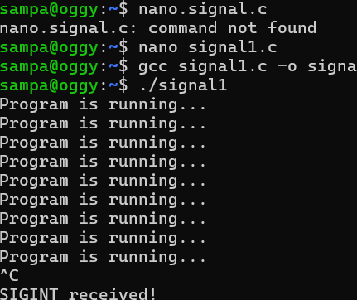

Program 2: SIGINT Without a Handler
Code:
#include <stdio.h>
#include <unistd.h>
int main()
{
while (1)
{
printf("Program is running...\n");
sleep(2);
}
return 0;
}
Output:
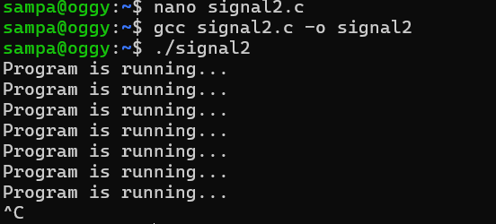
Program 3: SIGCHLD - Child Process Signal
Code:
#include <stdio.h>
#include <signal.h>
#include <unistd.h>
#include <sys/wait.h>
void handle_sigchld(int sig)
{
printf("SIGCHLD received: Child has terminated.\n");
}
int main()
{
signal(SIGCHLD, handle_sigchld);
pid_t pid = fork();
if (pid == 0)
{
// Child
printf("Child is running...\n");
sleep(3);
printf("Child is terminating...\n");
}
else
{
// Parent
printf("Parent is waiting...\n");
wait(NULL);
printf("Parent finished.\n");
}
return 0;
}
output:
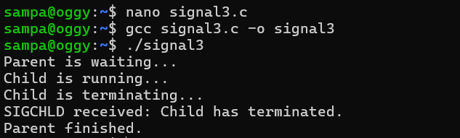
Program 4 - SIGPIPE - Broken Pipe
1. This one connects directly to the pipes you have already learned. SIGPIPE occurs when a process tries to write to a pipe after all readers have closed the read end.
2. SIGPIPE tells the writer that it is trying to write to a pipe whose read end has been closed.
code:
#include <stdio.h>
#include <unistd.h>
int main()
{
int fd[2];
pipe(fd);
close(fd[0]);
printf("Writing to pipe...\n");
write(fd[1], "Hello", 5);
printf("Write completed.\n");
return 0;
}
output:
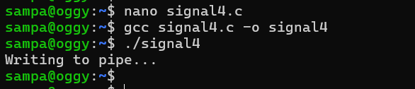
Program 5 - kill() program
In Linux, kill() is used to send a signal to a process.
Despite its name, kill() does not always mean "kill the process."
kill(getpid(), SIGUSR1) - means Send SIGUSR1 to process pid.
Parent sends signal to child Program
Code:
#include <stdio.h>
#include <signal.h>
#include <unistd.h>
#include <sys/wait.h>
void handler(int sig)
{
printf("Child received SIGUSR1\n");
}

int main()
{
pid_t pid = fork();
if (pid == 0)
{
// Child
signal(SIGUSR1, handler);
printf("Child waiting...\n");
while (1)
{
sleep(1);
}
}
else
{
// Parent
sleep(2);
printf("Parent sending signal...\n");
kill(pid, SIGUSR1);
sleep(2);
kill(pid, SIGTERM);
wait(NULL);
}
return 0;
}
output:
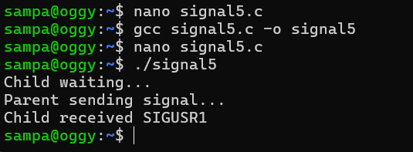
Program 6 - SIGABRT — Abort
code:
#include <stdio.h>
#include <stdlib.h>
int main()
{
printf("Program started\n");
abort();
printf("Program ended\n");
return 0;
}
output: 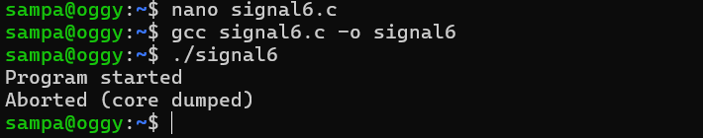
Program 7: SIGSEGV - Invalid Memory Access
code:
#include <stdio.h>
int main()
{
int *p = NULL;
printf("Before error\n");
*p = 10;
printf("After error\n");
return 0;
}
output:
