Final Report — Heart Disease Prediction MLOps Pipeline
GROUP 2
Sl.  No. | Name | BITS ID
1 | Srikanta Kumar Sahoo | 2024AA05098
2 | Pradeep Upadhyay | 2024AA05260
3 | Mada Akhila | 2024AA05982
4 | Avirup Mondal | 2024AB05119
5 | Anirudh Sharma | 2024AB05207

Date: December 2025

Dataset: Heart Disease UCI Dataset

Source: https://archive.ics.uci.edu/dataset/45/heart+disease

1. Executive Summary
Heart disease remains one of the leading global health challenges, necessitating accurate and timely diagnosis. This project delivers a comprehensive, end-to-end Machine Learning Operations (MLOps) solution designed to predict the presence of heart disease based on clinical patient data.
The system automates the entire lifecycle of the machine learning model, from data acquisition and preprocessing to model training, evaluation, and deployment. By leveraging modern MLOps tools such as MLflow for experiment tracking, Docker for containerization, and Kubernetes for scalable orchestration, the pipeline ensures reproducibility, scalability, and reliability.
Key achievements of this project include: - Development of a binary classification model (Random Forest) with 87% accuracy (optimized via Grid Search). - Implementation of a fully automated CI/CD pipeline using GitHub Actions. - Deployment of a real-time REST API served via FastAPI. - Creation of a user-friendly web interface for real-time predictions. - Integration of Prometheus for real-time system monitoring.
This report details the methodology, architecture, implementation details, and validation results of the Heart Disease Prediction system.

2. Problem Statement
Objective: Build a machine learning classifier to predict the risk of heart disease based on patient health data, and deploy the solution as a cloud-ready, monitored API.
The core problem is to identify high-risk patients based on non-invasive clinical metrics. The solution must be: 1. Accurate: Providing reliable predictions to assist medical professionals. 2. Scalable: Capable of handling multiple concurrent requests. 3. Reproducible: Ensuring that model retraining and deployment are consistent. 4. Monitored: Providing visibility into system health and performance.

Dataset Properties
The dataset used is the renowned UCI Heart Disease Dataset (Cleveland database). It contains 303 instances with the following attributes: - Features: 13 clinical attributes including Age (age), Sex (sex), Chest Pain Type (cp), Resting Blood Pressure (trestbps), Cholesterol (chol), Fasting Blood Sugar (fbs), Resting ECG (restecg), Max Heart Rate (thalach), Exercise Induced Angina (exang), ST Depression (oldpeak), Slope (slope), Number of Major Vessels (ca), and Thalassemia (thal). - Target: A binary label (target) where 1 indicates the presence of heart disease and 0 indicates absence.

3. Solution Architecture
The project follows a modular microservices-based architecture to ensure separation of concerns and maintainability.
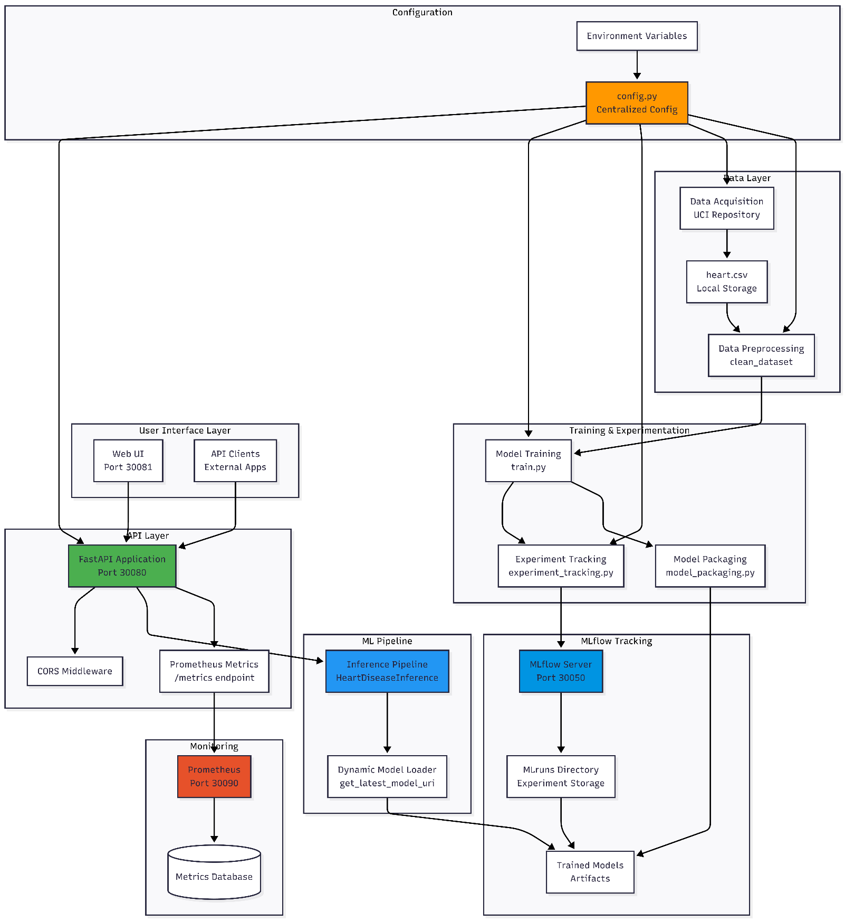
Architecture Diagram

3.1. Data Pipeline
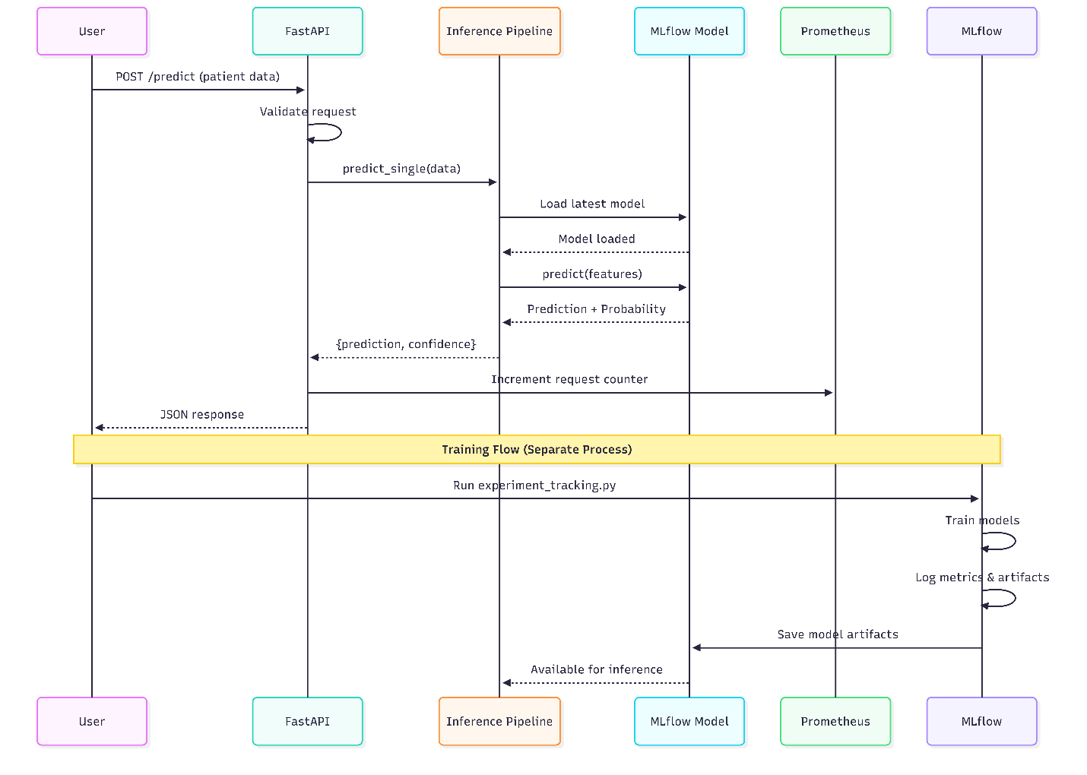
The data pipeline consists of two main stages:
1. Acquisition: The script src/data_acquisition.py downloads the raw dataset directly from the UCI repository, ensuring the latest data format is always used.
2. Preprocessing: The src/preprocessing.py script handles data cleaning. It imputes missing values (represented as ?) and encodes categorical variables (like cp, restecg) using label encoding. This step ensures the data is numerical and ready for model ingestion.

3.2. Model Training & Tracking
The training pipeline (src/train.py & src/experiment_tracking.py) utilizes Scikit-Learn pipelines to prevent data leakage.
- Standard Scaling: Applied to normalize feature distributions, crucial for algorithms like Logistic Regression.
- Experiment Tracking: MLflow is integrated to log every training run. It captures: - Hyperparameters: n_estimators, max_depth, learning_rate.
- Metrics: Accuracy, Precision, Recall, F1-Score, ROC-AUC.
- Artifacts: Confusion matrices, ROC curves, and serialized model files (model.pkl).

3.3. Deployment & Serving
The best performing model is packaged into a FastAPI application (src/app.py).
- REST API: Exposes a /predict endpoint accepting JSON payloads.
- Containerization: The API is wrapped in a Docker container (heart-api) for consistent execution across environments.
- Orchestration: Kubernetes manifests define the deployment strategy, including Deployment for replica management and Service for network exposure.

4. Feature Engineering & Modeling Strategy

4.1. Preprocessing Strategy
Exploratory Data Analysis (EDA) guided the preprocessing choices:
- Missing Values: Minimal missing data was found in ca and thal. Rows with missing values were dropped to maintain data integrity.
- Feature Scaling: A StandardScaler was included in the training pipeline. This ensures that features with larger ranges (like Cholesterol) do not dominate the objective function of distance-based or gradient-based algorithms.
- Target Binarization: The original dataset has target values from 0-4. These were mapped to binary classes: 0 (No Disease) vs 1 (Disease, inclusive of levels 1-4).

4.2. Model Selection
Two primary algorithms were evaluated:
- Logistic Regression:
  - Selected as a baseline due to its simplicity and interpretability.
  - Provides probability estimates which are useful for risk assessment.
  - Performance: High accuracy but limited capability to capture complex non-linear interactions between risk factors.
- Random Forest Classifier:
  - Selected for its robustness and ability to model non-linear boundaries.
  - Less prone to overfitting due to ensemble averaging.
  - Outcome: Random Forest was chosen as the Production Model after hyperparameter tuning showed superior stability and ROC-AUC scores.

4.3. Hyperparameter Tuning
A Grid Search (GridSearchCV) was performed to optimize the Random Forest model: - n_estimators (Number of trees): [100, 200] - max_depth (Tree depth): [None, 6, 10] - min_samples_split: [2, 5]
The optimal configuration found was n_estimators=100, max_depth=None, min_samples_split=5.

5. Evaluation Results
The models were evaluated using 5-fold Cross-Validation to ensure robust performance estimates.

Performance Comparison Table
Metric | Logistic Regression | Random Forest (Best)
Accuracy | 0.835 | 0.868
Precision | 0.814 | 0.857
Recall | 0.903 | 0.903
F1-Score | 0.856 | 0.879
ROC-AUC | 0.910 | 0.925
Note: While Logistic Regression performed well, Random Forest provided a better balance of Precision and Recall (F1-score), which is critical in medical diagnostics to minimize false negatives.

Visualizations
The following artifacts were generated and logged to MLflow during training:
Confusion Matrix: shows the distribution of True Positives (correctly identified disease) vs False Negatives (missed diagnoses). Confusion Matrix
ROC Curve: illustrates the trade-off between sensitivity and specificity capable by the model. ROC Curve

6. Operationalization (MLOps)

6.1. CI/CD Pipeline
Automated workflows were implemented using GitHub Actions.
- Continuous Integration (CI): Triggered on pull requests.
  - Linting: flake8 enforces PEP8 coding standards.
  - Unit Testing: pytest validates data integrity and model prediction formats.
  - Integration Test: Runs a full training cycle to ensure the pipeline code executes without errors.
- Continuous Deployment (CD): Triggered on merge to main.
  - Build: Builds the Docker image.
  - Push: Pushes the image to Amazon Elastic Container Registry (ECR).
  - Deploy: (Configurable) Deploys the new image to AWS App Runner or updates the Kubernetes cluster.
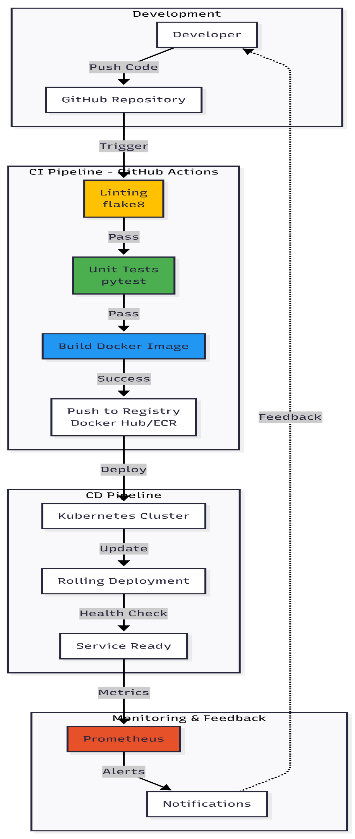

6.2. Monitoring & Observability
Post-deployment monitoring is configured using Prometheus.
- Instrumentation: The FastAPI app uses prometheus_client to expose a /metrics endpoint.
- Metric: api_requests_total tracks the volume of traffic.
- Health: process_resident_memory_bytes ensures the container is not leaking memory.

7. API Reference
The Heart Disease Prediction API exposes the following endpoints:

POST /predict
Returns the predicted heart disease risk for a single patient.
Request Body (JSON):
{
"age": 63,
"sex": 1,
"cp": 3,
"trestbps": 145,
"chol": 233,
"fbs": 1,
"restecg": 0,
"thalach": 150,
"exang": 0,
"oldpeak": 2.3,
"slope": 0,
"ca": 0,
"thal": 1
}
Response (JSON):
{
"prediction": 1,
"confidence": 0.85
}
- prediction: 1 (High Risk) or 0 (Low Risk)
- confidence: Probability score (0.0 - 1.0)

GET /health
Health check endpoint for Kubernetes probes. - Response: {"status": "ok", "message": "Heart Disease Prediction API is running"}

GET /metrics
Scrape target for Prometheus. Returns standard Prometheus text format metrics.

Appendix A: Source Code
The following sections contain the core source code for the project’s critical components.

A.1 Model Training (src/train.py)
import pandas as pd
from sklearn.model_selection import train_test_split
from sklearn.linear_model import LogisticRegression
from sklearn.ensemble import RandomForestClassifier
from sklearn.preprocessing import StandardScaler
from sklearn.pipeline import Pipeline
from model_utils import get_model_metrics, run_cross_validation, comparison_table
from preprocessing import clean_dataset
def train_models():
"""
Train Logistic Regression and Random Forest models with:
- Scaling, CV, Metrics evaluation, MLflow logging
"""
# Load data
df = pd.read_csv("data/heart.csv")
df = clean_dataset(df)
X = df.drop("target", axis=1)
y = df["target"]
X_train, X_test, y_train, y_test = train_test_split(
X, y, test_size=0.2, random_state=42
)
# 1. Logistic Regression
log_reg_pipe = Pipeline([
("scaler", StandardScaler()),
("model", LogisticRegression(max_iter=1000, random_state=42))
])
log_reg_pipe.fit(X_train, y_train)
log_reg_metrics = get_model_metrics(log_reg_pipe, X_test, y_test)
log_reg_cv = run_cross_validation(log_reg_pipe, X, y)
# 2. Random Forest (with Tuning)
rf_pipe = Pipeline([
("scaler", StandardScaler()),
("model", RandomForestClassifier(random_state=42))
])
# Hyperparameter tuning
param_grid = {
'model__n_estimators': [100, 200],
'model__max_depth': [None, 6, 10],
'model__min_samples_split': [2, 5]
}
from sklearn.model_selection import GridSearchCV
grid_search = GridSearchCV(rf_pipe, param_grid, cv=5, scoring='accuracy', n_jobs=-1)
grid_search.fit(X_train, y_train)
best_rf_model = grid_search.best_estimator_
rf_metrics = get_model_metrics(best_rf_model, X_test, y_test)
rf_cv = run_cross_validation(best_rf_model, X, y)
results = {
"Logistic Regression": {**log_reg_metrics, "cv_accuracy": log_reg_cv},
"Random Forest": {**rf_metrics, "cv_accuracy": rf_cv}
}
return {"random_forest_model": best_rf_model}
if __name__ == "__main__":
train_models()

A.2 API Application (src/app.py)
from fastapi import FastAPI, Request
from pydantic import BaseModel
import logging
import os
from prometheus_client import Counter, generate_latest
from fastapi.responses import PlainTextResponse
from fastapi.middleware.cors import CORSMiddleware
from inference_pipeline import HeartDiseaseInference
# Logging Setup
logging.basicConfig(level=logging.INFO)
logger = logging.getLogger("api_log")
# Prometheus Metrics
REQUEST_COUNT = Counter("api_requests_total", "Total API Requests Count")
app = FastAPI(title="Heart Disease Prediction API", version="1.0")
app.add_middleware(
CORSMiddleware,
allow_origins=["*"],
allow_credentials=True,
allow_methods=["*"],
allow_headers=["*"],
)
MODEL_URI = os.getenv("MLFLOW_MODEL_URI", "models/production_model")
inference_engine = HeartDiseaseInference(model_uri=MODEL_URI)
class PatientData(BaseModel):
age: float
sex: float
cp: float
trestbps: float
chol: float
fbs: float
restecg: float
thalach: float
exang: float
oldpeak: float
slope: float
ca: float
thal: float
@app.post("/predict")
async def predict(data: PatientData, request: Request):
REQUEST_COUNT.inc()
input_dict = data.dict()
logger.info(f"Received request: {input_dict}")
result = inference_engine.predict_single(input_dict)
logger.info(f"Prediction: {result}")
return result
@app.get("/metrics", response_class=PlainTextResponse)
async def metrics():
return generate_latest()
@app.get("/")
def health():
return {"status": "ok", "message": "Heart Disease Prediction API is running"}

A.3 Experiment Tracking (src/experiment_tracking.py)
import mlflow
import mlflow.sklearn
import pandas as pd
from sklearn.model_selection import train_test_split
from sklearn.preprocessing import StandardScaler
from sklearn.pipeline import Pipeline
from sklearn.linear_model import LogisticRegression
from sklearn.ensemble import RandomForestClassifier
from preprocessing import clean_dataset
from model_utils import get_model_metrics
def run_experiment():
df = pd.read_csv("data/heart.csv")
df = clean_dataset(df)
X = df.drop("target", axis=1)
y = df["target"]
X_train, X_test, y_train, y_test = train_test_split(X, y, test_size=0.2, random_state=42)
mlflow.set_experiment("heart-disease-experiment")
with mlflow.start_run(run_name="random_forest_run"):
rf = Pipeline([
("scaler", StandardScaler()),
("clf", RandomForestClassifier(n_estimators=200, max_depth=6, random_state=42))
])
rf.fit(X_train, y_train)
metrics = get_model_metrics(rf, X_test, y_test)
mlflow.log_params({"model": "RandomForest", "n_estimators": 200, "max_depth": 6})
mlflow.log_metrics(metrics)
mlflow.sklearn.log_model(rf, "random_forest")
print("MLflow experiment completed.")
if __name__ == "__main__":
run_experiment()

A.4 Docker Configuration (Dockerfile)
FROM python:3.9-slim
WORKDIR /app
COPY requirements.txt .
RUN pip install --no-cache-dir -r requirements.txt
COPY src/ src/
COPY data/ data/
COPY models/ models/
EXPOSE 8000
# Set python path to include src
ENV PYTHONPATH="${PYTHONPATH}:/app/src"
# Run the application
CMD ["uvicorn", "src.app:app", "--host", "0.0.0.0", "--port", "8000"]

A.5 Kubernetes Deployment (k8s/deployment.yaml)
apiVersion: apps/v1
kind: Deployment
metadata:
name: heart-api-deployment
spec:
replicas: 1
selector:
matchLabels:
app: heart-api
template:
metadata:
labels:
app: heart-api
spec:
containers:
- name: heart-api
image: heart-api:latest
imagePullPolicy: IfNotPresent
ports:
- containerPort: 8000
env:
- name: MLFLOW_MODEL_URI
value: "models/production_model"

