DATA ANALYTICS INTERNSHIP • WEEK 2

Data Collection, Cleaning, and Preprocessing for Logistics Analysis
A reproducible Python demonstration with quality audit, numerical results, and validation
PROJECT INFORMATION | DETAILS
Student / College | Srikrishna Samanta / Tamralipta Institute of Management and Technology
Assignment | Week 2 – Data Collection, Cleaning and Preprocessing
Implementation | Python, Pandas, NumPy, scikit-learn, Matplotlib
Data provenance | Public Olist dataset used as a research reference; demonstration records are synthetic
Evidence | Executable scripts, raw/cleaned/quarantined CSVs, JSON metrics and charts

Executive summary
This assignment demonstrates an end-to-end data preparation process for logistics analytics. The public Brazilian E-Commerce dataset by Olist provides the realistic research context, while a separate, explicitly synthetic order-level sample allows reproducible execution without redistributing or misrepresenting commercial transaction records. The simulation includes duplicates, missing values, inconsistent labels, invalid dates, impossible negative freight values and extreme-but-plausible numerical observations.
The script was executed against 62 simulated input rows. It removed 2 duplicate order-level records, quarantined 6 records requiring investigation and retained 54 analysis-ready orders. It imputed four freight amounts and two distances, labelled three missing states as UNKNOWN, flagged one freight and one distance outlier, and normalized two continuous features into an approximately 0–1 range. Each action is justified and the data remains traceable.
The results are an educational illustration, not measured performance of Olist. The principal outcome is an auditable preprocessing pipeline that can be adapted to actual logistics data once the real files, business rules, and permissions are available.

1. Problem statement and objectives
Delivery-data quality affects promised-date monitoring, transport cost analysis and downstream machine-learning inputs. Duplicate orders inflate volume; blank freight values distort averages; malformed timestamps prevent on-time delivery calculations; and extreme costs can dominate feature scaling. Before drawing business conclusions, analysts must ensure one consistent, validated record per order.
- Select and describe a genuine public logistics/e-commerce data source and an applicable order-level schema.
- Identify and correct duplicate, missing, inconsistent, invalid and outlying records with defensible rules.
- Implement preprocessing in executable Python; report before/after measurements and validation checks.
- Produce clean outputs and document practical implications, limitations and next steps.

2. Background research and source selection

2.1 Public source: Olist Brazilian E-Commerce dataset
The Brazilian E-Commerce Public Dataset by Olist, hosted on Kaggle, contains information on approximately 100,000 anonymized marketplace orders from 2016–2018 in Brazil. It provides relational tables for orders, line items, customers, products, sellers, payments, reviews and geolocation, including fields useful for delivery performance and freight analysis [1]. It is distributed with a CC BY-NC-SA 4.0 license; redistribution and use must respect its conditions [1].
Original Olist table | Relevant attributes | Preparation requirement
olist_orders_dataset.csv | order_id, customer_id, order_status, purchase / estimated / delivered dates | Parse dates; distinguish undelivered orders from defective timestamps.
olist_order_items_dataset.csv | order_id, order_item_id, freight_value | Aggregate item-level freight by order_id before order-level joins.
olist_customers_dataset.csv | customer_id, customer_state | Join customer details to orders on customer_id.
olist_geolocation_dataset.csv | ZIP prefixes, latitude, longitude | Optional approximation of geographic distances; not route kilometers.

Important grain rule: order_items can legitimately contain several rows with the same order_id. Duplicate removal by order_id is only appropriate after creating a one-row-per-order table. Applying it directly to item-level data would incorrectly discard purchased items [1, 2].

2.2 Research versus executed data
The real Olist CSV files were NOT imported, processed or evaluated here. Instead, the included generate_sample_data.py script produces 60 invented orders and adds two repeated records, yielding 62 raw rows. The schema deliberately resembles selected Olist attributes, with customer_state representing a customer-table join and freight_value representing aggregated order-level freight. distance_km is an extra invented feature and is NOT a supplied Olist distance column. Currency is treated as illustrative Brazilian real (BRL).
This separation is essential: the numerical tables and charts below describe only this synthetic teaching sample. They must not be presented as statistics from the Olist dataset.

3. Data collection simulation and data dictionary

3.1 Simulated data collection
The generation script uses NumPy with a fixed random seed (20261106) for repeatability. It creates purchase dates, estimated dates, actual delivery dates for delivered orders, Brazilian state codes, freight values and fictional travel distances. An anomaly-injection stage introduces representative failures. The raw CSV is then handed to a separate processing script, analogous to receiving an extract from an operational system.
Column | Type / expected meaning | Rule applied
order_id | Text; unique order-level identifier | Required, cannot be blank or repeated
order_status | Text; delivered/shipped/canceled | Trim spaces, lowercase, validate category
customer_state | Text; Brazilian state code | Uppercase; UNKNOWN if missing
order_purchase_timestamp | YYYY-MM-DD | Must be parseable
order_estimated_delivery_date | YYYY-MM-DD | Must be parseable, not before purchase
order_delivered_customer_date | YYYY-MM-DD / blank | Required only for delivered orders
freight_value | Non-negative BRL amount | Median-fill missing; quarantine negatives
distance_km | Non-negative simulated distance | Median-fill missing; not a real Olist field

3.2 Initial data-quality inspection
The 60 unique simulated order records contain 3 missing customer states, 4 blank freight values and 2 blank distance values. Additional problems include inconsistent status casing, 2 entire duplicate orders, 1 blank order ID, 1 negative freight value, 1 invalid estimated date, 2 missing or unparseable delivered dates on delivered orders, and 1 delivered-before-purchase timestamp. Missing delivered dates for shipped or canceled orders are expected and are not automatically errors.

4. Detailed preprocessing methodology

Step 1 — Import, standardize and check the record grain
Load all fields as strings to preserve raw content; trim whitespace and convert empty strings to missing values. Because this teaching file is explicitly order-level, remove repeated order_id values, keeping the first occurrence. In an operational system, check conflicting duplicates rather than arbitrarily selecting a version.
raw = pd.read_csv('sample_logistics_raw.csv', dtype='string')
for col in raw.columns:
raw[col] = raw[col].str.strip().replace('', pd.NA)
orders = raw.drop_duplicates(subset=['order_id'], keep='first')
orders['order_status'] = orders['order_status'].str.lower()
orders['customer_state'] = orders['customer_state'].str.upper()
Effect: duplicate counts no longer inflate demand, and labels such as “ DELIVERED ” and “Delivered” become the single category “delivered”. The raw input remains unchanged on disk.

Step 2 — Parse dates and validate business rules
Convert date strings with pd.to_datetime(..., errors="coerce"). Non-parsable values become NaT instead of crashing the program [3]. Rows with missing IDs, invalid core dates, negative freight or impossible chronology are sent to quarantined_records.csv with explicit reasons. Delivery dates are compulsory for status=delivered but correctly optional for shipped/canceled orders.
date_cols = ['order_purchase_timestamp',
'order_estimated_delivery_date',
'order_delivered_customer_date']
for col in date_cols:
orders[col] = pd.to_datetime(
orders[col], format='%Y-%m-%d', errors='coerce')
# See week2_preprocessing.py for all audit and quarantine rules.
Effect: invalid delivery timing cannot corrupt delivery-duration KPIs. Quarantined rows are retained as a separate audit trail instead of being silently deleted.

Step 3 — Resolve missing values according to meaning
Freight and simulated distance are continuous fields for which the retained-row median is a robust demonstration imputation strategy. The calculated medians are BRL 104.655 for freight and 327.05 km for distance. Missing customer_state is coded UNKNOWN rather than guessing a region. This preserves evidence of absent geography. Critically, actual delivery dates on undelivered orders are never imputed.
freight_median = clean['freight_value'].median()
distance_median = clean['distance_km'].median()
clean['freight_value'] = clean['freight_value'].fillna(freight_median)
clean['distance_km'] = clean['distance_km'].fillna(distance_median)
clean['customer_state'] = clean['customer_state'].fillna('UNKNOWN')
Why median? A freight outlier of BRL 3,000 is present in the sample. The mean is sensitive to this extreme value; using the median reduces the influence of such observations when imputing missing data. Imputed values must be labeled and rechecked in any production use [4].

Step 4 — Identify unusual observations without hiding them
For freight_value and distance_km, calculate Q1 and Q3; the interquartile range (IQR) equals Q3−Q1. Flag a value if it falls below Q1−1.5×IQR or above Q3+1.5×IQR. A flag triggers review, not automatic deletion: expensive shipments or long journeys may be genuine.
q1, q3 = clean['freight_value'].quantile([0.25, 0.75])
iqr = q3 - q1
upper = q3 + 1.5 * iqr
clean['freight_value_outlier'] = clean['freight_value'] > upper
Field | IQR lower bound | IQR upper bound | Flagged
Freight value (BRL) | 2.00 | 216.71 | 1
Distance (km) | -75.93 | 776.08 | 1

Worked examples: SIM-0016 has freight BRL 3,000 and is flagged as an extreme freight value; SIM-0021 has a synthetic distance of 2,200 km and is flagged as an extreme distance. Original values remain unchanged in the clean output for investigation.

Step 5 — Prepare normalized model features
Min–max scaling maps a feature to a roughly 0–1 range using (x−min)/(max−min) [5]. Since very large outliers compress ordinary observations, the demonstration first clips a modeling-only copy of each continuous feature at the observed 5th and 95th percentiles, then applies MinMaxScaler. It does not change original freight or distance values.
model_features = ['freight_value', 'distance_km']
clipped = clean[model_features].copy()
for col in model_features:
lo, hi = clean[col].quantile([0.05, 0.95])
clipped[col] = clipped[col].clip(lo, hi)
clean[['freight_scaled', 'distance_scaled']] = (
MinMaxScaler().fit_transform(clipped))
The upper 95th-percentile clipping limits in this simulation are BRL 162.62 and 595.64 km. After this step, the demonstration feature range is approximately 0 to 1 (floating-point rounding may create negligible deviations). For future predictive modeling, calculate clipping thresholds and fit the scaler on TRAINING data only, then transform validation/test data to prevent data leakage.

5. Reproducible results and quality evaluation

5.1 Record-level audit trail
Measure | Observed result | Interpretation
Raw imported rows | 62 | All simulated raw records
Repeated order IDs removed | 2 | Duplicate order-level rows
Unique records reviewed | 60 | After duplicate removal
Records quarantined | 6 | Business-rule violations or missing critical data
Analysis-ready records | 54 | 90.0% of the 60 unique orders
Unique order IDs after cleaning | 54 of 54 | All analysis-ready IDs unique

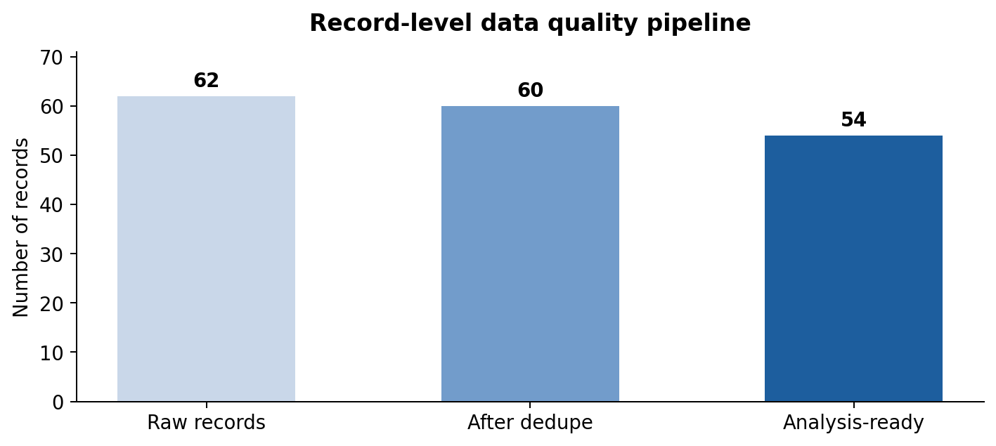
Figure 1. Actual record counts from executed Python pipeline.

5.2 Before / after missing-value comparisons
Field | Missing before* | Missing after | Treatment
customer_state | 3 | 0 | Replace with UNKNOWN
freight_value | 4 | 0 | Median imputation
distance_km | 2 | 0 | Median imputation

* “Before” means after duplicate removal, before quarantine and imputation. These counts identify initial issues, but the number corrected in analysis-ready rows can vary if an affected record is quarantined.
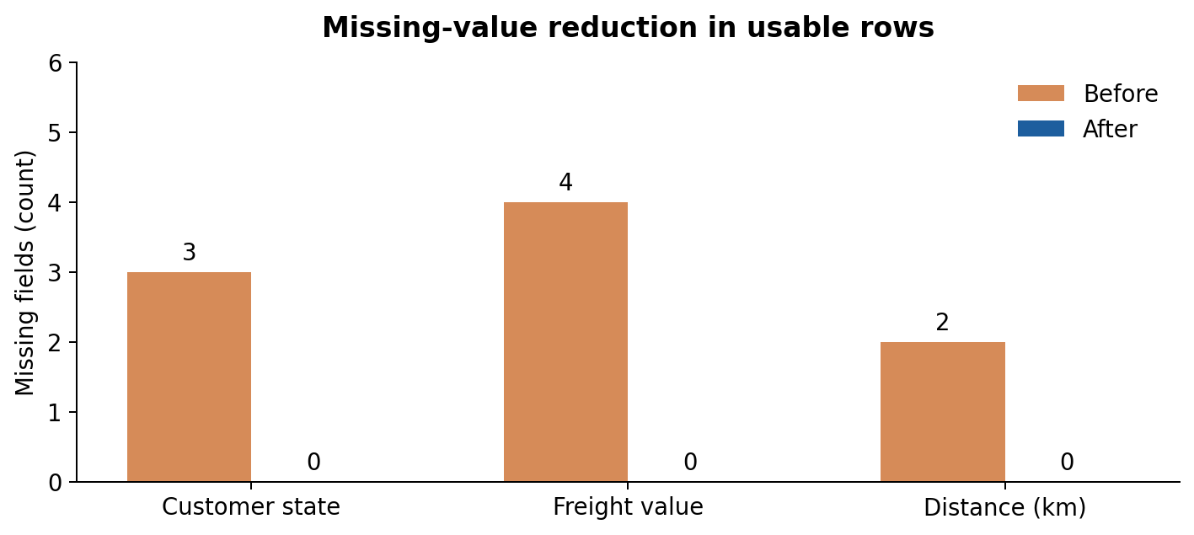
Figure 2. Counts extracted from the generated quality_summary.json file.

5.3 Delivery and freight sanity-check figures
Among 46 validated delivered orders in the simulated analysis-ready sample, 23 met their estimated delivery date. The illustrative on-time percentage is 50.0% (23 ÷ 46 × 100), and mean delivery time is 11.91 days. Mean freight across the 54 retained orders is BRL 157.61; it is strongly influenced by the flagged BRL 3,000 observation. These are NOT Olist delivery-performance measurements.
A clear example of the practical impact is that counting all 62 raw rows as orders would overstate genuine order volume by eight relative to the 54 valid analysis-ready rows. That difference consists of two duplicates and six quarantined records; it should never be interpreted as eight lost customer orders.

6. Worked record examples
Sample record | Issue observed | Decision and justification
SIM-0003 | Status “ DELIVERED ” | Normalize label; retain order
SIM-0008 | Missing freight value | Impute retained-row median (BRL 104.655)
SIM-0010 | Negative freight −25.00 | Quarantine; violates non-negative amount rule
SIM-0016 | Freight BRL 3,000 | Retain, flag, clip modeling-only feature
SIM-0025 | Delivered status; missing delivery date | Quarantine pending source-system correction
SIM-0032 | Invalid date 2025-15-99 | Parsing yields NaT; quarantine
SIM-0047 | Delivery before purchase | Quarantine inconsistent chronology
SIM-0054 | Shipped; delivery date blank | Retain; missing date is expected for undelivered order

One row-level normalization example: SIM-0001 has original freight BRL 117.05 and distance 174.2 km; the modeling-only scaled values are approximately 0.626 and 0.188. The original values remain available for reporting and auditing.

7. Code execution, outputs and verification

7.1 Run procedure
Install Python 3.10 or later. Put generate_sample_data.py and week2_preprocessing.py in the same folder. Open a terminal in that folder and run the following commands. No Kaggle download or login is necessary for this synthetic demonstration.
python -m pip install -r requirements.txt
python generate_sample_data.py
python week2_preprocessing.py

7.2 Files created
Output | Purpose
sample_logistics_raw.csv | Reproducible raw example with deliberately introduced defects
cleaned_logistics_orders.csv | Validated and augmented 54-row output for subsequent analysis
quarantined_records.csv | 6 problematic records with explicit rejection reasons
quality_summary.json | Machine-readable results and thresholds
figures/*.png | Charts used in this report
week2_preprocessing.py | Full runnable method and validation assertions

Automated assertions verify that remaining IDs are unique and nonblank, freight/distance are non-negative, delivered dates are chronologically valid, and scaled features fall inside 0–1 within numerical tolerance. Since the report contains selected snippets only, the included Python script is the complete executable source of truth.

8. Impact on logistics decisions and reflection
Without deduplication, order-volume dashboards may overcount demand and misallocate driver capacity. Incorrect or missing delivery timestamps create false late-delivery alerts and contaminate promised-date KPIs. Median imputation allows exploratory analysis to proceed for non-critical quantitative fields, but it also conceals uncertainty if the imputed flag is not retained. Identifying unusually costly orders helps a logistics manager investigate shipment complexity and pricing rather than remove commercially important exceptions.
Preprocessing is not the same as achieving a better delivery rate. The 50% on-time rate calculated above is only a descriptive result for an intentionally tiny synthetic example. It does not imply that the cleaning script improved operations. Operational improvements would require actual company data, confirmed business definitions, root-cause analysis and follow-up measurement.

Limitations and responsible interpretation
- A missing delivered date may be legitimate when order_status is shipped or canceled; one rule must not be applied to all statuses.
- Quarantine isolates uncertain records; an operational workflow should assign review responsibility, log changes and reconcile records later.
- Median imputation may reduce variance and change distributions; real projects should investigate the missingness mechanism and compare alternative strategies.
- For a predictive system, split data before fitting imputers, clipping thresholds and scalers to avoid leakage.

9. Conclusion and next-stage roadmap
The Week 2 deliverables document and execute a consistent data preparation process. The simulated exercise transformed 62 original rows into 54 analysis-ready order records while preserving 6 defective records in a separate audit file. The outcome includes standardized labels, parsed dates, condition-aware missing-value treatment, justified numerical imputation, outlier flags, capped/scaled modeling features and reproducible validation evidence. These techniques establish the data-quality foundation required for later descriptive dashboards, delay classification, forecasting or route-analysis work.
When advancing to real Olist data, the next steps are to download the licensed CSV files, join orders to customers, aggregate order-item freight, document missingness by order status, validate actual dates, and create a train/test separation if any predictive model is attempted. All real-data results should be recalculated and attributed, never copied from this simulated demonstration.

References
[1] Olist / Kaggle, Brazilian E-Commerce Public Dataset by Olist, dataset description, schema and licence. https://www.kaggle.com/datasets/olistbr/brazilian-ecommerce
[2] Olist dataset description / data dictionary (order, item and customer schema), community documentation. https://github.com/ali-0128/olist-ecommerce-analytics/blob/main/01_docs/02_data_dictionary.md
[3] pandas documentation, to_datetime: conversion and errors="coerce". https://pandas.pydata.org/docs/reference/api/pandas.to_datetime.html
[4] pandas documentation, DataFrame.fillna; and drop_duplicates. https://pandas.pydata.org/docs/reference/api/pandas.DataFrame.fillna.html
[5] scikit-learn documentation, MinMaxScaler. https://scikit-learn.org/stable/modules/generated/sklearn.preprocessing.MinMaxScaler.html

