# Part 1: Building the Topology

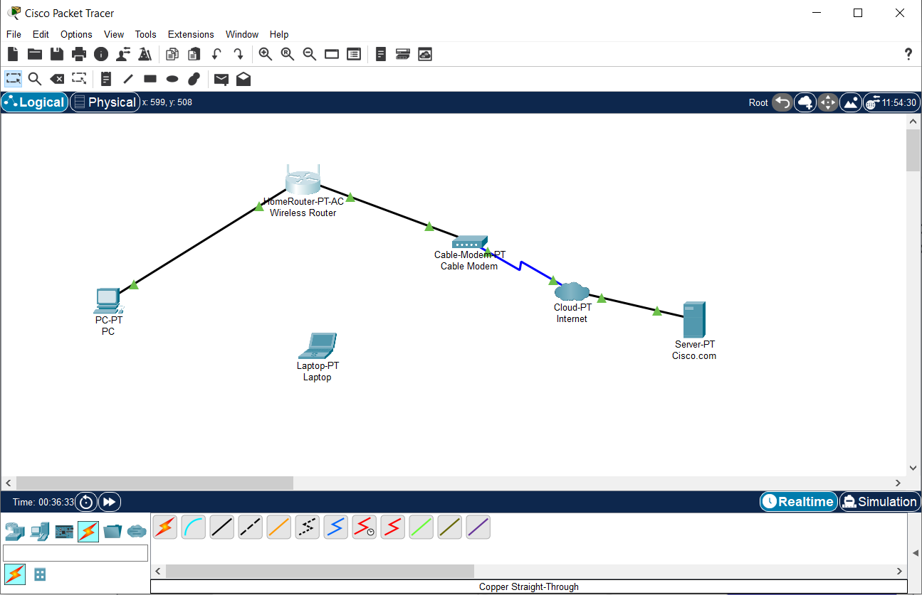

Adding the network devices to the workspace, configuring their display names and adding physical cabling between them.

# Part 2: Configuring the Network Devices

## Step 1: Configure the wireless router

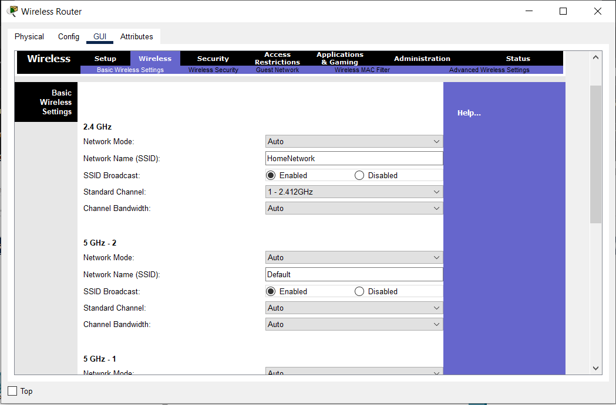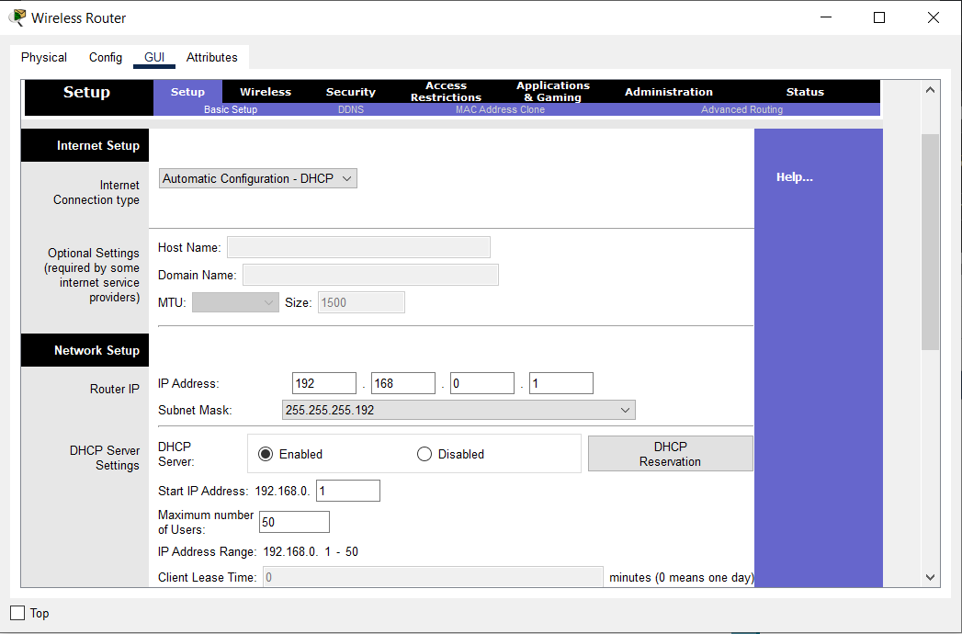

Configuring the SSID and DHCP settings

## Step 2: Configure the laptop

## 

## 

## 

Replacing the ethernet module with a wireless one and establishing a connection with the wireless router

## Step 3: Configure the PC

## 

## 

Setting the IP Configuration to DHCP and verification

## Step 4: Configuring the internet cloud

## 

Installing necessary modules and configuring the from and to ports

## Step 5: Configure the server

## 

## 

## 

## 

DHCP and Service Configuration, Global Configuration and Ethernet Interface Configuration

# Part 3: Verifying Connectivity

# 

# 

Renew ipconfig and ping the cisco.com server

# Part 4: Saving the file

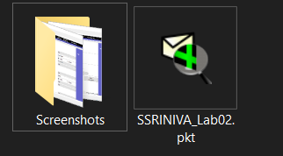

File is saved as SSRINIVA_Lab02.pkt on the filesystem