1. Create a file and add executable permission to all users (user, group and others)

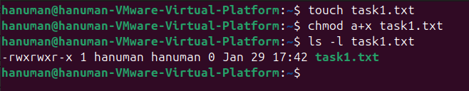
The rwxrwxr-x is the output where the x represents the this file has permission to all users

2. Create a file and remove write permission for group user alone.

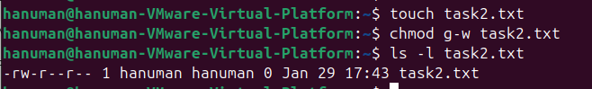
Here, x is not there, this represents that this file has removed the write permission for the group alone.

3. Create a file and add a softlink to the file in different directory (Eg : Create a file in dir1/dir2/file and create a softlink for file inside dir1)

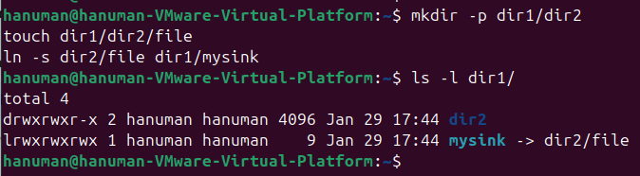
This creates a symbolic link (shortcut) in a parent directory that points to a file nested deep within subdirectories, allowing for easier access without navigating the full path.

4. Use ps command with options to display all active process running on the system

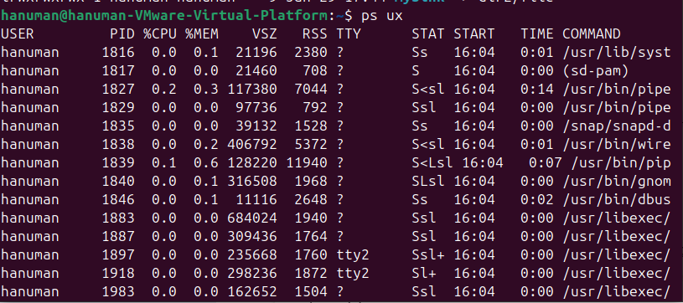
This command scans the system's process table to list every program currently running, providing details like the Process ID (PID) and the user who started it.

5. Create 3 files in a dir1 and re-direct the output of list command with sorted by timestamp of the files to a file

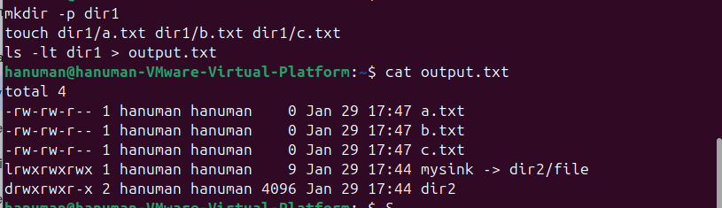

This captures a directory listing sorted by the most recent modification time and saves that specific output into a file instead of displaying it on the terminal screen.

