1) Use the appropriate command to list all files larger than 1 MB in the current directory and save the output to a file.


Command: find . -maxdepth 1 -type f -size +1M > large_files.txt
- find .: Tells Linux to start looking in the current directory (represented by the dot).
- -maxdepth 1: This ensures it only looks in the current folder and doesn't go digging into subfolders.
- -type f: Restricts the search to files only (excluding directories).
- -size +1M: The + sign means "greater than." You can also use k for Kilobytes or G for Gigabytes.
- >: This is a redirection operator. Instead of printing the names on your screen, it "pushes" them into the file large_files.txt.
Verification:
  - command: cat large_files, this command will display the files larger than 1MB. In my VM I have only one file named 1mb.pdf(A sample pdf downloaded from google) which is of 1MB.

2) Replace all occurrences of "localhost" with "127.0.0.1" in a configuration file named config.txt, and save the updated file as updated_config.txt.

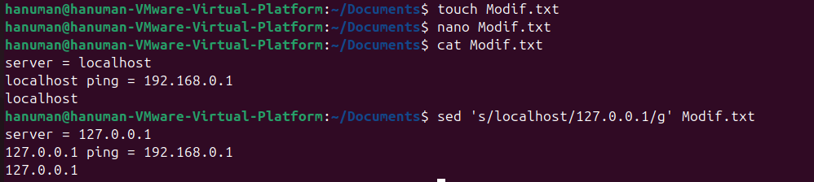
Command: sed 's/localhost/127.0.0.1/g' config.txt > updated_config.txt
- sed: Stands for "Stream Editor." It processes text line-by-line.
- s/old/new/: The standard syntax for substitution.
- /g (Global): Without this, sed only replaces the first "localhost" it finds on each line. The g tells it to replace every single one.
- Original vs. New: Note that we use > to save a new file. If you wanted to change the file "in-place" without creating a new one, you would use the -i flag (sed -i ...).

Verification:
  - The modif.txt is now updated. The word localhost has been replaced with 127.0.0.1
3) Use the appropriate command to search for lines containing the word "ERROR" in a log file but exclude lines containing "DEBUG". Save the results to a file named filtered_log.txt.
log:
DEBUG: Starting the application initialization.
ERROR: Unable to connect to the database.
INFO: User 'admin' logged in successfully.
DEBUG: Fetching configuration settings from the server.
ERROR: DEBUG - Configuration settings could not be applied.
INFO: Scheduled job 'backup' completed successfully.
DEBUG: Connection to server timed out. Retrying...
ERROR: Failed to fetch data from API endpoint '/users'.
INFO: Maintenance mode activated.
ERROR: DEBUG - Query execution failed due to a syntax error.
DEBUG: Reloading application modules.
ERROR: Missing required parameter in the request.
INFO: Shutting down the system gracefully.
DEBUG: Closing unused network connections.
ERROR: DEBUG - Unexpected server response received.

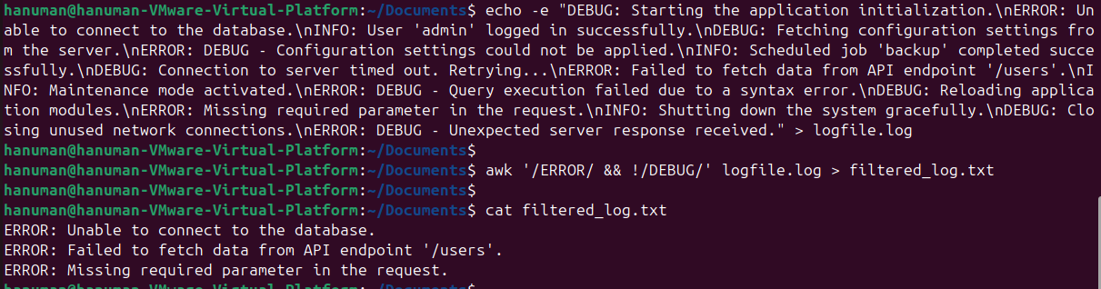
Command: grep "ERROR" log.txt | grep -v "DEBUG" > filtered_log.txt
- grep "ERROR": Searches log.txt and pulls out every line containing that word.
- The Pipe (|): This is one of the most powerful tools in Linux. It takes the output of the first command and feeds it as the input to the next.
- grep -v "DEBUG": The -v flag stands for invert-match. It tells the system: "Keep everything except the lines that contain 'DEBUG'."
  - In the log file, there is a line that says ERROR: DEBUG - by using the second grep, we successfully filter that out as requested.
Verification:
- In the output file, filtered_log.txt, the word ‘ERROR’ has been searched but the lines with the word ‘DEBUG’ has been neglected.
4) Write a code to identify the process with the highest memory usage and then terminate it.

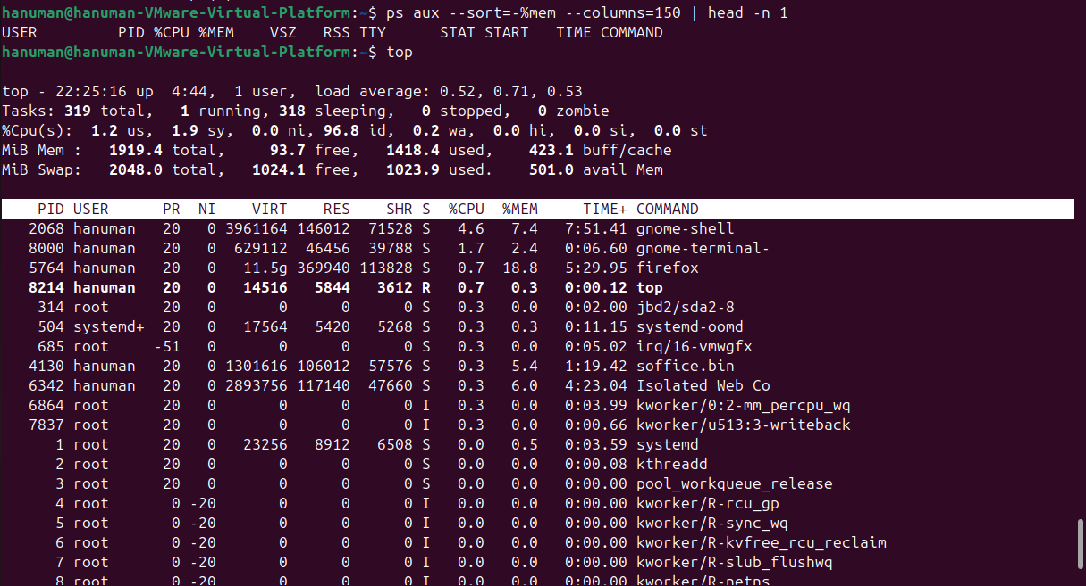
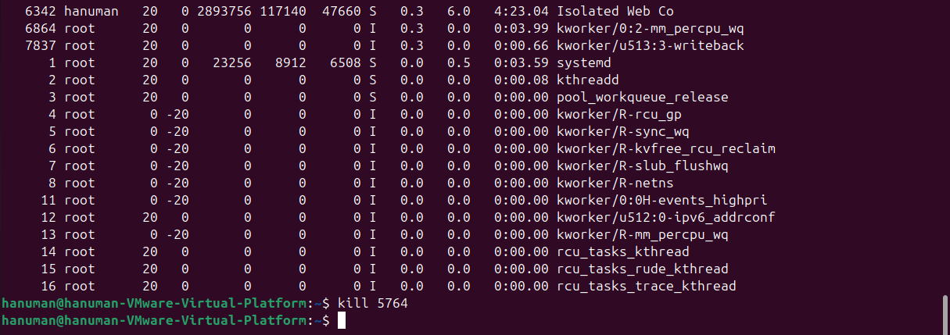
Command: ps aux --sort=-%mem | head -n 2
- ps aux: Displays every process running on the system.
- --sort=-%mem: The minus sign - indicates a descending sort (highest to lowest). %mem targets Memory usage.
- head -n 2: Shows only the top 2 lines (the header and the top process).
- kill [PID]: Once you identify the PID (Process ID) from the list, kill sends a signal to the OS to shut that process down.
Verification:
- The top command has given the highest memory usage and I have killed that process. For me the process was FireFox I killed it using kill <PID of FireFox>
5) Use the networking tool command and print all the gateway available in a sorted manner

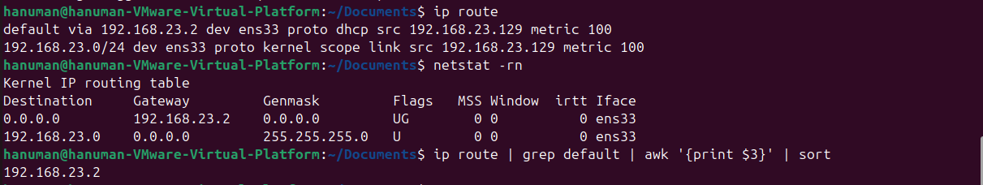
Command: ip route show | grep default | awk '{print $3}'
- ip route: The modern replacement for the old route or netstat commands. It shows how data packets travel out of your computer.
- grep default: The "default" route is typically your gateway (your router's IP).
- awk '{print $3}': awk is a text-processing tool that views a line as a series of columns. In the output of ip route, the gateway IP is usually the 3rd word on the line.
- sort -u: Ensures that if there are multiple identical paths, you only see a clean, unique list.
Verification:
- ip route displays all the routing network and I have displayed the sorted output.

