sriram11_g01230629.R

sumanth

2019-11-03

###Visualization

###Students Name: Sriram Sai Sumanth  
###GNumber:G-01230629  
  
  
rm(list=ls())  
  
data <- read.csv("../EmployeeAttrition.csv")  
  
#Create Histogram for Age using R   
#the generic function hist computes a histogram of the given data vales  
  
hist(data$Age, main = "Histogram")

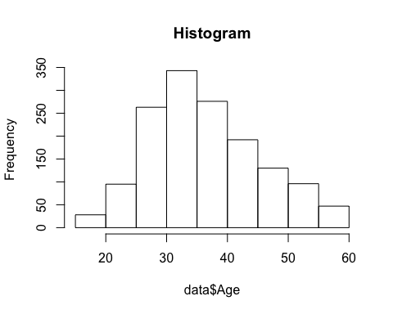

#Create Scatter Plot for Age and Monthly Income using R  
#generic function for plotting r objects, here age is the x cordinate and   
#monthlyincome is the y cordinate and the lab is used to label the axis  
  
plot(data$Age, data$MonthlyIncome, main = "scatter plot", xlab = "Age", ylab = "Monthly")

