

JAVA PROJECT REPORT ON
Complaint Management and Resolution Tracking System

Submitted by
Sri Subhiksha
25BIT129

Under the Guidance of
Mugilan.R
Technical Trainer
Technical Department, KG College of Arts and Science

Academic Year: 2025 – 2026
APRIL 2026
Semester: II

DECLARATION
I hereby declare that the project entitled “Complaint Management and Resolution Tracking System” submitted in partial fulfillment of the requirements for the course java programming is a record of my original work carried out under the guidance of [Mugilan.R], Technical Trainer, Technical Department, KG College of Arts and Science.
I further declare that this project has not been submitted previously, either in part or in full, for the award of any degree, diploma, or other similar title, at this or any other institution.
I have acknowledged all sources of information used in this project wherever applicable.

April 2026
Coimbatore

Sri Subhiksha

CERTIFICATE
This is to certify that the project entitled “Complaint Management and Resolution Tracking System” is a bona fide work carried out by Sri Subhiksha, [BSC.IT “B” (2025-2028) ], B.Sc.INFORMATION TECHNOLOGY, KG College of Arts & Science, in partial fulfillment of the requirements for the course JAVA PROGRAMMING
This project has been completed under my supervision and guidance during the academic period April 2026.

Place: Coimbatore
Date:

Submitted for the Viva-Voce Examination held on __________________________________

Guide: Head of the Department
(Technical Trainer, KGCAS) (Technical Head, KGCAS)

______________________ _______________________

TABLE OF CONTENTS
S. No. | Topics | Page. No.
1 | Introduction
1.1 | Objective
1.2 | Overview
1.3 | Features
2 | Program Analysis
2.1 | Problem Definition
2.2 | Project Overview
2.3 | Scopes and Limitations
3 | System Design
3.1 | Modules
4 | Methodology
4.1 | Problem Analysis
4.2 | System Design
4.3 | Program Development
4.4 | Testing and Validation
4.5 | Result and Documentation
4.6 | Algorithm
4.7 | Flowchart
5 | Source Code
6 | Input and Output Screens
7 | Discussion and Conclusion
7.1 | Discussion
7.2 | Conclusion
8 | References

ABSTRACT
The Complaint Management and Resolution Tracking System is a Java-based application developed to automate the process of placing complaints and generating complaint detailss in online shopping environments. In many small businesses, complaint management and complaint resolution are still handled manually, which can lead to calculation errors, delays in processing complaints, and difficulty in maintaining accurate records. This project aims to simplify and streamline the complaint management process by providing an automated system that processes user complaints and generates an accurate complaint details.
The system allows users to select complaints from a predefined complaint list, enter the description of each item, and automatically calculate the total cost of the complaint. It then generates a structured complaint details displaying details such as complaint name, description, price, subtotal, applicable taxes, and the final payable amount. The application is developed using Core Java programming concepts, including classes, objects, methods, loops, conditional statements, and exception handling. The project can be implemented as a console-based application or enhanced using Java Swing to provide a graphical user interface.
The main objective of the system is to improve the efficiency of complaint management, reduce manual errors, and provide faster and more reliable service to users. The system generates a clear and organized complaint details that helps both users and businesses maintain accurate transaction records.
This project demonstrates the practical implementation of object-oriented programming concepts in Java and provides a foundation for developing more advanced e-commerce and online complaint management systems in the future.

- INTRODUCTION
In today's digital world, online shopping and electronic transactions have become an important part of modern business operations. Many businesses sell complaints through online platforms where users can place complaints and receive complaint detailss automatically. However, in some small businesses, complaint management and complaint resolution are still performed manually using paper records or simple calculators. This manual approach can lead to calculation errors, delays in complaint management, and difficulties in maintaining transaction records.
With the advancement of computer technology, automated complaint management systems have become essential for improving efficiency and accuracy in business operations. A computerized complaint management system allows businesses to manage user complaints, calculate the total amount automatically, and generate complaint detailss quickly and accurately.
The Complaint Management and Resolution Tracking System is a Java-based application designed to automate the process of complaint management and resolution tracking for online purchases. The system allows users to select complaints from a predefined complaint list, enter the description of items, and automatically calculate the total cost including applicable taxes. The application then generates a structured complaint details displaying complaint details, quantities, prices, subtotal, tax, and final payable amount.
This project is developed using Core Java programming concepts such as classes, objects, methods, loops, conditional statements, and exception handling. The application can be implemented either as a console-based program or using Java Swing to create a graphical user interface (GUI).
The main goal of this system is to simplify complaint management, reduce manual errors, and provide faster resolution tracking for businesses and users. This project also demonstrates how Java programming can be used to develop practical applications for real-world business environments.

1.1 Objective
The main objective of the Complaint Management and Resolution Tracking System is to develop a simple and efficient Java-based application that automates the process of managing online complaints and generating complaint detailss.
The specific objectives of this project are:
• To design and develop a Java-based complaint management system.
• To automate the calculation of complaint prices and total complaint amount.
• To reduce manual errors in complaint management and complaint resolution.
• To provide a user-friendly system for generating complaint detailss quickly.
• To demonstrate the implementation of Core Java programming concepts such as classes, objects, loops, and conditional statements.
• To generate a clear and organized complaint details for users.

1.2 Overview
The Complaint Management and Resolution Tracking System is a menu-driven application developed using the Java programming language. The system provides a digital platform where users can select complaints from a predefined list and generate complaint detailss automatically.
The system displays a list of available complaints along with their prices. The user can select the required items and enter the description for each complaint. The program then calculates the total price for each item and generates a final complaint details including applicable taxes such as GST.
The system simplifies the complaint management process by eliminating manual calculations and reducing the chances of complaint resolution errors. The application can be implemented as a console-based program or as a graphical user interface using Java Swing.
This project demonstrates the practical use of Java programming in developing real-world applications for small businesses and online retail systems.

1.3 Features
The Complaint Management and Resolution Tracking System includes the following main features:
• Complaint Display – Displays a list of available complaints along with their prices.
• Complaint Selection – Allows the user to select complaints and enter the description.
• Automatic Price Calculation – Automatically calculates the total cost based on selected items and quantities.
• Tax Calculation – Calculates applicable taxes such as GST and adds them to the total amount.
• Resolution Tracking – Generates a detailed complaint details showing complaint names, quantities, prices, subtotal, tax, and final amount.
• User-Friendly Interface – Provides a simple and easy-to-use menu-driven interface.
• Fast Complaint Management – Reduces the time required to generate complaint detailss.

- PROGRAM ANALYSIS
Program analysis is an important stage in software development where the problem is studied and system requirements are identified. This phase helps in understanding how the system should function and what features are required to solve the problem effectively.
The analysis phase focuses on identifying the problems in the existing system and designing a computerized solution that improves efficiency and accuracy.
2.1 Problem Definition
In many small businesses, user complaints and complaint resolution are still managed manually using paper records or calculators. This traditional approach can create several problems.
Some common issues include:
• Errors in complaint calculation
• Time-consuming complaint resolution process
• Difficulty in managing multiple complaints
• Lack of proper transaction records
• Slow user service during busy hours
Manual systems also increase the workload for staff and may lead to user dissatisfaction due to delays or incorrect complaint detailss.
Therefore, an automated system is required to process complaints efficiently and generate accurate complaint detailss.
The Complaint Management and Resolution Tracking System is designed to solve these problems by providing a computerized solution that automates complaint management and complaint resolution.
2.2 Project Overview
The Complaint Management and Resolution Tracking System is a Java-based application designed to simplify the complaint management and complaint resolution process.
The system provides a menu-driven interface where users can select complaints from a predefined list and specify the description of each item complainted. The system automatically calculates the total price of the selected items and generates a final complaint details.
The system includes the following functionalities:
• Displaying the complaint list with prices
• Selecting complaints and entering description
• Automatically calculating item cost
• Computing subtotal and tax amount
• Generating the final complaint details for the user
This project is implemented using Core Java programming concepts and can be developed as either a console-based application or a GUI-based application using Java Swing.
2.3 Scopes and Limitations
Scope
The scope of the Complaint Management and Resolution Tracking System includes:
• Managing complaint information
• Processing user complaints
• Automatically calculating the total complaint amount
• Generating a detailed complaint details for users
• Demonstrating the practical use of Java programming concepts
The system can be used in:
• Online stores
• Retail shops
• Small businesses
• E-commerce applications
• Complaint Resolution systems for complaint sales

3.SYSTEM DESIGN
System design is the phase where the structure and components of the system are planned before implementation. This stage helps organize the program and define how different modules will work together.
The Complaint Management and Resolution Tracking System is designed as a menu-driven application where users can select complaints, enter quantities, and generate complaint detailss automatically

3.1 Modules
1. Complaint Display Module
This module displays the list of available complaints along with their prices.
Example Menu:
- Laptop – ₹50000
- Mobile Phone – ₹20000
- Headphones – ₹2000
- Keyboard – ₹1500
- Mouse – ₹500
The complaint list helps the user select items easily.

2. Complaint Selection Module
This module allows the user to select complaints and enter the description.
Functions include:
• Accepting complaint selection
• Accepting description input
• Storing complaint details temporarily
Users can select multiple complaints before generating the final complaint details.

3. Status Calculation Module
This module performs all complaint resolution calculations.
The system calculates:
• Total price of each complaint
• Subtotal of all items
• Applicable tax (GST)
• Final payable amount
Example Calculation:
Item Total = Price × Description
GST = 5% of Subtotal
Final Status = Subtotal + GST

4. Resolution Tracking Module
This module generates the final complaint details.
The complaint details includes:
• Complaint name
• Description
• Price
• Subtotal
• GST amount
• Final amount

Example Output:
------ INVOICE ------

Item Qty Price
Laptop 1 50000
Mouse 2 1000

Subtotal 51000
GST (5%) 2550
Total 53550

Thank You for Your Purchase!

5. Exit Module
This module allows the user to safely exit the application after completing the complaint process.

This module allows the user to exit the application safely after completing the complaint resolution process.
When the user selects the exit option, the system terminates the program.

4.METHODOLOGY
Methodology describes the process followed during the development of the project.
The development process includes:
• Problem Analysis
• System Design
• Program Development
• Testing and Validation
• Result and Documentation

4.1. Problem Analysis
In this phase, the problems in manual complaint management systems are studied.
Common problems include:
• Manual calculation errors
• Slow complaint resolution process
• Difficulty handling multiple complaints
• Lack of proper complaint records
Based on these issues, an automated system is designed.

4.2. System Design
The system is divided into modules:
• Complaint Display Module
• Complaint Selection Module
• Status Calculation Module
• Resolution Tracking Module
• Exit Module

4.3. Program Development
The system is developed using Java programming language.
The development process includes:
• Creating classes and methods
• Implementing menu-driven logic
• Writing complaint resolution calculation code
• Accepting user input
• Displaying the final complaint details

4.4. Testing and Validation
Testing ensures the program works correctly.
Example Test Cases:
Test Case |  |  |  | Expected Result
Select complaint |  |  |  | Complaint displayed correctly
Enter description |  |  |  | Description accepted correctly
Calculate status |  |  |  | Correct total displayed
Invalid input |  |  |  | Error handled properly

4.5. Result and Documentation
After successful testing, the system generates complaint detailss based on selected complaints and quantities.
Screenshots of program input and output are included for documentation.

4.6. Algorithm
Algorithm for the Complaint Management and Resolution Tracking System:
- Start the program.
- Display the complaint list with prices.
- Ask the user to select a complaint.
- Enter the description of the complaint.
- Calculate the total cost of the item.
- Add the cost to the subtotal.
- Repeat steps 3–6 for additional complaints.
- Calculate GST or tax amount.
- Calculate the final complaint details amount.
- Display the complaint details.
- End the program.

4.7. Flowchart
Example flow:
Start
↓
Display Complaint Menu
↓
Select Complaint
↓
Enter Description
↓
Calculate Status
↓
Generate Complaint Details
↓
End
Students can draw the flowchart using:
• draw.io
• Lucidchart
• MS Visio

5.SOURCE CODE
import java.util.ArrayList;
import java.util.Scanner;

class Complaint {
int id;
String name, description, status;

Complaint(int id, String name, String description) {
this.id = id;
this.name = name;
this.description = description;
this.status = "Pending";
}

void display() {
System.out.println("\nComplaint ID: " + id);
System.out.println("Name: " + name);
System.out.println("Description: " + description);
System.out.println("Status: " + status);
}
}

public class ComplaintManagement {
public static void main(String[] args) {
Scanner sc = new Scanner(System.in);
ArrayList<Complaint> complaints = new ArrayList<>();
int choice, id = 1;

do {
System.out.println("\n--- Complaint Management and Resolution Tracking System ---");
System.out.println("1. Register Complaint");
System.out.println("2. View Complaints");
System.out.println("3. Track Complaint");
System.out.println("4. Update Complaint Status");
System.out.println("5. Exit");
System.out.print("Enter your choice: ");
choice = sc.nextInt();
sc.nextLine();

switch (choice) {
case 1:
System.out.print("Enter your name: ");
String name = sc.nextLine();
System.out.print("Enter complaint description: ");
String description = sc.nextLine();
complaints.add(new Complaint(id, name, description));
System.out.println("Complaint registered successfully!");
System.out.println("Your Complaint ID is: " + id);
id++;
break;
case 2:
if (complaints.isEmpty()) {
System.out.println("No complaints found.");
} else {
for (Complaint c : complaints) c.display();
}
break;
case 3:
System.out.print("Enter Complaint ID: ");
int searchId = sc.nextInt();
boolean found = false;
for (Complaint c : complaints) {
if (c.id == searchId) {
c.display();
found = true;
break;
}
}
if (!found) System.out.println("Complaint not found.");
break;
case 4:
System.out.print("Enter Complaint ID: ");
int updateId = sc.nextInt();
sc.nextLine();
found = false;
for (Complaint c : complaints) {
if (c.id == updateId) {
System.out.print("Enter status (Pending/In Progress/Resolved): ");
c.status = sc.nextLine();
System.out.println("Status updated successfully!");
found = true;
break;
}
}
if (!found) System.out.println("Complaint not found.");
break;
case 5:
System.out.println("Thank you for using the system!");
break;
default:
System.out.println("Invalid choice. Try again.");
}
} while (choice != 5);
sc.close();
}
}
6.INPUT AND OUTPUT SCREENS

COMPILATION SCREEN:

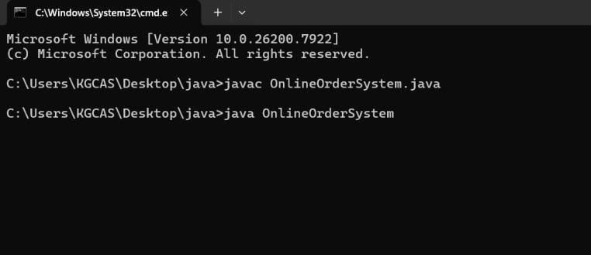

INPUT SCREEN:
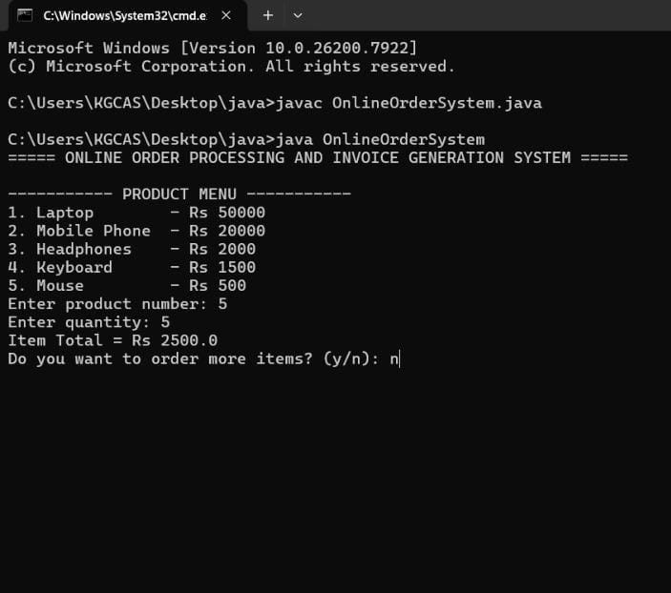

OUTPUT SCREEN:
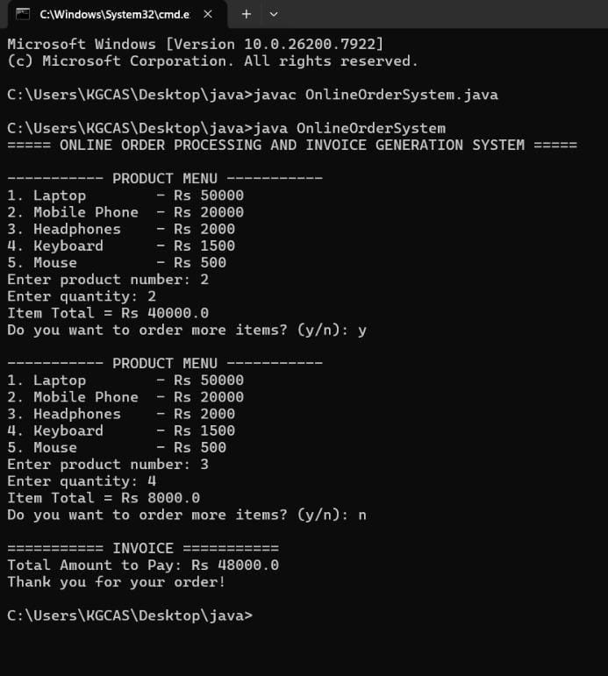

7.DISCUSSION & CONCLUSION

7.1 Discussion

The Complaint Management and Resolution Tracking System was developed to automate the complaint management and complaint resolution process. The system allows users to select complaints, enter quantities, and generate complaint detailss automatically.

The project applies Core Java programming concepts such as loops, conditional statements, methods, and object-oriented programming principles.

The system was tested with different inputs and successfully produced accurate complaint detailss.

7.2 Conclusion:

The Complaint Management and Resolution Tracking System demonstrates the practical use of Java programming in developing real-world applications.
The system simplifies complaint management, reduces calculation errors, and generates accurate complaint detailss quickly. It helps businesses improve efficiency and maintain proper transaction records.
This project provides a strong foundation for developing more advanced e-commerce and complaint resolution systems in the future.

8.REFERENCES

Books
• Herbert Schildt – Java: The Complete Reference
Websites
1.https://www.oracle.com/java
2.https://www.geeksforgeeks.org
3.https://www.w3schools.com
4.https://www.javatpoint.com

