**Questions**

1. Give the output for the following commands

a.. echo “hello world”

b.. List all the files(hidden included) present in the current directory in long format displaying files in reverse order , sorted based on the modification time .

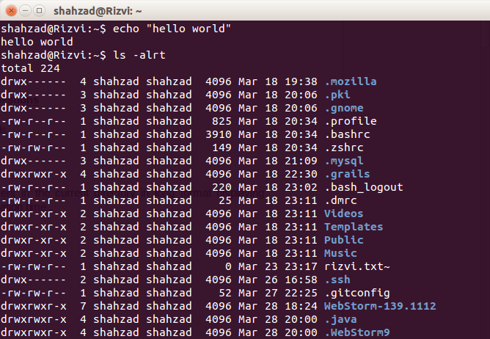

c.. Change your current password.

d.How to get the current date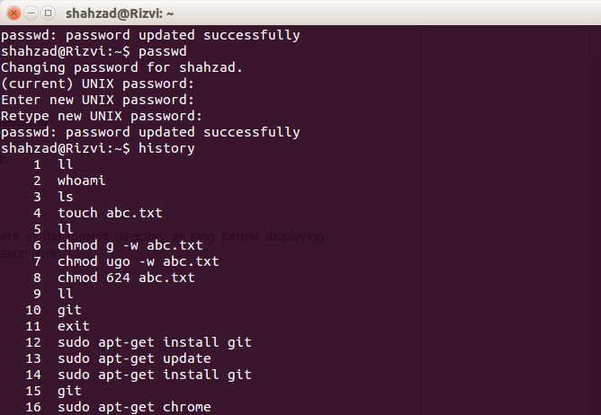

e.. How to get the current logged in user

f..How to get the current working directory.

g..How to get the list of all commands that you have typed so far

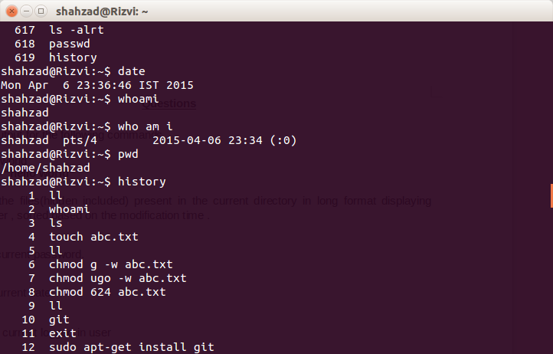

h.To get the information on the tcp ports

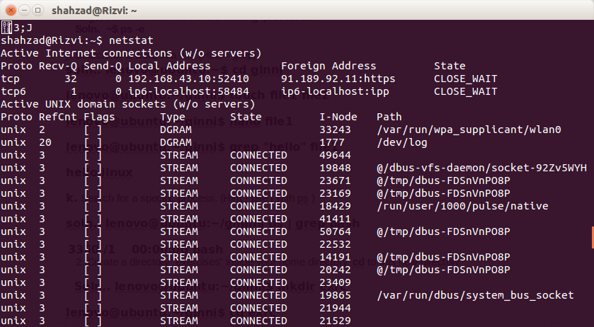

i.To get the information about the running processes.

**Soln. ~$ ps -e**

j. Search for a word in a file. (Hint – grep)

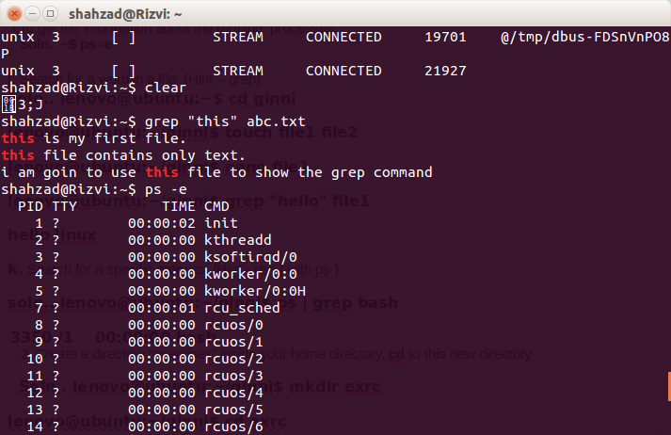

**k.** Search for a specific process. (Hint - use | with ps )

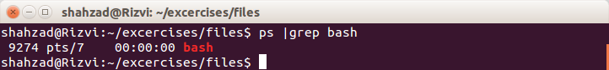

2..Create a directory “exercises” inside your home directory. **cd** to this new directory

3.. Create 3 empty files , file1.txt,file2.txt,file3.txt in current directory (exercises).

4.. Add some text to **file1.txt** and copy this to **~/exercises/files**.

5.Copy the entire **exercise** directory to this **files** directory.

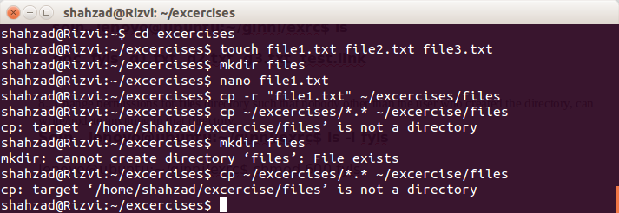6.Create a symlink “testlink” in your home directory that points to this file1.txt i.e. **~/exercises/files/file1.txt.**

**7. creating a hard link in your home directory that points to “files” directory .**

8..Difference between soft and hard link.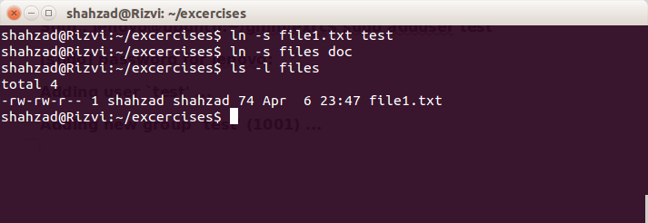

**Soft link has only a link to the file while hard link creates a copy of file.**

8.. Change permissions for **files** directory such that nobody other than the user who created the directory, can write/update anything in that directory.

9.Create a new user “test”.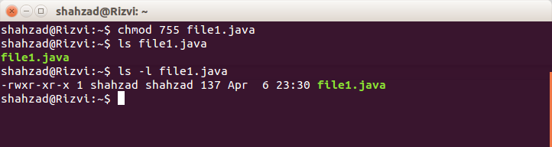

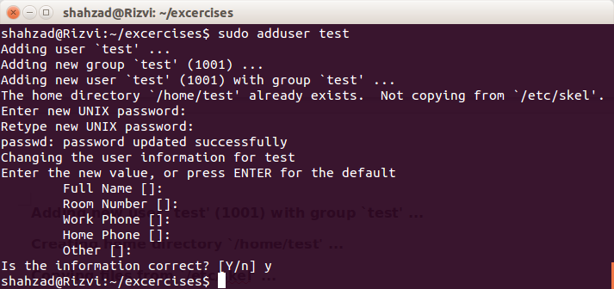

10. create following directory structure with single command -

home

|-john

|-work

|-scripts

|-bash

Assume that you are currently in ‘home’ directory

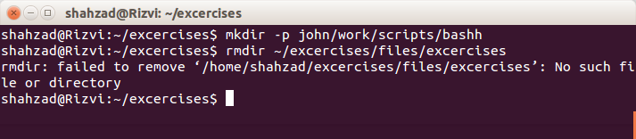

11.Try deleting the ~/exercises/files/exercises directory. See what happens

12.A file named employees.odt has a mode of rw-r- -r- -. If John is not the file's owner but is a member of the group that owns this file, what can he do with it?

**Soln..only read**

13..Create an alias for clearing the screen.

14.Create a tar archive of all the files in the current directory.

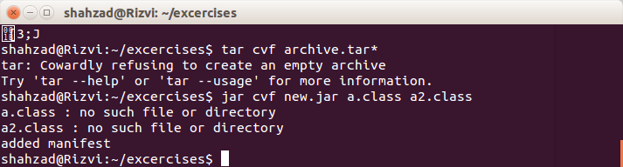

15..How to find if a jar file contains a particular class file?