1. Motivation
   1. We need to understand the SSGF to better understand the flux
   2. We can probably narrow down what the SSGF looks like from detailed measurements and backing out what the flux would be
   3. We can show that this supports the idea that the spray is 100% responsible for the heat flux
2. What is the heat flux
   1. Bell took detailed measurements of a hurricane and gathered information from dropsondes about the flux he measured.
   2. Can use different control volumes to ascertain the heat flux as a function of radius
   3. Repeat flux calculation
3. What is the heat flux of an individual drop?
   1. P and K define how a well-ventilated drop evaporates
      1. Fix, Ts, Ta, RH, tof
   2. Define the heat flux w.r.t. the weber number and when the drop would break up
   3. Cannot have too many small drops (no heat transfer)
   4. Cannot have too many large drops (not enough time/ drop break up)
   5. Within this idea, there is not an infinite number of potential distributions
4. Assume a gamma distribution for the SSGF and pick a volume flux
   1. We can prove that filament break-up leads to a gamma distribution, filament break up happens off the backs of waves
5. Show how to extract the desired amount of energy from different drop distributions
   1. Since the heat flux can account for all the energy transfer that is measured by observations, we found gamma distribution works for this.

*Motivation:*

It is important to understand the SSGF in the hurricane spray layer since it aids the parameterization of enthalpy and momentum flux.

There have been many SSGF’s proposed but most are for low to moderate wind speeds.

We propose that we can identify candidate SSGF’s by considering the microphysics of drop evaporation and the total heat flux to the atmosphere.

*What is the total heat flux?*

The control volume analysis conducted by Bell et al. demonstrates observations of heat flux into and out from the control volume with the residual being the heat that was released inside the volume.

Plot of CV and analysis.

Plot of Bell data like was in his paper.

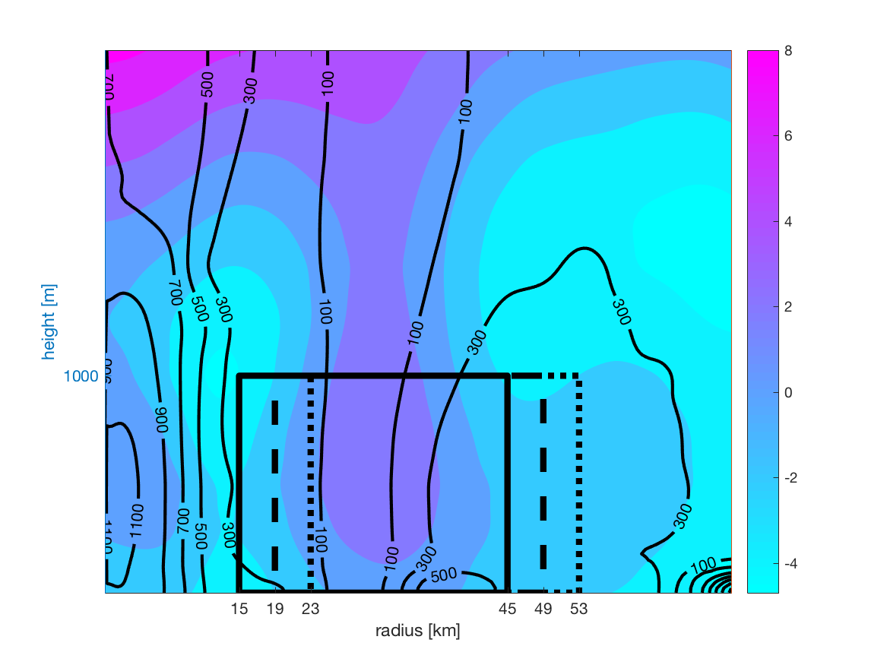

Colors are energy in kJ/kg, contours are TKE. The three control volumes provide different energy fluxes (solid line 386 W /m^2)

Energy equation to CV equation.

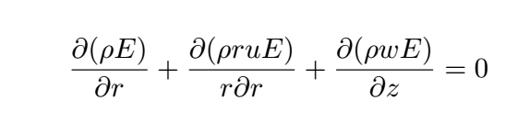

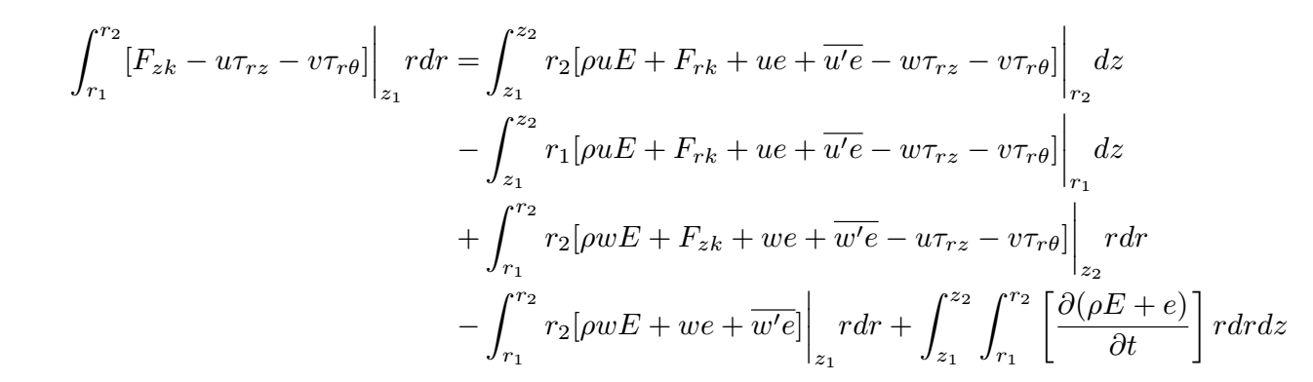

We are interested in the energy release in Watts/m^2 and test different control volumes to ascertain the way the energy flux changes with radius,

*What is the drop heat flux*

Evolution equations from P&K and the assumptions from P&K

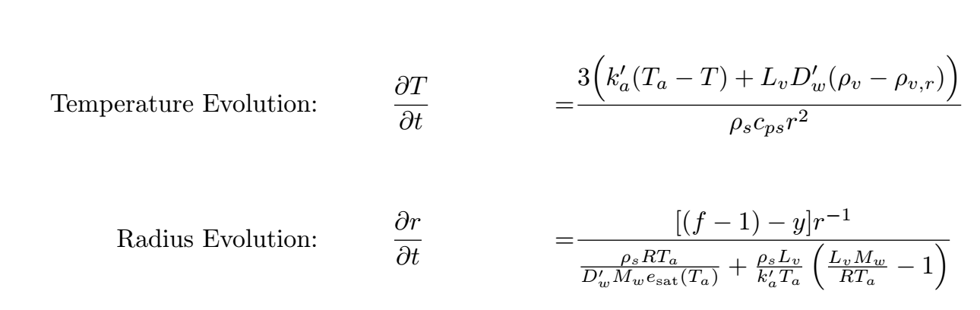

Discussion of the critical Weber number and how we don’t consider drops that break up immediately.

Heat release from a given drop

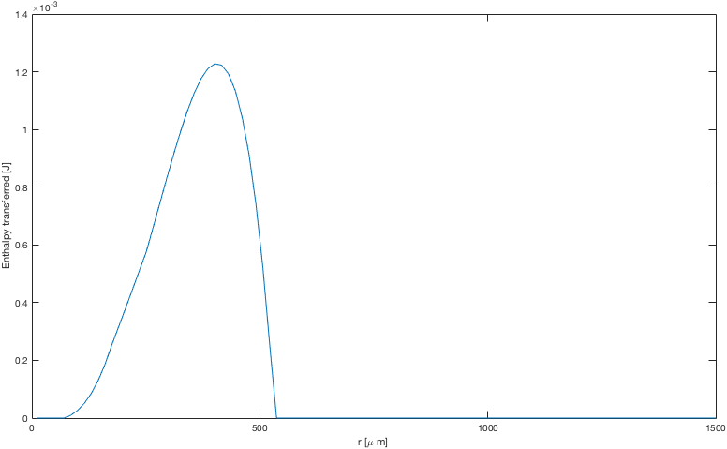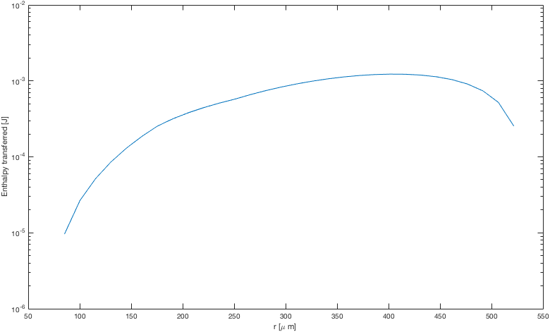

Other sources/losses of heat

The irrecoverable loss of heat due to friction of drops colliding is much smaller than the heat released during evaporation.

Why use a gamma distribution.

It has been proved analytically that this distribution is exactly the drop distribution of filament fragmentation.

If we use a gamma distribution and pick the volume flux estimated from another SSGF, all of which are pretty similar, can we identify a distribution that produces the desired flux?

Contour plot of gamma distribution parameters.

Obvious holes I can think of

Why is the relative humidity of the spray layer the value I say it is, RH inhibits evaporation severely.

Response – hurricane boundary layers are very well ventilated so this at least mitigates the idea of static high RH, also if the hurricane wasn’t exctracting heat from evaporating drops – at least this theory – proposes that the hurricane would diminish in power.