Please use a [free Google] virtual machine in a cloud data center with a public IP address as the lighthouse to set up the connectivity for computers behind NATs

Recommendations:
0. https://cloud.google.com/free/docs/free-cloud-features#compute
ionos.com
https://bandwagonhost.com/

1. https://github.com/slackhq/nebula

[Read Getting started (quickly)]

2. use a data comparison utility such as Meld and [Beyond Compare] to compare the configuration files attached to see where the changes should be made.

3. configure the config.yaml for the lighthouse and all participating computers.

Google Cloud Virtual Machine Configuration：
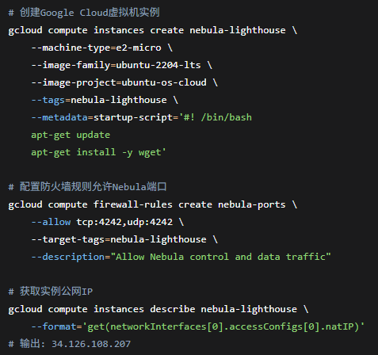

Nebula Installation and Certificate Generation
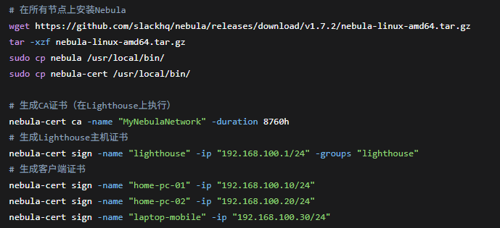

Lighthouse configuration
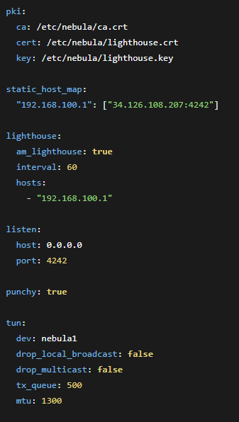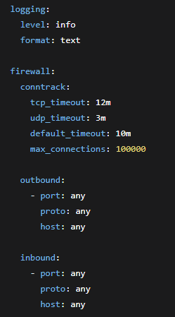

Client configuration (config-client.yaml) - Key differences
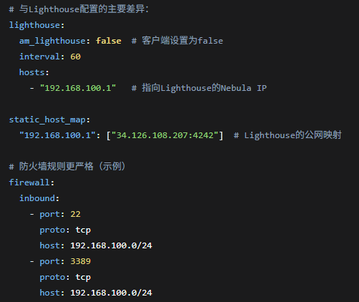
Service Deployment and Startup
