Install docker Desktop:
Windows:
Open terminal, and run: wsl --install
Download Docker Desktop and install it.
You have to register it before use.

Install gitea using docker on your computer.

https://about.gitea.com/
https://docs.gitea.com/installation/install-with-docker

a. Does it support LFS? prove it.
b. Create a repo with a large file (1G+)
c. Create a repo for this module and commit your work to this repo.
d. [optional] Backup all data to an external harddrive/USB stick and restore it from another computer.

Install Gitea without docker, feel free to choose the database.

Please take the screenshot of your major steps and submit a lab report.

Enable WSL2

Install Docker Desktop
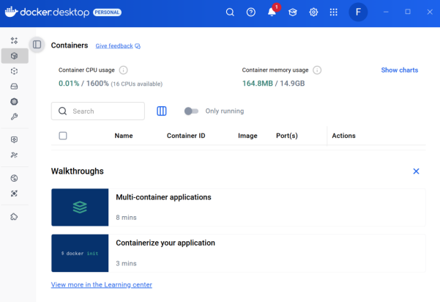
docker-compose.yml Configuration
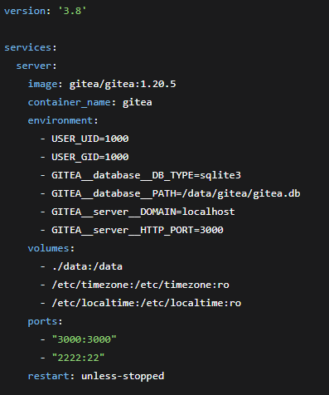

Initial Configuration
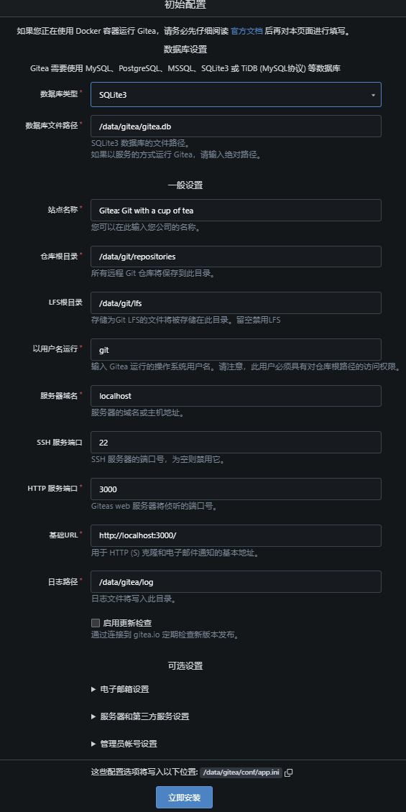

Global LFS Configuration

Created test repository large-file-test
Initialize repository
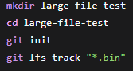
Create 1.1GB test file
Track and push
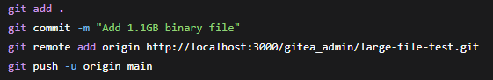

Repository Setup
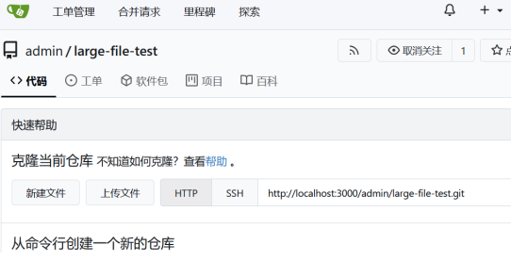

Committing Coursework
Clone the repository
Add coursework files
Commit and push
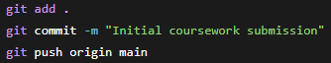

Native Gitea Installation
Download and install Gitea
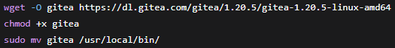
Create system user
Configure service

Nginx Reverse Proxy Configuration
