Container
Definition: A container is an isolated process for application components, providing an independent runtime environment for each component (e.g., frontend, API, database) that is completely isolated from the host machine and other containers.
Core Features
Self-contained: Includes all files and dependencies required for operation, with no reliance on pre-installed software on the host.
Isolated: Minimal impact on the host and other containers, enhancing application security.
Independent: The creation or deletion of a single container does not affect others.
Portable: Runs consistently across development machines, data centers, and cloud environments.
Difference from Virtual Machines (VMs)
Virtual Machines: Contain a complete operating system, kernel, drivers, etc., resulting in high resource overhead and low efficiency when used solely for isolating a single application.
Containers: Only isolate processes and share the host kernel, offering high resource utilization and enabling more applications to run on fewer infrastructure resources.
Synergistic Use: In cloud environments, containers are often deployed within VMs. A VM with a container runtime can host multiple containerized applications, improving resource utilization and reducing costs.
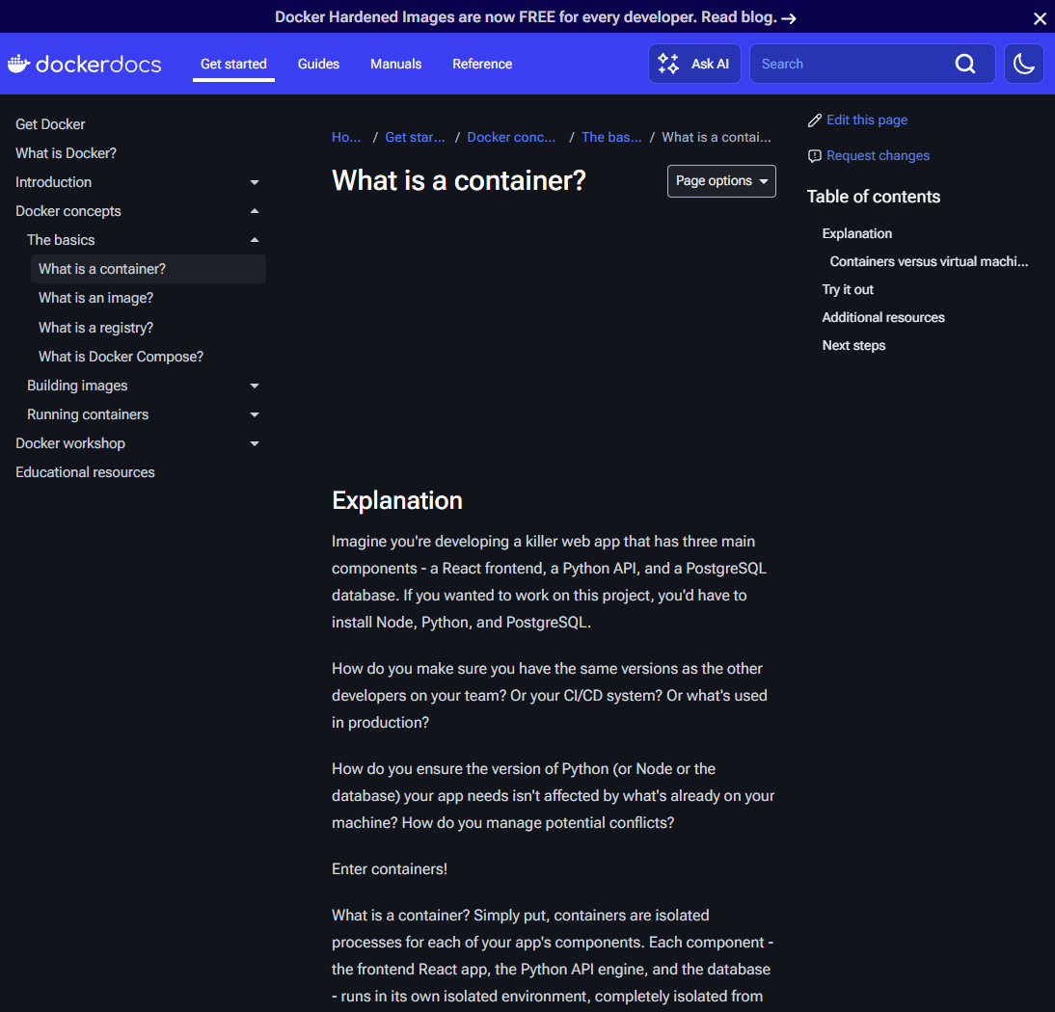
Image
Definition: An image is a standardized package that includes files, binaries, libraries, and configurations necessary to run a container, serving as the "template" for containers.
Core Features
Immutability: Once created, an image cannot be modified; new images or changes can only be added as additional layers.
Layered Structure: Composed of multiple filesystem change layers, where each layer corresponds to a set of operations such as adding, deleting, or modifying files.
Acquisition Channel: Docker Hub is the default image repository, hosting over 100,000 images, including official Docker images (e.g., Redis, Node.js), verified publisher images, and sponsored open-source project images, which can be directly searched, downloaded, and run.
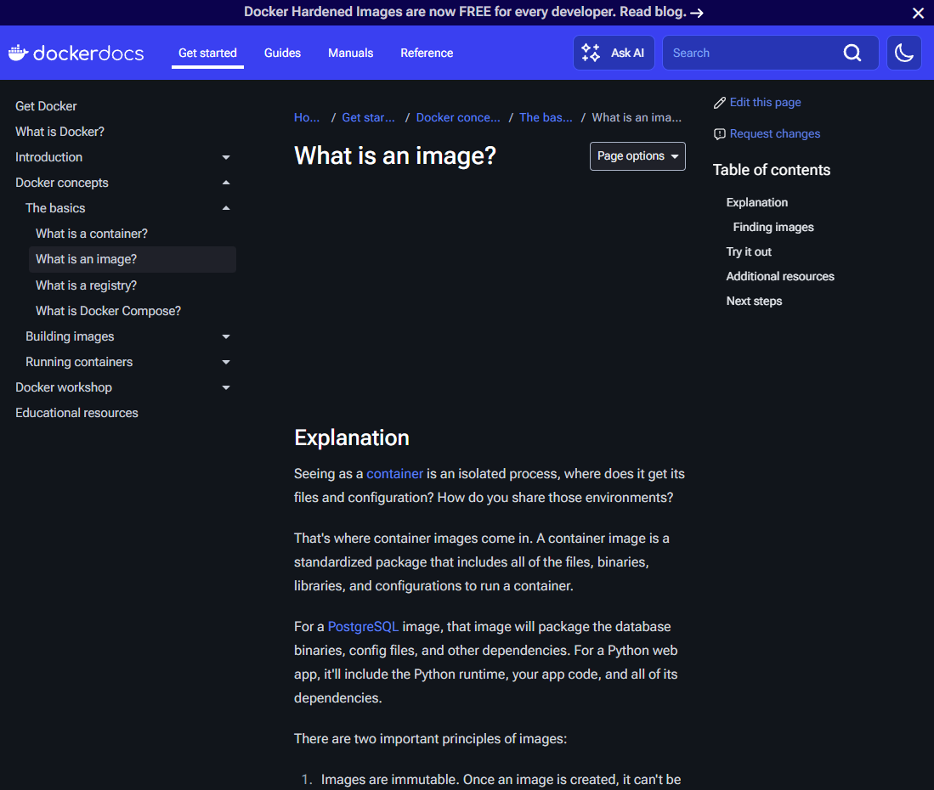

Docker Compose
Definition: Docker Compose is a declarative management tool for multi-container applications, defining configurations (images, ports, networks, volumes, etc.) for all containers through a single YAML file (compose.yaml).
Core Value
Simplified Configuration: Centralizes management of multi-container dependencies, eliminating the need to execute multiple docker run commands repeatedly.
Easy Deployment: After cloning a code repository, start the entire application stack with the single command docker compose up.
Intelligent Updates: After modifying configurations, re-run the start command, and Compose automatically reconciles and applies changes.
Difference from Dockerfile: A Dockerfile is used to build images, while a Compose file defines running containers. Compose can reference images built from Dockerfiles as the basis for services.
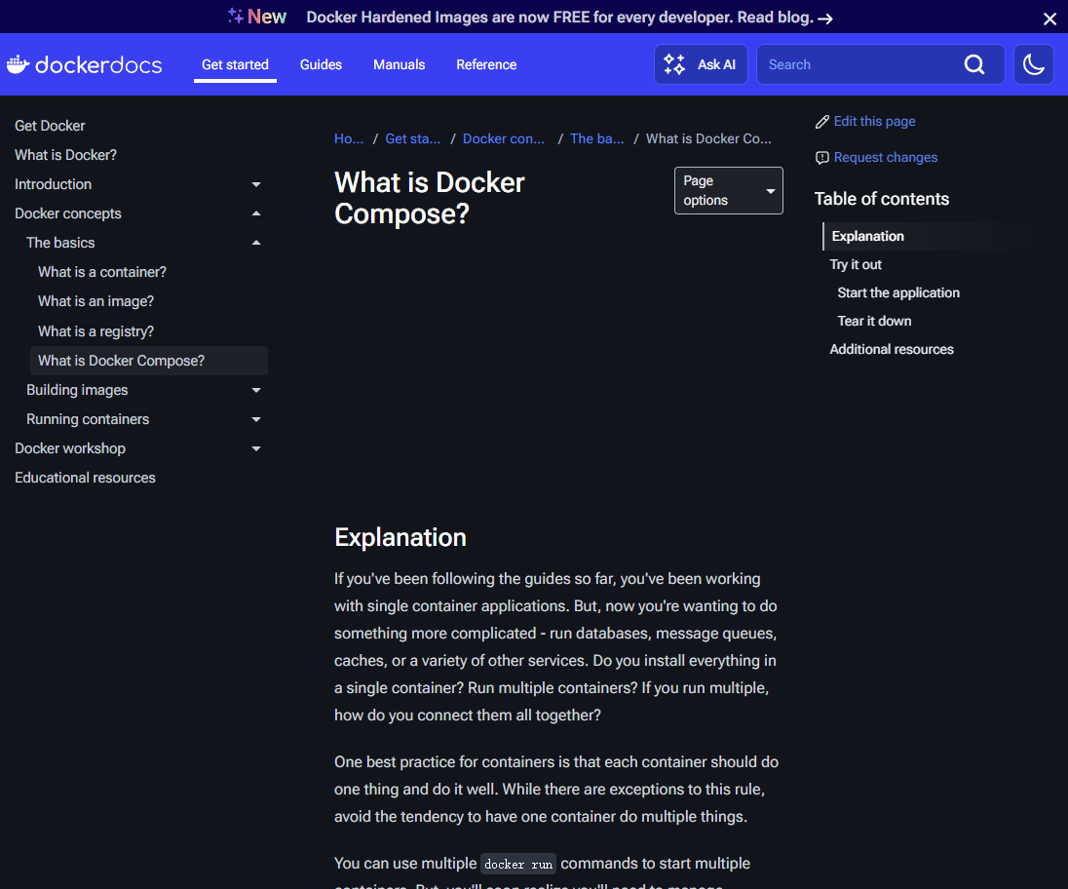

Port Publishing
Core Function: Break through container network isolation, establish port forwarding rules between the host and containers, and enable external access to applications within containers.
Three Publishing Methods
Specify Port Mapping: docker run -d -p HOST_PORT:CONTAINER_PORT <image name> (e.g., 8080:80, forwarding host port 8080 to container port 80).
Random Port Mapping: docker run -d -p CONTAINER_PORT <image name> (Docker automatically assigns a host port, which can be viewed via docker ps).
Publish All Exposed Ports: docker run -d -P <image name> (automatically maps ports declared by the image's EXPOSE instruction to random host ports).
Note: Ports are published to all network interfaces by default. Exercise caution when configuring sensitive services (e.g., databases) to avoid unauthorized access.
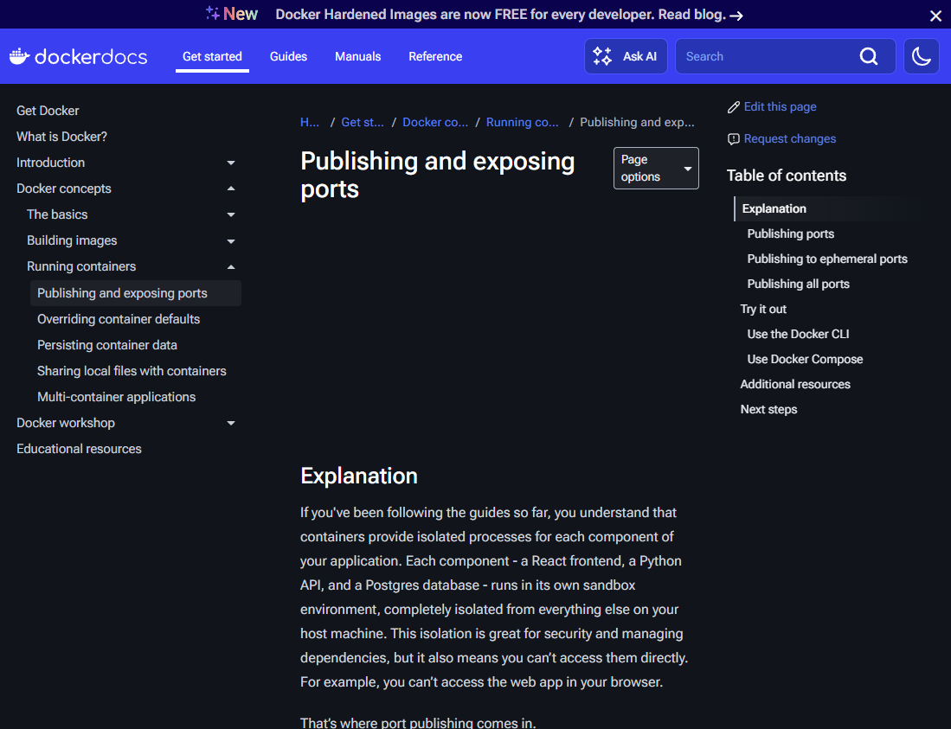

Overriding Container Default Configurations
Resolving Port Conflicts: Map to different host ports via docker run -d -p 5433:5432 postgres to run multiple instances of the same image.
Configuring Environment Variables: Set directly via the -e flag (docker run -e POSTGRES_PASSWORD=secret postgres) or in batches via a .env file (docker run --env-file .env postgres).
Resource Limitation: Use --memory and --cpus to limit container resources, e.g., docker run --memory="512m" --cpus="0.5" postgres (limits to 512MB memory and 0.5 CPU cores).
Network Configuration: Create a custom network (docker network create mynetwork). Containers added to this network can communicate via name resolution, improving isolation and security.
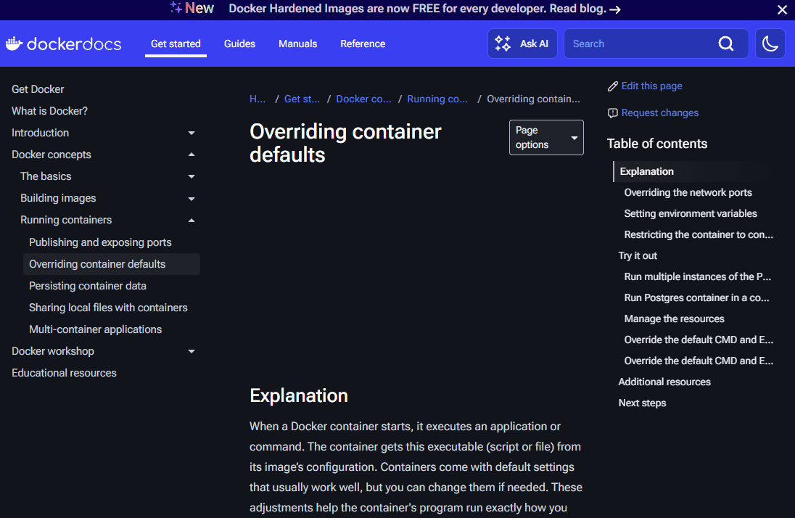

Data Persistence and File Sharing
Volumes
Function: Overcome the temporary storage limitation of containers, persist data (e.g., database files), and support sharing among multiple containers.
Core Operations: Create a volume (docker volume create <volume name>), start a container with a bound volume (docker run -v <volume name>:<container path> <image name>), and manage volumes (docker volume ls/rm/prune).
Practical Example: Bind a Postgres container to the volume postgres_data:/var/lib/postgresql. Data is retained after deleting the container, and a new container can reuse the data when restarted.
Bind Mounts
Function: Directly share host directories/files with containers, suitable for development environments (e.g., real-time synchronization of code modifications).
Operation Commands: docker run -v /host/path:/container/path <image name> or docker run --mount type=bind,source=/host/path,target=/container/path <image name> (Docker recommends the --mount syntax for greater flexibility).
Permission Control: Specify permissions via :ro (read-only) or :rw (read-write), e.g., docker run -v /host/path:/container/path:ro nginx.
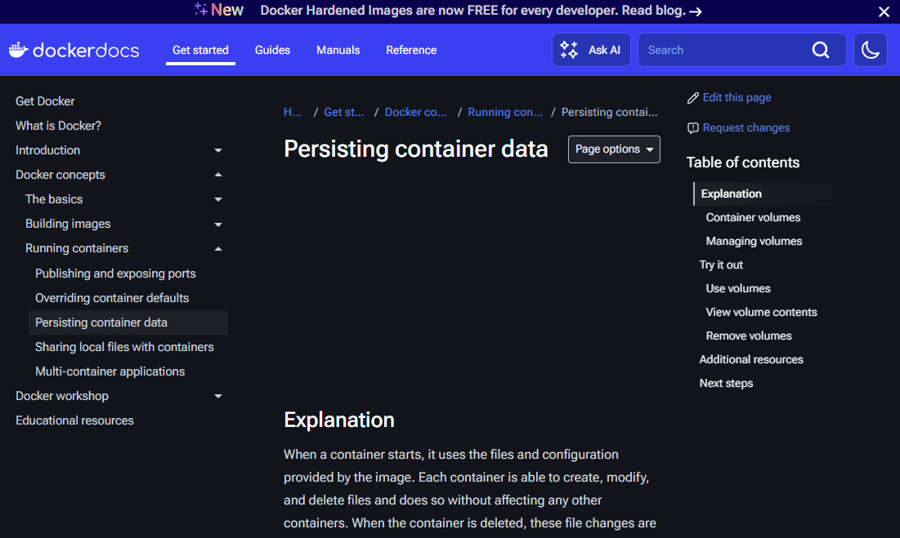
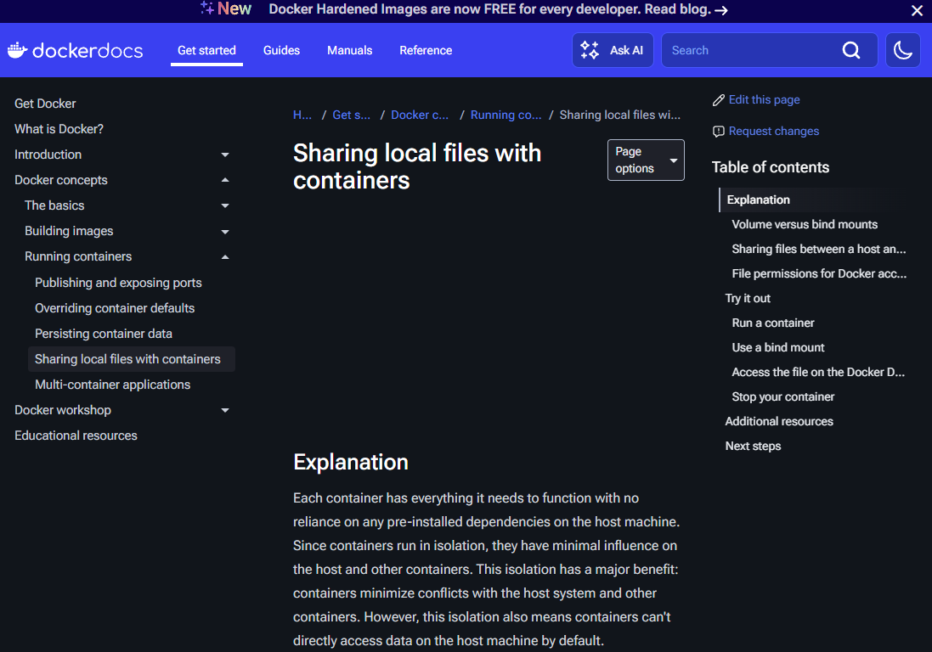
Multi-Container Application Deployment
Core Principle: A single container focuses on a single function (e.g., separating frontend, backend, and database), with unified management via Docker Compose.
Pain Points of Manual Deployment: Requires creating networks, starting containers, and configuring dependencies one by one, which is cumbersome, error-prone, and difficult to scale.
Compose Deployment Process
Write compose.yaml: Define services (e.g., frontend, backend, database), images, ports, networks, volumes, etc.
Start the Application: docker compose up -d --build (the --build flag builds the image before starting).
Stop and Clean Up: docker compose down (stops containers and deletes networks), docker compose down --volumes (additionally deletes volumes).
Practical Example: A to-do application based on Node.js + MySQL. Compose starts frontend, backend, and database services with one click, automatically creating networks and volumes without manual configuration of connections.
