Hello Minikube (https://kubernetes.io/docs/tutorials/hello-minikube/)

Step 1: Start the Minikube Cluster
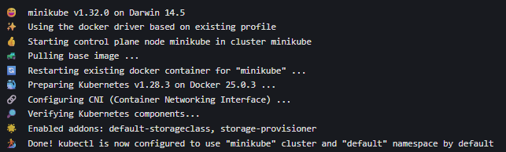

Step 2: Open the Kubernetes Dashboard
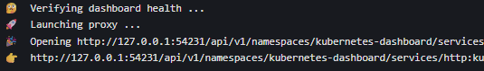

Step 3: Create a Deployment
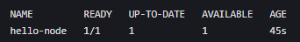

Step 4: Expose the Deployment as a Service
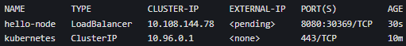

Step 5: Access the App
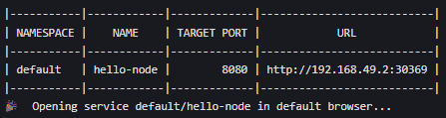

Step 6: View Application Logs

Step 7: Clean Up

Deploy an App (https://kubernetes.io/docs/tutorials/kubernetes-basics/deploy-app/deploy-intro/)

Step 1: Verify kubectl Configuration

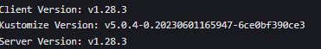
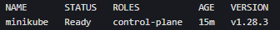

Step 2: Create a Deployment
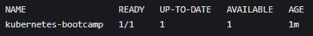

Step 3: Access the App via kubectl Proxy

Explore Pods and Nodes (https://kubernetes.io/docs/tutorials/kubernetes-basics/explore/explore-intro/)

Step 1: Describe a Pod
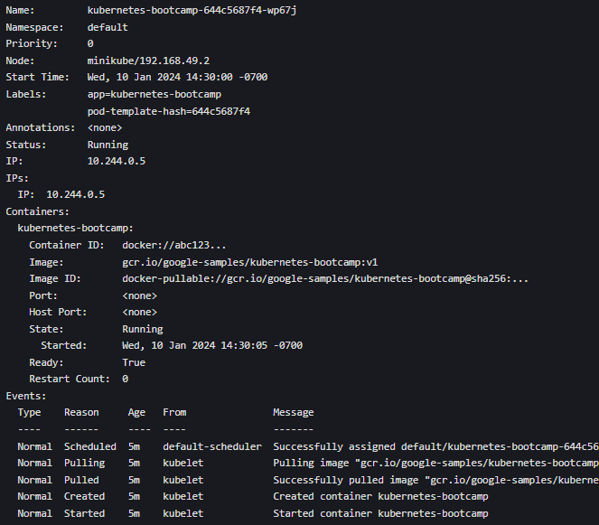
Step 2: Execute Commands in a Pod

Step 3: Explore Nodes

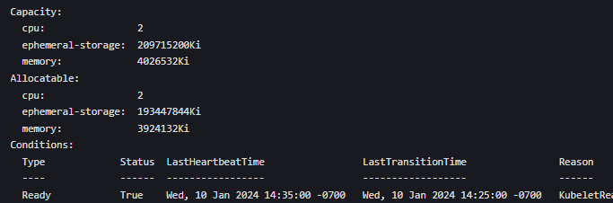

Expose Your App with a Service (https://kubernetes.io/docs/tutorials/kubernetes-basics/expose/expose-intro/)

Step 1: Expose the Deployment as a NodePort Service

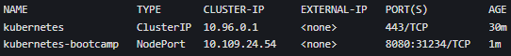

Step 2: Access the App Externally

Step 3: Use Labels and Selectors

Step 4: Delete the Service

Scale Your App (https://kubernetes.io/docs/tutorials/kubernetes-basics/scale/scale-intro/)

Step 1: Scale the Deployment to 4 Replicas
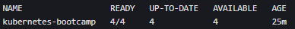

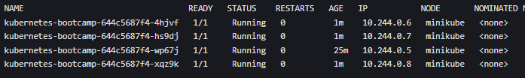

Step 2: Test Load Balancing
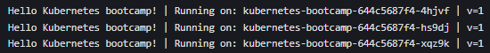

Step 3: Scale Down to 2 Replicas

Perform a Rolling Update (https://kubernetes.io/docs/tutorials/kubernetes-basics/update/update-intro/)

Step 1: Update the App to Version 2

Step 2: Verify the Update

Step 3: Roll Back a Failed Update

