Download Istio
Download the Latest Istio Release
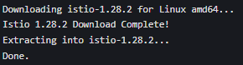

Add istioctl to System Path

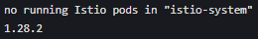

Install Istio
Install Istio with Demo Profile (No Gateways)
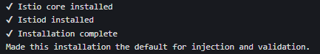

Enable Automatic Sidecar Injection

Install Kubernetes Gateway API CRDs

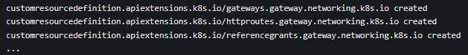

Deploy the Sample Application (Bookinfo)
Deploy Bookinfo Components
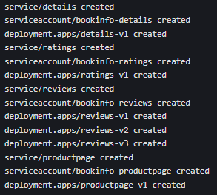

Verify Deployment
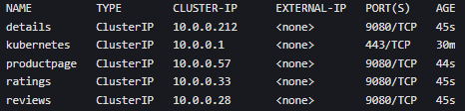
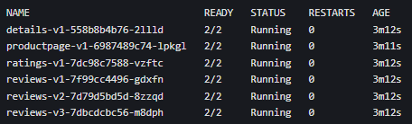

Validate Application Inside the Cluster

Open the Application to Outside Traffic
Create Kubernetes Gateway and HTTPRoute

Set Gateway Service Type to ClusterIP

Access the Application
Port-Forward to the Gateway
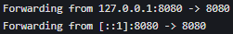

Access via Browser
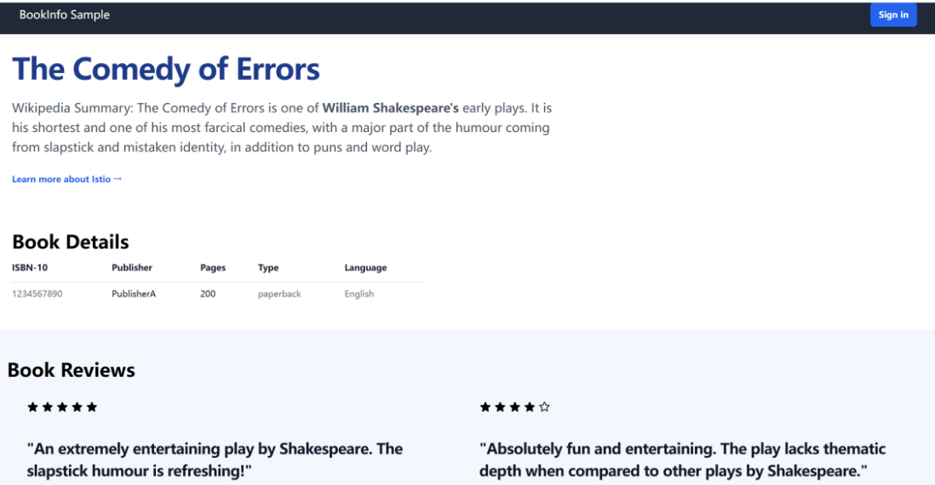

View the Dashboard (Kiali)
Install Kiali and Addons

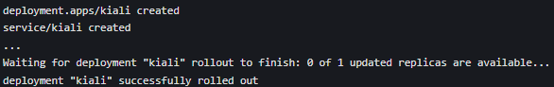

Access Kiali Dashboard
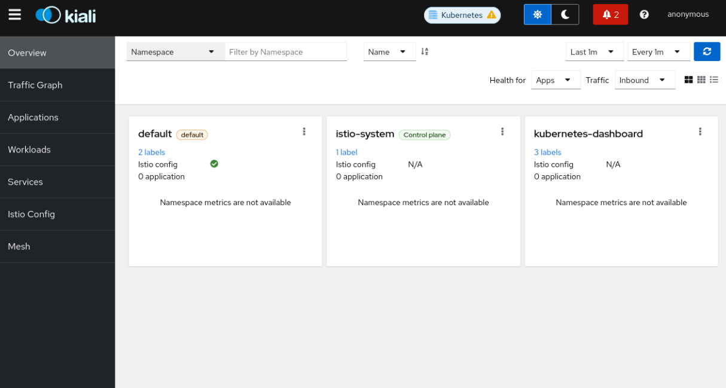

Visualize the Service Mesh

