Install and Configure KServe on Minikube
Start Minikube Cluster
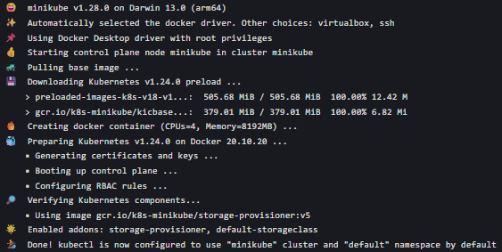

Install KServe
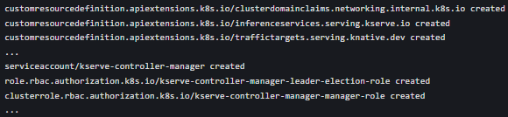

Verify KServe Installation

Deploy a Predictive Model using KServe InferenceService
Prepare the Model
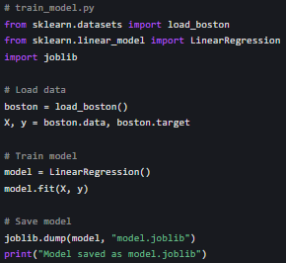

Create a KServe InferenceService Configuration
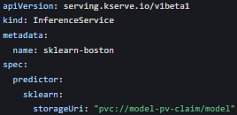

Create Persistent Volume for Model Storage
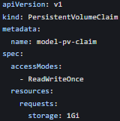

Copy Model to the Persistent Volume

Deploy the InferenceService

Monitor Service Status and Debug Issues
Check InferenceService Status

Check Predictor Pods

View Logs for Debugging
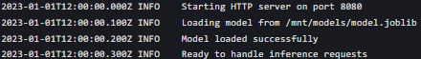

Access InferenceService from Outside the Cluster
Port Forwarding

Using Minikube Tunnel
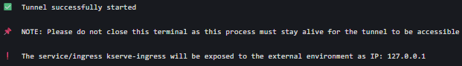

Get the Service URL

Send Inference Requests and Interpret Results
Prepare Inference Data
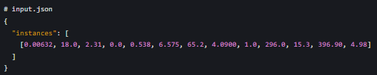
Send Inference Request using curl

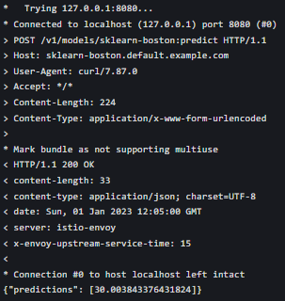

Batch Prediction Example
