Traffic Shifting
Deploy the Bookinfo Application
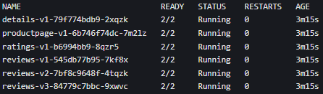

Route All Traffic to v1
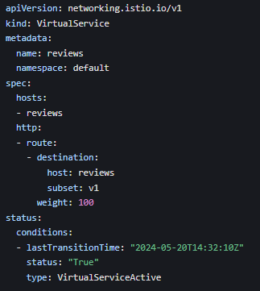

Shift 50% Traffic to v3

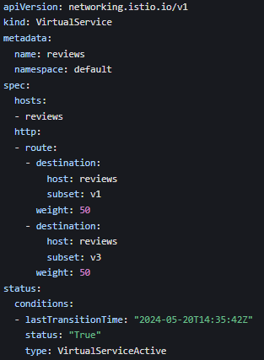

Shift 100% Traffic to v3
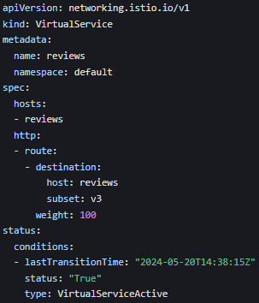

Request Routing
Route All Traffic to v1 (Same as Traffic Shifting Step 2)
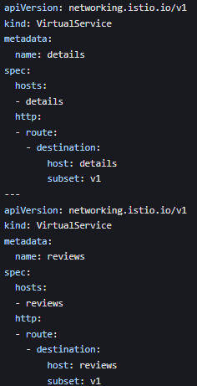

Route Traffic by User Identity
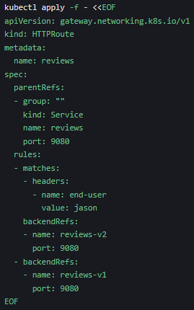

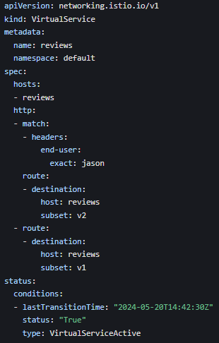
Fault Injection
Inject an HTTP Delay Fault
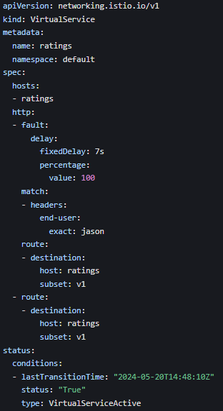

Test the Delay Fault

Analyze the Bug
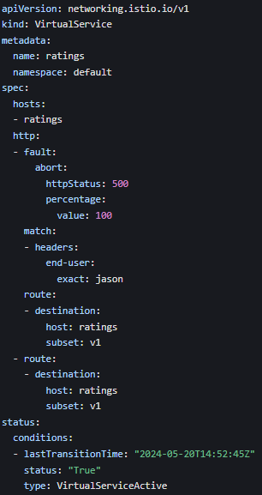

Test the Abort Fault
Log in as jason and refresh productpage.
The page loads immediately with an error message.

Circuit Breaking
Deploy the httpbin and Fortio Services

Configure Circuit Breaking Rules
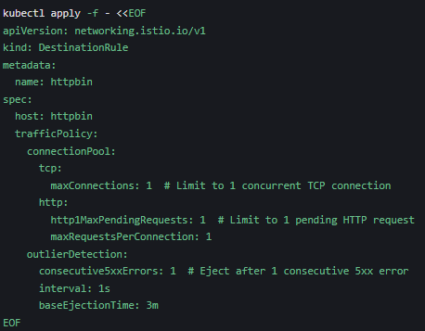
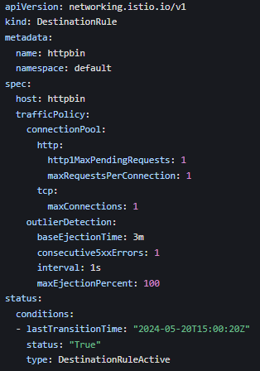

Test Circuit Breaking

Normal Traffic
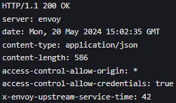
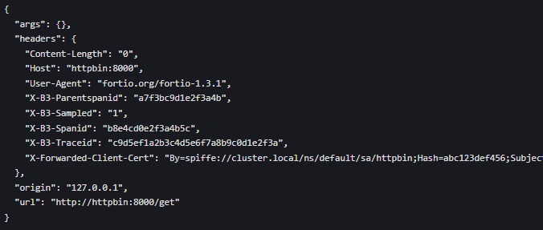

Overload Traffic
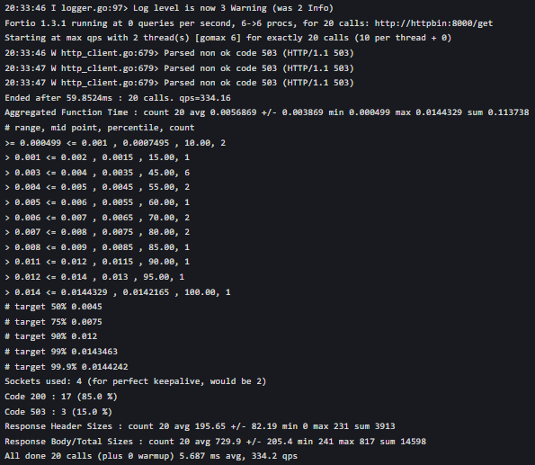
Severe Overload
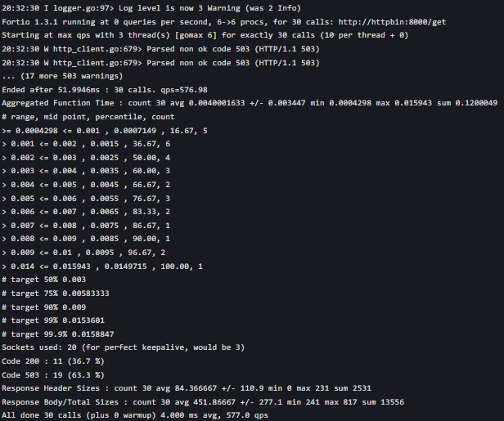

Verify Circuit Breaker Stats
