Environment Preparation
Start Minikube Cluster
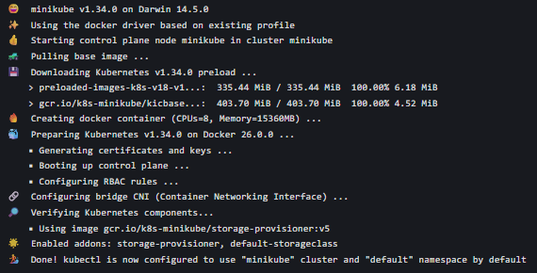

Install Knative Serving

Install Serving Custom Resources
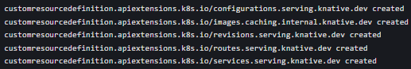
Install Serving Core Components
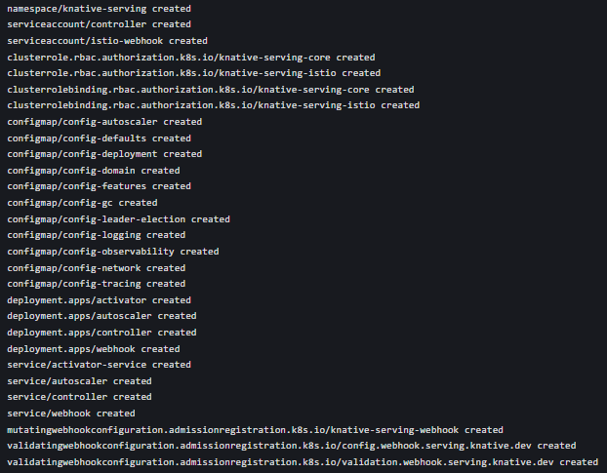
Verify Serving Core Installation
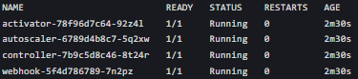
Install Istio Networking Layer
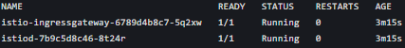

Configure Magic DNS

Install Knative Eventing
Install Eventing CRDs
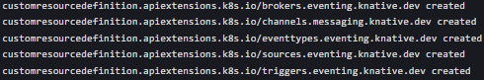

Install Eventing Core Components
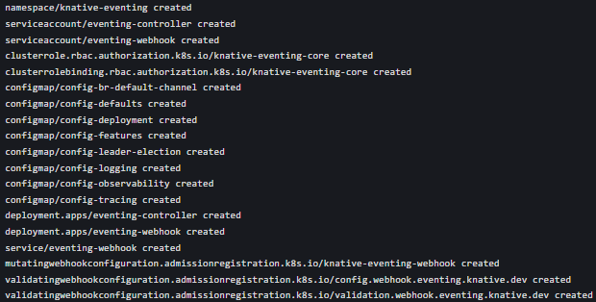

Verify Eventing Installation
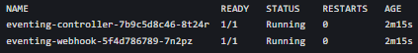

Knative Functions Setup
Start Local Docker Registry

Verify func CLI

Create & Test a Go Function
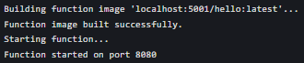
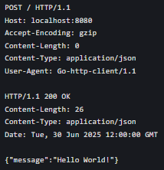

Build the Function Image
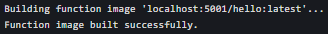

Deploy a Sample Knative Service
Deploy the Service via kn CLI
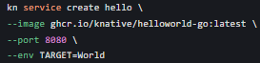
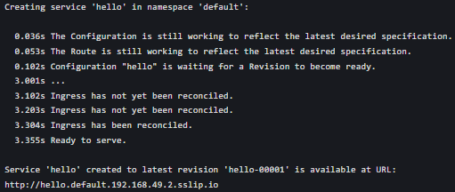

Verify the Service

