Instruction for N-ScanHub

1 Introduction
Newland’s SDK supports Windows and linux platforms and offers the C/C++ interface to interact with Newland devices. With the SDK, users can carry out secondary development, obtain devices, send instructions, upgrade firmware, etc.
Directory Structure
Items | Descriptions
Platform | Windows and Linux platforms
Programming Language | C/C++
Functions | Obtaining device, sending commands, upgrading firmware, read and write, opening and closing the device , collecting pictures, plugging and unplugging and data acquisition notification, etc.
SDK | N-ScanHubForLinux and N-ScanHubForWindows
API | N-ScanHubForLinux and N-ScanHubForWindows with the same interface name

2 Introduction to N-ScanHubForWindows

2.1 Directory Structure
N-ScanHubForWindows offers the API under the Windows platform, and its directory is shown as below.
Contents | Descriptions
include | Header file: N-ScanHub.h (all interfaces descriptions included)
lib/x64 | 64-bit N-ScanHub.dll and N-ScanHub.lib
lib/x86 | 32-bit N-ScanHub.dll and N-ScanHub.lib
demo | Library file and demo written by Visual Studio2019
help | Help document: N-ScanHub.pdf

2.2 NLSInfoStreamForWindows Operating Instructions
Device：FM430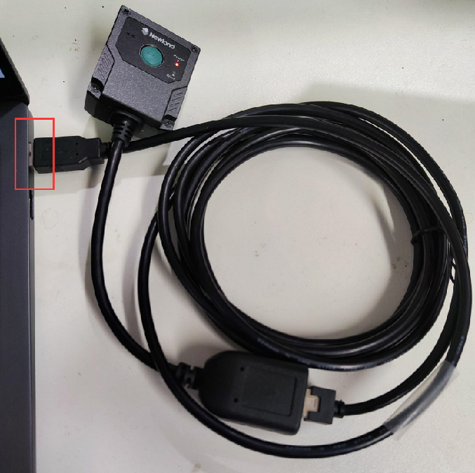 Tool：VS2019 System：Windows 10

N-ScanHubForWindows demo Operating Steps
1. The project contains paths of N-ScanHub.h and N-ScanHub.lib.
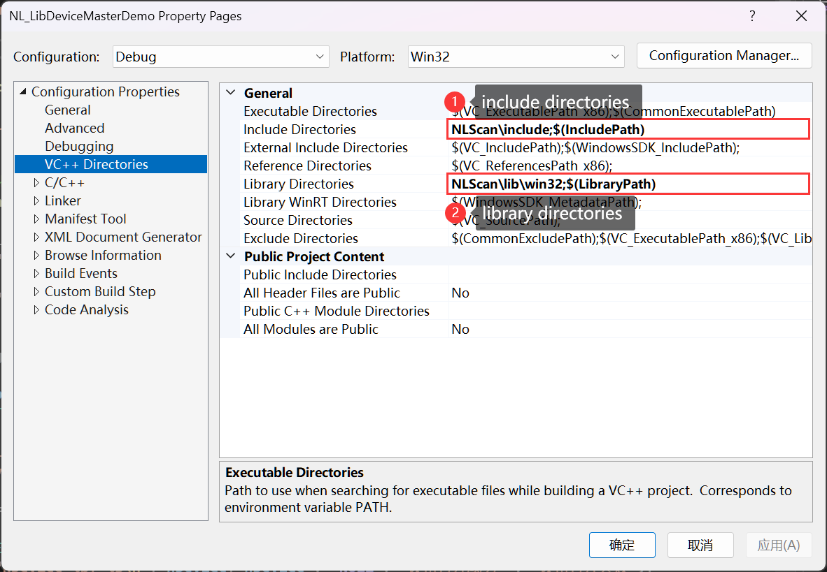
2. Add the dependency libnldevicemaster.lib.
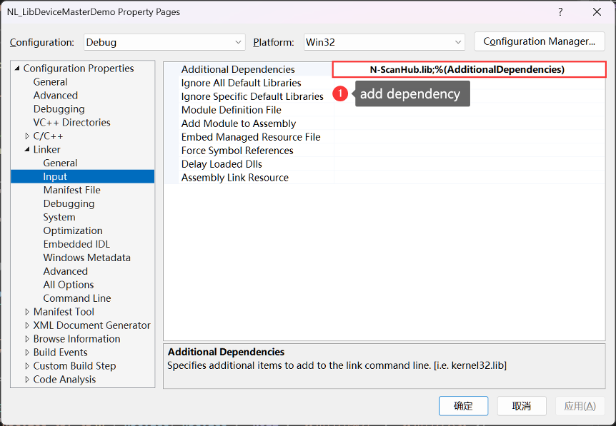
3. Call the function in the SDK.
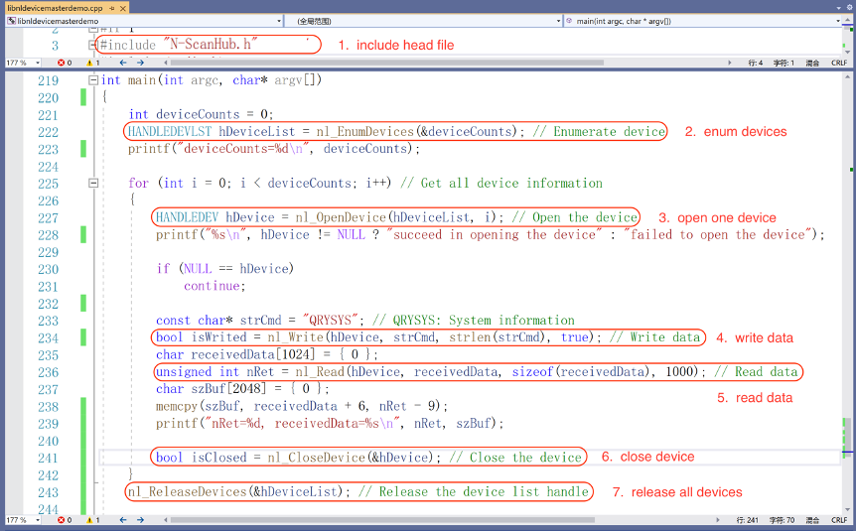
4. Start running the program.
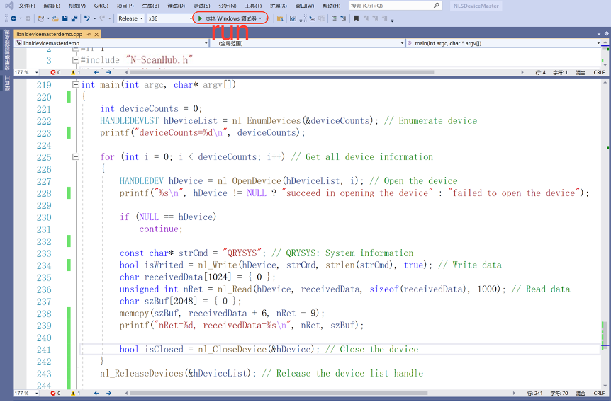
The result is as follows.
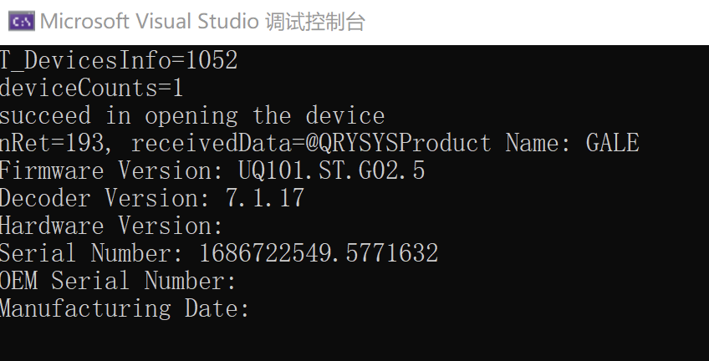

2.3 Example of demo
#include "N-ScanHub.h"
#include <stdio.h>
#include <windows.h>
#include <chrono>
#include <vector>
#include <string>
#include <iostream>
#include <fstream>
#include <stdlib.h>
#include <thread>
using namespace std;

#define NET_TEST 1

// Read device data
void __stdcall ReadCallback(const HANDLEDEV hDevice, const char* buf, int len)
{
printf("-----------ReadCallback len=%d, buf=%s\n", len, buf);
}

// Monitoring device status change
void __stdcall DevStatChangeCallback(const HANDLEDEV hDevice, bool isDevExisted)
{
if (isDevExisted)
printf("hDevice=%p, device is pushed in\n", hDevice);
else
printf("hDevice=%p, device is pushed out\n", hDevice);
}
#if NET_TEST
void __stdcall TcpServiceBack(int clientSocket, char* clientIp) {
printf("clientIp=%s\n", clientIp);
char buf[4096] = { 0 };
int len = 4096;
while (1) {
if (nl_readFromSocket(clientSocket, 2000, buf, &len) == 0) {
printf("TcpServiceBack buf=%s\n", buf);
memset(buf, 0, sizeof(buf));
}
Sleep(500);
}
}

int piccount = 0;
void __stdcall readNetImage(unsigned char* data, int data_len){
char filename[256] = { 0 };
sprintf(filename, "./pic/%d.jpg", piccount++);
//nl_saveNetImgData(0, data, data_len, filename);
}

void __stdcall readTcpIpData(unsigned char* data, int data_len) {
printf("data=%s\n", data);
}

void ServerThread() {
int ret = nl_CreateTcpService(10000, TcpServiceBack);
printf("ServerThread ret=%d\n", ret);
}

void NetImageThread(char* ip, int* port1, int* port2) {
int socket36520 = -1;

char sendbuf[1024] = { 0 };
char recvbuf[1024] = { 0 };
int socket30000 = -1;

strcpy(sendbuf, "\x01\x54\x04");

nl_connectToService(ip, *port1, &socket30000);
nl_connectToService(ip, *port2, &socket36520);
const int RECV_BUFFER_SIZE = 1920 * 1080 * 4;
char* recvBuffer = (char*)malloc(RECV_BUFFER_SIZE);
int realLen = 0, nRet = -1;
IMG_TYPE imgtype;
int w, h, f, q;
f = 2;
q = 2;
char filename[128] = { 0 };

for (int i = 0; i < 1000; i++) {
memset(recvBuffer, 0, RECV_BUFFER_SIZE);
memset(recvbuf, 0, 1024);
// rigger recognition
if (nl_sendDataToSocket(socket30000, sendbuf, 3) != 0) {
printf("nl_sendDataToSocket error\n");
continue;
}
//get code
if (nl_readFromSocket(socket30000, 2, recvbuf, &realLen) != 0) {
printf("nl_readFromSocket error\n");
nl_CloseClientSocket(socket30000);
Sleep(500);
nl_connectToService(ip, *port1, &socket30000);
if (socket30000 == -1) {
printf("reconncet error\n");
continue;
}
}
printf("code length=%d,data=%s\n", realLen, recvbuf);
// In retrieving images, the two most commonly used parameters are 'f,' which represents the data type of the image, and 'q,' which is the compression quality level for obtaining JPEG image data when 'f' is set to 2
nRet = nl_getNetImgData(socket36520, 0, 0, f, q, recvBuffer, &realLen, &imgtype, &w, &h);
printf("-------------------------------------ip=%s [%d][%d]\n", ip, nRet, realLen);
if (nRet != 0)
continue;
// When 'f' is set to 0, it represents raw data, and you need to call the image-saving interface to package the raw data in order to generate an image file
// If you prefer not to use the saving interface, you can also implement image data packaging on your own
if (f == 0) {
if (imgtype == TYPE_COLOR) {
sprintf(filename, "./pic/f0-%s-%04d.bmp", ip, i);

nl_SavePicDataToFile(filename, (unsigned char*)recvBuffer, w, h, 24); // Save image

sprintf(filename, "./pic/f0-%s-%04d.jpg", ip, i);

nl_SavePicDataToFile(filename, (unsigned char*)recvBuffer, w, h, 23); // Save image
DbgPrintf("nl_SavePicDataToFile jpg end");
}
else {
sprintf(filename, "./pic/f0-%s-%04d.bmp", ip, i);
nl_SavePicDataToFile(filename, (unsigned char*)recvBuffer, w, h, 8); // Save image
sprintf(filename, "./pic/f0-%s-%04d.jpg", ip, i);
nl_SavePicDataToFile(filename, (unsigned char*)recvBuffer, w, h, 13); // Save image
}
}
// When 'f' takes any of the following values, you will obtain image format data that can be directly saved as a binary file
else if (f == 1) {
sprintf(filename, "./pic/f1-%s-%04d.bmp", ip, i);
FILE* fp = fopen(filename, "wb");
fwrite(recvBuffer, 1, realLen, fp);
fclose(fp);
}
else if (f == 2) {
sprintf(filename, "./pic/f2-%s-%04d.jpg", ip, i);
FILE* fp = fopen(filename, "wb");
fwrite(recvBuffer, 1, realLen, fp);
fclose(fp);
}
else if (f == 3) {
sprintf(filename, "./pic/f3-%s-%04d.bmp", ip, i);
FILE* fp = fopen(filename, "wb");
fwrite(recvBuffer, 1, realLen, fp);
fclose(fp);
}
else if (f == 4) {
sprintf(filename, "./pic/f4-%s-%04d.bmp", ip, i);
FILE* fp = fopen(filename, "wb");
fwrite(recvBuffer, 1, realLen, fp);
fclose(fp);
}

Sleep(10);
}
nl_CloseClientSocket(socket36520);
nl_CloseClientSocket(socket30000);
free(recvBuffer);
//delete[]recvbuf;
recvBuffer = NULL;
printf("-------------------------------------ip=%s close\n", ip);
}
#endif

void SplitString(const string& s, vector<string>& v, const string& c)
{
string::size_type pos1, pos2;
pos2 = s.find(c);
pos1 = 0;
while (string::npos != pos2)
{
v.push_back(s.substr(pos1, pos2 - pos1));

pos1 = pos2 + c.size();
pos2 = s.find(c, pos1);
}
if (pos1 != s.length())
v.push_back(s.substr(pos1));
}

int main(int argc, char* argv[])
{
int deviceCounts = 0;
HANDLEDEVLST hDeviceList = NULL;

DbgPrintf("enum nl_EnumDevices begin\n");
hDeviceList = nl_EnumDevices(&deviceCounts, ENUM_ALL); // Enumerate device
DbgPrintf("enum nl_EnumDevices end\n");
printf("deviceCounts=%d\n", deviceCounts);

for (int i = 0; i < deviceCounts; i++) // Get all device information
{
HANDLEDEV hDevice;
hDevice = nl_OpenDevice(hDeviceList, i); // Open the device
printf("hDevice=%p, %s\n", hDevice, hDevice != NULL ? "succeed in opening the device" : "failed to open the device");

if (NULL == hDevice)
continue;

T_DeviceStatus status = nl_GetDevStatus(hDevice); // Get device status
printf("status=%d\n", status);
if (argc < 2) {
// Write character string data
// trigger recognition
const char* strCmd = "\x01\x54\x04"; // QRYSYS: System information
char receivedData[65565] = { 0 };
int recvlen = 0;
nl_Write(hDevice, strCmd, 3, false);
int ret = nl_Read(hDevice, receivedData, 1000, 1000);
printf("system info: \n%s\n", receivedData);
}

if (argc >= 2 && strcmp(argv[1], "--WriteAsHex") == 0) // Write data to the device in HEX character string
{
// Write hex character string data
const char* strCmdhEX = "7e 01 30 30 30 30 40 51 52 59 53 59 53 3b 03"; // System information
char receivedData[1024] = { 0 };
int nRet = 0;
bool isWrited = nl_WriteAsHex(hDevice, strCmdhEX, true); // Write data
nRet = nl_Read(hDevice, receivedData, sizeof(receivedData), 0); // Read data
printf("nRet=%d, receivedData=%s\n", nRet, receivedData);
}
else if (argc >= 2 && strcmp(argv[1], "--GetDeviceInfo") == 0) // Write data to the device in HEX character string
{
// Retrieve device information
STDeviceInfo info;
memset(&info, 0, sizeof(STDeviceInfo));
nl_GetDeviceInfo(hDeviceList, i, &info);
printf("GetDeviceInfo -------- info\n %s\ntype=%d\n", info.devInfo, info.devType);
}
else if (argc >= 2 && strcmp(argv[1], "--SendCommand") == 0) // Send control commands to the device and obtain the returned information
{
// Send a command and check if the command was successful.
char strCmd[2048] = { 0 };
strcpy(strCmd, "QRYSYS;");
int result = nl_SendCommand(hDevice, strCmd, strlen(strCmd)); // Send commands
printf("result=%d\n", result);
}
else if (argc >= 2 && strcmp(argv[1], "--SendCommandAsHex") == 0) // Send control commands to the device in the form of HEX character string and get the returned information.
{
const char* strCmd = "51 52 59 53 59 53"; // QRYSYS: System information
T_CommunicationResult result = nl_SendCommandAsHex(hDevice, strCmd, strlen(strCmd)); // Send commands
printf("result=%d\n", result);
}
else if (argc >= 2 && strcmp(argv[1], "--GetCommandResponse") == 0) {
// Send a command, receive the command returned by the device, with a maximum supported length of 20,000.
char strCmd[20480] = { 0 };
strcpy(strCmd, "QRYSYS;");
char recvData[20480] = { 0 };
int recvLen = 0;
bool result = nl_GetCommandResponse(hDevice, strCmd, strlen(strCmd), recvData, &recvLen, 500, true, false);
printf("result=%d\n", result);
printf("recvData=%s\n", recvData);
}
else if (argc >= 2 && strcmp(argv[1], "--GetPicture") == 0) // Get device image
{
// Basic interface for obtaining images, with all parameters set to default.
unsigned int imgWidth = 0, imgHeight = 0;
char filename[1024] = { 0 };
sprintf(filename, "1%d.bmp", i);
bool isGetPicSizeOK = nl_GetPicSize(hDevice, &imgWidth, &imgHeight); // Get the image width and height
printf("nl_GetPicSize isGetPicSizeOK=%d\n", isGetPicSizeOK);
if (isGetPicSizeOK && imgWidth > 0 && imgHeight > 0)
{
printf("imgWidth=%d,imgHeight=%d\n", imgWidth, imgHeight);
const int RECV_BUFFER_SIZE = imgWidth * imgHeight;
unsigned char* recvBuffer = (unsigned char*)malloc(RECV_BUFFER_SIZE);
bool isOK = nl_GetPicData(hDevice, recvBuffer, RECV_BUFFER_SIZE); // Get the image raw data
if(isOK)
nl_SavePicDataToFile(filename, recvBuffer, imgWidth, imgHeight, 8);
}
}
else if (argc >= 2 && strcmp(argv[1], "--GetPictureByConfig") == 0) // Get device image
{
// Obtain image data with configurable parameters.
unsigned int imgWidth = 0, imgHeight = 0;
bool isGetPicSizeOK = nl_GetPicSize(hDevice, &imgWidth, &imgHeight); // Get the image width and height
printf("nl_GetPicSize isGetPicSizeOK=%d\n", isGetPicSizeOK);
if (isGetPicSizeOK && imgWidth > 0 && imgHeight > 0)
{
printf("imgWidth=%d,imgHeight=%d\n", imgWidth, imgHeight);
const int RECV_BUFFER_SIZE = imgWidth * imgHeight * 4;
// Allocate a sufficiently large space to store image data
unsigned char* recvBuffer = (unsigned char*)malloc(RECV_BUFFER_SIZE);
STImgParam imgParam;
memset(&imgParam, 0, sizeof(STImgParam));
imgParam.f = 0;
imgParam.q = 3;
STImgResolution imgR[4];
memset(imgR, 0, sizeof(STImgResolution) * 4);
unsigned int nRealLen = 0;
bool isOK = nl_GetPicDataByConfig(hDevice, imgParam, recvBuffer, &nRealLen, imgR); // Get the image data
printf("isOK=%d\n", isOK);
char filename[1024] = { 0 };
if (isOK) {
if (imgParam.t == 2) {
for (int i = 0; i < 4; i++) {
printf("imgR[%d] width=%d height=%d\n", i, imgR->width, imgR->height);
}
}
if (imgParam.f == 1) {
sprintf(filename, "test3%d.bmp", i);
FILE* fp = fopen(filename, "wb");
fwrite(recvBuffer, 1, nRealLen, fp);
fclose(fp);
}
else if (imgParam.f == 2) {
sprintf(filename, "test4%d.jpg", i);
FILE* fp = fopen(filename, "wb");
fwrite(recvBuffer, 1, nRealLen, fp);
fclose(fp);
}
else if (imgParam.f == 3) {
sprintf(filename, "test5%d.tiff", i);
FILE* fp = fopen(filename, "wb");
fwrite(recvBuffer, 1, nRealLen, fp);
fclose(fp);
}
else if (imgParam.f == 4) {
sprintf(filename, "test6%d.bmp", i);
FILE* fp = fopen(filename, "wb");
fwrite(recvBuffer, 1, nRealLen, fp);
fclose(fp);
}
else if (imgParam.f == 0) {
long outLen = 0;
STImgResolution imgResIn, imgResOut;
if (imgParam.r == 1) {
imgWidth = imgWidth / 2;
imgHeight = imgHeight / 2;
}
else if (imgParam.r == 2) {
imgWidth = imgWidth / 4;
imgHeight = imgHeight / 4;
}
imgResIn.width = imgWidth;
imgResIn.height = imgHeight;
unsigned int imgLen = 0;
IMG_TYPE type = nl_GetDeviceImageColorType(hDevice, &imgResOut, &imgLen);
if (type == TYPE_COLOR) {
unsigned char* outBuf = (unsigned char*)malloc(imgLen);
printf("imgLen=%d\n", imgLen);
bool res = nl_ConvertImageColorSpace(hDevice, recvBuffer, RECV_BUFFER_SIZE, imgResIn, outBuf);
int oWidth, oHeight;
// If you are capturing a partial image, use the resolution of the captured portion
if (strlen(imgParam.b) != 0) {
oWidth = stoi(string(imgParam.b).substr(8, 4));
oHeight = stoi(string(imgParam.b).substr(12, 4));
}
else {
oWidth = imgResOut.width;
oHeight = imgResOut.height;
}
sprintf(filename, "./pic/test2%d%d.bmp", i, j);
nl_SavePicDataToFile(filename, outBuf, oWidth, oHeight, 24); // Save image
sprintf(filename, "./pic/test2%d%d.jpg", i, j);
nl_SavePicDataToFile(filename, outBuf, oWidth, oHeight, 23); // Save image
}
else {
int oWidth, oHeight;
if (strlen(imgParam.b) != 0) {
oWidth = stoi(string(imgParam.b).substr(8, 4));
oHeight = stoi(string(imgParam.b).substr(12, 4));
}
else {
oWidth = imgResOut.width;
oHeight = imgResOut.height;
}
sprintf(filename, "./pic/test1%d%d.bmp", i, j);
nl_SavePicDataToFile(filename, recvBuffer, oWidth, oHeight, 8); // Save image
sprintf(filename, "./pic/test1%d%d.jpg", i, j);
nl_SavePicDataToFile(filename, recvBuffer, oWidth, oHeight, 13); // Save image
}
}
}
free(recvBuffer);
recvBuffer = NULL;
}
}
else if (argc >= 2 && strcmp(argv[1], "--SetListener") == 0) // Asynchronous reading of device data
{
// Barcode scanning listener, when activated, the device will pass the scanned code to the callback function ReadCallback
nl_SetListener(hDevice, ReadCallback);
Sleep(1000000);
nl_StopListener(hDevice);
}
else if (argc >= 2 && strcmp(argv[1], "--ReadDevCfgToXml") == 0) // Read the configuration from the device and save it to the xml file.
{
char filename[128] = { 0 };
strcpy(filename, "./xml/2.xml");
nl_ReadDevCfgToXml(hDevice, filename);
}
else if (argc >= 2 && strcmp(argv[1], "--WriteCfgToDev") == 0) // Write the configuration file information to the device.
{
bool ret = nl_WriteCfgToDev(hDevice, "./xml/2.xml");
if (!ret)
printf("WriteCfgToDev %s\n", nl_GetLastError());//If there is an error during XML import, calling nl_GetLastError can provide information about which commands were imported incorrectly
}
else if (argc >= 2 && strcmp(argv[1], "--SetCbDevStatusChanged") == 0) // Set the callback function when the device status changes
{
// Monitor device plug and unplug states and take actions to open or close, only monitor local serial and USB devices, this interface is not effective for network devices
nl_SetCbDevStatusChanged(hDevice, DevStatChangeCallback);
Sleep(100000);
printf("SetCbDevStatusChanged finish\n");
}
else if (argc >= 2 && strcmp(argv[1], "--UpdateFirmware") == 0) // Update device
{
unsigned updateError = -1;
bool isUpdated = nl_UpdateKernelDevice(hDevice, "Y:/Newland/scan/firmware/soldier160/SOLDIER160_V1.04.003.4.bin2", 0, &updateError); // Firmware update
printf("updateError=%d,%s\n", updateError, isUpdated ? "succeed in updating the firmware" : "failed to update the firmware");
switch (updateError)
{
case Success:
printf("The firmware update is normal.\n");
break;
case FileNameExtError:
printf("file name error\n");
break;
}
}
else if (argc >= 2 && strcmp(argv[1], "--SetNetDeviceConfig") == 0) {
char configData[2048] = { 0 };
strcpy(configData, "Serial Number=A6516268F31B66FC;MAC Address=00:51:62:68:F3:1B;Device Use DHCP=1;Device IP Address=192.168.76.250;Device SubNetmask=255.255.255.0;Device Gateway Address=192.168.76.1;");
char outData[2048] = { 0 };
int nRet = nl_SetNetDeviceConfig(configData, strlen(configData), 5000, outData);
if (nRet != 0)
{
printf("nl_setNetDeviceConfig error\n");
}
printf("\n nl_setNetDeviceConfig outData=%s\n", outData);
}

bool isClosed = nl_CloseDevice(&hDevice); // Close the device
printf("hDevice=%p,%s\n", hDevice, isClosed ? "succeed in closing the device" : "failed to close the device");
T_DeviceStatus t = nl_GetDevStatus(hDevice);
printf("T_DeviceStatus t=%d\n", t);
}
nl_ReleaseDevices(&hDeviceList); // Release the device list handle
Sleep(1000);

#if NET_TEST
//----------net test------------
if (argc >= 2 && strcmp(argv[1], "--NetGetImg") == 0) {
char ip1[20] = { 0 };
char ip2[20] = { 0 };
char ip3[20] = { 0 };
int td1 = 1, td2 = 2;
int port2 = 36520;
int port1 = 30000;
strcpy(ip1, "192.168.3.193");
thread t1(NetImageThread, ip1, &port1, &port2);
strcpy(ip2, "192.168.3.219");
thread t2(NetImageThread, ip2, &port1, &port2);
strcpy(ip3, "192.168.3.197");
thread t3(NetImageThread, ip3, &port1, &port2);
t1.join();
t2.join();
t3.join();
return 0;
}
else if (argc >= 2 && strcmp(argv[1], "--ServerMode") == 0) {
// The network server only provides a simple mode for reference, and it is recommended to implement the server mode according to specific requirements
thread tt(ServerThread);
tt.detach();
Sleep(30000);
nl_ExitTcpService();
printf("exit\n");
return 0;
}
//----------net test over-------
#endif

// Network devices can be asynchronously refreshed in the background
if (argc >= 2 && strcmp(argv[1], "--EnumNetDevAsyn") == 0) {
printf("begin nl_BeginEnumNetDevice\n");
nl_BeginEnumNetDevice();
for (int i = 0; i < 16; i++) {
hDeviceList = nl_EnumDevices(&deviceCounts);
printf("------------asyn enum deviceCounts------------=[%d]\n", deviceCounts);
Sleep(1000);
}
nl_StopEnumNetDevice();
return 0;
}

printf("all over\n");
system("pause");

return 0;
}

3 Interface description
The SDK under Windows and Linux uses an API with the same name. The specific functions are as follows:
Function list
Function |  |  | description
HANDLEDEVLST nl_EnumDevices(int* deviceCount, EnumType = ENUM_ALL); |  |  | brief:enumerate device.  param[in] enumType Enumerate all types of devices by default  param[out] deviceCount Number of device  return:Device list handle Non-null: device list exists. Null: device list doesn't exist.
void nl_ReleaseDevices(HANDLEDEVLST* hDeviceList); |  |  | brief:Release the device list handle.  param[in] hDeviceList Device list handle
HANDLEDEV nl_OpenDevice(const HANDLEDEVLST hDeviceList, unsigned int index, T_Porotocol porotocol = Nlscan); |  |  | brief:Specify the indexed device on the device list.  param[in] hDeviceList Device list handle  param[in] index device index  param[in] porotocol Protocol of the manufacturer  return:Device handle Non-null: succeed in opening. Null: failed to open.
bool nl_Write(const HANDLEDEV hDevice, const char* data, unsigned int len, bool isPacked = true); |  |  | brief:Write data to the device.  param[in] hDevice Device handle  param[in] data Written data  param[in] len Data length  param[in] isPacked Whether data is packed  return:Whether data is written. true: succeed in writing data. false: failed to write data.
bool nl_WriteAsHex(const HANDLEDEV hDevice, const char* data, bool isPacked = false); |  |  | brief:Write data to the device in the form of HEX character string.  param[in] hDevice Device handle  param[in] data Written data  param[in] isPacked Whether data is packed  return:Whether data is written. true: succeed in writing data. false: failed to write data.
T_CommunicationResult nl_SendCommand(const HANDLEDEV hDevice, const char* command, unsigned int commandLen); |  |  | brief:Send control commands to the device (Commands will be packed according to different protocols inside the interface).  param[in] hDevice Device handle  param[in] command commands sent  param[in] commandLen Command length  return:Communication result
T_CommunicationResult nl_SendCommandAsHex(const HANDLEDEV hDevice, const char* command, unsigned int commandLen); |  |  | brief:Send control commands to the device in the form of HEX character string (Commands will be packed according to different protocols inside the interface).  param[in] hDevice Device handle  param[in] command Commands sent  param[in] commandLen Command length  return:Communication result
unsigned int nl_Read(const HANDLEDEV hDevice, char* buf, unsigned int len, unsigned int timeout); |  |  | brief:Read device data.  param[in] hDevice Device handle  param[out] buf data returned from the device  param[in] len Received data length  param[in] timeout Data reading timeout When it is set as 0, it continues reading until there is no returned data.  return:Data length returned from the device
void nl_SetListener(const HANDLEDEV hDevice, readCallback callback); |  |  | brief:Set monitor.  param[in] hDevice Device handle  param[in] callback callback function
bool nl_StopListener(const HANDLEDEV hDevice); |  |  | brief:Stop monitoring device data.  param[in] hDevice Device handle  return:Whether monitoring device data is stopped. true: succeed in stopping monitoring. false: failed to stop monitoring.
bool nl_GetPicSize(const HANDLEDEV hDevice, unsigned int* width, unsigned int* height); |  |  | brief:Get the size of device image.  param[in] hDevice Device handle  param[out] width Image width  param[out] height Image height  return:Whether device image size is obtained.true: succeed in getting device image. false: failed to get device image.
bool nl_GetPicData(const HANDLEDEV hDevice, unsigned char* imgBuf, int imgBufLen); |  |  | brief:Get device image.  param[in] hDevice Device handle  param[out] imgBuf Image data  param[in] imgBufLen Image data length  return:Whether device image is obtained.true: succeed in getting device image. false: failed to get device image.
bool nl_UpdateKernelDevice(const HANDLEDEV hDevice, const char* strFileName, unsigned int reserved = 0, unsigned int* error = 0); |  |  | brief:Update device.  param[in] hDevice Device handle  param[in] strFileName path of firmware file  param[in] reserved Reserved field  param[out] error Error number returned after the update failed.  return:Whether updating is successful.true: succeed in updating. false: failed to update.
bool nl_CloseDevice(HANDLEDEV* hDevice); |  |  | brief:Close the device.  param[in] hDevice Device handle  return:Whether the device is closed.true: succeed in closing the device. false: failed to close the device.
bool nl_SavePicDataToFile(const char* bmpName, unsigned char* imgBuf, int width, int height, int flag); |  |  | brief:Encapsulate the collected image data into BMP format and save it as a file.  param[in] bmpName bmp file name  param[in] imgBuf Image buffer data  param[in] width Image width  param[in] height Image height  param[in] flag Image bit depth or image quality level  When saving a file as a BMP bitmap, the image bit depth is specified, with possible values of 8 or 24.  When saving a file as a JPG, it represents the image quality level.  gray image: (10-Low, 11-Middle, 12-High, 13-Highest)  color image: (20-Low, 21-Middle, 22-High, 23-Highest)  return:Whether it is saved.true: saved. false: failed to save.
T_DeviceStatus nl_GetDevStatus(const HANDLEDEV hDevice); |  |  | brief:Get device status.  param[in] hDevice Device handle  return:Device status
bool nl_ReadDevCfgToXml(const HANDLEDEV hDevice, const char* cfgFilePath); |  |  | brief:Read the configuration from the device and save it to the xml file.  param[in] hDevice Device handle  param[in] cfgFilePath Path of configuration file  return:Whether it is saved.true: saved. false: failed to save.
bool nl_WriteCfgToDev(const HANDLEDEV hDevice, const char* cfgFilePath); |  |  | brief:Write the configuration file to the device.  param[in] hDevice Device handle  param[in] cfgFilePath Path of configuration file  return:Whether it is written.true: written. false: failed to write.
void nl_SetCbDevStatusChanged(const HANDLEDEV hDevice, DevStatChgCallback callback); |  |  | brief:Set the callback function when device status changes.  param[in] hDevice Device handle  param[in] callback Callback function
bool nl_GetCommandResponse(const HANDLEDEV hDevice, const char* command, unsigned int commandLen, char* response, int *responseLen, unsigned int timeout, bool isPacked, bool isHex); |  |  | brief Send commands and receive return commands.  param[in] hDevice Device handle  param[in] command command sent  param[in] commandLen command length  param[out]response command response  param[in/out] responseLen  [in]The length of response allocation space  [out] command response length  param[in]timeout time out  param[in]isPacked Whether data is packed  param[in]isHex Whether data is Hex  return true: successful. false: failed
bool nl_GetPicDataByConfig(const HANDLEDEV hDevice, STImgParam imgParam, unsigned char* imgBuf, unsigned int *imgBufLen, STImgResolution* imgR); |  |  | brief Retrieve image data based on the parameters  param[in] hDevice Device handle  param[in] imgParam image param set  T，type：0T - Real-time image (the latest captured image)，1T - Decoded successful image.  F，Image format：0F - Raw data, 1F - BMP， 2F - JPEG  Q，JPEG quality level：0Q - Low， 1Q - Middle， 2Q - High， 3Q – Highest  Other parameters are temporarily reserved, initialized as 0x00  param[out]imgBuf The returned image data requires a sufficiently large space for reception  param[in/out] imgBufLen  [in]The length of imgBuf allocation space  [out] image data length  param[out]imgR Keep the parameters, temporarily unused. The coordinates of the four endpoints of the barcode area, if available, require applying for an STImgResolution[4] array in advance.  return true: successful. false: failed
 | IMG_TYPE nl_GetDeviceImageColorType(const HANDLEDEV hDevice, STImgResolution* imgResOut, unsigned int * imgLen); | brief Obtaining the image type of the device's raw image  param[in] hDevice Device handle  param[out] imgResOut The real resolution of the raw image, If it's a color image, it's the converted resolution.  param[out] imgLen image data real length  return image type
 | bool nl_ConvertImageColorSpace(const HANDLEDEV hDevice, unsigned char* imgBufIn, long imgBufInLen, STImgResolution imgResIn, unsigned char* imgBufOut); | brief Color space conversion of the raw image nv12->bgr  param[in] hDevice Device handle param[in] imgBufIn Raw image data  param[in] imgBufInLen Raw image data length  param[in] imgResIn The real resolution of the raw image  param[out] imgBufOut Image data after color space conversion  return true: successful. false: failed
 | bool nl_GetDeviceInfo(const HANDLEDEVLST hDeviceList, unsigned int index, STDeviceInfo* stNetDevInfo); | brief Retrieve device information  param[in] hDeviceList Device handle list  param[in] index device index  param[out] stNetDevInfo device information struct  return true: successful. false: failed
 | bool nl_DeviceIsOpenByHandle(const HANDLEDEV hDevice); | brief Is the device open  param[in] hDevice Device handle  return true: open. false: close
 | bool nl_DeviceIsOpenByList(const HANDLEDEVLST hDeviceList, unsigned int index); | brief Is the device open  param[in] hDeviceList Device handle list  param[in] index device index  return true: open. false: close
 | char *nl_GetLastError(); | brief Retrieve the error message from the last operation  return error message
 | int nl_SetNetDeviceConfig(NET_SETTING_TYPE type, char* inData,int inDataLen,int recTimeout,char* outdata); | brief Set network device configuration information  param[in] type setting type  param[in] inData configuration information  param[in] inDataLen configuration information length  param[in] recTimeout time out  param[in] outdata Retrieve data  return 0 successful other fail
 | bool nl_GetDeviceInfoByHandle(const HANDLEDEV hDevice, STDeviceInfo* stNetDevInfo); | brief Retrieve device information  param[in] hDevice Device handle  param[out] stNetDevInfo device information struct  return true: successful. false: failed
 | bool nl_SendBmpDecode(const HANDLEDEV hDevice, const IMG_TYPE imgType, char* bmpFileName, char* retDecode, int* retLen, int* decodeTime, int timeout); | brief send image to decode  param[in] hDevice Device handle  param[in] imgType image type  param[in] bmpFileName image path  param[out] retDecode code data  param[out] retLen code len  param[out] decodeTime decode time  param[in] timeout time out  return true: successful. false: failed  注: The image must be obtained by Newland device
Network independent interfaces
int nl_CreateTcpService(int port, tcpServiceBack callback); | brief Create a network server.  param[in] port network port  param[in] callback Callback function  return Less than 0 fail.
int nl_CloseClientSocket(int *socket); | brief Close the client socket  param[in] socket network socket  return 0 successful other fail
int nl_ExitTcpService(); | brief exit tcp service  return
int nl_connectToService(char* serviceIp, int port, int* socket); | brief connect to tcp service  param[in] serviceIp service ip  param[in] port service port  param[out] socket network socket  return 0 successful other fail
int nl_sendDataToSocket(int socket, char* buf, int buf_len); | brief Send data by socket  param[in]socket network socket  param[in]buf send data  param[in]buf_len send data length  return 0 successful other fail
int nl_readFromSocket(int socket, int nTimeout, char* outbuf, int *buflen); | brief Receive network data  param[in] socket network socket  param[in] nTimeout time out  param[in] outbuf Receive data  param[in] buflen Receive data length  return 0 successful other fail
int nl_getNetImgData(int socket, int T, int R, int F, int Q, char *imgData, int *realLen, IMG_TYPE* imgtype, int *width, int *heigh); | brief Image data is obtained through the network  param[in] socket network socket  param[in] T type：0T - Real-time image (the latest captured image)，1T - Decoded successful image.  param[in] RImage ratio, Keep the parameters, temporarily unused, initialized as 0x00  param[in] F Image format：0F - Raw data, 1F - BMP， 2F - JPEG  param[in] Q JPEG quality level：0Q - Low， 1Q - Middle， 2Q - High， 3Q – Highest  param[out] imgData image data  param[in/out] realLen  [in]The length of imgData allocation space  [out] image data length  param[out] imgtype image type  param[out] width image width  param[out] heigh image heigh  return 0 successful other fail

Enum Description
brief:Abnormal type.
enum T_ErrorType
{
Success = 0, ///< Normal.
UnknownError = 1, ///< Unknown Error.
NotExistError = 2, ///< The device doesn't exit.
NotOpenError = 3, ///< The device is not opened.
AlreadyOpenError = 4, ///< The device is opened.
AccessDeniedError = 5, ///< Access to the device is denied.
NotInitializedError = 6, ///< The Device is not initialized.
InvalidParamsError = 8, ///< Invalid parameters.
InvalidFileFormatError = 9, ///< Invalid file format.
FileNameExtError = 10,///< File name error.
CommunicationError = 11,///< Communication error.
MallocError = 12,///< Memory allocation error.
UpdateFailedError = 13,///< Failed to update.
NoUpdateObjectError = 14,///< No updating object.
FileNotExistError = 15,///< the file doesn't exist.
BufferOverflowError = 16,///< Buffer overflows.
FileNotSuitableError = 17,///< The file is not suitable.
DeviceNotUniqueError = 18,///< The device is not unique.
};
brief:Device status.
enum T_DeviceStatus
{
Opened = 0, ///< Opened.
NotOpened, ///< Not opened.
Closed, ///< Closed.
NotClosed, ///< Not closed.
Updating, ///< Updating...
Updated, ///< Updating is finished.
Writing, ///< Writing data...
Written, ///< Data writing is finished.
Reading, ///< Reading data...
ReadOK, ///< Data reading is finished.
GettingPicData, ///< Getting image data...
GetPicDataOK, ///< Image data has been ontained.
UnknownStatus ///< Unknown status.
};
brief:Commands sending result.
enum T_CommunicationResult
{
SendError = 0, ///< Sending error.
Support, ///< Commands supported.
Unsupport, ///< Commands not supported.
OutOfRange, ///< Data value is not within the range.
UnknownResult, ///< Unknown error.
};
brief:Protocol.
enum T_Porotocol
{
Nlscan = 0, // Newland.
};
brief:image type
enum IMG_TYPE {
TYPE_UNKNOW = 0, ///< unknow image type
TYPE_GRAY = 1, ///< gray image
TYPE_COLOR = 2. ///< color image
};
brief:device type
enum NL_DEVICE_TYPE {
DEV_TYPE_UNKNOW = 0, ///< unknow device type
DEV_TYPE_COM = 1, ///< serial device
DEV_TYPE_USB = 2, ///< usb device
DEV_TYPE_NET = 4, ///< net device
};
brief The type of network parameter setting.
enum NET_SETTING_TYPE {
DEV_SETTING = 0, ///< Device network parameters
GROUP_SETTING = 1, ///< Network group parameters
};

