# **Price Monitoring And Comparison**

*Mini Project Report*

*Submitted in partial fulfilment of the*

*Requirements for the award of the Degree of*

**BACHELOR OF ENGINEERING**

IN

**INFORMATION TECHNOLOGY**

By

**V. VYSHALINI REDDY 1602-21-737-127**

**S. BHAVYA REDDY 1602-21-737-077**

**S. SRINIVAS SAI RAM 1602-21-737-118**



**Department of Information Technology**

**Vasavi College of Engineering (Autonomous)**

**(Affiliated to Osmania University)**

**Ibrahimbagh, Hyderabad-31**

**2022 – 2023**

**DECLARATION BY THE CANDIDATE**

We, **V. VYSHALINI , S. BHAVYA** and **S. SRINIVAS** bearing hall ticket numbers, **1602-21-737-127, 1602-21-737-077** and **1602-21-737-118**, hereby declare that the project report entitled **“PRICE MONITORING AND CCOMPARISON**” is submitted in partial fulfilment of the requirement for the award of the degree of **Bachelor of Engineering** in **Information Technology**

This is a record of bonafide work carried out by us and the results embodied in this project report have not been submitted to any other university or institute for the award of any other degree or diploma.

**V.VYSHALINI  
 S. BHAVYA REDDY**

**S. SRINIVAS SAI RAM**

(Faculty In-Charge) (Head,Dept of IT)

**ACKNOWLEDGEMENT**

We are grateful to our mentor S. Renuka madam ,L. Divya madam, N. David Raju sir for advising us and introducing the project in a easy to understand way which has helped us complete our project easily and effectively on time.

We are dearly obliged for giving us an opportunity to work on this project which will surely prove to be a great asset in the future and has a greater scope and updates in coming dates.

Thank you.

**TABLE OF CONTENT**

|  |  |  |
| --- | --- | --- |
| **S. No** | **Content** | **Page No** |
| **1.** | **Abstract** | **5** |
| **2.** | **Introduction** | **6** |
| **3.** | **Technology** | **7** |
| **4.** | **Proposed Work** | **8** |
| **5.** | **Result** | **13** |
| **6.** | **Conclusion and Future Work** | **14** |
| **7.** | **References** | **15** |

**Abstract**

The project involves two parts: the frontend and the backend. The frontend is designed using HTML, CSS, and JavaScript and is responsible for taking the input from the user, which is the URL of the desired product. The backend, which is built using Flask, requests the URL and uses BeautifulSoup to scrape the information from the page.

The backend uses a monitor_price() function that periodically checks the price of the product and compares it with the desired price set by the user. If the current price of the product is equal to or less than the desired price, the backend sends an email notification to the user using the smtplib library.

Additionally, the extracted information of the product is stored in a CSV file using the pandas library. The CSV file contains the details of the product such as its name, price, and the date and time when the information was extracted.

In conclusion, the Price Monitoring and Analysis project is an efficient tool that enables the user to keep track of the prices of multiple products and get notified when the desired price is reached. It is an excellent tool for making informed purchasing decisions.

**Introduction**

Shopping has evolved with the advent of the internet and technology. Consumers now have the ability to research products and compare prices before making a purchase. However, with prices fluctuating on a regular basis, it can be difficult to keep up with the best deals. To address this issue, we've created a solution using Python and its numerous libraries, including Beautiful Soup and Requests. This project automates the process of monitoring a particular product, keeping the data updated on a regular basis, and sending a notification to the end-user via email when the product reaches their desired price.

The goal of this project is to help consumers save time and money by finding the best deals on the products they want to purchase. With the use of web scraping, the system regularly checks for updates on the price of the desired product and alerts the user when the price drops to their desired level. This way, the end-user does not have to constantly monitor the price and can be informed of the best deals at the right time.

Furthermore, with the use of the Python programming language, this project is highly customizable. The end-user can set the desired price range and receive notifications only when the product is within their budget. Additionally, the end-user can monitor multiple products at the same time, making it a convenient and efficient solution for their shopping needs.

In conclusion, this project provides a solution for the problem of constantly fluctuating prices and the need for regular monitoring. With the use of Python and its various libraries, this project automates the process and saves time for the end-user. The goal is to help shoppers find the best deals and save money on their purchases.

**Technology**

1. **SOFTWARE REQUIREMENT:**

* **Operating System:** Windows XP / Windows11 / MAC
* Python IDLE
* VS Code

1. **HARDWARE REQUIREMENT:**

* On the server side, a PC/Web Server which meets these specifications:­

1. Ubuntu Operating System
2. At least 2 GB RAM and 150 GB Free Space
3. Python Compiler Installed
4. **Technology used:**

* FLASK framework
* HTML
* CSS

1. **Modules and Libraries used:**

* Beautiful Soup
* Requests
* SMPTLIB
* Time
* Pandas
* Flask

**Proposed Work**

1. **Design**

**Design Diagram**

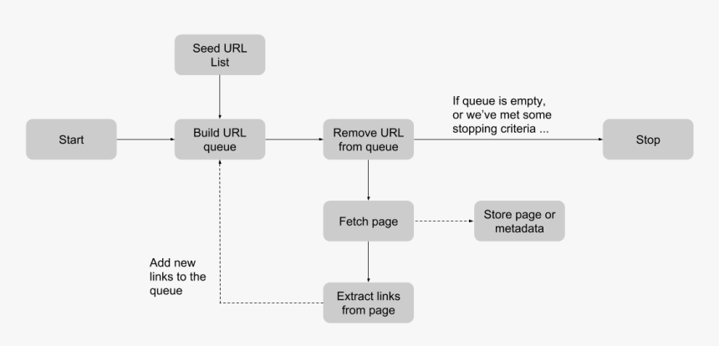

**Use Case Diagram**

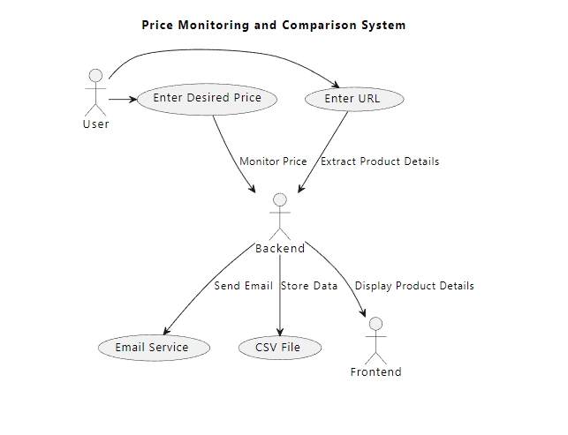

1. **Implementation**

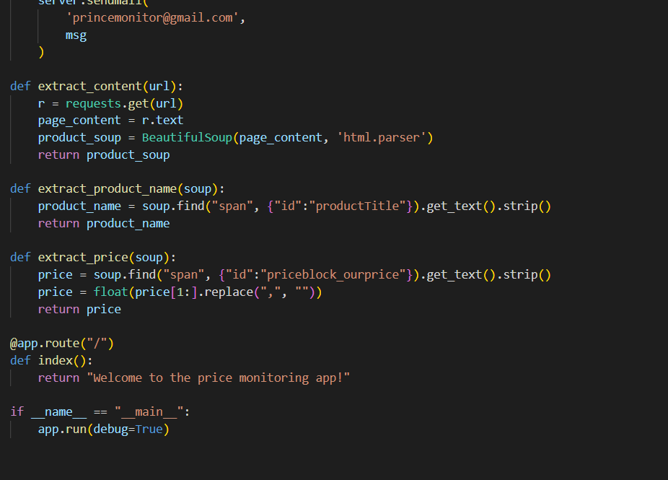

**Result:**

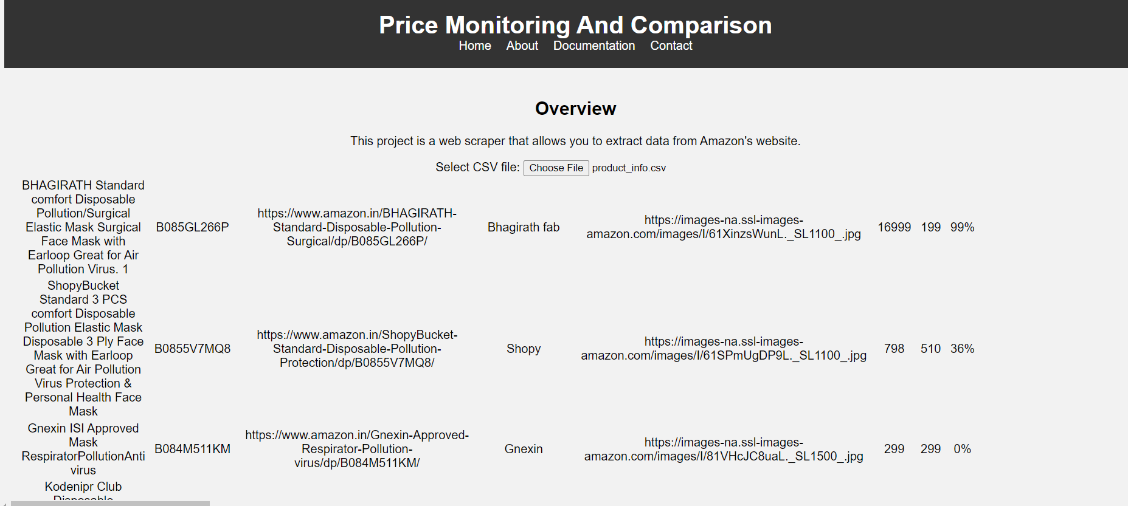

**Conclusion and Future work**

In conclusion, this project tries to provide the cheapest or best price to the requested goods given the growing popularity of online shopping and the knowledge that product prices frequently change and also vary across a wide range of websites. Python is one of the greatest programming languages for managing and handling data, which further simplified and advanced the process.

As for the future, we aim to develop this project into a full fledged website containing much more sophisticated design and premium features such a adding products to wish list, comparing multiple products at once and many more.

**References**

* <https://www.geeksforgeeks.org/python-web-scraping-tutorial/>
* <https://realpython.com/python-web-scraping-practical-introduction/>
* <https://www.python.org/>
* <https://www.scrapingbee.com/blog/web-scraping-101-with-python/>