Question 1

Soln:

select department_id, min(salary) "Second Lowest salary"

from employees e

where salary != (select min(salary)

from employees

where department_id = e.department_id)

group by department_id;

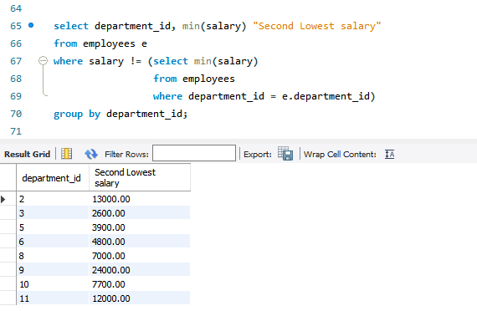

Question 2.1

Soln:

select * from employees

where salary < all (select avg(salary)

from employees

group by department_id) ;

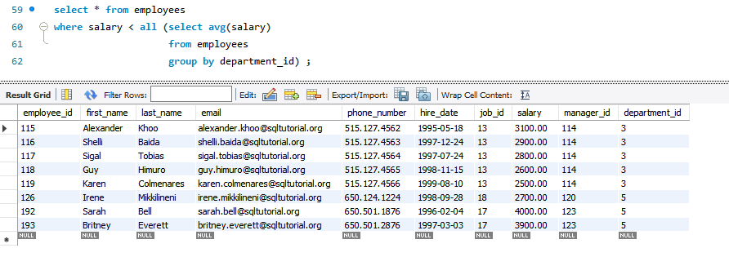

Question 2.2

Soln:

use dbt_01;

select * from emp

where sal between 100 and 999;

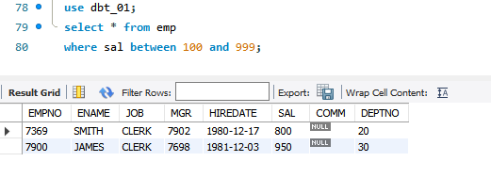

Question 3:

Soln:

select concat(e.first_name,' ', e.last_name) 'Full Name', d.department_name, e.job_id, concat(f.first_name, ' ', f.last_name) 'Manager'

from employees e

join employees f

on e.manager_id = f.employee_id

join departments d

on e.department_id = d.department_id

where e.salary between 9000 and 12000;

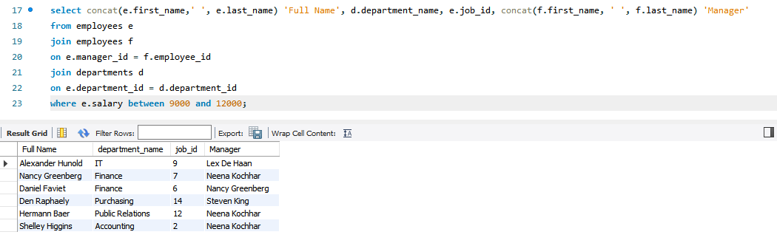

Qurstion 4

Soln:

select concat(first_name, last_name), department_name, hire_date, salary

from employees e

join departments d

on e.department_id=d.department_id

where datediff(sysdate(), hire_date)/365>12;

Question 5

Soln:

Select concat(concat(upper(left(first_name,1)),lower(substring(first_name,2))),' ',concat(upper(left(last_name,1)),lower(substring(last_name,2)))) 'Employee Name'

from employees

where first_name regexp '^[jam]';

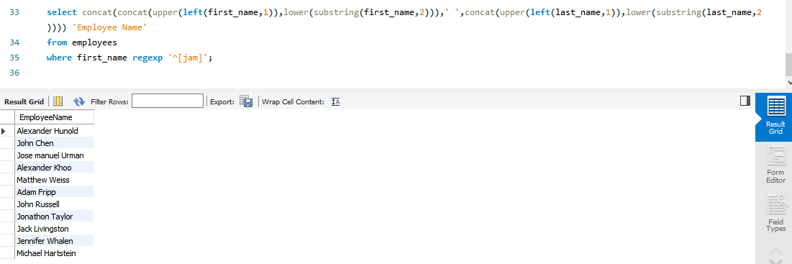

Question 6

Soln:

select * from departments d

join employees e

on d.department_id = e.department_id

where d.department_id NOT IN (select distinct department_id from employees);

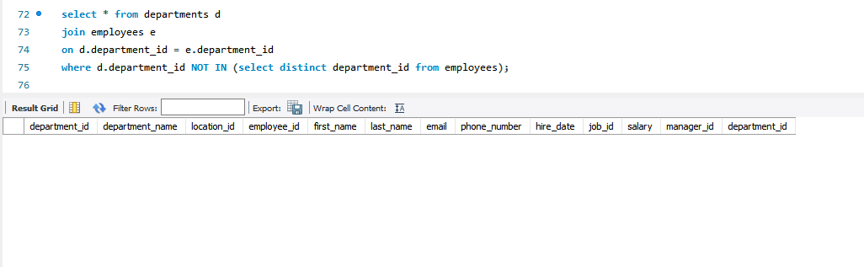 Empty SET

Question 7

Soln:

select first_name, last_name

from employees

where hire_date < (select hire_date

from employees

where first_name = 'LEX');

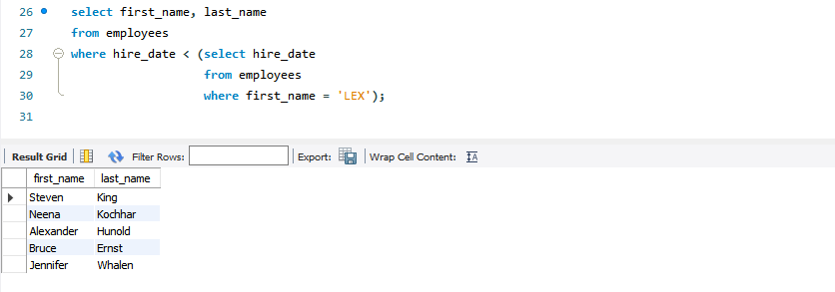

Question 8

Soln:

delimiter #

drop procedure if exists proc_const_pk#

create procedure proc_const_pk(IN p_table_name varchar(100), IN p_column_name varchar(100))

begin

set @primkey = concat('alter table ',p_table_name,' add constraint pk_on_table primary key(',p_column_name,')');

prepare stmt from @primkey;

execute stmt;

end#

delimiter ;

Before running the procedure:

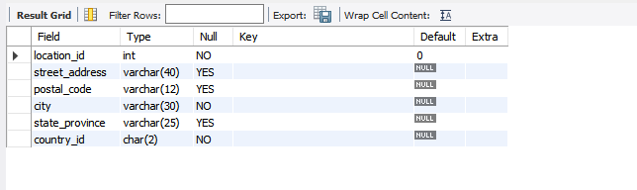

After running the procedure:

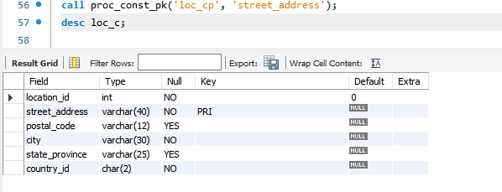

Question 9

Soln:

DELIMITER #

drop function if exists card_verification #

create function card_verification(sal int)

returns varchar(50)

deterministic

begin

if sal >= 1000 and sal <= 10000 then return 'SILVER CARD WITH 50000 LIMIT';

elseif sal > 10000 and SAL <= 20000 then return 'GOLD CARD WITH 150000 LIMIT';

elseif sal > 20000 then return 'PLATINUM CARD WITH 300000 LIMIT';

else

return 'PLEASE ENTER A VALID VALUE BETWEEN 1000 AND 10,000';

end if;

end#

delimiter ;

select card_verification(18700);

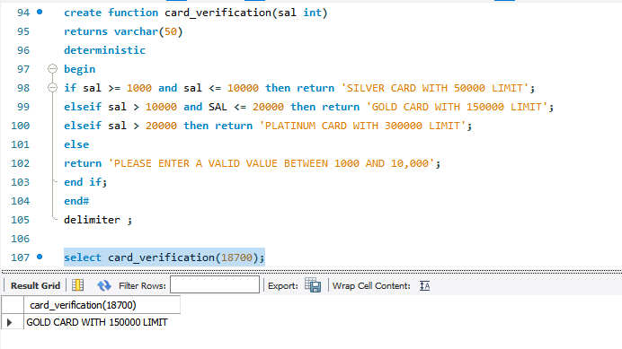

Question 10

Soln:

drop view if exists view_employee_details;

create view view_employee_details as

select concat(e.first_name, ' ',e.last_name) 'Employee Name', d.department_name 'Department', j.job_title 'Job', j.min_salary 'Min. Salary', j.max_salary 'Max. Salary'

from departments d

join employees e

on e.department_id = d.department_id

join jobs j

on e.job_id = j.job_id;

select * from view_employee_details;

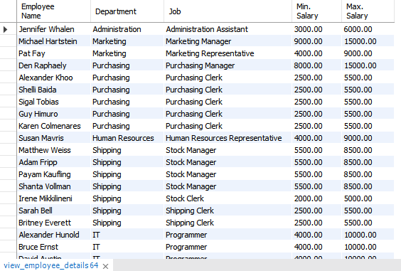

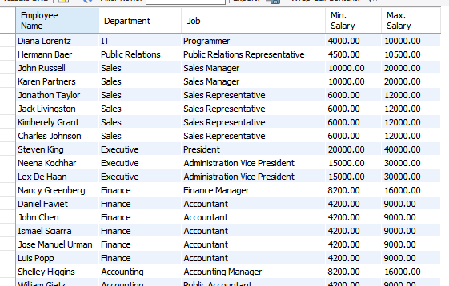

Question 11

Soln:

drop table if exists sales;

create table sales (sales_id INT PRIMARY KEY, product VARCHAR(50), QUANTITY INT, FYEAR DATE);

CREATE TABLE SALE_CHANGES (ID_OLD INT , Id_new int, product_old varchar(50), product_new varchar(50), quantity_old INT, quantity_new INT, fyear_old DATE, fyear_new DATE);

Delimiter #

CREATE TRIGGER trig_sales

After UPDATE

ON sales

FOR EACH ROW

BEGIN

insert into sale_changes values(old.id, new.id, old.product, new.product, old.Quantity, new.quantity, old.fyear, new.fyear);

END#

delimiter ;

insert into sales values (1, 'cycle', 5, current_date());

select * from sales;

update sales set product = 'Bike' where id = 1;

select * from sale_changes;

