**OBJECTIVE**

The purpose of this experiment is to gain familiarity with solar cells and their operation. This experiment will measure the following solar cell characteristics: the dark and light I-V characteristics, short circuit current, open circuit voltage under different optical stimuli.

**INTRODUCTION**

In the Semiconductor Optics experiment, two different types of photo-detectors were introduced: the photoconductor and the photodiode. The photodiode has a current voltage characteristic as shown in Figure 1a.

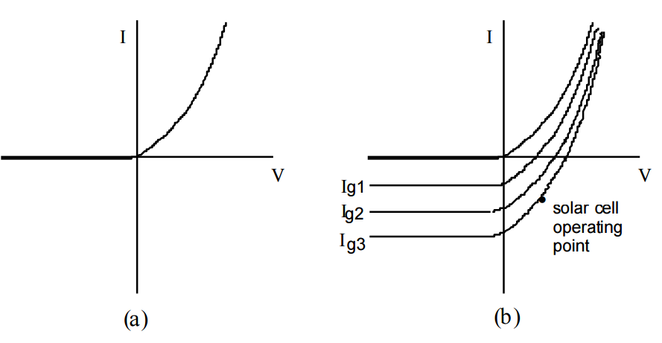

Figure 1a.

The photodiode is usually operated in reverse bias mode, so that the carriers generated within the depletion region are quickly swept toward the terminals. This is one reason why the response speed of a photodiode is fast. A photodiode is operated in the third quadrant of the I-V curve in Figure 1. A pn junction can also be operated in the fourth quadrant. If the p-n junction is operated in the fourth quadrant, the product of a negative current and a positive voltage will yield a negative power. The negative power indicates that the device is actually a power source. Consequently, a p-n junction operated in the fourth quadrant can be used as a source of power; this is the principle behind the solar cell. The solar cell converts photon power to electrical power and delivers this power to a load.

**THEORY**

Recall that the current and voltage through a p-n junction diode can be written:



Where Is is the reverse saturation current and n is an ideality factor that is introduced to modify the theoretical expression for use with "real" diodes. Under the presence of an optical stimulus, photons are absorbed to create electron hole pairs. Pairs that are generated within a diffusion length of the depletion region will be swept by the built in potential across the depletion region producing a photocurrent Igen in the reverse bias direction. If the generation current or photocurrent is included in equation (1), the net current will be given by:



Figure 1b demonstrates how optical excitation affects the I-V characteristic of the solar cell. Note that a larger generation rate corresponds to a larger generation current, corresponding to a larger downward shift in the I-V characteristics. Figure 2 shows an equivalent circuit that may be used to model the behavior of a solar cell. Notice that the photocurrent is represented by an independent source. The two resistors shown in Figure 2 model two of the losses in a solar cell. Rs is a series loss due primarily to the ohmic loss in the surface of the solar cell. The shunt resistance, Rsh, is used to model leakage currents. A shunt resistance of a few hundred ohms does not reduce the output power of the solar cell appreciably. In reality, Rsh is much larger than a few hundred ohms and can in most cases be neglected. The series resistance, however, can drastically reduce output power. For example, a series resistance of only 5 Ω can reduce output power by 30%.

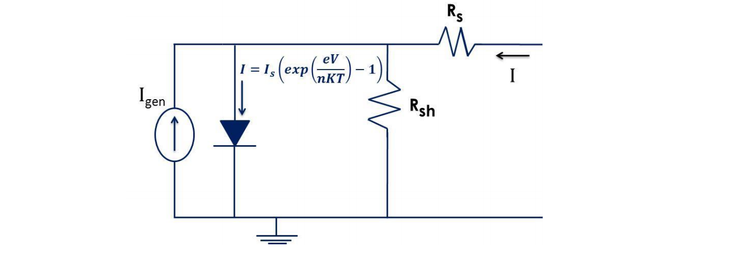

Two quantities of interest for a solar cell are the following: short circuit current (Isc) and open circuit voltage (Voc). Expressions for both Isc and Voc can be found from equation (2). The short circuit current is found by setting V = 0 in equation (2). This results in the following expression for Isc :



The minus sign in equation (3a) results from the fact that the current, Isc, is by definition the magnitude of the current at V= 0. To find the open circuit voltage, let I = 0 in equation (2) and solve for V:



Using the fact that Isc = Igen, equation (4) can be further simplified:



Note: In all of the preceding equations, we have neglected the effects of Rsh and Rs . That is, we have let Rsh = ∞ and Rs =0. Another characteristic property of solar cells is the fill factor, FF, which is defined as the ratio of the maximum power to the product of Isc and Voc:

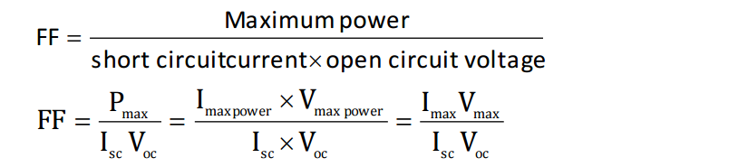

Isc is the maximum possible current and Voc is the maximum possible voltage. The fill factor is therefore a measure of the realizable power from the solar cell. Figure 3 shows the I-V characteristics of a solar cell and the maximum power rectangle

**Results**