**Distribution of Linux: (Type):**

1. Ubuntu
2. Kali Linux
3. Parrot
4. Arch Linux
5. Linux Mini

**Features of Linux Operating system:**

1. Open Source
2. Speed
3. Multiprocess
4. Multiple Network Protocol
5. Security
6. Shall (Program which execute of command in operating system)

**Advantage of Linux:**

1. Privacy
2. Free of cost
3. Software update

**Disadvantage of Linux:**

1. MS Office not work in Linux.

* **Command runs on Root or directory folder.**
* **Debine it is connection library**
* **CLI stands for command line interface**
* **GUI stands for graphical user interface**

**Shortcuts:**

1. ctr+alt+t 🡪for open terminal

**Commands:**

1. **Clear :- to clear screen**
2. **Ifconfig:- to check is the Linux system connect to other system[ result shows IP address]**
3. **apt-get :- [its is Debine library]**
4. **apt-get update:- to update system.**
5. **apt-get update && apt-get upgrade :- [&&]Run TWO command at a time.**
6. **uname:- user name [Linux]**
7. **uname -r :- linux version name (-r called as hyphen Recursive)**
8. **uname -a :- all data (-a called as hyphen All)**
9. **mv:- to move file**
10. **history:- all previous commands**
11. **ls:- show list of files and folders in present directory [list]**
12. **cd.. :- back one directory [change directory] [catch directory]**
13. **/#ls :- user directory (the directory open in computer called as user directory)[forward slash and hash]**
14. **~#ls :- root directory (directory open in computer and in another folder called as root directory)[curly hyphen and hash]**
15. **#cd desktop:- in desktop directory**
16. **Touch test:- touch for create a file (using this command we create a test file)**
17. **Touch test.txt:- file create with txt extension with file name test**
18. **Using upper arrow previous command comes in linux**
19. **rm test.txt:- to remove file [rm for Remove]**
20. **mkdir sushant:- create new folder [mkdir-make directory]**
21. **rmdir sushant:- remove created folder [rmdir-remove directory]**
22. **- - help:- for help**
23. **– help:- for help**
24. **man ls:- showing manual [man ls:- -manual list]**
25. **q: for quit**
26. **cp test/home :- to copy file and its goes to home folder [cp- copy]**
27. **pwd :- to check in which directory we are in present [present working directory]**

**Permeation in Linux:**

1. **ls - l test:- see the permission**

**permeation divides in 3 steps: admin, group, public**

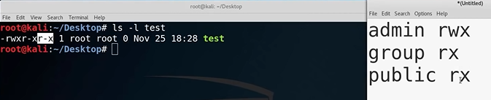

1. **chmod 764 test:- change the permission**

**permeation details:**

**1=execute**

**2=write**

**4=read**

**Admin= rwx =1+2+4=7**

**Group= rw =2+4=6**

**Public= r = 4**

