Design Document: Ingestion Interceptor
Field | Value
Version | 3.0
Status | Implemented
Module | ingestion_interceptor/
Authors | Sangam Kumar Mishra
PI | Dr. Padmalochan Bera, IIT Bhubaneswar
Sponsor | Bharat Electronics Ltd (BEL)
Project | Detection and Prevention of Malware and Malicious File Injection in RPA/Drone Feeds
Created | 2025-10-13
Last Updated | 2026-04-09
Depends On | Python 3.9+, hashlib, hmac, dataclasses, json, uuid, logging, socket, struct, threading
Depended On By | Game-Theoretic Threat Estimator, Metadata Sanitizer, Security Dashboard

v3.0 change summary: Added Stage 0 (Packet Reception & Reassembly). The interceptor now accepts wire-level UDP packets directly from drone platforms, in addition to the in-process dict entry point. New ingestion_interceptor/protocol/ subpackage defines a 32-byte fixed binary packet header and a TLV (Type-Length-Value) submission marshaller. A new packet_receiver.py module runs a UDP listener thread, verifies per-packet HMAC-SHA256, reassembles fragmented submissions, and feeds them into the existing 7-stage pipeline unchanged. v3.0 also fixes a latent bug where telemetry anomalies (negative speed, invalid battery, etc.) were detected but silently discarded — they now surface as telemetry_* security flags in IngestMetadata.insecure_flags. See §5.10, §5.11, §8.4, §9.6, §10.6, FR-21..25, R-16..21.

Table of Contents
Update this field to see table of contents with page numbers (right-click > Update Field)

1. Executive Summary
The Ingestion Interceptor is the first line of defence in the Multi-Layered Malware Detection and Threat Prevention System for drone and Remotely Piloted Aircraft (RPA) data streams. Developed under a Bharat Electronics Ltd (BEL) sponsored research project at IIT Bhubaneswar, this module sits at the edge network boundary between untrusted drone platforms and the operational security infrastructure.
The Ingestion Interceptor acts as a secure data funnel that prevents uncontrolled input from entering the analysis pipeline. Every incoming drone submission --- containing video, imagery, telemetry, and metadata --- passes through an eight-stage processing pipeline:
- Packet Reception & Reassembly --- receives wire-level UDP datagrams
from drone platforms, verifies per-packet HMAC-SHA256, reassembles fragmented submissions, and decodes the binary TLV payload back into a structured submission. This stage is optional: the interceptor also accepts in-process dict submissions via the process() entry point, which is the primary integration path for real drone deployments (see below).
- Structure Validation --- verifies required fields, data types, timestamps,
size limits, and path traversal defences.
- Device Authentication --- verifies drone identity through a device
registry, HMAC-SHA256 signature verification, and configurable unknown-device policy enforcement.
- Metadata Extraction --- extracts and normalizes mission context,
geolocation, telemetry summaries, and additional metadata with pre-sanitization.
- Payload Security Analysis --- applies a 9-point security heuristic to
every payload file, detecting encrypted content, nested archives, executable extensions, MIME mismatches, and other indicators.
- Checksum Verification --- computes and compares SHA-256 checksums to
detect file tampering.
- Artifact Cataloging --- generates unique artifact identifiers, storage
pointers, and thumbnail references.
- Output Assembly --- produces a structured IngestResult containing
IngestMetadata and ArtifactRecord entries.
The output feeds directly into the Game-Theoretic Threat Estimator, which uses the extracted metadata, security flags, device reputation, and zone risk to compute a Stackelberg-equilibrium threat score (T_S) that determines the inspection depth applied by downstream detection engines.
The module also supports a secure uplink channel from the control center, enabling real-time quarantine commands, device revocations, zone risk updates, and dynamic parameter adjustment for a live feedback loop between the security dashboard and the edge detection engine.
Real drone integration model: The interceptor provides two entry points. The `process(dict)` method (Stages 1--7) is the primary integration path for real drone deployments. Real drones (DJI, PX4/ArduPilot, or proprietary platforms) transmit data via their native protocols (MAVLink, DJI MSDK, etc.). A ground-station adapter on the edge node receives these native feeds, converts the data into the expected JSON dict format (drone_id, timestamp, payloads, and optional metadata fields), and calls process(). This architecture keeps the interceptor protocol-agnostic --- it validates, authenticates, and catalogues the submission regardless of how the data arrived at the edge.
Stage 0 (the custom RPAD binary UDP protocol) demonstrates wire-level security engineering --- per-packet HMAC, replay detection, reassembly --- and can be used when the drone platform is capable of running a custom firmware module that speaks the RPAD protocol. For drones that cannot be modified, the ground-station adapter path is the standard deployment pattern:
Real Drone (DJI / PX4 / ArduPilot / proprietary)
│
│ Native protocol (MAVLink, DJI MSDK, etc.)
▼
Ground Station / Edge Gateway
│
│ Adapter: parse native protocol → build submission dict
▼
IngestionInterceptor.process(dict) ← primary entry point
│
▼
IngestResult → Game-Theoretic Threat Estimator → downstream pipeline

2. Goals and Non-Goals
This section defines the precise scope of the Ingestion Interceptor by listing what the module is designed to achieve and what responsibilities are explicitly delegated to other modules in the pipeline.

2.1 Goals
The following goals define the core functional responsibilities of the Ingestion Interceptor.
ID | Goal
G-1 | Authenticate source devices using metadata (timestamps, drone ID, geolocation)
G-2 | Validate data format, structure, and integrity of every incoming drone submission
G-3 | Extract and record metadata: drone ID, mission zone, timestamps, encryption status
G-4 | Identify ZIP/encrypted file types and flag them for deferred deep analysis
G-5 | Act as a secure data funnel preventing uncontrolled input into the analysis pipeline
G-6 | Support secure uplink communication from the control center (quarantine commands, dynamic parameter adjustment, live feedback loop)
G-7 | Produce structured output compatible with the Game-Theoretic Threat Estimator input contract
G-8 | Provide configurable, defence-in-depth security posture with tuneable thresholds
G-9 | Maintain processing statistics for operational monitoring
G-10 | Support both class-based and functional API entry points

2.2 Non-Goals
The following items are explicitly outside the scope of this module and are handled by downstream components in the detection pipeline.
ID | Non-Goal
NG-1 | Deep content inspection (malware scanning, AI/ML classification, sandboxing) --- handled by downstream Multi-Layer Malware Detection Engine
NG-2 | Full metadata sanitization (EXIF scrubbing, embedded script removal) --- handled by Metadata Sanitizer module
NG-3 | Threat score computation or game-theoretic analysis --- handled by Game-Theoretic Threat Estimator
NG-4 | Long-term artifact storage management --- handled by storage infrastructure
NG-5 | Security dashboard rendering --- handled by Logging & Feedback Loop layer
NG-6 | Real-time video stream processing --- the module handles discrete submission payloads
NG-7 | Native drone protocol handling (MAVLink, DJI MSDK, etc.) --- a ground-station adapter converts native feeds into the submission dict format before calling process()

3. System Context
The Ingestion Interceptor operates within a three-layer architecture. The following diagram shows the complete system with all modules and the data flow between them.

3.1 Full System Architecture
The following diagram illustrates the complete three-layer system architecture, showing all nine modules and the data flow between them.
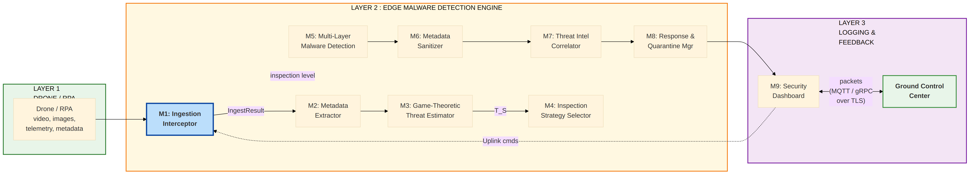

3.2 Ingestion Interceptor Boundary Context
The following diagram shows the trust boundary in which the Ingestion Interceptor operates, highlighting external inputs from the drone platform (UDP packets at Stage 0 or in-process dict via process()) and the security dashboard control center.
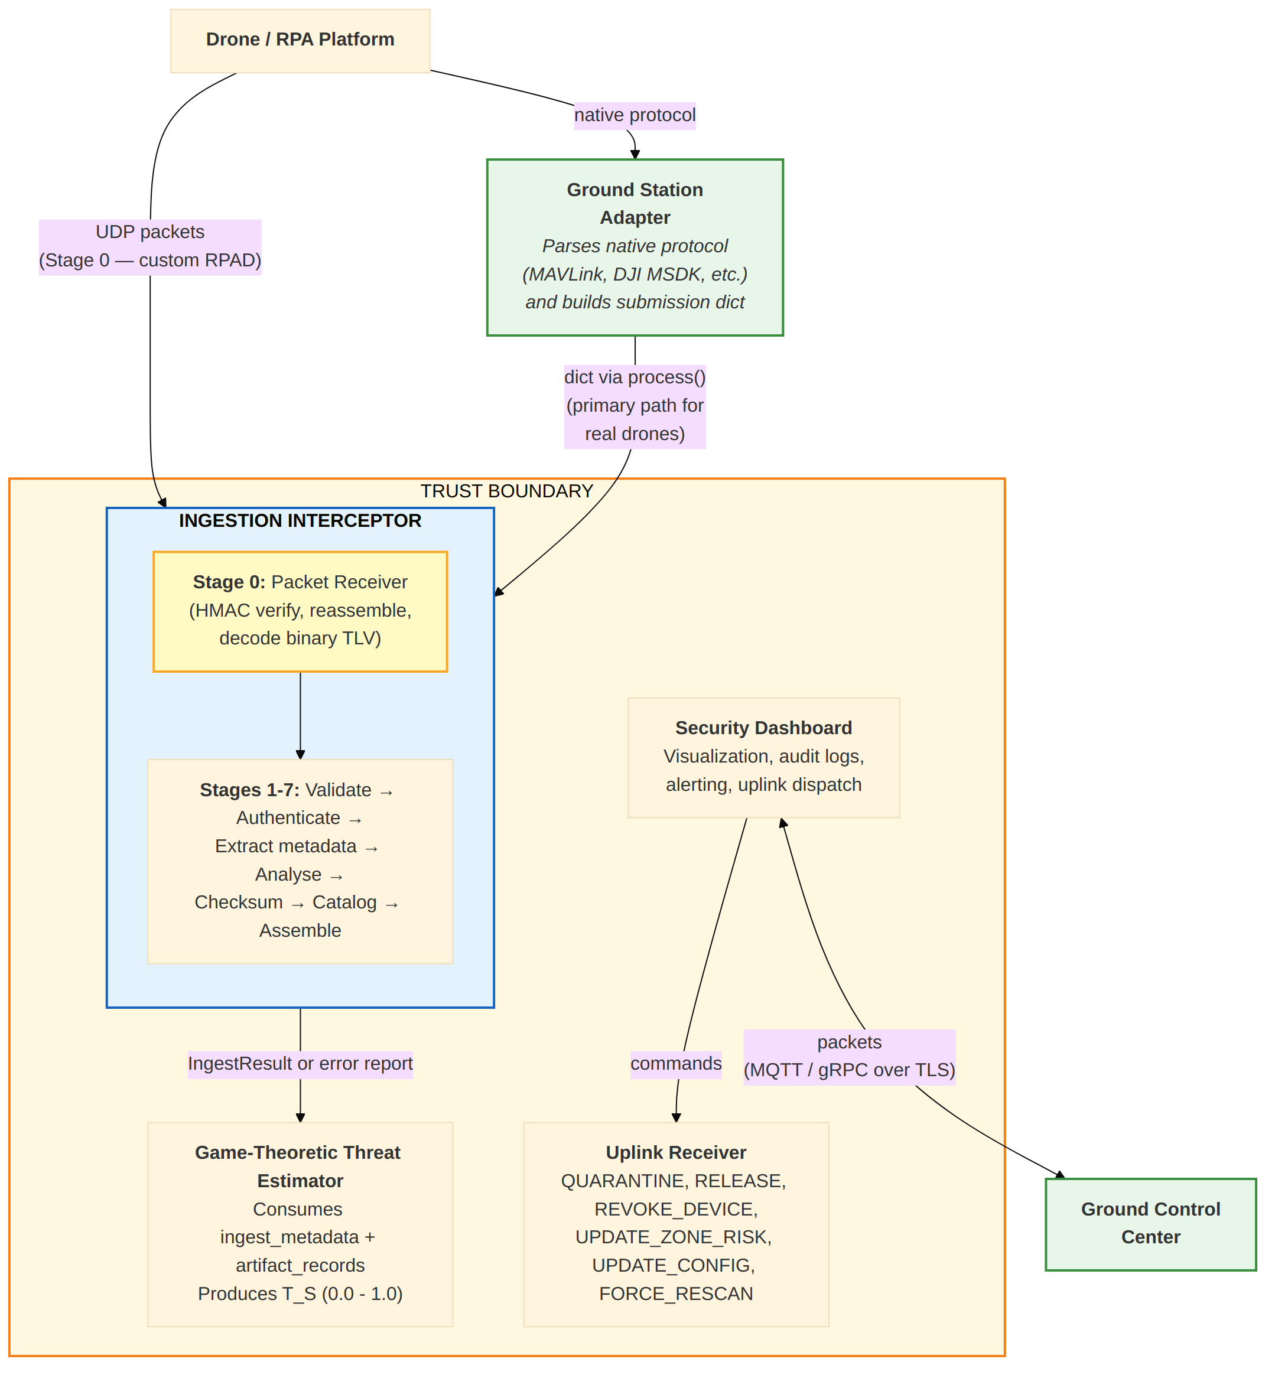

4. Architecture Overview
This section describes the internal architecture of the Ingestion Interceptor module, including its file structure, component dependencies, and the data flow through its eight-stage processing pipeline (Stage 0 packet receiver plus the original seven stages).

4.1 Module Structure
The module is organized as a Python package with each processing stage implemented in a separate file for clear separation of concerns. The following listing shows the directory layout, including the new Stage 0 packet receiver and the protocol/ wire-codec subpackage.
ingestion_interceptor/
├── __init__.py Public API surface and package exports
├── config.py InterceptorConfig dataclass (all tuneable parameters)
├── models.py Data model definitions (6 dataclasses)
├── validator.py Structure and constraint validation
├── authenticator.py Device registry, signature verification, auth orchestration
├── payload_analyzer.py 9-point security heuristic analysis and risk scoring
├── checksum_verifier.py SHA-256 file integrity verification and URI resolution
├── metadata_extractor.py Mission context, geo, telemetry, additional metadata
├── artifact_manager.py Artifact ID generation, storage pointers, thumbnails
├── uplink.py Control center uplink command handling
├── packet_receiver.py Stage 0: UDP listener, reassembly buffer, statistics
├── protocol/ Wire protocol subpackage (Stage 0 codec)
│ ├── __init__.py Re-exports the public protocol surface
│ ├── packet.py PacketHeader dataclass, PacketType enum, header layout
│ ├── codec.py encode_packet / decode_packet (32-byte header + HMAC)
│ ├── submission_codec.py Binary TLV marshaller for DroneSubmission
│ └── errors.py Codec exception hierarchy
├── interceptor.py Main orchestrator (8-stage pipeline)
└── tests/
├── test_interceptor.py 31 unit tests for the original 7 stages
├── test_packet_codec.py 13 tests for packet framing
├── test_submission_codec.py 14 tests for the binary submission marshaller
└── test_packet_receiver.py 17 tests for reassembly + UDP listener

4.2 Component Dependency Diagram
The following diagram shows how the main orchestrator (interceptor.py) depends on each processing component, how the shared configuration object flows to all modules, and how the Stage 0 packet_receiver and protocol/ subpackage feed reassembled submissions back into the orchestrator.
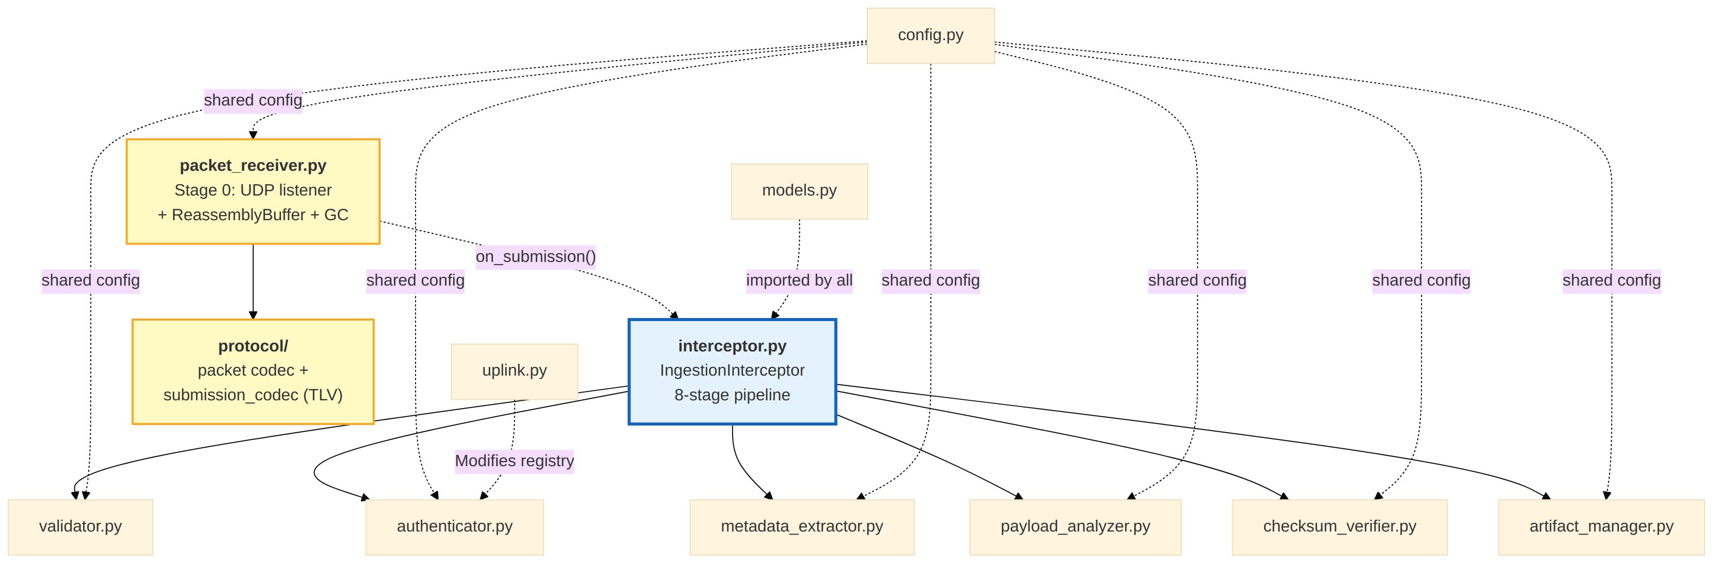

4.3 Data Flow Through the Pipeline
The following diagram traces the complete data flow, beginning at the optional Stage 0 UDP packet receiver and continuing through the seven processing stages to the final IngestResult output, including the rejection paths.
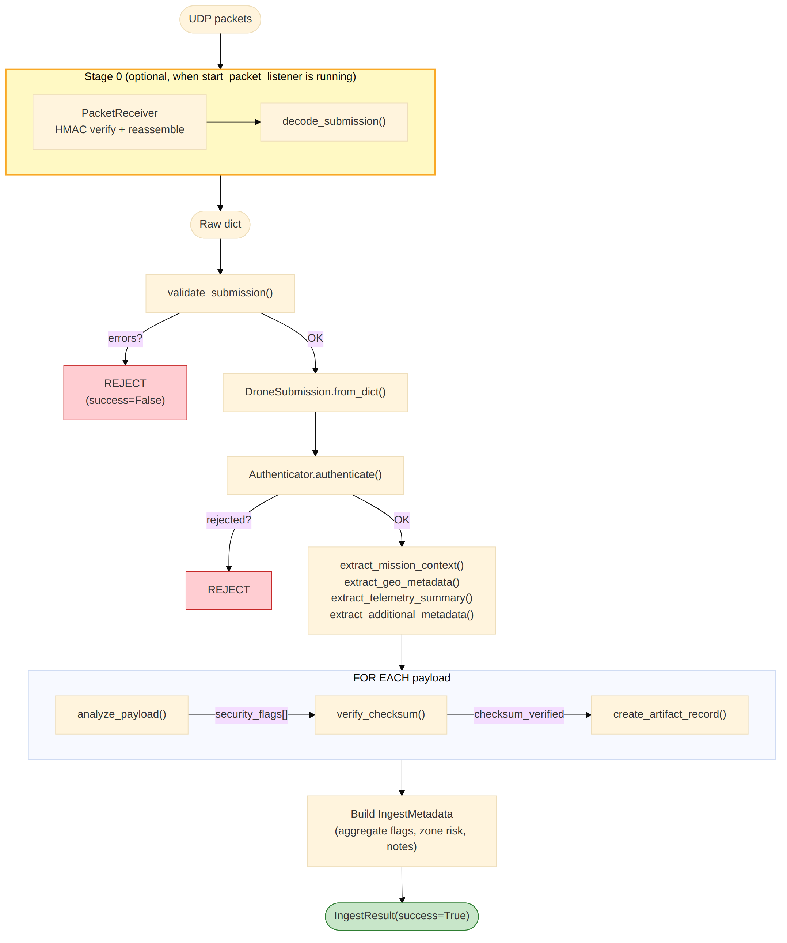

5. Component Design
This section provides detailed design documentation for each component in the Ingestion Interceptor module, describing their purpose, internal architecture, validation logic, and key design decisions.

5.1 config.py --- Configuration
Purpose: Centralizes all tuneable parameters into a single immutable-style dataclass. Every other module receives its configuration through this object, ensuring consistent behaviour across the pipeline.
Design rationale: A single configuration dataclass avoids scattered magic constants and makes the system testable by allowing callers to inject different configurations per test case. Default values are chosen for a balanced security posture suitable for field deployment.
Note --- Current vs Production backends: The current implementation defaults to in-memory data structures and local filesystem paths for ease of development, testing, and demonstration. For production edge deployments, the following backends are recommended:
Component | Current (Dev/Demo) | Production
Device registry | In-memory dict / JSON file | SQLite (edge) or PostgreSQL (centralized)
Uplink transport | In-memory queue / file polling | gRPC bidirectional streaming or MQTT broker
Artifact storage | Local filesystem | MinIO (edge-local S3-compatible) with S3 cloud archival
Zone risk lookup | In-memory dict | Redis or SQLite (must survive process restarts)
Quarantine set | In-memory set | Redis SET or SQLite (lost quarantine on restart = security gap)
HMAC key store | In-memory dict | HashiCorp Vault or hardware HSM (keys must never touch disk unencrypted)
Processing stats | In-memory counters | Prometheus + Grafana (time-series, alerting, historical trending)
Audit logs | Python logging to stdout/file | ELK stack (Elasticsearch + Logstash + Kibana) or Grafana Loki
The InterceptorConfig dataclass is designed so that swapping backends requires changing only the configuration values, not the pipeline logic.

Key parameter groups:
- Validation --- require_signature, max_payload_size_bytes,
max_payloads_per_submission, allowed_mime_types
- Security thresholds --- large_binary_threshold, suspicious_mime_types,
suspicious_extensions
- Authentication --- auth_backend, auth_timeout_seconds,
unknown_device_policy
- Checksum --- checksum_algorithm, verify_checksums
- Storage --- storage_backend, storage_base_path, artifact_uri_prefix
- Zone risk --- default_zone_risk
- Logging --- log_level, structured_logging
- Uplink --- uplink_enabled, uplink_endpoint,
uplink_poll_interval_seconds
- Stage 0 packet listener --- packet_listener_host,
packet_listener_port, packet_max_session_chunks, packet_max_concurrent_sessions, packet_session_timeout_seconds, packet_hmac_required, packet_replay_window_seconds

5.2 models.py --- Data Models
Purpose: Defines typed dataclasses for every entity that flows through the pipeline, from raw input parsing to final output assembly.
Design rationale: Typed dataclasses provide compile-time-like safety for field access, self-documenting APIs, and straightforward serialization via to_dict() methods. Every model includes a from_dict() class method for safe deserialization with fallback defaults, preventing KeyError crashes on malformed input.
Six dataclasses:
- GeoLocation --- latitude, longitude, altitude with validation-aware parsing
- PayloadEntry --- individual file metadata including encryption/container flags
- DroneSubmission --- complete parsed input with all optional fields
- ArtifactRecord --- per-file output record with security analysis results
- IngestMetadata --- aggregated submission metadata for downstream consumers
- IngestResult --- top-level pipeline output (success path or error path)

5.3 validator.py --- Structure Validation
Purpose: First-pass validation of the raw JSON dict before any processing occurs. Rejects structurally invalid submissions early, preventing downstream modules from operating on malformed data.
Validation checks performed:
- Required top-level fields: drone_id, timestamp, payloads
- drone_id is a non-empty string
- timestamp is a valid ISO 8601 string; warns if >24h in the future
- payloads is a non-empty list, within count limits
- Signature presence enforced when require_signature=True
- Each payload has type, filename, mime, size_bytes
- size_bytes is a non-negative number within configured maximum
- MIME type is within the allowed whitelist (warning, not fatal)
- Filename is a non-empty string without path traversal characters (/, \)
Return contract: Returns (errors: List[str], warnings: List[str]). Errors are fatal and halt the pipeline. Warnings are informational and propagated to the output.

5.4 authenticator.py --- Device Authentication
Purpose: Three-layer authentication system that verifies the identity and trust status of the submitting drone device.
Architecture:
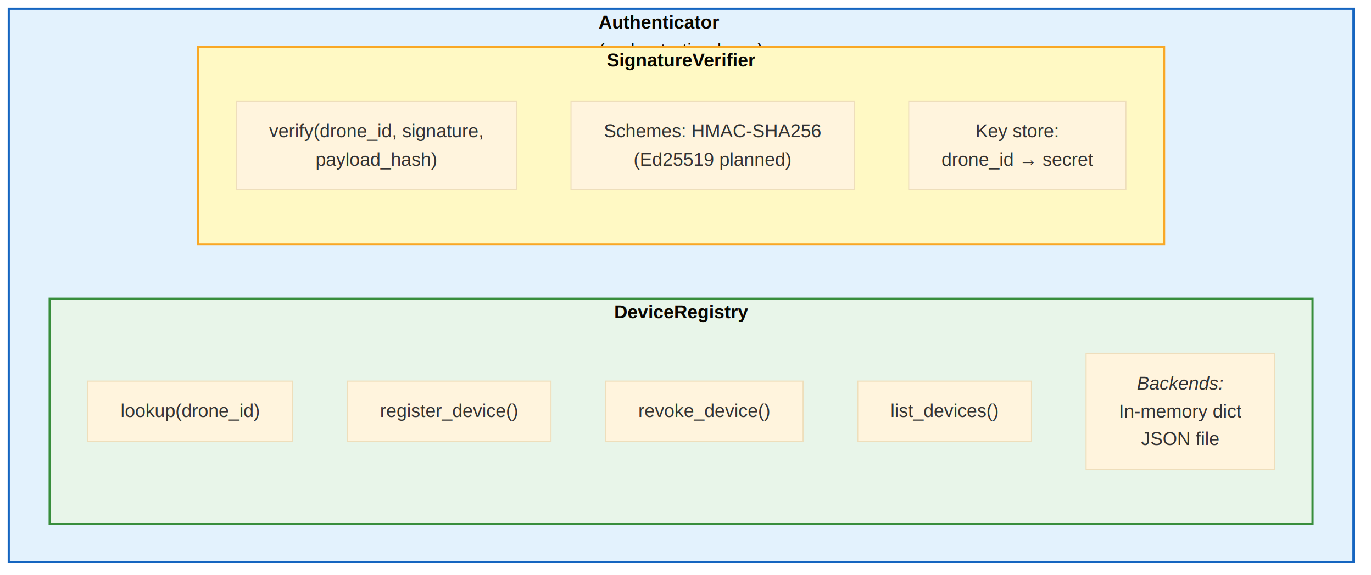
Authentication flow:
- Look up drone_id in the device registry.
- If not found, apply unknown_device_policy (flag / reject / allow).
- If found, check for revocation status.
- If a cryptographic signature is provided, verify it using HMAC-SHA256 against
the submission's payload hash. Failed signature verification downgrades trust.
- Return AuthResult with status, reputation, trust flag, and detail dict.
Note --- Production registry backend: The current implementation stores the device registry as an in-memory Python dict (optionally loaded from a JSON file at startup). This is sufficient for testing and demos but does not survive process restarts and cannot be shared across multiple edge nodes. For production deployments:
• Single edge node: Use a SQLite database (zero-config, ACID, single-file)
so that device registrations, reputations, and revocations persist across restarts.
• Multi-node / centralized fleet management: Use PostgreSQL or a REST
API backed by a central database, allowing the control center to manage the fleet-wide device registry with consistency guarantees.
• HMAC key store: Shared secrets used for per-drone signature
verification and Stage 0 packet authentication must be managed through HashiCorp Vault or a hardware HSM in production. Storing keys in a plain Python dict or JSON file is acceptable only for development.

`AuthResult.status` values:
- authenticated --- device found, trusted, signature valid (if checked)
- untrusted --- device found but not trusted, or signature verification failed
- unknown --- device not in registry, flag or allow policy applied
- rejected --- device not in registry with reject policy, or device revoked
- error --- internal authentication failure

5.5 payload_analyzer.py --- Security Heuristic Analysis
Purpose: Applies a 9-point security heuristic to each individual payload file, producing a set of security flags that feed into risk scoring and downstream threat estimation.
Security checks:
# | Flag | Severity | Trigger Condition
1 | encrypted_payload | medium | payload.encryption == True
2 | nested_archive | medium | payload.container == True
3 | large_binary | low | payload.size_bytes >= large_binary_threshold (default 10 MB)
4 | suspicious_mime | high | MIME type in suspicious_mime_types set
5 | executable_file | critical | File extension in suspicious_extensions set (.exe, .dll, etc.)
6 | double_extension | high | Filename has 2+ dots with final extension in suspicious set
7 | hidden_file | medium | Filename starts with . (Unix hidden file convention)
8 | zero_size_file | medium | size_bytes == 0 for video, image, or archive types
9 | mime_extension_mismatch | medium | Declared MIME does not match expected extensions for that MIME type

Risk scoring: compute_payload_risk_score() computes a normalized score (0.0--1.0) from the set of flags using severity weights:
critical = 1.0, high = 0.7, medium = 0.4, low = 0.2
score = min(1.0, sum(weights) / 3.0)

This risk score provides quick triage before the more sophisticated game-theoretic analysis.
Threat notes: generate_threat_notes() produces human-readable notes combining security flags and authentication status, used for dashboard display and audit logging.

5.6 checksum_verifier.py --- Integrity Verification
Purpose: Computes and verifies SHA-256 checksums for payload files to detect tampering between the drone platform and the edge ingestion point.
Capabilities:
- compute_file_checksum() --- streams a file from disk in 64 KB chunks,
computing the hash without loading the entire file into memory.
- compute_bytes_checksum() --- computes the hash of raw bytes (used for
submission-level payload hashing during authentication).
- verify_checksum() --- compares a computed checksum against a declared
expected value. Returns True (match), False (mismatch / possible tampering), or None (verification skipped).
- resolve_file_path() --- resolves file:/ URIs and relative paths to local
filesystem paths. Returns None for remote URIs (s3://, minio://) that cannot be verified locally.
Supported algorithms: SHA-256 (default), SHA-1, SHA-512, MD5.
Stub checksum handling: Checksums ending in ... (e.g., a1b2c3d4...) are recognized as placeholders and silently skipped.

5.7 metadata_extractor.py --- Metadata Extraction
Purpose: Extracts, normalizes, and pre-sanitizes metadata from drone submissions to produce structured data for downstream analysis.
Four extraction functions:
- `extract_mission_context()` --- Extracts mission_id, mission_zone,
operator_id, firmware_version, and mission_sensitivity (from additional_metadata). Normalizes sensitivity to lowercase.
- `extract_geo_metadata()` --- Validates geolocation coordinates with
sanity bounds:
- Latitude: -90 to +90
- Longitude: -180 to +180
- Altitude: -500 m to 100,000 m
Returns None if any coordinate is out of range.
- `extract_telemetry_summary()` --- Passes through telemetry data while
detecting anomalies:
- Battery level outside 0--100%
- Negative speed
- Signal strength outside 0--100
- Heading outside 0--360 degrees
Anomalies are appended as a telemetry_anomalies list.
- `extract_additional_metadata()` --- Pre-sanitization step that:
- Strips dangerous keys: __proto__, constructor, prototype, eval,
exec
- Truncates string values exceeding 10,000 characters
- Returns None if no safe keys remain

5.8 artifact_manager.py --- Artifact Management
Purpose: Generates unique identifiers, storage pointers, and thumbnail references for each payload, creating the ArtifactRecord objects that downstream modules use to locate and process files.
Key functions:
- generate_artifact_id() --- produces artifact://<16-hex-chars> URIs
- generate_ingest_id() --- produces ingest_<12-hex-chars> identifiers
- build_storage_pointer() --- constructs storage URIs based on backend:
- Filesystem: <storage_base_path>/<drone_id>/<filename>
- S3/MinIO: <artifact_uri_prefix>/<drone_id>/<ingest_id>/<unique>_<filename>
- resolve_storage_pointer() --- uses the payload's existing URI if present,
otherwise constructs one
- generate_thumbnail_ref() --- produces thumb://<12-hex-chars> for image
and video payloads
- create_artifact_record() --- assembles a complete ArtifactRecord
Note --- Production artifact storage: The current implementation constructs local filesystem paths (drone_remote_store/<drone_id>/) for artifact storage. For production deployments:
• Edge node: Deploy MinIO (self-hosted, S3-compatible object
store) on the edge node. MinIO provides versioning, erasure coding, and an S3-compatible API that downstream modules can use with pre-signed URLs.
• Cloud archival: Configure a replication policy from the edge MinIO
instance to a centralized AWS S3 or equivalent bucket for long-term forensic storage and cross-site analysis.
• Thumbnail generation: In production, thumbnail generation should be
an async task (e.g., via a Celery worker) rather than inline in the ingestion pipeline, to avoid blocking the critical path.
Set storage_backend = "minio" and artifact_uri_prefix = "s3://edge-forensics/artifacts" in InterceptorConfig to switch.

5.9 uplink.py --- Control Center Communication
Purpose: Enables bidirectional communication from the control center to the edge interceptor, supporting real-time operational commands.
Architecture:
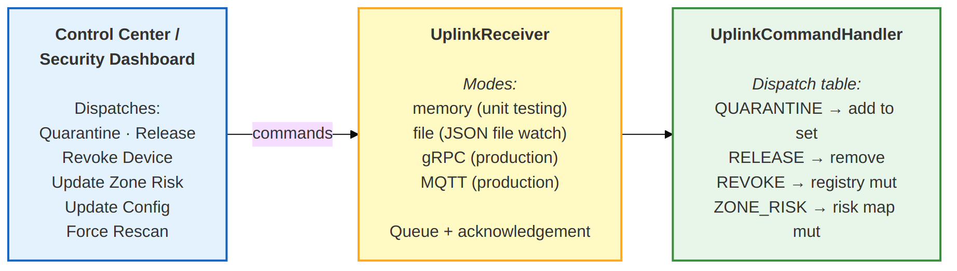
Command types:
Command | Target | Effect
QUARANTINE | ingest_id | Adds ingest ID to quarantine set
RELEASE | ingest_id | Removes ingest ID from quarantine set
REVOKE_DEVICE | drone_id | Sets trusted=False, revoked=True in device registry
UPDATE_ZONE_RISK | * | Updates zone risk map (params: zone, risk)
UPDATE_CONFIG | * | Reserved for dynamic configuration updates
FORCE_RESCAN | ingest_id | Reserved for triggering re-analysis

Note --- Production uplink transport: The current implementation provides two modes: memory (in-process queue for unit testing) and file (JSON file polling for integration testing). Neither is suitable for production because they do not guarantee delivery, persistence, or ordering under failure. For production deployments:
• Preferred: MQTT 5.0 over TLS with QoS 1 (at-least-once delivery).
MQTT is lightweight, widely supported on constrained edge hardware, and natively supports retained messages and last-will-and-testament for connection health monitoring.
• Alternative: gRPC bidirectional streaming over mTLS for
environments that already have a gRPC service mesh. Provides strong typing (protobuf), built-in flow control, and deadline propagation.
• Command persistence: In either mode, pending commands should be
backed by a Redis list or a SQLite WAL-mode table on the edge node so that commands received while the interceptor is restarting are not lost.
• Quarantine set persistence: The in-memory quarantine set must be
persisted to Redis or SQLite. A quarantine entry lost on restart means a suspicious submission could be released to the operational network unreviewed.

5.10 packet_receiver.py --- Stage 0: Packet Reception & Reassembly
This component implements Stage 0: a UDP listener thread, a per-session reassembly buffer, periodic garbage collection, and packet/session statistics. It is the wire-level entry point for drone submissions.
Purpose: Receives wire-level UDP packets from drone platforms, authenticates each packet via per-drone HMAC, reassembles fragmented submissions into a single binary blob, decodes that blob into a DroneSubmission dict, and hands it to the existing 7-stage pipeline through a callback.
Three classes:
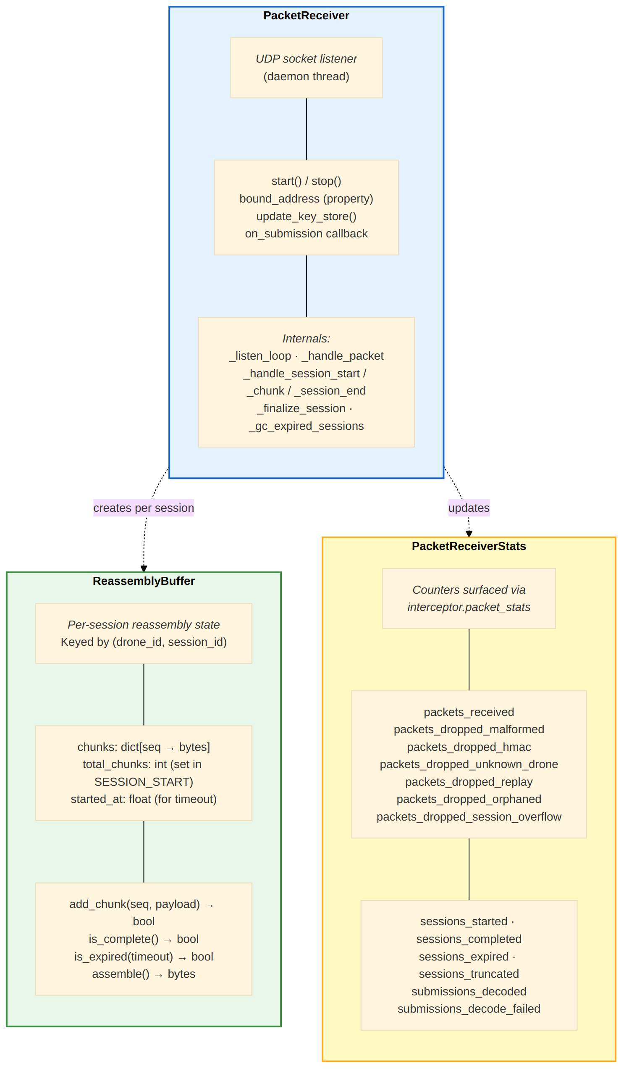
Reassembly trigger logic: A session is finalized whenever ANY of these happen first:
- Eager: all total_chunks chunks have arrived (fastest path)
- Explicit: SESSION_END packet received (handles dynamic streams)
- Timeout: session has lived longer than packet_session_timeout_seconds
(rejected as expired by the periodic janitor pass)
If SESSION_END arrives but chunks are missing, the session is rejected with incomplete_packet_stream and counted in sessions_truncated. This surfaces truncation attacks and benign network loss as a security signal.
Stage 0 security defenses (see also §10.6):
- Magic-byte + version verification
- Per-packet HMAC-SHA256 verification (constant-time compare)
- Per-session monotonic seq with duplicate detection
- Duplicate SESSION_START rejection (prevents buffer hijack via session-id guessing)
- Reassembly timeout (default 30s) enforced by a wall-clock periodic GC pass
that fires under both quiet and continuous traffic
- Max chunks per session (default 256)
- Max concurrent sessions per drone (default 100)
- Max payload_len per packet (1024 bytes)
- Sequence-gap detection at SESSION_END (truncation defense)

5.11 protocol/ --- Wire Protocol Subpackage
The protocol subpackage holds the wire contract: the 32-byte fixed packet header, the per-packet HMAC tag, and the binary TLV submission marshaller. Both the receiver and the drone simulator import from this subpackage so the wire contract has a single source of truth.
Purpose: Defines the binary packet format and the binary submission marshaller used by Stage 0. Both the drone (sender) and the interceptor (receiver) import from this subpackage so that the wire contract has a single source of truth.
Two layers:
- Packet framing (packet.py + codec.py)
- 32-byte fixed header + variable-length payload + 32-byte HMAC-SHA256 tag
- Three packet types: SESSION_START, CHUNK, SESSION_END
- encode_packet(header, payload, key) -> bytes and
decode_packet(raw, key) -> (header, payload) are the public API
- decode_packet_unverified() is used internally by the receiver to
extract the drone_id from a SESSION_START packet before looking up the per-drone HMAC key
- Submission marshalling (submission_codec.py)
- encode_submission(dict) -> bytes and decode_submission(bytes) -> dict
- TLV (Type-Length-Value) encoding modelled on MAVLink's spirit
- Envelope: "DSUB" magic + version + reserved + field count
- Top-level field tags carry drone_id, timestamp, mission_id, mission_zone,
geo (24 B fixed), telemetry (40 B fixed), signature, firmware_version, operator_id, additional_metadata (kv substream), and one tag per payload entry
- Payload substream encodes type/filename/mime/size_bytes/encryption/container/checksum/uri
- All strings are utf-8; numeric fields are big-endian
- Maximum value length per TLV: 65535 bytes (uint16 length field)
Design rationale:
- Custom binary framing demonstrates real packet-level security work
(magic, version, HMAC, replay) instead of leaning on a library that hides those concerns
- TLV encoding lets optional fields drop out naturally and supports
forward-compatible extension (unknown tags are skipped on decode)
- Zero external dependencies — pure struct.pack and hmac from stdlib
- Protocol is symmetric: the same protocol/ subpackage is imported by
the drone simulator (drone/packet_transmitter.py) and the receiver (packet_receiver.py)

5.12 interceptor.py --- Main Orchestrator
Purpose: The IngestionInterceptor class ties all modules together into a coherent eight-stage sequential pipeline. Stage 0 is the optional UDP packet receiver; Stages 1-7 run inside process(). The class is the primary entry point for processing drone submissions whether they arrive as wire packets or as in-process dicts.
Initialization parameters:
- config --- InterceptorConfig instance (or default)
- device_registry --- dict mapping drone_id to device info
- zone_risk_lookup --- dict mapping zone names to risk scores
- key_store --- dict mapping drone_id to HMAC shared secrets
Processing pipeline (`process()` method):
- Process any pending uplink commands
- Validate submission structure
- Parse into DroneSubmission model
- Authenticate source device
- Extract metadata (mission, geo, telemetry, additional)
- For each payload: analyze security, verify checksum, create artifact
- Assemble IngestMetadata and return IngestResult
Additional capabilities:
- process_batch() --- processes multiple submissions sequentially
- stats property --- returns {total_processed, total_rejected, total_flagged}
- authenticator property --- exposes the authenticator for direct access
- uplink_receiver property --- exposes the uplink receiver for command injection
- start_packet_listener(host, port) --- launches the Stage 0 UDP listener in
a daemon thread; reassembled submissions are forwarded automatically into process()
- stop_packet_listener() --- shuts down the listener thread and closes the socket
- packet_receiver property --- direct access to the PacketReceiver instance
- packet_stats property --- live snapshot of PacketReceiverStats
Functional API: ingestion_interceptor() provides a backward-compatible functional interface that creates a temporary IngestionInterceptor and processes a single submission, returning a plain dict.

6. Data Models
This section defines the typed dataclass models used throughout the pipeline, from input parsing to final output assembly. Each model includes field definitions with types, descriptions, and serialization methods.

6.1 GeoLocation
GeoLocation
Field | Type | Description
lat | float | Latitude (-90 to +90)
lon | float | Longitude (-180 to +180)
alt | float | Altitude in meters (default 0.0)

Methods: to_dict(), from_dict(d) -> Optional[GeoLocation]

6.2 PayloadEntry
PayloadEntry
Field | Type | Description
type | str | File type category
filename | str | Original filename
mime | str | MIME type declaration
size_bytes | int | File size in bytes
encryption | bool | Whether file is encrypted
container | bool | Whether file is an archive
checksum | Optional[str] | Declared checksum for
uri | Optional[str] | Storage URI (file:/,

(video, image, archive,
telemetry, text)
(default False)
or container (default False)|
integrity verification
s3://, relative path)
Methods: to_dict(), from_dict(d) -> PayloadEntry

6.3 DroneSubmission
DroneSubmission
Field | Type | Description
drone_id | str | Unique device ID
timestamp | str | ISO 8601 timestamp
payloads | List[PayloadEntry] | File entries
mission_id | Optional[str] | Mission identifier
mission_zone | Optional[str] | Operational zone
geo | Optional[GeoLocation] | GPS coordinates
telemetry | Optional[Dict] | Drone telemetry
signature | Optional[str] | Cryptographic sig
firmware_version | Optional[str] | Firmware version
operator_id | Optional[str] | Human operator ID
additional_metadata | Optional[Dict] | Extension fields

Methods: from_dict(d) -> DroneSubmission

6.4 ArtifactRecord
ArtifactRecord
Field | Type | Description
artifact_id | str | Unique artifact URI
filename | str | Original filename
type | str | File type category
mime | str | MIME type
size_bytes | int | File size in bytes
encryption | bool | Whether encrypted
container | bool | Whether archive/container
security_flags | List[str] | Detected security flags
checksum_verified | Optional[bool] | True/False/None
thumbnail | Optional[str] | Thumbnail URI for visual
pointer_storage | Optional[str] | Storage URI for file

(artifact://<hex>)
types (thumb://<hex>)
retrieval
Methods: to_dict()

6.5 IngestMetadata
IngestMetadata
Field | Type | Description
ingest_id | str | Unique ingest ID
drone_id | str | Source device ID
timestamp | str | Original timestamp
received_at | str | Server receive time
mission_id | Optional[str] | Mission identifier
mission_zone | Optional[str] | Operational zone
geo | Optional[Dict] | Validated GPS data
operator_id | Optional[str] | Operator ID
firmware_version | Optional[str] | Firmware version
num_files | int | Payload count
total_size_bytes | int | Sum of all sizes
insecure_flags | List[str] | Aggregated flags
auth_result | str | Auth status string
auth_details | Optional[Dict] | Full auth details
reputation | Optional[float] | Device reputation
zone_risk | Optional[float] | Zone risk score
notes | str | Threat notes
additional_metadata | Optional[Dict] | Sanitized metadata

(ingest_<hex>)
Methods: to_dict()

6.6 IngestResult
IngestResult
Field | Type | Description
success | bool | Pipeline outcome
ingest_metadata | Optional[IngestMetadata] | Metadata (if ok)
artifact_records | List[ArtifactRecord] | Per-file records
errors | List[str] | Fatal errors
warnings | List[str] | Non-fatal warnings

Methods: to_dict()
Success path: {"ingest_metadata": {...}, "artifact_records": []}
Error path: {"error": True, "errors": [...], "warnings": []}

6.7 Supporting Models
`AuthResult` (in authenticator.py):
AuthResult
Field | Type | Description
status | str | authenticated / untrusted /
drone_id | str | Device identifier
reputation | Optional[float] | Reputation score from registry
trusted | bool | Trust flag (default False)
details | Optional[Dict] | Extended authentication info

unknown / rejected / error
Methods: to_dict()
`UplinkCommand` (in uplink.py):
UplinkCommand
Field | Type | Description
command_type | CommandType | Enum: QUARANTINE, RELEASE,
target | str | drone_id, ingest_id, or "*"
parameters | Dict[str, Any] | Command-specific parameters
timestamp | float | Unix timestamp of creation
command_id | str | Unique command identifier

UPDATE_CONFIG, REVOKE_DEVICE
UPDATE_ZONE_RISK,FORCE_RESCAN
Methods: to_dict()

7. API Specification
This section documents the public API surface of the Ingestion Interceptor, including both the class-based and functional entry points, along with module-level utility functions for each component.

7.1 Class-Based API: IngestionInterceptor
Constructor:
IngestionInterceptor(
config: Optional[InterceptorConfig] = None,
device_registry: Optional[Dict[str, Dict[str, Any]]] = None,
zone_risk_lookup: Optional[Dict[str, float]] = None,
key_store: Optional[Dict[str, str]] = None,
)

Parameter | Type | Description
config | Optional[InterceptorConfig] | Configuration object; defaults if None
device_registry | Optional[Dict[str, Dict]] | Map of drone_id to device info dicts
zone_risk_lookup | Optional[Dict[str, float]] | Map of zone names to risk scores (0.0--1.0)
key_store | Optional[Dict[str, str]] | Map of drone_id to HMAC shared secrets

Methods:
Method | Signature | Returns | Description
process(drone_json) | (Dict[str, Any]) -> IngestResult | IngestResult | Process a single drone submission (dict entry point)
process_batch(submissions) | (List[Dict[str, Any]]) -> List[IngestResult] | List[IngestResult] | Process multiple submissions sequentially
start_packet_listener(host, port) | (Optional[str], Optional[int]) -> None | None | Stage 0: launch the UDP packet receiver in a daemon thread; reassembled submissions are fed into process() automatically. host/port default to config values; pass port=0 for OS-assigned ephemeral port.
stop_packet_listener() | () -> None | None | Stop the daemon thread and close the listener socket.

Properties:
Property | Type | Description
stats | Dict[str, int] | {total_processed, total_rejected, total_flagged} (pipeline counters)
authenticator | Authenticator | Direct access to the authenticator instance
uplink_receiver | UplinkReceiver | Direct access to the uplink receiver
packet_receiver | Optional[PacketReceiver] | Direct access to the Stage 0 receiver (None until start_packet_listener())
packet_stats | Optional[PacketReceiverStats] | Live snapshot of Stage 0 counters (None until packet listener is running)

7.2 Functional API
ingestion_interceptor(
drone_json: Dict[str, Any],
device_registry: Optional[Dict[str, Dict[str, Any]]] = None,
require_signature: bool = False,
zone_risk_lookup: Optional[Dict[str, float]] = None,
) -> Dict[str, Any]

Creates a temporary IngestionInterceptor instance with the given parameters and processes a single submission. Returns the result as a plain dictionary (via IngestResult.to_dict()). Provided for backward compatibility with prototype code.

7.3 Module-Level Functions
`validator.py`:
Function | Signature | Returns
validate_submission() | (drone_json: Dict, config: InterceptorConfig) -> Tuple[List, List] | (errors, warnings)
parse_timestamp() | (ts_str: str) -> datetime | Parsed datetime object

`authenticator.py`:
Function / Method | Signature | Returns
Authenticator.authenticate() | (drone_id, signature=None, payload_hash="") -> AuthResult | AuthResult
DeviceRegistry.lookup() | (drone_id: str) -> Optional[Dict] | Device info
DeviceRegistry.register_device() | (drone_id: str, info: Dict) -> None | None
DeviceRegistry.revoke_device() | (drone_id: str) -> bool | Success flag
SignatureVerifier.verify() | (drone_id, signature, payload_hash) -> Dict | {valid, reason}

`payload_analyzer.py`:
Function | Signature | Returns
analyze_payload() | (payload: PayloadEntry, config: InterceptorConfig) -> List[str] | Security flags
compute_payload_risk_score() | (flags: List[str]) -> float | Score 0.0--1.0
generate_threat_notes() | (flags: List[str], auth_status: str) -> str | Human-readable

`checksum_verifier.py`:
Function | Signature | Returns
compute_file_checksum() | (filepath, algorithm="sha256", chunk_size=65536) -> Optional[str] | Hex digest
compute_bytes_checksum() | (data: bytes, algorithm="sha256") -> Optional[str] | Hex digest
verify_checksum() | (filepath, expected_checksum, algorithm="sha256") -> Optional[bool] | True/False/None
resolve_file_path() | (uri, storage_base="") -> Optional[str] | Local path

`metadata_extractor.py`:
Function | Signature | Returns
extract_mission_context() | (submission: DroneSubmission) -> Dict[str, Any] | Mission context
extract_geo_metadata() | (submission: DroneSubmission) -> Optional[Dict] | Validated geo data
extract_telemetry_summary() | (submission: DroneSubmission) -> Optional[Dict] | Telemetry summary
extract_additional_metadata() | (submission: DroneSubmission) -> Optional[Dict] | Sanitized metadata

`artifact_manager.py`:
Function | Signature | Returns
generate_artifact_id() | () -> str | artifact://<hex>
generate_ingest_id() | () -> str | ingest_<hex>
build_storage_pointer() | (payload, drone_id, ingest_id, config) -> str | Storage URI
create_artifact_record() | (payload, security_flags, drone_id, ingest_id, config, checksum_verified) -> ArtifactRecord | ArtifactRecord

`uplink.py`:
Function / Method | Signature | Returns
UplinkReceiver.push_command() | (command: UplinkCommand) -> None | None
UplinkReceiver.poll_commands() | () -> List[UplinkCommand] | Pending commands
UplinkReceiver.acknowledge() | (command_id: str) -> None | None
UplinkCommandHandler.handle() | (command: UplinkCommand) -> Dict[str, Any] | Result dict

`protocol/codec.py`: (packet framing)
Function | Signature | Returns
encode_packet() | (header: PacketHeader, payload: bytes, hmac_key: bytes) -> bytes | Wire bytes (32B hdr + payload + 32B HMAC)
decode_packet() | (raw: bytes, hmac_key: bytes) -> Tuple[PacketHeader, bytes] | Parsed + verified packet
decode_packet_unverified() | (raw: bytes) -> Tuple[PacketHeader, bytes, bytes] | Parses header + payload + HMAC tag without verifying (used internally to fetch drone_id from SESSION_START before key lookup)
verify_hmac() | (header, payload, tag, hmac_key) -> None | Raises HmacMismatch on failure

`protocol/submission_codec.py`: (binary TLV marshaller)
Function | Signature | Returns
encode_submission() | (submission: Dict[str, Any]) -> bytes | Binary envelope + TLV records
decode_submission() | (buf: bytes) -> Dict[str, Any] | Reconstructed submission dict

`packet_receiver.py`: (Stage 0 listener)
Function / Method | Signature | Returns
PacketReceiver.start() | () -> None | Binds the UDP socket and launches the listener thread
PacketReceiver.stop() | (join_timeout: float = 2.0) -> None | Signals exit and closes the socket
PacketReceiver.update_key_store() | (key_store: Dict[str, str]) -> None | Replace the per-drone HMAC key store
PacketReceiver.bound_address | property | (host, port) actually bound (resolves ephemeral ports)
PacketReceiver.stats | property | Live PacketReceiverStats snapshot
PacketReceiverStats.to_dict() | () -> Dict[str, int] | All counters as a dict (for export to Prometheus/StatsD)

8. Sequence Diagrams
This section provides sequence diagrams that illustrate the interaction between components during key processing scenarios, including the happy path, authentication flow, uplink command handling, Stage 0 packet reassembly, and rejection handling.

8.1 Main Processing Flow (Happy Path)
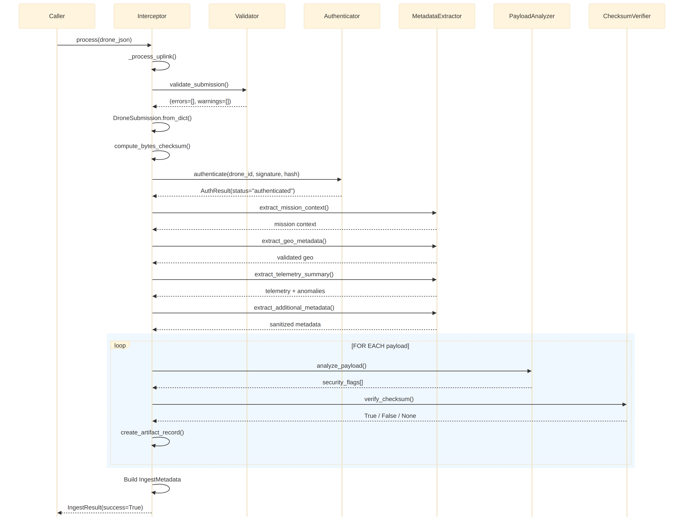

8.2 Authentication Flow (Detailed)
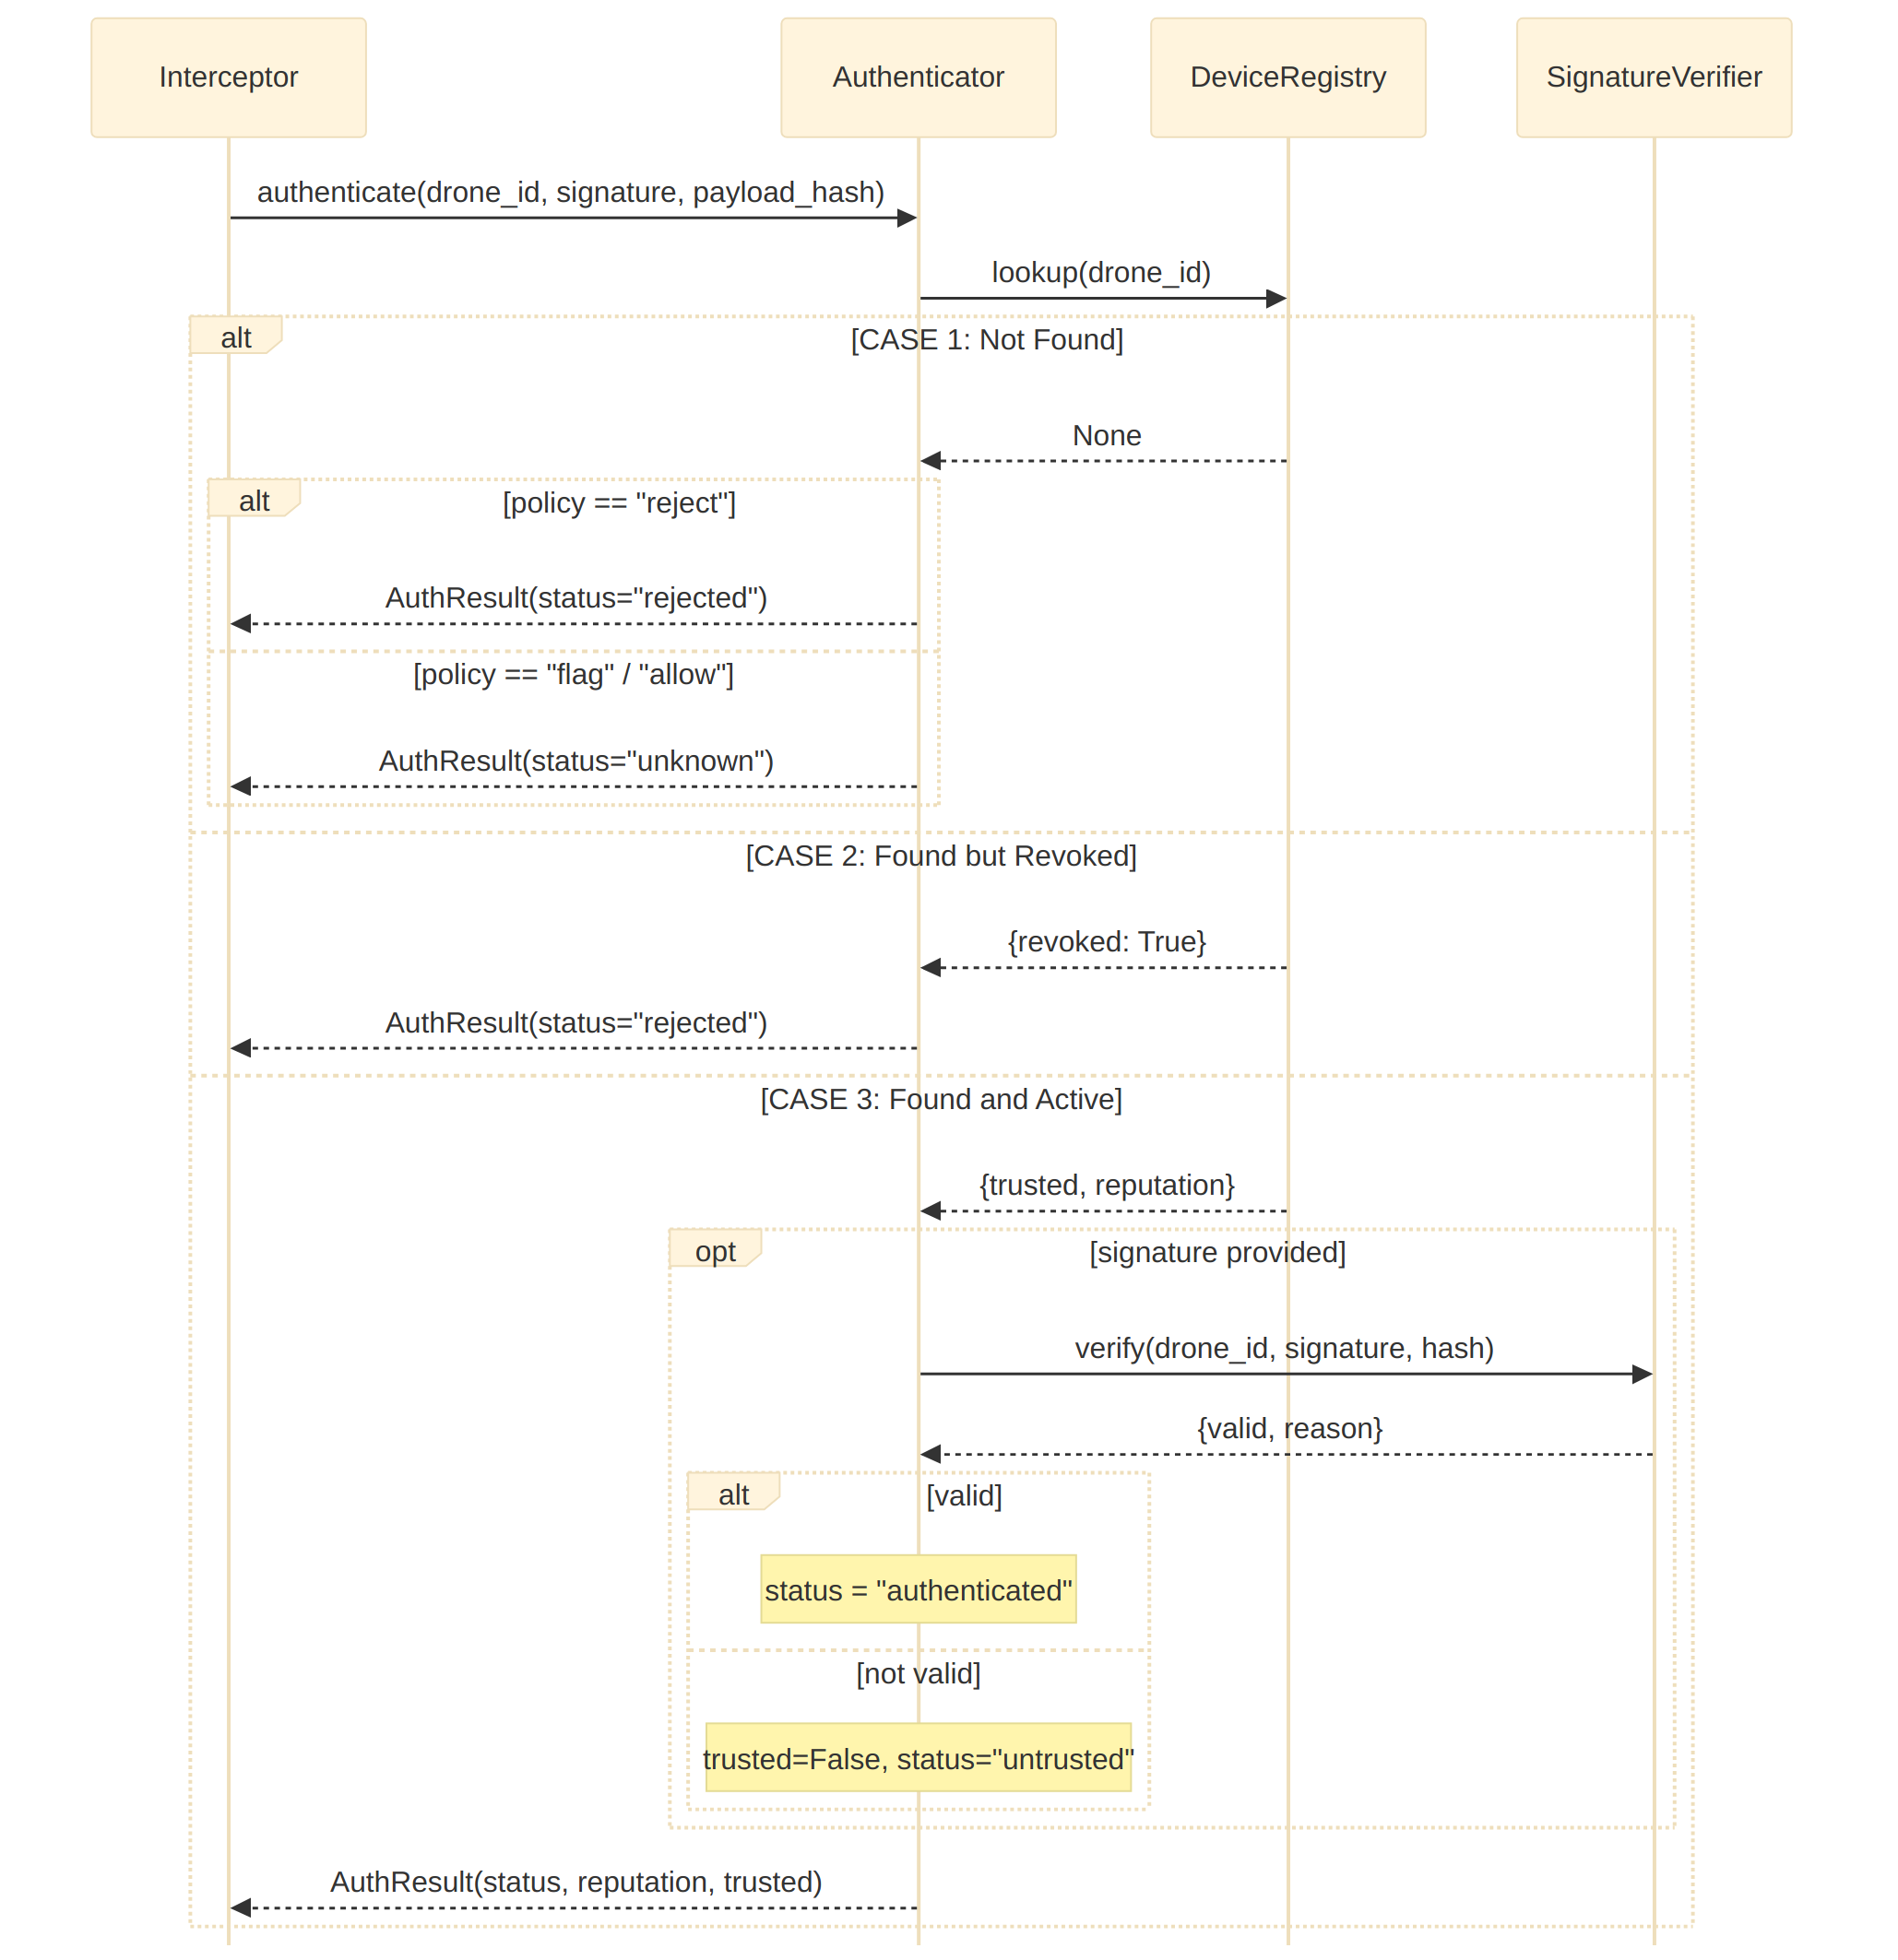

8.3 Uplink Command Flow
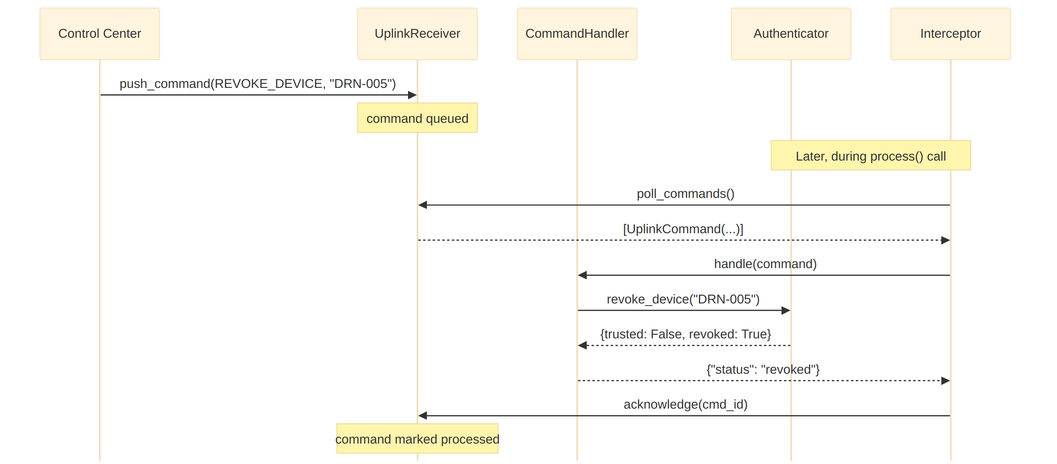

8.4 Stage 0 — Packet Reception & Reassembly Flow
The following sequence diagrams illustrate the wire-level Stage 0 lifecycle: the happy path of fragmenting, transmitting, verifying, and reassembling a submission via UDP, followed by the rejection and truncation paths that surface as PacketReceiverStats counters.
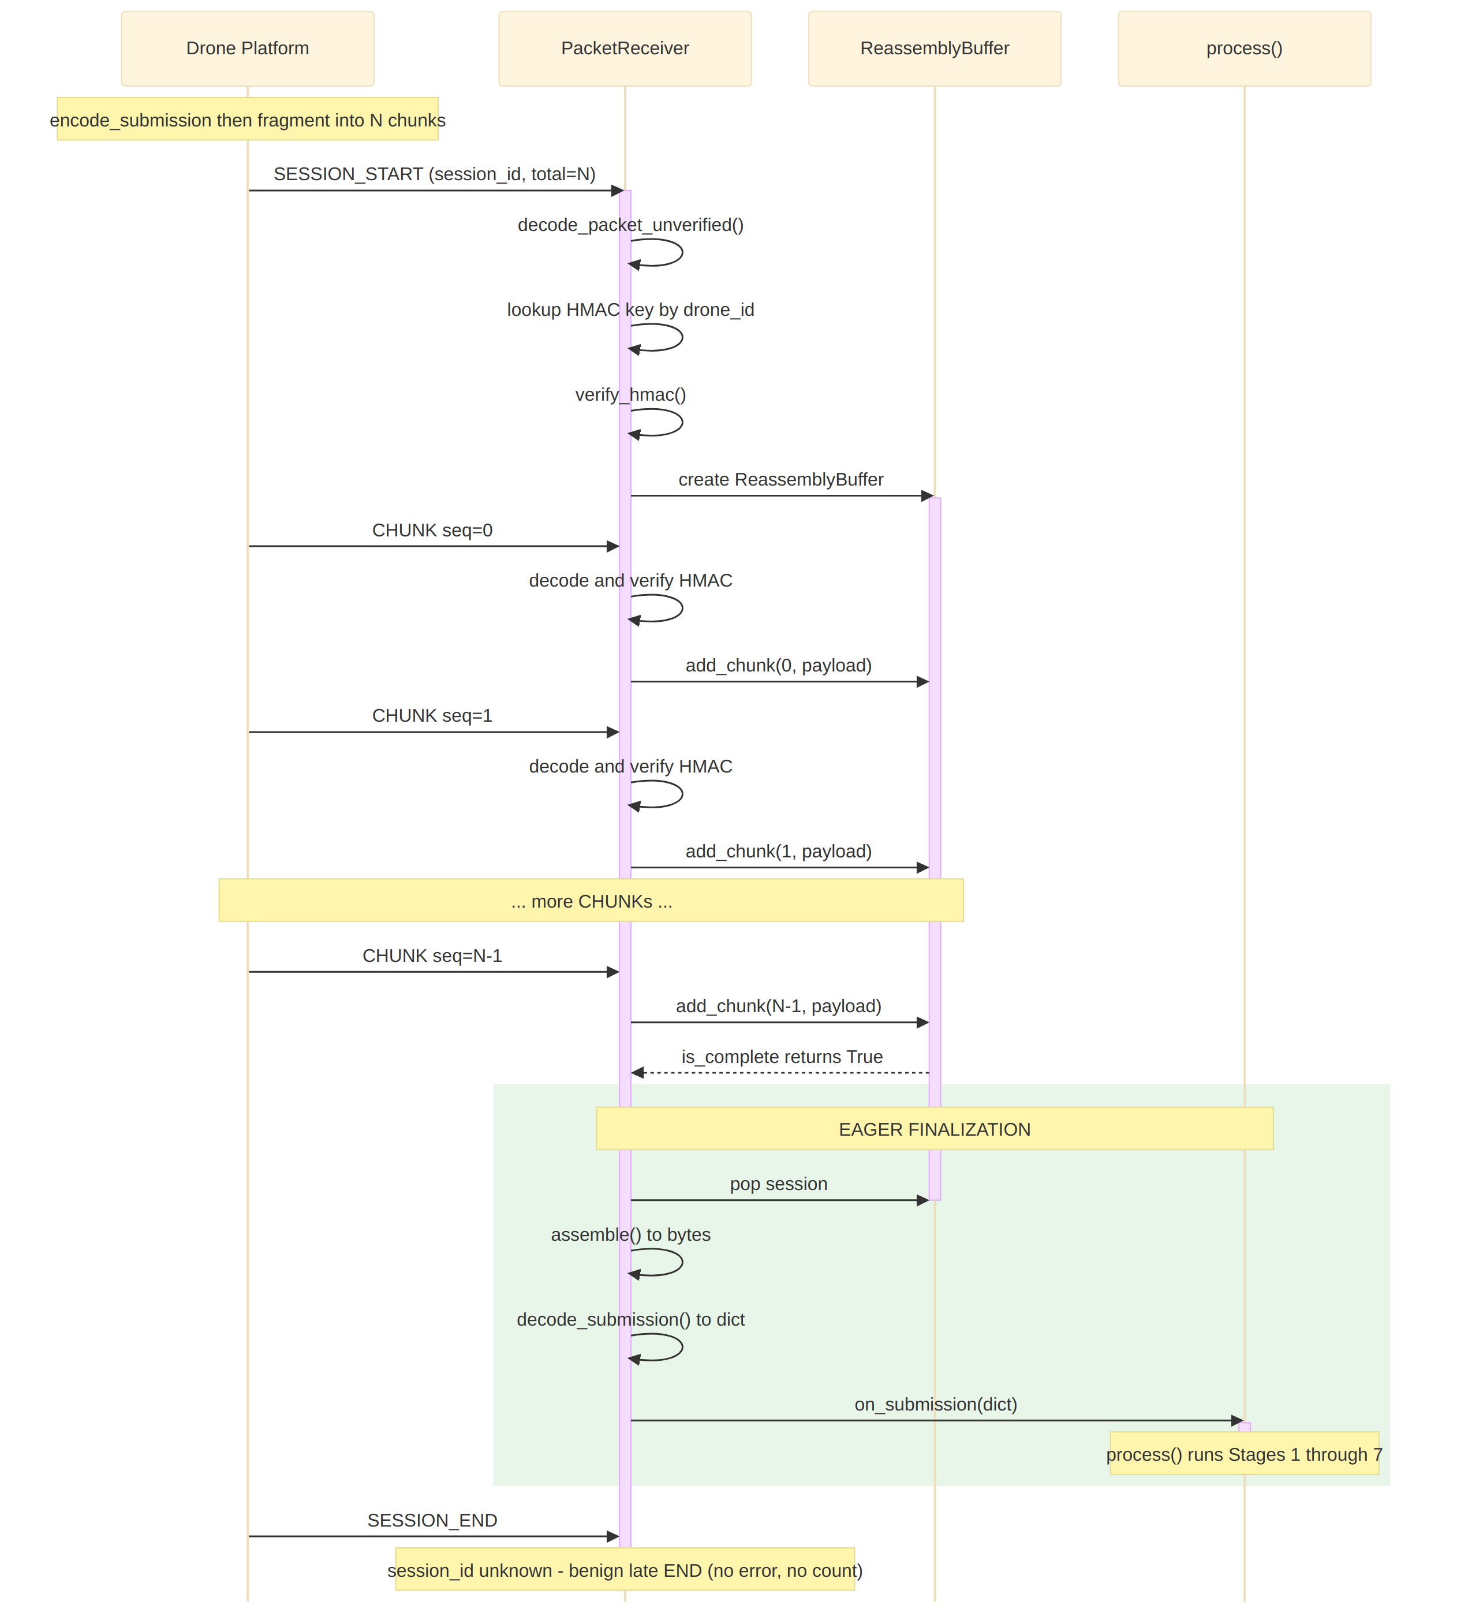
Rejection / truncation paths:
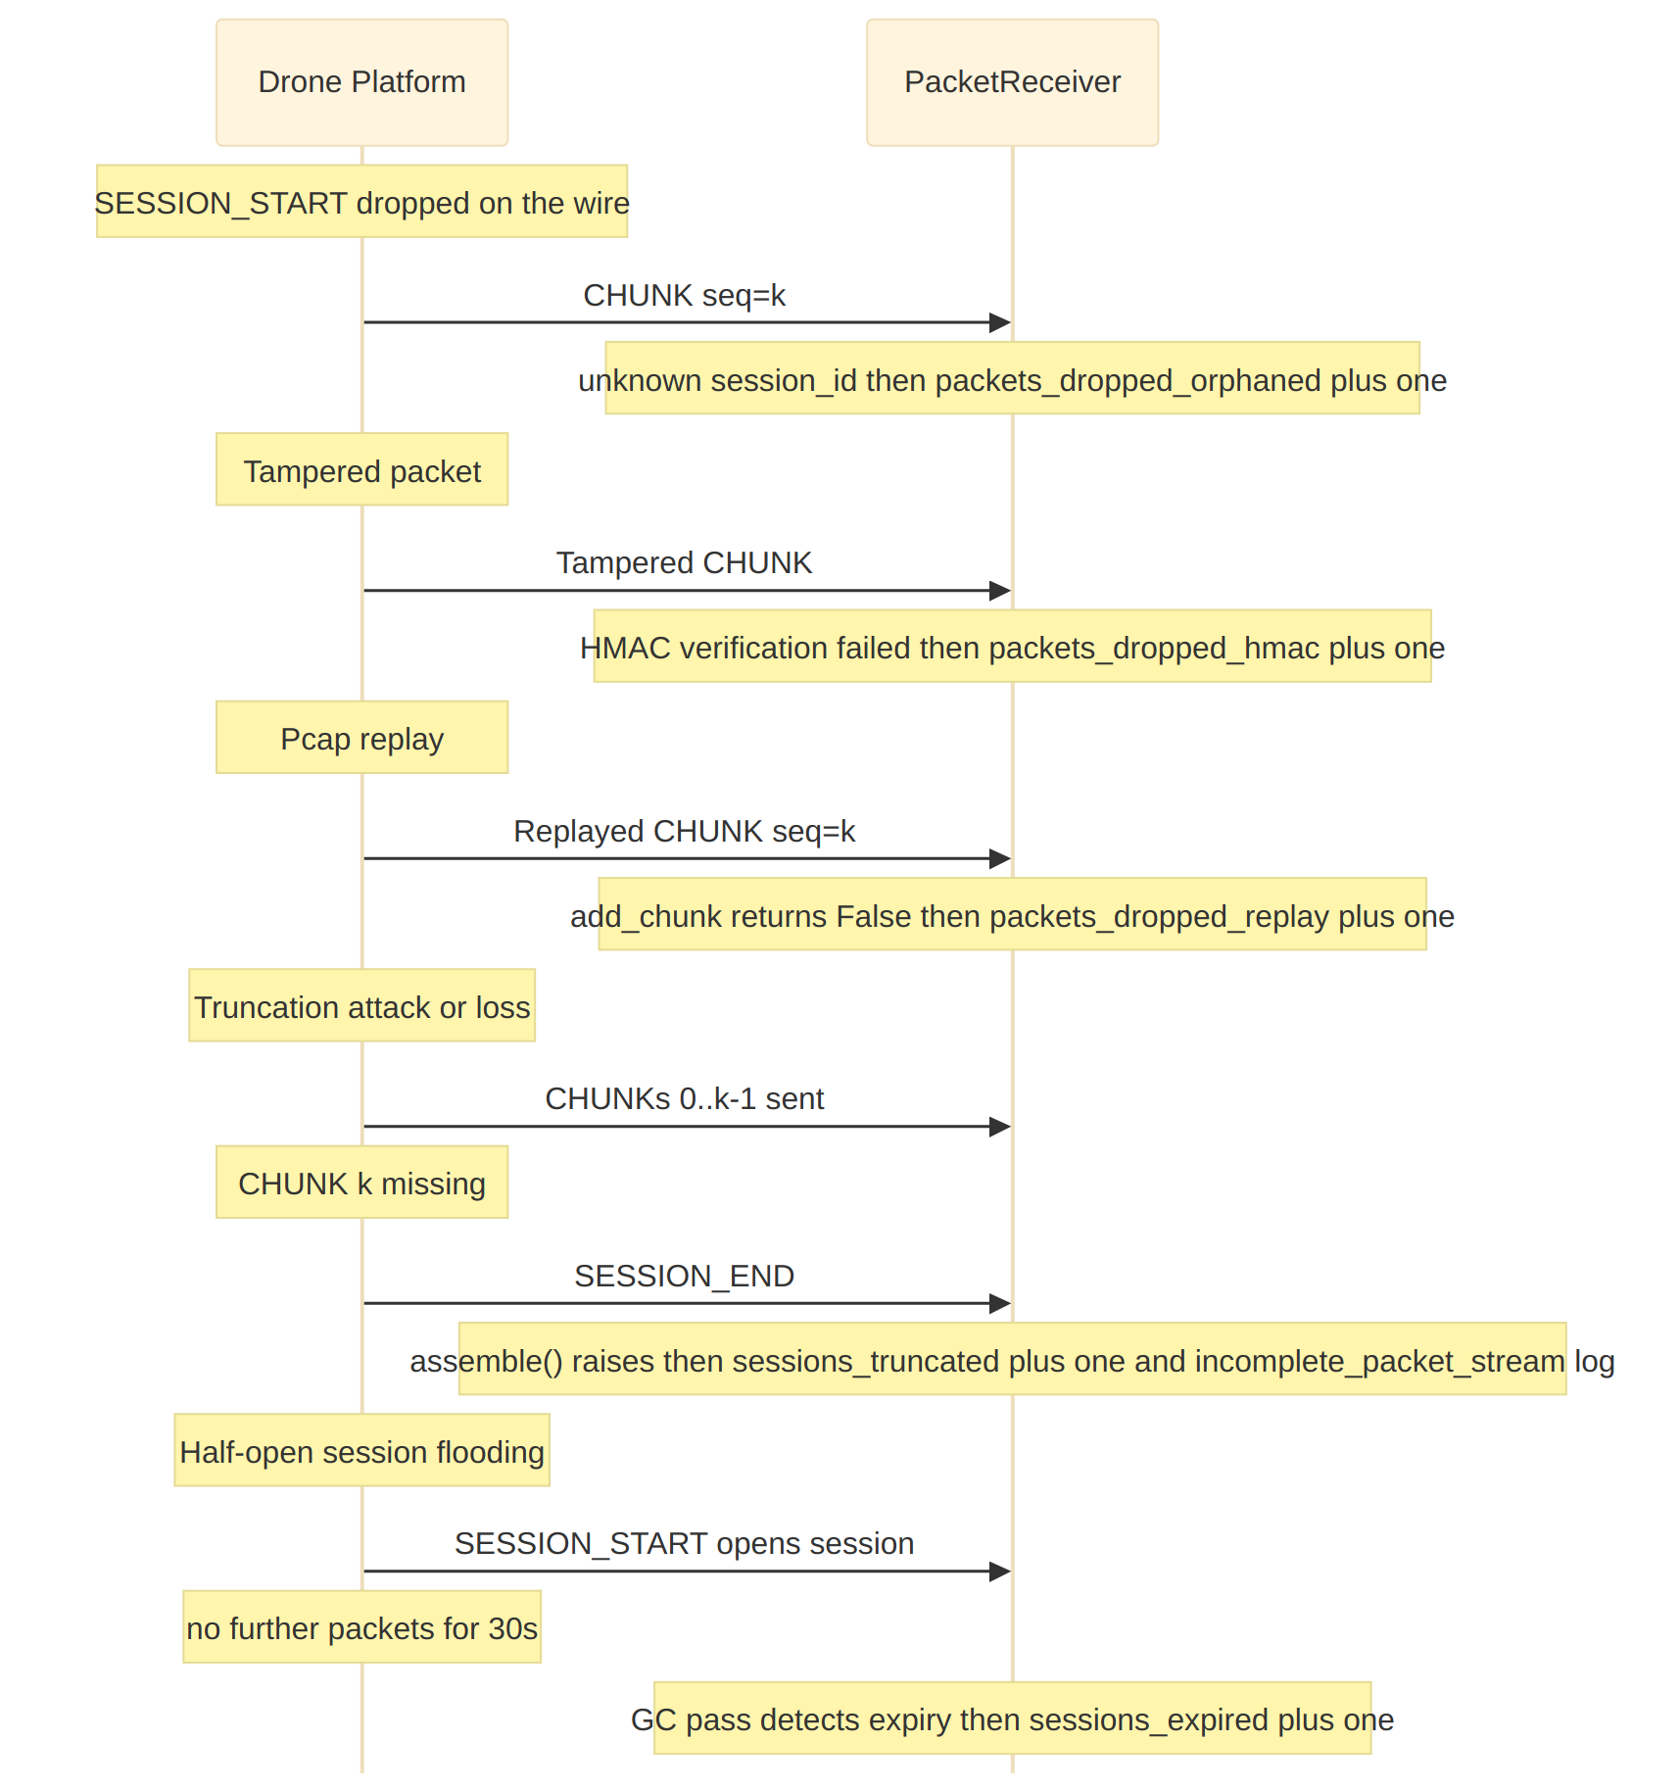

8.5 Rejection Flow (Validation Failure)
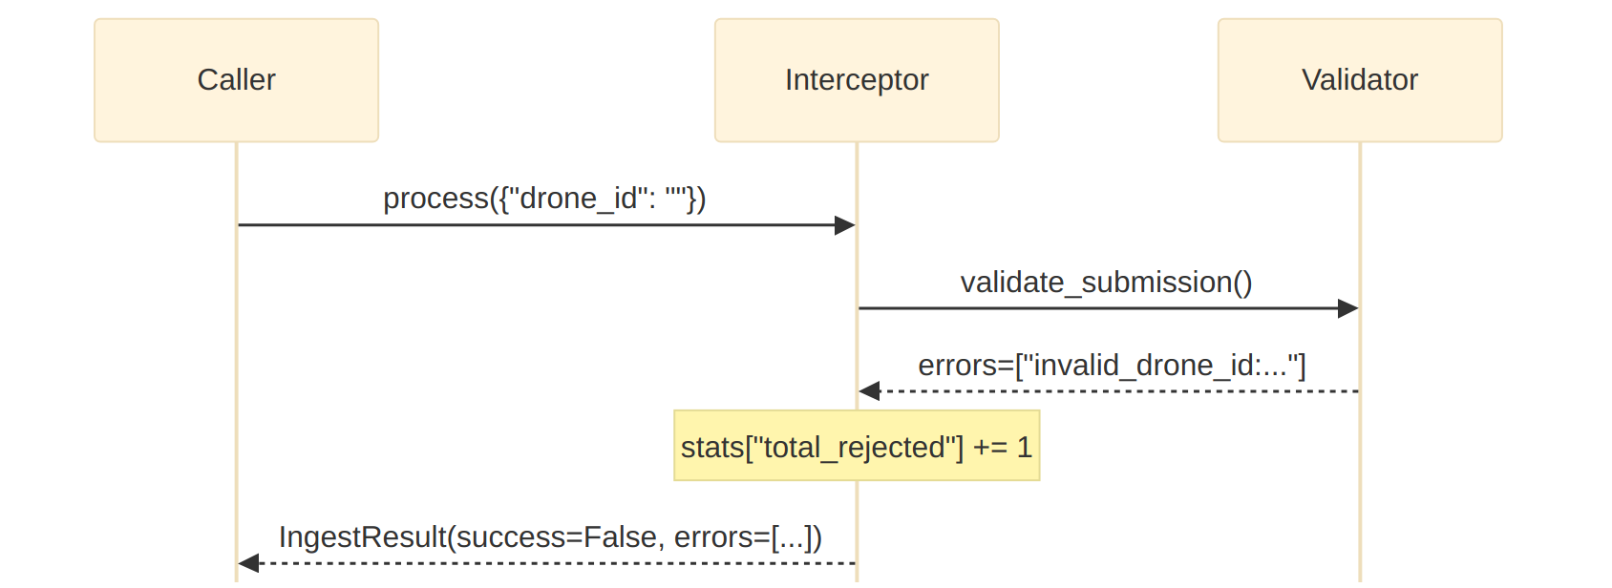

9. Input/Output Specification
This section documents the input formats accepted by the Ingestion Interceptor (the in-process JSON dict and the wire-level binary protocol used by Stage 0) along with the output IngestResult structure for the success, error, and flagged paths.

9.1 Input: Drone Submission JSON
Complete example with all fields:
{
"drone_id": "DRN-001",
"timestamp": "2025-10-13T03:00:12Z",
"mission_id": "MSN-142",
"mission_zone": "zone-a",
"geo": {
"lat": 12.971598,
"lon": 77.594566,
"alt": 120.0
},
"payloads": [
{
"type": "video",
"filename": "drn001_fpv_001.mp4",
"mime": "video/mp4",
"size_bytes": 4500000,
"encryption": false,
"container": false,
"checksum": "b5bb9d8014a0f9b1d61e21e796d78dccdf1352f23cd32812f4850b878ae4944c",
"uri": "file:/drone_remote_store/DRN-001/drn001_fpv_001.mp4"
},
{
"type": "image",
"filename": "drn001_ir_001.tiff",
"mime": "image/tiff",
"size_bytes": 2100000,
"encryption": false,
"container": false,
"checksum": "a3f2b8c1..."
}
],
"telemetry": {
"speed": 12.5,
"heading": 145.2,
"battery": 78.4,
"signal_strength": 92.0
},
"signature": "hmac-sha256:4a8c9f2b1d3e5f7a0b2c4d6e8f0a1b3c5d7e9f0a2b4c6d8e0f1a3b5c7d9e0f1",
"firmware_version": "v1.2.0",
"operator_id": "OP-12",
"additional_metadata": {
"camera_model": "CAM-X1000",
"flight_plan_id": "FP-2025-142",
"mission_sensitivity": "high"
}
}

Minimal valid submission:
{
"drone_id": "DRN-001",
"timestamp": "2025-10-13T03:00:12Z",
"payloads": [
{
"type": "image",
"filename": "test.jpg",
"mime": "image/jpeg",
"size_bytes": 50000
}
]
}

9.2 Output: IngestResult (Success Path)
{
"ingest_metadata": {
"ingest_id": "ingest_a1b2c3d4e5f6",
"drone_id": "DRN-001",
"timestamp": "2025-10-13T03:00:12Z",
"received_at": "2025-10-13T03:00:13.456789+00:00",
"mission_id": "MSN-142",
"mission_zone": "zone-a",
"geo": {
"lat": 12.971598,
"lon": 77.594566,
"alt": 120.0
},
"operator_id": "OP-12",
"firmware_version": "v1.2.0",
"num_files": 2,
"total_size_bytes": 6600000,
"insecure_flags": [],
"auth_result": "authenticated",
"auth_details": {
"status": "authenticated",
"drone_id": "DRN-001",
"trusted": true,
"reputation": 0.9
},
"reputation": 0.9,
"zone_risk": 0.6,
"notes": "normal feed",
"additional_metadata": {
"camera_model": "CAM-X1000",
"flight_plan_id": "FP-2025-142",
"mission_sensitivity": "high"
}
},
"artifact_records": [
{
"artifact_id": "artifact://a1b2c3d4e5f6a7b8",
"filename": "drn001_fpv_001.mp4",
"type": "video",
"mime": "video/mp4",
"size_bytes": 4500000,
"encryption": false,
"container": false,
"security_flags": [],
"checksum_verified": true,
"thumbnail": "thumb://c3d4e5f6a7b8",
"pointer_storage": "file:/drone_remote_store/DRN-001/drn001_fpv_001.mp4"
},
{
"artifact_id": "artifact://b2c3d4e5f6a7b8c9",
"filename": "drn001_ir_001.tiff",
"type": "image",
"mime": "image/tiff",
"size_bytes": 2100000,
"encryption": false,
"container": false,
"security_flags": [],
"checksum_verified": null,
"thumbnail": "thumb://d4e5f6a7b8c9",
"pointer_storage": "s3://forensics/artifacts/DRN-001//a1b2c3d4_drn001_ir_001.tiff"
}
],
"warnings": []
}

9.3 Output: IngestResult (Error Path)
{
"error": true,
"errors": [
"missing_field:drone_id",
"missing_field:timestamp"
],
"warnings": []
}

9.4 Output: IngestResult (Flagged Submission)
{
"ingest_metadata": {
"ingest_id": "ingest_f7e8d9c0b1a2",
"drone_id": "DRN-UNKNOWN",
"timestamp": "2025-10-13T04:15:00Z",
"received_at": "2025-10-13T04:15:01.123456+00:00",
"mission_id": null,
"mission_zone": null,
"geo": null,
"num_files": 1,
"total_size_bytes": 15000000,
"insecure_flags": [
"encrypted_payload",
"large_binary",
"nested_archive"
],
"auth_result": "unknown",
"reputation": null,
"zone_risk": null,
"notes": "device unknown; defer analysis: encrypted or nested contents; large binary - consider selective sampling"
},
"artifact_records": [
{
"artifact_id": "artifact://e8d9c0b1a2f3e4d5",
"filename": "bundle.zip",
"type": "archive",
"mime": "application/zip",
"size_bytes": 15000000,
"encryption": true,
"container": true,
"security_flags": [
"encrypted_payload",
"nested_archive",
"large_binary"
],
"checksum_verified": null,
"thumbnail": null,
"pointer_storage": "s3://forensics/artifacts/DRN-UNKNOWN/..."
}
],
"warnings": []
}

9.6 Stage 0 Wire Format
The following diagrams describe the binary wire format used by Stage 0: the packet framing (32-byte header, payload, HMAC tag) and the TLV-encoded submission envelope carried inside CHUNK packets.
When Stage 0 is enabled, drones submit data as a stream of UDP packets rather than a single JSON dict. Each packet is at most 1088 bytes:
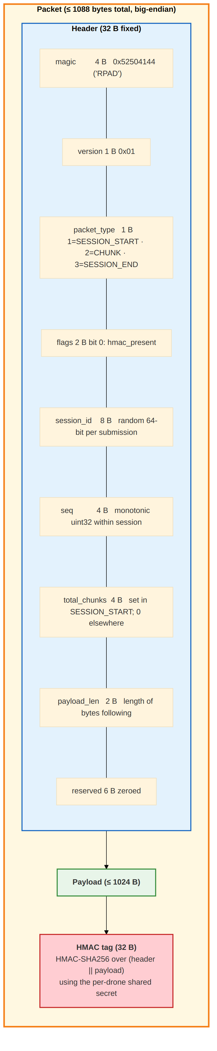
Per-submission packet sequence:
1. SESSION_START
seq=0, total_chunks=N
payload = drone_id (utf-8)
2. CHUNK seq=0
payload = first 1024 bytes of encode_submission(submission)
3. CHUNK seq=1
payload = next 1024 bytes
...
N+1. CHUNK seq=N-1
payload = final fragment
N+2. SESSION_END
seq=N, payload = b""

Application payload (the bytes inside CHUNK packets) is the binary TLV-encoded submission:
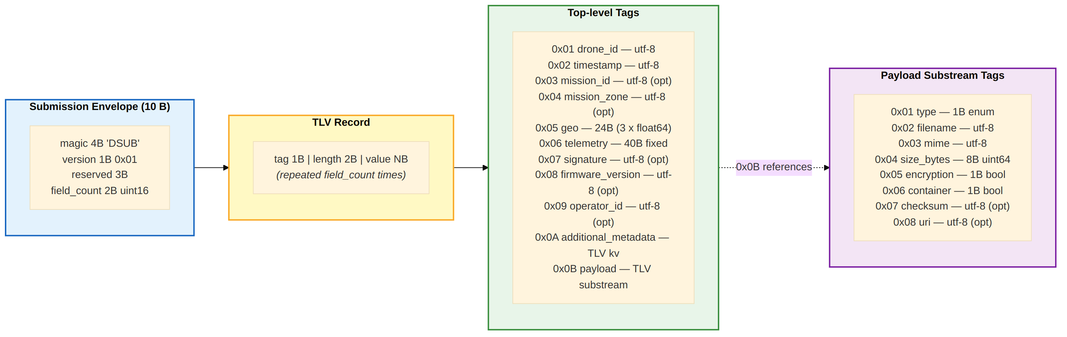
A typical drone submission with one image payload and full metadata serializes to ~250-300 bytes and fits in a single CHUNK (4 packets total including START and END).

9.5 Downstream Interface: Game-Theoretic Threat Estimator
The Game-Theoretic Threat Estimator consumes IngestResult and computes:
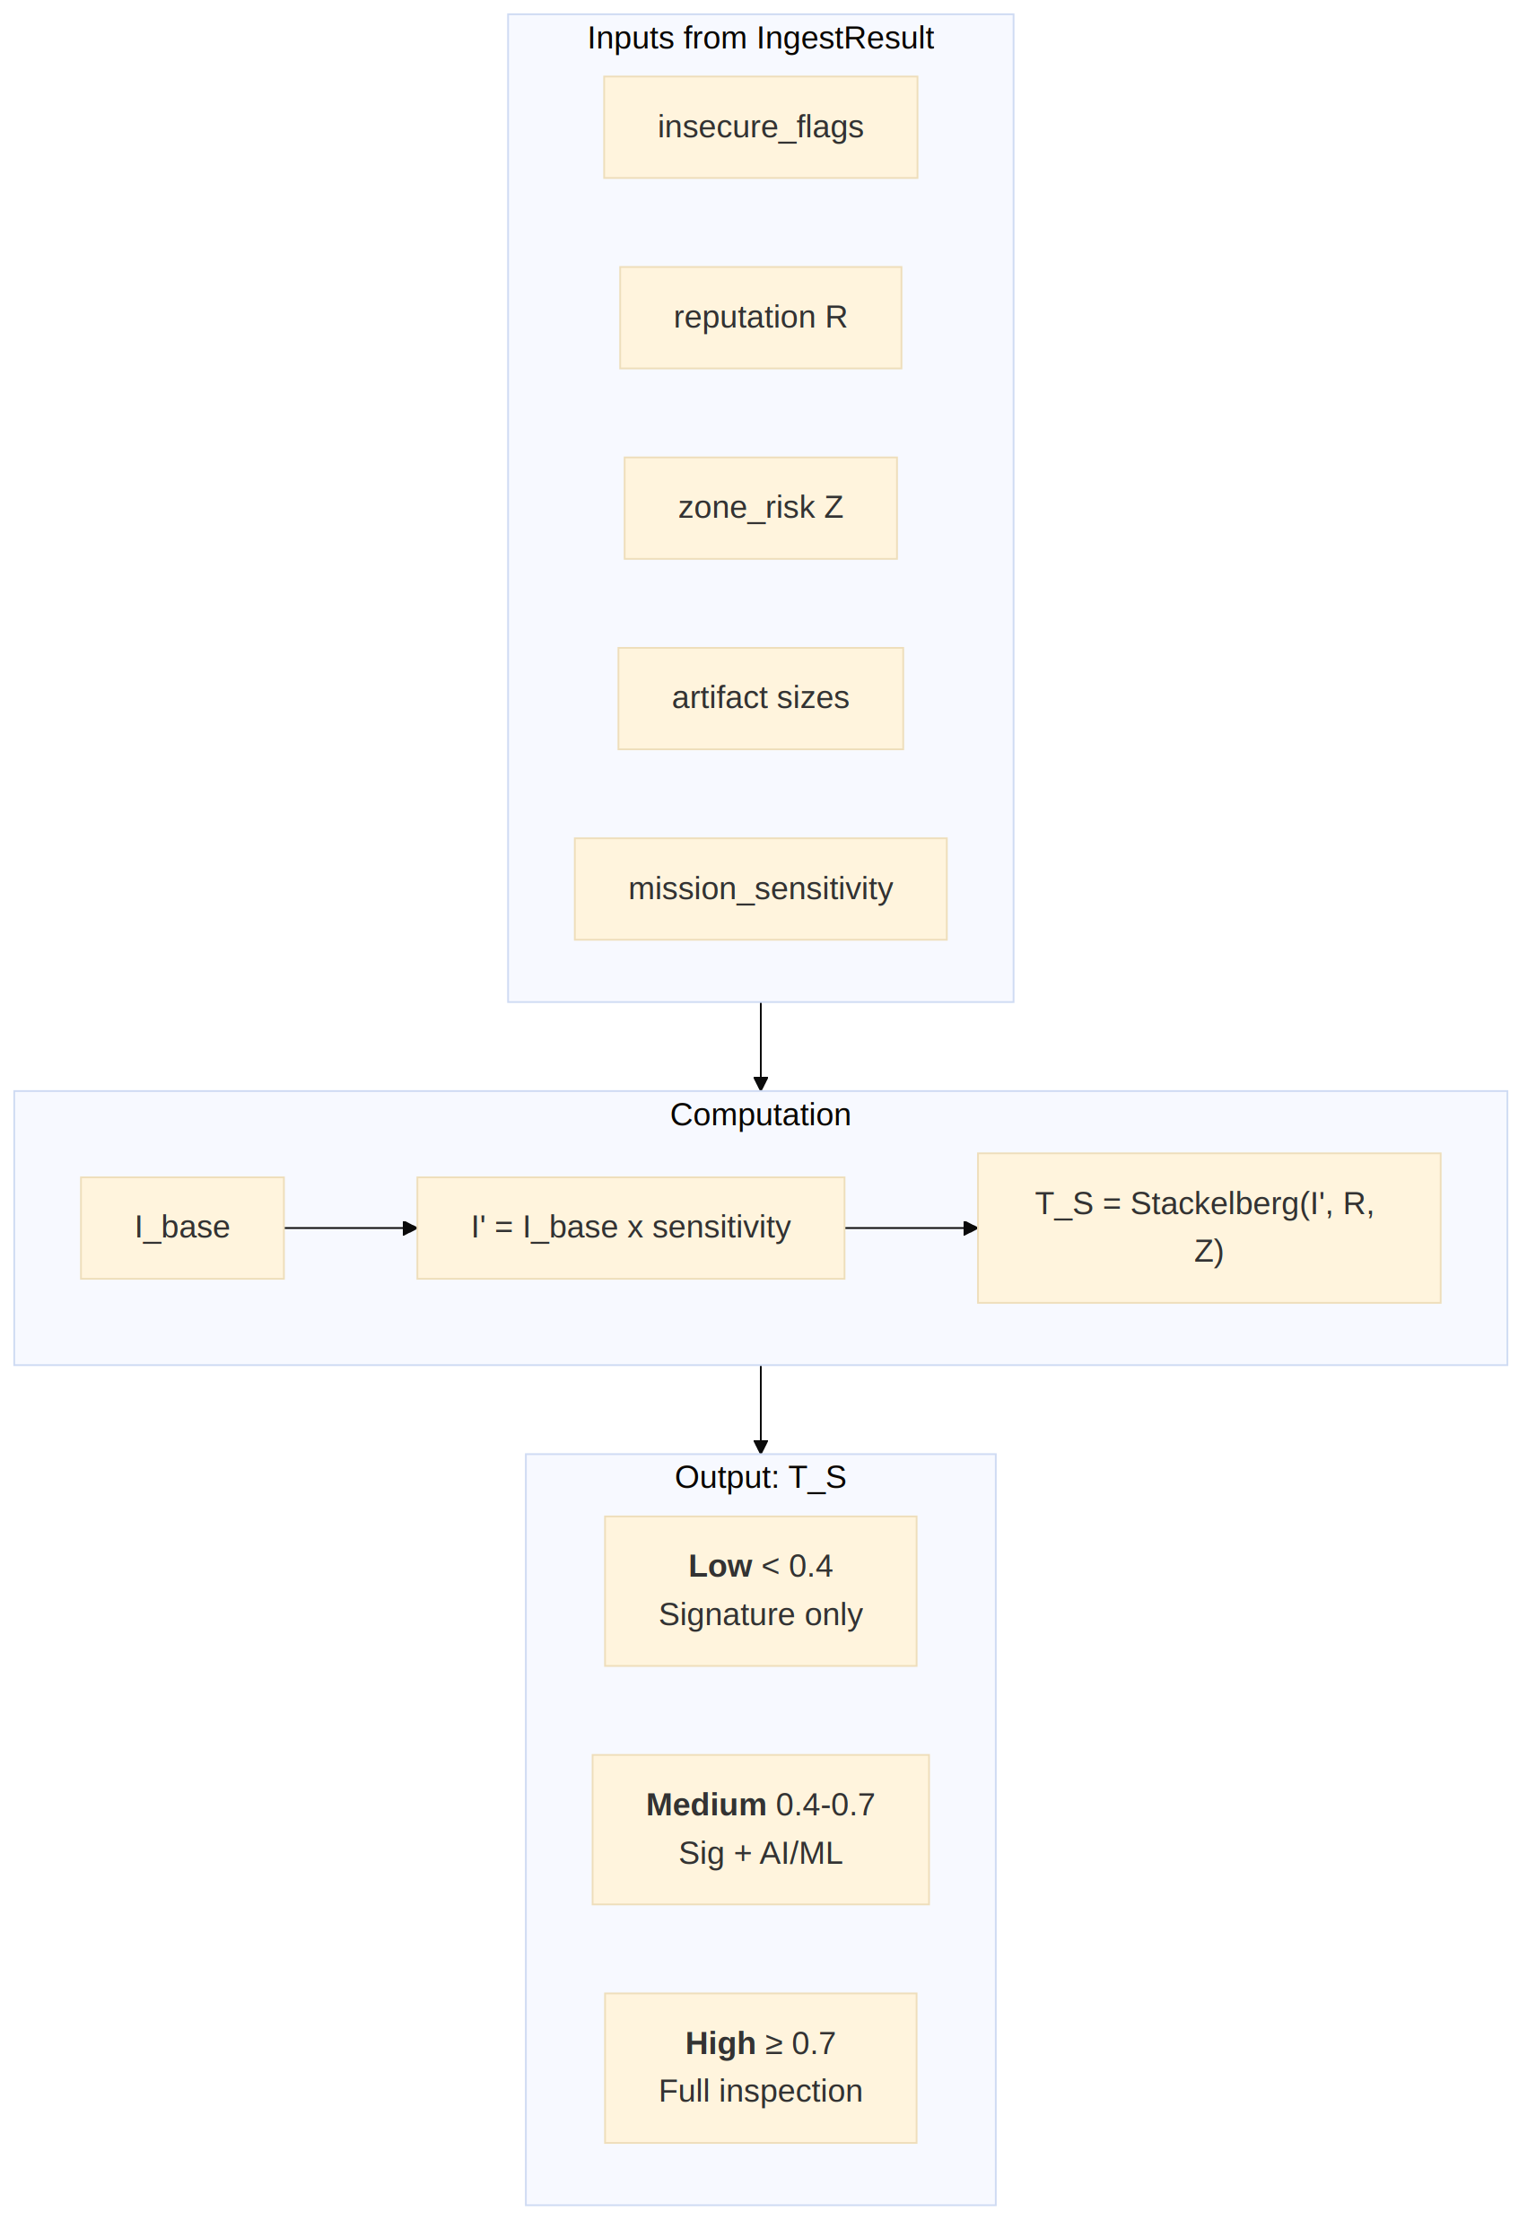

10. Security Considerations
This section documents the security defences implemented across all pipeline stages, including the new Stage 0 wire-layer defenses, mapping each defence mechanism to the specific threat it mitigates.

10.1 Input Validation Defences
Defence | Implementation | Threat Mitigated
Path traversal prevention | Reject filenames containing / or \ | Directory traversal, file overwrite attacks
Size limit enforcement | Configurable max_payload_size_bytes (default 500 MB) | Resource exhaustion, denial of service
Payload count limit | max_payloads_per_submission (default 50) | Batch flooding, memory exhaustion
Timestamp validation | ISO 8601 parsing, future-time warning | Replay attacks, timestamp spoofing
Required field enforcement | Fatal errors on missing drone_id, timestamp, payloads | Malformed input injection
MIME type whitelist | Configurable allowed_mime_types (warning on unknown) | Unexpected file type smuggling

10.2 Authentication Defences
Defence | Implementation | Threat Mitigated
Device registry verification | Lookup against known device database | Unauthorized device submissions
HMAC-SHA256 signatures | Cryptographic payload integrity + source authentication | Submission tampering, impersonation
Configurable unknown policy | reject / flag / allow for unregistered devices | Rogue drone injection
Device revocation | Uplink REVOKE_DEVICE command | Compromised device continued access
Trust downgrade on sig failure | Failed signature sets trusted=False | Forged signatures with known device IDs

10.3 Payload Security Analysis
Defence | Implementation | Threat Mitigated
Encrypted content detection | encryption flag check | Hidden malware in encrypted containers
Nested archive detection | container flag check | Archive bombs, recursive extraction attacks
Executable extension detection | Check against suspicious extension set | Direct executable file injection
Double extension detection | Multi-dot filename analysis | Extension spoofing (photo.jpg.exe)
MIME-extension mismatch | Cross-reference declared MIME vs file extension | MIME type spoofing
Hidden file detection | Unix dot-prefix check | Hidden malicious files
Zero-size file detection | Flag empty files for expected-content types | Placeholder / marker file attacks
Suspicious MIME detection | Check against known-dangerous MIME types | Executable MIME smuggling

10.4 Integrity Defences
Defence | Implementation | Threat Mitigated
SHA-256 checksum verification | Compare computed vs declared checksums | File tampering during transmission
Payload hash for auth | Hash entire submission for signature verification | Submission-level tampering
Streaming hash computation | 64 KB chunk-based file hashing | Memory exhaustion on large files

10.5 Metadata Defences
Defence | Implementation | Threat Mitigated
Prototype injection stripping | Remove __proto__, constructor, prototype, eval, exec | Prototype pollution, code injection
Value truncation | Cap string values at 10,000 characters | Payload injection via metadata fields
Geolocation sanity bounds | Reject lat/lon/alt outside physical ranges | Spoofed location data
Telemetry anomaly detection | Flag impossible values (negative speed, >100% battery) | Compromised drone telemetry

10.6 Stage 0 — Wire-layer Defenses
Defence | Implementation | Threat Mitigated
Magic-byte verification | Reject packets without 0x52504144 ("RPAD") header | Random scanner traffic, protocol confusion
Version check | Reject packets whose version byte is not the codec version | Protocol downgrade attack indicators
Per-packet HMAC-SHA256 | Constant-time HMAC verify against per-drone shared secret | Wire tampering, MITM injection
Per-session monotonic sequence | Reject duplicate seq within an active session | Pcap replay attacks
Reassembly timeout (30s default) | Periodic janitor drops half-open sessions | Slow-loris-style memory exhaustion, half-open flooding
Max chunks per session (256) | SESSION_START with total_chunks over the cap is dropped | Memory exhaustion via bloated session declaration
Max concurrent sessions per drone (100) | Reject SESSION_START when the per-drone count exceeds the cap | Session flooding
Max payload_len per packet (1024) | Reject packets whose declared payload length exceeds limit | Header lying about chunk size, oversized buffers
Sequence-gap detection | assemble() raises if any expected seq is missing | Truncation attacks; benign packet loss surfaced as event
Decode failure isolation | Malformed reassembled bytes counted, never escape callback | Corrupted/intentionally malformed submissions
Orphaned-packet classification | CHUNK without a known session counted separately | Distinguishes benign packet loss from session-id guessing

10.7 Operational Security
Defence | Implementation | Threat Mitigated
Uplink command authentication | Command queue with ID-based acknowledgement | Unauthorized command injection
Dynamic zone risk updates | Real-time risk level adjustment from control center | Evolving threat landscape
Quarantine support | Ingest-level quarantine via uplink commands | Contain suspicious submissions
Structured logging | All processing events logged with context | Forensic investigation, audit trail

10.8 Production Hardening Recommendations
The following measures are not yet implemented but are essential for production field deployment:
Area | Recommendation | Priority
Key management | Store all HMAC shared secrets and signing keys in HashiCorp Vault or a hardware HSM; rotate keys on a 90-day cycle | Critical
mTLS for uplink | Require mutual TLS between the edge node and the control center for uplink commands; reject unsigned commands | Critical
Rate limiting | Enforce a configurable token-bucket rate limiter per drone_id (e.g., 10 submissions/min); excess submissions are queued or rejected with backpressure | High
Graceful shutdown | On SIGTERM, finish the in-flight submission, flush pending stats to Prometheus, persist the quarantine set, and close the Stage 0 UDP socket cleanly | High
Health-check endpoint | Expose an HTTP /healthz endpoint returning pipeline state (up/degraded/down), device registry size, and uplink connectivity status; used by systemd/K3s liveness probes | High
State persistence | All mutable runtime state (device registry, quarantine set, zone risk map) must be persisted to SQLite or Redis so that no security-critical data is lost on process restart | Critical
Log retention and rotation | Ship structured JSON logs to Grafana Loki or ELK; retain at minimum 90 days for forensic audit; rotate local log files at 100 MB | Medium
Backup and recovery | Daily automated backup of the device registry and quarantine database; tested restore procedure documented in the runbook | Medium
Resource limits | Set ulimit -n (open files), memory cgroup limits, and CPU quotas; prevents a bug or attack from exhausting the edge node | Medium
Firmware allowlisting | Maintain a whitelist of approved firmware_version values; flag or reject submissions from drones running unrecognized firmware | Medium

11. Configuration Reference
This section provides the complete reference for all tuneable parameters in the InterceptorConfig dataclass, organized by functional area with defaults and descriptions.

11.1 Full InterceptorConfig Parameter Table
Parameter | Type | Default | Description
Validation
require_signature | bool | False | Reject submissions without cryptographic signatures
max_payload_size_bytes | int | 500_000_000 (500 MB) | Hard cap per individual payload file
max_payloads_per_submission | int | 50 | Maximum number of payload files per submission
allowed_mime_types | set | See 11.2 | Whitelist of acceptable MIME types (warning on mismatch)
Security Thresholds
large_binary_threshold | int | 10_000_000 (10 MB) | Size threshold for large_binary security flag
suspicious_mime_types | set | See 11.3 | MIME types that trigger suspicious_mime flag
suspicious_extensions | set | See 11.4 | File extensions that trigger executable_file flag
Authentication
auth_backend | str | "registry" | Authentication backend: registry, jwt, mtls
auth_timeout_seconds | float | 5.0 | Timeout for authentication operations
unknown_device_policy | str | "flag" | Policy for unregistered devices: flag, reject, allow
Checksum
checksum_algorithm | str | "sha256" | Hash algorithm: sha256, sha1, sha512, md5
verify_checksums | bool | True | Whether to verify file checksums when files are accessible
Storage
storage_backend | str | "filesystem" | Storage backend: filesystem, s3, minio
storage_base_path | str | "drone_remote_store" | Base path for filesystem storage
artifact_uri_prefix | str | "s3://forensics/artifacts" | URI prefix for S3/MinIO storage pointers
Zone Risk
default_zone_risk | float | 0.5 | Default zone risk when zone is not in the lookup table
Logging
log_level | str | "INFO" | Python logging level: DEBUG, INFO, WARNING, ERROR
structured_logging | bool | True | Enable structured (JSON-friendly) log format
Uplink
uplink_enabled | bool | False | Enable uplink command receiver
uplink_endpoint | str | "" | Endpoint URL for uplink communication (gRPC/MQTT)
uplink_poll_interval_seconds | float | 10.0 | Polling interval for file-based uplink mode
Stage 0: Packet Listener
packet_listener_host | str | "0.0.0.0" | UDP bind host
packet_listener_port | int | 5005 | UDP bind port (use 0 for OS-assigned ephemeral)
packet_max_session_chunks | int | 256 | Bound on total_chunks in SESSION_START (memory cap)
packet_max_concurrent_sessions | int | 100 | Per-drone concurrent session cap (DoS bound)
packet_session_timeout_seconds | float | 30.0 | Reassembly timeout; expired sessions are GC'd
packet_hmac_required | bool | True | Reject packets without a valid HMAC tag
packet_replay_window_seconds | float | 60.0 | Reserved for future cross-session replay protection

11.2 Default Allowed MIME Types
video/mp4, video/x-matroska, video/avi,
image/jpeg, image/png, image/tiff, image/bmp,
application/json, text/plain, text/csv,
application/zip, application/x-tar, application/gzip,
application/octet-stream

11.3 Default Suspicious MIME Types
application/x-msdownload, application/x-executable,
application/x-dosexec, application/octet-stream

11.4 Default Suspicious Extensions
exe, dll, bat, cmd, ps1, sh, vbs, js, msi, scr, com

12. Requirements

12.1 Functional Requirements
ID | Requirement | BEL Ref | Status
FR-1 | Authenticate source devices using metadata (timestamps, drone ID, geolocation) | 4.2.1 | Implemented
FR-2 | Validate data format, structure, and integrity of all incoming submissions | 4.2.2 | Implemented
FR-3 | Extract and record metadata: drone ID, mission zone, timestamps, encryption status | 4.2.3 | Implemented
FR-4 | Identify ZIP/encrypted file types and flag for deferred analysis | 4.2.4 | Implemented
FR-5 | Act as a secure data funnel preventing uncontrolled input into analysis pipeline | 4.2.5 | Implemented
FR-6 | Support secure uplink from control center: quarantine commands | 4.2.6 | Implemented
FR-7 | Support dynamic parameter adjustment via uplink | 4.2.6 | Implemented
FR-8 | Support live feedback loop between dashboard and edge | 4.2.6 | Implemented
FR-9 | Produce structured output compatible with Game-Theoretic Threat Estimator | 5.1 | Implemented
FR-10 | Support device revocation to immediately block compromised drones | 6.3 | Implemented
FR-11 | Support zone risk updates for dynamic threat landscape adaptation | 6.3 | Implemented
FR-12 | Generate unique artifact identifiers for traceability across the pipeline | 5.1 | Implemented
FR-13 | Verify file integrity through cryptographic checksums | 4.2.2 | Implemented
FR-14 | Detect MIME-extension mismatches as a spoofing indicator | 4.2.4 | Implemented
FR-15 | Detect double-extension filenames as an evasion indicator | 4.2.4 | Implemented
FR-16 | Enforce configurable size limits per payload file | 4.2.5 | Implemented
FR-17 | Enforce configurable payload count limits per submission | 4.2.5 | Implemented
FR-18 | Pre-sanitize metadata to strip prototype injection vectors | 4.2.3 | Implemented
FR-19 | Detect telemetry anomalies (negative speed, invalid battery, etc.) | 4.2.1 | Implemented
FR-20 | Support batch processing of multiple submissions | 5.1 | Implemented
FR-21 | Receive wire-level UDP packets from drone platforms (Stage 0) | 4.2.5 | Implemented
FR-22 | Verify per-packet HMAC-SHA256 against the per-drone shared key | 4.2.1 | Implemented
FR-23 | Reassemble fragmented submissions and decode the binary TLV payload | 4.2.2 | Implemented
FR-24 | Detect packet replay via per-session monotonic sequence numbers | 4.2.5 | Implemented
FR-25 | Bound memory and concurrency: max chunks/session, max sessions/drone, session timeout | 4.2.5 | Implemented

12.2 Non-Functional Requirements
ID | Requirement | Status
NFR-1 | Module must be stateless per-request (state only in registry and uplink handler) | Implemented
NFR-2 | All configuration must be centralized in a single config object | Implemented
NFR-3 | All data models must use typed dataclasses with serialization support | Implemented
NFR-4 | Checksum computation must use streaming (chunked) reads, not full-file memory load | Implemented
NFR-5 | All security-relevant events must be logged with structured context | Implemented
NFR-6 | Module must have zero external dependencies beyond Python 3.9 standard library | Implemented
NFR-7 | Module must support both class-based and functional API entry points | Implemented
NFR-8 | Authentication backend must be pluggable (registry, JWT, mTLS) | Partial
NFR-9 | Uplink receiver must support pluggable transport (memory, file, gRPC, MQTT) | Partial
NFR-10 | All public functions must have docstrings with clear parameter/return documentation | Implemented

13. Performance Requirements

13.1 Throughput Targets
Metric | Target | Rationale
Single submission latency | < 50 ms (without I/O) | Edge processing must not bottleneck the pipeline
Per-payload analysis latency | < 5 ms per payload | Heuristic checks are CPU-bound, not I/O-bound
Batch throughput | 100+ submissions/second | Supports multi-drone concurrent operations
Checksum verification | Bounded by disk I/O | Streaming 64 KB chunks; no full-file memory load
Memory per submission | < 10 MB overhead | Metadata-only processing; no payload content loaded

13.2 Scalability Considerations
Aspect | Current (Dev/Demo) | Production Recommendation | Rationale
Concurrency | Sequential processing | asyncio / thread pool for I/O-bound ops | Checksum I/O and network uplink must not block pipeline
Device registry | In-memory dict or JSON file | SQLite (edge) / PostgreSQL (centralized) | ACID persistence; survives restarts; shared across nodes
Uplink transport | Memory queue or file polling | MQTT 5.0 over TLS or gRPC bidirectional | At-least-once delivery; connection health monitoring
Artifact storage | Local filesystem (drone_remote_store/) | MinIO (edge S3) with cloud S3 replication | Versioning, pre-signed URLs, erasure coding
Checksum verification | Local file access only | MinIO S3 API + ETag / content-hash header | Avoid direct filesystem reads in object-store world
Zone risk / quarantine | In-memory dict / set | Redis (sub-ms reads, persistence via AOF) | Must survive restarts; shared state across processes
HMAC key material | In-memory dict | HashiCorp Vault or hardware HSM | Keys must never reside unencrypted on disk
Processing stats | In-memory counters | Prometheus exporter + Grafana dashboards | Historical trending, alerting, SLA monitoring
Audit logs | Python logging to stdout | Structured JSON logs → ELK stack or Loki | Centralized search, retention policies, forensics
Rate limiting | None | Token-bucket per drone_id (Redis-backed) | Prevent single drone from flooding the pipeline

13.3 Resource Bounds
Resource | Bound
CPU | O(n) per submission where n = number of payloads
Memory | O(n) for artifact records; constant per validation/auth step
Disk I/O | Only for checksum verification (optional) and file-based uplink
Network | None in current implementation; future gRPC/MQTT for uplink

14. Dependencies

14.1 Runtime Dependencies
Dependency | Version | Source | Purpose
Python | >= 3.9 | Standard | Runtime environment
dataclasses | built-in | Standard Library | Typed data model definitions
hashlib | built-in | Standard Library | SHA-256, SHA-1, SHA-512, MD5 hash computation
hmac | built-in | Standard Library | HMAC-SHA256 signature & per-packet verification
json | built-in | Standard Library | In-process serialization (legacy entry point only)
uuid | built-in | Standard Library | Unique identifier generation
logging | built-in | Standard Library | Structured event logging
datetime | built-in | Standard Library | Timestamp parsing and generation
os | built-in | Standard Library | File path resolution
time | built-in | Standard Library | Performance timing, GC scheduling, command timestamps
enum | built-in | Standard Library | CommandType / PacketType enumerations
socket | built-in | Standard Library | Stage 0: UDP packet listener
struct | built-in | Standard Library | Stage 0: binary packet header pack/unpack
threading | built-in | Standard Library | Stage 0: daemon listener thread + sessions lock

The module has zero external dependencies. All functionality is implemented using the Python standard library only.

14.2 Development Dependencies
Dependency | Version | Purpose
unittest | built-in | Test framework (78 unit tests in this package)
pytest | >= 7.0 | Alternative test runner (optional)

14.3 Downstream Module Dependencies
Module | Depends On From This Module
Game-Theoretic Threat Estimator | IngestResult, IngestMetadata, ArtifactRecord
Metadata Sanitizer | ArtifactRecord.pointer_storage for file access
Security Dashboard | IngestResult.to_dict() for display
Response & Quarantine Manager | IngestMetadata.insecure_flags, auth_result

15. Testing Strategy

15.1 Test Suite Overview
The test suite contains 78 unit tests in the ingestion_interceptor package across 4 test files (32 in test_interceptor.py for the legacy 7-stage pipeline + 13 in test_packet_codec.py + 14 in test_submission_codec.py + 19 in test_packet_receiver.py for Stage 0). A separate 38 unit tests live in drone/tests/ covering the drone simulator and the wire-side packet transmitter — together the project exercises 116 tests before any code change ships.
Locations:
- ingestion_interceptor/tests/test_interceptor.py
- ingestion_interceptor/tests/test_packet_codec.py
- ingestion_interceptor/tests/test_submission_codec.py
- ingestion_interceptor/tests/test_packet_receiver.py
Execution:
python -m unittest discover -s ingestion_interceptor/tests -v
python -m pytest ingestion_interceptor/tests/ -v

15.2 Test Classes and Coverage
Test Class | Tests | Coverage Area
TestValidator | 8 | Structure validation, missing fields, path traversal, size limits, timestamps, signature enforcement
TestPayloadAnalyzer | 8 | All 9 security flags, risk scoring (clean, critical), MIME mismatch, double extension
TestAuthenticator | 5 | Trusted/untrusted/unknown/rejected/revoked device states, policy enforcement
TestInterceptorPipeline | 6 | End-to-end processing (normal, suspicious, invalid), functional API, stats, telemetry-anomaly flags
TestUplink | 2 | Command push/poll cycle, acknowledgement and deduplication
TestChecksumVerifier | 3 | Bytes checksum computation, file URI resolution, S3 URI handling
TestPacketCodec | 13 | Header round-trip, oversize/empty-key rejection, bad magic, unsupported version, truncated payload, payload-len lying, HMAC mismatch, wrong-key
TestSubmissionCodec | 14 | Full + minimal round-trip, geo, telemetry, payloads, additional_metadata coercion, missing fields, bad magic, truncated TLV, unicode
TestReassemblyBuffer | 6 | In-order, out-of-order, duplicate, missing-chunk, expiration
TestPacketReceiverEndToEnd | 12 | Real-UDP reassembly, replay drop, HMAC mismatch, unknown drone, orphaned packets, two concurrent drones, max chunks, late SESSION_END, duplicate SESSION_START rejection, periodic GC under traffic
TestInterceptorPacketIntegration | 1 | Drone-to-interceptor wire path via start_packet_listener

15.3 Test Data Strategy
All tests use the _make_sample() factory function that produces a minimal valid drone submission. Tests apply targeted overrides to test specific conditions without duplicating boilerplate. This ensures tests remain focused and maintainable as the schema evolves.

15.4 Testing Gaps and Future Coverage
Area | Current State | Planned
HMAC signature verification | Covered at the wire layer (TestPacketCodec); the application-level signature path is still unit-tested only via authenticator tests | Add an explicit application-signature roundtrip test
File-based checksum verification | Not tested (no fixture files) | Add fixture files or mock I/O
File-based uplink receiver | Not tested | Add JSON file fixtures
Telemetry anomaly detection | Covered (test_telemetry_anomalies_become_security_flags) | —
Geolocation boundary validation | Implicitly tested | Add explicit out-of-range tests
Metadata pre-sanitization | Implicitly tested | Add prototype injection test
Concurrent batch processing | Not tested | Add thread safety tests
Configuration edge cases | Partial | Add tests for extreme config values
Stage 0 packet replay | Covered (test_replay_protection_drops_duplicate_chunk) | —
Stage 0 truncation | Covered (test_missing_chunk_triggers_truncation_on_session_end) | —
Stage 0 GC under load | Covered (test_periodic_gc_runs_under_continuous_traffic) | —
Stage 0 session-id collision | Covered by lookup-by-scan implementation; explicit dedup test planned | Add a test forcing two drones to use the same session_id

16. Deployment and Operations

16.1 Deployment Topology
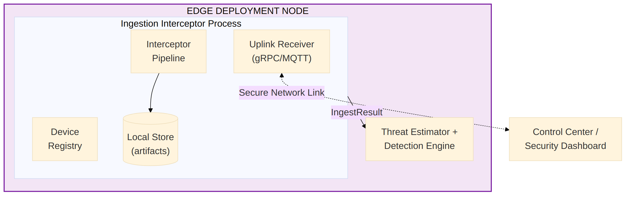

16.2 Operational Modes
Mode | Use Case | Configuration
Standalone | Testing, development | In-memory registry, memory uplink, filesystem
File-backed | Demo, integration testing | JSON file registry, file-based uplink polling
Production | Field deployment | See production stack below

Production stack (recommended for field deployment):
Layer | Technology | Purpose
Device registry | SQLite 3.x (WAL mode) | ACID-persistent device state on edge node
Fleet registry | PostgreSQL 15+ | Centralized fleet management (multi-node)
Artifact object store | MinIO (edge) + S3 (cloud) | Versioned, S3-compatible, erasure-coded storage
Command transport | MQTT 5.0 (Mosquitto/EMQX) over TLS | At-least-once delivery; retained messages
Command persistence | Redis 7+ (AOF persistence) | Survives restart; sub-ms reads for quarantine
Key management | HashiCorp Vault (auto-unseal) | Centralized secrets; dynamic per-drone keys
Metrics | Prometheus + Grafana | Time-series; alerting on flag ratios and drop rates
Logs | Structured JSON → Grafana Loki | Centralized search; 90-day retention minimum
Container runtime | Docker / Podman | Reproducible deployment; resource limits
Orchestration | systemd (single node) or K3s (multi-node) | Restart policy, health checks, rolling updates

16.3 Monitoring and Observability
Pipeline statistics (`stats` property):
- total_processed --- submissions that completed the full pipeline
- total_rejected --- submissions rejected at validation or authentication
- total_flagged --- submissions with one or more security flags
Stage 0 statistics (`packet_stats` property — present once `start_packet_listener()` is called):
- packets_received, packets_dropped_malformed, packets_dropped_hmac,
packets_dropped_unknown_drone, packets_dropped_replay, packets_dropped_orphaned, packets_dropped_session_overflow
- sessions_started, sessions_completed, sessions_expired,
sessions_truncated
- submissions_decoded, submissions_decode_failed
Logging:
- All processing events logged at INFO level with timing and flag data
- Authentication events logged with device ID and outcome
- Uplink commands logged with command type and result
- Checksum mismatches logged at WARNING level
- Registry load failures logged at ERROR level
- Stage 0 packet drops logged at WARNING level (HMAC mismatch, malformed,
truncation, replay) or DEBUG level (orphaned packets, late SESSION_END)
Recommended production monitoring:
- Export stats and packet_stats to Prometheus/StatsD at regular intervals
- Ship logs to ELK/Loki for centralized search
- Alert on total_rejected spike (possible attack)
- Alert on total_flagged / total_processed ratio exceeding threshold
- Alert on packets_dropped_hmac non-zero (wire tampering / wrong-key)
- Alert on sessions_truncated non-zero (truncation attack or chronic loss)
- Alert on packets_dropped_session_overflow non-zero (per-drone DoS)

16.4 Configuration Management
For production deployments, the InterceptorConfig dataclass can be initialized from environment variables or a YAML/JSON configuration file. The recommended approach is to load configuration at startup and pass it to the IngestionInterceptor constructor. Dynamic configuration updates are supported via the UPDATE_CONFIG uplink command (reserved for future implementation).
Production configuration loading priority (highest wins):
- Environment variables (e.g., II_REQUIRE_SIGNATURE=true)
- YAML/JSON config file (/etc/ingestion-interceptor/config.yaml)
- Dataclass defaults in InterceptorConfig
Production-recommended overrides:
Parameter | Dev Default | Production Override | Reason
require_signature | False | True | Reject unsigned submissions in the field
unknown_device_policy | "flag" | "reject" | Unknown drones must not enter the pipeline
storage_backend | "filesystem" | "minio" | S3-compatible object store with versioning
uplink_enabled | False | True | Enable real-time command channel
packet_hmac_required | True | True | Already correct; never weaken
log_level | "INFO" | "INFO" (or "WARNING" under load) | Reduce log volume if needed
structured_logging | True | True | Required for log aggregation

17. Risk Assessment
ID | Risk | Likelihood | Impact | Mitigation
R-1 | Rogue drone submits malicious payload | High | Critical | Device registry + signature verification + unknown policy
R-2 | Malware hidden in encrypted archive | High | Critical | encrypted_payload + nested_archive flags; deferred to sandbox
R-3 | Double-extension evasion (photo.jpg.exe) | Medium | High | double_extension + executable_file flags
R-4 | MIME type spoofing | Medium | High | mime_extension_mismatch + suspicious_mime flags
R-5 | Submission flooding (DoS) | Medium | High | Payload count and size limits; production: Redis-backed token-bucket rate limiter per drone_id
R-6 | Path traversal in filenames | Medium | Critical | Reject filenames containing / or \
R-7 | Prototype pollution via metadata | Low | High | Strip __proto__, constructor, etc. from additional metadata
R-8 | Compromised drone continues submitting | Medium | Critical | Uplink REVOKE_DEVICE command for immediate revocation
R-9 | File tampering during transmission | Medium | High | SHA-256 checksum verification against declared values
R-10 | Zone risk changes not reflected in analysis | Low | Medium | Uplink UPDATE_ZONE_RISK for dynamic zone risk adjustment
R-11 | Telemetry spoofing by compromised firmware | Medium | Medium | Telemetry anomaly detection (negative speed, invalid battery)
R-12 | Large binary exhausts processing resources | Low | Medium | large_binary flag + configurable threshold; streaming checksums
R-13 | Replay attack with old valid submission | Low | Medium | Timestamp validation with future-time warning; future: nonce tracking
R-14 | In-memory registry lost on process restart | Medium | High | File-backed registry mode; production: SQLite (edge) or PostgreSQL (centralized)
R-15 | Uplink command injection by adversary | Low | Critical | Uplink channel authentication; command ID tracking
R-16 | Wire-level packet replay (pcap capture and replay) | Medium | High | Per-session monotonic seq; receiver drops duplicate seq within an active session
R-17 | Packet tampering / MITM injection | Medium | Critical | Per-packet HMAC-SHA256 verified before any state mutation
R-18 | Half-open session flooding (start sessions, never finish) | Medium | Medium | Reassembly timeout + per-drone concurrent session cap
R-19 | Bloated SESSION_START with huge total_chunks | Low | Medium | packet_max_session_chunks enforced at SESSION_START handling
R-20 | Truncation attack (drop final chunks to suppress detection) | Medium | High | Sequence-gap detection at SESSION_END; sessions_truncated event
R-21 | Session-id guessing to inject CHUNKs into another drone's session | Low | High | Each session is keyed by (drone_id, session_id) and CHUNKs whose drone_id is unknown to a session_id are dropped as orphaned

18. Implementation Roadmap
Phase | Deliverable | Status
Phase 1 | Core framework: config, models, validator, authenticator | Done
Phase 1 | Payload analyzer (9-point security heuristic) | Done
Phase 1 | Checksum verifier (SHA-256 integrity verification) | Done
Phase 1 | Metadata extractor (mission context, geo, telemetry) | Done
Phase 1 | Artifact manager (ID generation, storage pointers) | Done
Phase 1 | Uplink receiver and command handler | Done
Phase 1 | Main orchestrator (IngestionInterceptor class) | Done
Phase 1 | Unit test suite (31 tests) | Done
v3.0 | Stage 0: protocol/ subpackage (packet codec + binary submission marshaller) | Done
v3.0 | Stage 0: packet_receiver.py (UDP listener thread, reassembly buffer, periodic GC, statistics) | Done
v3.0 | Stage 0: integration into IngestionInterceptor (start_packet_listener / stop_packet_listener) | Done
v3.0 | Drone-side packet transmitter and side-by-side demo | Done
v3.0 | Bug fix: telemetry anomalies promoted into insecure_flags | Done
v3.0 | Stage 0 unit tests (47 new tests) | Done
Phase 2 | Ed25519 asymmetric signature verification | Planned
Phase 2 | mTLS authentication for drone-to-edge communication | Planned
Phase 2 | Redis-backed token-bucket rate limiter per drone_id | Planned
Phase 2 | Firmware version whitelisting | Planned
Phase 2 | SQLite-backed device registry and quarantine persistence | Planned
Phase 2 | HashiCorp Vault integration for HMAC key management | Planned
Phase 2 | Health-check HTTP endpoint (/healthz) for liveness probes | Planned
Phase 2 | Graceful shutdown (SIGTERM handler: flush stats, persist state, close sockets) | Planned
Phase 3 | Async processing with asyncio for high-throughput | Planned
Phase 3 | MQTT 5.0 uplink channel over TLS (replace file/memory modes) | Planned
Phase 3 | MinIO edge object store for artifact storage (replace filesystem) | Planned
Phase 3 | Prometheus exporter + Grafana dashboards for metrics | Planned
Phase 3 | Structured JSON logging to Grafana Loki with 90-day retention | Planned
Phase 3 | Docker/Podman containerization with resource limits | Planned

19. Glossary
Term | Definition
RPA | Remotely Piloted Aircraft; unmanned aerial vehicles operated by a remote pilot
Edge Network Boundary | The network perimeter where data from external (untrusted) sources enters the internal (trusted) infrastructure
Ingestion | The process of receiving, validating, and cataloging incoming data submissions
Payload | An individual file (video, image, telemetry data, etc.) contained within a drone submission
Artifact | A cataloged payload file with a unique identifier, storage pointer, and security analysis results
Security Flag | A named indicator of a potentially suspicious attribute detected during payload analysis
Device Registry | A database of known drone devices with their trust status, reputation scores, and metadata
Reputation Score | A numerical value (0.0--1.0) representing the historical trustworthiness of a drone device
Zone Risk | A numerical value (0.0--1.0) representing the threat level associated with a geographic operational zone
T_S (Threat Score) | The output of the Game-Theoretic Threat Estimator; a value in [0.0, 1.0] determining inspection depth
Stackelberg Game | A game-theoretic model where a leader (defender) commits to a strategy before a follower (attacker) responds; used to compute optimal inspection allocation
HMAC-SHA256 | Hash-based Message Authentication Code using SHA-256; provides both data integrity and authentication
MIME Type | Multipurpose Internet Mail Extensions type; a standardized way to indicate the nature of a file
Path Traversal | An attack that uses directory navigation characters (../) in filenames to access files outside the intended directory
Prototype Pollution | A JavaScript/JSON injection attack that manipulates object prototypes via __proto__ or constructor keys
Uplink | The communication channel from the control center/security dashboard to the edge interceptor
Quarantine | The action of isolating a suspicious submission to prevent further processing until manual review
Pre-sanitization | A lightweight metadata cleaning step performed at ingestion time; distinct from the full Metadata Sanitizer module
Ingest ID | A unique identifier (format: ingest_<12-hex-chars>) assigned to each successfully processed submission
Artifact ID | A unique identifier (format: artifact://<16-hex-chars>) assigned to each cataloged payload file
BEL | Bharat Electronics Limited; the project sponsor and defence electronics manufacturer
TLV (Type-Length-Value) | Binary encoding scheme where each field is preceded by a type tag and a length, allowing optional fields and forward-compatible extension
MTU (Maximum Transmission Unit) | The largest packet size that can be transmitted over a network link without fragmentation. Stage 0 packets are sized to fit within a typical 1500-byte Ethernet MTU
Session ID | A random 64-bit identifier assigned by the drone for each submission; used to key the receiver's reassembly buffer
Reassembly Buffer | Per-session state held by the receiver while waiting for all CHUNK packets of a fragmented submission to arrive
Eager Reassembly | Reassembling a session as soon as all expected chunks have arrived, without waiting for the explicit SESSION_END marker
Orphaned Packet | A CHUNK or SESSION_END packet that arrives at the receiver with a session_id the receiver is not currently tracking; typically caused by SESSION_START being lost to network loss
Stage 0 | The Packet Reception & Reassembly stage that runs upstream of the original 7-stage pipeline when the wire-level UDP listener is enabled
IIT Bhubaneswar | Indian Institute of Technology Bhubaneswar; the research institution executing the project

