Design Document: Metadata Sanitizer
Field | Value
Document Version | 2.0
Status | Implementation Complete (Phase 1-2)
Module | metadata_sanitizer/
Authors | Sangam Kumar Mishra
Created | 2025-10
Last Updated | 2026-04
Depends On | Ingestion Interceptor, Game-Theoretic Threat Estimator
Depended On By | Threat Intelligence Correlator, Response & Quarantine Manager

Table of Contents
Update this field to see table of contents with page numbers (right-click > Update Field)

1. Executive Summary
The Metadata Sanitizer is a dedicated security module within the Multi-Layered Malware Detection and Threat Prevention System for drone/RPA data streams. It inspects and cleans embedded metadata in payload files (images, videos, PDFs, archives, telemetry) to neutralize covert channels, strip tracking data, and remove exploit payloads hidden in metadata fields.
Key capabilities:
- EXIF scrubbing for images (GPS, MakerNote, UserComment, embedded thumbnails)
- JavaScript/auto-action removal from PDFs
- Video metadata atom cleaning (MP4/MKV GPS tracks, custom atoms)
- Archive structure inspection (path traversal, zip bombs, hidden executables)
- Text/telemetry normalization (encoding, null bytes, embedded scripts)
- Threat-score-driven mode selection (strip / selective / audit-only)
- Full forensic audit trail with before/after metadata hashing
The module operates after the Malware Detection Engine as a defense-in-depth layer, cleaning files that passed malware scanning but may still carry embedded threats.

2. Goals and Non-Goals
This section defines the scope of the Metadata Sanitizer by specifying its intended capabilities and the responsibilities explicitly delegated to other modules in the pipeline.

2.1 Goals
The following goals define what the Metadata Sanitizer is designed to achieve within the multi-layered detection pipeline.
# | Goal | Rationale
G1 | Remove operationally dangerous metadata from all supported file types | Prevent covert data exfiltration and exploit delivery via metadata
G2 | Support three sanitization modes (strip, selective, audit-only) | Different operational contexts demand different aggressiveness levels
G3 | Automatically select mode based on threat score from the Game-Theoretic Estimator | Adaptive defense that scales response to observed threat level
G4 | Preserve file integrity and rendering correctness after sanitization | Cleaned files must remain usable for operational purposes
G5 | Produce full forensic audit trails | Every modification must be traceable for incident response
G6 | Integrate with Ingestion Interceptor artifact records | Seamless pipeline from ingestion through sanitization
G7 | Handle missing dependencies gracefully | System degrades to warnings rather than crashes when optional libraries are absent

2.2 Non-Goals
The following items are explicitly outside the scope of this module and are handled by other components in the system.
# | Non-Goal | Reason
NG1 | Malware detection or signature scanning | Delegated to the Malware Detection Engine (upstream)
NG2 | Deep content analysis (image recognition, video frame analysis) | Separate concern; belongs in domain-specific analysis modules
NG3 | Real-time streaming processing | Operates on stored files post-ingestion; near-real-time is sufficient
NG4 | Modification of media content (pixels, audio, video frames) | Only metadata is touched; media data remains byte-identical
NG5 | Archive decompression and recursive scanning | Archive contents are scanned by the Malware Detection Engine

3. System Context
This section describes how the Metadata Sanitizer fits within the overall multi-layered detection pipeline, its position relative to other modules, and the data flow between them.

3.1 Position in Detection Pipeline
The Metadata Sanitizer occupies a specific position in the multi-layered detection pipeline, running after malware detection and before the Threat Intelligence Correlator.
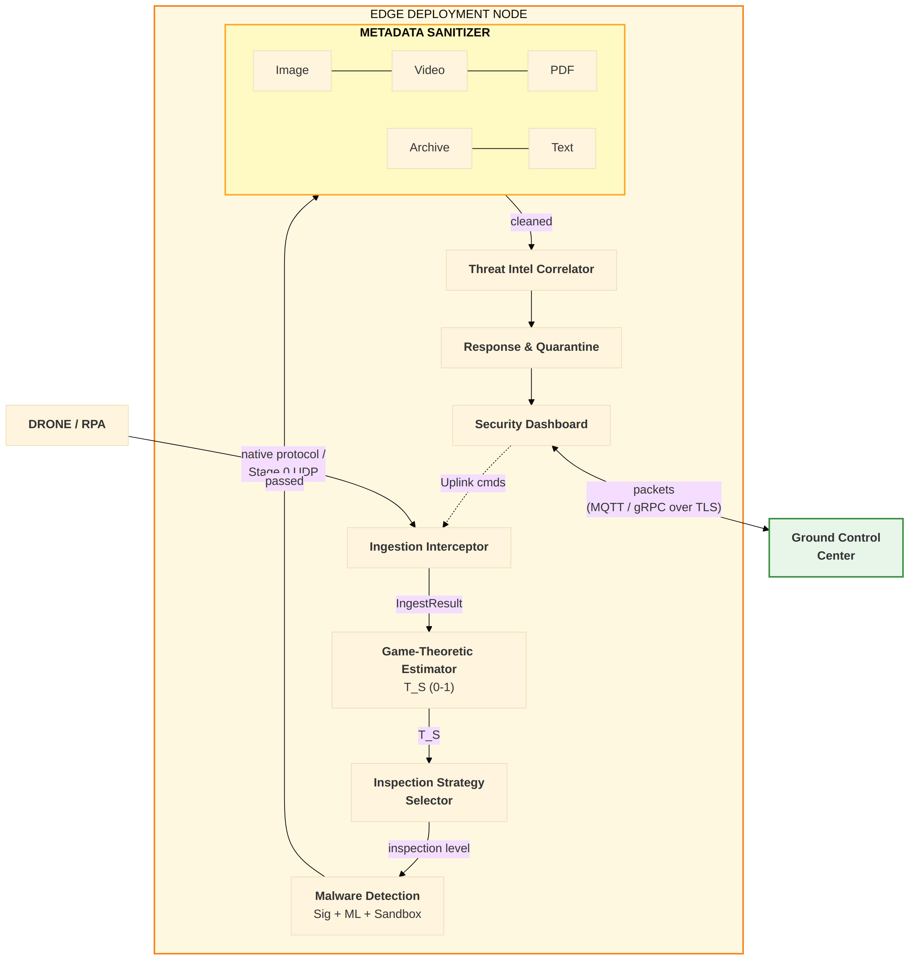

3.2 Why Separate from Ingestion Interceptor?
The following table explains why the Metadata Sanitizer is a separate module from the Ingestion Interceptor, despite both dealing with metadata-related operations.
Aspect | Ingestion Interceptor | Metadata Sanitizer
Operates on | Wire-level UDP packets (Stage 0) and parsed dicts (Stages 1-7) | File-level embedded metadata (binary content)
Position | First stage (before threat estimation) | After malware detection engine
Concerns | Structure validation, authentication, cataloging | Deep content inspection, EXIF scrubbing, script removal
Dependencies | None (stdlib only, entry point) | Pillow, piexif, pikepdf, mutagen (optional)
Latency | Must be near-zero for real-time ingestion | Can tolerate slightly higher latency (post-triage)
Failure mode | Rejects entire submission | Can fail per-file; submission already cataloged
Modifies files | Never (read-only analysis) | Yes (strips/rewrites metadata)

3.2.1 Wire I/O — out of scope (rationale)
Unlike the Ingestion Interceptor, the Metadata Sanitizer does not have a wire entry point and is not intended to. It runs entirely inside the trust boundary that the Interceptor establishes:
- Inputs are already-trusted Python objects: an ArtifactRecord dict
(from IngestionInterceptor.process()), a threat score (from the Game-Theoretic Estimator), and insecure_flags from IngestMetadata. All of these have already been authenticated, validated, and cataloged upstream.
- File bytes come from local edge-node storage, addressed by the
artifact's pointer_storage URI. The file was placed there by the ingestion pipeline; no untrusted network channel is involved.
- Sending file bytes over a wire protocol would be a regression.
Sanitizer reads multi-megabyte videos and PDFs for parsing; framing those into UDP packets adds latency and protocol ceremony for zero security benefit because the data is already authenticated.
Stage 0 packet reception belongs to Module 1 (Ingestion Interceptor) only. Modules 2-9 in the BEL architecture are internal pipeline stages that pass Python objects and filesystem references in-process.
Note --- Current vs Production file access: Currently the sanitizer reads and writes files directly on the local filesystem via pointer_storage paths under drone_remote_store/. For production deployments, the artifact storage layer will be MinIO (a self-hosted S3-compatible object store on the edge node). The sanitizer will resolve pointer_storage URIs via the S3 API, download the file to a temporary working directory, sanitize it, upload the cleaned copy back, and delete the temporary file. This change affects only the storage-pointer resolution layer; the handler pipeline itself remains unchanged.

3.3 Data Flow Between Modules
The following diagram shows the detailed data flow between the Ingestion Interceptor, Game-Theoretic Estimator, Malware Detection Engine, and Metadata Sanitizer, including the specific data fields exchanged.
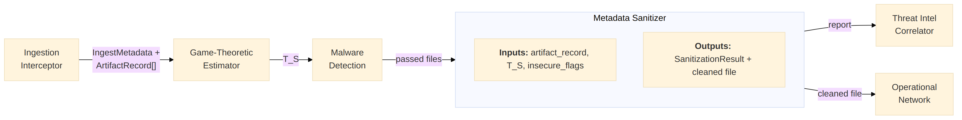

4. Architecture Overview
This section describes the internal architecture of the Metadata Sanitizer module, including its file structure, component hierarchy, handler interface design, and how the sanitization rules are organized.

4.1 Module Structure
The module is organized as a Python package with a handler-based architecture where each file type has a dedicated handler implementing a common interface.
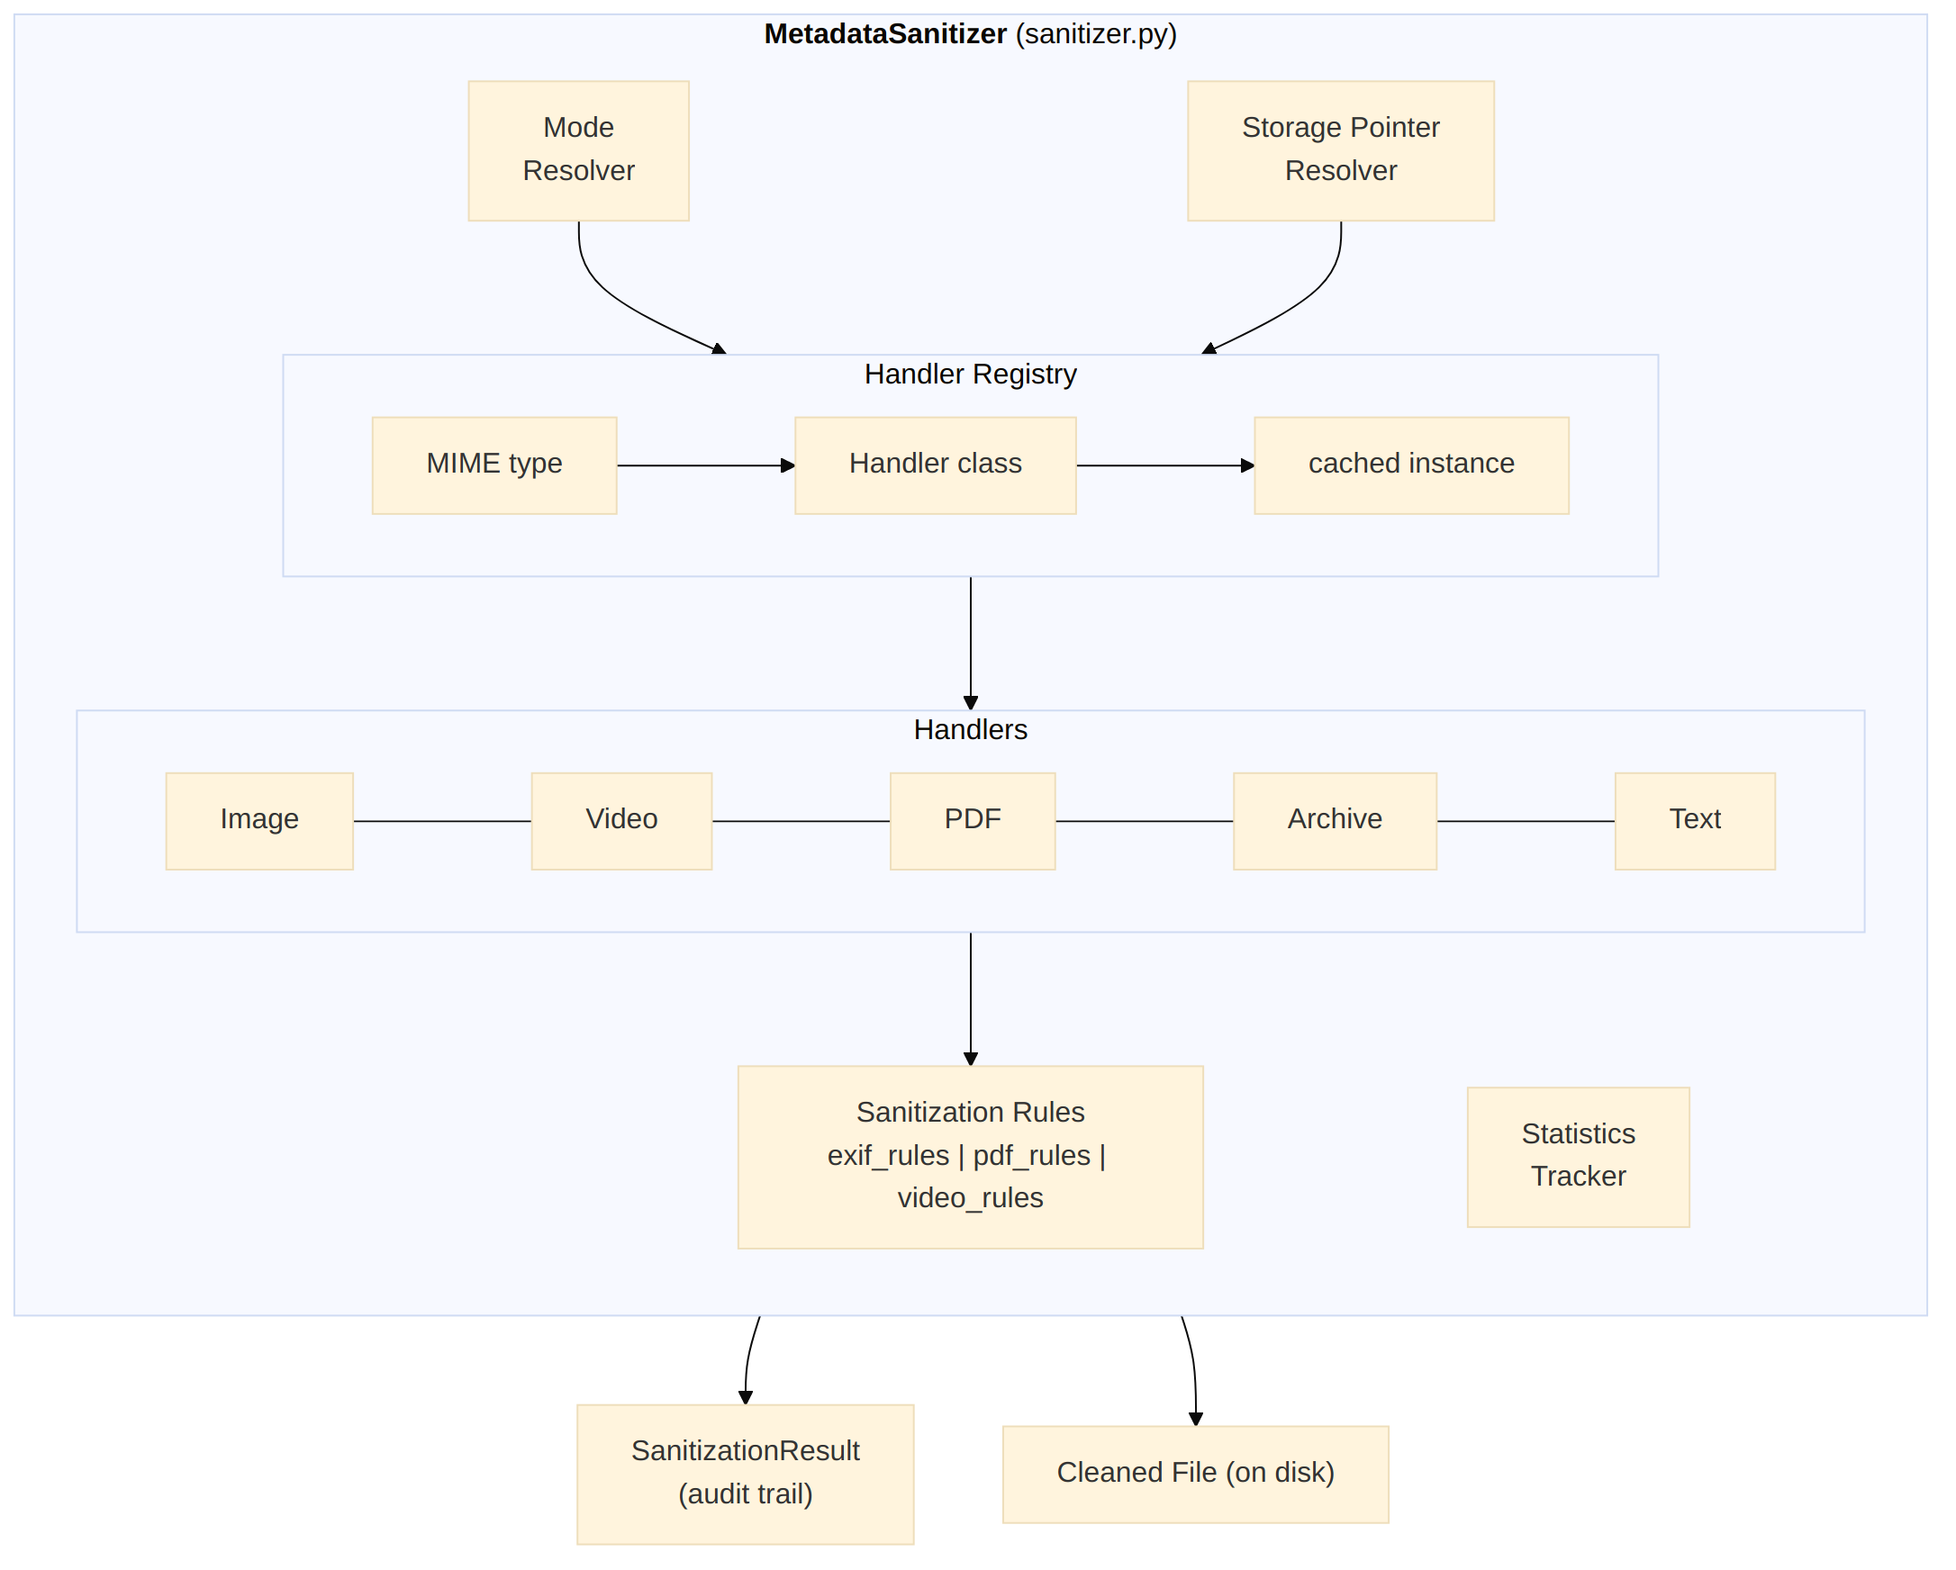

4.2 Component Diagram
The following diagram shows the internal component structure of the MetadataSanitizer orchestrator, including the handler registry, mode resolver, and the relationship between handlers and sanitization rules.


4.3 Handler Interface (BaseHandler)
Every file-type handler implements this interface:
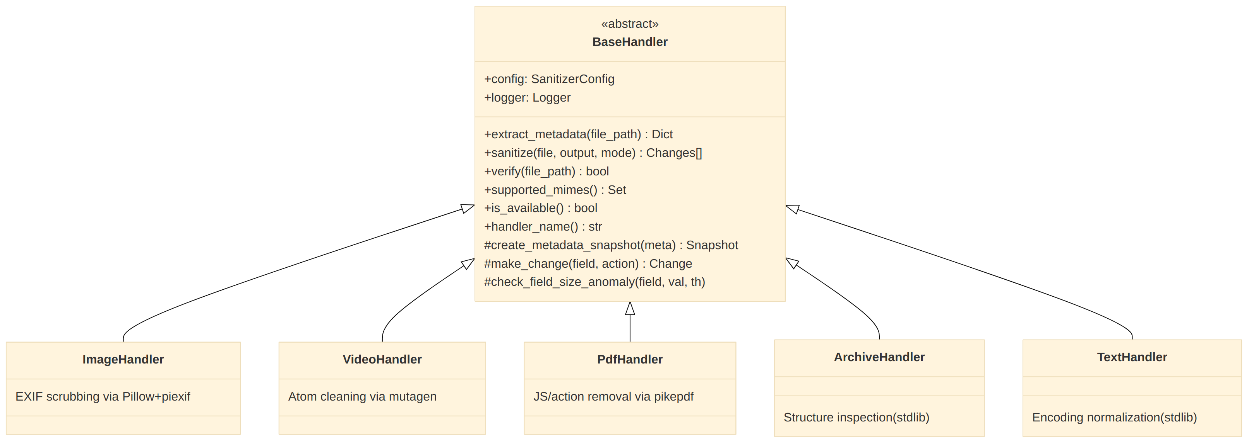

5. Component Design
This section provides detailed design documentation for each component, including the orchestrator, mode resolver, handler registry, and all five file-type-specific handlers.

5.1 MetadataSanitizer (Orchestrator)
File: sanitizer.py
The orchestrator manages the sanitization pipeline for each file:
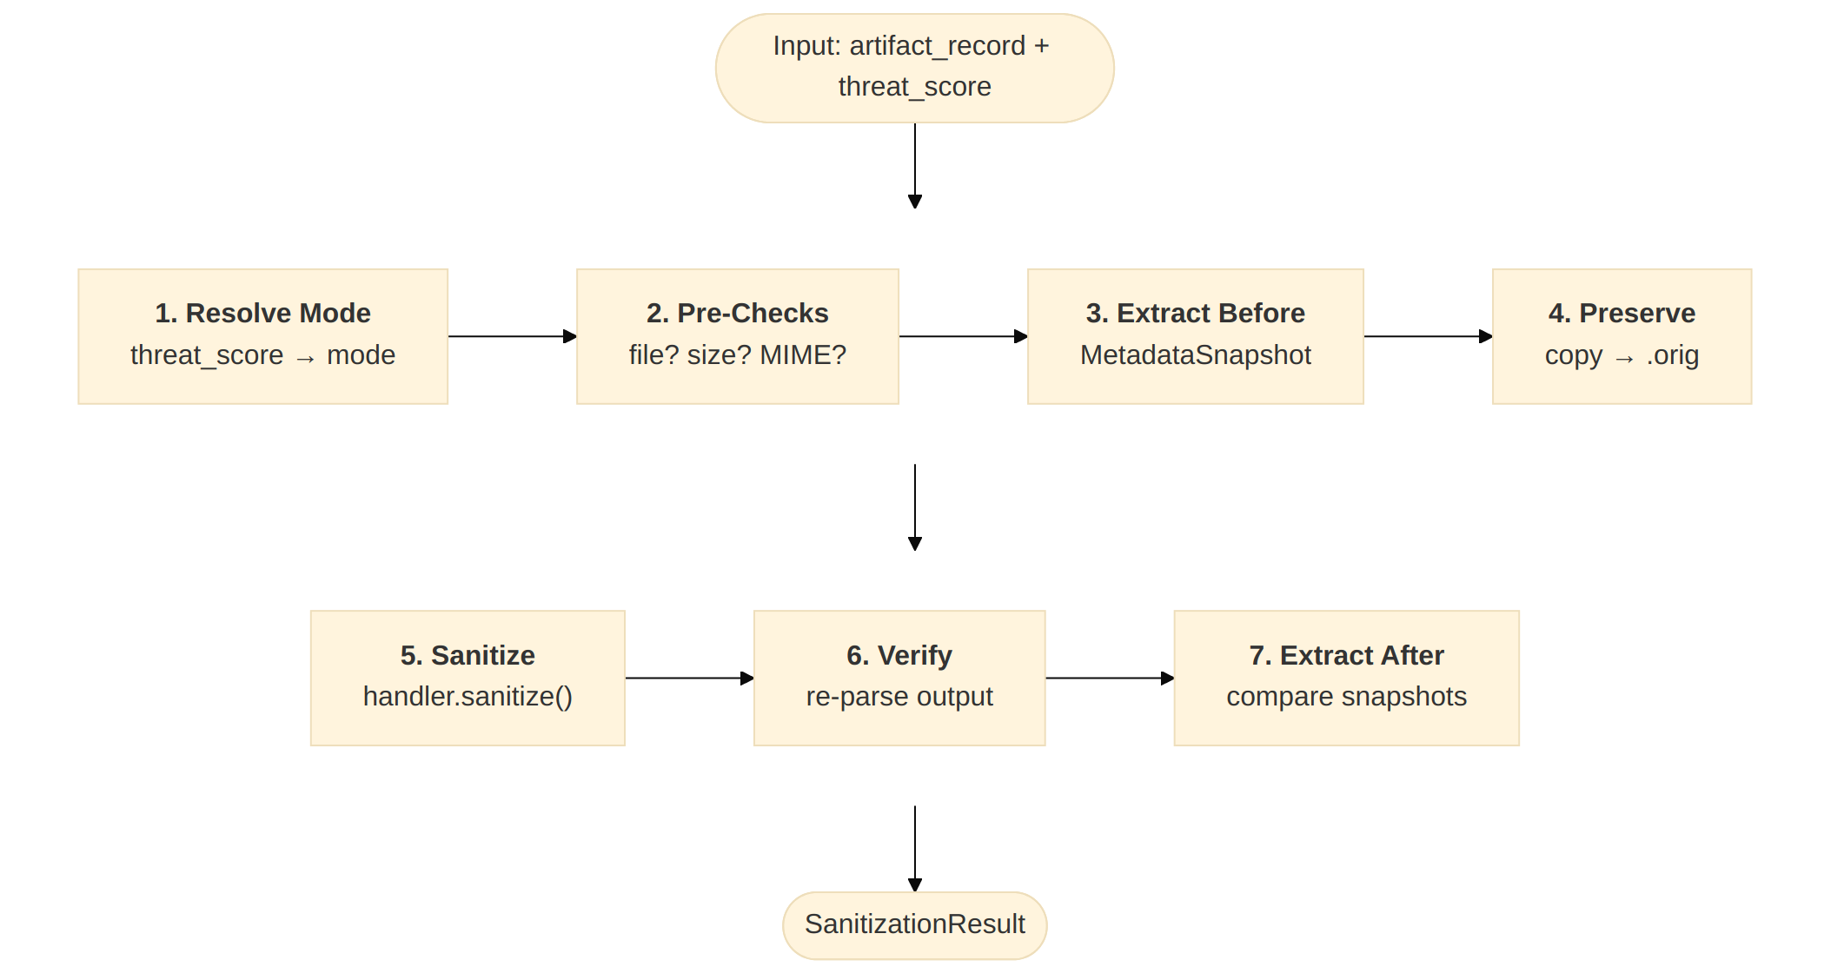
Key design decisions:
- Handler caching: One handler instance per class, reused across files
- Fail-safe: If sanitization corrupts a file, the original is restored from the .orig copy and the result's sanitized flag is reset to False so stats and the caller-facing report reflect the rollback
Note --- Production forensic-copy management: Currently, .orig copies are stored alongside the cleaned files on the local filesystem. This effectively doubles disk usage per artifact. For production:
• Storage: Write .orig copies to a separate forensic bucket in
MinIO (e.g., s3://edge-forensics/originals/) with write-once (WORM/Object Lock) policy so originals cannot be tampered with.
• Retention: Apply an automated lifecycle rule: retain .orig files
for 90 days (configurable), then delete or tier to cold storage (S3 Glacier / tape). This bounds disk growth.
• Cleanup: A cron job or lifecycle policy should purge expired
.orig files. The current implementation has no automatic cleanup.
• Disk monitoring: Alert when edge-node disk usage exceeds 80%.
The .orig files are the primary contributor to disk growth.

5.2 Mode Resolver
The sanitization mode is determined by a priority chain:
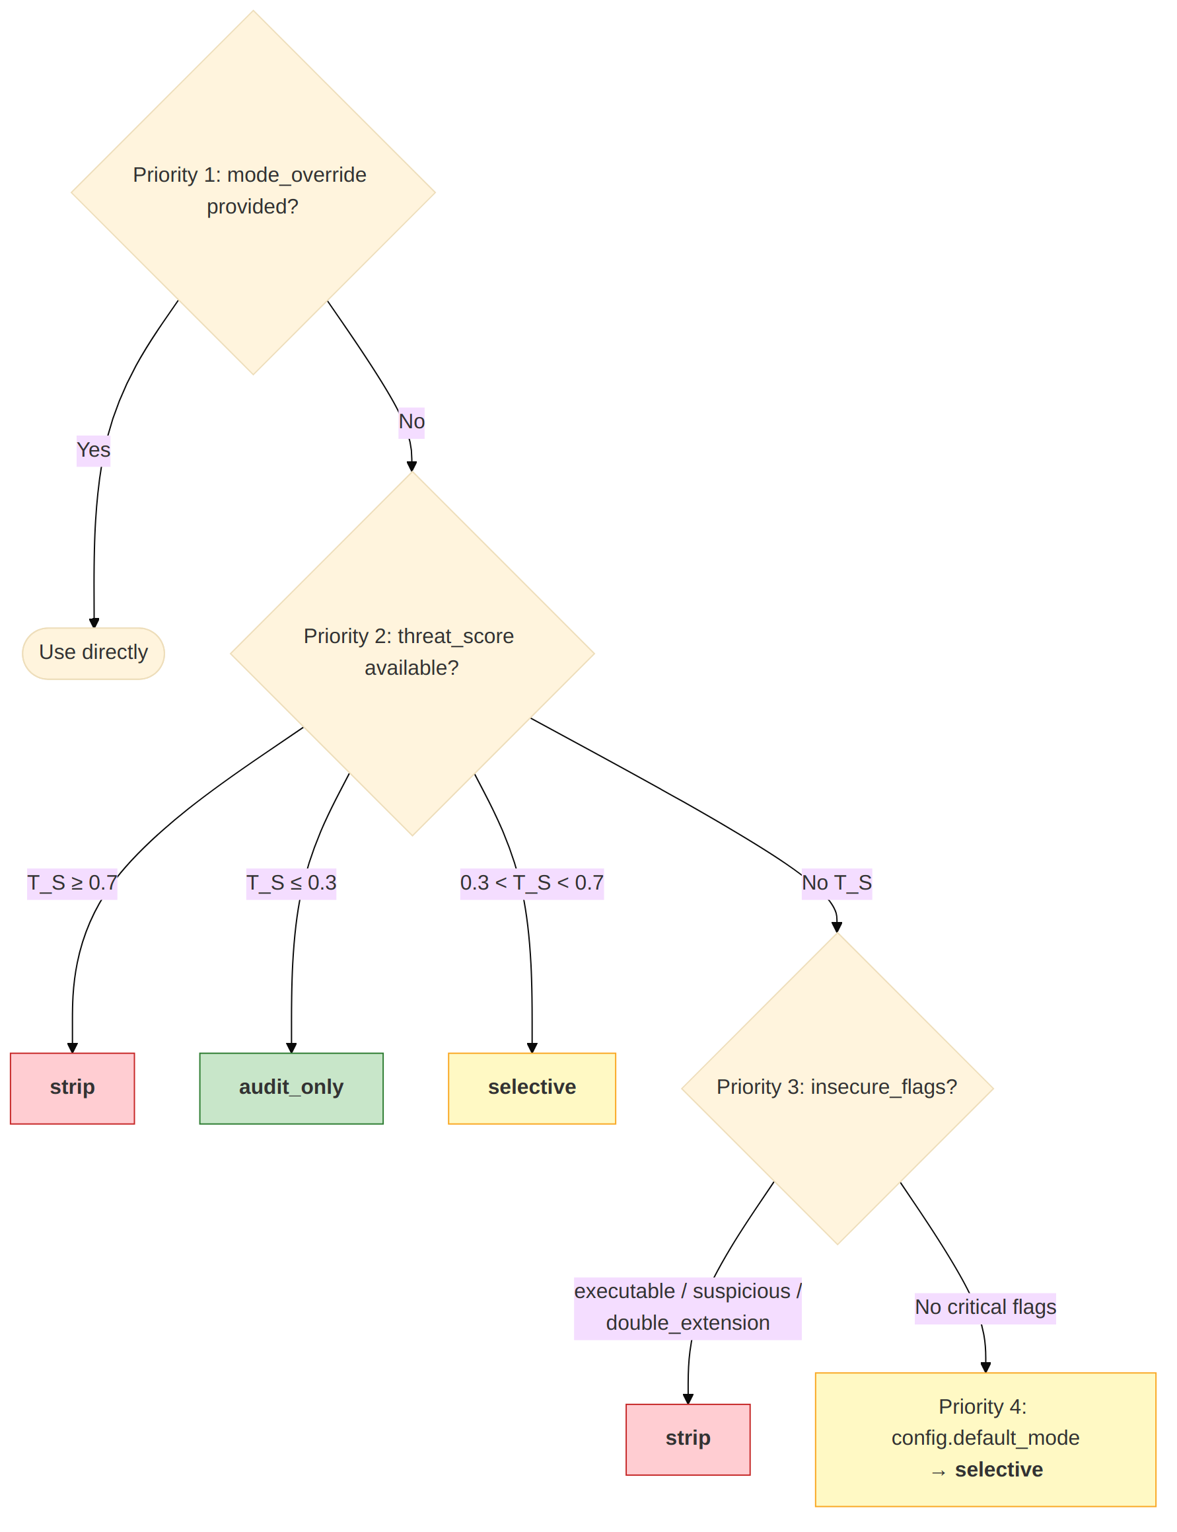

5.3 Handler Registry
# handlers/__init__.py — MIME type → Handler class mapping
HANDLER_REGISTRY = {
"image/jpeg": ImageHandler,
"image/png": ImageHandler,
"image/tiff": ImageHandler,
"video/mp4": VideoHandler,
"video/x-matroska": VideoHandler,
"application/pdf": PdfHandler,
"application/zip": ArchiveHandler,
"text/plain": TextHandler,
"application/json": TextHandler,
...
}

Fallback strategy:
- Exact MIME match in registry
- Prefix match (e.g., video/* → VideoHandler)
- Default to TextHandler (safe: treats file as opaque text)

5.4 Image Handler
Dependencies: Pillow (required), piexif (optional, enables surgical tag removal)
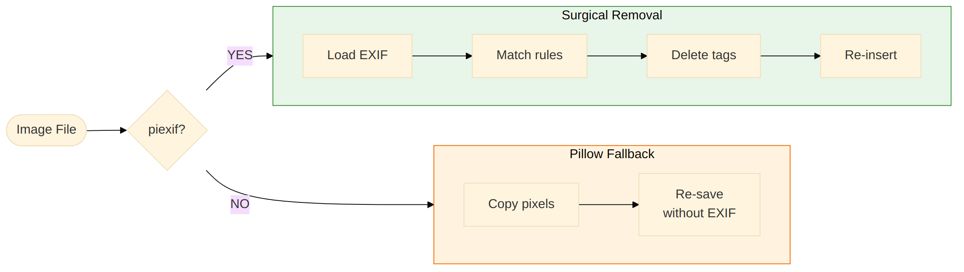
Surgical removal (piexif path):
- Loads EXIF into IFD-structured dict
- Iterates tag names against get_exif_strip_set(mode)
- Deletes matched tags, preserves all others
- Detects oversized fields (>64 KB) as potential payload carriers
- Writes cleaned EXIF back into the image
Fallback (Pillow-only path):
- Opens image, copies pixel data
- Re-saves without EXIF data (preserves ICC profile)
- Less precise but works for any Pillow-supported format

5.5 PDF Handler
Dependencies: pikepdf (required for PDF sanitization)
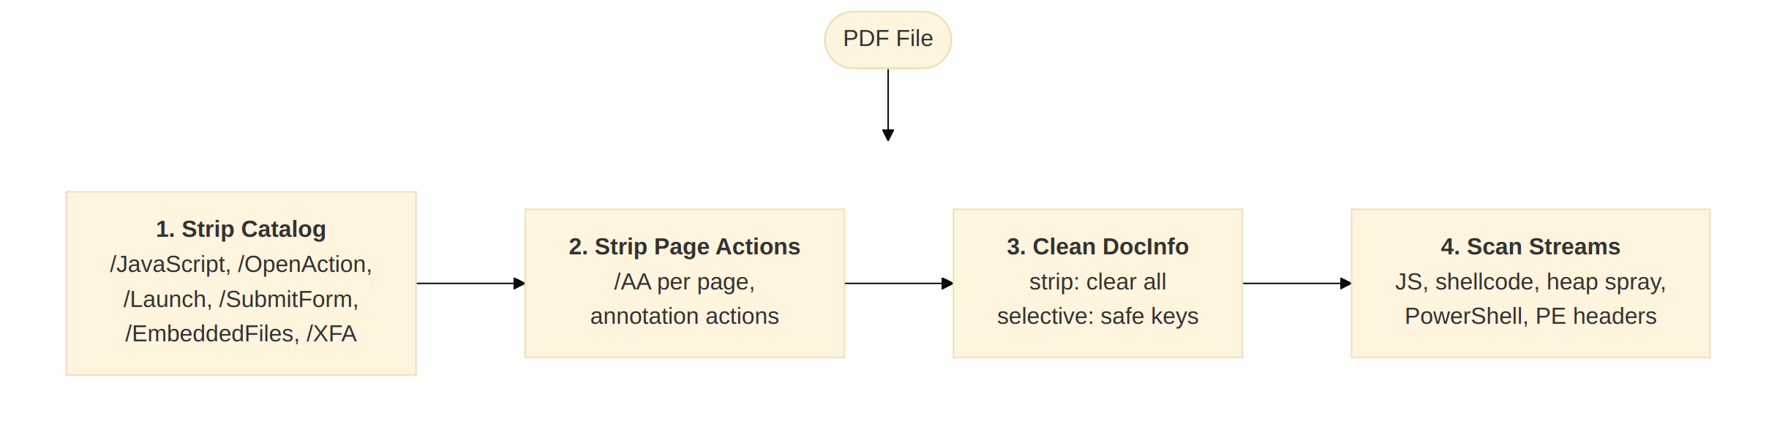

5.6 Video Handler
Dependencies: mutagen (required for video metadata manipulation)
Uses mutagen's format-agnostic interface to remove tags from MP4, MKV, OGG, FLAC, and other containers. Tag names are normalized (e.g., \xa9xyz → xyz) before matching against rule sets.

5.7 Archive Handler
Dependencies: None (Python stdlib zipfile, tarfile)
Archives are inspected but not modified. The handler reports:
- Path traversal attempts in archived filenames (../)
- Executable files within the archive
- Double extensions (photo.jpg.exe)
- Hidden files (.filename)
- Compression ratio anomalies (zip bomb detection: ratio > 100:1)

5.8 Text Handler
Dependencies: None (Python stdlib)
Normalizes encoding and detects embedded threats:
- Strips UTF-8 BOM, null bytes, control characters
- Normalizes line endings (CRLF → LF)
- Detects embedded scripts (<script>, shebang, eval/exec, SQL injection patterns)
- Validates JSON structure for telemetry files
- In strip mode: removes lines matching script patterns
Note --- Production handler isolation: Currently all handlers run in the same Python process as the orchestrator. A crafted malicious file (e.g., a JPEG triggering a Pillow heap overflow, or a PDF exploiting a pikepdf parser bug) could compromise the entire pipeline. For production:
• Phase 3 plan: Each handler invocation will run in a restricted
subprocess (or seccomp-sandboxed container) with a per-file timeout, memory limit, and no network access.
• Library pinning: Pin Pillow, piexif, pikepdf, and mutagen to
audited versions. Subscribe to their CVE feeds and apply security patches within 72 hours.
• Async parallelism: In production, sanitize multiple files in
parallel using a process pool (e.g., concurrent.futures.ProcessPoolExecutor). The current sequential design is safe but under-utilizes multi-core edge hardware.

6. Data Models
This section defines the data models used throughout the sanitization pipeline, including the sanitization mode enum, change records, metadata snapshots, and per-artifact and batch result objects.

6.1 SanitizationMode (Enum)
Value | Behavior | When Used
strip | Remove ALL non-essential metadata | T_S >= 0.7 or critical flags
selective | Remove known-dangerous fields only | Default; T_S between 0.3-0.7
audit_only | Log findings, modify nothing | T_S <= 0.3 or forensics mode

6.2 SanitizationChange (per-field record)
{
"field": "EXIF.GPSInfo",
"action": "removed",
"reason": "gps_data_policy",
"severity": "medium",
"original_value_preview": "12.97, 77.59...",
"original_value_size": 48
}

Actions: removed, redacted, normalized, truncated, flagged
Severities: info, low, medium, high, critical

6.3 MetadataSnapshot (forensic hash)
{
"field_count": 24,
"total_size_bytes": 12480,
"hash_sha256": "a1b2c3d4..."
}

6.4 SanitizationResult (per-artifact output)
{
"artifact_id": "artifact://a1b2c3d4e5f6",
"filename": "drn001_fpv_001.mp4",
"file_type": "video",
"mime_type": "video/mp4",
"sanitized": true,
"mode": "selective",
"changes": [
{"field": "Video.©xyz", "action": "removed", "reason": "gps_data_policy", "severity": "medium"},
{"field": "Video.©cmt", "action": "removed", "reason": "potential_payload_in_comment", "severity": "low"}
],
"warnings": [],
"errors": [],
"metadata_before_hash": "sha256:abc...",
"metadata_after_hash": "sha256:def...",
"file_valid_after_sanitization": true,
"processing_time_ms": 45.2,
"handler_used": "VideoHandler"
}

6.5 BatchSanitizationResult (aggregate output)
{
"summary": {
"total_processed": 5,
"total_sanitized": 3,
"total_skipped": 1,
"total_errors": 1,
"total_changes": 12,
"total_processing_time_ms": 234.5
},
"results": [ ... ]
}

7. API Specification
This section documents the public API surface of the Metadata Sanitizer, including the primary sanitization methods, their parameters, and an integration example with the Ingestion Interceptor.

7.1 Primary API: MetadataSanitizer
from metadata_sanitizer import MetadataSanitizer, SanitizerConfig

config = SanitizerConfig(default_mode="selective", preserve_gps=False)
sanitizer = MetadataSanitizer(config)

sanitize_file(artifact_id, file_path, mime_type, threat_score?, mode_override?, insecure_flags?) → SanitizationResult
Direct file sanitization. Primary entry point for custom integrations.
Parameter | Type | Required | Description
artifact_id | str | Yes | Artifact ID from Ingestion Interceptor
file_path | str | Yes | Absolute path to the file on disk
mime_type | str | Yes | MIME type of the file
threat_score | float | No | T_S from Game-Theoretic Estimator (0.0-1.0)
mode_override | str | No | Explicit mode: "strip", "selective", "audit_only"
insecure_flags | List[str] | No | Security flags from ingestion

sanitize_artifact_record(artifact_record, storage_base_path?, threat_score?, mode_override?, insecure_flags?) → SanitizationResult
Integration entry point. Accepts an ArtifactRecord.to_dict() from the Ingestion Interceptor.
Parameter | Type | Required | Description
artifact_record | Dict | Yes | ArtifactRecord dict (artifact_id, filename, mime, pointer_storage)
storage_base_path | str | No | Base path to resolve relative storage pointers
threat_score | float | No | T_S from estimator
mode_override | str | No | Explicit mode
insecure_flags | List[str] | No | Security flags

sanitize_batch(artifact_records, ...) → BatchSanitizationResult
Process multiple artifacts sequentially.

stats → Dict[str, int]
Returns cumulative processing statistics.

7.2 Integration Example
from ingestion_interceptor import IngestionInterceptor
from metadata_sanitizer import MetadataSanitizer, SanitizerConfig

# Ingestion
interceptor = IngestionInterceptor(device_registry={...})
ingest_result = interceptor.process(drone_json)

# ... Game-Theoretic Estimator produces threat_score ...
threat_score = 0.65

# Sanitization
sanitizer = MetadataSanitizer(SanitizerConfig())
for artifact in ingest_result.artifact_records:
san_result = sanitizer.sanitize_artifact_record(
artifact_record=artifact.to_dict(),
storage_base_path="drone_remote_store",
threat_score=threat_score,
insecure_flags=ingest_result.ingest_metadata.insecure_flags,
)
if san_result.errors:
# Handle sanitization failure
pass

8. Sequence Diagrams
This section provides sequence diagrams that illustrate the interaction between components during sanitization operations and the threat-score-driven mode selection logic.

8.1 Single File Sanitization Flow


8.2 Threat-Score-Driven Mode Selection
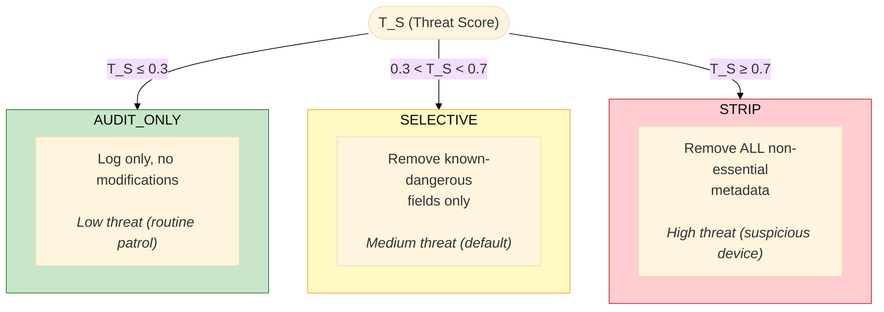

9. Sanitization Rules
This section defines the declarative sanitization rules for each file type, specifying which metadata fields are stripped, preserved, or flagged in each sanitization mode (strip, selective, audit_only).

9.1 EXIF Rules (Images)
Category | Fields | selective | strip | Rationale
GPS / Location | GPSInfo, GPSLatitude, GPSLongitude, GPSAltitude, GPS* | Strip | Strip | Exposes operating zones
MakerNote | MakerNote, MakerNote* (all vendors) | Strip | Strip | Arbitrary binary blob, covert channel
User Text | UserComment, ImageDescription, XPComment, XP* | Strip | Strip | Script injection vector
Embedded Thumbnails | JPEGInterchangeFormat, JPEGInterchangeFormatLength | Strip | Strip | Steganography vector
Software | ProcessingSoftware, Software, HostComputer | Strip | Strip | Pipeline fingerprinting
Device Serial | BodySerialNumber, CameraSerialNumber, LensSerialNumber | Keep | Strip | Device identification
Camera Model | Make, Model, LensModel, FirmwareVersion | Keep | Strip | Fingerprinting in high-sec
Timestamps | DateTimeOriginal, DateTimeDigitized, DateTime | Keep | Strip | Activity correlation
Rendering | Orientation, ImageWidth, ColorSpace, ExifVersion | Keep | Keep | Required for display

9.2 PDF Rules
Category | Keys | Action | Rationale
JavaScript | /JavaScript, /JS | Always strip | Code execution
Auto-actions | /OpenAction, /AA, /Launch | Always strip | Triggered without user interaction
Data exfil | /SubmitForm, /ImportData | Always strip | Sends/imports data automatically
Navigation | /URI, /GoToR, /GoToE | Always strip | Phishing, remote document loading
Forms | /AcroForm, /XFA | Always strip | Complex scripting surface
Embedded | /EmbeddedFiles, /Names | Always strip | Hidden file attachments
Preservation | /Title, /Pages, /MediaBox, /Contents | Always keep | Structural / display

Stream scanning patterns: eval(, app.alert, app.launchURL, shellcode NOP sleds, heap spray, PowerShell commands, PE headers.

9.3 Video Rules
Category | Atoms/Tags | selective | strip | Rationale
GPS | ©xyz, ©loc, GPS, location, ISO6709 | Strip | Strip | Location data
Comments | ©cmt, ©des, ©inf, COMMENT, DESCRIPTION | Strip | Strip | Payload carrier
Cover art | covr, APIC | Strip | Strip | Embedded image risk
Custom/UUID | uuid, XMP_ | Strip | Strip | Arbitrary data
Encoder | ©too, ©enc, ENCODER, WRITING_APP | Keep | Strip | Fingerprinting
Timestamps | ©day, creation_time, DATE_* | Keep | Strip | Correlation
Structural | moov, trak, stbl, mvhd, ftyp, mdat | Keep | Keep | Playback required

9.4 Anomaly Detection (All Types)
Check | Threshold | Severity | Action
EXIF field size | > 64 KB | High | Flag + strip in strip mode
Video metadata atom | > 1 MB | High | Flag + strip in strip mode
Archive compression ratio | > 100:1 | Critical | Flag (zip bomb)
Text null bytes | Any | Medium | Strip
Embedded script patterns | Regex match | Critical | Flag / strip lines

10. Configuration Reference
This section provides the complete reference for all tuneable parameters in the SanitizerConfig dataclass, with defaults and descriptions.
Parameter | Type | Default | Description
default_mode | str | "selective" | Default sanitization mode
high_threat_mode | str | "strip" | Mode when T_S >= strip threshold
low_threat_mode | str | "audit_only" | Mode when T_S <= audit threshold
threat_score_strip_threshold | float | 0.7 | T_S above this → strip mode
threat_score_audit_threshold | float | 0.3 | T_S below this → audit mode
preserve_gps | bool | False | Keep GPS data in images/video
max_file_size_bytes | int | 500,000,000 | Skip files larger than 500 MB
max_exif_field_bytes | int | 65,536 | Individual EXIF/atom field size cap (used by BaseHandler.check_field_size_anomaly)
verify_after_sanitize | bool | True | Re-parse file after cleaning; rollback to .orig on failure
preserve_originals | bool | True | Keep .orig copy for forensics
original_suffix | str | ".orig" | Suffix appended to the preserved-original copy
compute_before_after_hash | bool | True | SHA-256 of metadata before/after
output_suffix | str | "" | Suffix for sanitized files ("" = in-place)
output_directory | str | "" | Separate output dir (empty = same as source)
log_all_metadata | bool | True | Log extracted metadata before sanitization
log_level | str | "INFO" | Logging level

Production-recommended overrides:
Parameter | Dev Default | Production Override | Reason
preserve_originals | True | True | Essential for forensic audit; store in separate WORM bucket
verify_after_sanitize | True | True | Never weaken; catches parser-induced corruption
preserve_gps | False | False | GPS data is a covert exfiltration vector; strip always
max_file_size_bytes | 500,000,000 | Tune per deployment | Reduce if edge node has limited disk/RAM; increase for 4K video
output_directory | "" (in-place) | Dedicated cleaned dir | Separating clean/dirty files simplifies downstream consumption
log_level | "INFO" | "INFO" or "WARNING" | Reduce volume under high throughput if log pipeline is bottleneck
compute_before_after_hash | True | True | Essential for tamper-evidence chain; minor CPU cost is justified
skip_mime_types | Set[str] | executables | MIME types to skip entirely

Reserved (Phase 3): the following config knobs were stubbed in earlier drafts but never wired up. They have been removed from SanitizerConfig in v2.0 to keep the surface area honest, and will be reintroduced when the corresponding features land:
• sandboxed_execution, sandbox_timeout_seconds — subprocess sandbox for handlers
• skip_already_sanitized, sanitization_marker_key, sanitization_marker_value — idempotency marker
• preserve_camera_serial — finer-grained EXIF preservation (currently camera serials are removed in strip mode along with other identifying tags via EXIF_STRIP_IN_HIGH_SECURITY)
• max_metadata_size_bytes — global metadata-size flag (handlers currently use max_exif_field_bytes and per-handler constants)
• structured_logging — JSON log format flag

11. Security Considerations
This section documents the security threat model, defense-in-depth layering, and security properties that the Metadata Sanitizer provides as part of the overall detection pipeline.

11.1 Threat Model
Threat | Vector | Mitigation
Covert data exfiltration | GPS coordinates, operator info embedded in EXIF/video metadata | Strip GPS and identification tags
Exploit delivery | JavaScript in PDF, shellcode in MakerNote, encoded payloads in comments | Remove all executable content from metadata
Steganography | Thumbnail that differs from main image, oversized metadata fields | Strip thumbnails, flag oversized fields
Pipeline fingerprinting | Software version, encoder info leaks detection capabilities | Strip software/encoder tags in strip mode
Parser exploitation | Malformed metadata crafted to exploit Pillow/piexif/pikepdf | Use well-tested libraries, verify output, sandbox
Zip bombs | High compression ratio archives | Detect ratio > 100:1, flag as critical
Path traversal | ../../../etc/passwd in archive entries | Detect and flag traversal patterns

11.2 Defense-in-Depth Layers
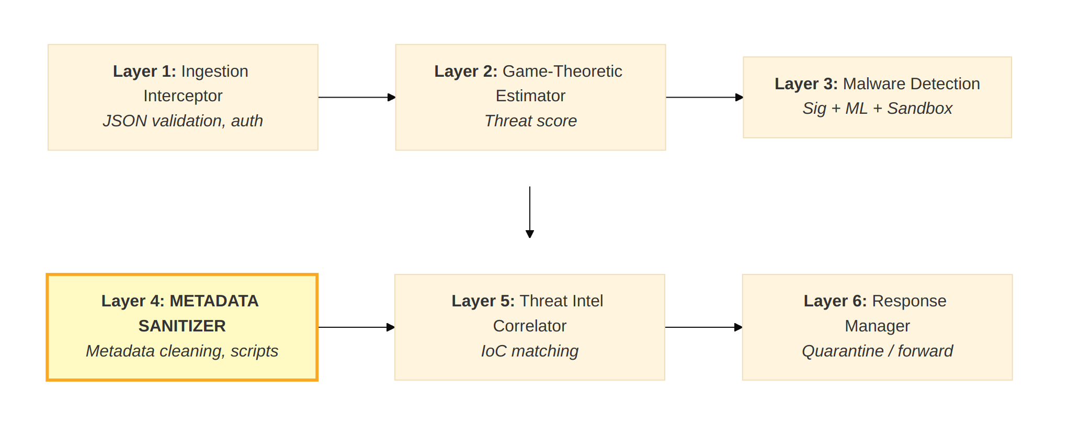

11.3 Security Properties
Property | Implementation
Parser safety | Use well-maintained libraries (Pillow, pikepdf, mutagen); no custom binary parsers
Output validation | Always verify file integrity after sanitization (re-parse, check rendering)
Sandboxed execution | Planned (Phase 3) — handlers will run in a restricted subprocess (no network, limited FS). Not implemented in v2.0.
Idempotency marker | Planned (Phase 3) — files will carry an X-Sanitized-By marker so re-runs short-circuit. Not implemented in v2.0; in practice, re-sanitizing an already-cleaned file is a no-op for SELECTIVE/STRIP mode because there is nothing left to strip.
Forensic preservation | Keep original file copy and full before/after metadata hash
Graceful degradation | Missing library → handler unavailable → skip with warning (not crash)
Fail-safe restoration | If verification fails after sanitization → restore original from .orig copy AND reset result.sanitized=False so the rollback is reflected in stats and the caller-facing report

11.4 Production Security Hardening
The following measures are not yet implemented but are recommended for production field deployment:
Area | Recommendation | Priority
Handler sandboxing | Run each handler invocation in a seccomp-restricted subprocess or namespaced container with no network access, a per-file timeout (30 s), and a memory limit (512 MB). A parser exploit in Pillow/pikepdf/mutagen must not escape the sandbox. | Critical
Library version pinning | Pin Pillow, piexif, pikepdf, and mutagen to audited versions in a lock file. Subscribe to their CVE feeds (e.g., GitHub Dependabot, Snyk) and apply security patches within 72 hours. | Critical
Forensic copy integrity | Store .orig files in a WORM (Write-Once-Read-Many) bucket on MinIO with Object Lock enabled. This prevents tampering with the forensic baseline even if the edge node is compromised. | High
Disk usage alerts | Alert when edge-node disk usage exceeds 80%. The .orig copies are the primary contributor to disk growth. Automate a lifecycle policy: retain 90 days, then tier to cold storage or delete. | High
Idempotency marker | Stamp cleaned files with an X-Sanitized-By: v<version> marker (EXIF UserComment for images, XMP metadata for PDFs). On re-entry, detect the marker and short-circuit to avoid redundant processing. | Medium
Audit log export | Export per-file sanitization results (mode, changes, before/after hashes) as structured JSON to Grafana Loki or ELK for centralized forensic search and 90-day retention. | High
Processing timeout | Enforce a hard 60 s wall-clock timeout per file. If a handler hangs (e.g., on a crafted PDF with deep nesting), kill the subprocess and flag the file as sanitization_timeout. | High

12. Performance Requirements

12.1 Latency Targets
File Type | Typical Size | Target Latency | Notes
Image (JPEG) | 300 KB - 5 MB | < 100 ms | EXIF manipulation is fast
Video (MP4) | 5 MB - 500 MB | < 500 ms | Tag-level only; no transcoding
PDF | 100 KB - 50 MB | < 200 ms | Catalog/page scan; stream scan bounded
Archive (ZIP) | Variable | < 100 ms | Listing inspection only
Text (JSON/CSV) | 1 KB - 10 MB | < 50 ms | In-memory processing

12.2 Resource Bounds
Resource | Bound | Rationale
Memory per file | < 2x file size | File loaded once for parsing
PDF stream scan | Max 50 objects | Prevent DoS from PDFs with millions of objects
Text file read | Max 10 MB | Larger files skipped
Handler timeout | 30 seconds (configurable) | Prevent hanging on malformed files

12.3 Throughput
The sanitizer processes files sequentially within a single submission. For high-throughput deployments, multiple sanitizer instances can run in parallel across different submissions (stateless design).
Note --- Production throughput: The current sequential design is correct for a single-threaded demo but under-utilizes multi-core edge hardware. For production:
• Intra-submission parallelism: Use concurrent.futures.ProcessPoolExecutor
to sanitize multiple payloads from the same submission in parallel. Each handler already operates on an independent file, so no shared state is involved.
• Cross-submission parallelism: Deploy the sanitizer behind a
task queue (e.g., Celery with Redis broker or a simple multiprocessing.Pool) so that submissions from different drones are processed concurrently.
• Backpressure: If the sanitizer cannot keep up with the ingestion
rate, apply backpressure to the upstream pipeline rather than dropping files silently.

13. Dependencies
This section lists all runtime and optional dependencies, including the graceful degradation behaviour when optional libraries such as Pillow, piexif, pikepdf, or mutagen are absent.

13.1 Required Dependencies
Library | Purpose | License | Required By
Python 3.9+ | Runtime | PSF | All
Python stdlib | zipfile, tarfile, json, hashlib, re | PSF | ArchiveHandler, TextHandler

13.2 Optional Dependencies
Library | Purpose | License | Required By | Fallback
Pillow (PIL) | Image parsing and metadata extraction | MIT | ImageHandler | Handler unavailable
piexif | Surgical EXIF tag read/write for JPEG | MIT | ImageHandler | Pillow-only fallback (strips all EXIF)
pikepdf | PDF structure manipulation | MPL-2.0 | PdfHandler | Handler unavailable
mutagen | Video/audio metadata read/write | GPL-2.0 | VideoHandler | Handler unavailable
python-magic | File type detection via magic bytes | MIT | Future: magic-based type detection | MIME from ingestion

13.3 Installation
# Core (stdlib only — archive + text handlers work immediately)
pip install .

# Full installation (all handlers)
pip install pillow piexif pikepdf mutagen

# Verify handler availability
python -c "from metadata_sanitizer import ImageHandler, PdfHandler, VideoHandler; \
print(f'Image: {ImageHandler.is_available()}, PDF: {PdfHandler.is_available()}, Video: {VideoHandler.is_available()}')"

14. Testing Strategy
This section describes the testing strategy, including test coverage across all components, instructions for running the test suite, and the demo runner for manual verification.

14.1 Test Coverage
Test Class | Tests | What's Covered
TestSanitizerConfig | 4 | Default values, custom overrides, thresholds, skip sets
TestModels | 8 | Enum values, to_dict() serialization, snapshot creation
TestExifRules | 10 | Strip sets per mode, GPS preservation, no strip-preserve overlap
TestPdfRules | 4 | JavaScript/action presence, dangerous actions, no overlap
TestVideoRules | 4 | GPS/comment/structural tags, no strip-preserve overlap
TestHandlerRegistry | 10 | MIME routing, prefix fallback, unknown MIME default
TestBaseHandler | 5 | Snapshot creation, change recording, size anomaly detection
TestTextHandler | 13 | Encoding, null bytes, BOM, line endings, script detection, audit mode
TestArchiveHandler | 9 | ZIP metadata, path traversal, executables, double ext, zip bomb
TestSanitizer | 19 | Mode selection (threat/override/flags/default), pre-checks, text/archive/batch processing, stats, serialization, verification rollback (with and without `.orig`)
TestHandlerAvailability | 5 | is_available() for each handler
TestStoragePointerResolution | 5 | Absolute paths, file:/ URIs, S3 fallback, relative paths

Total: 96 unit tests

14.2 Running Tests
# All tests
python -m unittest metadata_sanitizer.tests.test_sanitizer -v

# With pytest
python -m pytest metadata_sanitizer/tests/ -v

# Specific test class
python -m pytest metadata_sanitizer/tests/test_sanitizer.py::TestTextHandler -v

14.3 Demo Runner
python -m metadata_sanitizer.run_demo

Processes sample files from drone_local_storage/ in three modes (audit, selective, threat-driven) and saves results to sanitizer_demo_output.json.

15. Deployment and Operations
This section covers the deployment topology, monitoring metrics, alert thresholds, and operational procedures for the Metadata Sanitizer in field deployments.

15.1 Deployment Topology
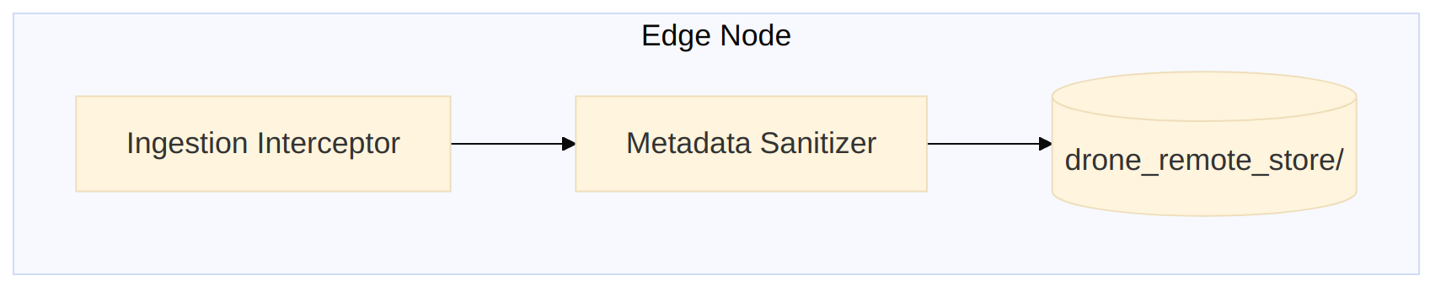
Note --- Current vs Production topology: The diagram above shows the current development setup where both modules share a local filesystem directory. For production field deployment, the recommended topology is:
Layer | Technology | Purpose
Artifact storage | MinIO (edge S3) | Shared object store replacing drone_remote_store/
Forensic copies | Separate MinIO bucket with WORM policy | Tamper-proof .orig storage with 90-day lifecycle
Processing model | Same process (default) or Celery worker pool | Parallel file sanitization across CPU cores
Metrics export | Prometheus client (/metrics HTTP endpoint) | Sanitization rates, error counts, latency histograms
Log aggregation | Structured JSON → Grafana Loki | Centralized search over sanitization audit trails
Container | Docker/Podman with seccomp profile | Resource limits (CPU, memory), filesystem isolation
The sanitizer is stateless --- it reads a file, cleans it, writes it back. This makes horizontal scaling trivial: add more worker processes or containers as throughput demands increase.

15.2 Monitoring Checklist
Metric | Source | Alert Threshold
Sanitization failures | sanitizer.stats["total_errors"] | > 5% of processed
Verification failures | Results with file_valid_after_sanitization=false | Any occurrence
Critical findings | Changes with severity="critical" | Any occurrence
Processing latency | result.processing_time_ms | > 1000 ms per file
Handler unavailability | Results with skip_reason="handler_unavailable" | Persistent
Disk usage (.orig files) | Filesystem / MinIO bucket monitoring | > 80% capacity
Handler timeout | result.errors containing timeout | Any occurrence (possible crafted file)
Library CVE | Dependabot / Snyk alerts | Any new CVE in Pillow, pikepdf, mutagen

15.3 Operational Procedures
Procedure | Steps
Enable GPS preservation | Set preserve_gps=True in SanitizerConfig
Switch to audit mode | Set default_mode="audit_only" or pass mode_override="audit_only"
Install missing handler | pip install pillow piexif then restart
Investigate sanitization failure | Check result.errors[], examine .orig file, verify handler availability
Forensic review | Compare .orig file with sanitized version; check metadata_before/after hashes

16. Risk Assessment
This section identifies key risks associated with the Metadata Sanitizer operation and their planned mitigations.
Risk | Likelihood | Impact | Mitigation
Parser vulnerability in Pillow/pikepdf | Medium | High | Pin library versions, monitor CVEs via Dependabot/Snyk, patch within 72h; production: sandbox each handler in a seccomp-restricted subprocess
False positive: legitimate metadata stripped | Medium | Medium | Audit-only mode for validation; preserve originals in WORM bucket; 90-day retention for forensic review
Performance degradation on large batches | Low | Medium | Bound per-file timeout (30 s); skip oversized files; production: parallel processing with ProcessPoolExecutor or Celery workers
Handler library not installed | Medium | Low | Graceful degradation with warnings; stdlib handlers always work; production: Docker image bakes all dependencies
Corrupted output after sanitization | Low | High | Post-sanitization verification; auto-restore from .orig; production: WORM forensic bucket guarantees original is never lost
Evolving exploit techniques bypass rules | Medium | High | Rule sets are declarative and easily updated; stream scanning catches novel patterns; subscribe to Pillow/pikepdf security advisories
GPL license concern (mutagen) | Low | Medium | mutagen is optional; video handler disabled without it; procurement review required before production deployment
Forensic copy disk exhaustion | Medium | Medium | Currently .orig copies have no automatic cleanup; production: MinIO lifecycle rule with 90-day retention + 80% disk alert

17. Implementation Roadmap
Phase | Deliverable | Status
Phase 1 | Core framework: config, models, orchestrator, handler registry | Done
Phase 1 | Text handler + Archive handler (stdlib only) | Done
Phase 1 | Sanitization rules (EXIF, PDF, video) — declarative definitions | Done
Phase 1 | Image handler (Pillow/piexif, with graceful fallback) | Done
Phase 1 | PDF handler (pikepdf, with graceful fallback) | Done
Phase 1 | Video handler (mutagen, with graceful fallback) | Done
Phase 1 | Unit test suite (94 tests) | Done
Phase 2 | Threat-score-driven mode selection | Done
Phase 2 | Forensic preservation (.orig files, before/after hashing) | Done
Phase 2 | Post-sanitization verification with auto-restore | Done
Phase 2 | Batch processing API | Done
Phase 3 | Seccomp-sandboxed handler execution (subprocess isolation, no network, memory limit) | Planned
Phase 3 | Magic-bytes-based file type detection (python-magic) to catch MIME spoofing | Planned
Phase 3 | Integration with Threat Intelligence Correlator (IoC extraction from stripped metadata) | Planned
Phase 3 | Parallel processing with ProcessPoolExecutor / Celery worker pool | Planned
Phase 3 | MinIO S3 storage-pointer resolution (replace local filesystem reads) | Planned
Phase 3 | WORM forensic bucket for .orig files with 90-day lifecycle policy | Planned
Phase 3 | Prometheus metrics exporter (/metrics endpoint) with Grafana dashboards | Planned
Phase 3 | Idempotency marker (X-Sanitized-By) to short-circuit re-sanitization | Planned
Phase 3 | Docker/Podman containerization with pinned dependency versions and seccomp profile | Planned
Phase 3 | Custom rule engine (user-defined strip/keep rules per deployment) | Planned

18. Glossary
Term | Definition
Artifact | A single file (image, video, PDF, etc.) within a drone submission, cataloged by the Ingestion Interceptor
ArtifactRecord | Structured metadata about an artifact: ID, type, MIME, storage pointer, security flags
EXIF | Exchangeable Image File Format — metadata standard for images (GPS, camera info, etc.)
IFD | Image File Directory — a section within EXIF data (IFD0, ExifIFD, GPSIFD, etc.)
IoC | Indicator of Compromise — observable artifact suggesting a security breach
MakerNote | Vendor-specific EXIF field with arbitrary binary content; no standard schema
Sanitization | The process of removing or neutralizing potentially harmful metadata from a file
T_S | Threat Score — output of the Game-Theoretic Estimator (0.0-1.0)
Stackelberg equilibrium | Game theory concept used by the Threat Estimator to compute optimal inspection strategy
moov/udta | MP4 container atoms: moov (movie container), udta (user data with tags)
Zip bomb | A malicious archive with extreme compression ratio designed to exhaust resources when decompressed
Defense-in-depth | Security strategy using multiple independent layers so no single failure compromises the system

