Design Document: Sandbox Analyzer
Field | Value
Module | sandbox_analyzer/
Version | 1.0
Status | Production
Layer | Layer 3 of the Multi-Layer Malware Detection Engine
Upstream | Inspection Strategy Selector (triggered when Threat Score is HIGH)
Downstream | Response & Quarantine Manager, Threat Intelligence Correlator, Security Dashboard / ML Loop
Research notebook | sandbox_explained_v2_(1).ipynb
Python version | 3.10+
Platform | Linux (kernel setrlimit + /proc required for Stages 3 and 4)
External deps | psutil (required by the process monitor)

Table of Contents
Update this field to see table of contents with page numbers (right-click > Update Field)

1. Executive Summary
The Sandbox Analyzer is Layer 3 of the Multi-Layer Malware Detection Engine. It activates only when the Game-Theoretic Threat Estimator has scored an ingestion submission as HIGH — the static Signature Scanner and AI/ML Classifier (Layers 1 and 2) run on every submission, but the expensive dynamic analysis here is reserved for the small minority of inputs that look genuinely suspicious.
The analyzer executes one suspicious artifact inside a kernel-limited Linux sandbox, observes it through four /proc-based monitors, scores the resulting behavioural events, correlates any observed indicators against threat intelligence, and emits one of three verdicts (CLEAN, SUSPICIOUS, MALICIOUS) together with a fully serialisable audit trail.
Three design decisions are load-bearing:
- Magic-byte routing. Extensions are never trusted — the File
Router reads the first 16 bytes of every artifact and uses the extension only as a fallback. A .jpg that begins with #! is handled as a script, not an image.
- Encrypted archives are evidence, not a challenge. The Archive
Handler never attempts password cracking. An encrypted archive arriving in a drone feed with no declared key is itself a suspicious indicator and adds risk points; extraction is skipped.
- Kernel-level isolation, userspace observation. Resource caps
(RLIMIT_AS, RLIMIT_CPU, RLIMIT_FSIZE, RLIMIT_NPROC, RLIMIT_CORE) are applied in a preexec_fn so they are in place before the target's exec(). Monitoring is done from outside the process by reading /proc — the monitored process cannot spoof what the kernel reports about it.

2. Goals and Non-Goals
This section defines the scope of the Sandbox Analyzer by listing the capabilities it implements and the responsibilities explicitly handled by other modules.

2.1 Goals
The following goals define the dynamic-analysis responsibilities of the sandbox.
ID | Goal
G-1 | Produce a bounded risk score and a three-level verdict for every submission handed to analyze()
G-2 | Identify file type via magic bytes, with extension as fallback, to defeat trivial disguise
G-3 | Safely handle archives (ZIP) with bomb detection, depth caps, and encrypted-payload flagging
G-4 | Execute suspicious files under kernel-enforced resource limits that malware cannot bypass
G-5 | Observe the running process via four independent /proc monitors at a configurable poll cadence
G-6 | Correlate observed IOCs (file hash, IPs, domains) against threat intelligence through an injected client
G-7 | Expose pluggable integration seams for threat intel, response management, dashboard, and ML retraining
G-8 | Fail closed on mis-configurations (SandboxConfig.__post_init__) and degrade safely on non-Linux hosts
G-9 | Emit a forensically complete report (routing, archive findings, execution results, events, score, IOC)
G-10 | Maintain processing statistics for operational monitoring (stats property)

2.2 Non-Goals
The following items are explicitly outside the scope of this module.
ID | Non-Goal
NG-1 | Windows executable emulation — PE files are flagged SUSPICIOUS for analyst review and never executed; cross-VM execution is out of scope for this module
NG-2 | Dictionary attacks on encrypted archives — encrypted-no-key is scored as a suspicious indicator instead
NG-3 | Signature-based antivirus scanning or ML-based classification — handled by Layers 1 and 2
NG-4 | Native drone protocol ingestion — the Ingestion Interceptor delivers artifacts on disk
NG-5 | Persistence of reports / findings — the host persists SandboxReport.to_dict() to its chosen store
NG-6 | Distributed sandbox coordination — one analyzer instance per edge node; cross-node fan-out is the host's concern
NG-7 | Sandbox escape research / exploit mitigation beyond POSIX setrlimit + /proc observation

3. System Context
This section places the Sandbox Analyzer inside the Multi-Layer Malware Detection Engine and enumerates its integration seams.

3.1 Position in the edge malware detection pipeline
The following diagram shows how the Inspection Strategy Selector routes HIGH-threat-score submissions to the sandbox and how verdicts flow back to the Response & Quarantine Manager and the reputation feedback loop.
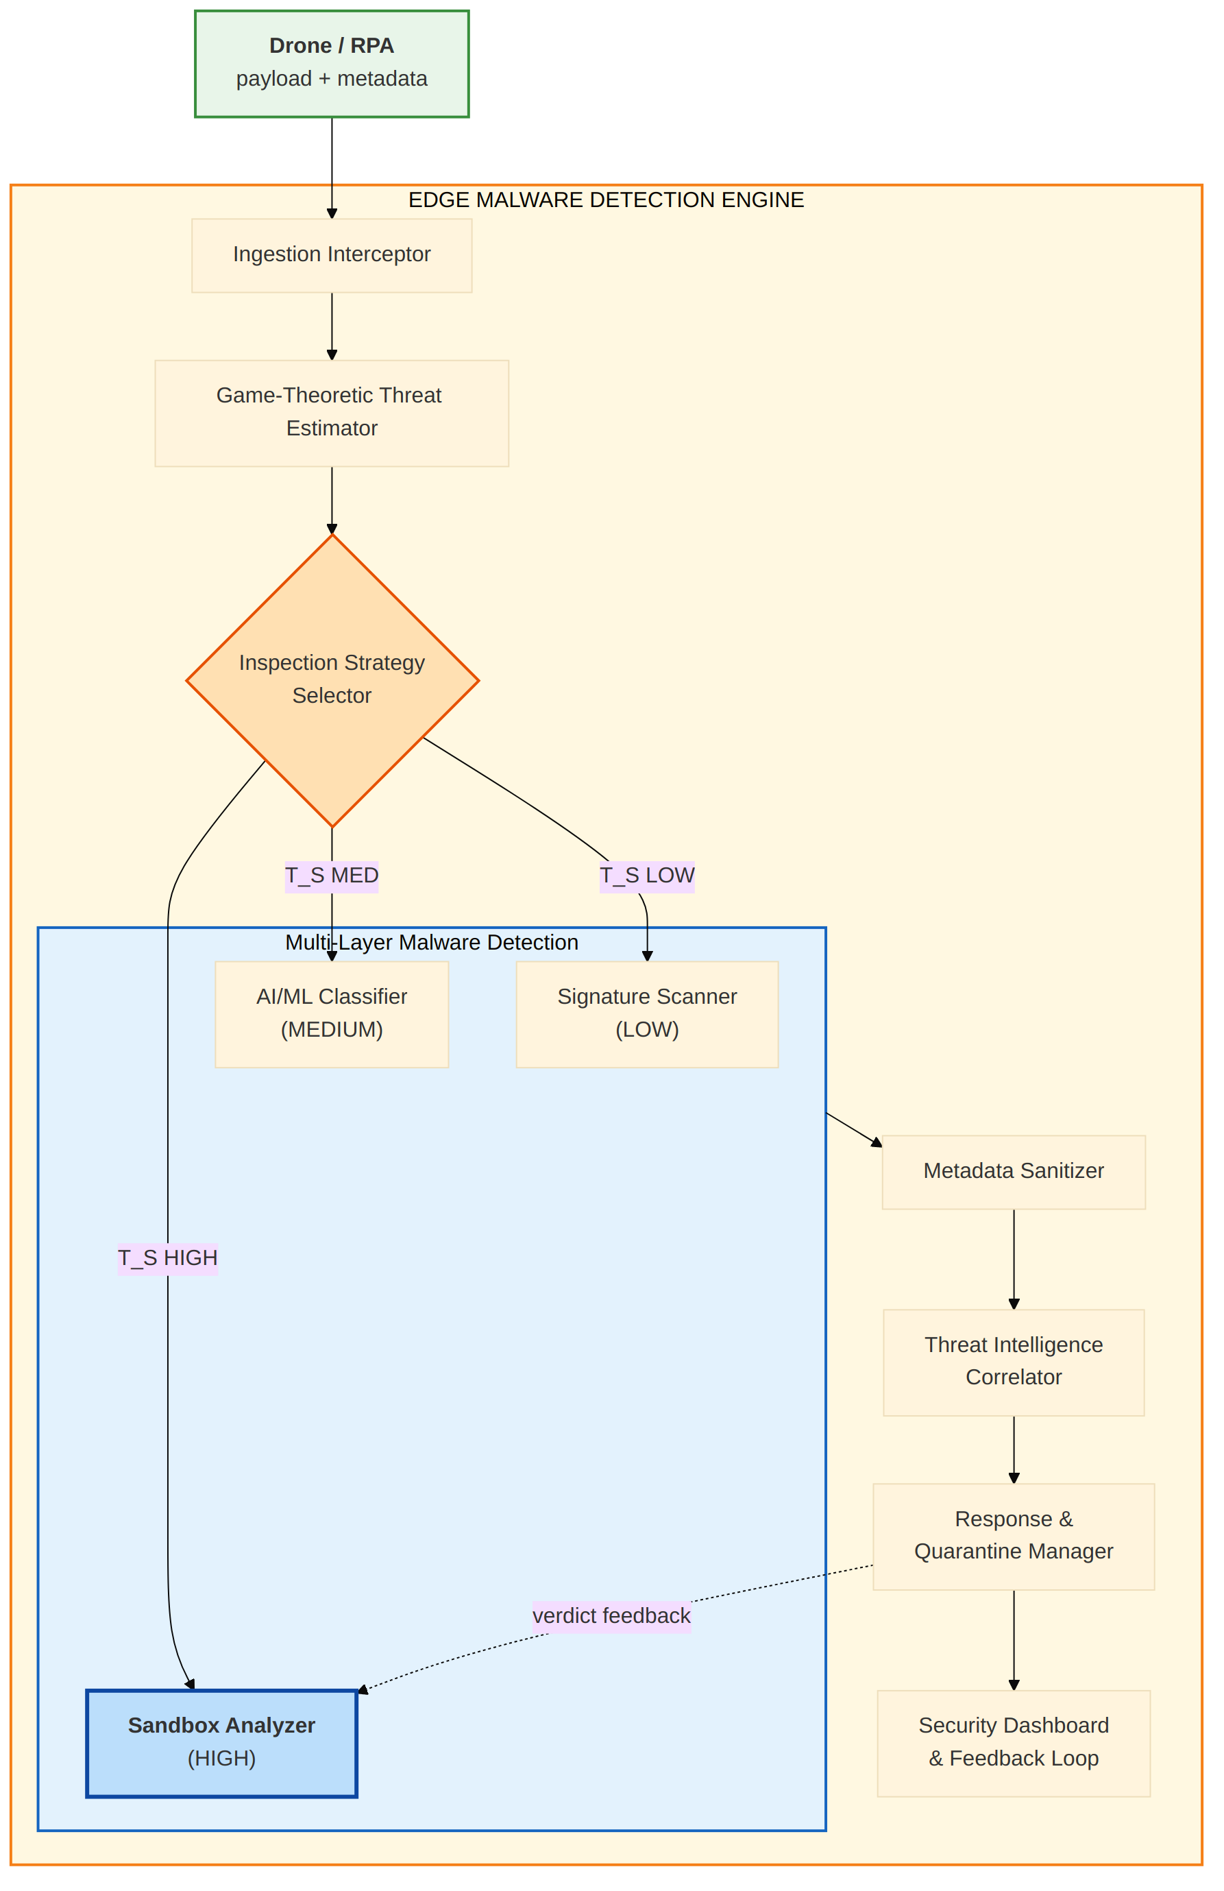

3.2 Integration seams
The analyzer is driven by one public method and two dependency-injected seams. Both seams have a reference implementation that is safe in isolation and a clear production path.
The analyzer is driven by one public call (analyze(file_path, drone_id, ...)) and two dependency-injected seams. Both seams have a reference implementation that is safe in isolation; production deployments subclass or replace them.
Seam | Reference implementation | Production backend
threat_intel_client | LocalThreatIntelClient (in-memory sets) | Subclass of ThreatIntelClient talking to VirusTotal / AlienVault OTX / MISP / internal Threat Intelligence Correlator
feedback_sink | LoggingFeedbackSink (structured log lines) | Subclass of FeedbackSink — or compose via build_sink(...) — bridging to Response & Quarantine Manager, Security Dashboard, and the ML retraining queue

The analyzer performs no network, filesystem (beyond the sandbox work dir), or subprocess calls outside the target artifact's own execution. All cross-module side effects flow through the two seams.

4. Architecture Overview
This section describes the internal architecture of the Sandbox Analyzer module: its file layout, the eight-stage pipeline, and the component dependency graph.

4.1 Module layout
The module is organised as a Python package with each pipeline stage implemented in a dedicated file for clear separation of concerns.
sandbox_analyzer/
├── __init__.py # public API re-exports
├── config.py # SandboxConfig dataclass + __post_init__ validation
├── models.py # SandboxReport, MonitorEvent, RoutingDecision, ...
├── router.py # Stage 1 — magic bytes + extension → RoutingDecision
├── archive_handler.py # Stage 2 — ZIP extraction, encryption / bomb / double-ext
├── execution.py # Stage 3 — subprocess under setrlimit + watchdog
├── monitors.py # Stage 4 — FS / Network / Process / Privilege monitors
├── scoring.py # Stage 5 — additive behaviour-weight scoring
├── ioc.py # Stage 6 — ThreatIntelClient + LocalThreatIntelClient
├── verdict.py # Stage 7 — threshold mapping + action strings
├── feedback.py # Stage 8 — FeedbackSink + LoggingFeedbackSink + build_sink
├── analyzer.py # SandboxAnalyzer orchestrator (all 8 stages)
├── run_demo.py # standalone demo
├── tests/
│ └── test_analyzer.py # 50 stdlib-unittest tests
└── README.md

4.2 Internal pipeline
The following diagram traces the eight stages of the sandbox pipeline, including the SAFE and WINDOWS-PE short-circuits that bypass execution.
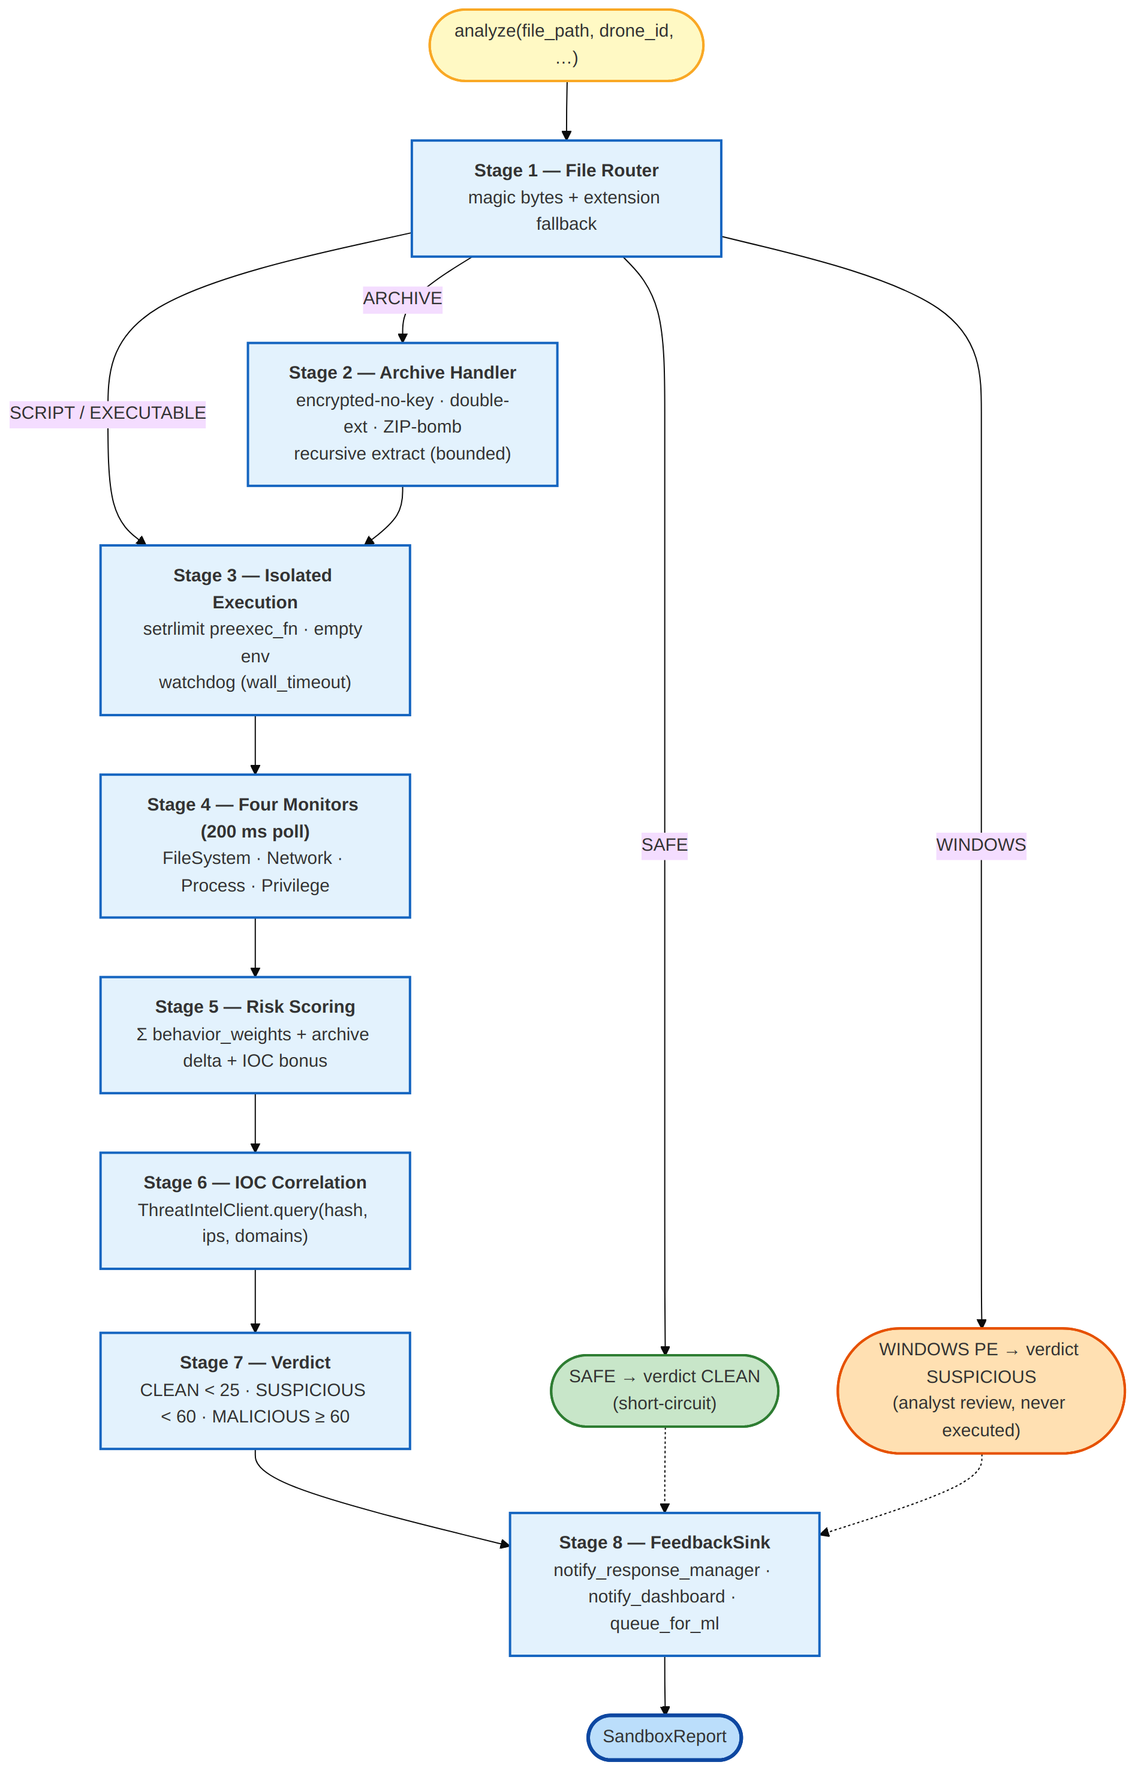

4.3 Component dependency diagram
The following diagram shows how SandboxAnalyzer composes the eight stage functions plus the two injected integration seams.
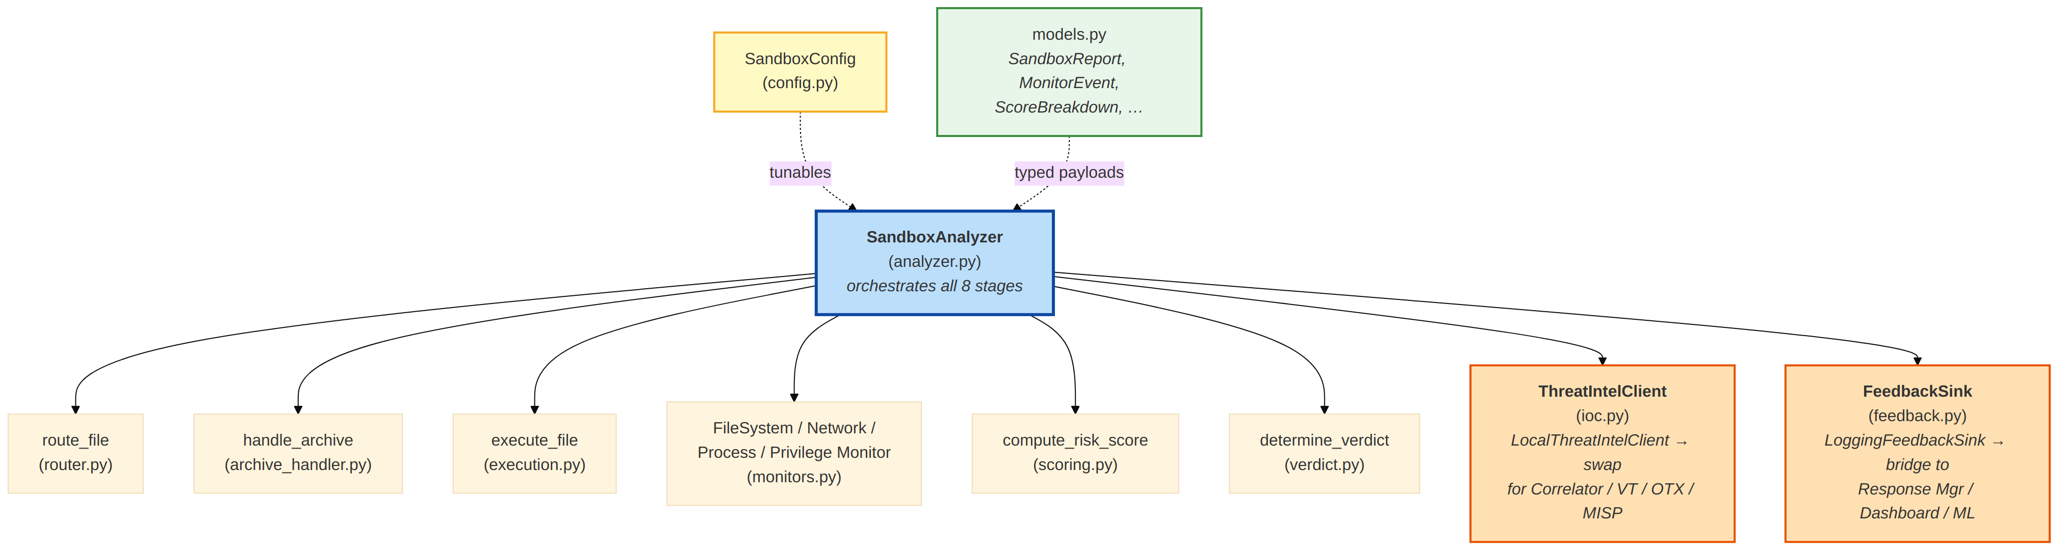

5. Component Design
This section provides detailed design documentation for every stage, including the routing rules, archive safety layers, kernel-enforced execution limits, the four monitors, the scoring engine, the IOC correlator, the verdict mapper, and the feedback sink.

5.1 SandboxConfig (config.py)
Single @dataclass holding every tunable: routing behaviour (skip_safe_files, flag_windows_executables), archive caps (max_extract_depth, zip_bomb_ratio, zip_bomb_min_size_bytes, encrypted_no_key_score, double_extension_score), execution limits (memory_bytes, cpu_seconds, file_bytes, max_processes, wall_timeout_seconds, empty_environment), monitor flags + poll cadence, suspicious-target lists (paths, processes, shells, executable extensions), risk-scoring weights, IOC bonus, verdict thresholds, and feedback enable flag.
__post_init__ fails the constructor if:
- malicious_threshold ≤ suspicious_threshold,
- any resource cap is ≤ 0,
- zip_bomb_ratio ∉ (0, 1],
- poll_interval_seconds ≤ 0,
- any behaviour weight is negative,
- clamp bounds are inverted.

5.2 File Router (router.py)
Reads the first 16 bytes of the artifact, matches against MAGIC_BYTES, and falls back to EXTENSION_MAP if no magic matches. Produces a RoutingDecision with category, interpreter (for scripts), skip flag (for SAFE), magic-match flag, and a human-readable reason.
Magic bytes covered: ZIP (PK\x03\x04, PK\x05\x06, PK\x07\x08), ELF (\x7fELF), JPEG, PNG, GIF, PDF, Windows PE (MZ), shebang (#!).

5.3 Archive Handler (archive_handler.py)
handle_archive(zip_path, output_dir, config, provided_password, depth) implements the encrypted-is-suspicious, ratio-based-bomb, and double-extension safety layers. Recursion through nested ZIPs is bounded by config.max_extract_depth. Every finding contributes an ArchiveResult.suspicious_flags entry and increments ArchiveResult.extra_risk_score; the orchestrator synthesises corresponding MonitorEvents (category file_write_executable for double-extension, high_entropy_write otherwise) so scoring is uniform across discovery mechanisms.

5.4 Isolated Execution (execution.py)
execute_file(file_path, config, interpreter, ..., on_pid) launches a child with subprocess.Popen and a preexec_fn that calls resource.setrlimit for RLIMIT_AS, RLIMIT_CPU, RLIMIT_FSIZE, RLIMIT_NPROC, and RLIMIT_CORE. The on_pid callback hands the child PID to the orchestrator as soon as it is known, so monitors can attach without racing the target.
A daemon watchdog thread sends SIGKILL at config.wall_timeout_seconds. communicate() carries an additional communicate_grace_seconds so genuine clean exits are not mis-reported as timeouts. On non-Linux hosts the function raises a clear RuntimeError; the orchestrator skips execution on such hosts.

5.5 Four Monitors (monitors.py)
Each monitor reads a different /proc source at a configurable poll cadence while the sandboxed process runs. The following table lists the data source and the event categories emitted by each monitor.
Every monitor appends MonitorEvent rows to a shared thread-safe EventLog. All are instantiated via build_monitors(pid, log, config) which respects the four enable_*_monitor flags.
Monitor | Source | Events raised
FileSystemMonitor | /proc/<PID>/fd + /proc/<PID>/fdinfo | file_system_write, file_write_executable
NetworkMonitor | /proc/net/tcp baseline diff | network_connect
ProcessMonitor | psutil.Process(pid).children(True) | process_spawn, shell_command
PrivilegeMonitor | /proc/<PID>/status (CapEff, VmRSS) | privilege_escalation, memory_inject

ProcessMonitor uses two sets from SandboxConfig to classify children: shell_processes is the canonical shell list (bash, sh, zsh, dash, fish), and suspicious_processes is the broader lateral-movement set (wget, curl, nc, sudo, compilers, cron tools, ...). Children whose name falls in either set are recorded as shell_command so the scoring engine treats suspicious-tool invocations as seriously as shell spawns; everything else is recorded as process_spawn.

5.6 Risk Scoring (scoring.py)
compute_risk_score(events, config) sums config.behavior_weights[ev.category] across all events and returns a ScoreBreakdown with totals, per-category counts, and a pre-sorted top_factors list. Unknown categories contribute zero so new event kinds can be introduced in the monitors without breaking this stage.

5.7 IOC Correlation (ioc.py)
correlate_iocs(file_path, events, config, client) computes the file's SHA-256, extracts IPs and domains from Network-monitor events, and hands all three to the injected ThreatIntelClient.query(). The response is translated into an IOCResult with bonus_score = config.ioc_match_bonus on any match.
Client exceptions are swallowed and logged — a transient Threat Intelligence Correlator outage must not prevent verdict emission.

5.8 Verdict (verdict.py)
Pure threshold mapping:
- score < suspicious_threshold → CLEAN
- suspicious_threshold ≤ score < malicious_threshold → SUSPICIOUS
- score ≥ malicious_threshold → MALICIOUS
action_for(verdict) returns the operator-facing action string consumed by the Response & Quarantine Manager.

5.9 Feedback (feedback.py)
FeedbackSink declares three no-op methods (notify_response_manager, notify_dashboard, queue_for_ml). LoggingFeedbackSink is the reference implementation; build_sink(...) composes a sink from three callables without subclassing. The orchestrator invokes each method with per-channel exception isolation so a broken dashboard does not block the response manager.

5.10 SandboxAnalyzer (analyzer.py)
The orchestrator. Public surface:
- analyze(file_path, drone_id, artifact_id=None, archive_password=None, threat_score=None) → SandboxReport
- stats property — live counters (total_analyzed, total_clean,
total_suspicious, total_malicious, total_skipped, total_archive_runs, total_execution_runs, total_errors, last_report_id).
Thread safety: a single SandboxAnalyzer instance is intended for one request-handling thread at a time. Host processes that fan out across threads should instantiate one analyzer per worker and share only the two injected dependencies (which must be thread-safe themselves). The reference LocalThreatIntelClient and LoggingFeedbackSink satisfy this contract.
Platform handling: on non-Linux hosts, Stages 3 and 4 are skipped and the report carries a warning. Stages 1, 2, 5, 6, 7, and 8 still run, so routing, archive safety, and IOC correlation remain available for investigation in development environments.

6. Data Models
This section defines the typed dataclasses exchanged across the Sandbox Analyzer's public API, including the SandboxReport output and its supporting models.
All models are @dataclass-based with a to_dict() method for structured logging and wire transport.

6.1 SandboxReport (output)
Returned by every call to analyze(). Carries the verdict, the score, and the full per-stage audit trail.
Field | Type | Notes
report_id | str | Opaque ID prefixed sbx_
file_path | str | Absolute path on disk
file_hash | str | SHA-256 hex, empty string on I/O error
drone_id | str | Propagated from the caller
artifact_id | Optional[str] | artifact://… ID for cross-module correlation
file_category | str (FileCategory value)
routing | Optional[RoutingDecision]
skipped | bool | True if a short-circuit fired (SAFE → CLEAN, WINDOWS → SUSPICIOUS)
skip_reason | Optional[str] | Human-readable reason set alongside skipped=True
archive_result | Optional[ArchiveResult] | Present for ARCHIVE categorisations
execution_results | List[ExecutionResult] | One per executed file (archives may produce several)
events | List[MonitorEvent] | Full behavioural trace
score_breakdown | Optional[ScoreBreakdown]
ioc_result | Optional[IOCResult]
risk_score | int | Total score after archive bonus and IOC bonus
verdict | Verdict | CLEAN / SUSPICIOUS / MALICIOUS
action | str | Operator-facing action for the Response Manager
created_at | str (ISO-8601 UTC)
duration_sec | float | End-to-end wall-clock
warnings, errors | List[str]
config_snapshot | Dict[str, Any] | Subset of SandboxConfig used for this report (for forensic replay)

6.2 Supporting models
Model | Purpose
RoutingDecision | Stage 1 output: category, interpreter, should-skip, magic-match, details
ArchiveResult | Stage 2 output: extracted files, encryption flags, double-extension list, risk delta
ExecutionResult | Stage 3 output per file: pid, exit code, stdout/stderr previews, timed-out, duration
MonitorEvent | Stage 4 observation: timestamp, monitor, category, detail, structured data
ScoreBreakdown | Stage 5 output: total score, per-category totals, per-category counts, top factors
IOCResult | Stage 6 output: any-match flag, matched hashes/IPs/domains, bonus, source
Verdict | Enum — CLEAN, SUSPICIOUS, MALICIOUS
FileCategory | Enum — EXECUTABLE, SCRIPT, ARCHIVE, IMAGE, DOCUMENT, SAFE, WINDOWS, UNKNOWN
MonitorName | Enum — FileSystem, Network, Process, Privilege, ArchiveHandler, Router, Execution

7. API Specification
This section documents the public Python API: constructor arguments, primary methods, supporting stage helpers, and an integration example.

7.1 Construction
SandboxAnalyzer(
config: Optional[SandboxConfig] = None,
threat_intel_client: Optional[ThreatIntelClient] = None,
feedback_sink: Optional[FeedbackSink] = None,
)

All three arguments have reference implementations, so the minimum viable instantiation is SandboxAnalyzer().

7.2 Primary methods
Method | Purpose
analyze(file_path, drone_id, artifact_id=None, archive_password=None, threat_score=None) -> SandboxReport | Run all eight stages on one artifact
stats (property) | Live counters for operational monitoring

7.3 Supporting APIs
Each stage exports a pure-function or class that can be consumed standalone for unit testing, batch jobs, or custom orchestration:
- route_file(path, skip_safe_files=True) → RoutingDecision
- handle_archive(zip_path, out_dir, config, provided_password=None, depth=0) → ArchiveResult
- execute_file(path, config, interpreter=None, work_dir=None, env=None, on_pid=None) → ExecutionResult
- build_monitors(pid, log, config) → list[Monitor]
- compute_risk_score(events, config) → ScoreBreakdown
- correlate_iocs(file_path, events, config, client=None) → IOCResult
- determine_verdict(score, config) → Verdict / action_for(verdict) → str
- ThreatIntelClient, LocalThreatIntelClient, FeedbackSink, LoggingFeedbackSink, build_sink(...)

7.4 Integration example
from sandbox_analyzer import (
SandboxAnalyzer, SandboxConfig,
ThreatIntelClient, build_sink,
)

class CorrelatorClient(ThreatIntelClient):
source = "threat_intelligence_correlator"
def query(self, file_hash, observed_ips, observed_domains):
return tic_backend.lookup(file_hash, observed_ips, observed_domains)

analyzer = SandboxAnalyzer(
config=SandboxConfig(),
threat_intel_client=CorrelatorClient(),
feedback_sink=build_sink(
response_manager=response_mgr.apply,
dashboard=dashboard.emit,
ml_queue=ml_retraining_queue.enqueue,
),
)

report = analyzer.analyze(
file_path=artifact.pointer_storage,
drone_id=artifact.drone_id,
artifact_id=artifact.artifact_id,
archive_password=feed_metadata.archive_password,
threat_score=threat_estimate.threat_score,
)

8. Input / Output Specification
This section defines the exact input contract accepted by analyze(), the integration-seam contracts the host must satisfy, and the stable output contract emitted as SandboxReport.to_dict().

8.1 Input contract
analyze() takes one file path plus structured metadata:
Argument | Type | Required | Meaning
file_path | str | Yes | Absolute path to the artifact on disk (produced by the Ingestion Interceptor)
drone_id | str | Yes | Originating drone identifier; carried through to the report and feedback callbacks
artifact_id | Optional[str] | No | artifact://… ID from the Ingestion Interceptor; propagated for correlation
archive_password | Optional[str] | No | Key from feed metadata for encrypted archives; None = not declared
threat_score | Optional[float] | No | T_S from the Game-Theoretic Threat Estimator; recorded for audit, not used for routing

Preconditions (caller's responsibility — the sandbox does not re-validate):
- The file exists and is readable. (If it does not, the router records
a warning and the execution stage emits an ExecutionResult with an error field; the run still completes with a CLEAN verdict based on zero observed behaviour.)
- The artifact has already been authenticated by the Ingestion Interceptor.
- The caller has chosen to run the sandbox (typically because T_S ≥ θ_high).

8.2 Integration-seam contracts
`ThreatIntelClient.query(file_hash, observed_ips, observed_domains) -> dict` must return a dict with exactly these four keys:
{
"matched_hashes": list[str],
"matched_ips": list[str],
"matched_domains": list[str],
"any_match": bool,
}

`FeedbackSink` has three methods that accept a full SandboxReport:
- notify_response_manager(report) — the Response & Quarantine Manager applies the action.
- notify_dashboard(report) — the Security Dashboard logs the full report.
- queue_for_ml(report) — the ML retraining queue receives the behavioural trace and label.

8.3 Output contract
SandboxReport.to_dict(include_events=True) is the stable wire format consumed by downstream modules. include_events=False drops the event list (replacing it with event_count) for high-volume logging while preserving every other field.
Example (include_events=False, verdict = MALICIOUS):
{
"report_id": "sbx_8a0c19d41f52",
"file_path": "/var/artifacts/DRN-002/payload.py",
"file_hash": "e3b0c44298fc1c14...",
"drone_id": "DRN-002",
"artifact_id": "artifact://c1d2e3f4",
"file_category": "script",
"skipped": false,
"skip_reason": null,
"risk_score": 85,
"verdict": "MALICIOUS",
"action": "Block. Alert SOC/SIEM. Flag drone feed as compromised.",
"created_at": "2025-10-13T03:05:45.123456+00:00",
"duration_sec": 2.14,
"warnings": [],
"errors": [],
"routing": { "category": "script", "interpreter": "python3",
"should_skip": false, "magic_match": true,
"details": "Script — run with declared interpreter" },
"score_breakdown": { "total_score": 65, "by_category": { "network_connect": 50,
"shell_command": 25 }, "event_count": { ... },
"top_factors": [ "network_connect (x2 = +50)", "shell_command (x1 = +25)" ] },
"ioc_result": { "any_match": true, "matched_hashes": [],
"matched_ips": ["203.0.113.42"], "matched_domains": [],
"bonus_score": 20, "source": "threat_intelligence_correlator" },
"execution_results": [ { "pid": 14223, "exit_code": 0, "duration_sec": 1.83,
"timed_out": false, "error": null, ... } ],
"event_count": 3,
"config_snapshot": { "memory_bytes": 134217728, "cpu_seconds": 20, ... }
}

8.4 Downstream consumption contract
Downstream modules should consume only the stable fields below; the rest are audit-only and their schema may evolve:
Consumer | Fields read
Response & Quarantine Manager | verdict, action, drone_id, file_path, report_id
Threat Intelligence Correlator (feedback-loop ingress) | file_hash, ioc_result.matched_ips, verdict (to learn from malicious samples)
Security Dashboard / SIEM | Full to_dict(include_events=True) — forensic replay
ML retraining queue | events categories + verdict label

9. Sequence Diagrams
This section provides sequence diagrams for three canonical flows: a SAFE CSV short-circuit, an archive path with double-extension detection, and a script execute-and-monitor flow.

9.1 Happy path — SAFE CSV
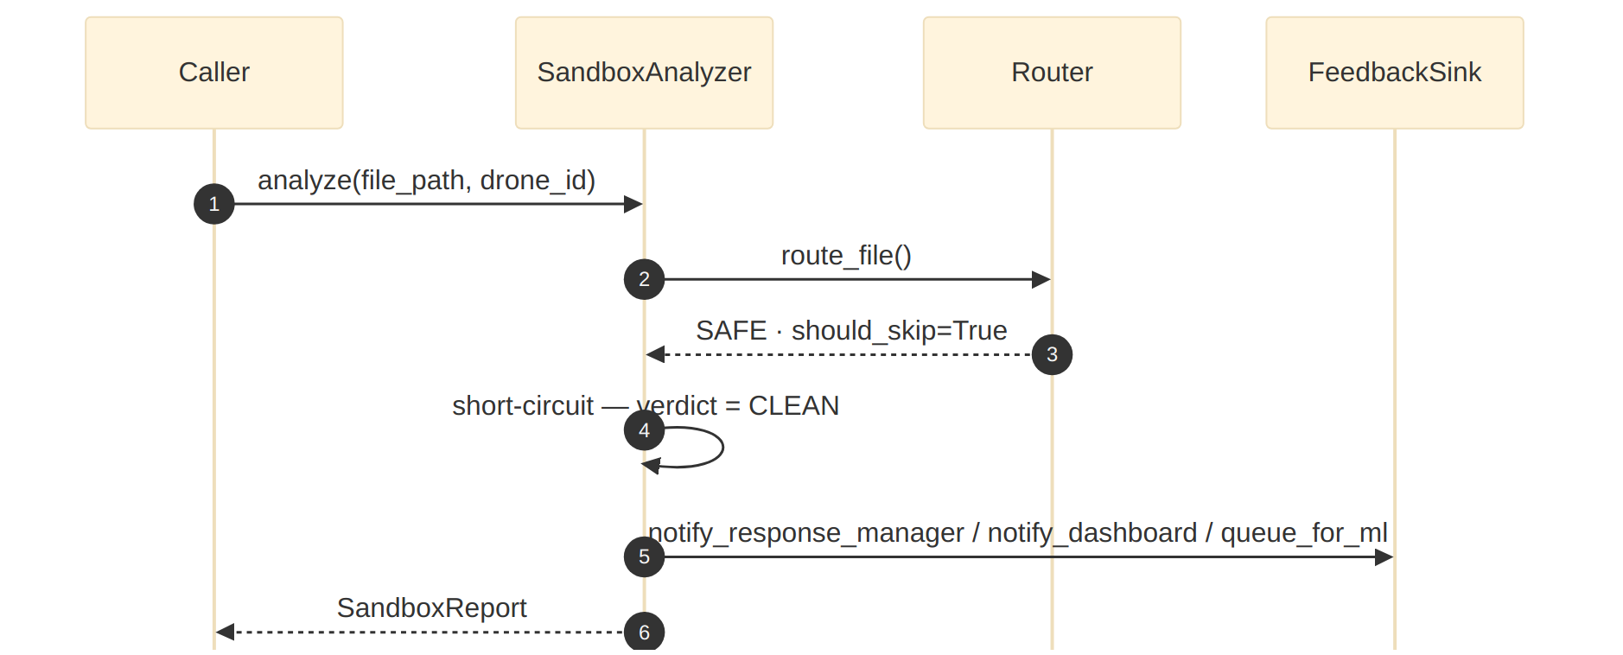

9.2 Archive path (double extension)
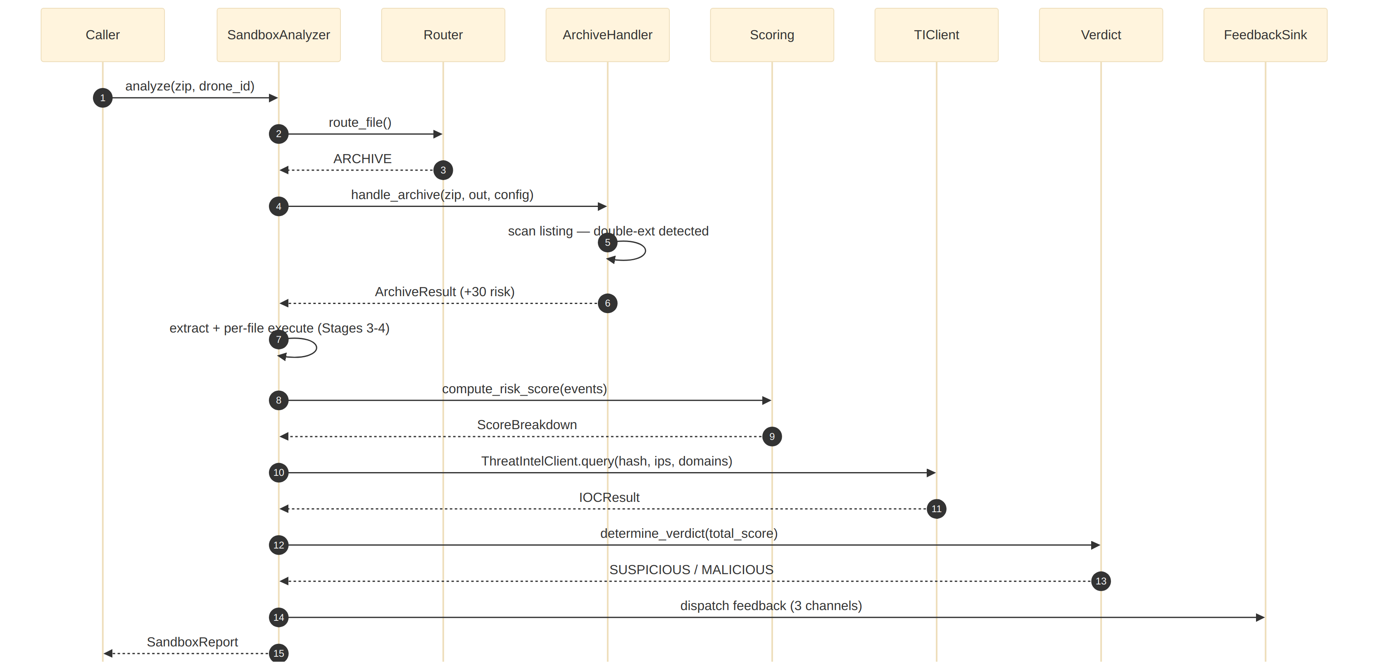

9.3 Execute + monitor path
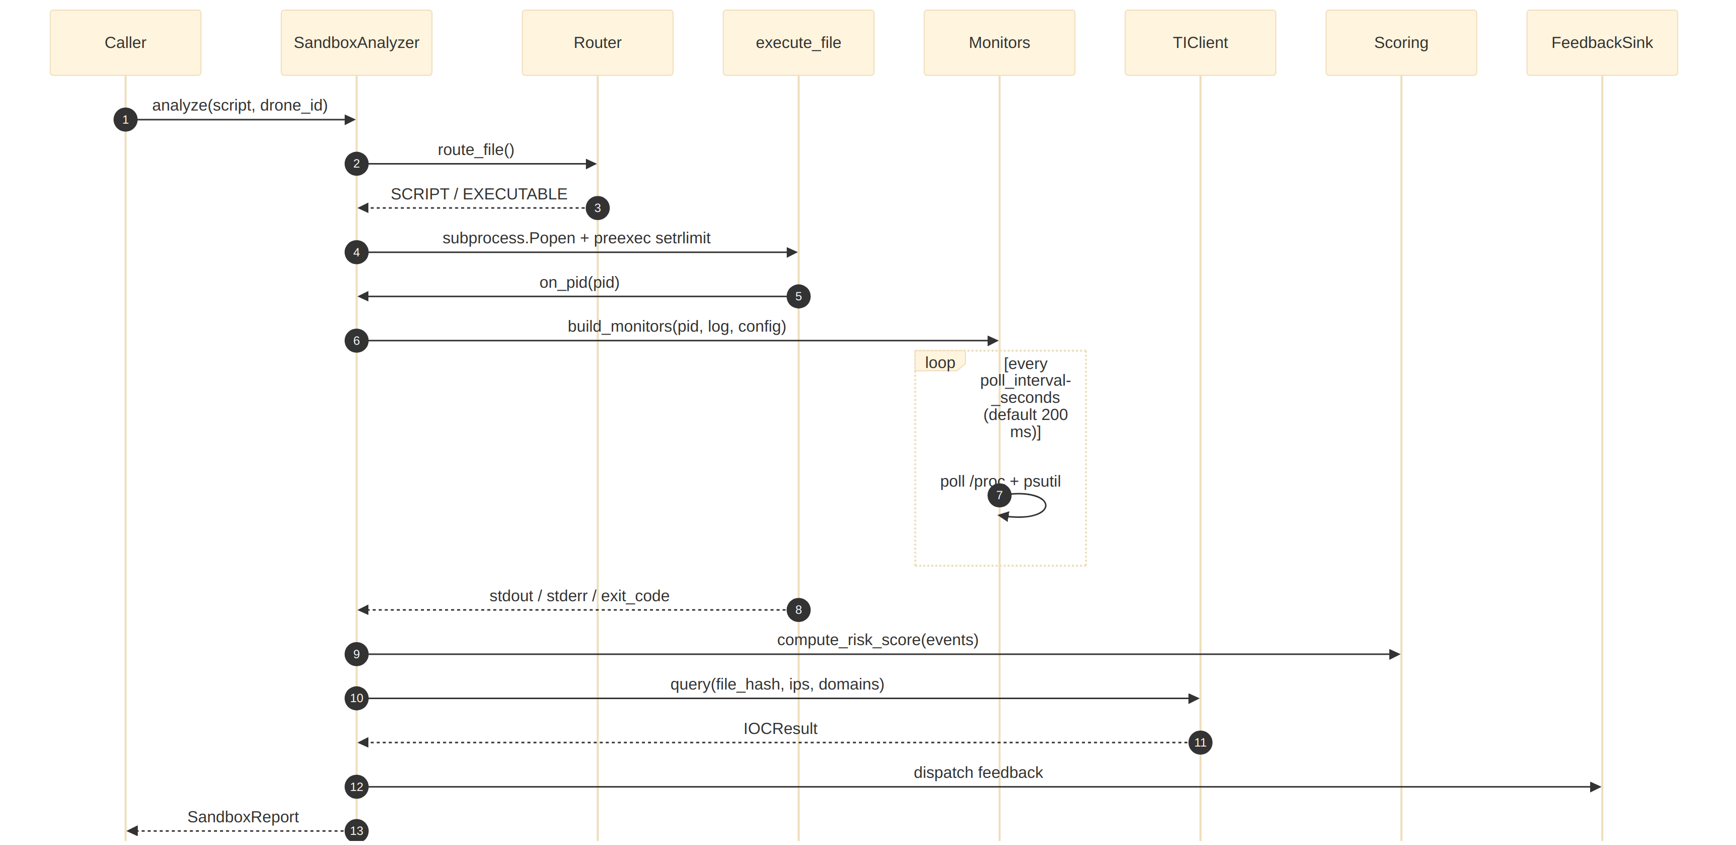

10. Risk Scoring Reference
The following table lists the default behaviour weights with a rationale per category, the three additive signals bolted onto the behaviour score, and the verdict bands. Weight calibration is an engineering judgement traced in the operational notes.
The default behavior_weights are:
event category weight rationale
─────────────────────────────────────────────────────────────────────
self_replication 40 copies itself into persistence locations
privilege_escalation 35 setuid / effective-capability gain
memory_inject 35 sudden VmRSS spike (payload unpacking)
api_hooking 30
file_write_executable 30 drops a new binary or script
network_connect 25 any outbound TCP attempt (SYN_SENT or ESTABLISHED)
shell_command 25 shell spawned by a data file
registry_write 20
high_entropy_write 15 packed / encrypted write
dns_lookup 15
process_spawn 10 generic child process
file_delete 10
file_system_write 5 low-weight baseline

Additive signals bolted onto the behaviour score:
Signal | Points | Source
Encrypted archive, no declared key | config.encrypted_no_key_score (25) | Archive Handler
Double-extension member in archive | config.double_extension_score (30) per occurrence | Archive Handler
Any IOC match | config.ioc_match_bonus (20) | IOC correlator

Verdict bands:
score < 25 → CLEAN
25 ≤ score < 60 → SUSPICIOUS
score ≥ 60 → MALICIOUS

Calibration discipline: the approach (weighted additive scoring of behavioural features) is standard in open-source dynamic-analysis sandboxes; the specific weights are engineering judgements seeded from threat severity and are expected to be re-tuned against a labelled malware corpus during evaluation.

11. Configuration Reference
This section enumerates every tunable parameter on SandboxConfig with its default value and meaning, grouped by functional area.
Every field of SandboxConfig, with defaults:
Group | Field | Default | Meaning
Routing | skip_safe_files | True | SAFE files return CLEAN without execution
Routing | flag_windows_executables | True | Windows PE files short-circuit with verdict SUSPICIOUS; never executed
Archive | max_extract_depth | 3 | Nesting cap for recursive ZIP extraction
Archive | zip_bomb_ratio | 0.005 | Abort extraction when compressed/uncompressed < this
Archive | zip_bomb_min_size_bytes | 10 MB | Only check ratio above this uncompressed size
Archive | encrypted_no_key_score | 25 | Risk bump for encrypted archive with no declared key
Archive | double_extension_score | 30 | Risk bump per double-extension member
Execution | memory_bytes | 128 MB | RLIMIT_AS cap
Execution | cpu_seconds | 20 | RLIMIT_CPU cap
Execution | file_bytes | 32 MB | RLIMIT_FSIZE cap
Execution | max_processes | 50 | RLIMIT_NPROC cap
Execution | wall_timeout_seconds | 30 | Watchdog kill
Execution | empty_environment | True | Run with env={}
Execution | communicate_grace_seconds | 2 | Grace after wall timeout for proc.communicate
Monitors | poll_interval_seconds | 0.2 | Monitor poll cadence
Monitors | enable_filesystem_monitor | True
Monitors | enable_network_monitor | True
Monitors | enable_process_monitor | True
Monitors | enable_privilege_monitor | True
Monitors | memory_spike_threshold_kb | 51200 | RSS jump (KB) that triggers memory_inject
Monitors | stdout_capture_bytes / stderr_capture_bytes | 2000 / 2000 | Output caps stored in ExecutionResult
Lists | suspicious_paths | see config.py | Paths that are suspicious to write into
Lists | suspicious_processes | see config.py | Lateral-movement tools (wget, curl, nc, sudo, compilers, cron) — names in this set are recorded as shell_command
Lists | shell_processes | {bash, sh, zsh, dash, fish} | Canonical shells; always recorded as shell_command
Lists | executable_extensions | (.sh, .py, .elf, .bin, .pl, .rb) | Used to promote file_system_write to file_write_executable
Scoring | behavior_weights | see §10 | Per-category additive weights
IOC | enable_ioc_correlation | True
IOC | ioc_match_bonus | 20 | Score bump on any IOC match
Verdict | suspicious_threshold | 25
Verdict | malicious_threshold | 60 | Must be strictly greater than suspicious_threshold
Feedback | enable_feedback_hooks | True | Disable to suppress all three post-verdict callbacks
Logging | log_level | "INFO" | Host installs handlers

12. Security & Threat Model
This section enumerates the adversary model with per-vector mitigations, describes the non-repudiation guarantees, specifies the input trust boundary, documents fail-closed configuration validation, and lists the external side effects the sandbox can and cannot have.

12.1 Adversary model
The attacker's goal is to have a malicious payload complete one or more harmful actions without tripping the verdict threshold. Known vectors and mitigations:
Vector | Mitigation in this module
Rename a script to look like an image to escape file-extension classification | Magic-byte inspection beats extension; #! / ELF / ZIP / PE all detected by header
Ship malware inside an encrypted ZIP so automated analysers cannot read it | Encrypted-no-key is scored as +25 and extraction is skipped — no dictionary attacks
Hide a binary inside a double-extension archive member (recon.jpg.sh) | Double-extension detection adds +30 per member before extraction
Exhaust sandbox memory or CPU to crash analysis | Kernel-enforced RLIMIT_AS, RLIMIT_CPU, RLIMIT_FSIZE, RLIMIT_NPROC, RLIMIT_CORE
Fork a legion of children to escape observation | RLIMIT_NPROC caps total children; ProcessMonitor walks the full descendent tree
Connect to a C2 server quickly then exit before the poll fires | Kernel records SYN_SENT in /proc/net/tcp; the baseline diff catches the row even after the process exits
Bypass process observation by tampering with /proc/<PID>/status | /proc is kernel-maintained; the monitored process cannot rewrite what it reports about itself
Use legitimate-looking behaviour to bias scoring | Additive scoring across four independent monitors makes single-action evasion insufficient for MALICIOUS
Leverage environment variables or cwd to find host data | Empty environment (env={}) and isolated temp cwd
Produce a core dump to exfiltrate memory | RLIMIT_CORE = 0 disables core dumps
Ship a Windows PE to a Linux sandbox expecting it to be forwarded unanalysed | Router short-circuit marks PE as SUSPICIOUS (quarantine + analyst review); never forwarded as CLEAN

12.2 Non-repudiation
Every SandboxReport carries report_id, created_at, the full event trace, per-file ExecutionResults, the score breakdown, the IOC result (including the backend's source tag), and a snapshot of the knobs that produced the decision. Persisting report.to_dict(include_events=True) is sufficient for replay.

12.3 Input trust boundary
The analyzer trusts that the caller has:
- authenticated the drone via the Ingestion Interceptor,
- decided (via the Threat Estimator) that this artifact warrants dynamic analysis,
- placed the artifact on a filesystem the analyzer can read.
The analyzer does not re-authenticate the source or re-validate the file format. Invoking analyze() on unvetted input is out of scope and unsupported.

12.4 Fail-closed configuration
SandboxConfig.__post_init__ rejects inconsistent deployments at construction time (inverted verdict thresholds, zero / negative resource caps, out-of-range compression ratio, negative behaviour weights). There is no silent-degrade path for bad configs.

12.5 External side effects
- Subprocess execution. One child process per analysed file, with
kernel-enforced caps and a 30-second watchdog.
- Filesystem. Temporary directories under the OS default
(tempfile.mkdtemp) for archive extraction and execution cwd; cleaned up after each call when owned by the analyzer.
- Network. Zero. The sandbox should run on a network-isolated
host. Network observation happens via /proc/net/tcp without ever opening sockets from the analyzer itself.

13. Performance Characteristics
This section documents the latency budget per phase, the memory bounds of every internal structure, and the throughput characteristics.

13.1 Latency budget
Phase | Typical time (Linux, single core)
Routing (magic-byte read) | < 1 ms
Archive extraction (small ZIP) | 10 – 100 ms
Subprocess launch + setrlimit | 5 – 20 ms
Target execution | dominated by the target itself; capped at 30 s
Monitor polling | ~1 ms per poll per monitor; 5 polls/sec × 4 monitors
Risk scoring | O(n) over events; sub-millisecond for typical n < 1000
IOC correlation | dominated by the injected client; reference impl < 1 ms
Verdict + feedback dispatch | microseconds
Full `analyze()` on a short-lived script | 0.5 – 2 s
Full `analyze()` on a long-running target | bounded by `wall_timeout_seconds` (30 s default)

13.2 Memory bounds
Structure | Bound
Target process | config.memory_bytes (128 MB default) — kernel-enforced
Sandbox file writes | config.file_bytes (32 MB default) — kernel-enforced
Child processes | config.max_processes (50 default) — kernel-enforced
Monitor event log | O(events); unbounded per report but each event is small
Per-analysis temp dirs | Cleaned up on return

13.3 Throughput
Dynamic analysis is expensive by design. A single analyzer instance sustains tens of analyses per minute for short-lived targets; long targets are bounded by wall_timeout_seconds. Because each analyser instance owns only ephemeral per-call state, horizontal scaling is trivial: one instance per ingestion worker, sharing the two injected dependencies (both of which are thread-safe).

14. Testing Strategy
This section describes the test-suite layout, how to run it (including the Linux-only integration tier that is auto-skipped on other platforms), and the invariants explicitly enforced.
50 tests live in sandbox_analyzer/tests/test_analyzer.py. Run with:
python -m unittest sandbox_analyzer.tests.test_analyzer -v
# or
python -m pytest sandbox_analyzer/tests/ -v

Coverage groups:
Group | Count | Highlights
TestSandboxConfig | 7 | Defaults, overrides, and every __post_init__ rejection (inverted thresholds, zero limits, bad ratio, negative weights)
TestFileRouter | 6 | Magic-byte precedence, CSV/ZIP/EXE detection, interpreter selection, unknown-type
TestArchiveHandler | 7 | Plain extraction, encrypted-no-key, encrypted-with-metadata-key, double-extension, depth cap, double-extension predicate (true/false)
TestScoringAndVerdict | 6 | Empty, single-write, suspicious band, malicious band, unknown categories → 0, top-factors ordering
TestIOC | 7 | Hash / IP match, structured data field extraction, loopback filter, bonus application, disabled path, error swallowing, domain regex rejects filenames
TestFeedbackSinks | 3 | Base no-op, logging sink, build_sink composition
TestAnalyzerStatic | 8 | Cross-platform paths: SAFE skip, Windows PE → SUSPICIOUS (not forwarded), archive double-ext, JSON round-trip, feedback invocation + isolation, stats, Windows-PE counter
TestAnalyzerLive | 1 | Linux-only integration test (auto-skipped elsewhere)
TestHelpers | 5 | compute_file_hash stable + missing file, is_encrypted_zip positive (via byte-level flag patching) and negative, action_for

Invariants specifically enforced:
- All three verdict bands (CLEAN / SUSPICIOUS / MALICIOUS) are
reachable without live execution — in particular, Windows PE input reaches SUSPICIOUS without executing a subprocess.
- Unknown event categories contribute zero — new monitors can be added
without breaking scoring.
- SandboxReport.to_dict() round-trips through json.dumps.
- Feedback-channel exceptions never propagate to the caller.
- Domain-extraction regex does not false-match bare filenames
(photo.jpg) — only multi-label FQDNs reach the threat-intel client.
- LocalThreatIntelClient.source == "local_stub" so a dashboard can
tell the reference implementation from a real correlator at a glance.

15. Operations
This section covers deployment, the operational monitoring checklist, and runbook snippets for common incidents.

15.1 Deployment
Single-process Python library. Deploy on Linux edge nodes with:
- Python ≥ 3.10
- psutil (required — used by ProcessMonitor)
- Network isolation — the host should not have outbound connectivity
so that observed C2 attempts fail cleanly into SYN_SENT rows the network monitor can detect.
- A writable temp directory for extraction / execution cwds.
The host process is responsible for:
- Constructing the SandboxConfig (or accepting the defaults).
- Wiring a real ThreatIntelClient subclass pointing at the Threat
Intelligence Correlator.
- Wiring a real FeedbackSink (or build_sink(...)) to the Response
& Quarantine Manager, Security Dashboard, and ML retraining queue.
- Installing log handlers for the sandbox_analyzer package logger.

15.2 Monitoring checklist
Scrape SandboxAnalyzer.stats periodically and alert on:
Signal | Alert when
total_malicious / total_analyzed | Sudden shift up or down by > 30 % vs. recent baseline
total_errors / total_analyzed | > 1 % — indicates environment issues (missing psutil, read-only /proc)
total_execution_runs / total_analyzed | Drops toward zero — most submissions are hitting SAFE / WINDOWS short-circuit
last_report_id unchanged for multiple minutes | No traffic reaching the sandbox
p99 duration_sec from reports | Approaching wall_timeout_seconds — targets are timing out

15.3 Runbook snippets
- Sandbox CPU saturated. Lower config.wall_timeout_seconds
temporarily; more submissions will bucket into SUSPICIOUS via timeouts rather than completing analysis. Review whether the Threat Estimator is routing too many submissions to HIGH.
- `psutil` import fails on startup. pip install psutil and
restart. Without it, ProcessMonitor becomes a no-op and shell / process spawn events are missed.
- Threat Intelligence Correlator down. The sandbox swallows
ThreatIntelClient.query() exceptions and continues; the report will show ioc_result.source with a non-stub value and any_match = False. No action required beyond reviving the correlator.
- Config rejected on startup. Read the ValueError raised from
SandboxConfig.__post_init__; fix the offending field; redeploy.
- All reports come back `CLEAN` unexpectedly. Inspect a sample
SandboxReport: check skipped/skip_reason first (likely SAFE short-circuit), then execution_results (are Linux stages enabled?), then events (is the monitor poll cadence too slow for short-lived targets?).

16. Risk Assessment
This section enumerates known risks with their likelihood, impact, and the in-module mitigation.
Risk | Likelihood | Impact | Mitigation
Behaviour weights diverge from the observed malware distribution | High (day 0) | Medium | Weights live in SandboxConfig.behavior_weights; refresh from a labelled corpus during evaluation without code changes
Short-lived targets exit before monitors poll | Medium | Medium | config.poll_interval_seconds is tunable; the analyzer runs one final sweep after the process exits
Host /proc not available (containers without /proc, non-Linux) | Medium | High | Module short-circuits Stages 3 and 4 with an explicit warning in the report; deploy only on Linux in production
ThreatIntelClient backend is flaky | Medium | Low | Exceptions are swallowed; verdicts continue without IOC bonus
FeedbackSink raises in one channel | Medium | Low | Per-channel exception isolation; other channels still fire
Malicious archive nests ZIPs beyond max_extract_depth | Low | Low | Depth cap halts recursion and flags the truncation
Attacker uses a platform-specific payload we cannot execute (Windows PE) | Medium | Medium | Flagged for manual review (FileCategory.WINDOWS); a Windows-VM adapter may be added as a separate module
Host forgets to install psutil | Low | Medium | ProcessMonitor becomes a safe no-op; README + runbook call this out
Monitor noise from other processes on the host leaks into NetworkMonitor | Medium | Low | Network baseline diff is per-analysis; deploy on dedicated / isolated hosts to minimise noise
Sandbox host is compromised and subverts the monitors | Low | High | Out of scope; the sandbox's security depends on host integrity — run under host-level EDR and restricted access

17. Glossary
- C2 server — Command & Control: an attacker-controlled host that a
compromised system "calls home" to for instructions and payloads.
- IOC — Indicator of Compromise: a piece of evidence (hash, IP,
domain, path) that a system has been compromised.
- Magic bytes — The first few bytes of a file that identify its
true format regardless of filename extension.
- `/proc` — The Linux pseudo-filesystem that exposes kernel state
as files; used here for every monitor except ProcessMonitor (which uses psutil).
- `setrlimit` / RLIMIT_\* — POSIX system call and resource-limit
identifiers used to cap memory (AS), CPU time (CPU), file size (FSIZE), child processes (NPROC), and core dumps (CORE).
- ZIP bomb — A crafted archive whose uncompressed size is many
orders of magnitude larger than its compressed size.
- Double extension — Disguise where a dangerous final extension
(.sh, .exe) is hidden behind a benign middle extension (.jpg, .pdf).
- Shebang — The #!interpreter line at the start of a Unix
script that tells the kernel how to execute it.
- Stackelberg equilibrium — The leader-follower game solution
produced by the Threat Estimator upstream of this module; the sandbox itself does not solve any games.
- SIGXCPU — Signal delivered to a process that exceeds its
RLIMIT_CPU allowance.

