Design Document: Game-Theoretic Threat Estimator
Field | Value
Module | threat_estimator/
Version | 1.0
Status | Production
Upstream | ingestion_interceptor — produces IngestResult
Downstream | Multi-Layer Malware Detection Engine, metadata_sanitizer, Response & Quarantine Manager
Research notebook | Game_theoretic_threat_estimator_v3.ipynb
Python version | 3.10+
External deps | None (standard library only)

Table of Contents
Update this field to see table of contents with page numbers (right-click > Update Field)

1. Executive Summary
The Game-Theoretic Threat Estimator consumes the structured output of the Ingestion Interceptor and emits a per-submission Threat Score T_S ∈ [0, 1] plus a discrete inspection level (Low / Medium / High) that routes the submission to an appropriate subset of the multi-layer detection stack (Signature → AI/ML → Sandbox).
Three capabilities distinguish this module from a static threshold classifier:
- Stackelberg game model. The defender is modelled as the leader
and the attacker as the follower. The module picks the inspection strategy that maximises defender utility under the attacker's best response, so low-risk feeds skip the sandbox and high-risk feeds trigger it automatically.
- Bayesian cold-start reputation. When a drone has no history,
reputation is computed from observable context (Zone × File Type) via a small Bayesian Belief Network, avoiding a dangerous static default.
- Adaptive thresholds driven by feedback. θ_low and θ_high
are soft-updated from live FPR / FNR metrics so the system self-calibrates as attack patterns evolve.
The module depends only on the Python standard library, is fully deterministic given its inputs, and emits a serialisable audit trail for every estimate.

2. Goals and Non-Goals
This section defines the scope of the Game-Theoretic Threat Estimator by listing the capabilities it is responsible for and the responsibilities explicitly delegated to other modules.

2.1 Goals
The following goals define the core functional responsibilities of the Threat Estimator within the edge malware detection pipeline.
ID | Goal
G-1 | Produce a bounded, calibratable Threat Score T_S ∈ [0, 1] from the upstream IngestResult payload
G-2 | Route every submission to Low / Medium / High inspection with clear, auditable reasoning
G-3 | Solve the cold-start problem using observable context without requiring labelled history
G-4 | Adapt routing thresholds in response to observed FPR / FNR drift using a bounded soft-update rule
G-5 | Expose dependency seams (reputation store, feedback loop, CPTs) so production backends plug in cleanly
G-6 | Run with only the Python standard library — no ML framework or network dependency
G-7 | Emit a forensically complete audit record for every estimate (Bayesian trace, payoffs, equilibrium, config)
G-8 | Fail closed on inconsistent configuration (validation in EstimatorConfig.__post_init__)
G-9 | Guarantee bounded memory: all internal caches are size-capped by configuration
G-10 | Maintain processing statistics for operational monitoring (stats property)

2.2 Non-Goals
The following items are deliberately outside the scope of this module.
ID | Non-Goal
NG-1 | File-content inspection, AV scanning, AI/ML classification, or sandbox execution — handled by downstream modules
NG-2 | Persistent storage of reputation or feedback state — the reference implementation is in-memory
NG-3 | Wire-level ingestion — assumes the Ingestion Interceptor has already produced an authenticated IngestResult
NG-4 | Training of ML classifiers — the Bayesian network uses hand-tunable CPTs, not gradient-learned parameters
NG-5 | Distributed coordination — one estimator instance per edge node; cross-node consistency is not addressed here
NG-6 | Mixed-strategy Stackelberg equilibria — the solver enumerates pure strategies only
NG-7 | Cryptographic verification of drone identity — fully delegated to the Ingestion Interceptor

3. System Context
This section places the Threat Estimator in the broader edge malware detection pipeline and identifies the four dependency-injected seams through which it connects to production backends.

3.1 Position in the edge malware detection pipeline
The following diagram shows how the Threat Estimator sits between the Ingestion Interceptor and the Multi-Layer Malware Detection Engine, and how verdicts from the Response Manager and metrics from the Dashboard feed back into the estimator.
The Threat Estimator sits between ingestion and detection. It converts metadata + artifact summaries into a routing decision.
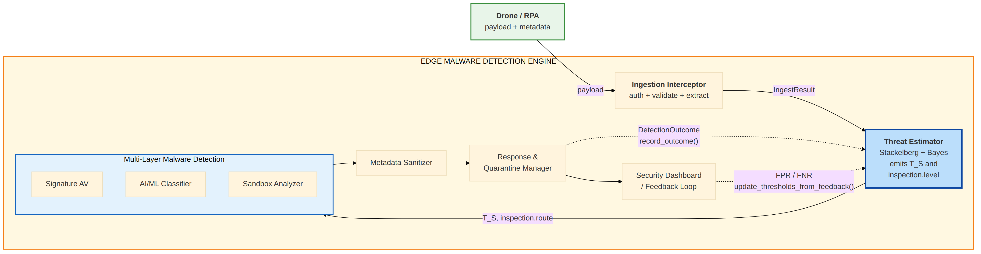

3.2 Integration seams
The following table enumerates the four dependency-injected integration points; each has a reference implementation that is safe in isolation and a clear path to a production backend.
Four dependencies are injected into GameTheoreticThreatEstimator so host processes can supply production backends without touching the algorithms:
Seam | Reference implementation | Production backend
reputation_store | InMemoryReputationStore (thread-safe dict) | Subclass backed by Redis / Postgres / RocksDB; implements the same four-method contract
feedback_loop | FeedbackLoop (rolling-window, in-process) | Subclass that subscribes to Response & Quarantine Manager / SIEM events
bayesian_estimator.zone_likelihood, file_likelihood | Seed CPTs matching the reference worked example | Periodic refresh via BayesianReputationEstimator.update_cpts() from a learning job
estimate(history=, threat_intel=) | 0.0 / 0.0 | Rolling infection frequency from the Response Manager; IOC corroboration from the Threat Intelligence Correlator

No network, filesystem, or subprocess calls happen inside this module by default. All external integration is gated by the constructor.

4. Architecture Overview
This section describes the internal architecture of the Threat Estimator module: its file layout, component dependencies, and the data flow of a single estimate.

4.1 Module layout
The module is organised as a flat Python package with each algorithmic concern in its own file.
threat_estimator/
├── __init__.py # public API re-exports
├── config.py # EstimatorConfig dataclass + __post_init__ validation
├── models.py # dataclasses: ThreatEstimate, BayesianTrace, ...
├── bayesian.py # BayesianReputationEstimator + CPTs + reputation update
├── stackelberg.py # I', DSR', payoff builder, solver, T_S mapping
├── adaptive.py # AdaptiveThresholdManager (soft-update rule + clamps)
├── reputation_store.py # InMemoryReputationStore (thread-safe dict; subclass for prod)
├── feedback.py # FeedbackLoop (rolling FPR/FNR aggregator)
├── estimator.py # GameTheoreticThreatEstimator orchestrator
├── run_demo.py # standalone demo runner
├── tests/
│ └── test_estimator.py # 48 stdlib-unittest tests
└── README.md

4.2 Component dependency diagram
The following diagram shows how GameTheoreticThreatEstimator composes the Bayesian estimator, Stackelberg helpers, adaptive threshold manager, reputation store, and feedback loop.
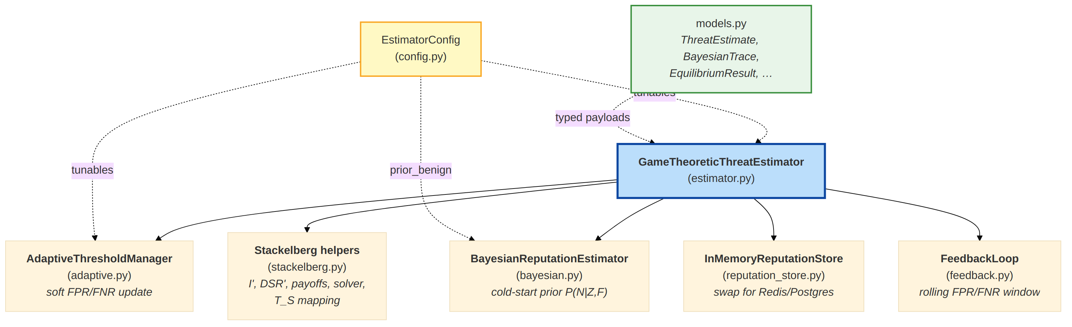

4.3 Data flow through the pipeline
The following numbered steps trace a single call to estimate() from raw IngestResult to an emitted ThreatEstimate.
- Caller hands an IngestResult dict to
estimator.estimate_from_ingest_result().
- _resolve_reputation() picks R from (in priority order) upstream
metadata, reputation store, Bayesian prior, configured default.
- _resolve_zone_risk() picks Z from upstream metadata, configured
zone lookup, or the default.
- _compute_I_base() folds artifact sizes + per-type risk + mission
sensitivity, then _apply_flag_bumps() adds deltas for every insecure flag raised upstream.
- compute_I_prime(I_base, R, Z) and
compute_DSR_primes(DSR_base, H, TI) produce the game inputs.
- build_payoff_matrices() constructs U_d and U_a;
solve_stackelberg_pure() returns the pure-strategy equilibrium.
- compute_threat_score() maps the equilibrium to T_S.
- AdaptiveThresholdManager.classify(T_S) returns the inspection
decision using the live thresholds.
- A ThreatEstimate is assembled with the full audit trail and
returned; the last estimate per drone is cached in a bounded LRU so record_outcome() can correctly classify follow-up verdicts.

5. Component Design
This section provides detailed design documentation for every component, including the orchestrator, algorithmic helpers, persistent stores, and feedback-loop aggregator.

5.1 EstimatorConfig (config.py)
Single @dataclass holding every tunable: impact weights (alpha, beta, gamma, delta), threat-score mapping (kappa, lambda_blend), defender / attacker strategy sets, DSR base rates, defender and attacker costs (C_d / C_a), adaptive-threshold bounds, Bayesian prior, asymmetric reward / penalty rates, per-file-type risk lookup, insecure-flag impact bumps, and the LRU cache bound.
__post_init__ enforces internal consistency:
- every defender strategy has a matching entry in DSR_base and C_d,
- every attacker action has a matching entry in C_a,
- 0 ≤ th_low < th_high ≤ 1,
- clamp bounds are ordered (*_min ≤ *_max),
- prior_benign ∈ (0, 1), reward_rate, penalty_rate ∈ [0, 1],
- eta ≥ 0, estimate_cache_max_size ≥ 1.

5.2 BayesianReputationEstimator (bayesian.py)
Implements the posterior R = P(Benign | Zone, FileType) with conditional independence between Zone and File Type given Attack Status. Ships with seed CPTs (DEFAULT_ZONE_LIKELIHOOD, DEFAULT_FILE_LIKELIHOOD) and pessimistic fallbacks for unseen labels. update_cpts() is the refresh hook for online learning.
A module-level update_reputation(R, verdict, reward_rate, penalty_rate) function implements the asymmetric reward / penalty rule used by GameTheoreticThreatEstimator.record_outcome().

5.3 Stackelberg primitives (stackelberg.py)
Pure-function layer — no state, no I/O:
- compute_I_prime(I_base, R, Z)
- compute_DSR_primes(DSR_base, H, TI)
- build_payoff_matrices(I', DSR', C_d, C_a, S_d, S_a)
- solve_stackelberg_pure(payoffs, C_d) — defender-as-leader,
pure-strategy enumerator. Attacker breaks ties in the direction that hurts the defender; defender breaks ties toward the cheaper strategy.
- compute_threat_score(U_a_eq, U_d_eq, R) — sigmoid normalisation +
reputation blend.

5.4 AdaptiveThresholdManager (adaptive.py)
Owns the live θ_low and θ_high. update(fpr, fnr) applies the soft-update rule and clamps to the safe bounds declared in the config; a configurable threshold_min_gap stops θ_high - θ_low from collapsing under aggressive updates. classify(T_S) returns an InspectionDecision containing the level and an ordered route list (e.g. ["signature", "ml", "sandbox"]). Disabling adaptive_thresholds makes update() a no-op, which is useful for deterministic replays and canary comparisons.

5.5 InMemoryReputationStore (reputation_store.py)
Thread-safe dict wrapper over ReputationProfile. get() returns a defensive copy so callers cannot mutate stored state. snapshot() serialises the full store for persistence or audit. Production deployments subclass it and override get, put, delete, and list_drones.

5.6 FeedbackLoop (feedback.py)
Rolling-window (deque(maxlen=window_size)) aggregator. observe(outcome, inspection_level) records a (level, verdict) pair. compute_metrics() returns a cached FeedbackMetrics with TP / FP / TN / FN / precision / recall / FPR / FNR over the current window.
Classification convention:
- High or Medium level × malicious verdict → True Positive
- High or Medium level × benign verdict → False Positive
- Low level × malicious verdict → False Negative
- Low level × benign verdict → True Negative
- unknown / quarantined verdicts are skipped

5.7 GameTheoreticThreatEstimator (estimator.py)
Orchestrator; the public API is listed in §7. Internally:
- _resolve_reputation() picks R from the priority chain in §4.3.
- _resolve_zone_risk() does the same for Z.
- _compute_I_base() + _apply_flag_bumps() compute the pre-game
impact from artifact records and insecure flags.
- _cache_last_estimate() writes into the bounded LRU so that
record_outcome() can back-fill the inspection level used when the estimate was produced (the feedback loop needs it) and can seed the reputation-update step from the Bayesian prior when the store has no history for this drone.
Thread-safety: injected stores are thread-safe; the orchestrator itself is intended to be invoked from one request-handling thread at a time, matching the pattern of the sibling modules. Host processes that fan out across threads should instantiate one estimator per worker and share only the underlying stores.

6. Data Models
This section defines the typed dataclasses exchanged across the Threat Estimator's public API, including the ThreatEstimate output and its supporting models.
All models are @dataclass-based with to_dict() methods for structured logging and wire transport.

6.1 ThreatEstimate (output)
Returned by every call to estimate(). Carries the final score, the inspection decision, and the complete audit trail.
Field | Type | Notes
estimate_id | str | Opaque ID, prefix est_
drone_id | str | Propagated from ingest_metadata.drone_id
ingest_id | Optional[str] | For cross-module correlation
mission_zone | Optional[str]
file_type | Optional[str] | Dominant type across artifact records
reputation | float | R ∈ [0, 1] actually used for scoring
reputation_source | str | One of history / bayesian_prior / provided / default
bayesian_trace | Optional[BayesianTrace] | Present only when source = bayesian_prior
I_base | float | Pre-game impact after flag bumps, clamped to [0, 10]
I_prime | float | Adjusted impact used by the game
DSR_prime | Dict[str, float] | Detection success rate per defender strategy
payoffs | Optional[PayoffMatrix] | U_d and U_a matrices with strategy labels
equilibrium | Optional[EquilibriumResult] | Defender strategy, attacker action, equilibrium utilities
raw_attacker_advantage | float | U_a_eq - U_d_eq
T_raw | float | σ(κ · raw_attacker_advantage)
threat_score | float | T_S ∈ [0, 1]
inspection | Optional[InspectionDecision] | Level + ordered route + live thresholds
created_at | str (ISO-8601 UTC)
config_snapshot | Dict[str, Any] | Subset of config used for this estimate (for replay)
warnings | List[str]

6.2 Supporting models
Model | Purpose
BayesianTrace | Priors, per-evidence likelihoods, numerator / denominator, final R, fallback flags
PayoffMatrix | Strategy and action labels plus U_d / U_a
EquilibriumResult | Chosen defender strategy, attacker action, equilibrium utilities
InspectionDecision | Level (Low / Medium / High), ordered route, live thresholds
ReputationProfile | Stored reputation record: value, source, updated_at, sample count, last verdict
DetectionOutcome | Input to record_outcome()
FeedbackMetrics | FPR / FNR / precision / recall + confusion counts
BatchThreatEstimate | Aggregate output of estimate_batch()
InspectionLevel | Enum — Low, Medium, High
ReputationSource | Enum — history, bayesian_prior, provided, default
DetectionVerdict | Enum — benign, malicious, unknown, quarantined

7. API Specification
This section documents the public Python API surface: constructor arguments, primary methods, and an end-to-end integration example.

7.1 Construction
GameTheoreticThreatEstimator(
config: Optional[EstimatorConfig] = None,
reputation_store: Optional[InMemoryReputationStore] = None,
bayesian_estimator: Optional[BayesianReputationEstimator] = None,
threshold_manager: Optional[AdaptiveThresholdManager] = None,
feedback_loop: Optional[FeedbackLoop] = None,
)

Every argument has a sensible default, so the minimum viable instantiation is GameTheoreticThreatEstimator().

7.2 Public methods
Method | Purpose
estimate(ingest_metadata, artifact_records, history=0.0, threat_intel=0.0) -> ThreatEstimate | Score a single submission
estimate_from_ingest_result(ingest_result, **kwargs) -> ThreatEstimate | Convenience wrapper accepting an IngestResult dict directly
estimate_batch(list[(metadata, artifacts)]) -> BatchThreatEstimate | Score many submissions; aggregates per-level counts
record_outcome(DetectionOutcome) -> ReputationProfile | Consume a detection verdict; updates reputation and feeds the feedback loop
update_thresholds_from_feedback() -> Tuple[float, float] | Pull FPR / FNR from the feedback loop and soft-update the thresholds
update_thresholds(fpr, fnr) -> Tuple[float, float] | Direct pass-through for hosts that compute metrics externally
stats (property) | Live counters, threshold state, store / window sizes

7.3 Integration example
from ingestion_interceptor import IngestionInterceptor
from threat_estimator import (
GameTheoreticThreatEstimator,
EstimatorConfig,
DetectionOutcome,
)

interceptor = IngestionInterceptor(...)
estimator = GameTheoreticThreatEstimator(EstimatorConfig())

ingest_result = interceptor.process(drone_json).to_dict()
estimate = estimator.estimate_from_ingest_result(ingest_result)

# Run the engines listed in estimate.inspection.route
# e.g. ["signature", "ml", "sandbox"]
verdict = detection_engine.run(estimate.inspection.route, ingest_result)

estimator.record_outcome(DetectionOutcome(
drone_id=estimate.drone_id,
verdict=verdict, # "benign" | "malicious" | ...
source="sandbox",
estimate_id=estimate.estimate_id,
))

# Periodically, from a monitoring loop
estimator.update_thresholds_from_feedback()

8. Input / Output Specification
This section defines the exact input contract accepted by estimate() and the stable output contract emitted as ThreatEstimate.to_dict(), plus the downstream consumption contract per module.

8.1 Input contract
estimate() takes two dict arguments. Both shapes are produced directly by the Ingestion Interceptor — the estimator does not re-validate authenticity, signatures, or file format (those are the interceptor's responsibility).

8.1.1 ingest_metadata — accepted fields
Field | Type | Required | Source / Notes
drone_id | str | Yes | Propagated into the estimate
ingest_id | str | No | Used only for cross-module correlation
mission_zone | str | No | Default: "unknown". Used as Zone in Bayesian prior
insecure_flags | List[str] | No | Each known flag adds a delta to I_base (see §11)
auth_result | str | No | "fail" / "failed" add flag_impact_bumps["auth_failed"]
reputation | float in [0, 1] | No | If present, takes priority over history and Bayesian prior
zone_risk | float in [0, 1] | No | If present, overrides zone_risk_lookup
additional_metadata | Dict[str, Any] | No | mission_sensitivity substring of critical/high/med adds to I_base
notes | str | No | Same sensitivity-substring matching as a fallback

Unknown fields are ignored. Errored IngestResult dicts (those with {"error": True, ...}) cause estimate_from_ingest_result() to raise ValueError.

8.1.2 artifact_records — accepted fields per record
Field | Type | Required | Notes
type | str | Yes | Lookup key in config.type_risk; unknown types fall back to "other" (0.4)
size_bytes | int | Yes | Averaged across all artifacts to compute size contribution
filename | str | No | Not used for scoring; preserved in logs
mime | str | No | Not used for scoring (interceptor has already classified)
encryption | bool | No | Signals via insecure_flags, not read directly
container | bool | No | Signals via insecure_flags, not read directly

Any extra keys produced by the interceptor are passed through unchanged and ignored.

8.1.3 Feedback inputs
record_outcome(DetectionOutcome) — fields:
Field | Type | Required | Notes
drone_id | str | Yes
verdict | str | Yes | One of benign, malicious, unknown, quarantined
source | str | No | "signature" / "ml" / "sandbox" / "triage"
estimate_id | Optional[str] | No | For cross-correlation with the originating estimate
artifact_id | Optional[str] | No
observed_at | str (ISO-8601) | No | Auto-filled by the dataclass
confidence | Optional[float] | No | Detector's self-reported confidence

8.2 Output contract

8.2.1 ThreatEstimate.to_dict(include_matrices=True)
Lightweight mode (include_matrices=False) drops DSR_prime, payoffs, and config_snapshot, keeping the estimate small enough for high-volume logging. Full mode includes everything and is the default for forensic storage.
Example (lightweight mode, irrelevant long fields trimmed):
{
"estimate_id": "est_f3a9c1d28e4b",
"drone_id": "DRN-002",
"ingest_id": "ingest_c7d6e5f4a3",
"mission_zone": "zone-c",
"file_type": "archive",
"reputation": 0.256725,
"reputation_source": "bayesian_prior",
"I_base": 5.58,
"I_prime": 7.88,
"raw_attacker_advantage": -0.89,
"T_raw": 0.33,
"threat_score": 0.374,
"bayesian_trace": { "zone": "zone-c", "file_type": "archive",
"P_N": 0.85, "P_A": 0.15,
"P_Z_given_N": 0.12, "P_Z_given_A": 0.35,
"P_F_given_N": 0.08, "P_F_given_A": 0.45,
"numerator": 0.00816, "denominator": 0.031785,
"R": 0.256725,
"used_fallback_zone": false,
"used_fallback_file": false },
"equilibrium": { "defender_strategy": "signature",
"attacker_action": "inject",
"defender_index": 0, "attacker_index": 0,
"U_d_eq": 4.30, "U_a_eq": 3.41 },
"inspection": { "level": "Low",
"route": ["signature"],
"threshold_low": 0.4,
"threshold_high": 0.7 },
"created_at": "2025-10-13T03:05:45.123456+00:00",
"warnings": []
}

8.2.2 Downstream consumption contract
Downstream modules should consume only the following stable fields:
Consumer | Fields read
Multi-Layer Malware Detection Engine | inspection.route, inspection.level
metadata_sanitizer | threat_score (maps to sanitization mode via its config)
Response & Quarantine Manager | threat_score, inspection.level, drone_id, estimate_id
Security Dashboard / SIEM | full to_dict() for forensic replay

Fields outside this set (intermediate game values, Bayesian trace, config snapshot) are considered audit-only and their schema may evolve.

9. Sequence Diagrams
This section provides sequence diagrams for the three canonical flows: a cold-start happy-path estimate, the verdict-feedback + threshold-refresh cycle, and the rejection of an errored IngestResult.

9.1 Happy path — cold-start submission
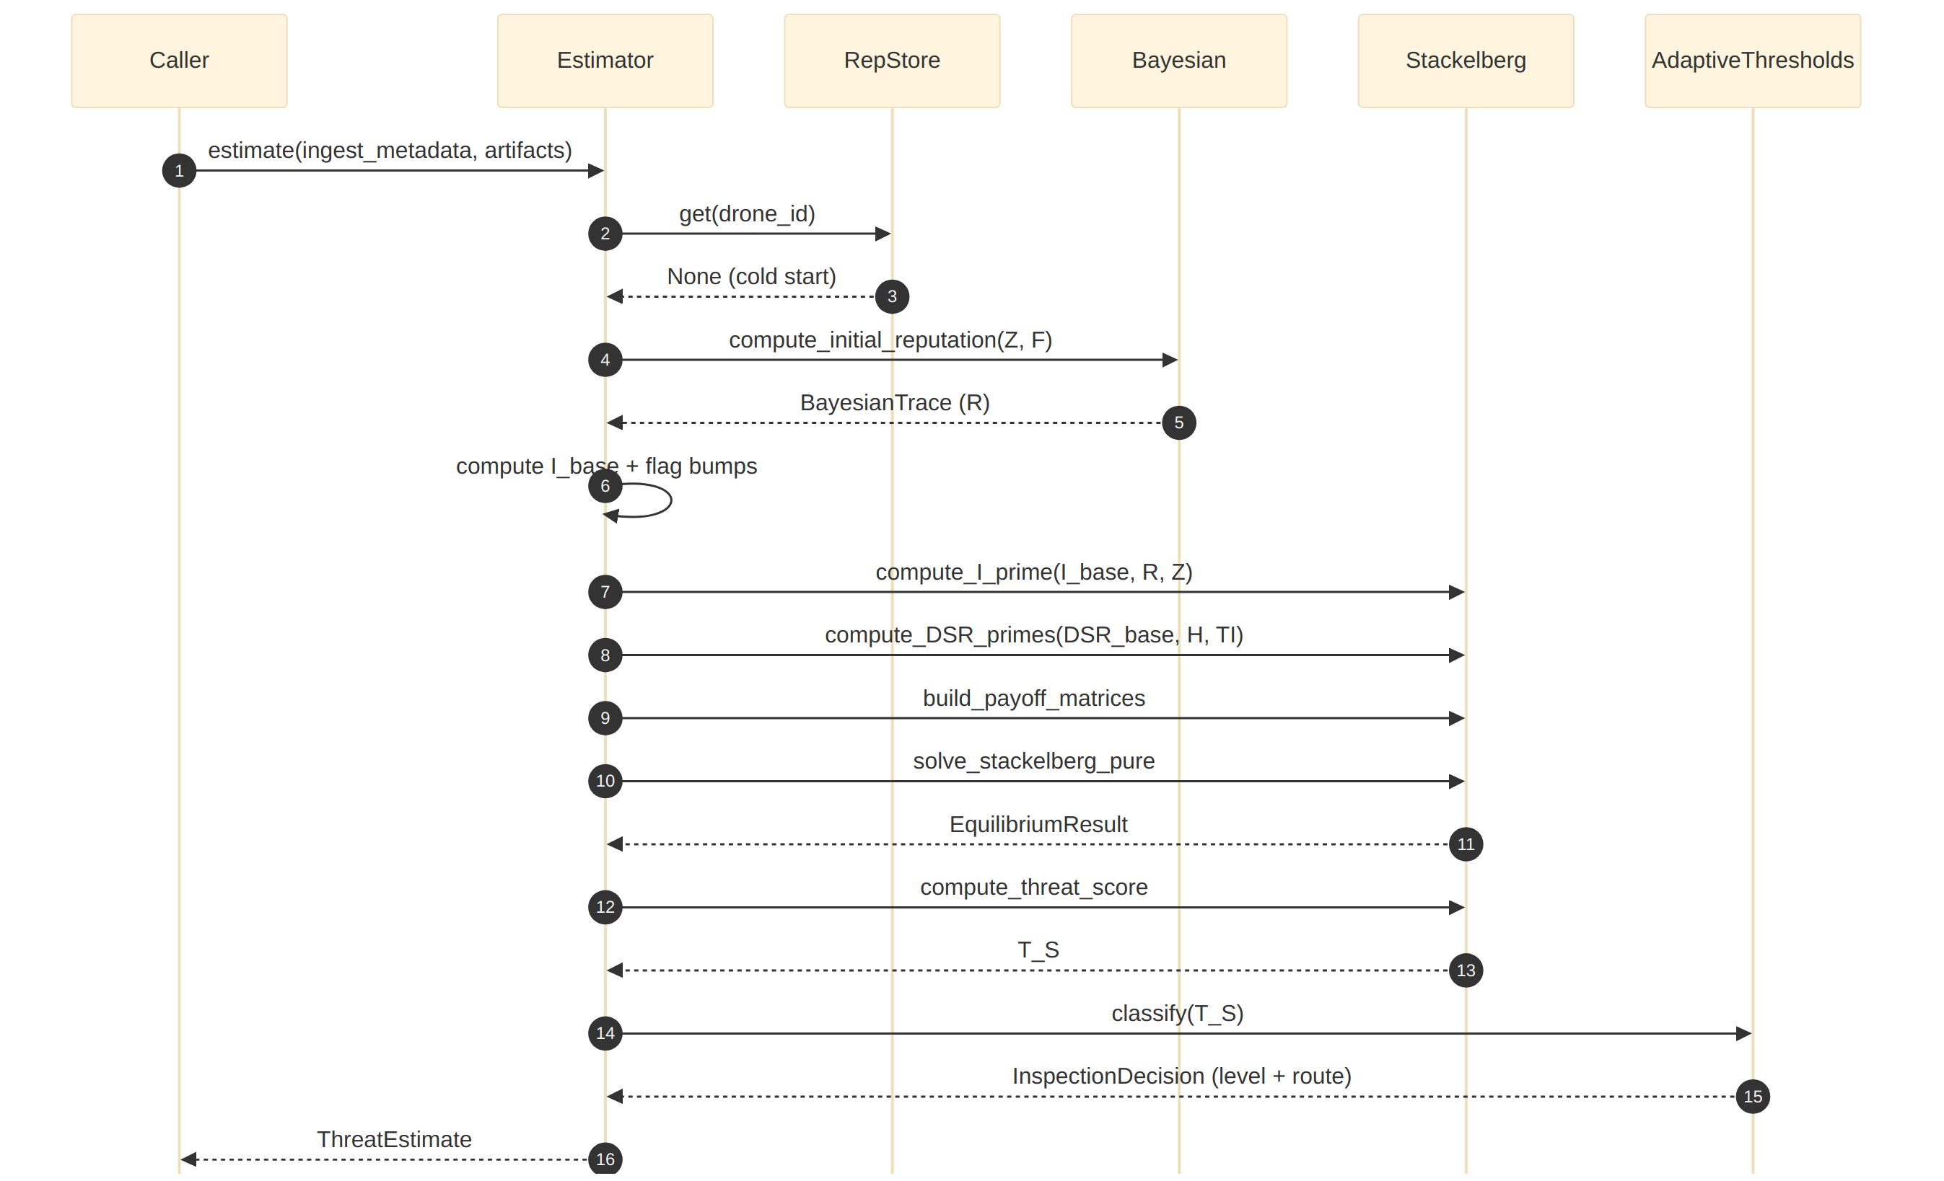

9.2 Feedback cycle
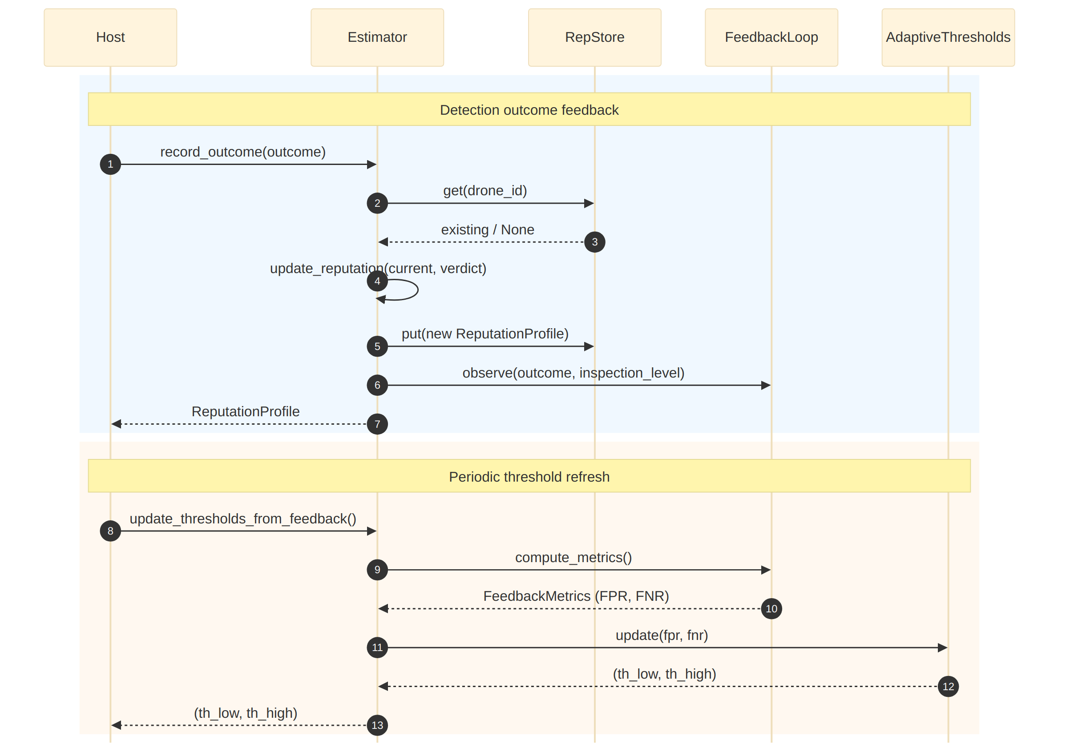

9.3 Rejection — errored IngestResult
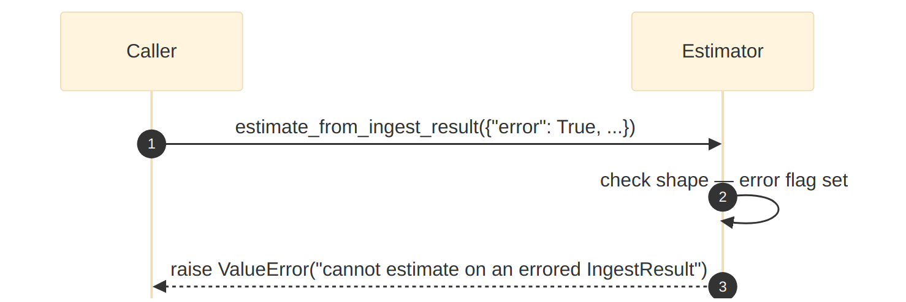

10. Mathematical Core
This section documents every formula used by the estimator: adjusted impact, adjusted detection success rates, the Stackelberg payoffs and solver, the sigmoid-blend threat-score mapping, the adaptive-threshold update rule, the Bayesian cold-start posterior, and the asymmetric reputation update.

10.1 Adjusted impact
I' = I_base · (1 + α·(1 − R)) · (1 + β·Z)

I_base ∈ [0, 10] derived from artifact types + sizes + mission sensitivity + flag bumps
R ∈ [0, 1] reputation (higher is safer)
Z ∈ [0, 1] zone risk
α, β ≥ 0 multiplicative weights from config

Lower reputation or higher zone risk inflates I' multiplicatively.

10.2 Adjusted detection success rate
DSR'(s) = clamp( DSR(s) · (1 − γ·H) · (1 + δ·TI), ε, 1 − ε )

DSR(s) ∈ (0, 1) base detection rate for strategy s
H ∈ [0, 1] recent infection frequency (evasion signal)
TI ∈ [0, 1] threat-intel corroboration strength
γ, δ ≥ 0 multiplicative weights from config
ε > 0 clamp epsilon to keep DSR'(s) strictly inside (0, 1)

10.3 Payoffs (conservative rule)
U_d(s, inject) = DSR'(s) · I' − C_d(s)
U_d(s, no_inject) = − C_d(s) (defender pays inspection cost only)
U_a(s, inject) = (1 − DSR'(s)) · I' − C_a(inject)
U_a(s, no_inject) = 0 (attacker does nothing, no cost)

10.4 Pure-strategy Stackelberg (defender as leader)
for each defender strategy s:
a*(s) = argmax over a of U_a(s, a) # attacker best response
(on ties: prefer the action that minimises U_d)

s* = argmax over s of U_d(s, a*(s)) # defender picks best reply-aware strategy
(on ties among equal U_d values: prefer the strategy with the lower C_d(s))

equilibrium = (s*, a*(s*)), U_d_eq = U_d(s*, a*(s*)), U_a_eq = U_a(s*, a*(s*))

Complexity: O(|S_d| · |S_a|) per submission; |S_d| = 3, |S_a| = 2.

10.5 Threat score and inspection level
raw = U_a_eq − U_d_eq
T_raw = σ(κ · raw) where σ(x) = 1 / (1 + e⁻ˣ)
T_S = λ · T_raw + (1 − λ) · (1 − R)
T_S = clip(T_S, 0, 1)

inspection level =
Low if T_S < θ_low
Medium if θ_low ≤ T_S < θ_high
High if T_S ≥ θ_high

10.6 Adaptive threshold update
θ_high_new = θ_high_old + η·(FPR − FPR_target) − η·(FNR − FNR_target)
θ_low_new = θ_low_old + η·(FPR − FPR_target) − η·(FNR − FNR_target)

then clamp each θ to its [*_min, *_max] bounds,
and enforce θ_high − θ_low ≥ threshold_min_gap

High FPR pushes θ_high up (fewer sandbox routings, fewer false alarms). High FNR pulls θ_high down (more sandbox routings, better recall). θ_low is nudged in parallel to keep the band coherent.

10.7 Bayesian cold-start posterior
P(N) · P(Z|N) · P(F|N)
R = P(Benign | Zone, FileType) = ───────────────────────────────────────────────────
P(N)·P(Z|N)·P(F|N) + P(A)·P(Z|A)·P(F|A)

N = Benign (No Attack)
A = Malicious (Attack)
P(N) = prior_benign, P(A) = 1 − prior_benign
P(Z|·), P(F|·) come from the CPTs (DEFAULT_ZONE_LIKELIHOOD, DEFAULT_FILE_LIKELIHOOD)

Worked reference example (Zone 3 × ZIP with prior_benign = 0.85):
numerator = 0.85 × 0.12 × 0.08 = 0.00816
denominator = 0.00816 + (0.15 × 0.35 × 0.45) = 0.031785
R = 0.00816 / 0.031785 ≈ 0.257

10.8 Reputation update (asymmetric)
R_new =
clip(R + η₊·(1 − R), 0, 1) if verdict = "benign" (reward)
clip(R − η₋·R, 0, 1) if verdict = "malicious" (penalty)
R otherwise (unknown / quarantined: no-op)

Defaults: η₊ = 0.05 (reward_rate)
η₋ = 0.50 (penalty_rate) — one infection costs ten clean deliveries

11. Configuration Reference
This section enumerates every tunable parameter on EstimatorConfig with its default value and meaning, grouped by functional area.
Every field of EstimatorConfig, with defaults:
Group | Field | Default | Meaning
Impact | alpha | 0.5 | Reputation weight on I'
Impact | beta | 0.3 | Zone-risk weight on I'
Impact | gamma | 0.2 | History weight on DSR'
Impact | delta | 0.0 | Threat-intel weight on DSR'
Impact | eps | 1e-3 | Clamp epsilon for probabilities
Score | kappa | 0.8 | Sigmoid scale on raw utility gap
Score | lambda_blend | 0.9 | Model-vs-reputation blend in T_S
Game | defender_strategies | ("signature", "ml", "sandbox")
Game | attacker_actions | ("inject", "no_inject")
Game | DSR_base | {signature: 0.70, ml: 0.85, sandbox: 0.95} | Base detection success rates
Game | C_d | {signature: 1, ml: 3, sandbox: 6} | Defender inspection costs
Game | C_a | {inject: 2, no_inject: 0} | Attacker action costs
Thresholds | th_low, th_high | 0.40, 0.70 | Initial inspection-level cut-offs
Thresholds | adaptive_thresholds | True | Disable to freeze θ
Thresholds | FPR_target, FNR_target | 0.05, 0.03 | Detection objectives driving the update rule
Thresholds | eta | 0.10 | Learning rate for threshold soft-update
Thresholds | threshold_low_min, _max | 0.20, 0.50 | Safe clamp on θ_low
Thresholds | threshold_high_min, _max | 0.55, 0.85 | Safe clamp on θ_high
Thresholds | threshold_min_gap | 0.10 | Minimum θ_high − θ_low
Bayesian | prior_benign | 0.85 | P(N) in the cold-start prior
Reputation | reward_rate | 0.05 | η₊ — benign-verdict reward
Reputation | penalty_rate | 0.50 | η₋ — malicious-verdict penalty (intentionally asymmetric)
Reputation | default_reputation | 0.80 | Fallback only when both history and Bayesian prior are unavailable
Impact heuristics | type_risk | {telemetry: .1, text: .2, image: .5, video: .9, archive: .8, zip: .8, pdf: .6, audio: .4, other: .4} | Per-file-type risk contribution to I_base
Impact heuristics | I_base_min, _max | 0.0, 10.0 | Clamp on I_base
Impact heuristics | default_zone_risk | 0.5 | When mission_zone is not in zone_risk_lookup
Impact heuristics | zone_risk_lookup | {} | Per-zone override for Z
Impact heuristics | flag_impact_bumps | see config.py | Delta to I_base per insecure flag raised upstream
Impact heuristics | unsafe_auth_results | {"fail", "failed"} | auth_result values that trigger the auth_failed bump
Caches | estimate_cache_max_size | 1024 | LRU size for the record_outcome seeding cache
Logging | log_level | "INFO" | Host installs log handlers

12. Security & Threat Model
This section enumerates the adversary model, describes the non-repudiation guarantees, specifies the input trust boundary, and documents the fail-closed configuration validation.

12.1 Adversary model
The attacker's goal is to maximise the probability of delivering a malicious payload undetected. Known vectors and mitigations:
Vector | Mitigation in this module
Submit encrypted / nested archives to evade signature scans | Flag bumps on encrypted_payload + nested_archive inflate I_base; Bayesian prior for archive / zip is low
Spoof drone identity to inherit a trusted reputation | Upstream interceptor authenticates; auth_result = fail triggers flag_impact_bumps["auth_failed"] (default +1.5)
Reputation laundering (many benign, then a single malicious) | Asymmetric rates: one malicious verdict halves reputation; recovery requires many benign verdicts
Threshold poisoning (flooding benign traffic to drift θ_high up) | Safe-bound clamps on θ; FPR_target is explicit; CPT refresh runs on a slower cadence than threshold updates
Exploit Bayesian cold-start by rotating drone IDs | Unknown zone/file-type fallbacks are pessimistic; cold-start R is explicitly tagged bayesian_prior so consumers can require extra corroboration
Force collisions by submitting many tied utilities | Deterministic tie-breakers: attacker hurts defender, defender prefers cheaper strategy

12.2 Non-repudiation
Every ThreatEstimate carries estimate_id, created_at, the full BayesianTrace, the payoff matrices, the equilibrium, and a snapshot of the config knobs that produced the decision. Persisting estimate.to_dict(include_matrices=True) is sufficient for forensic replay.

12.3 Input trust boundary
The estimator trusts that the Ingestion Interceptor has:
- authenticated the drone,
- validated the submission structure,
- detected and flagged encryption / nesting / suspicious MIME / size
anomalies,
- produced the IngestResult with canonicalised types.
The estimator does not re-validate cryptographic signatures or re-parse file formats. Bypassing the interceptor and feeding unvetted input to the estimator is out of scope and unsupported.

12.4 No external I/O
By default, the module performs no network, filesystem, or subprocess calls. All external integration flows through the injected seams (§3.2) or through methods the host explicitly invokes (record_outcome, update_thresholds_from_feedback).

12.5 Fail-closed configuration
EstimatorConfig.__post_init__ rejects inconsistent deployments at construction time (missing DSR / C_d entries, inverted thresholds, out-of-range priors, negative learning rate, etc.). There is no "silent degrade" path.

13. Performance Characteristics
This section documents the latency budget per phase, the memory bounds of every internal structure, and the expected throughput per core.

13.1 Latency
Phase | Complexity | Observed (stdlib Python, single core)
_compute_I_base + flag bumps | O(n) over artifact records | sub-microsecond for typical n ≤ 10
Bayesian posterior | O(1) dict lookups | sub-microsecond
Payoff-matrix construction | O( | S_d
Stackelberg solver | O( | S_d
Full estimate() end-to-end | O(n) dominant | under 200 µs per submission on commodity CPU

Empirical: the 48-test suite completes in ≈ 5 ms on a developer laptop; stage 2 of run_demo.py (five end-to-end estimations) runs in under 1 ms.

13.2 Memory
Structure | Bound
InMemoryReputationStore | O(number of known drones); profile ≈ 200 bytes each
FeedbackLoop._window | O(window_size) outcomes; default 500 records
AdaptiveThresholdManager.history | O(update_count); one small dict per update()
_last_estimate_by_drone | Bounded LRU, max config.estimate_cache_max_size (1024)

No unbounded structures. Long-running edge processes have a well-defined memory ceiling.

13.3 Throughput
At < 200 µs per estimate(), a single estimator instance sustains ≳ 5 000 submissions/second on one CPU core, well above the ingestion rate for any realistic drone fleet. Scale horizontally (one estimator per ingestion worker) rather than vertically.

14. Testing Strategy
This section describes the 48-test suite layout, how to run it, and the invariants explicitly enforced by the tests.
48 tests live in threat_estimator/tests/test_estimator.py. Run with:
python -m unittest threat_estimator.tests.test_estimator -v
# or
python -m pytest threat_estimator/tests/ -v

Coverage groups:
Group | Count | Highlights
TestEstimatorConfig | 8 | Defaults, DSR / cost ordering, override, __post_init__ rejects every invalid combination
TestBayesianReputation | 6 | Reference example R ≈ 0.257, unit-interval invariant, fallback flags, prior validation, monotonicity across zones
TestReputationUpdate | 4 | Monotone reward / penalty, unknown-verdict no-op, asymmetry
TestStackelbergPrimitives | 5 | I' / DSR' math, payoff-matrix signs, sandbox selection for high impact, T_S bounded
TestAdaptiveThresholds | 5 | FPR / FNR response, clamp bounds, gap preservation, disabled mode, classify boundaries
TestReputationStore | 4 | Put / get / delete, initial seed, defensive copy on get(), range validation
TestEndToEnd | 13 | Samples A–D + high-risk, priority of reputation sources, feedback cycle, batch, JSON round-trip, bounded LRU cache
TestFeedbackLoop | 3 | TP / FP / TN / FN accounting, empty metrics, window size

Key invariants covered explicitly:
- T_S ∈ [0, 1] for any inputs (test_threat_score_bounded)
- Bounded LRU cache does not leak (test_last_estimate_cache_is_bounded)
- JSON round-trip is clean for the full audit payload (test_to_dict_is_serializable)
- Cold-start reputation exactly matches the reference Bayesian example
(test_plan_worked_example, test_cold_start_uses_bayesian_prior)

15. Operations
This section covers deployment, the operational monitoring checklist, and runbook snippets for common incidents.

15.1 Deployment
Single-process Python library, no daemons. Instantiate one estimator per ingestion worker in the edge node's detection process. Because all dependencies are in-memory by default, there are no startup dependencies beyond the Python runtime. The host process is responsible for:
- Constructing the EstimatorConfig (or accepting the defaults).
- Choosing a reputation_store backend and wiring persistence /
replication if needed.
- Bridging FeedbackLoop to the Response & Quarantine Manager so
every verdict results in an observe() call.
- Scheduling update_thresholds_from_feedback() (e.g. every few
minutes).
- Installing log handlers for the threat_estimator package logger.

15.2 Monitoring checklist
Scrape GameTheoreticThreatEstimator.stats periodically:
Signal | Alert when
total_high / total_processed | Above operational sandbox capacity for more than 5 minutes
thresholds.th_high | Pinned at threshold_high_max (0.85) or threshold_high_min (0.55) for three updates in a row
total_cold_start / total_processed | Above 20% — reputation store is losing coverage
feedback_window_size | Stays at 0 — the feedback loop is disconnected
thresholds.update_count | Zero over a multi-hour window — update_thresholds_from_feedback() not running

15.3 Runbook snippets
- Sandbox overloaded. Temporarily raise FPR_target or
threshold_high_max so θ_high can drift higher; then refresh CPTs to reflect the new attack mix.
- Detection rate dropped. Lower FNR_target. Confirm that the
Response & Quarantine Manager is calling record_outcome (check feedback_window_size).
- Reputation noise. Lower penalty_rate. Require multiple
corroborating verdict sources before calling record_outcome for a given submission.
- Config rejected on startup. EstimatorConfig.__post_init__
fail-closes on inconsistency; read the ValueError message, fix the offending field, and redeploy.

16. Risk Assessment
This section enumerates known risks with their likelihood, impact, and the in-module mitigation.
Risk | Likelihood | Impact | Mitigation
CPT seed values diverge from the observed distribution | High (day 0) | Medium | update_cpts() refresh hook; tests verify fallback invariants rather than absolute values outside the reference example
Feedback loop not wired — thresholds frozen at defaults | Medium | Medium | Operational monitor on feedback_window_size; dashboards surface thresholds.update_count
Pure-strategy solver ignores mixed-strategy equilibria | Low | Low | Conservative by construction; adaptive_thresholds compensates for boundary oscillation
Host forgets to persist reputation_store snapshot — cold start after every restart | Medium | High | InMemoryReputationStore.snapshot() provided; persistence is an explicit host responsibility (§15.1)
I_base heuristic too coarse for a new artifact type | Medium | Medium | type_risk and flag_impact_bumps are config knobs; new keys can be added without code changes
Reputation update over-penalises a noisy detection engine | Medium | Medium | penalty_rate is tunable; host can require multi-source corroboration before calling record_outcome
Adversary bypasses the interceptor and feeds unvetted input | Low | High | Out of scope by contract (NG-7); the interceptor is the sole authentication point

17. Glossary
- Stackelberg equilibrium — Leader-follower game solution; here the
defender moves first and the attacker best-responds.
- Reputation (`R`) — Drone trustworthiness in [0, 1].
- Threat Score (`T_S`) — Bounded output in [0, 1] driving
inspection-level routing.
- Cold start — Scoring a drone that has no entry in the reputation
store.
- Bayesian Belief Network (BBN) — Here, a two-feature naive-Bayes
network with Zone and File Type as evidence and Attack Status as the class variable.
- Conditional Probability Table (CPT) — Tabulated likelihoods
P(Z | ·) and P(F | ·).
- Inspection level — Discrete output in {Low, Medium, High},
mapping to the subset of detection engines to run.
- Soft update — Additive adjustment scaled by a small learning rate
η, as opposed to a hard swap.
- DSR — Detection Success Rate of a defender strategy.
- ASP — Attacker Success Probability, 1 − DSR'.
- FPR / FNR — False-Positive / False-Negative rate over the current
monitoring window.
- `I_base` / `I'` — Base impact and reputation-and-zone-adjusted
impact used by the game.

