
AOI Basemap Clipper
QGIS plugin: specification, operation and user guide
Version 2.0.2 | Author: Satyabrata Sahoo | GPL-2.0

Contents
1. Overview
2. Specification
3. How it works
4. Why it is better
5. Installation
6. How to use it
7. Output files
8. Troubleshooting
9. Notes and limitations
10. Version history

1. Overview
AOI Basemap Clipper cuts any raster image or online basemap to the shape of an Area of Interest (AOI) polygon, at full native resolution, as fast as the data source allows. In one run it produces a clipped GeoTIFF mosaic, a set of GeoTIFF tiles, and a GeoPackage tile index that can be moved between computers because it stores relative paths.
It is built for field and engineering teams who regularly need an offline, clipped copy of imagery for a work area, for example 6-inch aerial imagery for a survey polygon, without chaining several QGIS tools together and without losing pixel quality on the way.

What it accepts
- A polygon layer in any CRS (reprojected automatically). One or many polygons; optionally only the selected features.
- A local raster read through GDAL: GeoTIFF, GPKG, NetCDF, files in /vsizip or /vsicurl, and similar sources.
- An XYZ tile layer (OpenStreetMap-style {z}/{x}/{y} URLs, including TMS {-y}).
- Any other QGIS raster layer, for example WMS or WMTS, which is rendered block by block on an exact pixel grid.

What it produces
- A clipped mosaic GeoTIFF (optional to keep).
- Tiles of a size you choose (default 1024 x 1024 px), empty ones skipped.
- A GeoPackage tile index with one polygon per tile and one-click Load Image / Remove Image actions.

2. Specification
Item | Detail
Plugin name | AOI Basemap Clipper (menu: Raster; toolbar button)
Version | 2.0.2
QGIS requirement | 3.22 or newer. Contains compatibility code for Qt5 and Qt6 builds.
Dependencies | GDAL/OGR Python bindings and numpy, both already shipped with QGIS. No extra installation.
Inputs | AOI polygon layer (any CRS); local raster, XYZ layer, or other raster layer (WMS etc.)
Source routes | A: direct from file on its own pixel grid. B: parallel XYZ tile download (EPSG:3857 layers). C: QGIS renderer fallback for WMS and other layers.
Resolution modes | Auto (native); XYZ zoom level; fixed output width in px; match current canvas zoom; custom ground pixel size in m/px.
Reprojection | Off by default. Optional reprojection to EPSG:4326, done in the same single warp as the clip.
Resampling | Auto, Cubic, Bilinear, Lanczos, Nearest. Auto uses nearest neighbour for palette / class rasters. Only used when the output grid differs from the source grid.
Transparency | Real transparency: source alpha band or nodata is kept; an alpha band is added when neither exists. Palette rasters are expanded to RGBA so colours are never blended as class indices.
Compression | Deflate fast (level 1, default), Deflate normal (level 6), ZSTD (when available), LZW, None. All lossless.
Tile size | 64 to 40000 px per side (default 1024 x 1024)
Download threads | 1 to 64 (default 16)
Render requests (WMS) | 1 to 16 blocks at once (default 6); block size 2048 px
Tiling threads | 1 to 64 (default: CPU count, between 2 and 8)
Safety checks | Size warning above 150 megapixels; free-disk check; overwrite confirmation; partial files removed on cancel or error
Outputs | <name>_clipped.tif (or <name>_4326.tif), <name>_tiles/<name>_rN_cM.tif, <name>_tileindex.gpkg (layer: tileindex)
Tile index fields | location (relative path), name, row, col, width, height, vendor, acq_date
Metadata written | vendor and acquisitionTime tags on the mosaic and every tile, when you fill them in
Licence | GPL-2.0
Repository | https://github.com/sssatyabrata-cell/aoi_basemap_clipper

3. How it works
Every run follows the same six stages. The heavy work is done by GDAL in worker threads, so QGIS stays responsive and a Cancel button works at any time.
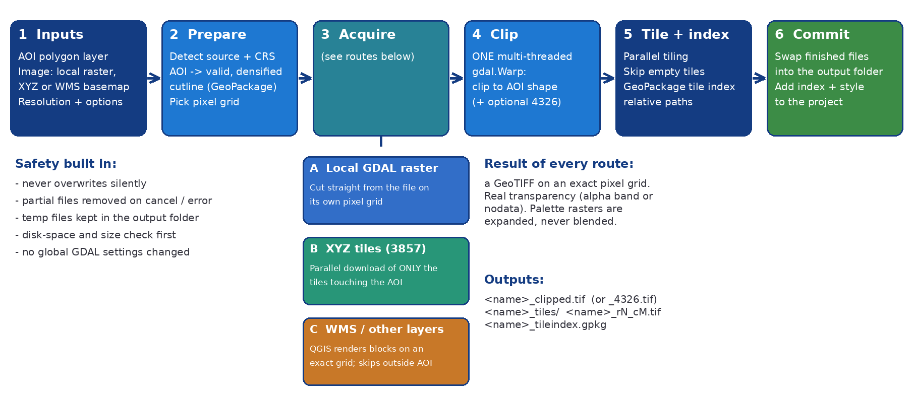
Figure 1. Processing pipeline

Stage 1-2: prepare
The plugin reads the source's own CRS from GDAL when available, builds the AOI cutline in that CRS and writes it to a temporary GeoPackage. Long polygon edges are densified before reprojection so they follow their true curved shape; invalid geometries are repaired and empty ones are skipped with a note in the log. If the image has no CRS, the map canvas CRS is used and the log says so.

Stage 3: acquire the pixels
Route A, local raster. Nothing is re-rendered. The AOI is cut straight from the file on the file's own pixel grid with nearest-neighbour sampling, so the output pixels are bit-identical to the source and keep the native bit depth and band layout.
Route B, XYZ tiles. The plugin reads the layer's tile URL, probes one real tile to learn whether tiles are 256 or 512 px, and then downloads tiles itself, many at a time, through QGIS' own network stack, so proxy settings, authentication configurations and the cache keep working. Only tiles that touch the AOI polygon are requested (Figure 2). Each tile is written straight into a tile-aligned GeoTIFF, so one output pixel equals one tile pixel with no resampling. Failed tiles are retried; if the server keeps refusing, the job stops early with a clear message instead of hammering it.
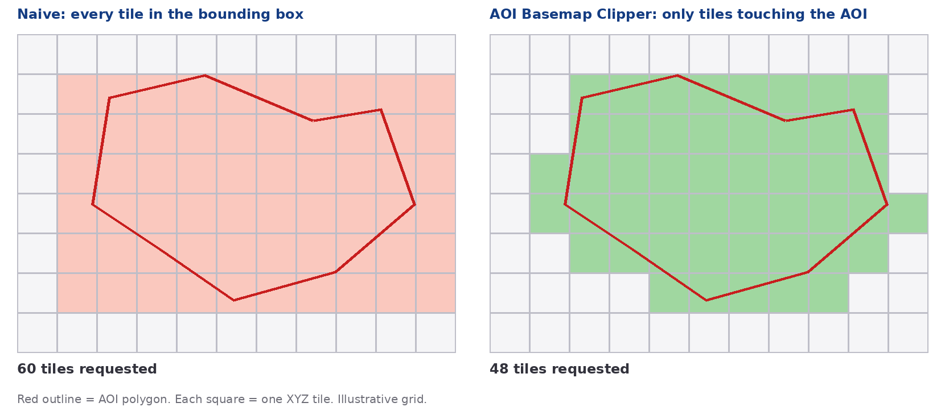
Figure 2. Only tiles that touch the AOI are requested (illustration)
Route C, WMS and other layers. QGIS renders the layer in 2048 px blocks on an exact pixel grid, several blocks at the same time. Blocks outside the AOI are never rendered. A private clone of the layer is used, with opacity, blending, brightness and saturation reset, so the exported pixels are the source's and not what the project styling happens to show.

Stage 4: clip in one warp
The clip, and the optional reprojection to EPSG:4326, happen in a single multi-threaded gdal.Warp call with the AOI as cutline. Using one resampling step at most keeps quality high and avoids the shifted, squeezed or blurred results that come from chaining separate tools.

Stage 5: tiling and index
The mosaic is split on whole-pixel boundaries by several workers in parallel, each with its own dataset handle. Tiles that are completely transparent (or entirely nodata) can be skipped. The GeoPackage tile index stores each tile's footprint and a path relative to the index file.

Stage 6: commit
All work happens in hidden temporary names inside the output folder (same disk, so no slow copy and no full system drive). Only when everything has succeeded are the finished files swapped into place. If you cancel or an error occurs, the temporary files are removed and your existing outputs are left alone.

4. Why it is better
The usual manual workflow in QGIS is to export the basemap to a raster, clip it with a mask layer, then cut it into tiles and build an index with separate tools. Each step re-reads and re-writes the data, and each can resample it. AOI Basemap Clipper replaces that chain with one purpose-built pipeline.
Topic | Typical manual chain | AOI Basemap Clipper
Steps | Export, clip, tile, build index: 3 to 4 tools | One dialog, one Run
Pixel quality | Possible resampling at each step | Local rasters: bit-identical pixels. XYZ: no resampling. At most one resample, only if you ask to reproject or resize
Online XYZ basemaps | One map render per block, then a second pass | Direct parallel tile download, only tiles touching the AOI
Wasted work | Whole bounding box processed | Tiles and blocks outside the AOI shape are never fetched or rendered
CPU use | Often single-threaded | Multi-threaded warp, compression and tiling
Transparency | Black or white outside the AOI is common | Real alpha / nodata; palette rasters expanded
Portability | Absolute paths in the index | Relative paths: move or zip the whole folder
Safety | Easy to overwrite files or leave partial ones | Confirmation before overwrite, atomic swap, cleanup on cancel
Other plugins | n/a | No global GDAL settings changed

Real-world speed depends on the tile server, your network, your disk and the size of the AOI, so this document does not quote fixed timings. The gains come from doing less work (skipping tiles outside the AOI), doing it in parallel, and avoiding repeated read and write passes.

Compact window for small screens
From version 2.0.2 the window opens sized to fit your screen. Options are arranged in two columns inside a scroll area, while Run, Cancel, Clear, the progress bar and the log stay visible underneath. Long explanations were moved into tooltips (hover over an option to read them).
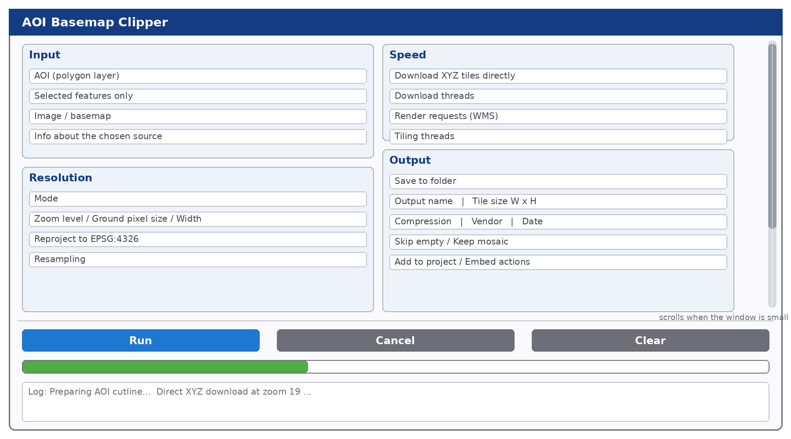
Figure 3. Compact two-column layout (schematic)

5. Installation
- In QGIS open Plugins > Manage and Install Plugins.
- Choose Install from ZIP, select aoi_basemap_clipper.zip and click Install Plugin.
- Open the Installed tab and make sure AOI Basemap Clipper is ticked.
- Start it from Raster > AOI Basemap Clipper or from the toolbar button with the plugin icon.
If the plugin is published in the official repository, you can instead search for its name in the All tab. To update from a new ZIP, install it the same way; if QGIS still shows the old icon or old options, close and reopen QGIS.

6. How to use it
Load your imagery layer and your AOI polygon layer into the project first. Then open the plugin. The numbered markers in Figures 4a and 4b match the sections below.
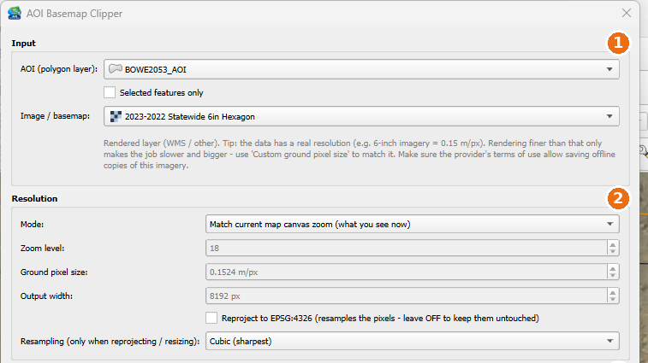
Figure 4a. Dialog, top half: areas 1 and 2 (screenshot)
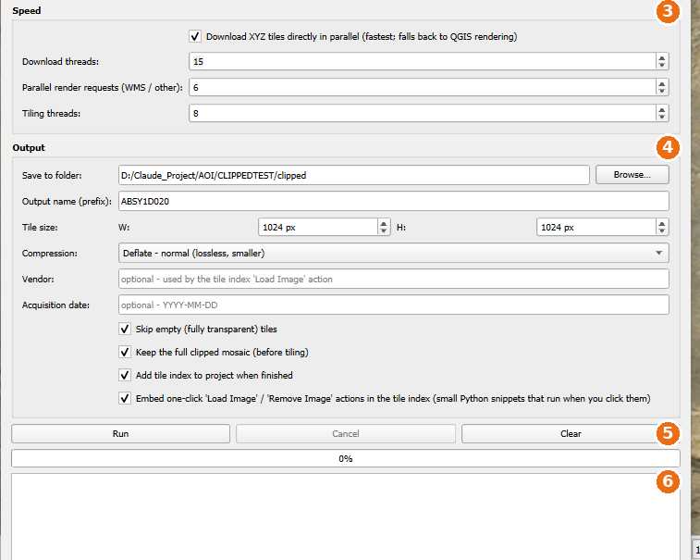
Figure 4b. Dialog, bottom half: areas 3 to 6 (screenshot of the 2.0.0 single-column layout; version 2.0.2 shows the same options in two columns)

Area 1: Input
- AOI (polygon layer): the area to cut out. Any CRS is fine.
- Selected features only: tick to use only the polygons you selected. The plugin warns if nothing is selected.
- Image / basemap: the source. The grey note underneath tells you which route will be used (GDAL raster, XYZ tiles, or rendered layer) and shows the native pixel size or a resolution tip.

Area 2: Resolution
Mode | What it does
Auto (recommended) | Local raster: keeps full native resolution. XYZ: uses the layer's maximum zoom. WMS/other: uses a resolution hint in the layer name such as 6in or 30cm if found, otherwise the finer of the provider and canvas resolution.
XYZ zoom level | Choose a zoom level (0 to 24). Only enabled for EPSG:3857 layers. Zoom above the layer's maximum is lowered to the maximum.
Fixed output width (px) | Output is this many pixels wide; height follows the AOI shape.
Match current map canvas zoom | Uses the pixel size of what you currently see. For XYZ it snaps to the next finer zoom level.
Custom ground pixel size (m/px) | Enter the real ground resolution, for example 0.1524 for 6-inch imagery. Correct for Web Mercator latitude stretch and for CRSs measured in feet.

- Reproject to EPSG:4326: off by default so pixels stay untouched. Tick it only if you need geographic coordinates; it resamples the pixels.
- Resampling: only used when reprojecting or resizing. Leave on Auto unless you have a reason.
Tip: rendering finer than the data's real resolution only makes the job slower and bigger. For 6-inch imagery use Custom ground pixel size 0.1524 m/px. The plugin warns before producing more than 150 megapixels.

Area 3: Speed
- Download XYZ tiles directly in parallel: fastest for XYZ layers; the plugin falls back to QGIS rendering automatically when a direct download is not possible (for example, URLs that use {s} or {q}).
- Download threads: simultaneous tile downloads. Lower it (for example 4 to 8) if the server answers with HTTP 429 or 403.
- Render requests (WMS): blocks rendered at the same time for WMS and other layers.
- Tiling threads: workers that cut and compress output tiles.

Area 4: Output
Option | Meaning
Save to folder | Output folder. Temporary files are also created here, so it needs free space.
Output name (prefix) | Used in every file name. Unsafe characters are replaced with underscores.
Tile size W / H | Size of each output tile in pixels.
Compression | Lossless choices. Deflate fast is the default; ZSTD is fast and small but needs a modern GDAL to read.
Vendor / Acquisition date | Optional text (date as YYYY-MM-DD). Stored in the files and used to group layers when you load tiles.
Skip empty tiles | Does not write fully transparent tiles.
Keep the full clipped mosaic | Keeps the single big GeoTIFF as well as the tiles.
Add tile index to project | Loads the finished tile index into QGIS.
Embed Load / Remove Image actions | Stores two small Python actions in the tile index style. They only run when you click them. Untick if you do not want code in the GeoPackage.

Area 5 and 6: Run, Cancel, Clear, progress and log
- Run starts the job. If outputs with the same name already exist you are asked to confirm; layers using them are removed from the project first.
- Cancel stops safely at any time and removes partial files. Closing the window during a job also stops it first.
- Clear empties the folder, name, vendor and date fields, the log and the progress bar (not available while running).
- The log shows what was chosen (route, resolution, size) and how long each stage took.

Step by step
- Load the imagery and the AOI polygon layer; make sure the AOI is visible in the layer list.
- Open Raster > AOI Basemap Clipper.
- Pick the AOI layer and, if needed, tick Selected features only.
- Pick the Image / basemap and read the note below it.
- Choose a Resolution mode. For most work leave Auto; for WMS imagery use Custom ground pixel size.
- Leave Reproject off unless you need EPSG:4326.
- Choose the output folder, a name prefix, tile size and compression. Optionally add vendor and date.
- Click Run, confirm any prompts, and watch the progress bar and log.
- When it finishes, the tile index appears in the project. Use the Load Image action on a tile to add that tile to the map.

Loading and removing tiles from the index
Select the tile index layer, choose the Load Image or Remove Image action from the Run Feature Action dropdown, and click a tile on the map. Load Image adds the tile raster under a vendor / date group, skips tiles that are already loaded, and reports missing files. Remove Image removes it again and deletes empty groups.

7. Output files
For an output name ABSY1D020 and no reprojection the output folder contains:
ABSY1D020_clipped.tif full clipped mosaic (if kept)
ABSY1D020_tileindex.gpkg tile index (layer: tileindex)
ABSY1D020_tiles/ ABSY1D020_r0_c0.tif, ABSY1D020_r0_c1.tif, ...

With Reproject ticked, the mosaic is named <name>_4326.tif instead. Because the index stores relative paths such as ABSY1D020_tiles/ABSY1D020_r0_c0.tif, you can move, copy or zip the whole folder and the index keeps working.

8. Troubleshooting
Message or symptom | What to do
HTTP 429 or 403 errors, 'server keeps refusing tiles' | Lower Download threads, check your connection, and check that the provider allows bulk downloads.
Not enough free disk space | Free space on the output drive or choose another folder. The temporary image is created in the output folder.
Warning about many megapixels | Use Custom ground pixel size to match the data's real resolution instead of rendering finer.
Could not write ... is it open in another program | Close the file or remove it from QGIS and run again.
The AOI does not overlap the selected image | Check that the AOI and the image cover the same place and that both have a correct CRS.
Layer has no CRS | The canvas CRS is used. Set the correct CRS on the layer if the result is misplaced.
No tiles were produced | The clipped area is empty. Check the AOI, or untick Skip empty tiles to inspect the output.
Direct download not possible, using the QGIS renderer | The XYZ URL is unsupported for direct download or the server refused tiles. The slower renderer is used automatically.
Old icon or old options after updating | Close and reopen QGIS; if needed delete the old plugin folder and install the ZIP again.

9. Notes and limitations
- Terms of use: many tile providers (Google, Esri, Bing and others) forbid bulk offline copies. Make sure your licence allows it.
- Direct XYZ download works for EPSG:3857 layers whose URL uses only {x}, {y} (or {-y}) and {z}. Other layers use the renderer.
- XYZ data cannot be finer than the server's maximum zoom. Some servers return placeholder images for areas without imagery.
- Local rasters are cut as they are: QGIS layer styling such as band order or colour ramps is not applied. Palette rasters are expanded to RGBA.
- The mosaic and tiles are lossless GeoTIFFs and can be large. Check the megapixel and disk-space messages before confirming.

10. Version history
Version | Changes
2.0.2 | Compact dialog: two columns, scrollable options, opens sized to the screen, shorter labels with tooltips, plugin icon in the title bar.
2.0.1 | Fixes: dialog no longer stays disabled if the output folder is not writable; options locked while a job runs; tiling stops at once after an error; XYZ download stops early when the server refuses tiles; '+' preserved in tile URLs; curved AOI geometries handled; size and disk check for resized local rasters; temporary style file removed.
2.0.0 | Much faster direct parallel XYZ download, multi-threaded warp and compression, parallel tiling; safe defaults (reprojection off); relative-path tile index with Load / Remove actions; no global GDAL changes; never overwrites silently; README, licence and tests.
1.1.0 | Fixed shifted, squeezed or expanded output and loss of resolution; single-step clip and reproject.

Author: Satyabrata Sahoo (sssatyabrata@gmail.com). Source and issue tracker: https://github.com/sssatyabrata-cell/aoi_basemap_clipper

