**Computer Communications and Networks Sadhana Seetamsetty(800904075)**

**Project 1**

**HTTP Client and HTTP Server**

In this programming assignment, HTTP Client and HTTP Server have been implemented in Java. The server is multithreaded and will stay open for incoming requests.

Along with the source code files(HTTPClient.java and HTTPServer.java) , test files(test.html and text.txt) have been provided for testing the GET and PUT methods.

**Steps for Execution:**

1. Run HTTP Server

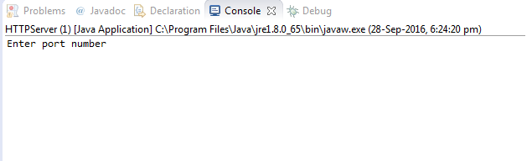

When prompted enter the port number

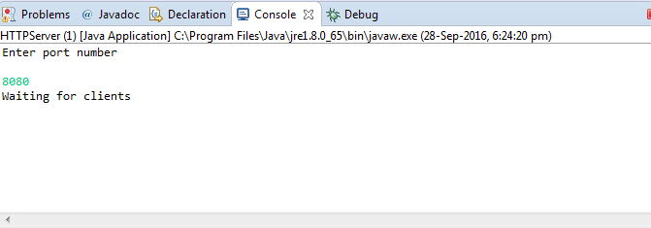

1. Run HTTP Client

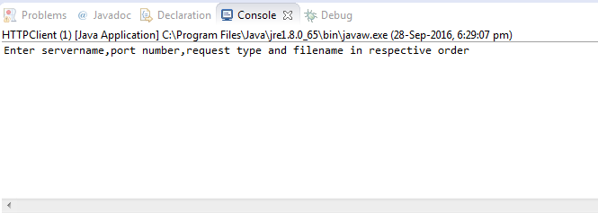

**GET:**

For example: localhost 8080 GET test.html

The program returns whether the request was a success or not and if it is a success it displays the contents of the file as well.

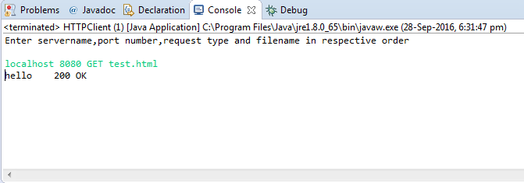

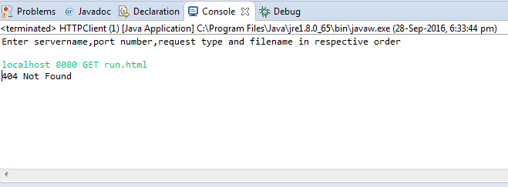

***On server side:***

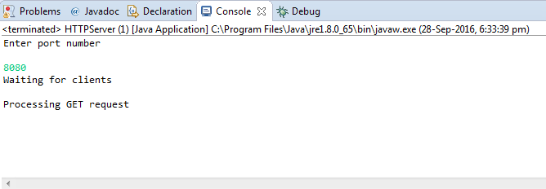

**PUT:**

For example: localhost 8080 PUT test.html

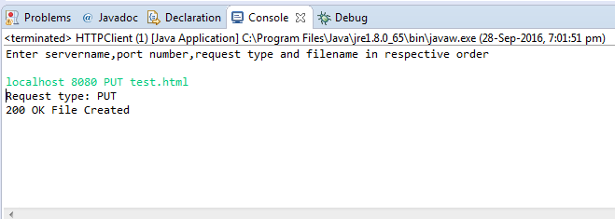

***On Server side:***

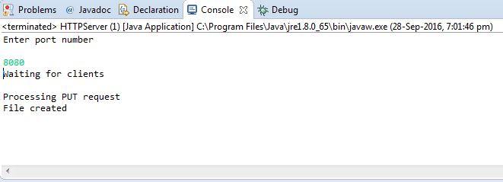

***In the file system:***

Before PUT request

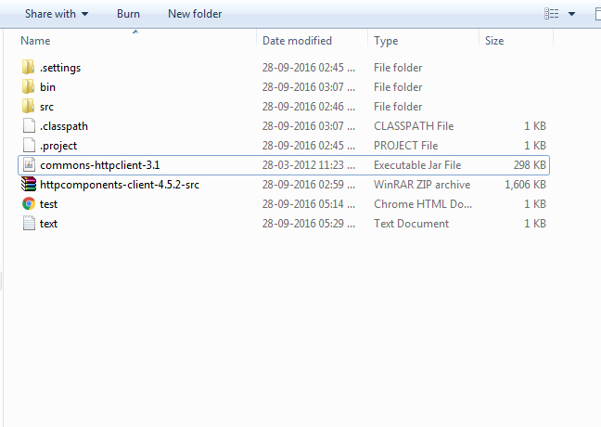

After PUT request: The file is saved locally with the format local+filename

