台北市立松山高中一百學年度第一學期高一第一次期中考英文科試題
Part A: Magazine (Live ABC September 1~ October 7/2011) 30%

- Picture Questions (2%)
For questions number 1 and 2, please look at the picture.
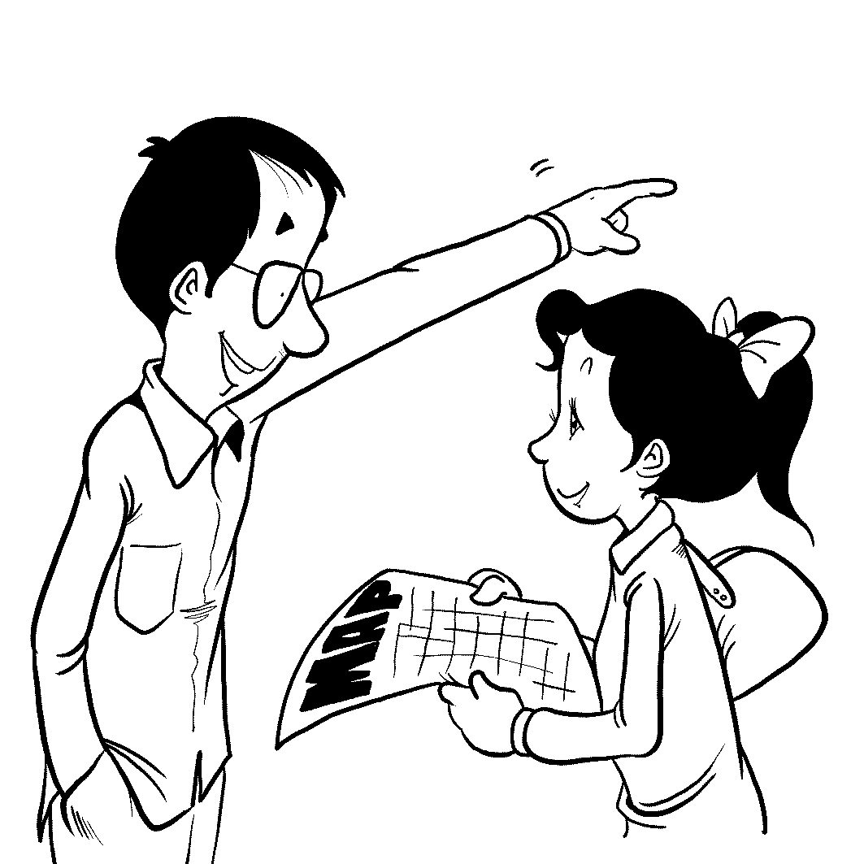
1.

2.

- Best Response Questions (4%)
Listen to the question or statement and choose the best response.

3. (A) I like ice cream more than cake, too.
(B) I agree. I don’t like ice cream very much.
(C) Sure. You can have both cake and ice cream.
(D) Why don’t you want cake and ice cream?

4. (A) No. Be careful how much Vitamin D you take.
(B) Yes. You can avoid it by not eating eggs.
(C) Yes. Just expose your skin to the sunlight.
(D) No. Regular exercise is more important.

5. (A) I guess it’s difficult to find around here.
(B) Yeah, it does cost a lot of money.
(C) Oh, I’m sure you can fit into it.
(D) No, you are not supposed to wash it.

6. (A) I know. She is a loyal dog.
(B) Yeah. She can fly high, too.
(C) Right. She swims so well.
(D) Yes. She is such a lovely cat.

- Conversation Questions (4%)
7. (A) At the man’s house.
(B) At a restaurant.
(C) At a supermarket.
(D) At the woman’s kitchen.

8. (A) Chat in a bar.
(B) Watch a sports movie.
(C) Play a football game.
(D) Have a nice dinner.
9. (A) Steve will take a day off tomorrow.
(B) Melissa complains about her stomachache.
(C) The man has to cover Steve’s work.
(D) The woman wants to take a sick day.

10. (A) She will bake the moon cakes by herself.
(B) She may buy moon cakes through computer.
(C) She decides not to buy moon cakes as a gift.
(D) She will buy moon cakes in a nearby store.

- Cloze Test (12%)
The world can seem very 11 sometimes. Upon a closer look, 12 , many of these mysteries have very simple explanations. For example, lions were killing each other and the 13 was in serious trouble on the Serengeti. One researcher then noticed that the lions were eating more buffalo 14 because of a drought. When lions with the dog diseases also
15 a disease from the buffalo, they had bad seizures. This was scary to the other lions, 16 they attacked and killed.

11. (A) glamorous | (B) mysterious | (C) hilarious | (D) numerous
12. (A) though | (B) further | (C) therefore | (D) besides
13. (A) competition | (B) interpretation | (C) population | (D) direction
14. (A) as usual | (B) than usual | (C) as before | (D) so often
15. (A) pursued | (B) invented | (C) contracted | (D) achieved
16. (A) then | (B) but | (C) thus | (D) so

Wei Te-Sheng, the director of Seediq Bale, creates one movie miracle after another. 17 , it is his passion for movies that drives him on. He says that while 18 may lead to failure, that’s nothing compared with a life of boredom without 19 . That’s 20 he is not frustrated by the lack of fund from investors. Furthermore, the more people say it’s impossible, 21 he will become to give it a shot. As his efforts are being rewarded by huge box-office returns, Wei 22 his goals and brings the world stunning movies.

17. (A) For instance | (B) In fact | (C) No wonder | (D) What’s worse
18. (A) to be sensible | (B) to be confused | (C) being elegant | (D) being bold
19. (A) taking chances | (B) slipping up | (C) inheriting genes | (D) calling names
20. (A) how | (B) what | (C) why | (D) when
21. (A) the most eager (B) the very challenging
(C) the more fascinating (D) the more determined
22. (A) accomplishes (B) emerges (C) inspires (D) releases

- Reading comprehension (8%)
23. In the short story of The Pied Piper of Hamelin, the townspeople lost their 130 children because ______.
(A) all the children were bitten to death by rats
(B) the piper led the children to live in the cave
(C) they paid the piper what they owed
(D) they broke their promise

24. About the delicious American snack, the doughnut, which statement is NOT true?
(A) The treat came from the immigrants of the Netherlands.
- The traditional Dutch version was a round ball with nuts inside.
- The hole in the snack was said to be invented by a sailor in the 19th century.
- Sweet and savory choices for doughnuts are sold all over the world.

25. The facts and legends about the Moon are equally rich. Which statement is NOT true?
- We are warned that we should cut our hair before a full moon.
- Pointing at the Moon brings bad luck.
- Science teaches us there is more gravity on the Moon.
- The Moon is egg-shaped but not smooth at all.

26. When visiting Edinburgh, we can spit on ______ for good luck.
- an alley with the tale of Dr. Jekyll and Mr. Hyde
- a table in the Elephant House
- the statue of a loyal dog, Greyfriars Bobby,
- a mosaic in the street, the Heart of Midlothian,

27. According to a recent research, ______.
- genetics is partly responsible for a person’s niceness
- being nice is completely decided by genes
- genetics has nothing to do with niceness
- the only way to improve a person’s niceness is the Golden Rule: Treat others as you would like others to treat you

28. About the short story The Shoemaker and The Elves, which statement is TRUE?
(A) Diligent in his shoemaking, the shoemaker had plenty of wealth.
(B) With the growing business in the shoemaker’s store, the shoemaker and his wife set
out on a trip at the sunrise.
(C) By staying up one night, the couple found the answer to their puzzle about those
expertly made shoes on his worktable.
(D) With a sad ending, two elves left and never returned in the end.
29. Are you smarter than an elementary school student? Choose the CORRECT one.
(A) The North Pole is much colder than the South Pole because it is in the middle of the
ocean.
(B) Water lilies are closely associated with Claude Monet, one of the most famous
impressionist painters.
(C) Our eyes’ corneas have blood vessels to let light in.
(D) In the fairy tale Snow White, the seven dwarfs go off to hunt in the woods every day.

30. About taking time off, choose the CORRECT one.
(A) Paul asks Mary to pick up the absence form from the administration office for him
because he has a car accident and can’t work for the next few days.
(B) Jenny is feeling under the weather, so she needs to take a personal leave.
(C) Jack is getting married and is going to take maternity leave for seven days.
(D) Because Peggy will be out of class next Friday for the English contest, she has to take
a sick leave in advance.

Part B: Textbook (LungTeng B1 L1-L4) 70%

- Cloze test (23%)
It is true that English is the most 31 language in the world although Mandarin Chinese is spoken by more people. According to statistics, more than one-third of the world’s population
32 English 32 their means of communication. English is also the official or the first foreign language in about seventy five countries. 33 , almost ninety percent of the information on the Internet 34 English. Believe it or not, we can hardly do anything without English in our daily lives, books, the media, science, music, and business 35 . Actually,
36 in so many fields and countries, English has taken thousands of words from other languages over the centuries. These words are so-called “borrowed words” in English, 37 “fiancé” from French, “magazine” from Arabic, and “typhoon” from Chinese. These borrowed words not only make English more interesting 38 make it international in another way. Thus, if we want to make ourselves 39 , we had better learn it well without a doubt.

31. (A) used-commonly | (B) commonly-using | (C) using-widely | (D) widely-used
32. (A) speak, for | (B) takes, as | (C) speaks, with | (D) use, as
33. (A) Beside | (B) In addition to | (C) What’s more | (D) Therefore
34. (A) is with | (B) is in | (C) are by | (D) are from
35. (A) inclusive | (B) including | (C) included | (D) to include
36. (A) being used | (B) using | (C) to use | (D) to be used
37. (A) for example | (B) for instance | (C) besides | (D) such as
38. (A) but | (B) and | (C) so | (D) then
39. (A) well-informing and cool-looked (B) well-informed and cool-looked
(C) well-informed and cool-looking (D) well-informing and cool-looking
Dear Eva,
I’m a freshman in Song Shan Senior High School, but I’m not happy with my new life. Other girls in my school 40 attractive or smart. 41 me, I’m 42 plain and unsure of myself that I seldom talk to others and I’m even afraid to make friends. Additionally, I really hate all the exams every day. I always feel nervous whenever the word “exam” 43 . As a matter of fact, I don’t know 44 , but maybe just being a plain Jane makes me want to stop going to school. What should I do?
A Plain Jane in SSSH
Dear Plain Jane,
I’m so sorry to know that your new life brings you so much worry. Have you heard of “Ugly Betty,” a popular American TV series? The main character, Betty Suarez, who is not pretty in people’s eyes, is a 45 girl. 46 all the hardships, Betty looks on the bright side of her work and life 47 giving up. Remember that beauty is only skin-deep. You need to change 48 you study too, and spend more time 49 part in some fun activities. I’m sure that you will become a happier and more confident girl. Enjoy your life in SSSH.
Eva

40. (A) seems that | (B) seem | (C) seems to be |  | (D) seem to have been
41. (A) For | (B) With | (C) As for |  | (D) Next to
42. (A) very | (B) too | (C) such |  | (D) so
43. (A) mentions | (B) to mention | (C) is mentioned |  | (D) is mentioning
44. (A) why do I worry |  | (B) what am I worried
(C) why do I worry about |  | (D) what I am worried about
45. (A) kind-hearted and hard-working |  | (B) kind-hearting and hard-worked
(C) kind-heart and work-hard |  | (D) heart-kinded and work-harded
46. (A) To face | (B) Being faced | (C) Facing | (D) Faced
47. (A) rather than | (B) instead of | (C) owing to | (D) as a result of
48. (A) the time when | (B) the reason for | (C) the way that | (D) the place where
49. (A) taking | (B) to take | (C) have taken | (D) taken

Most of the people in the world use their right hands to do almost everything. However, there are people who prefer 50 their left hands 50 use their right hands. These people face a lot of other difficulties in their lives. They looked clumsy when they use scissors. That’s the reason why left-handedness was once 51 abnormal or sometimes even a disease. In reality, they are not, and some of them can be very outstanding. Da Vinci, Beethoven, and Napoleon were all left-handed. In spite of the unknown causes, it is 52 that people gradually know their left-handed friends, and there are tools especially 53 for them.
50. (A) using, to | (B) to use, than | (C) using, to | (D) to use, rather than
51. (A) considered | (B) thought as | (C) looked upon | (D) regarded
52. (A) fortune | (B) fortunate | (C) fortunately | (D) unfortunate
53 (A) design | (B) designing | (C) which design | (D) designed
- Grammar (7%)
  - Ben didn’t seem
  - The basketball team of SSSH is the most cooperative one
56. Although he studied very hard,
57. Alice finally passed the college entrance exam
58. Da Vinci and Beethoven were left-handed,
- It was very kind
- In the park, there are a lot of people
(A)…….for you to help the poor girl.
(B).……but he didn’t pass the exam
(C)…. ..of her to reach out a helping hand.
(D)…….go jogging or take strolls.
(E) …….by achieving her goal in senior high.
(AB).…..to like his new neighborhood.
(AC) …. with her parents’ encouragement and support.
(AD) …. which I have ever seen.
(AE) …..and so does Wang Leehom.
(BC) …..that he liked his new job.
(BD)…..that he has ever heard.
(BE) ….he didn’t do well on the exam.
(CD) ….and so is Obama.
(CE) ….having picnics or taking walks.

- Reading Comprehension (4%)
As hallyu (韓流) sweeps across the world, girls seem hooked on the Korean look. "Korean women like delicate makeup. They prefer feminine, bright colors instead of dark, passionate ones," said Myeong-suk Byeon, head makeup artist for a Korean cosmetics company. At present, you can now find thousands of posts on YouTube when you type in "Korean Beauty" or "Korean Makeup." It seems that girls from all over the world are sitting in front of their cameras to demonstrate how to use makeup like Korean stars.
Some fans have even posted specific tutorials that focus on helping girls look like their idols, such as "How to Do Taeyeon's Natural Eye Makeup." Many of these popular videos have over 200,000 hits. Korean makeup trends are spreading out to the world, first to Asian countries and now to America and Europe. Following 'Hollywood style,' we can now say that 'Korean chic' is gaining popularity.

61. According to this passage, which of the following statements is TRUE?
(A) Korean women use dark colors when applying makeup.
(B) You can find makeup videos on YouTube starring specific Korean stars.
(C) Many girls around the world are paying attention to Korean makeup styles.
(D) All of the above.

62. What does the word “trends” in the second paragraph mean?
(A) fashions
(B) traditions
(C) products
(D) idols

- Vocabulary (16%)
63. Climbing on the top of the mountain, I enjoyed o king the whole beautiful valley.
64. Each person’s fingerprints are u e. It’s impossible to find any identical ones.
65. Julia hoped her divorce wouldn’t have n e effect on her children, but they still felt badly hurt.
66. A study shows that four seconds of silence is all it takes to make a conversation feel
a d. Such a pause can make people feel embarrassed.
67. The Taipei City Hall is within walking d e of our school. We don’t need to take a bus there.
68. After taking a bath, my mother didn’t d n the water from the bathtub. She kept it to mop the floor and flush the toilet.
69. Even though my English teacher is in her fifties, she looks young and e c.
She is full of energy when teaching.
70. Sharapova, one of the top female p l tennis players, is coming to Taipei for exhibition matches.
71. We haven’t arranged a d e date for our class reunion yet. We’re awaiting some classmates’ reply.
72. Although the patient’s health was w ning, he never stopped sharing his life experiences with his roommate.
73. In the age of (global), more and more people are leaving their home countries and working abroad.
74. J. K. Rowling is a world-famous novelist of rich and vivid (imagine).
75. The purpose of the garden party is to raise (aware) of the dangers of passive smoking.
76. The police need the only witness to provide an accurate and detailed (describe) of the murderer.
77. Taipei 101 is one of the most popular tourist (attract) in Taipei. There are a lot of tourists visiting it every day.

78. I moved to the south of Taipei last month because Tamsui is (considerable) cold in winter for me.

- Translation 20 % (每格2分) <＊請注意：每格不只一個字，錯一字扣一分＊>

繼"海角七號"創造台灣國片最高票房之後，也是由魏德聖所導演的電影”賽德克巴萊”似乎創造了另一個國片奇蹟。人們在私底下或公開場合都非常稱讚他。
After the film Cape No.7 created the highest earner in the Taiwanese box office, Seediq Bale, also directed by Wei Te-Sheng, 79 another miracle in Taiwan history. People
80 him either in private or 81 .

其實，魏德聖製作這部電影是非常艱辛的。有些人嘲笑他，也有些人認為他是個夢想家。
Actually, Wei Te-Sheng had 82 the film. Some people 83 ; 84 him as a dreamer

然而，由於他對於自己的生活和夢想抱持著積極的態度，他一步步地完成了這部史詩鉅作。
所以，當電影一上映，同學們都忍不住去看了這部電影。
However, 85 his 86 his life and dream, he completed this epic film step by step. Therefore, 87 the film was released, my classmates 88 the movie.

<試題結束>

台北市立松山高中一百學年度第一學期高一第一次期中考英文科答案卷

班級:____________ 座號:____________ 姓名:____________________

63 | 64 | 65 | 66
67 | 68 | 69 | 70
71 | 72 | 73 | 74
75 | 76 | 77 | 78
IV. Vocabulary : 16 % (每格1分)

V. Translation: 20 % (每格2分) <＊請注意：每格不只一個字，錯一字扣一分＊>
79 | 80
81 | 82
83 | 84
85 | 86
87 | 88

台北市立松山高中一百學年度第一學期高一第一次期中考英文科解答卷

PartA: Magazine (30%) 每題1分
(1-5) CBBCB (6-10) DBADB (11-15) BACBC (16-20) DBDAC
(21-25) DADBC (26-30) DACBA

Part B : Text Book 每題1分
(31-35) DBCBC (36-40) ADACB (41-45) CDCDA (46-50) CBCAD
(51-53) ABD (54) AB (55) BD (56) BE (57) AC (58) CD (59) C (60) CE

III. Reading Comprehension (4%) 每題2分
(61-62) CA

IV. Vocabulary : 16 % (每格1分)
63 | overlooking | 64 | unique | 65 | negative | 66 | awkward
67 | distance | 68 | drain | 69 | energetic | 70 | professional
71 | definite | 72 | worsening | 73 | globalization | 74 | imagination
75 | awareness | 76 | description | 77 | attractions | 78 | considerably

V. Translation: 20 % (每格2分) <＊請注意：每格不只一個字，錯一字扣一分＊>
79 | seemed to create | 80 | speak well of  (spoke)
81 | in public | 82 | a hard time making / producing  (a difficult time)
83 | made fun of him | 84 | others thought of  ( looked upon / regarded / referred to)
85 | due to / because of / owing to /  on account of / as a result of | 86 | positive attitude(s) toward(s)
87 | as soon as | 88 | couldn’t help but see

