台北市立松山高中一百學年度第一學期高一第二次期中考英文科試題

Part A: Magazine ( Live ABC Oct. 10 –Nov. 11) 30%

I. Picture Questions (2%)
For questions number 1 and 2,please look at the picture A.
A.
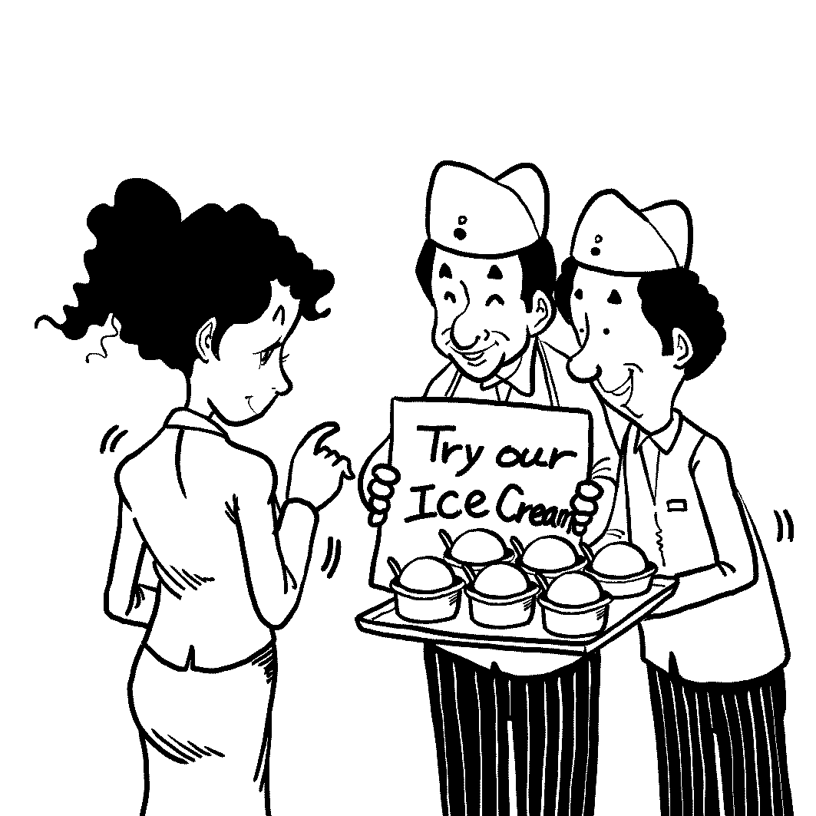
1.

2.

II. Best Response Questions (4%)
Listen to the question or statement and choose the best response.

3. | (A) OK. It’s certainly easy to kill time there.
 | (B) I was sitting at the front door the entire time.
 | (C) I know. I can never find a parking space around there.
 | (D) Yes, they have a great selection on the second floor.

4. | (A) Sure. Do you need me to get it for you?
 | (B) No. There aren’t any messages for her.
 | (C) OK, but what does she need a rope for?
 | (D) No problem. I’ll give her some tips.

5. | (A) I haven’t stop coughing the whole day.
 | (B) I think we’re lost. Let’s ask someone.
 | (C) I passed the test with a very high score.
 | (D) Thank you! I’m fine. How about you?
6. | (A) Yeah, Jack loves to eat steak.
 | (B) What did Jack order instead?
 | (C) I didn’t know Jack was a waiter.
 | (D) How could Jack eat two steaks?
III. Conversation Questions (4%)
Listen to each conversation and answer the question.

7. | (A) Write a card to the woman.
 | (B) Keep the cards for himself.
 | (C) Join the woman’s game.
 | (D) Stay away from the card game.
8. | (A) His handsome looks.
 | (B) His tools and technology.
 | (C) His fighting ability.
 | (D) His character and behavior.
9. | (A) He has tooth problems.
 | (B) He has heart problems.
 | (C) He has eye problems.
 | (D) He has back problems.

10. | (A) He is handsome
 | (B) He is rich.
 | (C) He is brave.
 | (D) He is generous.

IV. Cloze Test (12%)

Soap has been around for thousands of years. The Babylonians made the first soap in 2800 BCE by mixing sesame oil with ash. By 1550 BCE, the Egyptians were washing with soap ___11___ animal fat and salt. ____12____, it was the Celts who actually gave us the word “soap” when they mixed animal fat with ashes and called it “saipo”. Different soaps from around the world all ____13___ two things __13____—oil and lye. When these two things combine, they ___14___ to dirt and allow water to easily wash it away. The best soaps __15____ to come from Italy, France, and the Middle East. This is because soap from these places is made with olive oil which leaves skin smoother and softer. ___16___ you get your soap from, just make sure you use it!

11. | (A) made of | (B) made up of | (C) made into | (D) made from
12. | (A) However | (B) Besides | (C) Instead | (D) Therefore
13. | (A) share…together | (B) have…in common | (C) put…aside | (D) make…the same
14. | (A) gather | (B) spray | (C) stick | (D) form
15. | (A) are saying | (B) say | (C) said | (D) are said
16. | (A) Whichever | (B) Wherever | (C) Whatever | (D) However

Visitors to Geneva, Switzerland’s second largest city, will find ___17___ things to see and do. Any trip to see the city should start at the Jet d’Eau, a large fountain which shoots water 140 meters into the air. Next, the St. Pierre Cathedral __18____. Its mix of styles makes it look like several churches stuck together. ____19__, there is Geneva’s Flower Clock, ___20___ combines the area’s natural beauty with the Swiss love of clock-making. Many visitors also spend time enjoying Lake Geneva, ___21___ its deep blue waters and snowy mountains all around. Geneva is often ___22__ as one of the world’s most livable cities, and many international organizations have settled there, turning it into a global hub. Anyone who spends any time visiting Geneva is sure to agree.

17. | (A) plenty of | (B) variety of | (C) many of | (D) a few of
18. | (A) is worth to see | (B) is worth seeing | (C) is worth of seeing | (D) is worthy seeing
19. | (A) In addition to | (B) Beside | (C) Then | (D) Second
20. | (A) that | (B) it | (C) which | (D) what
21. | (A) through | (B) within | (C) from | (D) with
22. | (A) called | (B) named | (C) ranked | (D) attracted

V. Reading comprehension (8%)

- Taiwanese butterflies flew across an ocean and were found in Japan because of their migration with strong wings.
 | (A) True. | (B) False.

- No matter how worse global warming is, there is still at least 10 % of the Polar bears.
 | (A) True. | (B) False.

- A sonnet is a fourteen-line poem with a special rhythm.
 | (A) True. | (B) False.

- King Solomon knew the real mother of the living child was the first one because she gave the kid to the other mother in order not to hurt her baby.
 | (A) True. | (B) False.

- In the article of Say Good-bye to Shyness, which of the following is NOT what Dr. Sociable suggested to the shy boy?
 | (A) Think of other people much more. | (B) Keep smiling.
 | (C) Try to fit in as hard as possible. | (D) Take heart.

- According to The Salon Du Chocolate, where is the world’s largest chocolate show held?
 | (A) In London. | (B) In Paris. | (C) In Milan. | (D) In Tokyo.

- In Elizabeth Barrett Browning’s “Sonnet 43”, what is true?
(A) At first, the intensity of the author’s love is higher than her religion.
(B) Browning contrasts her current love to that God gives her.
(C) The author repeats “I love thee” to increase the power of the statement.
(D) The end of the poem shows that Browning will stop her love because of her death.

- Which of the following has NOT won the prize of the Webby Awards?
 | (A) eBay | (B) Twitter | (C) Anger Birds | (D) Facebook

Part B: Textbook (Lung Teng B1 L5-L8) 70%

I. Cloze Test (22%)

As soon as I arrived in the Old Town of Lijiang, I __31__ a huge water wheel. As Lijiang’s landmark, it showed that Lijiang was famous __32__ its smart ways of water use.
The old town had an orderly system of waterways and bridges. The snow in the nearby mountains turned into countless streams, which __33__ a marvelous network of canals and __34__ water __34__ every need. On some streets, there were three-eyed wells __35__ three levels of pools. The water at each level __36__ a different purpose and was used again and again. Most admirable was the town’s “street-cleaning” system. When a day’s trade __37__, people would close a water gate on the canal __38__ make the water flow over all the streets and thus clean the dirty square. Then the dirty water __39__ into the ditch on the other side of the square and __40__ out of town to water the nearby farms. In Lijiang, water had indeed __41__ treasured as a gift from God for hundreds of years.

31. (A) came into view (B) come into sight (C) had seen (D) saw
32. (A) in (B) of (C) for (D) as
33. (A) formed (B) was formed (C) had formed (D) being formed
34. (A) provided…for (B) supply…with (C) provide…with (D) supplies…for
35. (A) made up of (B) compose of (C) consisted of (D) made into
36. (A) was used to (B) was used for (C) used to (D) used as
37. (A) is finished (B) was done (C) had done (D) has finished
38. (A) so that (B) in order that (C) so as to (D) with a view to
39. (A) flew (B) flies (C) flowed (D) flowing
40. (A) was directed (B) had directed (C) directed (D) directing
41. (A) being (B) be (C) was (D) been

The first elevator was invented more than 100 years ago. Though built long ago, the elevator was, on the whole, quite __42__ the one we use today. The greatest difference __43__ in the fact that it got its energy from steam. It was not until 1880 that Werner von Siemens built the __44__ elevator.
As time went by, elevators became __45__. Now __46__ is common that at least one elevator is installed in a tall building. Sometimes, waiting for the elevator can be __47__ because, more often than not, the elevator has to __48__ several stops before people get to their desired floor. Thus, people spend too much time squeezing each other in a stuffed space. To deal with this problem, a new elevator __49__. People push the number for the floor they want before entering the elevator, and then the computer decides __50__ floor the elevator will stop. People going to the same floor will take the same elevator so that they will __51___ save a lot of time and enjoy more fresh air. However, there is also a disadvantage – if you get in the wrong elevator, you may have no choice but __52__ to the lobby and start your trip again!

42. (A) unlike (B) dislike (C) like (D) alike
43. (A) lies (B) lays (C) laid (D) lied
44. (A) electrified (B) electronic (C) electric (D) electrical
45. (A) wide use (B) widely used (C) common use (D) useful
46. (A) such (B) so (C) that (D) it
47. (A) encouraged (B) encouraging (C) discouraged (D)discouraging
48. (A) do (B) take (C) make (D) get
49. (A) is inventing (B) has invented (C) has been invented (D) being invented
50. (A) which (B) at which (C) where (D) what
51. (A) can (B) able to (C) be able to (D) unable to
52. (A) return (B) to return (C) returning (D) returned

II. Matching (7%)

53. Not only you but also your brother
54. The thief was seen
55. Hundreds of people have
56. He walked so fast
57. I was made by Mom
58. Upon entering the classroom, I heard my name
59. The donation of organs has made

(A)…….and save a large number of people.
(B)…….to do the dishes and then walk the dog.
(C)……was heard playing the guitar in the garden last night.
(D)……it possible for patients in critical conditions to survive.
(E)……play an important role in the team.
(AB)….been driven away from home by the flood.
(AC)…caught by the police.
(AD)…as not to get there in time.
(AE)…break into that apartment.
(BC)…calling over the loudspeaker.
(BD)…that I could hardly keep up with him.
(BE)…enough to leave us behind.
(CD)…called in a familiar voice.
(CE)…water the flowers in the yard.
III. Reading Comprehension (6%)

Two Poems:

Nothing Gold Can Stay
Nature’s first green is gold,
Her hardest hue to hold.
Her early leaf’s a flower;
But only so an hour.
Then leaf subsides to leaf.
So Eden sank to grief,
So dawn goes down to day.
Nothing gold can stay.

--Robert Frost..

To Electra
I dare not ask a kiss,
I dare not beg a smile,
Lest having that, or this,
I might grow proud the while.

No, no, the utmost share
Of my desire shall be
Only to kiss that air,
That lately kissed thee.

--Rober Herrick

60. The main idea of “Nothing Gold Can Stay” is that_______.
(A) human beings should be environment-friendly.
(B) change is a natural part of life.
(C) the Garden of Eden never existed.
(D) How valuable gold is.

61. The main idea of “To Electra” is that __________.
(A) the poet will be happy just to love her from a distance.
(B) the poet is not afraid about asking for a kiss.
(C) a kiss from her would make him humble.
(D) the poet prefers kissing the air to kissing her.

62. Which of the following statements is False?
(A) “Nothing Gold Can Stay” begins in springtime.
(B) “To Electra” has no rhythm or rhyme.
(C) In the first poem, the green does not stay long, nor does the golden light.
(D) In the second poem, the poet shows his love to the girl.

IV. Vocabulary (15%)
63. All the p__________rs are required to fasten their seat belts.
64. We stopped to stare at the strangely-dressed boy, w________ring who he was.
65. Jenny, who always wears a p_______t smile on her face, is among the most popular girls at school.
66. Standing at the top of the mountain, we a_________ted the beauty of sunrise and clouds.
67. Citizens over 40 are advised to undergo an a______l physical checkup.
68. We always keep a first aid kit a_______le in the house in case of emergency.
69. Lisa felt f________ted after the defeat, and didn’t have the slightest idea of what to do next.
70. In the course of g________y, students study all the continents, oceans, mountains, etc.
71. In the nineteenth century, people could hardly accept the c______t that human beings might have evolved from monkeys.
72. People build s________rs in big cities because land is scarce and very expensive.
73. The witch wiggled her ears, stuck out her t_______e, and then turned the children into apples.
74. The audience was fascinated by the sweet m_______y that flowed through the fingers of the pianist.
75. I always can’t make the ends meet at the end of the month. I have to learn to live within a _______(limit) budget.
76. In Greek mythology, Narcissus fell in love with his own _______(reflect) in a pool of water.
77. _________(harmony) relationships are far more important than beautiful decorations in a company.
78. There are some ____________( similar) between these two novels.

V. Translation (20%，每格2分) ※每格不只一個字，錯一字扣一分

你曾注意到台北街頭的動態藝術嗎？在台北，無論你走到哪裡，這些藝術作品皆能映入眼簾，當你一到達捷運車站時，你或許就會看見從天花板垂掛下來的造型品。

________79._______ the kinetic art on Taipei streets? In Taipei, no matter where you go, the artwork always comes into view. The _______80._______ the MRT station, you may see a series of shapes hanging from the ceiling.

動態藝術很新，創造於20世紀初。正如其名，動態藝術是指一種會動的零件而非靜止不動的物品，設計師們利用天然資源使作品運轉，舉公館(Gongguan)為例，有一幅巨大的壁畫在水源市場的側邊牆面，為了能夠看到壁畫的動態效果，觀看者必須移動才能欣賞。

Kinetic art is pretty new. _______81._______ in the early 1900s. ______82______, kinetic artwork is a type of art containing moving parts _______83.________ the still objects. The designers can _________84.________ natural resources to make kinetic art move. ________85._______, there is a giant mural on the side of the building of the Shui-yuan market. The mural relies on the movement of the viewer _______86._______ see its effect.

動態藝術如同生活，不斷地在改變，這些藝術不但增加了生活的樂趣，而且也為藝術增加一個面向，讓觀賞者能用新方式看待藝術，甚至是生活。

Kinetic artwork, which is constantly changing, ________87.________. It ______88._______ adds some pleasures in life ______88._______ adds one more dimension to art and allows viewers to look at art－and even life－in a new way.

台北市立松山高中一百學年度第一學期高一第二次期中考英文科答案卷

班級：_______________ 座號：____________ 姓名:__________________

IV. Vocabulary：(16%，每格1分 )

63. | 64. | 65. | 66.
67. | 68. | 69. | 70.
71. | 72. | 73. | 74.
75. | 76. | 77. | 78.

V. Translation：(20%，每格2分 ) ※每格不只一個字，錯一字扣一分

79. | 80.
81. | 82.
83. | 84.
85. | 86.
87. | 88.

台北市立松山高中一百學年度第一學期高一第二次期中考英文科答案卷

1-5 BDADA 6-10 BCDAB
11-16 DAB CDB 31-41 DCAAA BBCCAD
17-22 ABC CDC 42-52 CACBD DCC BCB
23-30 BB AA CB CD 53-59 C, AC, AB, BD, B, CD, D 60-62 BAB

IV. Vocabulary：(16%，每格1分 )
63. passengers | 64. wondering | 65. pleasant | 66. appreciated
67. annual | 68. available | 69. frustrated | 70. geography
71. concept | 72. skyscrapers | 73. tongue | 74. melody
75. limited | 76. reflection | 77. Harmonious | 78. similarities
V. Translation：(20%，每格2分 ) ※每格不只一個字，錯一字扣一分

79. Have you (ever) paid attention to/  Have you (ever) noticed | 80. moment/instant you arrive at / get to
81. It was created | 82. As its name suggests / indicates / implies
83. rather than / instead of | 84. make use of
85. Take Gongguan for example  Take Gongguan as an example | 86. so that they can  in order to / so as to
87.is similar to life / lives  is like life / lives | 88. not only…but (also)

