台北市立松山高中101學年度第二學期第二次段考高二英文試題

Magazine: All+ 2013 April 1-May 7
A. Listening section 12%

Part 1: Picture Questions
Look at each picture and answer the question.
1. | 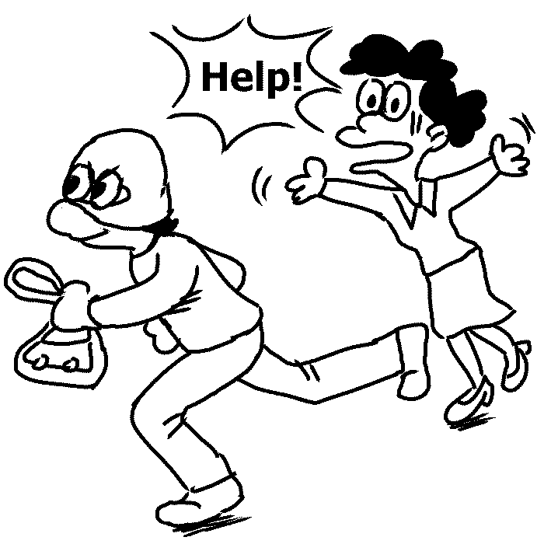 | 2. | 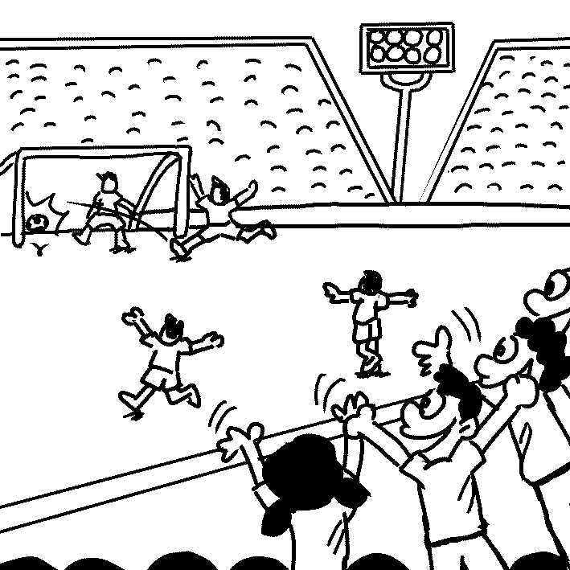

Part 2: Best Response Questions
Listen to the question or statement and choose the best response.
3. (A) Yes. He will demonstrate how to start a conversation.
(B) I know. He likes to interrupt others.
(C) Yes. I can’t get a word in while he’s around.
(D) I know. He leaves when we are in the middle of talking.

4. (A) Yeah. They are so gloomy and different.
(B) I agree. She uses lots of lively colors.
(C) I know. She makes them so detailed.
(D) Yes. They are dark, but realistic.

5. (A) Really? Maybe he should explain to his classmates what happened.
(B) Yes, he told his colleagues his adventures in Africa.
(C) I know. They are spending a weekend in the mountains.
(D) Yes, he will have a physical examination this weekend.

6. (A) Yes, it was pulled from the shelves due to safety issues.
(B) How are consumers responding to it?
(C) Now that it is planned, let’s get to work on it.
(D) They did that because the product became less popular.

Part 3: Conversation Questions
Listen to each conversation and answer the question.
7. (A) He doesn’t like the woman’s ideas.
(B) He insists that they should use his ideas.
(C) He doesn’t have any good ideas.
(D) He wants to give the woman some ideas.

8. (A) She won’t read the whole novel with patience.
(B) She won’t tell the man her opinion about his book.
(C) She will say negative things about his book.
(D) She will praise the man for his book.
9. (A) The procedures for making the soup.
(B) Where he found the recipe.
(C) If he ever made it before.
(D) What things he put in it.

Part 4: Short Talk Questions
Listen to the following paragraph and answer the questions.
10. (A) It doesn’t affect her anymore.
(B) It makes her unable to achieve international fame.
(C) It becomes a generating force for her art.
(D) It is caused by her sweet childhood memories.

11. (A) She checked into a special hospital.
(B) She introduced her first artwork.
(C) She recovered from her mental illness.
(D) She worked for a big fashion brand.

12. (A) Set a record.
(B) Create tension.
(C) Make the artist’s depression worse.
(D) Change the artist’s painting style.

B. Reading section
I. Cloze 28%
While most people are aware of the dangers of additive 13 such as tobacco, betel nuts and cocaine, they know little about the addictive effects of processed food. Thanks to the efforts of researchers, the addictive properties of processed food are now being 14 . The theory researchers have proposed is 15 many processed foods use texture and carefully selected components to 16 certain brain chemicals and get people hooked.
Addiction to processed food is commonly developed early in life. 17 the increased attention paid to the issue, many people are still unaware of the downside to these products. Oftentimes, busy parents allow their children to 18 in convenient vending machine snacks and drinks. Once the habit is formed, the products’ addictive effects make it very difficult to 19 .

13. | (A) radishes | (B) attachments | (C) consequences | (D) substances
14. | (A) demolished | (B) exported | (C) disclosed | (D) installed
15. | (A) what | (B) that | (C) which | (D) because
16. | (A) trigger | (B) lure | (C) mirror | (D) consume
17. | (A) Because of | (B) Besides | (C) Although | (D) In spite of
18. | (A) launch | (B) involve | (C) indulge | (D) evolve
19. | (A) flatten | (B) repair | (C) break | (D) misplace

Nuclear energy is a controversial issue. Proponents of nuclear energy argue that nuclear power plants are a clean form of 20 electricity because they do not create any greenhouse gases. In addition, 21 with wind and solar power, nuclear power can produce larger 22 of electricity. However, since the Fukushima disaster in Japan occurred, more and more people have 23 doubts about the safety of nuclear power plants. Opponents of nuclear energy question if nuclear waste can be stored safely. They also wonder if humans have the ability to prevent another nuclear disaster from happening. Since it is hard to put an end to controversies surrounding nuclear energy, perhaps it is time that humans 24 safer ways to produce electricity such as using wind and solar power.

20. | (A) tackling | (B) generating | (C) retrieving | (D) recreating
21. | (A) comparing | (B) to compare | (C) compared | (D) in comparing
22. | (A) amounts | (B) numbers | (C) deal | (D) plenty
23. | (A) risen | (B) arisen | (C) aroused | (D) raised
24. | (A) adapted | (B) adopted | (C) admit | (D) adjust

With the development of high technology, scientists have created a number of super-intelligent robots. These advanced robots not only 25 us in behavior and appearance, but they are also able to 26 increasingly complex tasks. Take Matilda for example. Matilda is a robotic health-care professional 27 to assist the elderly. Matilda’s software and hardware actually allow “her” to read human emotions and 28 to them. Matilda represents an 29 trend that is seeing robots
30 facets of our lives once thought impossible for them to function purposefully within. However, not everyone welcomes such a trend.

25. | (A) assemble | (B) resemble | (C) dissemble | (D) attach
26. | (A) take up | (B) take in | (C) take on | (D) take over
27. | (A) which has designed |  | (B) which are designed
 | (C) designing |  | (D) designed
28. | (A) correspond | (B) react | (C) portray | (D) inspire
29. | (A) emerged | (B) emerging | (C) immersed | (D) immersing
30. | (A) evade | (B) register | (C) invade | (D) expand

Francis Scott Fitzgerald is renowned 31 one of the best American writers of the 20th century. Some of his famous works were written 32 an autobiographical fashion. That is, rather than writing merely fiction, Fitzgerald
33 many aspects of his personal life and displayed them in his writing.
In his highly 34 masterpiece The Great Gatsby, Fitzgerald depicted the
35 lives of the well-to-do in the early 1920s. The novel showed the loves, illusions, and 36 of those who had more money than they knew what to do with. He also described vividly the social environment 37 he lived. The time Fitzgerald lived in was certainly a time of 38 . It was the time of Prohibition in

the United States, and selling or consuming alcohol was illegal. However, for those whose wealth appeared boundless, the laws 39 with Prohibition meant little or nothing. Politicians, police, and many others in the government were 40 to keep quiet about the booming bootleg trade in liquor. It was as if nothing was prohibited at all, at least for the select few.

31. | (A) for | (B) to | (C) as | (D) by
32. | (A) with | (B) in | (C) by | (D) through
33. | (A) acted upon | (B) drew upon | (C) dwelled on | (D) caught on
34. | (A) acclaiming | (B) presumed | (C) characterizing | (D) praised
35. | (A) elaborate | (B) glistened | (C) glittering | (D) intelligent
36. | (A) deceits | (B) receipts | (C) frames | (D) gangsters
37. | (A) which | (B) that | (C) what | (D) where
38. | (A) express | (B) evaluation | (C) excess | (D) composite
39. | (A) associating | (B) associated | (C) were associated | (D) to associate
40. | (A) pounded | (B) explored | (C) bribed | (D discarded

II. Fill in the blank with a proper phrase (大小寫不拘) 10%

(A) taking hold | (B) resigned to | (C) phased out
(D) shed light on | (AB) reflective of | (AC) of the essence
(AD) passed out | (BC) in light of | (BD) sounded the alarm

(A) Because of the slow economic recovery in Taiwan, there are fewer job opportunities for recent college graduates. Therefore, it takes a longer time for them to find their first job. Moreover, 41 the bleak job market in Taiwan, most college graduates are 42 working for very little pay. Take Amy Wu for example. She spent half a year landing a low-paid job in a bookstore. She worked for long hours only to earn twenty thousand dollars per month. A study conducted by an American scholar, Cliff Zukin, 43 Amy’s situation. As Cliff said, “Recent college graduates are a postponed generation. They seem to be living with parents longer and taking longer to become financially secure.”

(B) Speed is 44 in dealing with an emergency. That is, it is crucial to take prompt action when an emergency occurs. Last Sunday, fifty people 45 from heat at the outdoor rock concert. Fortunately, the organizers took good care of them immediately and no serious harm was done.

課本部份: 龍騰版B4L4~L8
I. Cloze 19%
Marshall McLuhan meant well in his book titled The Medium is the Massage. Nowadays, the media have a great influence on our life, especially when the strategy of product replacement is used. 46 no escape for us to get away from product replacement because we watch TV almost every day. No wonder product companies are paying a lot of money to place their products in scenes. This has 47 the rise of an ever-growing placement industry, 48 to earn $1 billion a year in the U.S.
We tend to receive messages of a certain product from TV without giving them a second thought and thus 49 a positive impression of it unconsciously. 50 that we may be tricked into buying a thing every minute without knowing why we need it.
What’s more, when we see our favorite movie stars dressed in fashionable costumes, driving fancy race cars or wearing expensive watches – with the brand name prominently 51 , we are charmed once again. As a matter of fact, the filmmakers
52 incorporating these “props” into their films and many famous producers even have the total cost of production paid off before the first movie ticket is sold.
Is there a possibility 53 we can avoid falling into the trap the advertising company has set for us? As one media scholar commented, “It is inherently deceptive if people don’t realize that ads are ads.” 54 messages from many media, we’d better remain 55 the secret force of the “massage” and control ourselves well.

46.(A) It seems to be (B) There seems to be (C) We seem to be(D) What seems to be
47.(A) contributed (B) resulted in (C) been caused (D) resulted from
48.(A) estimating (B) which estimates (C) is estimating (D) which is estimated
49.(A) it is likely that we form (B) it is least likely that we form
(C) we are possible to form (D) we are likely that we form
50.(A) There’s no exaggeration to say (B) It is not too much to say
(C) There’s not so much to say (D) It is no exaggerating to say
51.(A) displaying (B) display (C) on display (D) displayed
52.(A) get paid for (B) pay for (C) will pay to (D) are paid to
53.(A) which (B) x (C) that (D) in that
54.(A) To live in a world full of (B) Living in a world fill with
(C) Living in a world full of (D) Live in a world filled with
55.(A) alarmed to (B) unconscious of (C) ethical to (D) alert to

How do you look at the complicated images in your dream? 56 you were a newcomer in a big city, would you be nervous? One night, you dreamed of yourself sitting at the table talking happily with many people, 57 were strangers. But suddenly, people in your dream changed. You find the guests were your friends
58 your parents were among them. What does the dream mean exactly?
According to Freud, “repressed” memories or thoughts were hidden in the unconscious mind. They were altered or disguised when they appeared in our actual dreams at night so that we could continue to sleep 59 being disturbed.
60 , when confronted by these memories or thoughts, we would become distressed and soon wake up. 61 , dreams fundamentally 62 the guardians of sleep.
There are two very important mechanisms, condensation and displacement, mentioned in his book The Interpretation of Dream published in 1899. 63
combining two or more unrelated, or even contradictory, dream-thoughts, one single element can be formed to account for the dream. 64 , if a troubling thought is replaced by a symbol, it will remove the emotional significance of the thought so that the dreamer does not become suspicious.
Does Freud’s theory of dream interpretation make sense? Perhaps the answer is still unknown because man is his own greatest mystery.

56. (A) Suppose (B) Compose (C) Expose (D) Impose
57. (A) and whom (B) they all (C) none of them (D) all of whom
58. (A) and that (B) and (C) so that (D) with
59. (A) while (B) although (C) if (D) without
60. (A) Therefore (B) For example (C) Otherwise (D) Instead
61. (A) Thus (B) On the contrary (C) However (D) What’s more
62. (A) disguise as (B) are in favor of (C) act as (D) consider
63. (A) With (B) For (C) By (D) Unless
64. (A) First of all (B) On the other hand (C) In general (D) Without doubt

II. Reading Comprehension 6%
One does not often mention poetry and advertising in the same breath. Poetry is universally conceded to be the loftiest attainment of the verbal arts; advertising, however, is not even an autonomous art; it is the handmaiden of commercial motives; its name carries connotations (well earned, one might add) of half-truths, deceptions and of appeals to vanity, fear and snobbery.
There are many more contrasts. The best poetry seems to be fully appreciated only by the few and to be beyond the comprehension of the many. Advertising, however, is considered best when it is laughed over, thought about, and acted upon by multitudes. Poetry is, in the general apprehension, something solemn to be studied in schools and enjoyed by cultivated people. Advertising is a part of everyday life.
But poetry and advertising have much in common. They both make every possible use of rhyme and rhythm, of words chosen for their connotative rather than their denotative values, of ambiguities that strike the level of unconscious responses as well as the conscious. Furthermore, they both strive to make the objects of experience symbolic of something beyond themselves. A primrose by the river’s brim ceases to be “nothing more” because the poet invests it with meaning; it may symbolize the benevolence of God, or anything else he wants it to symbolize. The advertiser is concerned with the primrose only if it happens to be for sale. Once it is on the national market, the advertiser can increase its saleability by making it thrillingly reminiscent of happiness, romance, and elegance, or symbolic of solid, traditional American virtues, depending upon his whim. Indeed almost all advertising directed to the general public is the poeticizing of consumer goods.
Poetry and advertising are similar too in that they invite the reader to put himself in a role other than his own. In reading poetry we identify ourselves with the characters that a poet creates or with the poet himself. Advertisers also invite us to make

identifications of ourselves in new roles, although the roles are simpler, pleasanter, and more easily within reach. Readers are invited to look upon themselves as “smart housewives and hostesses’ (who serve Spam), and “men of distinction” (who drink Calvert’s).

- From the first two paragraphs, we know that __________
  - people who like poetry usually dislike advertising.
  - advertising helps people to earn a living.
  - Cultivated people enjoy poetry as well as advertising.
  - people seldom associate poetry with advertising.

66. The purpose of displaying “solid, traditional American virtues” in an advertisement is most probably that ________
  - Americans are usually eager to cultivate virtues on a whim.
  - it is easy for American consumers to identify themselves with the product.
  - American people are always proud of being men of virtues.
  - the advertising company wants to make fun of the Americans for their vanity.

67. Which of the following is NOT true of poetry and advertising?
- Both may exhibit deliberate ambiguities.
- Both make use of everyday experience.
- Both try to make objects of experience symbolic of something good.
- Both may draw unconscious responses.

------------------------------------------------------------------------------------------------
以下題目的答案請寫在答案卷上

I. Vocabulary 15%
- Fiona’s father became very angry with her when he saw she had had her nose
p ed.
- Though May and Helen are twins, they have u rly different personalities.
- Victims of domestic violence have to s n their courage to ask the police for help.
- The most striking features of c y international affairs are economic globalization and the search for solutions to shared problems.
- A joint v e involves two or more business pooling their resources and expertise to achieve a particular goal. The risks and rewards of the enterprise are also shared.
- A powerful earthquake hit the Sichuan province of China near Ya’an city on April 20. It is in the same region where a m e quake occurred five years ago and killed about 70,000 people.
- Some people in Asia are devoted to raising more comprehensive awareness of the rich heritage of o l culture so that the westerners can have a better understanding of it.
- Birds build nests by i t. It is a natural ability, so they do not need to learn from other birds.

- To take a good picture successfully, one needs a good camera as well as some
t es in photography.
- A concert s red by an international bank will be held on the Mother’s Day in the National Concert Hall in celebration of the special holiday.
- The environmental protection cannot be over-emphasized and the workshop is meant to help the public understand the s e of it.
- Most balls are ______ (circle) in shape, but American footballs are not.
- Our website is not accessible now, for the web designer is making a few ______ (alter).
- As the first step in their ______ (enroll), all new students will be requested to fill in their own personal information.
- After the rampage shooting in the elementary school, the ______ (necessary) of tighter gun control for an orderly and secure society was emphasized.

II. Idioms and phrases 10% (每格不只一個字，全對才給分)
16. To attract customers, the advertising company intends to ____________ (打破模式) and put their new advertisements in a different way.
17. If we do not work hard now, how can we put our dream of entering an ideal college ____________? (實踐;實行)
18. My boss is never satisfied. S what I have done in job. (他很少對…感到高興) (用倒裝句)
19. We are left (確信; 深信不疑) that Jeremy Lin is one of the best Asian American basketball players ever.
20. In our life, true friends are always there for us; that is, through thick and thin, they will ____________ (在我們身旁) for good.
21. Since more and more people are reported to have been killed by a new strain of avian influenza, H7N9, in China, public concern over health is growing and China becomes _____________ place people will choose to travel. (=it is almost impossible that people will choose to travel China.)
22. The wedding planner prepared everything in detail in order to make the atmosphere and the occasion perfectly ____________. (搭配得宜; 適合相襯)
23. It is ________________ its importance. (我們直到失去健康才知道)
24. Two blasts turned a celebration into a bloody scene of destruction at Boston Marathon on April 15. Both the runners and the spectators near the finish line were struck by the explosions.
_________________, they were so frightened that they ran away from the place in panic. (一看到這景象…)
= As soon as they saw the sight, they were so frightened that they ran away from the place in panic.
= N the sight than they were so frightened that they ran away from the place in panic.

臺北市立松山高級中學第101學年度第二學期第二次段考
高二英文科答案
I. Vocabulary 15%

1. pierced | 2. utterly | 3. summon | 4. contemporary
5. venture | 6. massive | 7. oriental | 8. instinct
9. techniques | 10. sponsored | 11. significance | 12. circular
13. alterations | 14. enrollment | 15. necessity

II. Idioms and phrases 10% (每格不只一個字，全對才給分)

16. break the mold | 17. into practice
18. Seldom is he pleased with | 19. with no doubt
20. be by our side | 21. the last/ the least likely/ the most unlikely
22. fit together | 23. not until we lose health that we realize
24. (1) On seeing the sight | 24.(2) No sooner had they seen the sight

01-10 CACBC, BDCDC
11-20 AADCB, ADCCB
21-30 CADBB, CDBBC
31-40 CBBDC, ADCBC
41-50 BC, B, D,AC, AD BBDAB
51-60 DACCD, ADADC
61-64 ACCB 65-67 DBC
(41-45 及65-67 每題2分; 其餘選擇題每題1分)

