台北市立松山高中102學年度第二學期高二英文科第一次期中考試題

Part A: All+ Feb. 17~28 March 1~16

Listening Comprehension

Part 1: Picture Questions (2%)
Look at each picture and answer the question.
1. | 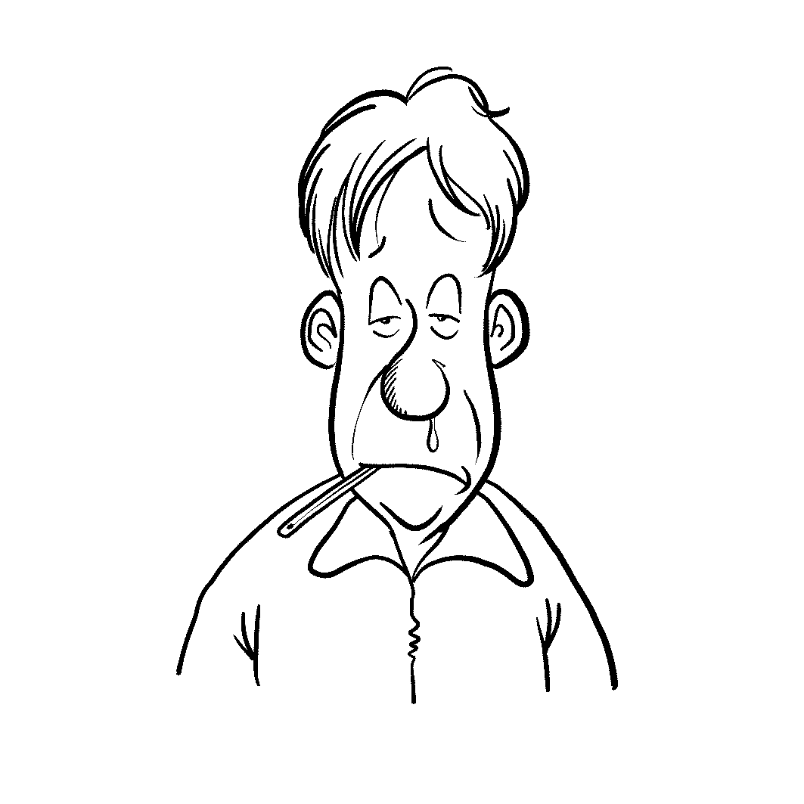 | 2. | 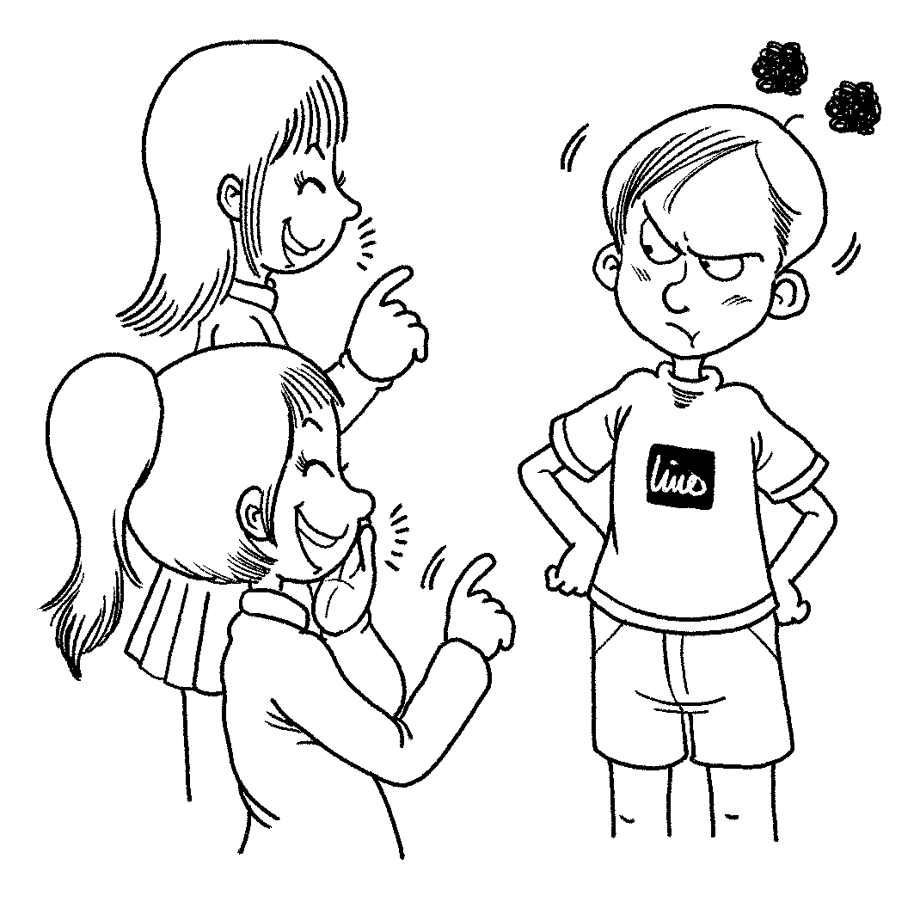

Part 2: Best Response Questions (2%)
Listen to the question or statement and choose the best response.
( ) 3. (A) Yeah, a good relationship with the boss is key.
(B) Yes, an employee must come up with good ideas.
(C) Yes. It takes hard work and loyalty to do a good job.
(D) No, you don’t have to make lots of friends to do well.
( ) 4. (A) Yes. They stopped playing when they saw lightning.
(B) Yeah. They didn’t start playing until the rain stopped.
(C) Yeah, they still completed it. They got very wet though.
(D) That’s right. They will have to finish it another day.

Part 3: Conversation Questions (3%)
Listen to each conversation and answer the question.
( ) 5. (A) Help people with serious illnesses.
(B) Report news for television stations.
(C) Entertain people by singing and dancing.
(D) Design and build buildings.
( ) 6. (A) He or she should have many skills.
(B) He or she should be patient with people.
(C) He or she should be able to work long hours.
(D) He or she should be willing to travel abroad.
( ) 7. (A) There were papers everywhere.
(B) Lots of people were very tired.
(C) Everyone felt really satisfied.
(D) People were nervous and stressed.

Part 4: Short Talk Questions (3%)
Listen to the following paragraph and answer the questions.
( ) 8. (A) It was his childhood dream.
(B) It is his number one interest.
(C) It is not something he is good at.
(D) It doesn’t bring him the most joy in life.
( ) 9. (A) It is all about who has the biggest car.
(B) It tests performance over a long period of time.
(C) It is especially popular among celebrities.
(D) It takes place every year in the UK.
( ) 10. (A) They have acted in racing movies.
(B) They own their own racing teams.
(C) They share a passion for racing.
(D) They have competed in Le Mans.

Reading Comprehension

Cloze Test: 25% (每題1分)
Nowadays, many people have the problem of allergies. These allergies usually cause ___11___ such as sneezing, runny noses, and itchy eyes. Most of us ___12___ nuts a simple, tasty snack, but for those allergic ___13___ them, eating a peanut or any other kind of nut could cause a serious reaction.
Nuts are not the only kind of food that makes people allergic. Shellfish allergies can be just as serious as nut allergies, but it most often ___14___ people suffering swollen faces and tongues. Though some doctors have tried increasing patients’ ___15___ to problem foods by having them eat tiny amount of them, they are getting more worried about food allergies because an increasing number of children are suffering from them. One theory is that improved standards of hygiene make living environments too clean. This cleanliness ____16____ children’ s immune systems ___16___ developing properly, and allergies are the result.
11. (A) professionals (B) characteristics (C) illustrations (D) symptoms
12. (A) look (B) regard (C) reflect (D) consider
13. (A) for (B) to (C) on (D) from
14. (A) results in (B) beats out (C) results from (D) accounts for
15. (A) residence (B) commitment (C) resistance (D) endurance
16. (A) leads…to (B) protects…from (C) rests…on (D) stops…from

Have you ever dreamed of rocketing into space and living on another planet? The Mars One Astronaut Selection Program is already underway. Round one of the Mars One Astronaut Selection Program ___17___ in April of last year when candidates were invited to ___18___ an application online. In this round, applicants had to send in a one-minute video ___19___ they answered a few questions. In all, over 200,000 people decided to ___20___. A team of experts then watched the videos and determined who moved on to the second round.
Two more elimination rounds are scheduled over the next couple of years. As they advance, prospective astronauts will be ___21___ on their ability to work in harsh conditions. When all is said and done, six four-person teams will become Mars One employees, and one of those teams will be sent to Mars in a few years’ time.
17. (A) blasted off (B) pulled through (C) lived on (D) kicked off
18. (A) sponsor (B) submit (C) stock (D) spare
19. (A) which (B) , which (C) in which (D) that
20. (A) let their imagination take flight (B) sing their praises
(C) follow in their fathers’ footsteps (D) throw their hats in the ring
21. (A) extracted (B) derived (C) evaluated (D) redefined

Primarily known for her role as Hermione Granger in the Harry Potter series of films, Emma Watson is ___22___ close to a shrinking violet. Since Watson ___23___ Hermione exceptionally well, moviegoers got to know her ___24___ the quick thinking, brave, and extremely smart muggle-born, and she stole the hearts of Harry Potter fans around the world. For ten years, people watched Emma Watson grow up through the Harry Potter movies, and she is now a highly ___25___ young actress.

22. (A) nothing (B) anything (C) nearly (D) precisely
23. (A) unveiled (B) patented (C) adhered (D) portrayed
24. (A) as (B) by (C) with (D) for
25. (A) depressing (B) accomplished (C) delicate (D) fascinated

Over the past twenty years, the haze has become a regularly occurring phenomenon. Terrible haze in Southeast Asia first ___26___ international headlines in the 1990s, and the same headlines have shown up throughout the 2000s. The 2013 haze was ___27___ the result of huge fires burning in Indonesia, which were caused by slash-and-burn planting techniques. This is a cheap and easy way to clear land for farming, but it’s terrible for the environment. The smoke from those fires ___28___ with the area’s usual industrial pollution, and a cloud of ash, acids, and chemical droplets covered an area of three million square kilometers. The problem with air pollution is still getting worse. The solutions demand less slash-and-burn farming ___29____ cleaner ways of generating electricity. Nevertheless, something must be done, as the consequences are already too dire to ignore.

26. (A) hit (B) did (C) caught (D) appeared
27. (A) absolutely (B) aptly (C) partially (D) desperately
28. (A) curved (B) confessed (C) compressed (D) combined
29. (A) rather than (B) in comparison with (C) instead of
(D) along with
Innovators are finding ways to use cork to bring down energy consumption. In Warsaw, Poland, cork was ___30___ into the floors of metro train cars. As cork is so lightweight, it helps reduce the weight of each train, which ___31____ into huge energy savings. Cork can also be used to reduce noise pollution. Cork flooring, because it’s so soft, can ___32___ harsh sounds like dropped plates in restaurant kitchens.

30. (A) navigated (B) incorporated (C) transformed (D) ridiculed
31. (A) coordinates (B) instills (C) translates (D) divides
32. (A) shoot up (B) make up (C) bring out (D) cut down on

Many themes in Andersen’s fairy tales, such as loneliness and rejection, were ___33___ his experiences in life. Other fairy tales by Andersen also give autobiographical glimpses. In The Little Match Girl, a poor child dies on a cold night after warming her hands with the few matches she had but was supposed to sell. This story was a reminder ___34___ his extremely poor early life and also ___34___ his mother, who had once ____35____ begging on the streets as a girl.

33. (A) informed of (B) originated from (C) drawn from (D) passed on
34. (A) of…of (B) from…from (C) for…for (D) on…on
35. (A) made a splash by (B) resorted to (C) referred to (D) discouraged from

Part B: Easy Access to Vocabulary 4500-7000 Book 1 (pp.2~35)

Vocabulary: 15% (每題1分)
36. On the first day of my new job, my ______ instructed me to punch my card when I arrive at work in the morning.
(A) tenant (B) successor (C) sergeant (D) supervisor
37. The airline company is going to be the new ______ of the charity program.
(A) villain (B) sponsor (C) sheriff (D) veteran
38. The man needs a(n) _______ to help him get over his drug and alcohol addiction.
(A) usher (B) umpire (C) therapist (D) traitor
39. After twenty hit records, the singer retired and live off her ______.
(A) sovereignty (B) vocation (C) residence (D) royalties
40. Since the new mayor replaced his _______, things in the city have been much better.
(A) premier (B) prophet (C) poacher (D) predecessor
41. The hospital ______ new volunteers to help care for the sick.
(A) captured (B) attended (C) recruited (D) commuted
42. Matthew McConaughey was the ______ of the Best Actor Award at this year’s Oscars.
(A) personnel (B) recipient (C) participant (D) organizer
43. The ______ uncovered information that proved the famous hot-pot restaurant had lied to the people.
(A) intruder (B) linguist (C) descendant (D) investigator
44. The ______ were sent to jail because they pushed for an all-out political reform.
(A) dissidents (B) counterparts (C) casualties (D) pedestrians
45. A well-respected businessman headed the ______ to the APEC summit.
(A) correspondence (B) delegation (C) nomination (D) presidency
46. _______ crime is on the increase because many teenagers are addicted to on-line games.
(A) Editorial (B) Aboriginal (C) Administrative(D) Juvenile
47. The journalist interviewed the financial ______ to hear what he thought about the stock market.
(A) advocate (B) adolescent (C) analyst (D) apprentice
48. Many people want to work for the large _______ because it offers job security.
(A) corporation (B) constituent (C) pension (D) missionary
49. The _____ listened to all the evidence in the courtroom before retiring to consider their verdict.
(A) convict (B) jury (C) interpreters (D) columnists
50. Four bank clerks were taken _______ by the terrorists, and the police tried to negotiate with them.
(A) hypocrite (B) contractor (C) hostage (D) legislator

Part C: Textbook
I. Cloze Test : 14% (每題1分)
Aware of the electronics waste crisis, ECO-CELL, a cell phone-recycling company, has designed a program which encourages organizations to collect used electronics to save the environment. __(51)__ the number of cell phone users growing rapidly, the demand for materials to produce cell phones soars high than ever. Plus, the average lifespan of a cell phone is estimated __(52)__ 18 months ten years ago, but it decreases to 14 months only. The reduction of the average length suggests that the increasing need for coltan __(53)__ the gorilla habitat. The conservationist said that the chemical element is widely used in cell phones, __(54)__ up to 80% of the coltan supply is from the deep forests of Congo, __(55)__ is home to the endangered gorillas. __(56)__ on a large scale, the gorilla habitat has aroused the environmentalists’ attention. For example, according to ECO-CELL, it is vital that everyone __(57)__ their best to recycle their used cell phones. To encourage more people to get involved, they will pay for every phone collected – even up to $50 per phone!

51. (A) As (B) With (C) Because (D) By
52. (A) that (B) like (C) to be (D) to have been
53. (A) should threaten (B) posed a threat
(C) has threatened (D) has been threatened
54. (A) and (B) that (C) where (D) and that
55. (A) it (B) which (C) where (D) what
56. (A) Mine (B) Mining (C) Mined (D) To mine
57. (A) do (B) does (C) did (D) doing

When Tourism Queensland announced a job vacancy, calling for a caretaker for its largest inhabited island, it was viewed as the most attractive position on earth ever. __(58)__ between the Queensland Coast and The Great Barrier Reef, Hamilton Island is among the other 74 tropical islands, __(59)__ a perfect place to relax and unwind. __(60)__ the other 35,000 applicants from 22 countries, Ben, together with the other 14 candidates, won favor of the judges to enter the final stage. The British fundraiser eventually __(61)__ defeat his rivals, securing his place to be the lucky island caretaker. __(62)__ many regarded this position as a ‘sinecure’, an easy job with very high pay, he was faced with many challenges at the same time. It was not until his 6-month contract expired__(63)__ the importance to preserve the pristine ecosystem. He __(64)__ it necessary for every global villager to adopt a more environmentally-friendly lifestyle. After all, only by living peacefully with the nature could its resources remain sustainable.

58. (A) Lied (B) Situating (C) Located (D) Stood
59. (A) applying to (B) running into (C) soaking up (D) serving as
60. (A) On account of (B) Though (C) In addition to (D) Despite
61. (A) enabled to (B) managed to (C) succeeded in (D) failed to
62. (A) While (B) Since (C) When (D) As
63. (A) did he realize (B) when he realized
(C) that he realized (D) then he realized
64. (A) kept (B) founded (C) regarded (D) thought

II. 文意選填 7% (每題1分，選項不受大小寫影響)
Featuring the romantic love between a teenage girl and a vampire, Twilight is a romantic novel written by the American novelist Stephenie Meyer. Due to its popularity, it was __(65)__ into a film in 2008. In the romance, the one that Bella __(66)__ was her Mr. Right was not a human being but a vampire. It seems ridiculous in the real world, yet the extraordinary plot arrangement had __(67)__ tens of thousands of fans. In fact, the idea occurred to Meyer accidentally in her dream one night in 2003. From then on, the great task to transform the dream into a complete novel had kept her __(68)__ for 3 months. After the draft was completed, her sister read through it immediately. __(69)__ attracted by the story, she persuaded Meyer to get it published. Although the work was rejected for times, her sister was __(70)__ with no doubt that the romance would become a bestseller one day. Just as she had expected, it was printed up to 75,000 copies after being published in 2005, and the box office of the movie version in 2008 even __(71)__ $125million, achieving a grand victory over the other films at that time.

- impressed (B) adopted (C) occupied (D) left (E) lively
(AB) adapted (AC) more than (AD) crushed (AE) believed
(BC) exceeded (BD) utterly

III. Reading Comprehension : 6% (每題2分)
With the myriad of indoor entertainment options for kids these days, it’s no wonder that playing outside tends to fall by the wayside. There are video games, online games, smart phones, tablet PCs, and e-readers to keep children entertained. As a result, there’s little incentive for them to get active and enjoy the great outdoors. All of this is leading to more and more young people suffering from something known as Nature Deficit Disorder (NDD).
NDD is a direct result of the human race, at least the urbanized portion of it, losing regular contact with the natural world. According to Louv, a US journalist, our new, increasingly urban lives are stopping kids from playing outside as previous generation did.
As for what can be done to prevent NDD from becoming a major social and health epidemic, it is obvious: get outside! Obesity and other related health problems simply weren’t issues for our ancestors because they expended energy planting and harvesting crops, and didn’t have social networking to keep them shut-in all day and night. But in just a generation or two, beginning with the advent of television, our lifestyle began to alter greatly with each new generation as technology continued to make us even more sedentary.
Hope is not lost, however, as there are programs that aim to take the human race at least partway back to our natural roots. Many schools have begun to offer outdoor education programs. Studies have shown these programs lead to students having longer attention spans, more creativity, increased self-confidence, and higher test scores. Besides, these programs teach young people to care for the environment. The National Wildlife Federation (NWF) is also promoting the Green Hour---one hour a day for kids to enjoy unstructured play outdoors. With any luck, NDD will be a thing of the past before it gets a chance to become an unfortunate part of our future.

72. What does the article say causes kids to mostly stay indoors these days?
(A) They prefer to read e-books at home.
(B) They are afraid of being bullied by other playmates.
(C) Their parents won’t let them play outside because it’s dangerous.
(D) They have many entertainment options.
73. What is being done to prevent NDD from becoming a bigger problem?
(A) Schools are offering alternative education programs.
(B) People are being asked to eat healthier and exercise more.
(C) Students are being asked to concentrate in class and study harder.
(D) People are bringing aspects of nature to indoor environments.
74. What is implied about NDD?
(A) No one knows exactly what causes it yet, so it can hardly be stopped.
(B) It is a problem of the past, not the future.
(C) It can be prevented if the right steps are taken.
(D) Nothing can be done to stop its progress.
IV. Vocabulary : 15% (每題1分)
- Dinosaurs are completely e______t. They can only be seen in movies or museums.
- Luckily, the family miraculously s______ed the fire. No one was even hurt.
- Fujian is a p______e on the southeast coast of mainland China.
- Starting with California, they finally reached the d______n, New York City, after the 5-day road trip.
- Mothers tend to protect their children by i______t. It seems like a kind of inborn ability.
- The e______y of the developing country is growing rapidly since there are more and more business activities ongoing every day.
- Interested in farming and plant modification, Greg has determined to study in the a______l college.
- The parents were warned that they had been n______t in leaving their young baby at home alone.
- The French E______y is very near the most expensive neighborhoods in the city. It’s where ambassadors from around the world frequent.
- Watch out for p______s snakes when you go hiking in the mountains.
- Jerry likes to go traveling on a regular basis to broaden his h______ns.
- Albert Einstein was an influential p______t in the 20th century, who had developed the general theory of relativity.
- It was such a c______e that he was born on his mother’s birthday.
- As time went by, Mr. Darcy’s love for Elizabeth i______fied.
- The r______ns of the football star’s private life greatly astonished his fans.

V. Translation : 8% (每格不只填入一字)

台北市立松山高中102學年度第二學期高二英文科第一次期中考試題
IV. Vocabulary : 15% (每題1分)
75 | 76 | 77 | 78
79 | 80 | 81 | 82
83 | 84 | 85 | 86
87 | 88 | 89

V. Translation : 8% (每格不只填入一字)
90. 他不僅被誘騙去買盜版DVD，而且還公開播放電影。2%
Not only pirated DVDs, but he also played the movies in public.
91. 藉由垃圾回收，我們的環保意識得以提升。2%
the garbage, our eco-friendly awareness could .
92. 問題在於Hank不可能接受新的挑戰。3%
The problem l the fact that Hank is to _ new challenges.
93. 在他買新平板前，舊的已經被丟掉了，這真是種浪費！1%
By the time he bought the new tablet, the old one , which was a great waste!

台北市立松山高中102學年度第二學期高二英文科第一次期中考試題
Key 77% (1-71每題1分, 72-74每題2分)
1-5 C A C C D
6-10 A D D B C
11-16 D D B A C D
17-21 D B C D C
22-25 A D A B
26-29 A C D D
30-32 B C D
33-35 C A B
36-40 D B C D D
41-45 C B D A B
46-50 D C A B C
51-57 B D C D B C A
58-64 C D D B A C D
65-71 AB BE A C BD D BC
72-74 D A C
IV. Vocabulary : 15% (每題1分)
75  extinct | 76  survived | 77  province | 78  destination
79  instinct | 80  economy | 81  agricultural | 82  negligent
83  Embassy | 84  poisonous | 85  horizons | 86  physicist
87  coincidence | 88  intensified | 89  revelations
V. Translation : 8% (每格一分)
90. Not only was he tricked into buying pirated DVDs without knowing it, but he also played the movies in public. 2%
91. By recycling the garbage, our eco-friendly awareness could be raised. 2%
92. The problem lies in the fact that Hank is the last person/unlikely to take on new challenges. 3%
93. By the time he bought the new tablet, the old one had been thrown away 1%

