台北市立松山高中103學年度第一學期高一英文科試題卷

Live ABC
I. Listening comprehension question15%

Part 1. Picture Questions
Look at each picture and answer the question.

1. | 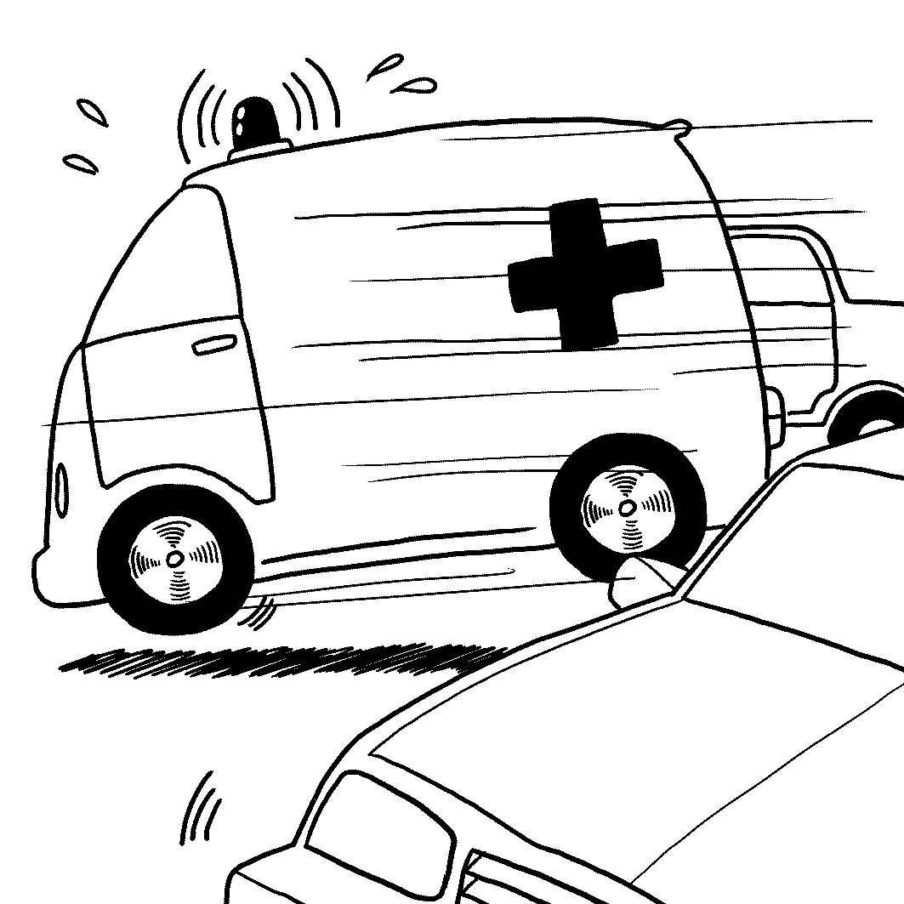 | 2. | 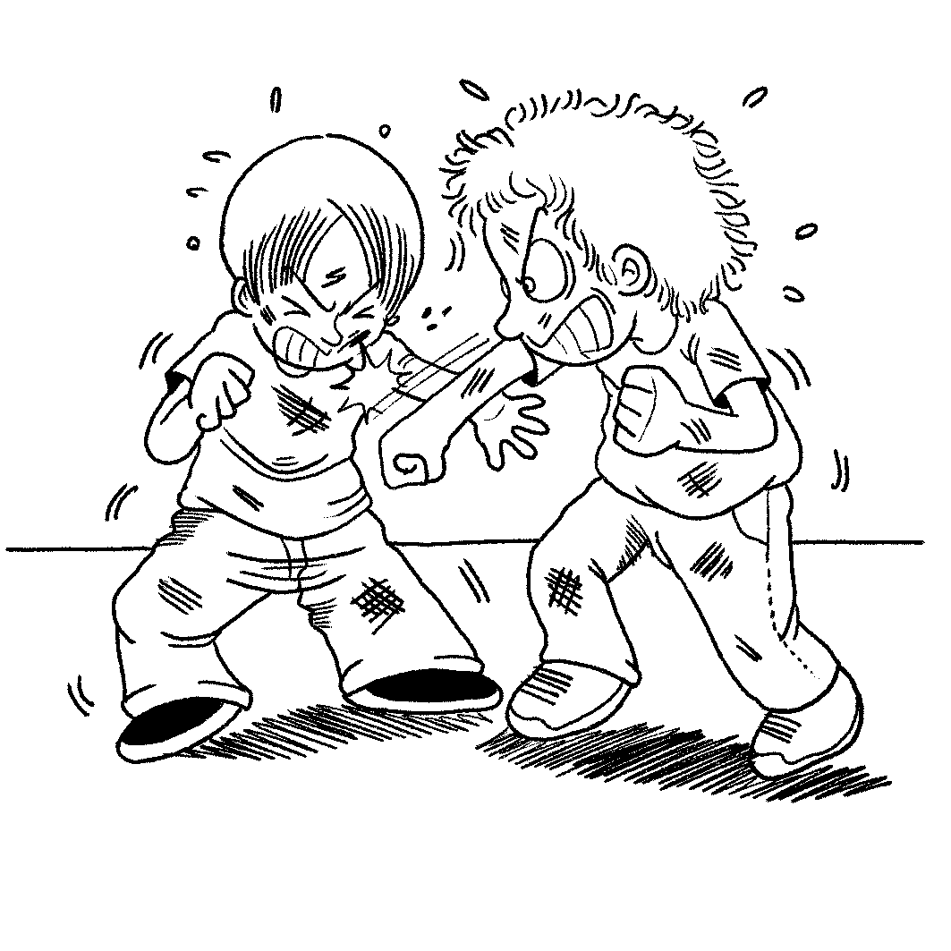

Part 2: Best Response Questions
Listen to the question or statement and choose the best response.

3. (A)Tell me! I want to know, too.
(B)I know. She won’t tell me, either.
(C)She shouldn’t tell people your secret.
(D)She loves to hear about your problems.

4. (A)Mark. I’m glad to work with him.
(B)Ted. He is a very helpful coach.
(C)Ricky. I’m sure that I’ll win the game.
(D)Sam. He will come to watch the game.

5. (A)No. I don’t think I can afford them.
(B)Alright. You can try them on one by one.
(C)OK. I’ll give them to people in need.
(D)Sure, I’ll put them in the front window.

Part 3: Conversation Questions
Listen to each conversation and answer the question.

6. (A)She has been to the museum.
(B)She likes the museum more.
(C)She wants to see a movie.
(D)She has already seen a movie.

7. (A)She likes it very hot.
(B)She likes it very cold.
(C)She likes it not too cold.
(D)She likes it without lemon.

8. (A)You have to use your brain.
(B)It has to do with eating food.
(C)You need lots of muscles.
(D)It goes on for a long time.

9. (A)It’s a good idea.
(B)You need one to get in.
(C)Everyone’s bringing one.
(D)It’s not needed.

Part 4: Short Talk Questions
Listen to the following paragraphs and answer the questions.

Paragraph A
10. (A)It spreads diseases.
(B)It produces bad tasting eggs.
(C)It leads to high prices.
(D)It makes it hard to count them.

11. (A)To get people to eat more eggs.
(B)To create new products with real eggs.
(C)To get people to eat less eggs.
(D)To improve the quality of chicken meat.

12. (A)Sugar.
(B)Plants.
(C)Milk.
(D)Meat.

Paragraph B
13. (A)He was left outdoors.
(B)He was fixed for the first time.
(C)He was put inside a museum.
(D)He fell over in an earthquake.

14. (A)Animals.
(B)Wars.
(C)The weather.
(D)Visitors.

15. (A)In the home of a private collector.
(B)Outside of the city.
(C)Touring across Europe.
(D)Inside of a museum.
II. Cloze test 15%
(A) Flying commercial airlines offers freedom of travel and the excitement of flying. ___16___, it can’t be taken lightly, since it involves being responsible for passenger’s lives. Almost everything pilots do is for the safety of their passengers and crew. Before takeoff, pilots ___17___ many tasks. They check flight plans, weather conditions, and all the controls and system in the cockpit. While on duty, pilots must be highly detail-oriented. In addition, they must never panic while ___18___ dangerous situations. If the plane experiences extreme turbulence mid-flight, pilots must find a way to deal with it. ___19___ a pilot, you must first pass the written exams, an interview, and physical exams. Then, you go abroad for flight training, which normally lasts one year. Back at home, you train for your specific plane model. Finally comes the flight test. If all goes well, you may become a first officer. Although the training of a skilled pilot is tough, it can absolutely make you go ___20___.
16. (A) Therefore (B) Besides (C) However (D) For instance
17. (A) command (B) perform (C) respond (D) interrupt
18. (A) facing (B) to face (C) they facing (D) face
19. (A) Become (B) To become (C) Becoming (D) To becoming
20. (A) in no way (B) by the way (C) a certain way (D) a long way

(B) These days, false news can spread at lightning speed. In fact, in the age of social networks, information spreads quickly, which ___21___ false news being accepted as the truth by people around the world. To solve this problem, European computer scientists are developing a system that can immediately reveal the truth. First, the system divides rumors into many types. One involves claims regarding what could happen soon. Another type involves hotly-debated subjects like Taiwan’s recent trade agreement with China. Other types of rumors include that people unknowingly share ___22___ information or spread lies on purpose to damage a person’s image. The system will classify information sources to determine if they can be trusted. In addition, it also can examine the history of social media accounts to see whether they’ve been created only to spread gossip. Despite ___23___ , it still has some limits. For instance, it doesn’t recognize images or videos, even though they are often the sources of rumors. Furthermore, the system might lead to misjudgments, where people always trust news outlets or always mistrust single persons. Actually, the system’s creators hope this tool can ___24___ users ___24___ believing fake stories. __25__, what we can do is to take online information with a grain of salt.
21. (A) results in (B) changes into (C) comes from (D) puts forth
22. (A) shiny (B) sincere (C) proper (D) inaccurate
23. (A) the system is well-functioned (B) the well-functioned system
(C) it’s a well-functioned system (D) have well-functioned system
24. (A) prevent..from (B) look..after (C) leave..behind (D) prefer..to
25. (A) In the end (B) However (C) In the meantime (D) Afterwards
(C) Astrology matches people’s personalities with stars and planets. Every person has a sign according to his or her date of birth. The following are some star signs with their personality traits. First, Aries are not only energetic but also confident. Sometimes, they are impatient and can act ___26___ thinking. Second, a Taurus is a trustworthy friend who you do not want to anger. In addition, they are noted for their good temper and ___27___ get angry. Third, a Gemini adapts easily ___28___ changes, but this restless nature sometimes keeps them from finishing projects. When it comes to loving family, no one is more attached to their families than Cancers. ___29___ kind and loving, they can become moody. Finally, Virgo is ___30___ and can be counted on to keep promises and be on time. So, next time you are not quite sure of yourself, why not look at the sky on a starry night? The stars may open your eyes to new ways of looking yourself.
26. (A) without (B) with (C) by (D) from
27. (A) temporarily (B) vividly (C) rarely (D) repeatedly
28. (A) in (B) to (C) on (D) between
29. (A) Because (B) Though (C) When (D) If
30. (A) sensitive (B) reliable (C) practical (D) jealous
III. Blank-filling test 10% (作答時請忽略大小寫)
A
- stable | - technical | - which | - whose | - from | (AB)with | (AC)while | (AD)dressed
The Historical Regatta is a series of boating races that have taken place every September in Venice since 1315. The festival kicks off with a water parade with boats of every kind and color. Boats are decorated in 16th century style and passengers are ___31___ in period costumes. The parade reproduces a historical event: the warm welcome that Venice gave the Queen of Cyprus in 1489, when the queen gave her island to Venice, ___32___ power increased greatly because of it. The races start just as the sun sets. There are four separate races, with different boats and participants. Young people compete first, followed by women. The races test not so much the rowers’ strength as their ___33___ abilities. Music fills the air and crowds cheer as winners receive red flags ___34___ runners-up receive flags of other colors. After experiencing the activities of the Historical Regatta, all the people will leave the scene ___35___ Venice’s beauty and history impressed deeply on their hearts.
B
- appointment | (B)interact with | (C)similary | (D)howerever | (E)in general | (AB)keep pace with
(AC)delays | (AD)finished
Although everyone has twenty-four hours equally, how people experience it varies depending on culture. This is clearly evident in a culture’s pace. One group of people may appear lazy to you because they walk slowly or take too long to get things ___36___. However, this could just be a sign that your own culture is faster-paced. ___37___, industrialized countries have fast rhythms of life. On the other hand, Arab or South American countries tend to stop and smell the flowers. It’s common to hear the phrase “time is money” in English-speaking industrialized countries. This attitude is reflected in the strict way North Americans structure time for meetings and appointments. ___38___, the Japanese mostly live by the clock. In Spain and Italy, however, ___39___ are acceptable and people live by a more relaxed rhythm. Therefore, next time when you go traveling, try to ___40___ the rhythm of the country in case you might trip and fall.
Focus on
IV. Multiple choice 15％
41. After a long discussion, all the group members finally reach a(n) ________.
(A) agreement (B) weight (C) space (D) cost
42. Thomas has _____ medicine for more than ten years; he works as a resident doctor in a hospital.
(A) worn (B) blocked (C) practiced (D) examined
43. Most of the employees don’t like their boss because he is hard to _______.
(A)notice (B) checked (C) please (D) draw
44. Leo is always nervous when ______ a large audience in public.
(A) addressing (B) reaching (C) blowing (D) printing
45. Because the global warming is getting worse and worse, we should take ______to stop it as
soon as possible.
(A) order (B) action (C) note (D) look
46. Sam ______ two rabbits in the back yard of his house and takes good care of them every day.
(A) raises (B) counts (C) directs (D) orders
47. The woman works hard every day for the_______ of supporting her whole family.
(A) level (B) purpose (C) voice (D) class
48. The criminal robbing the bank was _______ to ten years in prison.
(A) rooted (B) sentenced (C) headed (D) lay
49. Because the Hong Kong government didn’t stress the human rights, some people
started a(n) ______against it.
(A) unit (B) army (C) trip (D) movement
50. My friend advised me not to buy the house near the park because it was in a terrible _______.
(A) race (B) state (C) sight (D) bar
51. Lawrence has a lot in ____ with Jack; for example, both of them like to play basketball.
(A) common (B) public (C) danger (D) bottom
52. The government encouraged the companies to do more investment due to
the ____ fall in the economy.
(A) equal (B) difficult (C) false (D) sharp
53. May has a high ____ in the company; she needs to make important decisions for it.
(A) position (B) rise (C) look (D) weight
54. It is improper to _____ others to agree with you on this issue. You should respect others’ opinions.
(A) continue (B) allow (C) force (D) serve
55. The movie “Kano”, _____ on a true story, received box office success in Taiwan.
(A) based (B) caused (C) closed (D) blocked
Textbook L1-3
V. Cloze test 17%
(A) It happened when I was only 12. On a quiet Saturday afternoon, a friend and I were throwing stones onto the roof of the old lady’s house from a secluded spot in her backyard. I found a perfectly smooth stone and sent it for a ride. However, the stone was too smooth ___56___, so it slipped from my hand and hit straight a small window on the old lady’s back porch. ___57___ the broken glass, we took off from the old lady’s yard. That first night, I was in ___58___ fright about being caught ___58___ think of the old lady with the broken porch window. However, a few days later, when I was sure that I hadn’t been discovered, I started to feel ___59___ for her misfortune. Every day, when I passed the old lady her newspaper, she still greeted me with a warm smile, but I felt comfortable ___60___. My conscience pricked me, so much so that I determined to make up for the mistake I made. I saved my paper delivery money, and in three weeks I had the seven dollars ___61___. I put the money along with a note in an envelope. That night, I secretly slipped the envelope under the lady’s door. My soul felt redeemed and I couldn’t wait for the freedom of, once again, looking the lady straight ___62___.
56. (A) so I couldn’t grasp it (B) to grasp it
(C) that I couldn’t grasp (D) to grasp
57. (A) When we hearing (B) As soon as hearing
(C) At the sound of (D) The moment we sounded
58. (A) so…that I (B) too…to
(C) such…that I didn’t (D) too…that I
59. (A) relieved (B) confused (C) guilty (D) frightened
60. (A) any more (B) any longer (C) no more (D) no longer
61. (A) prepare (B) to prepare (C) ready (D) readily
62. (A) in her eye (B) on her eye (C) in the eye (D) on the eye
(B) When Dr. Spencer Silver worked as a scientist at 3M, which is known ___63___ producing many handy products such as Post-it note, he had tried to invent a strong glue. Although he experimented with different chemicals, the glue he ___64___ didn’t stick very well. However, he wasn’t disappointed. ___65___, he tried to convince his co-workers of the usefulness of his glue; they just took the weak glue with a grain of salt,___66___. Silver had a co-worker named Art Fry, who often sang hymns during church services. When he did that, he always depended on the bookmarks to mark the right page. But what’s ___67___ was that these bookmarks kept falling out of his hymn book ___68___ was a big headache for him. One day, ___69___ that Silver’s weak glue might be a solution ___70___his problem. He thus tried using weak glue on a piece of paper to mark his book. To his surprise, he found the weak glue could help stick paper on his hymn book ___71___ the book. Fry later shared his thought with others in the company. In 1980, the 3M company began to sell the Post-it note to the public and since then, it ___72___ one of the most popular products in the world.
63. (A) for (B) as (C) by (D) to
64. (A) checked out (B) came from (C) came up with (D) dealt with
65. (A) As a result (B) Since then (C) Similarly (D) Instead
66. (A) though (B) despite (C) as well (D) in fact
67. (A) disappointed (B) spreading (C) experimented (D) frustrating
68. (A) which (B) that (C) ,which (D) , that
69. (A) he occurred (B) it occurred to him (C) he struck (D) it struck to him
70. (A) for (B) of (C) on (D) to
71. (A) without being damaged (B) without damaging
(C) but not damage (D) but not damaging
72. (A) became (B) had become (C) has become (D) becomes
VI. Reading Comprehension: 4%
Nowadays, auto-flush motion sensor toilets are in schools, airports, hotels, and tourist spots around the world. But do you know who invented this modern convenience? It was Teng Hung-Chi of Nantou, Taiwan, who was only 19 when he created the original sensor urinal!
Since childhood, Teng has enjoyed learning about such appliances by taking them apart. His curiosity and persistence have helped him create many quality innovations. For Teng, inventing is nothing more than changing the status quo.
Teng's passionate interest in inventing has helped him win many prizes at the annual World Invention Contest. But behind these prestigious awards lie days and nights of continuous hard work.
For example, in 1999, Teng's "Remote Control Pager Device" made him the first Asian winner of the Genius Prize at iENA. This invention can control every single appliance in a building from far away! During his award acceptance speech, Teng thanked retailers in Taiwan. If Teng was inspired and needed components, he would knock on the doors of these retailers, even in the middle of the night! Their doors were always open to him.
In addition to his lifelong interest in inventing things himself, Teng is also devoted to educating others about invention. Teng encourages people to pursue fantastic notions and make them reality, instead of being limited by conventional thinking.
"As long as you can endure loneliness and you never give up, becoming an inventor isn't difficult at all," Teng says. "If every school cultivated just one outstanding inventor, our country would definitely benefit from spectacular inventions!"
73. What of the factors does not contribute to Teng’s success?
(A) He is curious about taking apart appliances.
(B) He persists in creating new things.
(C) He puts days and nights of continuous hard work into inventing.
(D) He is encouraged in his ambition for conventional thinking.
74. Which of the following statements is NOT TRUE?
(A) The auto-flush motion sensor toilet won Teng the Genius Award at iENA.
(B) With “Remote Control Pager Device,” one can be in control of appliances from far away.
(C) When Teng was in need of the materials for invention, he would turn to retailers for help.
(D) Teng encourages people to be creative and make their dreams come true.
以下部分請作答於答案卷上
VII. Vocabulary: 12%
1. The twenty-fifth school anniversary of SSSH is s__________ed for November 8, and the school has planned to hold a series of celebration activities that day.
2. Those who came to the book fair were impressed with the comic fans, who dressed themselves in bright c_________es, just like the comic characters walking into the real life.
3. According to my father’s c__________n, the oil price is likely to fall next week. He is sure of his judgement.
4. The national treasure meat-shaped stone is now on e_________n in Japan. It is not being displayed in the National Palace Museum.
5. In the meeting, school administrators and r__________es from each class will discuss the change in school backpacks.
6. Out of economic n__________y, Rachel went out to work soon after her baby was delivered. She needed to work to help support her family.
7. The wonderful performance of the ROC pitcher in the baseball final of Asian Games was beyond all e__________ns. We didn’t think he could do such a good job.
8. The chemistry teacher gave a detailed e_________n of how to perform the experiment. He said in a clear way to make himself understood.
9. Those who arrived late c________t into the office from the back door so as not to disturb those who were already present.
10. As a result of low birth rate, more and more schools in Taiwan have suffered a d________c drop in student numbers. The drop is really great and sudden.
11. Let’s go somewhere where we can talk without i__________n. I don’t want our talk to be stopped temporarily.
12. Smartphones are such a b________t and amazing invention that they have greatly changed our way of life.

VIII. Translation :12% (請用提示字作答)
After months of working hard, (13) 最後結果是 (turn) Brian 進入松山高中(SSSH)就讀. Today is his first day in his new school. When he is standing at the school gate, (14)他看見牆上一塊巨大的牌子寫著, “Confident, Conscientious, Creative, Passionate, Caring－A Warm School with Happiness. ” He is wondering what the school is like. When he is at a loss where to go, a senior comes over to help him find his classroom. He feels so warm in heart that (15)不久(before)他的緊張轉變(turn)為放心. As he sits down, he sees the homeroom teacher greet him with a warm smile. He then is asked to (16)在新同學面前(presence)做自我介紹. Although it is a bit embarrassing,(17)他鼓起勇氣(courage)走到台前. After that, his teacher and classmates give him a big hand. Just then, he feels a sense of belonging here. (18)他下定決心(mind)要盡快融入(fit) in the future.

台北市立松山高中103學年度第一學期高一英文科答案卷

Class_________ No_______ Name__________

VII. Vocabulary: 12%

1 | 2 | 3 | 4
5 | 6 | 7 | 8
9 | 10 | 11 | 12

VIII. Translation: 12% ((請用提示字作答)

13.
14.
15.
16.
17.
18.

