台北市松山高中 103學年度第一學期第二次期中考高一英文科試題卷
Live ABC
I. Listening comprehension questions: 15%

Part 1: Picture Questions
Look at each picture and answer the question.
1. | 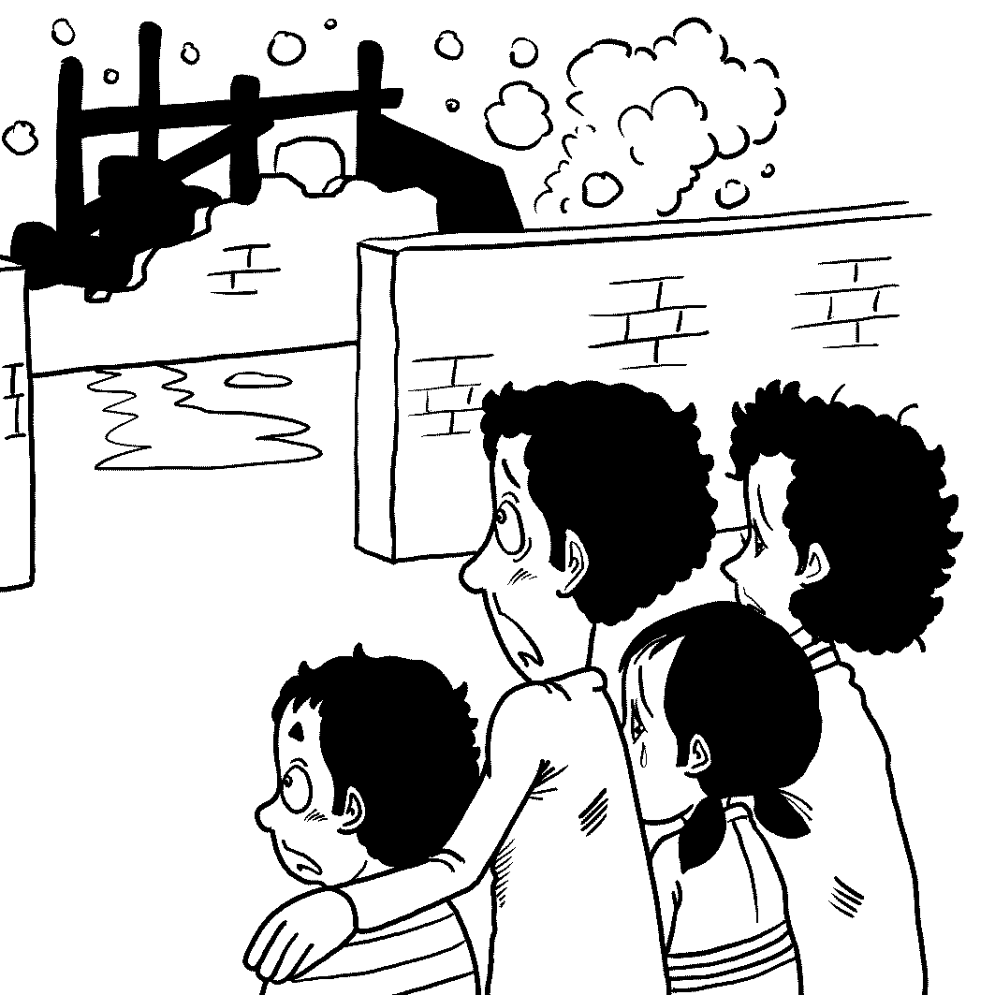 | 2. | 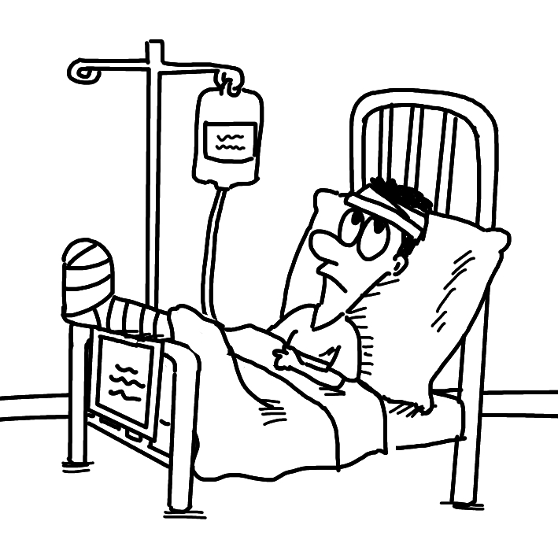

Part 2: Best Response Questions
Listen to the question or statement and choose the best response.
( ) 3. (A) Yeah, the writer chose his words very carefully.
(B) The colorful drawings do make it more interesting.
(C) Really? I didn’t like the main characters in it.
(D) Oh, I didn’t know the book was on sale right now.

( ) 4. (A) Yes. I’m glad the weather will be good.
(B) No, but my dad told me about the funny story.
(C) Yeah. I can’t believe that we finally won.
(D) Of course. I cried reading the sad news.

( ) 5. (A) Yes. The medicine worked very well.
(B) Good. She’s getting better and better.
(C) Yeah. She doesn’t have much energy.
(D) Right. She is even stronger than before.

( ) 6. (A) Yes. There are more people in a smaller area.
(B) Right. They have a lot more money in the city.
(C) True. Everything moves so fast in the big city.
(D) I know. It is much easier to get around.

( ) 7. (A) I’m not sure who is going to play.
(B) You have to ask someone else about prizes.
(C) Every player must touch the ball once.
(D) The game is becoming more and more popular.

Part 3: Conversation Questions
Listen to each conversation and answer the question.

( ) 8. (A) Math is his favorite subject.
(B) To make his parents happy.
(C) He is helping the woman.
(D) To prepare for his next test.

( ) 9. (A) He’s thinking about taking it.
(B) He’ll take it for sure.
(C) He doesn’t think he’ll take it.
(D) He is sure he can’t take it.

( ) 10. (A) He will have to work hard at it.
(B) It will be too simple for him.
(C) She will be happy to help him with it.
(D) It’s unlikely he will finish it.

( ) 11. (A) He should get enough rest.
(B) He is important to the team’s success.
(C) He needs to get stronger.
(D) He has to practice more.

( ) 12. (A) It will be gone by itself.
(B) It can’t be removed.
(C) She’ll wash it off at once.
(D) She wants to keep it a few days.

( ) 13. (A) She has a lot of work to do.
(B) She doesn’t like someone who is coming.
(C) She is really tired.
(D) She has another party to go to.

Part 4: Short Talk Questions (2%)
Listen to the following paragraph and answer the questions.

( ) 14. (A) It is error-free now.
(B) It helps people communicate.
(C) It is created by Microsoft.
(D) It can be used in many fields.

( ) 15. (A) It has stopped the Skype Translator program.
(B) It is working hard to improve the Skype Translator.
(C) It has made a lot of money from the Skype Translator.
(D) It has spent too much money on the Skype Translator.
II. Cloze test:15%
- When Carl Wilkens was in college, he wasn’t sure about his future. At that time, he didn’t know ___16___ he wanted to finish his degree. So he went to Africa as a volunteer and then fell in love with the land and people. Later, he went back home to finish school. In 1990, he and his wife moved to Rwanda, where there were conflicts between two ethnic groups, the Tutsis and the Hutus. ___17___ of the horror he would experience. He witnessed the mass killings and tried to help his neighbors who protected his family. Today, Wilkens, a pastor, talks about his experiences of Rwanda and tries to ___18___ an important message to school children. He often mentions that despite ethnic origins, all people are equal. Occasionally, kids who wonder what to do with their life approach him for ___19___. He tells them not to be afraid. Besides, they shouldn’t fear letting their parents down or losing what they have. ___20___ being overcome by fear, they should make the best choices they know and try to change our surroundings for the better. Everybody has the power to make a difference to the world.
16. (A) as if (B) because (C) whether (D) until
17. (A) Little he knew (B) Little knew he
(C) Did he know little (D) Little did he know
18. (A) carve (B) scatter (C) convey (D) combine
19. (A) apology (B) advice (C) opportunity (D) tragedy
20. (A) By (B) Without (C) As soon as (D) Rather than

- If we have chosen passwords that are easy to remember, it means: they may be easy to guess. It doesn’t take a genius, ___21___ a professional hacker, to guess them. If a stranger knows our password, he or she can ___22___ our personal data from a website from Facebook. This may give rise to a disaster. For example, a man found that his bride-to-be was engaged to someone else before. She didn’t want to tell him about her other relationships. However, the photos from Facebook told the truth and he saw them. Of course, they broke up in the end. Therefore, our passwords must ___23___ our private information ___23___ more protection. When we set our passwords, one important tip is that the lengthier passwords are, ___24___ it is to figure out. Another basic tip is that we had better not use ___25___ combinations of letters or numbers, such as those in our name, address or birthday. Thus, choosing a strong password can ensure the security of our personal data online.
21. (A) much less (B) much more (C) more or less (D) less and less
22. (A) process (B) recess (C) access (D) success
23. (A) turn, into (B) equip, with (C) compare, with (D) pick, up
24. (A) harder (B) the harder (C) hardly (D) the hardly
25. (A) internal (B) obvious (C) digital (D) visible
- Being a firefighter is the dream job for a lot of American kids when they are young. Firefighters do not simply ___26___ fires but also rescue people’s lives in dangerous situations. Sometimes, they even have to serve their community. To become firefighters, applicants need to meet some requirements. First of all, they must have a high school ___27___. Then, they have to take a written exam and a physical ability exam. After they have passed both exams, they ___28___ in an eighteen-month training program. After getting a certificate, they wait to be ___29___ to a fire station. As we know, some firefighters are on duty 48 hours straight. When emergency occurs, they respond to it right away because lives are ___30___. Firefighters are considered heroes in the American society.
26. (A) work out (B) put out (C) keep to (D) keep down
27. (A) element (B) journey (C) procedure (D) diploma
28. (A) take up (B) make up (C) take part (D) take apart
29. (A) assigned (B) transferred (C) located (D) enclosed
30. (A) open to debate (B) under the weather
(C) at stake (D) under lock and key

III. Blank-filling test:10%(作答時請忽略大小寫和動詞變化)

(A) surrounding (B) launch (C) magnets (D) boil down to
(AB) surrounded (AC) on (AD) minerals (BC) look forward to
(BD) weaken (CD) with
In one study, some American researchers had doubts about the benefits ___31___ organic food. They found that produce grown organically and conventionally contains almost the same amounts of vitamins and ___32__. Afterwards, they concluded that there is little nutritional difference between the two types of food. One thing all consumers agree ___33___ is that organic products are more expensive in most cases. The high prices ___34___ the case for such products in the minds of people who do not want to pay too much for their food. Whether they should buy organic products or not, it ___35___ personal choice and the money issue.

(A) carry, out (B) experiment (C) spend (D) affect
(AB) turn, into (AC) publish (AD) take (BC) effect
(BD) come with (CD) come up with
Manga artists must draw well and they should be able to ___36___ interesting storylines in the first place. It ___37___ them quite a while to develop the two skills. The next step they have to take is to ___38___ a story ___38___ illustrations. At this stage, Manga artists are like directors for movies. They pave the panels, choose perspectives and add speech bubbles and sound ___39___. People interested in writing stories and drawing can create their own fan comics. For beginners, they can ___40___ with different styles based on their favorite manga. Everyone has the potential to become a manga artist.
Focus on
IV. Multiple choice:15%
41. Our English teacher told us to _____ good reading habits when we were freshmen.
(A) contact (B) provide (C) settle (D) develop
42. The fierce snowstorm _____ a dozen people’s lives last October.
(A) claimed (B) collected (C) attacked (D) measured
43. It is our honor to have your _____. We are so happy to see you here.
(A) control (B) presence (C) spirit (D) policy
44. The news that the two actors got married quickly _____ all over the world.
(A) spread (B) wondered (C) improved (D) measured
45. Please give me a(n) _____ idea of your plan. You can tell me the details later.
(A) active (B) sudden (C) additional (D) broad
46. The library has a good _____ of science fiction films that appeal to teenagers.
(A) selection (B) region (C) possibility (D) population
47. The rich couple never _____ their only son anything. Thus, he became a spoilt brat.
(A) doubt ed (B) traded (C) denied (D) shared
48. The union asked its members to go on a(n) _____ on Labor’s Day.
(A) figure (B) opinion (C) strike (D) addition
49. The machines seem to _____ normally, but we still have to keep an eye on them.
(A) supply (B) function (C) express (D) complete
50. The _____ of the desk is not smooth. You need to place a desk writing pad.
(A) essence (B) stage (C) field (D) surface
51. “Honesty is the best policy,” is the _____ that my homeroom teacher always values.
(A) principle (B) pattern (C) effect (D) hobby
52. I can’t stand the service in that hotel. It is below ______.
(A) mark (B) limit (C) doubt (D) standard
53. Her uncle, who used to teach in college, was a(n) _____ professor in NTNU.
(A) live (B) ancient (C) former (D) international
54. Have you read the _____ in the magazine? It was written by my cousin.
(A) article (B) symbol (C) quality (D) textbook
55. Everybody should be ______ for what he or she has done and take the consequences.
(A) painful (B) responsible (C) private (D) distant

Textbook.
V. Cloze test: 15%
(A)
With a little knowledge of basic science, you can take common household items to perform magic when you know ___56___ take full advantage of them. __57__ sugar cubes, for example. The sugar cubes in the jar can keep cookies crisp ___58___ absorbing moisture. That’s why you can keep cookies ___59___ soggy. Better yet, you can keep other similar food stored with the same method.
If your friends are not ___60___ by the magic of sugar cubes, try the following trick. When you have difficulty ___61___ the stains with tissues, rags, or even your bare hands, try ___62___ citrus peel. Citrus peel can ___63___ the stains which are made by markers or correction fluid. The secret ___64___ the magic is that the organic substances from the oil and acid content from a citrus peel can help break down the stains, and thus, make them easier to remove.
56. (A) what to (B) what do you (C) how to (D) how do you
57. (A) Make (B) Have (C) Get (D) Take
58. (A) by (B) from (C) with (D) in
59. (A) turned (B) from turning (C) turning (D) to turn
60. (A) excited (B) blessed (C) impressed (D) satisfied
61. (A) remove (B) removing (C) removed (D) to remove
62. (A) to use (B) used (C) using (D) use
63. (A) run out of (B) get rid of (C) catch up with (D) give up on
64. (A) below (B) between (C) beyond (D) behind
(B)
The meanings of the same gesture can vary ___65___, even though people ___66___ the world use body language to communicate without speaking. For instance, Indians ___67___ their heads to express their approval. Their head bobble ___68___ watching snake charming. This can confuse people who shake their heads from left to right to show disagreement.
From time to time, using the wrong gesture in the wrong place may ___69___. For example, in Greece, the gesture of showing one’s palm toward someone can be ___70___ and may bring trouble on those people who make it. Therefore, it is critical to remember the golden rule: When in Rome, do as the Romans do.
65. (A) width (B) wide (C) widely (D) widen
66. (A) with (B) through (C) out (D) throughout
67. (A) tilt (B) have tilted (C) who tilt (D) tilting
68. (A) was fond of (B) grew out of (C) got used to (D) was similar to
69. (A) meet one’s approval (B) reach an agreement
(C) bring about trouble (D) work like magic
70. (A) an insult (B) of insult (C) insulted (D) to insult

VI. Reading Comprehension: 5%
In a recent research, scientists reported that thousands of new neurons (神經元) were born in our brains every day. However, many of them, sadly, also die shortly after birth. The factor that appears to matter most to the length of their lives is whether or not you have actually done any learning at the same time. And by learning, the authors say that this doesn’t mean learning the plot of a TV show. They mean effortful learning where you try hard, and you might still not get it. This includes things like learning a new language, a new musical instrument, or even a new route to your school.
Hard learning often includes two key factors: 1) spacing your learning and 2) testing yourself. If you space the learning in several different sessions, instead of cramming all the material into your head in one session, then the material has the opportunity to stay in your brain. Cramming often leads to rapidly forgetting.
Spaced learning also allows you to test yourself—the second key ingredient—which is one of the most powerful forms of learning. By testing yourself, you create ways for reviewing the information in the future, which leads to better learning in the long run. So, instead of re-reading something you are hoping to remember, it is much better to test yourself on the material and then correct your errors. Indeed, this study suggests that getting something wrong is just as good as getting it right for your learning—and for your brain.
- What does the underlined word effortful in line 5 mean?
(A) effective (B) difficult (C) different (D) efficient
- What is the main idea of the passage?
(A) With regard to learning, re-reading is better than testing yourself.
(B) We should try to remember all the material at one time.
(C) Making mistakes is not good for your brain.
(D) Effortful learning is good for your brain.
- If you space your learning, what may happen?
(A) You put your textbooks all in one place.
(B) You study for your exam in a private space.
(C) You wait until the last night to prepare for your exam.
(D) To learn your materials well, you learn them through several sessions.
- Which of the following statements is NOT true?
(A) It usually takes efforts to learn another language.
(B) Learning to play the piano is good for your brain.
(C) Watching TV shows is helpful for growing new neurons.
(D) You forget the material faster when you study it all at once.
- What attitude toward learning does the writer hold?
(A) We should avoid making mistakes.
(B) It’s important to have enough space to study.
(C) We should not be afraid of making mistakes.
(D) Cramming your material all at once is effective for learning.
以下部份請作答於答案卷上
VII. Vocabulary: 15%
- Stop having n e thoughts; try to look on the bright side of life.
- With his amazing record, Michael Jordan is a living l d
in the world of basketball.
- After getting his parents’ e t, Larry regained his confidence
and made great progress.
- The chef s zed a few drops of lemon juice on the fish to make it tasty.
- Jay Chou’s catchy songs have the capacity to inspire and connect people.
They are w listening to over and over again.
- A large number of sharks are hunted for their fins (鰭); therefore, they are thought
to be e t in some parts of the world.
- Even though so many people disagree with Jason’s plan, he doesn’t want to change it. He is as s n as a mule.
- To his disbelief, the pretty girl he admired turned out to be a dangerous c l wanted by the police.
- After years of practicing, Joan finally r zed her dream of becoming a pianist.
- The side dish has increased Jack’s a e; he finished everything on his plate.
- The gutter oil scandal has s ned the reputation of Taiwan’s food safety.
- To protect our earth, we need to live in h y with our environment.
- Jack Ma, the founder of the Chinese Internet giant Alibaba, has become one of the richest and the most i l men in China.
- Tony’s boss was very pleased with what he has done for the compny
and c ted him on his achievement.
- The poetic scenery on the hilltop is so breath-taking that it is beyond d n (describe).

VIII. Translation: 10% (請用提示字作答)
16. 他頓悟到:世代以來，天然資源一直供養著他的部落。(It …had supported….)3%

17. 令父母大失所望的是，他向NTU提出的申請被拒絕了。(To…., his…)3%

18. 當提到交朋友，它就像是做湯一樣。 (… it…, it…)2%

19. 由於人類貪婪的結果，老虎的數量已經急遽減少。 (….human…, …has….)2%

