台北市松山高級中學103學年度第一學期高二第二次段考英文試題
Part One: Studio Classroom (Oct 13 ~ Nov 13) (共35分)
I. Listening Section 聽力部份 (共10分)
I) Pictures 看圖辨義 (1題1分, 10題共10分)
Listen to the questions. Then choose the best answer according to each picture.
A. Questions 1-2

For questions 1 and 2, please look at picture A.
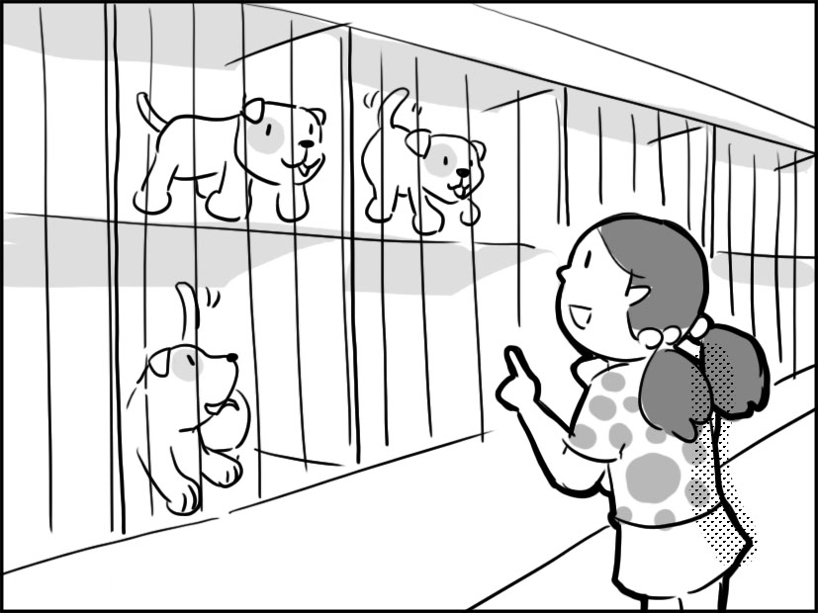

B. Questions 3-4

For questions 3 and 4, please look at picture B.
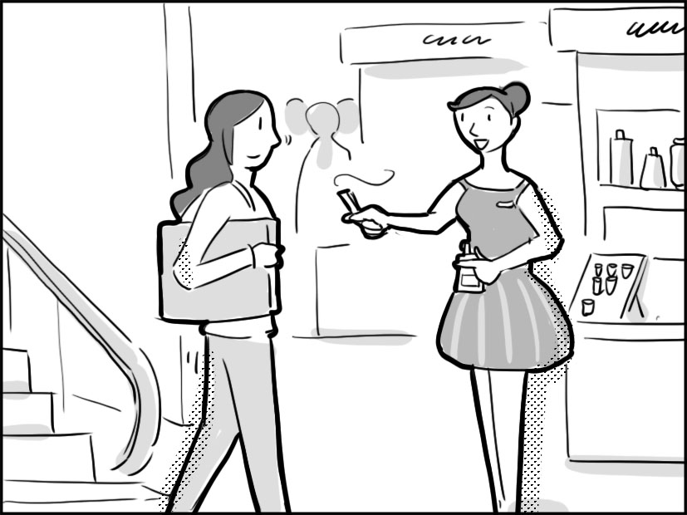

II) Best Response 最佳回應句
Choose the best response to each question or statement.

5. (A) I put the appointment on my calendar.
(B) My computer can check if the spelling is correct.
(C) You can try to find the definition in my new dictionary.
(D) There’s a new app that lets me put in the words I need to remember.

6. (A) Shall we move it to another day?
(B) The park by the beach is a lovely place to visit.
(C) I have a basket if you want to put your food in it.
(D) Will you repair your car at the garage close to our house?

III) Short Conversations 簡短會話
Listen to the conversations. Then answer the questions.

7. (A) To get a different version of something.
(B) To see her Chinese boyfriend.
(C) To study in Great Britain.
(D) To get a job application.

8. (A) The man’s car isn’t good for driving long distances.
(B) The man’s car isn’t as safe as other cars.
(C) The man’s car needs to be washed.
(D) The man’s car was really cheap.

IV) Short Talk 短文
Listen to the talk. Then choose the best answer to each question.

9. (A) School lecture.
(B) News report.
(C) Bank advertisement.
(D) Phone message.

10. (A) School lecture.
(B) News report.
(C) Bank advertisement.
(D) Phone message.

II. Reading Section 閱讀部份 (共25分)
I) Cloze Test 克漏字 (1題1分, 15題共15分)
A) Is art worthwhile? Actually, there are different opinions about it. Talking about it is just like opening a can of worms. To some people, it is a form of beauty, and also a form of self-expression. It’s not just some __11__, but work of great quality and creativity. Art reflects truths in life. However, to others, art is useless because it cannot get a person to do anything. That is, art won’t __12__ people into some sort of action. There is no purpose for it and thus it doesn’t __13__ at all. But whether you like it or not, we cannot deny that it __14__ a great deal of time and skill to produce a work of art and it can communicate with people across time and culture. Perhaps that is why it is so special and worth cherishing.
11. (A) decoration (B) finances (C) lotion (D) fragrance
12. (A) squeeze (B) bulge (C) compose (D) spur
13. (A) open mind (B) make sense (C) interact with (D) shut off
14. (A) spends (B) acquires (C) takes (D) offers

B) Did you know?
Seahorses: With a scientific name that means “horse caterpillars,” these fish are __15__
mate for life. The male carries and gives birth to the eggs the female deposits
in his pouch.
Dogs’ noses: No two people have the same set of fingerprints, so they are used to
identify people. __16__, dogs have unique sets of ridges on their noses. No two
dogs have the same nose print!
Goats: When you hear the bleating of goats, you may think it all sounds __17__, but
you would be wrong. As they grow older, goats, like us, develop __18__ based on
who they hang out with!
15. (A) reported (B) thought as (C) believed to (D) said to be
16. (A) To be outdone by humans (B) Not to be outdone by humans
(C) To not outdo humans (D) Not outdo humans
17. (A) like (B) alike (C) liking (D) unlike
18. (A) scents (B) devices (C) accents (D) wrecks

C) Every October, hundreds of thousands head to the New River Gorge Bridge, the third tallest in the U.S. The majority of the people __19__, but the event, Bridge Day, sees the world’s largest gathering of BASE jumpers. These athletes jump off heights, __20__ the release of their parachute for both safety and ultimate excitement. In recent years, jumpers __21__ enjoy an additional thrill – the human catapult. Jumpers are launched 50 feet beyond the bridge before taking the plunge.
19. (A) is viewer (B) is audience (C) are spectators (D) are seekers
20. (A) timing (B) to time (C) in timing (D) to timing
21. (A) are also able to (B) were also able to
(C) will be also able to (D) have also been able to

D) Now, __22__ people are attempting to implant devices in their bodies for other purposes. __23__ biohackers, these folks strive to use technology to __24__ their normal human abilities. A few biohackers have already implanted RFID tags in their hands that act as passwords, opening locked doors __25__ the wave of a hand.
22. (A) the number of growing (B) the growing number of
(C) a number of growing (D) a growing number of
23. (A) Called (B) Calling (C) To be called (D) To call
24. (A) preserve (B) intercept (C) nominate (D) enhance
25. (A) across (B) with (C) on (D) of

II) Cloze Structure文意選填 (1題2分, 5題共10分)
A. shock-absorbing B. as C. made of D. so
E. is made from AB. that AC. as opposed to AD. application

The URB-E __26__ aircraft-grade aluminum and comes in two basic models: the URB-E Commuter and the URB-E GP. The main difference between the two is __27__ the Commuter model has two rear wheels while the GP has only one. That means the Commuter offers greater stability, __28__ the GP’s ability to make sharper turns like a bicycle.
Both models come with accessories such as LED front and rear lights and a __29__ seat. They also feature a smartphone holder and USB charging port right on the steering column. In fact, smartphones play a big role in the URB-E, __30__ drivers can use the official URB-E app to do things like monitor battery charge or control the lights.

Part Two: Focus On ( Level 3 P. 37 ~ Level 4 P. 8) (共15分)
Cloze Test 克漏字 (1題1分, 15題共15分)
Standing by the ice cream stand, Nancy couldn’t make up her mind what she should buy. A cone, or a bowl with as many __31__of different flavors as possible? She had labored a whole day, running __32__ for her boss on such a hot day. It was time for her
to relax herself. __33__, she just wanted some drink to quench her __34__, but all she could find was the ice cream stand. She __35__ some of her happy childhood memories with a smile and walked toward it.
To meet her __36__, the vendor made a huge cone for her. Additionally, he __37__ some chocolate chips around the ice cream, and stuck one __38__ biscuit on the side. Satisfied, Nancy found a seat, starting to enjoy the “sweet” moment.
However, some noise drew her attention. She noticed a large crowd of people __39__ for human rights were coming in her direction. The tension of the crowd showed a sharp __40__ with her present state of mind. She frowned a little and __41__ her position on the bench, looking away. Yet, on the other side of the park, there was an ongoing election campaign. The __42__ for the mayor was making a speech to his supporters. He spoke with great __43__but the voice coming out from the loudspeaker __44__ her day. She stood up with a sigh, knowing that under such circumstances, she had better head back home immediately before she got her hand __45__ with the melting ice cream.

31. (A) scoops (B) scopes (C) screws (D) scrubs
32. (A) deposits (B) errands (C) facilities (D) procedures
33. (A) Scarcely (B) Slightly (C) Annually (D) Initially
34. (A) limb (B) crutch (C) thirst (D) cradle
35. (A) emerged (B) recalled (C) accompanied (D) preserved
36. (A) demand (B) magnet (C) bacteria (D) comment
37. (A) sprained (B) splashed (C) sprinkled (D) assigned
38. (A) tame (B) objective (C) rotten (D) crunchy
39. (A) contributing (B) flattering (C) demonstrating (D) dodging
40. (A) conference (B) authority (C) contrast (D) intention
41. (A) tickled (B) adjusted (C) identified (D) constructed
42. (A) shepherd (B) candidate (C) tailor (D) poster
43. (A) intensity (B) appliance (C) similarity (D) reflection
44. (A) occupied (B) stitched (C) reflected (D) spoiled
45. (A) sticky (B) rusty (C) tidy (D) stale

Part III Textbook (三民版Book 3 Lesson 5~8) (共50分)
I) Cloze Test克漏字 (1題1分, 16題共16分)
(A) Global warming is a hot issue to be debated even among scientists. Governments have been urged to __46__ based on the most commonly-believed scientific evidence. As the temperature is rising, the sea level goes up rapidly, __47__ icebergs around the Arctic drifting southward. Not merely polar bears but their main food---seals are therefore left __48__. A film, produced to mark the problem, successfully captured the audience’s heart by __49__ a helpless polar bear on a floating ice plate. Devastating and alarming __50__ the film is, some countries are still not aware of the facts and keep polluting and destroying the Earth. __51__ huge is the damage that our land will need quite some time to recover. If the climate is getting warmer, we will have no places to __52__and no food to __52__. That is, effective action should be taken right away, __53__ we are saying farewell to the Earth very soon.
46. (A) give in (B) warm up (C) take action (D) go too far
47. (A) bringing on (B) causing (C) resulting from (D) resulting in
48. (A) unlimited (B) homeless (C) extinguished (D) clueless
49. (A) featuring (B) focusing (C) leaving (D) performing
50. (A) may (B) nevertheless (C) although (D) as
51. (A) What (B) So (C) Enough (D) Such
52. (A) stay with; eat (B) sleep; eat up (C) live on; eat with (D) live in; eat
53. (A) or (B) thus (C) therefore (D) what if

(B) Online communities have played a significant part in our life. There are several terms created to explain our cyber-related activities. In the past, finding a long-lost friend might be difficult, but nowadays you __54__. Just upload some photos of your friend, google his or her background and you are doing what is jokingly called “__55__.”
The term “netizens” refers to those people spending time __56__ online activities. Some of them are playing “heroes” in online rescue games while other are heroes __57__ hunting down real-world wrong-doers. No matter which role we play, the “footprints” __58__online reveal our “true identity” and “history.” Tons of mistreated cases uploaded to YouTube and one man, in particular, angered millions of viewers. __59__ a fire hydrant, his dog howled dreadfully with this guy laughing evilly. Soon, he was made to apologize in public. Netizens __60__ show greater anger behind the keyboard, __61__ they find it safe to utter their voice, than in real life. However, their overage tends to turn them into “cybermob”—the self-righteous and abusive kind.
54. (A) need not worry (B) need to be not worried
(C) do not need worry (D) need not to worry
55. (A) hacking (B) clouding (C) FBI (D) witch-hunt

56. (A) involving (B) involve with (C) engage with (D) engaging in
57. (A) running into (B) dropping out (C) taking part in (D) reporting to
58. (A) having left (B) left (C) leaving (D) to leave
59. (A) Chaining on (B) Tied up to (C) Fastening with (D) To bind to
60. (A) appear to (B) appeal to (C) are sure to (D) are about to
61. (A) to which (B) that (C) where (D) with which

II) Reading Comprehension 閱讀測驗 (1題2分, 4題共8分)
The presidential turkey pardon is an interesting White House tradition that has captured the attention of the public in recent years. Live Thanksgiving turkeys have been presented to presidents since the Lincoln administration. The turkey pardon ceremony has been said to date back to 1947, when President Harry Truman received a turkey as a gift from the National Turkey Federation. However, the Truman Library says that no documents, speeches, newspaper clippings, photographs or other contemporary records are known to exist that specify that he ever "pardoned" a turkey; there are only records that he publicly admitted to eating at least some of them.
The first President on record issuing a "pardon" to his turkey was Ronald Reagan, who pardoned a turkey named Charlie and sent him to his petting zoo in 1987. In fact, Reagan did so to divert criticism on his refusal to pardon a political criminal, Oliver North, who was involved in an arms dealing scandal. Reagan did not pardon a turkey in his final year as President in 1988, but his successor, George H. W. Bush, instituted the turkey pardon as a permanent part of the presentation beginning his first year in office, 1989. Since then, at least one of the turkeys presented to the President has been taken to a farm where it will live out the rest of its natural life.
62. Which of the following statements is TRUE according to the article?
(A) Harry Truman was the first president on record to free a turkey in 1947.
(B) Ronald Reagan kept the turkey, Charlie, in his zoo in 1987.
(C) George H. W. Bush succeeded to the presidency in 1988
(D) During Lincoln’s presidency, only well-cooked turkeys could be sent to the
White House.
63. What does the underlined word “institute…as” mean in second paragraph?
(A) establish..into (B) talk…into
(C) insist…upon (D) contribute…to
64. What was Oliver North’s role in the turkey pardon ceremony?
(A) He was caught stealing a turkey from the White House.
(B) He was found delivering money inside the turkey to the president.
(C) He was denied the pardon by President Reagan.
(D) He was criticized by the National Turkey Federation.

65. The presidential turkey pardon tradition catches’ public attention because____ on
Thanksgiving day.
(A) the turkey is dubbed as knight by the president
(B) the turkey presented to the president will be set free
(C) the president will take a photography with the turkey
(D) a lucky person working in a farm can take the turkey home

------------------------------------------------------------------------------------------------------

III) Fill-in the Blanks字彙填空題 (1題1分, 16題共16分)
1. The patient was a______ced dead by the doctor after the failed surgery.
2. The factory gets a water pollution fine for the illegal d____e of wastewater.
3. Many of life’s f____es happen when people don’t realize how close they are to
success when they gave up.
4. The general gave a c____d to all the soldiers to shoot the enemy so they obeyed.
5. The farmers, after the training, learned how to turn barren land into f____e one to
expect more harvest.
6. U____l love happens when one is willing to give without asking for anything in
return.
7. There are many i____ries about the ticket since the show is very popular.
8. Freedom of speech and assembly is c____l to the countries who are building up
democracy.
9. The hotel room is huge with two s____e areas, one for the bed with TV and, the
Other, the sitting area with a couch.
10. Students who v____e the school regulations will be punished.
11. D____ely, without doubt, this is the most delicious food we have ever tasted.
12. The hacker bore an ill intention to h____e the actress by posting her nude
photos on tweeter along with some false statements about her.
13. In ____ (compare) with other plants, teak is a wood harder and therefore more
suitable for making furniture.
14. The empire began its first military ____(expand) to attack its neighboring countries so
as to meet his ambition.
15. Environmental concerns and the ____(reduce) of carbon footprints are a high
priority to many building designs.
16. ____(persevere) is the key to success, the saying of which indicates that we should
continue our efforts to achieve the goals.

IV) Guided Translation引導式翻譯 (1格不只1字, 全對才得分, 1格1分, 10格
共10分)
17. 颱風過後一個月, 受災戶排除萬難重新開始新生活。
A month after the typhoon, the disaster-stricken households fought against __①__ and __②__ a new life.

18. 不景氣時, 投資者如果想搶便宜買進股票的話, 就會冒著賠大錢的危險。
Investors, who intend to buy cheap stocks, are __①__ losing a huge __②__ money when the whole nation is thrown into recession (不景氣).

19. 比賽期間, 選手使用類固醇禁藥的話題激起民眾討論, 結果一些競賽者最後因
此被取消資格。
During the competition, the topic of the steroid use (使用類固醇禁藥) __①__ the public discussion, and some competitors __②__ being disqualified for that reason.

20. 由於擁有想像力和原創力, 藝術家能夠創造出不朽的作品, 同時, 他們能看到
藏身於平凡事物背後的不凡。
Artists are able to created long-lasting works __①__ their imagination and originality. In the meantime, they can see the extraordinary __②__ everyday objects.

21. 這項計畫因為一些因素運作不良, 例如: 人力不足, 時間有限。最糟糕的, 科學
家們難以找到資金繼續進行研究。
The project couldn’t function well for several factors, such as lack of manpower and limited time. ___①___, the scientists ___②___ finding financial support to proceed it.

台北市松山高級中學103學年度第一學期高二第二次段考英文
答案
Part One 01-10 CABCD, AABBA
11-20 ADBCC, BBCCA
21-30 DDADB, E, AB, AC, A, B
Part Two 31-40 ABDCB, ACDCC
41-45 BBADA,

Part Three
Cloze Test 46-53 C D B A D B D A
54-61 A D D C B B A C

Reading Comprehension 62-65 B A C B

------------------------------------------------------------------------------------

手寫部份:
字彙填空題Vocabulary (1題1分, 16題共16分)
1. announced 2.discharge 3. failures 4. command
5. fertile 6. Unconditional 7. inquiries 8. crucial
9. separate 10. violate 11. Definitely 12. humiliate
13. comparison 14. expansion 15. reduction 16. Perseverance

Guided translation引導式翻譯
(1格不只1字, 全對才得分, 1格1分, 10格共10分)

17. all odds started over/with
18. at risk of amount/sum of
19. stirred up ended up
20. by virtue of/because of/due to/owing to (having) lie/ lying behind
21. Worst of all had trouble/difficulty/problems

