台北市立松山高中104學年度第一學期第一次期中考 高一英文 試題卷
PART I : English 4U September&Voc4500
I. Listening Comprehension: 10%
Part A: Picture Questions (2%)
Look at each picture and answer the question.
1. | 2.
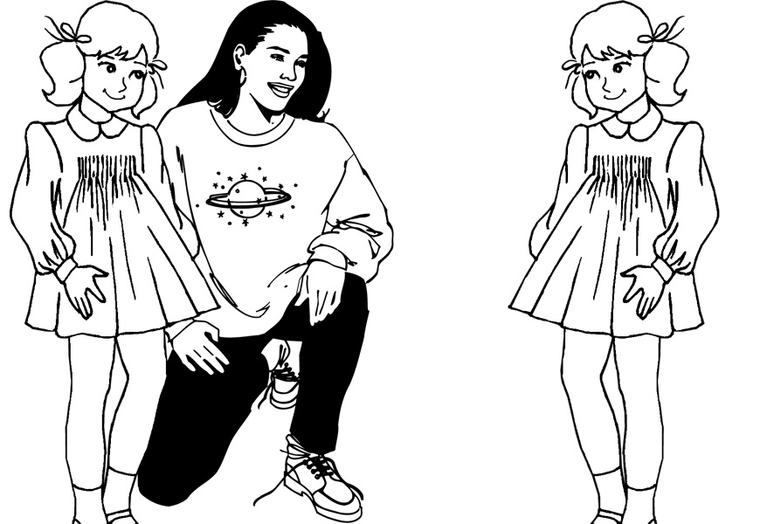 | 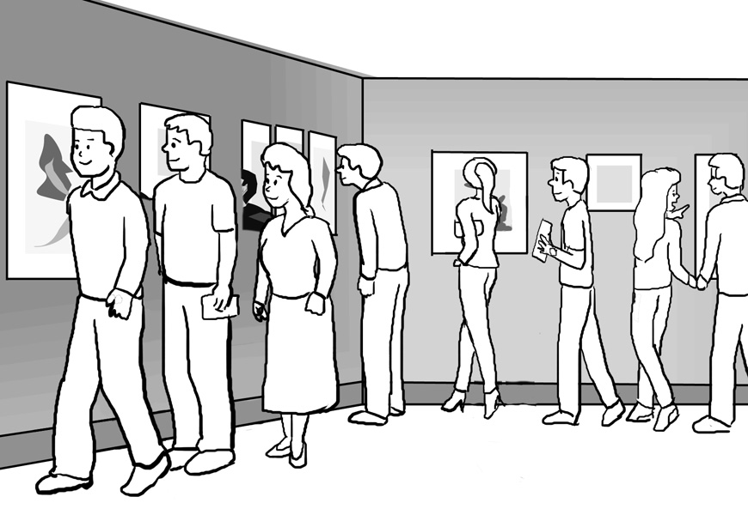
Part B: Response Questions (3%)
Listen to the questions or statements and choose the best response.
3. (A) Yes, I work for this company.
(B) Yes, the company belongs to me.
(C) Yes, I buy things from this company.
(D) Yes, I’ve heard of this company before.
4. (A) I got up at around 7:30 a.m. today.
(B) The race will start after school.
(C) My first job was as a cook.
(D) I was a bad student in high school.
5. (A) I want to buy more gum.
(B) Oh, I’ll throw it in trash.
(C) I see; let’s both chew gum.
(D) Oh, you can have gum, too.
Part C: Conversation Questions (3%)
Listen to each conversation and choose the best response.
6. (A) He needs to go home.
(B) He needs to hold her hand.
(C) He needs to wait a bit longer.
(D) He needs to pick out some groceries.
7. (A) A phone call from a stranger.
(B) The answers to a test she wrote.
(C) A message saying someone is hurt.
(D) A short written note on her phone.
8. (A) What the boss did next.
(B) Why Ryan was so angry.
(C) Why the man was yelling at her.
(D) What Ryan will do next time.
Part D: Short Talk Questions (2%)
Listen to the following paragraph and answer the questions.
9. (A) To introduce an organization.
(B) To help disadvantaged children.
(C) To help teachers find jobs.
(D) To start a new school.
10. (A) In big cities in Taiwan.
(B) At schools in the US.
(C) In the countryside.
(D) On the Internet.
II. Cloze Test: 12%
There’s a tickle deep inside your nose. Before you even notice it, you just let out a big loud sneeze in a second. Basically, a sneeze is your body’s way of getting rid of something. In other words, sneezing is a natural way of keeping our air passages free of __11__, smoke, and other harmful things. Our body uses air and the liquid from our nose and mouth __12__ keep things out of our lungs and other organs. Sneezing prevents us from getting sick. Sometimes we even sneeze many times in a row. This is the body’s way of making sure the invader is completely gone. Sneezing can also __13__ cold air and bright sunshine. The bright light brings on a reaction in your brain which sets off the sneezing action.
There are several __14__ beliefs about sneezing. Some believe sneezing is good luck. However, some say it’s bad luck when two people sneeze at the same time. There is also the belief that your heart stops when you sneeze. This is wide of the mark, though. Since you know the purpose of a sneeze, don’t be afraid to let it all out!
11. (A) tide (B) cycle (C) pity (D) dust
12. (A) for (B) to (C) with (D) as
13. (A) cause (B) causes (C) causing by (D) be caused by
14. (A) shallow (B) constant (C) cultural (D) typical

Many people enjoy the feeling of bouncing on a trampoline. The first modern trampoline was created by the circus entertainer George Nissen. To do this, he and his business partner, Larry Griswold, used scrap steel and inner tubes. They formed a company to sell trampolines to the public, and their business was a big success for many years. __15__, they closed in 1989 following several lawsuits after children were hurt in trampoline accidents. Nevertheless, the bouncing also gave Nissen plenty of exercise; he stayed __16__ until his death at the age of 96.
If you’re a trampoline fan in Taiwan, __17__ you’ve spent some time at Flip Out. It is a trampoline center in an underground facility in Taipei. Flip Out has not only the space for adults but also a smaller __18__ that’s just for kids. People can bounce, jump, and land in a pit of foam. Check out Flip Out for some fun trampoline activities. It’s sure to have you jumping for joy!
15. (A) Besides (B) Thus (C) However (D) Furthermore
16. (A) hit (B) wit (C) bit (D) fit
17. (A) odds are (B) odds is (C) odd are (D) odd is
18. (A) statue (B) attraction (C) section (D) religion
Manny Pacquiao is a true hero of the Philippines. Although he is best known for his boxing career, he is also an actor and a politician. He has even __19__ three music albums! More than all of these things, though, he is a role model to the whole country. These things make him one of the most positive figures in his nation’s recent history. One example of this is that even though the Philippines has experienced a civil war for many years, when Pacquiao has a boxing match, both sides __20__ to watch.
However, Pacquiao’s life didn’t get off to the best start. His parents separated when he was a child, leaving Pacquiao to live with his mother and five brothers and sisters. They were so poor that Pacquiao left school at 14 and began living on the streets in Manila __21__ he learned how to box. He wasn’t a big guy; at 16 years old, Pacquiao was only 149 centimeters tall and weighed only 44 kilograms. __22__ this, he soon started beating opponents left and right. He went on to have many epic fights and win many championship belts.
19. (A) received (B) reported (C) recycled (D) released
20. (A) stop fighting (B) stop to fight (C) start fighting (D) start to fight
21. (A) which (B) , which (C) where (D) , where
22. (A) Besides (B) Despite (C) Except (D) Though
III. 篇章結構: 8%
Mathilde is a beautiful, charming woman who comes from a poor family. She dreams of being rich. __23__ Her husband, Liosel, appreciates all the simple things in their life, such as the supper she prepares for him. Mathilde, on the other hand, regrets her fate and dreams of one day having fancy jewels, nice clothes, and lots of nice things to eat.
__24__ But Mathilde is upset as she has no jewels to wear. Liosel suggests that Mathilde borrow something nice from her wealthy friend, Madame Forestier. Madame Forestier lends Mathilde a diamond necklace. Mathilde feels very attractive with it around her neck. She considers herself as the party queen of the night but her good mood doesn’t last long. __25__ She has lost it! Liosel goes out and searches everywhere. __26__ What are Liosel and Mathilde going to do now? Sadly, they are forced to borrow money from others and live as poor people in order to pay their debts.
(A) While Mathilde looks at herself in the mirror one last time, she finds the necklace no more around her neck.
(B) Even though he doesn’t come back until dawn, he still hasn’t found it.
(C) However, she marries a humble clerk instead of a man with wealth or power.
(D) Liosel tries to please his wife by getting an invitation to a fancy party.

IV. Vocabulary 2500-4500 (pp.1-39) : 10%
27. The price listed is quite high, but the seller might be willing to ________.
- furnish (B) stitch (C) bargain (D) conquer
28. Laura holds a/an ________ attitude toward life while her husband is very conservative. The couple fights over traditional family values from time to time.
- humorous (B) ignorant (C) innocent (D) liberal
29. It is common _____ to take off your shoes before entering a house in most Asian countries.
- diligence (B) courtesy (C) honesty (D) generosity
30. In fairy tales, the fox is usually regarded as a ________ character that does some evil tricks.
- dependable (B) gracious (C) cunning (D) capable
31. Jeremy Lin was born in California, but his parents were born in Taiwan and ________ to
the United States.
- immigrated (B) marched (C) awoke (D) afforded
32. The author has been very ________ in selling his new book. He has spent a lot of money on
advertisement.
- clumsy (B) aggressive (C) fluent (D) modest
33. Ruby described Jimmy as an "intelligent, educated, charming, funny and ________ man."
No wonder everyone loves him.
- brutal (B) drowsy (C)awkward (D) elegant
34. Elsa didn’t have enough money for the bus ________. How embarrassing!
- gear (B) fare (C) yolk (D) robe
35. Tiger moms are said to have great ________ over their children.
- authority (B) bravery (C) loyalty (D) poultry
36. After the Typhoon Dujuan, we ________ and started to clean the campus.
- brought home the bacon (B) washed our dirty linen
(C) rolled up our sleeves (D) sewed up the wound

PART II: TEXTBOOK
- Cloze 20%
As an old saying __37__, “Necessity is the mother of invention.” People often think of ideas for the purpose of satisfying their own needs and the solutions __38__ their problems may become great inventions to change our way of life to a great level. __39__ Teng Hung-chi created his first invention when he was working in a factory at 17. In order not to dirty the faucet after working, he invented a special faucet __40__ automatically without being touched. The faucet was controlled by __41__. This young inventor later sold the rights __42__ his invention for NT$1.5 million. Since then, Teng has created many other useful inventions and __43__ Taiwan at the iENA. He has won first prize there many times and __44__ “Taiwan’s Edison.”
37. (A) going (B) goes (C) gone (D) which goes
38. (A) to (B) of (C) at (D) about
39. (A) Take Teng Hung-chi, for example ,
(B) Taking Teng Hung-chi, as an example .
(C) Take Teng Hung-chi, as an example ,
(D) Take Teng Hung-chi, for example .
40. (A) , which could run (B) , that could run (C) which it could run (D) which could run
41. (A) a building-in sensing device (B) a built-in sensing device
(C) a built-in sensed device (D) a building-in sensed device
42. (A) with (B) in (C) to (D) at
43. (A) has been a representative of (B) has been represented for
(C) represented for (D) was a representative of
44. (A) has known for (B) has known as (C) has become known as (D) known for

The invention of Post-it note started with a simple need. Dr. Spencer Silver worked at the 3M Company. He had a strong desire __45__ a strong glue, but he didn’t make it. __46__, the glue that he made turned out to be very weak. One of his co-workers, Art Fry, usually sang hymns during church services and while he was singing, his bookmark kept falling out of his hymn book repeatedly __47__. Suddenly he __48__ the idea of using Silver’s weak glue on a piece of paper to help him mark the right page without damaging the book. Before long, the Post-it note was born, and it __49__ around the world.
45. (A) for inventing (B) to invent (C) to inventing (D) of inventing
46. (A) Though (B) As a result (C) Accordingly (D) Instead
47. (A) which really frustrated him (B) , which was really frustrated to him
(C) , which really made him frustrated (D) which really frustrating him
48. (A) figured out (B) came up with (C) worked out (D) struck
49. (A) has since successfully spread (B) since then successfully spread
(C) was successfully spreaded (D) since then has successfully spreaded

Through centuries, colors __50__ many things. For example, “a white elephant costs more than it is worth,” and “people with blue blood think they are members of noble families.” How colors affect appetite is another thing that most people probably fail to notice. __51__ studies, the colors of our dining environment can influence __52__. Most fast-food restaurants are decorated in bright colors to increase people’s appetites. This is because bright colors are the natural colors of many foods and are able to __53__ people’s spirits. On the other hand, blue is likely to ruin a person’s appetite because very few foods are blue in nature. Therefore, for __54__, blue dishes and bowls might help a lot. Believe it or not, though we may not __55__ them, colors are everywhere both in our daily routine and __56__!
50. (A) have been used to describe (B) are used to describing
(C) used to describe (D) have used to describe
51. (A) In addition to (B) Basing on (C) According to (D) Apart from
52. (A) the amount of food that being eaten (B) how much food do we eat
(C) the number of food we eat (D) how much we eat
53. (A) arouse (B) rise (C) arise (D) raise
54. (A) these who are on a diet (B) those who are on a diet
(C) people who on a diet (D) someone who on a diet
55. (A) be aware of (B) aware of (C) be aware (D) beware
56. (A) in everyday conversation (B) in every day conversations
(C) in everyday conversations (D) in every day conversation
- Choice ( Choose the WRONG one) 10%
57. (A) Sending people to the moon was such a difficult task that it took scientists many years to complete this task.
(B) The basketball player was so tired that the coach put him on the bench.
(C) The entire nation was in such chaos that many people were fleeing to other countries.
(D)The painter painted so well that attracted a large crowd to gather and watch him paint.
58. (A) It is the classroom which you have to go to at the beginning of your school day.
(B) Allen was a very talented basketball player whose career was ruined by his scandals.
(C) The old lady whose son is regarded as a genius has never received any education.
(D) The waiter that a customer complained was new to the job.
59. (A) When I was sure that I wasn’t in trouble, I started to feel guilt.
(B) Green Island sounds like a wonderful place for a vacation.
(C) To me, the stones looked just like comets that fell from the sky.
(D) The coffee looks like dishwater, but it smells great.
60. (A) Paul finally realized that his parents had never been serious about his sailor dream.
(B) Stacy has studied English for six years when she went to Canada.
(C) Tina has been to London twice. She loves the life there.
(D) I am sad to know that Mr. Smith has died.
61. (A) Who killed the old lady is still unknown to the police.
(B) I wondered what happened to Jane yesterday.
(C) Vicky hasn’t yet decided which pair of earrings should she wear to go with her dress.
(D) Robert didn’t ask the clerk when the next flight will be.
- Reading Comprehension 6%
Many animals have developed an ability called camouflage that serves to prevent them from being seen by attackers or to help them to find food. Camouflage is the animal's color or shape that appears to mix with its surroundings.
Animals such as deer, squirrels, mice, etc. have the colors of the trees and soil on the forest floor. Many sea creatures like sharks and dolphins have a grayish-blue coloring, which helps them blend in with the soft light underwater. Many animals have developed special adaptations that let them change their colors as their surroundings change. One of the biggest changes in an animal's surroundings occurs during the change of the seasons. The forest may be green and brown in summer, but it is covered with snow in winter, making colorful animals an easy target. Many birds and animals, such as foxes, rabbits, squirrels etc., deal with this by producing different colors of fur or feathers depending on the time of year. Some skillful hiders, such as chameleons (變色龍) and octopuses (章魚), can change their colors instantly according to a change in their surroundings. And some animals, such as some kinds of butterflies or toads (蟾蜍), do not hide at all because they confuse predators (掠奪者) by disguising themselves as something dangerous.
In different parts of the world, you'll find all kinds of animals camouflaging themselves. This adaptation is often a more effective survival tool than teeth or claws. After all, it is much better to be entirely ignored by an attacker than to have to fight with it. This is also true in the case of humans.
爪
62. “This” in the second paragraph refers to (意指) .
(A) the predators in different surroundings
(B) the change of colors of the surroundings
(C) the rapid growth of animals
(D) the ability to camouflage
63. Which of the following statements is true according to the passage?
(A) Animals use camouflage to protect themselves from being attacked by their predators.
(B) Some animals, such as some kinds of toads, hide from other animals that may eat them
by disguising themselves as something dangerous.
(C) Only small animals use camouflage to protect themselves.
(D) Chameleons have different colors in winter and summer.
64. What can be inferred (推論) from the last paragraph?
(A) Animals which fight against predators survive more easily.
(B) Few animals use camouflage to protect themselves from predators.
(C) It is safer to be unnoticed and avoid possible dangers.
(D) The rules for animals cannot be applied to human beings.

- Vocabulary 15%
- There are no mail d______ies on weekends, so you will have to wait until Monday to mail
your package.
- When Stacy finally agreed to go out with him, Albert’s heart p_____ded with excitement.
- The thief s_____ped the empty wallet back into Jenny’s bag after he had taken all the money inside.
- It is common in Disneyland to see people dress up in c_______es and act like those cartoon characters.
- Christina made a lucky e______e when her house caught fire; she got away without being hurt.
- Our school anniversary celebration is usually s________ed for November, and this year our school plans to hold more activities for it.
- Someone’s cell phone kept ringing during the movie and the i________n bothered everyone in the theater.
- To my great r______f, someone found my purse and sent it to the police. I don’t have to worry about it any more.
- We should c________e how much each of us should spend on the tour and decide whether we will join it.
- You have to give a good e______n for being late, or you will lose the chance to be interviewed for the job.
- The e______n of Monet’s paintings in the museum draws at least one thousand visitors every Sunday.
- With strong determination and constant effort, the promising young man had a b________t career at the age of 25.
- We are just o________y people like everyone else, but there must be something that we can be proud of.
- The beauty of the sunrise on the mountaintop is beyond d________n. You have to see it in person and then you can understand it.
- The survey i_______es that over 70 percent of the students are not in the habit of having breakfast.

- Translation 9% (每格1分， 每格至少2字)
80.這間自助餐廳的食物一點也不美味。它不符合我們的期待。 我們是如此的失望以致
於決定不再去那裡用餐了。
The food in the cafeteria is ____________ delicious. It doesn’t _____________________.
We are we decide not to eat there any more.
- 為了和他的同學相處融洽，他鼓起勇氣主動和他們交談。
In order to f with his classmates, he his talk to them
actively.
- 當Allan 送上一打玫瑰當作驚喜時，Melody非常開心。她從來沒想過Allen會如此。
和別的男生相比，他真的比較體貼浪漫
Melody pink when Allan surprised her with a dozen red roses.
It never o that Allan would do so. In other boys, he was indeed more considerate and romantic.

台北市立松山高中104學年度第一學期第一次期中考 高一英文 答案卷
班級:_____ 座號:_____ 姓名:______________
- Vocabulary 15%
請由左往右填，注意題號
65 | 66 | 67
68 | 69 | 70
71 | 72 | 73
74 | 75 | 76
77 | 78 | 79

- Translation 9% (每格1分， 每格至少2字)

- 這間自助餐廳的食物一點也不美味。它不符合我們的期待。 我們是如此的失望以致
於決定不再去那裡用餐了。
The food in the cafeteria is ____________ delicious. It doesn’t _____________________.
We are we decide not to eat there anymore.
- 為了和他的同學相處融洽，他鼓起勇氣主動和他們交談。
In order to f with his classmates, he his talk to them
actively.
- 當Allan 送上一打玫瑰當作驚喜時，Melody非常開心。她從來沒想過他會如此。
和別的男生相比，他真的比較體貼浪漫
Melody pink when Allan surprised her with a dozen red roses.
It never o that Allan would do so. In other boys, he was indeed more considerate and romantic.
80

81

82

台北市立松山高中104學年度第一學期第一次期中考 高一英文 答案卷
- Vocabulary 15%
由左往右填，注意題號
65 deliveries | 66 pounded | 67 slipped
68 costumes | 69 escape | 70 scheduled
71 interruption | 72 relief | 73 calculate
74 explanation | 75 exhibition | 76 brilliant
77 ordinary | 78 description | 79 indicates

- Translation 9% (每格1分， 每格至少2字)

80 far from  /by no means/anything but | meet /live up to  our expectations | so disappointed that
81 fit in | plucks up/plucked up | courage to
82 was tickled | occurred to her | comparison with

1-5 BCBCB
6-10 CDAAC
11-14 DBDC
15-18 CDAC
19-22 DADB
23-26 CDAB
27-30 CDBC
31-36 ABDBAC
37-40 BADD
41-44 BCAC
45-49 BDCBA
50-56 ACDDBAC
57-61 DDABC
62-64 BAC

