台北市立松山高中104學年度第二學期高二英文科第二次期中考試題
**答案卡未正確劃記班級和座號扣總分5分**

(1) All+ April all
Part A: Listening Section (10%)

1: Picture Questions (2%)
Look at each picture and answer the question.
1. | 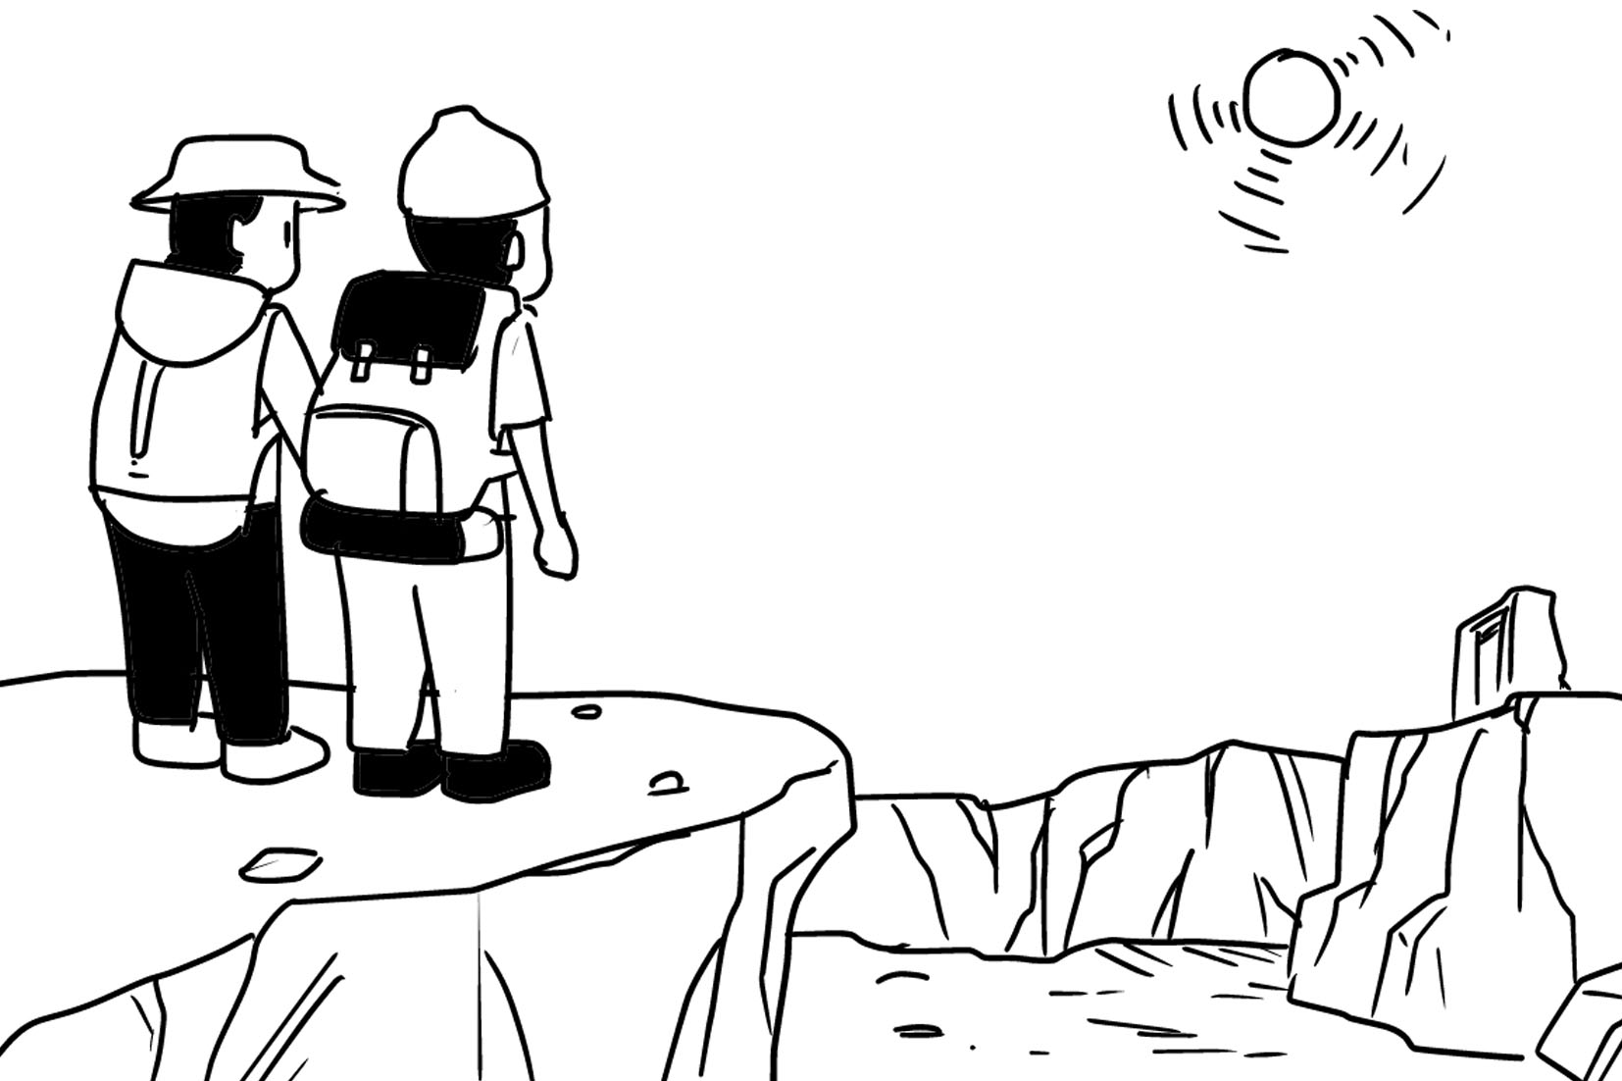 | 2. | 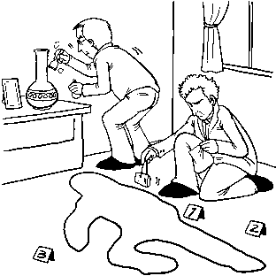

2: Best Response Questions (3%)
Listen to the question or statement and choose the best response.

( ) 3. (A) I know that you don’t like to bring attention to yourself.
(B) I am sure there will be a place for you to sit down.
(C) I know what you mean. It’s always crowded on the weekend.
(D) No problem. I will meet you at the front gate in an hour.

( ) 4. (A) You can send them to my apartment.
(B) You can read them when you get time.
(C) You can spread them out on that table.
(D) You can pile them on the bottom shelf.

( ) 5. (A) Yes, many plants are used for medicine.
(B) I know. Let’s bring some of them home.
(C) OK. I’ll be careful not to touch them.
(D) Yes. Eating them is good for your health.

3: Conversation Questions (3%)
Listen to each conversation and answer the question.

( ) 6. (A) Watch over Kerry.
(B) Put Kerry to sleep.
(C) Get some rest.
(D) Clean the place up.

( ) 7. (A) It is too expensive.
(B) It is wrong color.
(C) It is uncomfortable.
(D) It is not designed well.

( ) 8. (A) Go fishing in a river.
(B) Go swimming in a river.
(C) Take a walk along a river.
(D) Jog along a river.

4: Short Talk Questions (2%)
Listen to the following paragraph and answer the questions.

( ) 9. (A) It was created by a chemist.
(B) It only kept away UV radiation.
(C) It was attractive in its appearance.
(D) It came in various forms and colors.
( ) 10. (A) It can absorb harmful chemicals in the air.
(B) It can cause soldiers to lose their protection.
(C) It can absorb too much sunlight and harms humans.
(D) It can prevent the body from making enough vitamin D.

Part B: Reading Section
Cloze Test: 30% (每題1分)
A.
A new type of wireless technology that uses visible light as its medium, Li-Fi, which ____11____ “light fidelity,” amazes the world with its lightning speed－transmitting data at one gigabyte per second, which is _____12_____ the average Wi-Fi speeds. With Li-Fi, downloading music and movies can be completed within mere seconds. ____13____, since light can’t penetrate walls like Wi-Fi’s radio waves, it ensures that the data being transmitted won’t be able to be ____14_____ by other people. It is expected that the widespread implementation of this innovative technology is _____15______.

11. (A) stands to (B) stands on (C) stands for (D) stands out
12. (A) faster than 100 times (B) the speed of 100 times
(C) 100 times as faster as (D) 100 times the speed of
13. (A) However (B) Moreover (C) That is (D) Therefore
14. (A) dangled (B) accessed (C) overlooked (D) distinguished
15. (A) a long way off (B) nowhere near (C) on the horizon (D) no surprise

B.
Born to legendary comedians Jerry Stiller and Anne Meara, Ben Stiller ____16____ performing arts at a very early age. Upon graduating high school, he attended UCLA but ____17____ after only nine months. He then made his acting debut in a Broadway revival of The House of Blue Leaves in 1985. In 1989, he worked as a writer for the sketch comedy show Saturday Night Live. Five weeks later, he headed back to Los Angeles and began working on The Ben Stiller Show. ____18____ much critical acclaim, the show was canceled after 12 episodes. Stiller’s next project was directing and acting in Reality Bites. The film was received both critically and commercially. Ben Stiller’s versatility makes him ____19____ other celebrities and ____20____ is no surprise that he is considered one of the most adored celebrities around.
16. (A) came into contact with (B) came across
(C) came to terms with (D) came into play
17. (A) stuck it out (B) stood out (C) dropped out (D) rested assured
18. (A) In spite of (B) Instead of (C) Owing to (D) In addition to
19. (A) keep track of (B) rest assured from
(C) stand out from (D) take advantage of
20. (A) what (B) it (C) there (D) that
C.
Artificial Intelligence is the goal of many experts, but how we deal with it is an issue worthy of concern. Some worry that the use of robots or programs underpinned by AI will pose a threat to the long term survival of humanity, while some believe they would help improve the ____21____ of the human beings, such as self-driving cars or robots that do household tasks. Telsa founder Elon Musk, renowned ____22____ Stephen Hawking, and nearly 2000 other experts have signed an open letter that urges a ban ____23____ AI and robotic systems in weapons. They warn that it may be possible for weapons to become ____24____ killers without human command. However, not all experts are so ____25____. They say machines are ____26____ intelligent enough to take over the world. In their opinion, Artificial Intelligence that can think on its own is still a long way off.

21. (A) gear (B) insight (C) psychology (D) well-being
22. (A) physicist (B) physician (C) psychologist (D) psychiatrist
23. (A) of (B) to (C) on (D) in
24. (A) critical (B) ruthless (C) coarse (D) tattered
25. (A) optimistic (B) ashamed (C) potent (D) pessimistic
26. (A) free from (B) nowhere near (C) as well as (D) nothing more than
D.
With romantic ideals about war, young Henry joins the army at 18. He is first doubtful about no action in the regiment but then when the violent battle breaks out, he panics and flees by instinct. He is so ____27____ of himself that he escapes to a forest. In the forest, he ____28____ a group of injured soldiers with red badges of courage. They ____29____courageously and show concern for Henry, which keeps reminding Henry of his own ____30____ and leaves him a deep sense of guilt. One day, he is injured in the head by accident. Exhausted, hungry and thirsty, he decides to return to his regiment. To his ____31____, he discovers that nobody found him running away ____32____ his wound is taken for a bullet wound. He then fights bravely with his comrade and wins praise from his lieutenant. It is not until then that he ____33____ his earlier timidity and takes it as a part of being a man.
27. (A) shame (B) shameful (C) shameless (D) ashamed
28. (A) comes upon (B) keeps track of (C) frees from (D) takes advantage of
29. (A) stand out (B) carry out (C) stick it out (D) make sense
30. (A) sketch (B) cowardice (C) gear (D) well-being
31. (A) regret (B) disappointment (C) relief (D) luck
32. (A) and (B) so (C) and that (D) so that
33. (A) comes into contact with (B) comes across
(C) comes into play (D) comes to terms with

E.
The Caribbean has lost 80 percent of its coral reefs in the last 50 years. Although some say warming waters and damage from the fishing and tourism industries are to blame for coral bleaching, a worsening ____34____ where the living reefs go completely white and die, study shows that a ____35____ ingredient in sunscreen－oxyybenzone－may be a(n) ____36____ to the destruction of the coral reefs. According to the research, oxybenzone has ____37____ effects on young coral for it may cause coral to ____38____algae, which provides food for coral, and starve to death. Even in concentrations as low as 65 parts per trillion, oxybenzone is ____39____ to coral. To solve this problem, research team say they aren’t advocating getting rid of sunscreen, which protects against skin cancer. ____40____, they advise consumers consider carefully what sunscreen they buy and urge sunscreen manufacturers to replace oxybenzone with ingredients like titanium oxide and zinc oxide that can protect skin and do less harm to coral reefs.
34. (A) limitation (B) sequel (C) phenomenon (D) investigation
35. (A) filtering-UV (B) filtered-UV (C) UV-filtering (D) UV-filtered
36. (A) contributor (B) access (C) application (D) prey
37. (A) ruthless (B) circular (C) gracious (D) toxic
38. (A) exterminate (B) reign (C) eject (D) monitor
39. (A) critical (B) lethal (C) essential (D) coarse
40. (A) In other words (B) Thus (C) Moreover (D) Instead

(2) Focus on Level 5 (pp.1—12)
Multiple Choice: 15% (每題1分)
- During concealment in Secret Annex, the only way for Anne Frank to give _________ to her mingled feelings was to keep a diary.
(A) emission (B) mock (C) resort (D) vent

- At the beach of Kenting, we ________ ourselves in playing with the sand and soaking our feet in the cooling sea water.
(A) withheld (B) indulged (C) commended (D) elevated
- That old film _________ memories of my childhood when I was free from worries and pressure.
(A) evoked (B) menaced (C) defied (D) surged
- On seeing Jim’s pale look, his mother had an _________ that he was ill, and took him to see a doctor immediately.
(A) indifference (B) assault (C) intuition (D) intent
- There has been a growing dissatisfaction and _________ in Taiwan over Japan’s detaining a Taiwanese fishing boat near the Okinotori atoll.
(A) consent (B) resentment (C) deceit (D) alteration
- When we _________others on the basis of race, religion, nationality, or sexual orientation, it is a form of prejudice.
(A) stride (B) impair (C) stereotype (D) disrupt
- Rumor has it that the CEO is going to resign for poor health, but the rumor has not been ___________ yet.
(A) suppressed (B) verified (C) deceived (D) mocked
- Being a victim of bullying, Andrew has long been used to feeling ________ toward people around.
(A) absurd (B) naïve (C) hostile (D) transparent
- A gang of scammers were arrested in Kenya and were sent back to Taiwan with a police __________.
(A) escort (B) parallel (C) confession (D) torture
- Ben Stiller is very protective of his family’s private life, so he tends to keep a low _________ in talking about his family.
(A) hierarchy (B) profile (C) aspiration (D) veil
- People are advised to stay indoors when the _________ of PM2.5 exceed the standard, or parts of their lungs are vulnerable to injury.
(A) delegates (B) detergents (C) tournaments (D) emissions
- Over the past few years, with the change of consuming behavior, online shopping has been __________.
(A) alternating (B) flourishing (C) staggering (D) patronizing
- As soon as Andrea knew someone was speaking ill behind her back, she was overwhelmed with a ________ of anger.
(A) spur (B) deceit (C) surge (D) profile
- Teenagers must be warned about the ________ of swimming in unsafe rivers with torrents.
(A) scrutiny (B) fatigue (C) peril (D) asset
- The government is taking urgent measures to __________ the spread of the avian flu.
(A) despise (B) curb (C) discard (D) convict

(3)Textbook Book4 (U5-8)
I. Cloze (16%)
A.
Anne Frank is a Jewish girl who has to go into hiding during World War Two to avoid the Nazis. During the time of concealment in Secret Annex in Amsterdam, Anne, like the others, __(56)__ to be confined to the limited space all day long. Relying on the supplies from Mr. Frank’s employees, all they could do was __(57)__ for the end of the war. With remarkable talent for writing, Anne’s diary, which she received as a birthday gift, had become a tool __(58)__ her frustrations off her chest in the tense life. Unfortunately, things changed after two years of hiding. __(59)__ to Nazi authorities, the Frank family was arrested by Gestapo. The Frank family were sent to different concentration camps, one of __(60)__ that survived the Holocaust was Anne’s father, Otto Frank. The father did his utmost to look for his beloved daughters, __(61)__ find that both of the Frank sisters had died from typhus in Bergen-Belson concentration camp. Having read his daughter’s diary, Otto Frank decided to __(62)__ it be published. Nowadays, it has been translated, and adapted to both film and theatre. Thus, Anne becomes world famous __(63)__ the diary she kept while in hiding.
56. (A) had difficulty (B) had been difficult (C) found it difficult (D) found the difficulty
57. (A) wait (B) waiting (C) to waiting (D) being waiting
58. (A) able (B) enabling (C) that was allowed (D) that was able
59. (A) Having betrayed (B) Betrayed (C) Betraying (D) To betray
60. (A) which (B) them (C) that (D) whom
61. (A) but (B) yet (C) only to (D) in order to
62. (A) let (B) get (C) have (D) make
63. (A) because (B) as a result (C) on account of (D) thanks for

B.
The global villagers nowadays are faced with a formidable crisis: the ecosystem is on the verge of destruction. __(64)__ various genetic formations, species, and habitats, the ecosystem requires biodiversity to maintain its balance. First of all, experts have proposed that efforts __(65)__ to collect and preserve endangered organisms' DNA, so as to retain the genetic diversity. Without sufficient gene variety __(66)__ in Nature, humans along with some species may become endangered. Secondly, with the pesticide __(67)__ in crop planting on a large scale, certain species such as bees would also be affected, thus leading to ecological imbalance. If bees__(68)__, pollination, which facilitates fertilization and reproduction, would be suspended. __(69)__, the natural habitats should be preserved by reducing the use of pesticide and improving the tendency to grow only a few types of cash crops. All in all, humans will __(70)__ survive for good without the balanced ecosystem, and the problem __(71)__ human activities needs to be solved by themselves as well.
64. (A) Composing of (B) Consisting of (C) Making up of (D) Containing of
65. (A) make (B) would make (C) were made (D) be made
66. (A) put on (B) stopped by (C) put aside (D) kept down
67. (A) applying (B) applied (C) is applied (D) has applied
68. (A) disappeared (B) are dying off (C) become extinct (D) had become extinct
69. (A) However (B) Last but not least (C) As a result (D) On the contrary
70. (A) be able to (B) be incapable of (C) be unable to (D) be capable of
71. (A) leads to (B) stems from (C) resulting in (D) arising from
II. Reading Comprehension (4%)
According to urban legend, the idea of “suspended coffee” started in Italy as a way for people to donate a warm cup of coffee to a needy stranger.
The idea is pure simplicity: people pay in advance for a coffee meant for someone who cannot afford a warm beverage. It is generally an act of charity without knowing each other’s names. In some places, you can not only order a coffee, but also a sandwich or a full meal. This can let homeless people have something a bit more nutritious.
Where does it come from? This suspended coffee (originally, "caffe sospeso" or "caffè pagato") tradition is born in Italy's southern city of Naples, but it has spread all over the world. Historically, right after the war, many gentlemen had lost everything they had, and couldn't even afford coffee. Now, being that the black hot liquid pleasure is not considered a treat, but rather a basic human right in the life of any Neapolitan, those gentlemen who can still afford to have one, take a habit of paying for two: one they drink, the other is credited, to be had by the first less fortunate peer who would casually walk in the coffeehouse, restaurant or bar. The barista would then say: “Would you like a coffee, sir?”, Which means: there is a coffee paid for you, if you can’t afford one.

One 2010 account claims the tradition is over 100 years old. The donor and the recipient would remain anonymous to each other, to protect generosity, pride, and the pleasure of coffee beyond hardships.

72. Which of the following statement is FALSE?
(A) The act of charity may also allow the financially disadvantaged a chance to be treated with something nutritious.
(B) According to the history of suspended coffee, the war once deprived people of nearly all their fortune.
(C) Nowadays, the Neapolitan regard it as a privilege to have a cup of coffee.
(D) Suspended coffee is meant to help the underprivileged by chance.

73. Which of the following is the closest in meaning to “anonymous” in the last paragraph?
(A) unidentified
(B) friendly
(C) known
(D) humble

III. Vocabulary (17%) (每題1分) *請直接作答於答案卷上*
74. To persuade Jane to go for a movie together, Aaron g ed with full confidence that she would
definitely love the animation. Owing to his promise, Jane readily accepted the invitation.
75. Ju Ming, whose sculpture works fully show the spirit of the modern era, is considered a prominent
c y artist.
76. With no variety in his tone, the speaker’s m s voice put the audience to sleep.
77. G ing on the bone, the dog wagged its tail happily.
78. With a view to countering terrorism, a suitable s y must be carried out. Only with the right
military plan can the acts of violence be controlled.
79. It is no e n to say that the little girl sings like an angel. The audience all agree that it is a proper
saying, rather than an overstatement.
80. It is widely recognized that smoking is i s to health, as its ingredients will do harm to the lungs.
81. The actor plays m e roles in the movie: a housewife, a scientist, and a spy. To interpret the
personality of diversified roles is truly a great challenge.
82. The painting on the vase shows so many complicated details of the ancient Egyptian’s life. What an
e e work it is!
83. Since more than 60% of the land is used for a e in this country, most residents here choose
farming as their occupation.
84. To run a restaurant is not as p e as people tend to suppose. Actually, the money earned is quite
limited.
85. As the swimming pool is a e only in summer, students are encouraged to make good use of it
during the season when they have access to it.
86. Fed up with the noise in the city, Charlotte decided to move to the s n area, where she could
enjoy the peace and tranquility.
87. As money is w n from the ATM, count it right away to make sure of the correct amount.
88. Kate couldn’t wait to feast on the Italian c e, among which spaghetti and ravioli are her favorite.
89. To deal with the financial crisis, the CEO called for f e and achievable solutions from the
reliable employee. They hope that these methods may be likely to work.
90. Many animal lovers campaigned against those hunters who cruelly s ed baby seals. They
regarded the mass killing as merciless.

IV. Translation (8%) (每題1分) *請直接作答於答案卷上*
Brian過去是一位隨興而為的學生。他(91)偶爾會去衝浪以追求刺激。然而，(92)令我們詫異的是，今天Brian，(93)連同他的同學，成功地(94)抵抗在段考前去衝浪的(95)誘惑。雖然他們很(96)期待去衝浪，但他們依然(97)為了更好的學業表現，而將課業列為優先。就是決心(98)激發他們做了如此的決定。
Brian used to be a student who usually did things at his pleasure. He went surfing (91) once ______ _____ ______ in pursuit of excitement. However, (92) ____ _____ a______, Brian, (93) t____ ______ his classmates, successfully (94)__ __ the (95)_ ___ of going surfing before the exam today. Though they are (96) l____ _____ _____ _____surfing, they still prioritize their studies (97)____ _____ s_____ _____ a better academic performance. It is their determination (98)__ s _ __ them to make such a decision.

台北市立松山高中104學年度第二學期高二英文科第二次期中考答案卷
Class:_________ No:_________ Name:__________________
III. Vocabulary (17%) (每題1分)
請按照題號寫，不符者不予計分。未寫班級姓名座號者扣5分。
74 | 75 | 76
77 | 78 | 79
80 | 81 | 82
83 | 84 | 85
86 | 87 | 88
89 | 90

IV. Translation (8%) (每題1分)
(91) once __________ __________ __________
(92) __________ __________ a__________
(93) t__________ __________
(94) __________
(95) __________
(96) l__________ __________ __________ __________
(97) __________ __________ s__________ __________
(98) __________ s__________

