台北市立松山高中九十七學年度第一學期第二次段考高二英文試題
PART I: All+

I. Listening Comprehension: 12%
A: Picture Questions
Look at the picture and answer the question.
1. 2. 3.
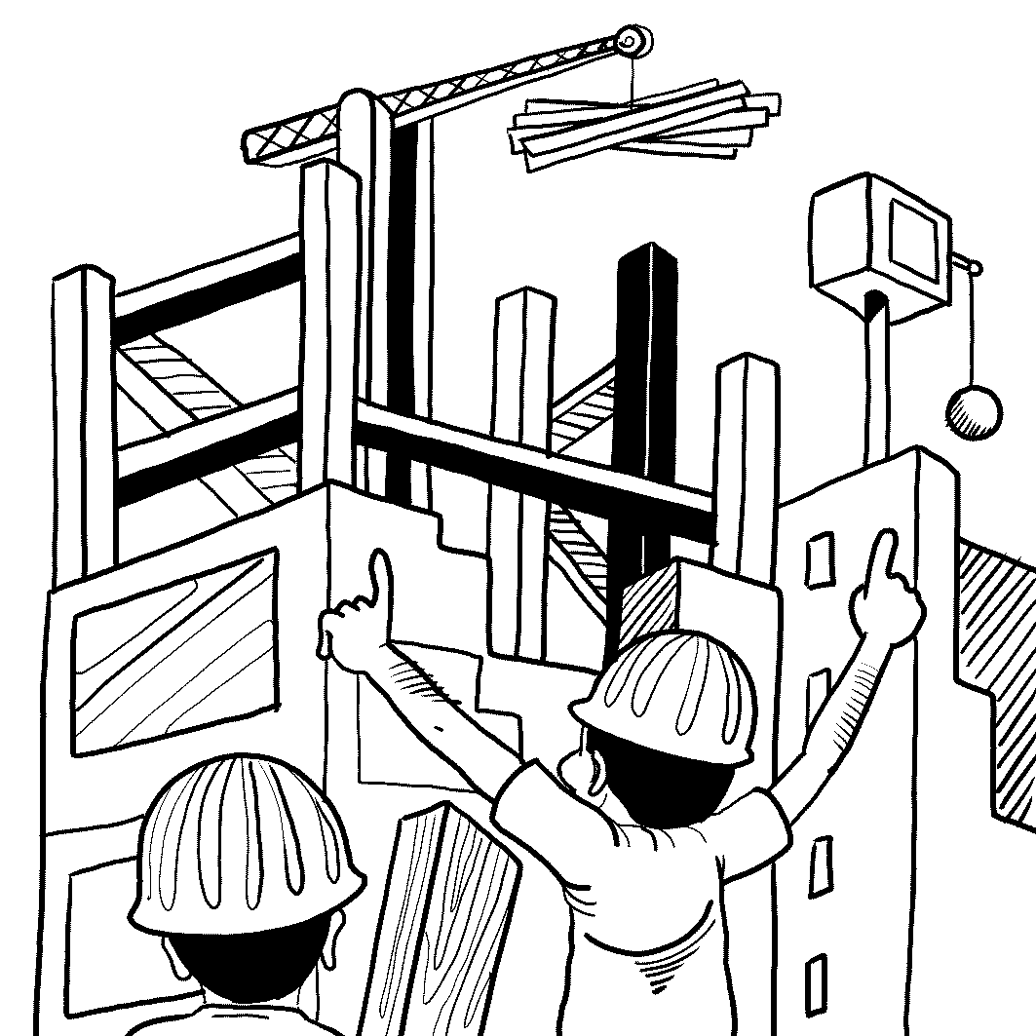
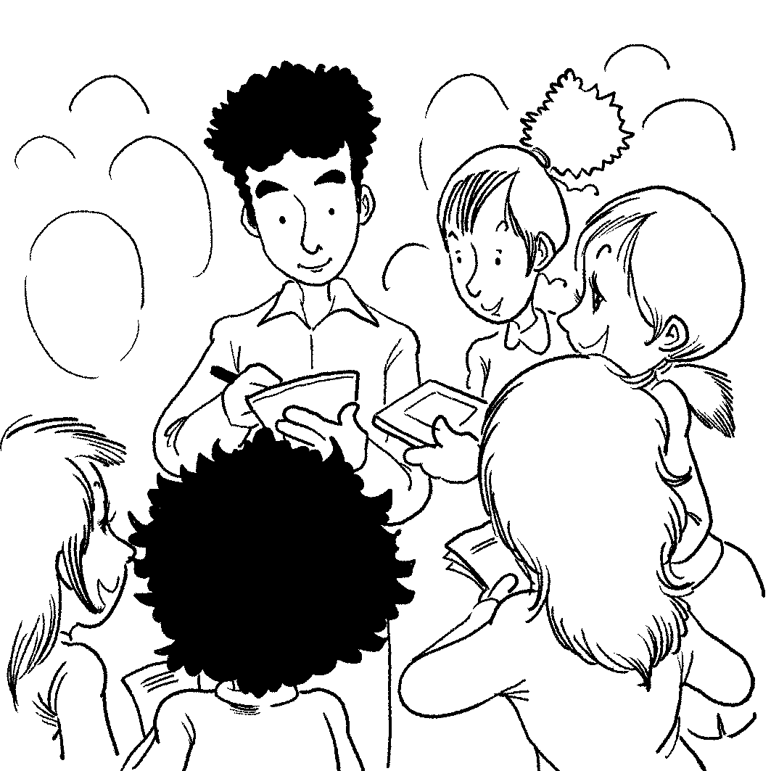
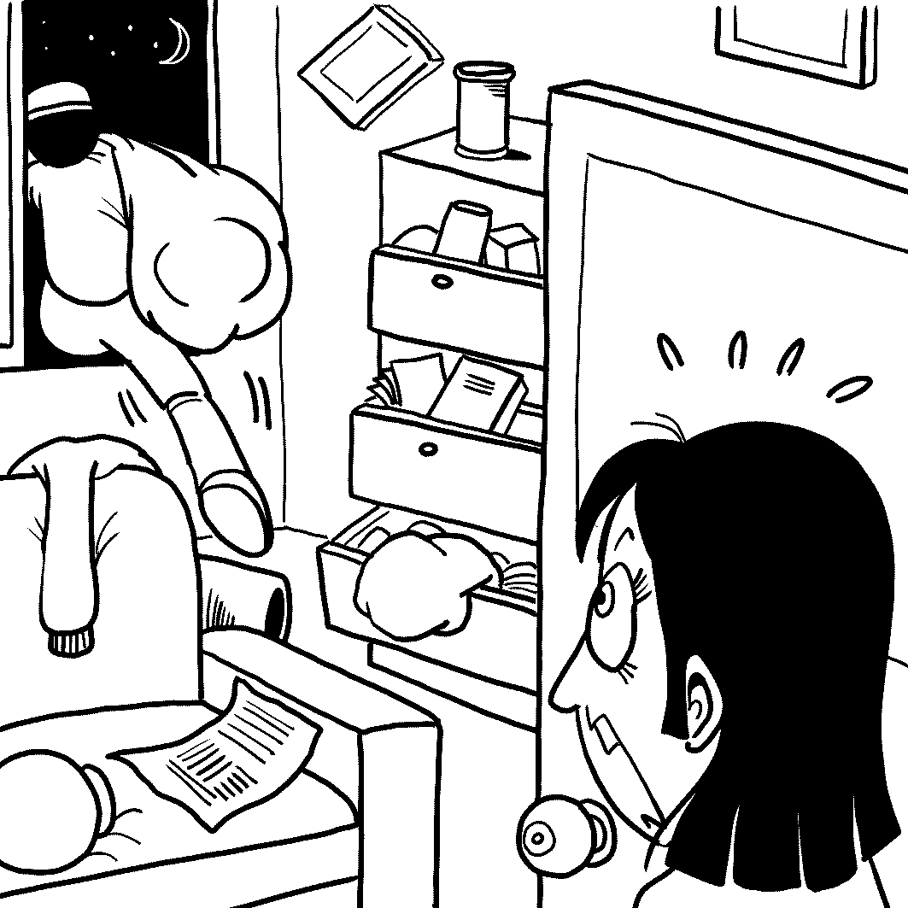

.

B: Best Response Questions
Listen to the question or statement and choose the best response.

4. (A) Me too. After all, what will we do if there’s no clean water to drink?
(B) Right, it’s getting harder and harder to grow good crops in the ground.
(C) I know. The air we breathe is no longer as clean as it used to be.
- We should do something about all the animals that have got diseases.

5. (A) He comes from the South where they pronounce words differently.
(B) Well, he’s an educated man, so he has a very large vocabulary.
(C) I agree that he does have a strange sense of humor sometimes.
(D) I think he’s shy which is why he speaks so softly.

6. (A) If he doesn’t pay enough attention to her, she should break up with him.
(B) If he hits her or is violent towards her, there is really no excuse at all.
(C) That’s so sweet that her boyfriend buys her lots of cute gifts and things.
(D) Well, some guys don’t understand that calling every hour is annoying.

C: Conversation Questions
Listen to each conversation and answer the question.

7. (A) The professor is too busy to give him feedback.
(B) The professor is quick to point out his mistakes.
(C) The professor gives him too much homework to do.
(D) The professor does not know enough about the subject.

8. (A) She hasn’t seen Pete in a long time, either.
(B) Pete has just shown up after they mentioned him.
(C) She thinks Pete is a pretty mean guy.
- Pete just called her the other day.

9. (A) She thought something was funny.
(B) She is angry about something.
(C) She is not really sure what is going on.
(D) She paused for a brief moment to decide.

D: Short Talk
Listen to the passage and answer the questions.

10. (A) Fans will have something to discuss about afterwards.
(B) Officials will disagree with one another, which is fun.
(C) People can win a lot of money if the call goes their way.
(D) Errors just can’t happen in sports anymore.

11. (A) It is a special camera held by the official of a game.
(B) It is a special pair of glasses so officials can see better.
(C) It is a sensor in the court that beeps when the ball is out.
(D) It is advanced computer technology for making correct calls.

12. (A) It costs too much to install and use.
(B) It slows the game down too much.
(C) It will often make mistakes itself.
(D) It gives the officials too much control.
II. Vocabulary:10%
13. The parents made a lot of ___________ to save money to send their child to university.
A. compliment B. authority C. reputation D. sacrifice
14. Some people believe if you live a good life on Earth, you will be given a(n) __________ life
in Heaven.
A. definite B. moderate C. numerous D. eternal
15. If your bags are over the _________ amount of weight allowed by the airline, you'll have to pay an
extra fee.
A. redeeming B. maximum C. minimum D. potential
16. Clara was __________ by the fear that she would not be able to enter an ideal college.
A. embraced B. haunted C. fascinated D. equipped
17. We have nothing but __________ for those who break the law.
A. contempt B. hesitation C. bond D. fascination
18. Ever since the contaminated milk scandal happened, there has been a greater _________ for domestically produced milk.
A. tension B. outcome C. contest D. demand
19. Henry has a very close _________ with his mother. Other people can hardly understand the strong attachment between them.
A. formula B. bond C. foundation D. awareness
20. To ___________, the unemployed person set fire to the factory.
A. free up B. move along C. get revenge D. hold back
21. Studies have shown that red wine __________ can actually be good for your health.
A. in moderation B. in motion C. to a large degree D. to the end
22. We all _________ remember the good times and forget the bad ones.
A. to some extent B. beyond our control C. look forward to D. set to
III. Cloze Test: 10%
A.
The reality television talent contest American Idol has proven to be a hit the world over. Much has been said and written about the show's great popularity, with words _____23_____ both praise and contempt. ___24_____ everyone has been too excited about American Idol's success. Starry-eyed teens neglect their homework to pursue dreams of one day becoming the next pop or rock___25____. Some parents complain about the show's influence on their children, ___26____ the rudeness, materialism, and sexism in the show are not fit for children.
Those with a more favorable view of Idol, ___27____, point out its more positive aspects. They argue that ___28____ it may be true the judges frequently criticize the contestants harshly, it's all part of the process that weed out the less talented from the truly gifted.
23. A. telling B. told C. expressing D. expressed
24. A. Only B. Nearly C. Not D. Almost
25. A. sensation B. witness C. folklore D. triumph
26. A. said B. saying C. and saying D. say
27. A. therefore B. moreover C. actually D. nevertheless
28. A. despite B. because C. while D. unless
B.
Only some forms of chocolate have health benefits. Studies suggest that dark chocolate－and only dark chocolate with 65 percent cocoa or more－___29___blood flow and ____29____ blood pressure. It also has properties that help prevent blood clots. ____30__ from the cacao tree, some forms of chocolate are rich in antioxidants, which can neutralize free radicals that the body produces as it ages. Nevertheless, some doctors feel that the high fat and sugar in most chocolate may _____31___ any positive impact on health. One thing __32___ doctors do agree is that more research should be conducted.
29. A. increases…increases B. lowers…lowers
C. lowers…..increases D. increases…lowers
30. A. To come B. Come C. Coming D. Have come
31. A. add up to B. cancel out C. be followed by D. be associated with
32. A. which B. that C. on which D. for which
PART II. 學測字彙攻略 : 12%
IV. Vocabulary
33. Too frequent contact with water or cleansing solutions can _______ the skin's protective layer.
A. rid B. ruin C. blend D. observe
34. We felt regret about the young female teacher who committed _______ just because she didn't want to see herself aging.
A. composition B. spells C. crime D. suicide
35. Laws have to balance the rights of the _________ with the needs of the group; the welfare of a single person and that of a group should be equally considered before the law.
A. staff B. resident C. witness D. individual
36. When you breathe in, your lungs _________.
A. extent B. expose C. expand D. explore
37. Eating a low-fat, low-sugar, low-salt diet may ________ the risk of heart disease.
A. cast B. distribute C. ensure D. lessen
38. Those bullies _________ to give the weaker student a good beating if he dared to tell the truth.
A. extended B. indulged C. threatened D. acquired
39. As people grow older, their skin loses its __________.
A. elasticity B. atmosphere C. wrinkles D. defense
40. Any forms of ________ shouldn't be justified in a truly democratic country. People should seek peaceful solutions to any conflicts.
A. defense B. depression C. violence D. exploration
41. Under the influence of economic recession, my father has been ________ for three months.
A. unemployed B. endured C. conquered D. adapted
42. In winter, the leaves fell off the tree and _________ all over the ground.
A. melted B. crushed C. blended D. scattered
43. You'd better leave the papaya in room temperature for two days more because it is not yet _________.
A. outstanding B. mature C. moderate D. native
44. Cell phones are a(n)__________ invention because they allow communication to take place
anytime and anywhere, which was impossible before.
A. transparent B. organic C. revolutionary D. professional
PART III. TEXTBOOK
V. Cloze Test 7%
A
Joanna spoke in a low voice. She told Sue that only five leaves ___45__ on the vine. Just as the leaves were falling, Joanna thought her life would ___46__ when the last leaf fell. “Stop ___47__ such nonsense and go back to sleep!” Sue scolded. And after Joanna __48__ asleep, Sue went out to get some hot chicken soup for her.

45. A. were left B. left C. leaving D. to leave
46. A. come up B. come to an end C. come alive D. come about
47. A. speaking B. to say C. talking D. to tell
48. A. has felled B. had fallen C. falls D. was felled
B.
It seems that she, like Harry, had to overcome an unhappy childhood. One way __49__ was by losing herself in books. Rowling has a great love of literature, __50__ she actually began writing when she was five or six years old. Her first writing __51__ was called “Rabbit.” In the story, she revealed a lively imagination.

49. A. what she did B. which she does C. she did that D. how did she do
50. A. nevertheless B. likewise C. and D. if
51. A. effort B. obstacle C. awe D. gesture
VI. Matching 4%
52. By the time the ambulance arrived at the hospital,
53. These experiences may have contributed
54. It was what he said
55. Children should be aware

- with which the young woman was sick.
- of the importance of being polite to others.
- for others in surprising ways.
- to be a published author.
- the place where Rowling gave birth to a daughter, Jessica.
- to her sympathy for those who are different from ordinary people.
- the injured man had died.
- that interested me.
VII. Choose the INCORRECT one(用法錯誤者) 18%
56. 選出本題四句中文意與另三句不相同的一句
A.The team stands a fair chance of winning in the game.
B. There is one chance in ten that the team can win in the game.
C. The team is very unlikely to win in the game.
D. The odds are against the team winning in the game.
57. A. I think the old lady may be idle when young.
B. They lived on the third floor of an inexpensive apartment building since they could not afford anything better.
C. Edward didn’t take part in the competition; he could have won, though.
D. The findings show that we spend at least two hours dreaming every night, whatever we may have done the day.
58. A. It took her almost a year to find work as an English teacher in Scotland.
B. As an English teacher kept her busy in the afternoons and evenings.
C. That is because Harry needed to be trained for seven years as a wizard at Hogwarts.
D. Rowling described herself as a quiet, shy girl and with no ability at sports.
59. A. Was it during her long train ride to London that she made up the story of Harry Potter?
B. Is it the woman, J.K. Rowling, that has become popular all over the world?
C. It was in the big suitcase that the police dog found the drugs.
D. It was that she thought she was going to die she was getting weaker and weaker.
60 A. I don’t think it appropriate to talk out loud on the cell phone in theater.
B. Old Behrman’s work on his painting kept him awake at night.
C. Joanna unwilling agreed with Sue to go to see a doctor.
D. The beggars did not wear heavy clothes to stay warm in the winter cold.
61. A. If you look thorough a telescope, you can see many more stars in the sky.
B. The police launched a thorough investigation into the murder case.
C. Her childhood, though poverty stricken, had been a happy one.
D. I have thought about whether I should move to the suburbs.
62. A. Those mountain climbers got lost in the snow, and nearly froze to death.
B. “Freeze!” the police cried out loud to the pickpocket.
C. Those children enjoyed skating on the freezing pond. .
D. The missing mountaineer was finally searched but was found frozen to death..
63. A. His plan was ended up in failure in spite of much effort.
B. About 100 people were killed in the crash, including the pilot.
C. The first volume was finally accepted for publication in 1997.
D. I was awoken deep in the night by the sound of thunders.
64. A. Harry and other young wizards were gazing wonderingly at the scene ahead of them.
B. Diana stared her husband at the eye and doubted what he was saying to her.
C. I don’t like to be looked at while dressing or undressing.
D. The lady shut the door and went inside without a backward glance at the stranger.

65. A. Next to him lay a ladder along with a lantern, brushes and some paint.
B. In front of the house laid a beautiful garden.
C. Under the table was lying a half-conscious man.
D. At the lake was laid a broken bulletin board.
66. A. My mom has been sick for a week; all she could do was stay in bed.
B. The doctor said, “ I’ll do what I can, but if she thinks she’s going to die, there’s little I can do to help her get better.”
C. Old Behrman said he had to go run an errand and left in haste.
D. The doctor added, “If you can get her think about living, she’ll have a much better chance of getting well.”
67. A. These ideas are dealt with more fully in Chapter four.
B. We shouldn’t be discouraged when we are lost in fear and grief.
C. Nothing are matched up the thrill of succeeding at something important to you.
D. His shoes and clothing were soaked with rain when they found him.
VIII. Reading Comprehension: 6%
Sometimes the real world can be a confusing place. It is not always fair or kind. And in the real world there are not always happy endings. That is why, every once in a while, we like to escape into the world of fantasy—a place where things always go our way and there is always a happy ending.
We want to believe in fantastic creatures in imaginary lands. We want to believe in magic powers, good friends, and the power of good to overcome evil. We all fantasize about being able to fly and lift buildings off the ground. And how good a magic sword would feel in our hand as we go off to kill a dragon or win the hand of a beautiful princess.
The amazing adventures of Superman, Peter Pan, and Harry Potter have charmed many people, children and adults alike. The main reason is that these stories offer us chances to get away from this real, frustrating world and allow us to find some magical solutions to our problems. For example, Superman always arrives in the nick of time to prevent a disaster from happening, Peter Pan can fly at will to tease the bad guy Captain Hook, and Harry Potter has his magic power to take revenge on his uncle, aunt, and cousin, who always ill-treat him.
68. People enter the world of fantasy for the following reasons EXCEPT that _______.
A. we can always have our wishes fulfilled
B. the world of fantasy frightens us
C. the real world is often disappointing
D. we can find happy endings there
69. Superman, Peter Pan, and Harry Potter have charmed many people, because _______.
A. the bad guys always have their upper hand
B. their solutions are anything but magical
C. they possess powers that ordinary people don’t have
D. they end up getting married to beautiful princesses
70. This article about fantasy literature is intended to ________
A. teach people to avoid disasters
B. criticize its unrealistic concepts
C. explain why people like to read it
D. ridicule those people reading it
以下部份請作答於答案卷上
IX. Vocabulary: 10%
- The a____g young man left his hometown for the big city to seek his fortune.
- I was r_____t to lend my new laptop to Tom, for he had been known as a careless person.
- The architect has i_____ed traditional and modern themes in the building’s design-- the blend of the old style and the new one.
- Bocelli is b______sed with a beautiful vocal style, which makes the blind man a successful singer.
- Beauty is an abstract c_____t, so its definition varies from person to person.
- The development of economy must go in p_____l with that of democracy.
- It is offensive to give i_____g remarks to others in communication.
- President Bush and President-elect Barack Obama held their first and highly s_____c talks in the Oval Office of the White House Monday, Nov. 10.
- Frederick p_____ed to catch his breath and then continued climbing the mountain.
- O_______y, there used to be a flag-raising ceremony every morning before the classes.
X. Paraphrases 7% (除13 題外其餘請用課本上之片語釋義) 全對始得分
- My parents approved of my majoring in art.
= My parents gave me a t______ ______ about my majoring in art.
- The stock market crashed, resulting in Palin’s being penniless.
= When the stock market crashed, Palin ____ _____ penniless.
- The streets in the country are wide. The streets in the city are much wider.
= The streets in the country are wider, and ______ in the city are much wider.
- My father is skilled in gardening.
= My father has a ______ _______.
- At the meeting, they discussed, among other things, the alternative energy production.
= At the meeting, they discussed, _______ _________, the alternative energy production.
- I can only try to strike a balance between work and play.
=I can do _____ ______ try to strike a balance between work and play.
17. I have been told to face hardship with a brave attitude.
= I have been told to t_____ hardship on the c______.

XI. Translation: 4%(一格限填一字 每題全對始得分)
18. 哈利波特這本書現已賣到二億多本
At present, the book, Harry Potter, _____ _______ ______ over 200 ______.
- 如果你還誤解她的善意 那你就大錯特錯了
If you keep on misunderstanding her goodwill, you do _____ far _____.
- 他酗酒是因為他一直沒畫出年輕時夢想畫出的傑作.
He was indulged in drinking too much because he hadn’t painted the m______ he ______
_______ _______ painting when he was young.
21. 這個十字路口經常有一連串的事故發生
There are often ______ s_______ ______ car accidents __________ at the crossing.

台北市立松山高中九十七學年度第一學期第二次段考高二英文
答案卷
1—5 DBACA 6—10 ABBDA
11—15 DBDDB 16—20 BADBC
21—25 AACCA 26—30 BDCDC
31—35 BCBDD 36—40 CDCAC
41-45 ADBCA 46—50 BCBCC
51—55 AGFHB 56—60 AABDC
61—65 ACABB 66-70 DCBCC

IX. Vocabulary: 10%
1 aspiring | 2 reluctant | 3 incorporated | 4 blessed | 5 concept
6 parallel | 7 insulting | 8 symbolic | 9 paused | 10 Originally

X. Paraphrases 7% (全對始得分)
11 thumbs up | 12 ended up | 13 those | 14 green thumb
15 in particular | 16 nothing but | 17 take chin

XI. Translation: 4% (全對始得分)
18 has been sold million | 19 go wrong
20 masterpiece had dreamed of | 21 a series of happening

Class______________ No.__________ Name________________

