台北市立松山高級中學九十七學年度第二學期英文科高二第一次期中考

I. Listening Comprehension 10%
A. Picture Questions
Look at the picture and answer the question.
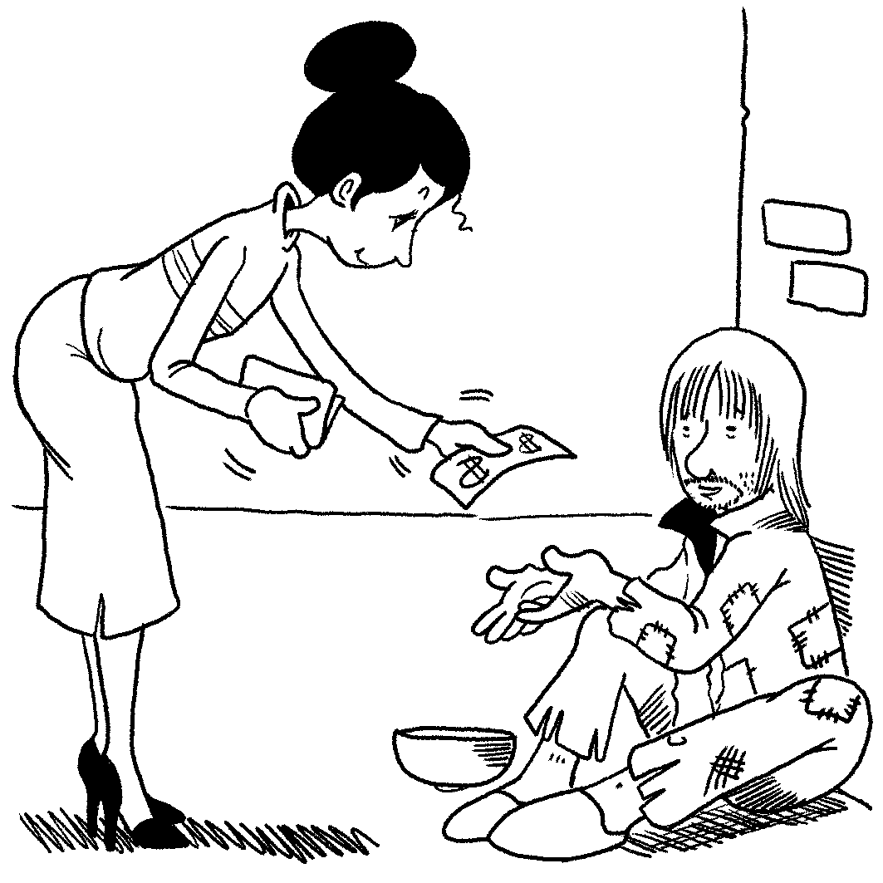
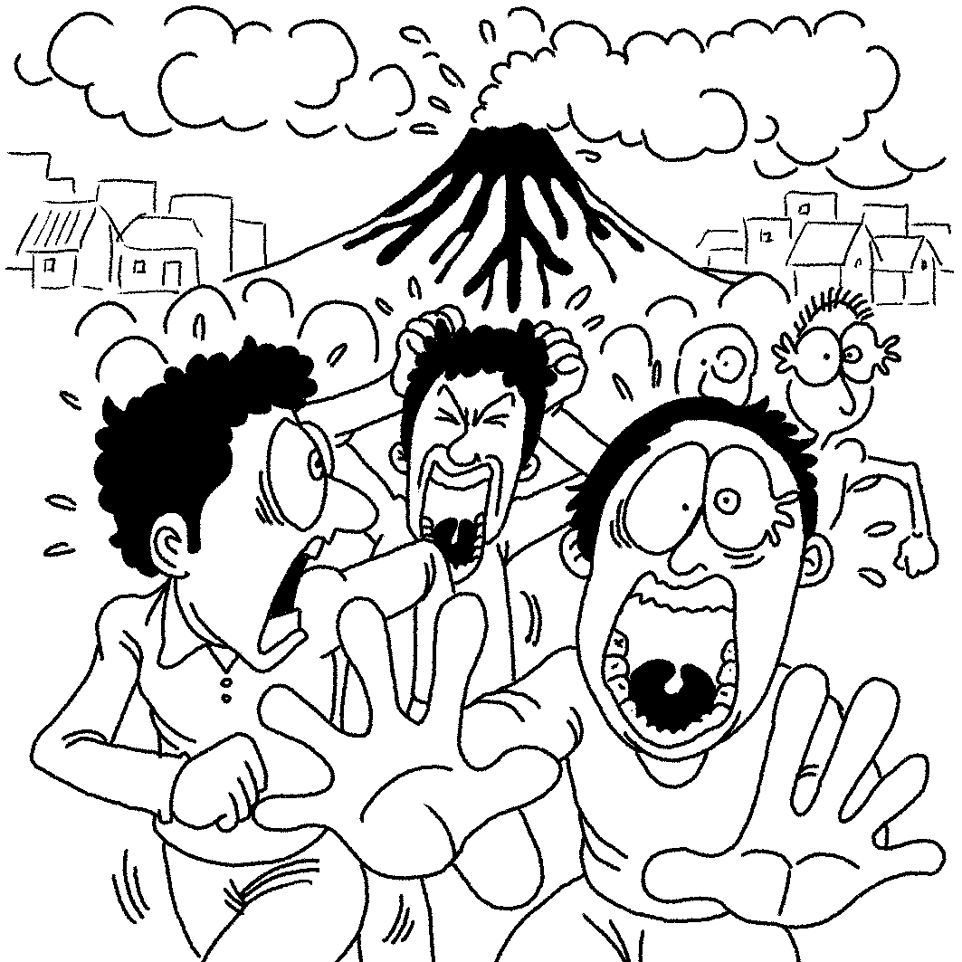
1. 2.

B. Best Response Questions
Listen to the question or statement and choose the best response.
3. (A) I know. She loves telling us about what is going on in her life.
- Actually, she really likes the job she is doing at the moment.
- You’re right that she can be selfish sometimes, but I still like her.
- Yeah, sometimes it is not easy to figure out what she’s thinking.
4. (A) Yeah, that dog never seems to stop jumping around and playing.
- It’s true that Rex always obeys him and takes care of him.
- Come to think of it, I’ve never heard him barking or making noise.
- I agree that his dog is one of the most handsome in the neighborhood.
5. (A) Wow! With two teachers you must have learned many new things.
- Having two big tanks of air on your back must have been heavy.
- I believe people put them on their feet in order to swim faster, right?
- That’s nothing. I actually had to change my diving suit three times!
6. (A) I disagree. Their bodies look so beautiful with all those stripes.
- Well, I can’t say for sure since I have never tasted tiger shark before.
- They may be common, but I’m not sure you can find them everywhere.
- You're right. They have no fear and will attack almost anything.

C. Conversation Questions
Listen to each conversation and answer the question.
7. (A) They will throw a huge party to celebrate their important victory.
- They will play in the final game to decide which team is the best.
- They will go home and relax since their season has been completed.
- They will have to travel to another country in a few weeks.
8. (A) The towel is too small to clean up the mess the man made.
- The towel is her favorite and she doesn’t want the juice to stain it.
- The towel will be used for something else in just a moment.
(D) The towel won’t soak up the juice because it’s not dry.
D. Short Talk Questions
Listen to the following paragraph and answer the questions.
9. (A) At a local sporting goods shop.
(B) At a university near his home.
(C) He learned with his good friends.
(D) At the beach while he was on vacation.
10. (A) They were not pushing the nose of the glider up enough.
(B) They were jumping before it was time to fly.
(C) They were letting go of the glider too soon.
(D) They were not running fast enough before taking off.

- Vocabulary & Phrases(All+ &指考單字)12%
11. In the activity, although there is not a sober person in sight, the only danger is that you will be by the people scrambling to catch ornaments.
(A) trampled (B) relished (C) dispatched (D) radiated
12. The president was by a beautiful woman and ignored his country’s problems.
(A) glittered (B) applauded (C) seduced (D) staggered
13. The Carnival celebration is best known for its costumes made of expensive fabrics and elaborate masks.
(A) shrine (B) exquisite (C) gloom (D) solitary
14. The kind teacher hugged his student in a display of emotion.
(A) spontaneous (B) strategic (C)truant (D) barren
15. According to the communicative teaching , which underlies many classes, the students need to speak in order to learn.
(A) warranty (B) perseverance (C) irritation (D)doctrine
16. The critics said the politician’s speech was empty , and he had no plan for action.
(A) expertise (B) aptitude (C)reinforce (D)rhetoric
17. Science beckons to us, helping us to depart from the realm of the prophet and the .
(A) expedition (B) momentum (C) superstitious (D) versatile
18. Propelled by mainstream media , Second Life now has 13million accounts on the Net.
(A) hurdle (B) coverage (C) retrieve (D) shrewd
19. This situation began to change over the last decade or so with the rise of citizen journalism, also known as or public media.
(A) insulation (B)grassroots (C)gallery (D)harness
20. When the actor supported religious freedom in the country, his caused more people to support it as well.
(A) prominence (B) veteran (C) criticism (D) cactus

21. For fear that someone might break into his house, Edward had an alarm system and had extra locks put on his doors.
(A) mourned (B) installed (C)crushed (D)withdrew
22. One of the children started making noise, and pretty soon all the rest of them .
(A)jumped on the bandwagon (B) thrust on
(C) took flight (D) pushed themselves to the limit

III. Cloze Test (All+ &指考單字)23%
A. Gettysburg was one of the key events in the American Civil War. The combat lasted from July 1-3, 1863, and it was a 23 . There were around 50,000 casualties during those three days, counting those injured and killed. It is always a moving experience to visit the
24 in Gettysburg where those who died still lie. In fact, it was there that Abraham Lincoln gave the famous Gettysburg address at the dedication ceremony. On July 1, 1998, more than 41,000 people 25 to commemorate the Battle of Gettysburg by reenacting it.
23.(A) cavalry (B) comrade (C)crouch (D) massacre
24.(A) corpse (B) cemetery (C) trophy (D) sprint
25.(A) assembled (B) relished (C) blasted (D) sermoned

B. Notting Hill Carnival started in 1965, with a tiny cluster of Caribbean 26 who lived in Notting Hill district. There was racial hostility in the air of London at that time, and many Caribbean youths used the festival to express their 27 . They felt that they were treated as intruders, and they were mocked and despised by the locals. Violence and 28 reached a peak in 1976 and the crowds were dispersed by the police. The government intervened and proposed the closure of the event. Luckily it didn’t happen, as it would have been a great 29 for diversity in London.
26.(A) immigrants (B) cosmopolitan (C) emigrants (D) trots
27.(A) restraint (B) lunatic (C) indignation (D) dynamite
28.(A)adolescence (B) bulge (C) textile (D) aggression
29.(A) setback (B) boom (C) rehearse (D) smother

C. Color does affect the way we think, but to what degree is still 30 . Today, legal pads are still made with yellow paper because yellow was once thought to stimulate the intellect. Restaurants may still paint their walls red because 31 make people eat faster. Companies still use the color gray to show that they are solid as a rock. These ideas about color aren’t scientific facts though, and they could turn out to be 32 wishful thinking.

30.(A) in its entirety (B) on the scene (C)open to question (D) on the bandwagon
31.(A) they thought to (B) they are thought to(C) it is thinking to (D) it is thought to
32.(A) little more than (B) anything but (C) anything more than (D) a little more than
D. We’ve all been told that fresh fruit and vegetables are good for us. They often contain more vitamins and nutrients than 33 . However, the opposite is true with tomatoes; cooking them is actually a good thing. A group of scientists in the U.S. has found a tasty way tomatoes help prevent cancer. It turns out that eating tomato pasta sauce 34 with a bit of olive oil added actually makes it healthier. The key is lycopene, a molecule found in tomatoes that may help prevent cancer. Human blood also contains lycopene, 35 it’s usually in a bent form. In tomatoes, the lycopene tends to be straight, 36 for humans to absorb.
33. (A) when they are cooked (B)they are cooked(C) they being cooked (D) to cook
34. (A) is reheated (B) has reheated (C) that has been reheated(D)when it reheated
35. (A) that (B) where (C) which (D) and which
36. (A) which making hard (B) making it hard
(C) and make it hard (D) which make hard

E. The most amazing green building is perhaps the one envisioned by the architect David Fisher. He has designed a dynamic tower concept that 37 independently rotating floors with wind turbines between each floor. Instead of fighting the wind and the destabilizing effect
38 skyscrapers, Fisher plans to use it to turn his building into a mini power plant. The building could produce 39 it uses. Plans are already 40 to build dynamic towers in Dubai and Moscow, and Fisher hopes the buildings will be completed by 2010.
37.(A)is made up (B)is consisted of (C)composed of (D)comprises
38.(A) they have on (B)it has on (C)which it has (D)which is on
39.(A)ten times as electric as (B)more ten times electricity than
(C)more than ten times electricity (D) ten times more electricity than
40.(A)in place (B)taking on (C)on the scene (D)racking up

F. Kobe’s father decided to play for an Italian team, moving the family to Italy. Kobe kept up his passion for basketball and made his first dunk when he was fourteen. 41 in Italy, Kobe also became a soccer fan. “ I’d have tried to become a professional soccer player 42 in Italy,” Kobe once confessed. Luckily for basketball fans, the Bryants moved back to Philadelphia for Kobe to start high school. Kobe’s 43 skills on the court, including his famous crossover dribble, 44 national recognition right away. Adding his good grades and SAT scores to the equation 45 him a scholarship to the university of his choice. In the end, Kobe made the decision to go directly into the NBA. He was only 18 years old.
41. (A).Grown up (B)Bring up (C)Growing up (D) Brought up
42. (A).have we stayed (B)if we would stay (C)had we stayed (D)if we stayed
43. (A).dominant (B)wary (C) intestinal (D)streak
44. (A).earning him (B) earned him (C)earning for him (D)and earned for him
45. (A).submitted (B)stumbled (C)generated (D)guaranteed

IV. Cloze Test:( Textbook) 19%
A. I often wonder why men and women are so different from each other sometimes. Well, scientists are trying to ____46____ an answer. They theorize that men and women are different because small differences in their brains ____47____ the sexes ___47___ information in slightly different ways.
For example, girls seem to ____48___ boys in language acquisition; therefore, they learn to speak ____49___ full sentences earlier than boys. ___50____, men do better than women in tests of spatial ability, which means that the former can better picture objects’ shapes and positions in their mind’s eye than ___51___. That’s why men are ___52___ to deal with mathematical problems of spatial relationships better than women. Nevertheless, women seem to be better ____53____ other people’ s feelings , and they are more ____54____ dealing with situations that require complicated communication with others. But men have a better sense of directions, so they are seldom at a loss ____55____ which way to go.
46. (A) look after (B) run into (C) search for (D) point to
47. (A) cause…handled (B) let …handling (C) get…handle (D) lead…to handle
48. (A) have outperformed (B) be outperformed(C) outperform (D) outperforming
49. (A) in (B) on (C) with (D) for
50. (A) As a result (B) In other words (C) In addition (D) On the other hand
51. (A) the later (B) the latter (C) the last (D) the lately
52. (A) unlikely (B) tend (C) easily (D) inclined
53. (A) than detected (B) for defined (C) at detecting (D) on defining
54. (A) able to (B) likely to (C) incapable of (D) capable of
55. (A) regardless of (B) as to (C) not to mention (D) as long as

B. Although no one reads a dictionary page by page, it is still interesting to know how the modern dictionary _____56_____. The early dictionary-makers were monks. This was ___57___ when Latin was used by educated people in Europe. Before the printing press was invented, the monks ____58_____ notes explaining difficult words in the margins of their hand-lettered books. After one thousand years, some monks ____59___ making lists of these Latin glosses and translating them into English. That is so called the first dictionary.
Later, an English gentleman called Robert Cawdrey published a dictionary ____60___ the words were listed in alphabetical order. A few years later, another Englishman, Henry Cockeram published his own dictionary. He didn’t do any research ____61____ how people used words, ____62_____ his own definitions.
Then in 1721, Nathaniel Bailey wrote his dictionary. It was so popular that it was reprinted thirty times. Next, Samuel Johnson also wrote his own dictionary. In his opinion, a good dictionary should fix the pronunciation of words and be ____63____ good words. It took Johnson eight years to finish his dictionary. During that time, Johnson discovered that language changed all the time and he no longer believed _____64_____ to fix the language. Johnson also realized that dictionary were out of date as soon as they were printed.
56. (A) came into existence (B) coming into being (C) to exist (D) originated
57. (A) at times (B) at one time (C) at that time(D) at a time
58. (A) used to make (B) used to making
(C) were used to make (D) were used for making
59. (A) got the idea to (B) came upon with (C) came up with an idea of (D) occurred to
60. (A) that (B) in which (C) when (D) from which
61. (A) for (B) at (C) on (D) with
62. (A) so set up (B) or setting up (C) for making up (D) but made up
63. (A) consisted of (B) excluded from (C) included of (D) composed of
64. (A) it was possibly (B) he was possible (C) it possible (D) he could possibly

V. Multiple choices: 10% (Please choose an INCORRECT answer.)
65. (A) If the world were to end tomorrow, I would let you play my Wii.
(B) If he had listened to my advice, he might not have been in jail now.
(C) How nice it would be if I were a college student now!
(D) If he had handed in the report yesterday, he wouldn’t have got himself in trouble.
66. (A) Kevin’s test scores are not well enough for him to enter his dream college.
(B) The issue isn’t important enough to raise everyone’s concern.
(C) The bridge is not strong enough to withstand the flood.
(D) Vivian was thoughtful enough to bring food for everyone so that we could keep on working.
67. (A) How easy do you find spelling new words and writing essays?
(B) How easy is it for you to picture their faces if their names mentioned the following day?
(C) How easy is it for you to recognize that voice in the few seconds before the person
identifies himself?
(D) How close can you be seated to people of the same sex as yourself without feeling
uncomfortable?
68. (A) We have all heard the rumor that the movie star is getting another divorce.
(B) George felt it difficult for him to find a job based on the report that unemployment
rate is rising.
(C) John’s belief where there is a will, there is a way helped him succeed in the business world.
(D) The fact that people in Taiwan are having fewer children per family has been
proven by statistics.
69. (A) Lisa believes it beneficial to her health to practice yoga three times a week.
(B) Susan has made it a rule never to make any complaint about her school life to
her parent’s face.
(C) Miss Lee thinks it essential to set some regulations for children to follow.
(D) Computers make it possible that people living in different countries to chat
through the Net.
VI. Reading Comprehension: 4%
Andy Warhol, a famous American artist, once said that everybody will have fifteen minutes of fame. Judging from the current worldwide popularity of TV talent contests, there is no shortage of people trying to grab their moment in the spotlight. Here in Taiwan, for example, viewers enthusiastically tune into shows like One Million Star where wannabe singers attempt to impress the judges and sometimes even turn their dreams of celebrity into reality.
For a lucky few, an appearance on a TV talent show leads to fame and fortune. Take the shy
British opera singer Paul Potts, for example. In June 2007, following regional additions, he appeared
on a national TV program called Britain’s Got Talent. At first, the judges did not seem to expect
much from the overweight, soft-spoken young man in the cheap suit. But Potts possesses a powerful
singing voice, and he stunned them with a superb performance of Puccini’s “Nessun Dorma.”
One of the judges was moved to tears, and Potts received a standing ovation from the audience
of two thousand.
Though he clearly had talent, Potts had followed an unlikely road to stardom. He received
some formal opera training in Italy at his own expense, and he did sing in front of audiences
both as a soloist and as a member of an opera group. Unfortunately, he was forced to give up
singing lessons after getting sick. He also had an accident from which he spent a long time
recovering. His confidence weakened, Potts ended up earning a modest living as a cell phone
salesperson. He never let go of his dream, though, and finally worked up the courage to audition
for the popular TV show.
Potts went on to win the final of Britain’s Got Talent, and more than 13 million TV viewers
watched his triumph. As well as 100,000 in prize money, he won a recording contract. He is now
traveling the world promoting his recently released CD. In the meantime, videos of Potts’
appearances on the talent show have received millions of hits on YouTube. His story is a shining
example of how it is possible to live one’s dream. The experiences of Paul Potts and others
like him help to explain the massive appeal of TV talent contests. These shows promote
the idea that anybody can become a star. They offer a once-in-a-lifetime opportunity to
ordinary people who are willing to give it a shot. Of course, these people hope their fame
will last longer than fifteen minutes.
70.Which of these points is made in the first paragraph?
(A) Andy Warhol became famous after going on a talent show.
(B) One Million Star is a popular TV show around the world.
(C) TV talent shows are widely seen as a way to achieve fame.
(D) Few people achieve fame by appearing on a talent show.
71. When Paul Potts sang on a British TV talent show, ___________.
(A) he was already well-known in that country
(B) the judges were not impressed by his voice
(C) no one was surprised that he had talent
(D) the whole audience stood up and clapped
VII. Vocabulary: 12%
- Tony suffers from n_______m; he is constantly looking at himself in a mirror.
- Greek m________y is usually regarded as one of the most important origins of classical
literature.
- The prime minister was c________ted with the biggest crisis of his political career.
- Professor Lin’s letter of r_________n is highly respected if you want to apply for
admission to a prestigious university in the U.S.A.
5. There are shuttle buses to transport passengers between the two t_______ls of the airport.
6. A flight a_______t is a member of the cabin crew, whose job is to wait on the passengers
on the plane.
7. The little boy can’t write yet, but he loves to s________e with a crayon.
8. The government conducted a s_______y to find out how many voters were against the
new project.
9. In the future, older people may make up a large p________n of the world’s population
because the birthrate is declining.
10. A book is a concrete object, but the ideas expressed in this book are a_________t.
11. My brother has worked all his life in the p_______t of fame and wealth, but I think real
happiness lies in contentment.
12. After seeing the doctor, Linda went to a pharmacy to have the p________n filled.

VIII. Translation: 10% (每格不只填一個字)
1. Irene 覺得在空閒時瀏覽一些時尚和流行的雜誌是很有趣的。
Irene _______1_______ some fashion magazines in her spare time.
2. 令我失望的是，即使我一個月必須少拿新台幣一萬元，我還是得接受那份工作。
_____2____, I have to take the job even if I have to ____3_____ NT$10,000 a month.
3. 儘管同時享有一些男性和女性的大腦特質，這未必意味著你比較不像一個男人或比較不像
一個女人。(Despite…)
_____4_____ of both the male and the female brain, it doesn’t necessarily mean that you are
any less a man or a woman.
5. 隨著考試的接近，學生們不得不熬夜唸書。(With…) 2%
6. 就某種意義而言，遵守承諾是很值得的。只有這麼做才能使你贏得他人的信任與尊重。
(Only by…) 4%

台北市立松山高級中學九十七學年度第二學期英文科高二第一次期中考
Class__________No_______Name_____________

VII. Vocabulary: 12%
1 | 2 | 3
4 | 5 | 6
7 | 8 | 9
10 | 11 | 12

VIII. Translation: 10% (1~4題每題1分，第五題2分，第六題4分)

1.

2.

3.

4.

5.

6.

台北市立松山高級中學九十七學年度第二學期英文科高二第一次期中考
Class__________No_______Name_____________

VII. Vocabulary: 12%
1  narcissism | 2  mythology | 3  confronted
4  recommendation | 5  terminals | 6  attendant
7  scribble | 8  survey | 9  proportion
10  abstract | 11  pursuit | 12  prescription

VIII. Translation: 10% (1~4題每題1分，第五題2分，第六題4分)
1. feels it interesting to browse through

2. To my disappointment

3. take a cut of

4. Despite sharing some characteristics

- With the approach of the examination, / students have no choice but to stay up
late studying.

- In one sense, / it is worthwhile to keep your word.
Only by doing so / can you win others’ trust and respect.
(選擇題 1~64題每題1分，65~71題每題2分) 78%
1~5 B C D B A 6~10 D B D B D 11~15 A C B A D
16~20 D C B B A 21~25 B A D B A 26~30 A C D A C
31~35 D A A C B 36~40 B D B D A 41~45 C C A B D
46~50 C D C A D 51~55 B D C D B 56~60 A D A C B
61~64 C D D C
65~69 B A B C D 70~71 C D

