台北市立松山高中九十七學年度第二學期第二次段考高二英文試題
I. Listening Comprehension 聽力測驗 10%
Part 1. Picture Questions
Look at each picture and answer the question.
1. 2.
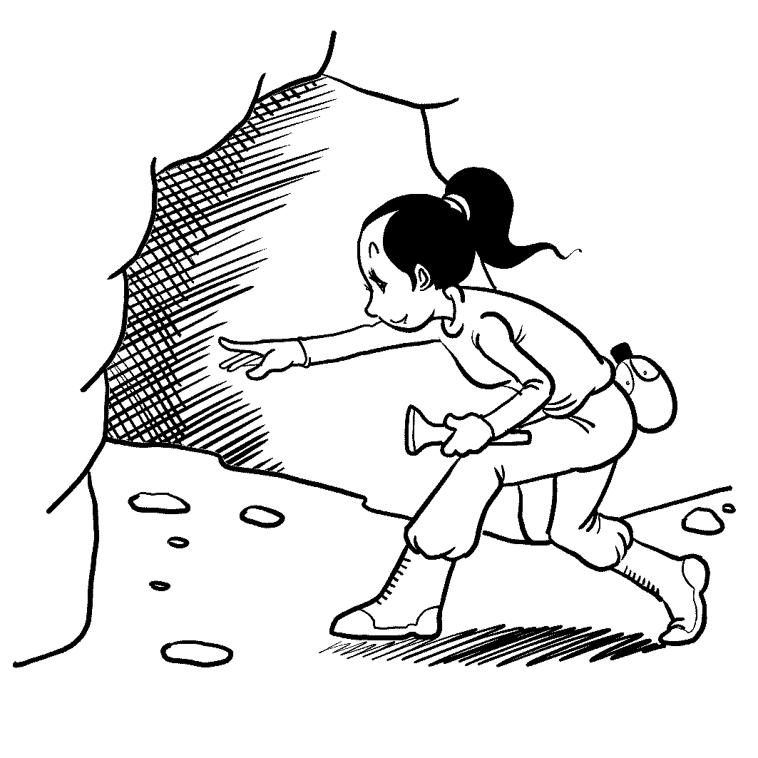
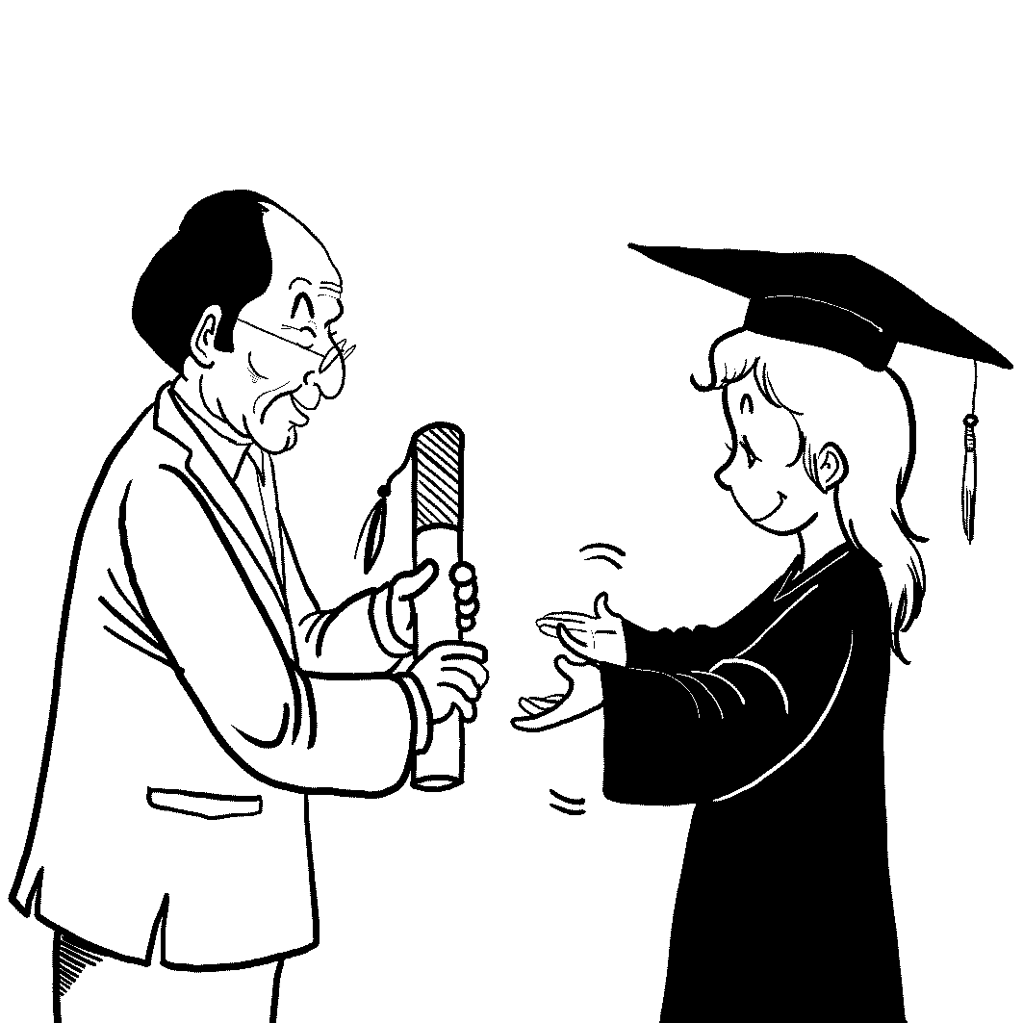

Part 2. Best Response Questions
Listen to the statement or question and choose the best response.
3. (A) I guess he still hasn’t forgiven his brother for that fight that they had.
(B) He must be thankful that his brother takes care of him after school.
(C) It’s normal for young boys to want to be just like their big brothers.
(D) I’ve noticed that he’s always bugging his brother with silly questions.
4. (A) It seems that people who work there all want to be the best.
(B) You bet. It’s so much fun that it doesn’t seem like real work.
(C) I agree. Working there isn’t stable and probably not the best choice.
(D) If you work there, you can take days off whenever you want.
5. (A) I’m afraid that I forgot my driver’s license at home this morning.
(B) OK. Why don’t we find someone who can take our picture together?
(C) Sure, but I need to borrow a pen from you in order to sign my name.
(D) If it’s alright, I would rather not sing for anyone at this moment.
6. (A) Yes, it’s usually inappropriate for teachers and students to be friends.
(B) It’s written clearly in the rules that teachers shouldn’t hit students.
(C) Teachers can really hurt students by saying rude things about them. (D) Isn’t it the teachers’ job to attempt to teach their students?
Part 3. Conversation Questions
Listen to each conversation and answer the question.
7. (A) He is shopping at the China town to prepare for his trip.
(B) He has already left for his business trip.
(C) He just got back home from his trip to China.
- He had to cancel his travel plans due to an important meeting.
8. (A) He fell and hurt his leg or foot.
(B) He may have broken his arm.
- He must have hit his head.
- He hurt his back somehow.
Part 4. Short Talk Questions
Listen to the following paragraph and answer the questions.
9. (A) The ticket he purchased for today’s flight.
(B) A photograph of him and his family.
(C) One of his major credit cards.
(D) Some identification with his picture.
10. (A) It is too heavy, so Michael has to pay extra for it.
(B) It is locked and Michael can’t remember how to open it.
(C) It is too heavy, so Michael is not allowed to check it through.
(D) It is too large, so Michael has to pay $100 for it.
II Vocabulary: (All+ & 指考字彙 ) 19%
11. The swine flu has proven itself a global illness—a strange new ____ which hopscotches from the dirt roads of Mexican village to the concrete canyons of big-city America to a glittering Hong Kong hotel. No one knows precisely where it will pop up next.
A. virus B. vacancy C. stack D. ethic
12. He spent his boyhood on his father’s crocodile farm. And perhaps this is why he seemed to have absolutely no fear of snakes, alligators, or any of the other ____ that so many people fear.
A. visas B. glaciers C. menaces D. reefs
13. The image of Buddha contemplating under the Bodhi Tree is said to symbolize the path to follow for spiritual _____.
A. enlightenment B. establishment C. component D. equipment
14. The Taiwanese are not novice tea drinkers and they understand the ____ delights of different tea leaves.
A. colloquial B. toxic C. synonymous D. subtle
15. Japan was ____ its missile defense system, and U.S. Navy ships were deploying to the Sea of Japan, as North Korea prepared to launch a rocket in April, 2009.
A. mobilizing B. lingering C. kidnapping D. enduring
16. The _____ of EasyCard involves such facilities as Taipei Rapid Transit System, Taipei buses, Public car parking, Taiwan Railway, and Maokong Gondola.
A. wrestle B. validity C. zeal D. starch
17. Some fruitarians have _____ ideals; they believe that “only fruit is nonviolent food.” They don’t wish to kill any living creature.
A. moldy B. manual C. lofty D. abrupt

18. From his skills to his _____ enthusiasm, almost everything about Jay Bruce recalls a young Ken Griffey Jr., who happens to be the idol—and now mentor—of the Reds’ rookie outfielder.
A. infectious B. indifferent C. tragic D. corrupt
19. Anyone reading the news can see the economic landscape looks bleak right now. In the future the price of anything that has a finite or _____ supply is going to keep going up.
A. escalating B. shoplifting C. accounting D. diminishing
20. Teenagers’ clothes are a declaration of ____ with the group they belong to, which is why they all look the same.
A. quiver B. solidarity C. dialect D. abundance
21. On April 12, tornadoes wrecked ____ in U.S: A tornado killed a woman and her nine-week-old infant and also injured at least 30 people on Friday in central Tennessee as a line of storms lifted homes, ripped off roofs and dumped hail in the southeast.
A. intent B. havoc C. barrier D. outrage
22. If you can get past your ____, you may find that the teenage slang is not all bad, but a descriptive form of expression.
A. lumps B. calories C. textures D. prejudices
23. The main _____ for the job is that the applicant must speak Spanish.
A. abstraction B. qualification C. notion D. variation
24. The nationwide English teachers ____ students’ poor scores in English when informed of the figures, which showed the number of examinees scoring zero reached a five-year high of 22,462, out of total of 141,858 test-takers.
A. converted B. lamented C. addicted D. transplanted
25. Locavores are against the wasted resources used in _____ freight for long distances; they only eat food produced within 100 miles of where they live.
A. hauling B. lounging C. dissuading D. intimidating
26. If the rice crops fail, it could mean _____ for millions of people.
A. synonym B. stew C. famine D. ounce
27. There is something truly unique. ____ your nostrils and breathe in the odor.
A .Flare B. Quench C. Sustain D. Slam
28. Without becoming misers, we can still ____ more money to the basics and cut back on optional goods.
A. lessen B. persist C. allocate D. dazzle
29. Animal ____ say, “ We’re really hoping to change people’s perception of where they need to go to get a dog—especially if they want a purebred—and go to a shelter and rescue a dog that doesn’t have a home.”
A. advocates B. surplus C. specimens D. parlors
III. ALL+: Blank-filling 請從選項中選出符合文意的答案(*不考慮大小寫 *選項可重複使用 或不使用) 13%
(A) from (B) off (C) big ( D ) as long as (E) at
(F) on ( G ) that ( H ) had ( I ) since ( J ) not
30. Despite its infinite possibilities, buckypaper is presently being produced in small amounts and ____ a fraction of its potential strength.
31. Sometimes you can get ____ the beaten track and visit spots the average tour bus would never go near.
32. The massive complex is made entirely of bamboo, and its founders, John and Cynthia Hardy, hope it’ll be ____ the very cutting edge of environmental education.
33. If you believe the ghost stories, just remember to leave a nightlight ___ the next time you stay in a haunted hotel.
34. ____ trees produce electricity has been known for quite some time, but how they do it was a mystery.
35. In order to learn the queen’s secrets, d’Artagnan ____one of the queen’s maids, Constance, kidnapped.
36. Many hoteliers have embraced if ____ the spirits then at least the stories behind them.
37. The special material is 500 times stronger than steel, and on top of ___, it is 10 times lighter. Unlike regular paper, buckypaper is made from tube-shaped carbon molecules called nanotubes.
38. Buckypaper conducts electricity, perfect for shielding airplanes _____ lightning.
39. The men who started the company are thinking ___, and they believe the sky is the limit.
40. I’ll explain how to deal with this problem later, but for now, let’s ____ get ahead of ourselves.
41. Animals have played a part in war for ___ people have been fighting.
42 Bali’s Green School is designed to have the smallest carbon footprint possible, ____ composting toilets to no air-conditioning.
IV. Cloze Test: 23% (Textbook)
A.
Studies show that birth order influences our personalities and later development to a certain degree. ___43___ first-borns for example. When they are born, the first role models for them to learn from are their parents. So they tend to ___44_____ their parents’ values and see things ___45___ their parents’ likes and dislikes. ___46___ their sensitivity to their parents’ needs and expectations, they often demand more of themselves. Besides, as the oldest children, they often have to shoulder such responsibilities beyond their age ___47___ taking care of their younger siblings during the absence of their parents. All these seem to be pressures for the first-borns. But ____48__, their efforts may ___49___ them __49__ high achievers who can succeed in high-pressure jobs.
____50___ the first-borns, the other children in the family can enjoy more space and freedom because the attention, or the pressure, they get from their parents is comparatively less. ___51___, they often turn to the outside of the family for approval and acceptance. By finding their strength outside, they learn valuable social skills like listening or relating to others. The youngest children even develop manipulative skills ___52__ by being obedient __52__ by taking the advice from others. And they often don’t have to pay for what they have done, for their parents seem less rigid in disciplining them. Thus, the youngest usually grows up experiencing fewer family pressures from their parents___53__ allows them to be more creative and carefree persons. It is no surprising that the youngest frequently ____54___ artists, entertainers, or salespersons.
43. A. To Take B. Take C. Taking D. Taken
44. A. take on B. identify with C. put in D. disagree with
45. A. as well as B. depend on C. in terms of D. in addition to
46. A. Despite B. In case of C. But for D. Due to
47. A. like B. of C. and D. as
48. A. on the contrary B. by contrast C. as a result D. on the other hand
49. A. lead …to B. prepare…for C. turn…into D. put …in
50. A. In addition to B. In spite of C. Instead of D. In contrast with
51. A. Consequently B. After all C. Likewise D. Otherwise
52. A. either…or B. both…and C. neither…nor D. not only…but
53. A. who B. which C. ,who D. ,which
54. A. end up in B. succeed in C. turn out D. work into
B.
Hostility leads to more hostility and the converse is true as well. The longer one person ____55___ a bad relationship with another, ___56___ they are to find a way out. However, what if there are people who really can’t get along with one another? Those around them can be relay stations of goodwill to help ___57___ the gap that has distanced them, feeble ____58___ the flicker of goodwill.
But how can they ___59___ the downward spiral of hostility? One way might be by giving a “second-hand compliment”－ ___60___, to try to listen for any positive comments which one individual makes about another and ___61___ . This behavior will be very rewarding! The originator of goodwill will benefit from the gratitude of the one who receives. ___62___, the recipient’s need for praise can be met in an unexpected way. ___63___, when the recipient is praised behind his back, he will see it as something the speaker really means ___64___ as just politeness. But no one can get ___65__ than those “goodwill messengers,” who have released some tiny sparks of goodwill into the environment.
55. A. remains B. maintains C. contains D. obtains
56. A. the more possible B. the more impossible
C. the less likely D. the less unlikely
57. A. jumping B. closing C. bridge D. widen
58. A. as B. with C. like D. for
59. A. reserve B. reverse C. conserve D. converse
60. A. for example B. instead C. likewise D. that is
61. A. pass it on B. pass it away C. pass them along D. pass them by
62. A. For one thing B. For the reason C. As a rule D. On the other hand
63. A. Of course B. Otherwise C. After all D. As a result
64. A. as much B. as well C. in addition to D. instead of
65. A. the most satisfaction B. more satisfied
C. as satisfied D. more satisfactory
V. Reading Comprehension 3%
Royal Mail and China Post went for gold in an historic joint issue of a special set of stamps to mark the handover of the Olympic Flag from Beijing to London.
On 22 August the stamps started to be available at Post Offices across the UK, two days before the Games’ closing ceremony when the Olympic Flag would pass from Beijing to London. The special stamps marked the first event in the handover celebrations and everyone across the UK could participate.
Stamps with identical images were issued across China by China Post from 24 August 2008. This stamp issue was the first partnership of its kind between Royal Mail and China Post. The four 1st Class stamps featured landmarks of the two cities. The astonishing mesh of steel of the National Stadium in Beijing sits next to the London Eye which recently welcomed its 30 millionth visitor.
Representing the past tradition of each country, further stamps showed Beijing’s Corner Tower of the Forbidden City - home to China’s Emperors for five centuries - beside another former Royal residence, The Tower of London.
Each stamp on the Sheet- entitled ‘Olympic Games - Handover of the Olympic Flag from Beijing to London’- features the famous Olympic rings, representing the five continents of the world.
Julietta Edgar, Head of Special Stamps, Royal Mail said: "The moment when the Olympic Flag passes from one city to another is always a ceremony of great poignancy at the close of any Olympic Games.” "These stamps are made all the more special as they not only celebrate a wonderful Games in Beijing, but they whet our appetite for what is to come as the UK takes over the honor of hosting the Olympic Games."
66. For what were “these stamps” issued?
  - To mark the landmarks of the two cities, Beijing and London.
  - To mark the handover of the Olympic Flag from Beijing to London.
  - To devalue the first partnership of its kind between Royal Mail and China Post.
  - To honor the five continents of the world.
- How many stamps were made into a set for the issuing?
  - Four pieces. B. Six pieces.
- As much as required in U.K and in China.
- Not mentioned in the passage.
- According to the passage, which of the following statements is incorrect?
A. The mentioned stamps issued in London had different images from those issued in Beijing.
- The Beijing Olympic closing ceremony was held on 24 Aug.
- Two of the set stamps are characterized individually by the late rulers’ residence.
- It’s revealed that the stamps were made more special compared with a ceremony of great poignancy in the handover of the hosting the Olympic games .
VI. Vocabulary 17 %
- Taiwan occupies a s_______c position in the western Pacific Ocean.
- The two female stars appeared embarrassed because they dressed in the same-style gowns to the party by c______e.
- The saying “ Imitation is the sincerest form of f_____y” means that a person who imitates another is really expressing a kind of admiration.
- Everyone e_______rs heartaches as well as happiness in life.
- Academically, students in our school have to complete at least 160 c______ts to graduate.
- The diplomat’s p________ve remarks about Taiwan have raised a lot of criticism from the society.
- The laid-off workers protested with i_______n because their company had fired them without any warning.
- Over the years, the a______n of his parents has been supporting him through thicks and thins.
- The kid who has Enterovirus(腸病毒) should be s_______ed from other kids because it is a highly infectious disease.
- Books with a lot of i_______ns make the meaning of the story easier to understand.
- Johnson is held in high esteem. That's because he is genuinely m_______t about his achievements even if he is successful.
- It is often said that v_______e is its own reward. Those who do good deeds will benefit a lot from the conduct itself.
- The childless woman has lived in i_______n since her husband died three years ago.
- The most e_______t way to plan is to put your tasks in order of priority.
- After a fierce competition, the tennis player finally defeated his o_______t and won the championship.
- Wearing p_______e is no longer women's privilege; more and more men care about how they smell in public.
- The local residents o______ted to the building of the incinerator in their neighborhood because they thought it might cause harm to their health.

VII. Translation 15% 請根據畫線部份寫出正確的用語 (每格不只一字)
(1至11格每格一分 *每格全對始得分)

- 記者在報導新聞時不應該(supposed)偏袒
Journalists ______1_____ ____2_____ when they cover a news story.
- 我們一生應該做的是把我們的優點發揮到極致
All we have to do during our lifetime is carry_____3_______.
- 在國民政府接管之前 台灣是日本的殖民地
Taiwan was ______4_______ before _______5_______ by the KMT government.

- 說到 使用手機, 瑞典普及率最高，截至2007年，手機用戶比人口還多
When _____6______ ____7_____, Sweden was ranked first and had more cellular accounts than inhabitants by 2007.
5. 我真希望我能說英文 說得有Tina一半好！
How I wish ______8_______ ______9_______ Tina!

- 阿基米德突然想到:藉由溢出的水,他也許可以知道皇冠的體積
______10_______ Archimedes that he might be able to know the volume of the crown ______11______ the amount of the spilt water.

- 你為自己設的標準越高,你承擔的壓力越大 (4%)
____________________________12____________________________________

台北市立松山高中九十七學年度第二學期第二次段考高二英文答案卷
VI. Vocabulary 17 %
1 strategic | 2 coincidence | 3 flattery | 4 encounters
5 credits | 6 provocative | 7 indignation | 8 affection
9 separated | 10 illustrations | 11 modest | 12 virtue
13 isolation | 14 efficient | 15 opponent | 16 perfume
17 objected
VII. Translation 15% 請根據畫線部份寫出正確的用語 (每格不只一字)
(1至11格每格一分 *每格全對始得分)
1 are not supposed to | 2 take sides
3 our merits/strengths to an extreme | 4 colonized by Japan/the colony of Japan
5 (being) taken over | 6 it comes to
7 using cell phones | 8 I could speak English
9 half as fluently/well as | 10 It occurred to/struck/hit
11 by means of
12(4%) The higher standard/ you set for yourself,/ the heavier/higher/stronger/greater pressure/ you will feel/bear/come under/ be under
1—10 DABAC/ CBCDA 11—20 ACADA/ BCADB 21—30 BDBBA/ CACAE
31—40 BFFGH/ JGACJ 41—50 DABBC / DDDCD 51—60 ACDCB/ CCABD
61—68 CDCDB/ BAA
Class______________ No.________ Name_______________ Score____________________

