台北市立松山高中九十七學年度第二學期高二英文科期末考試卷
I. Listening Comprehension 10%
A. Picture Questions
Look at each picture and answer the question.

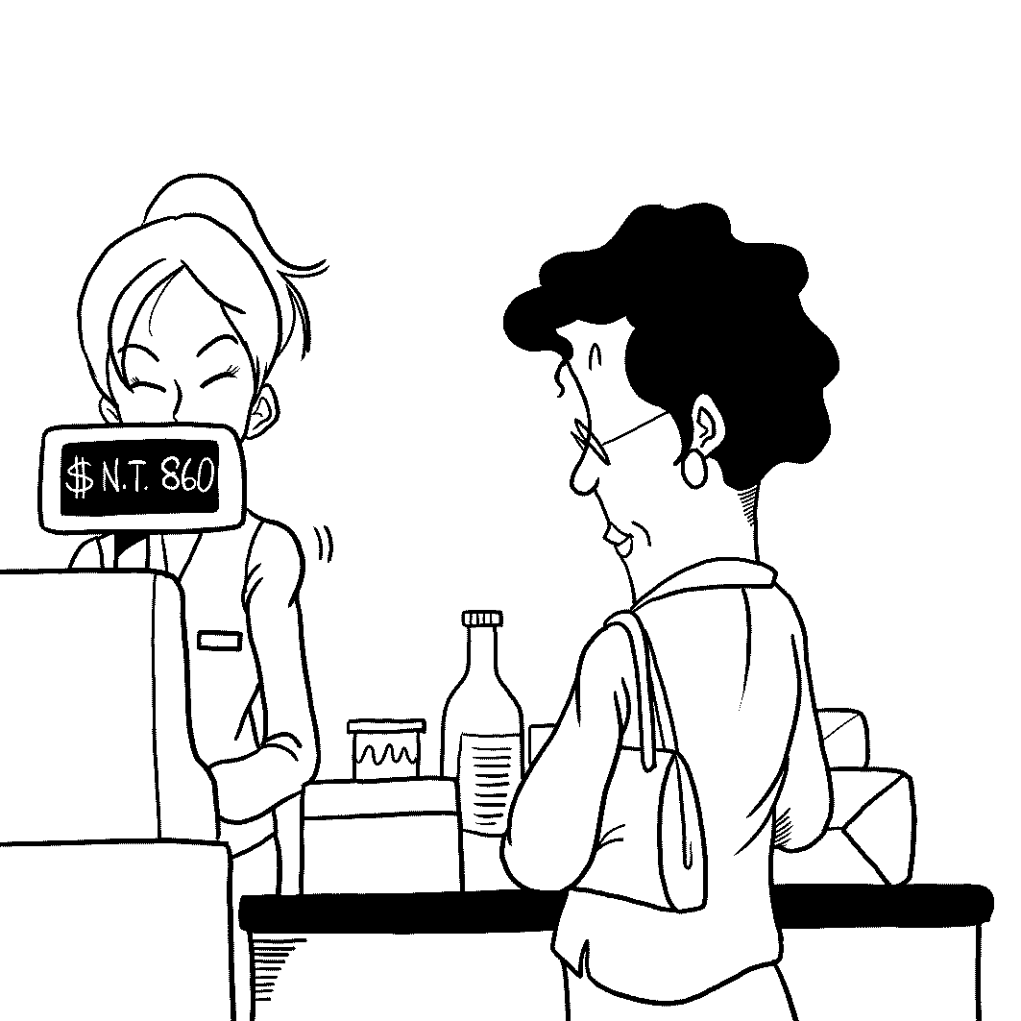
1. 2.
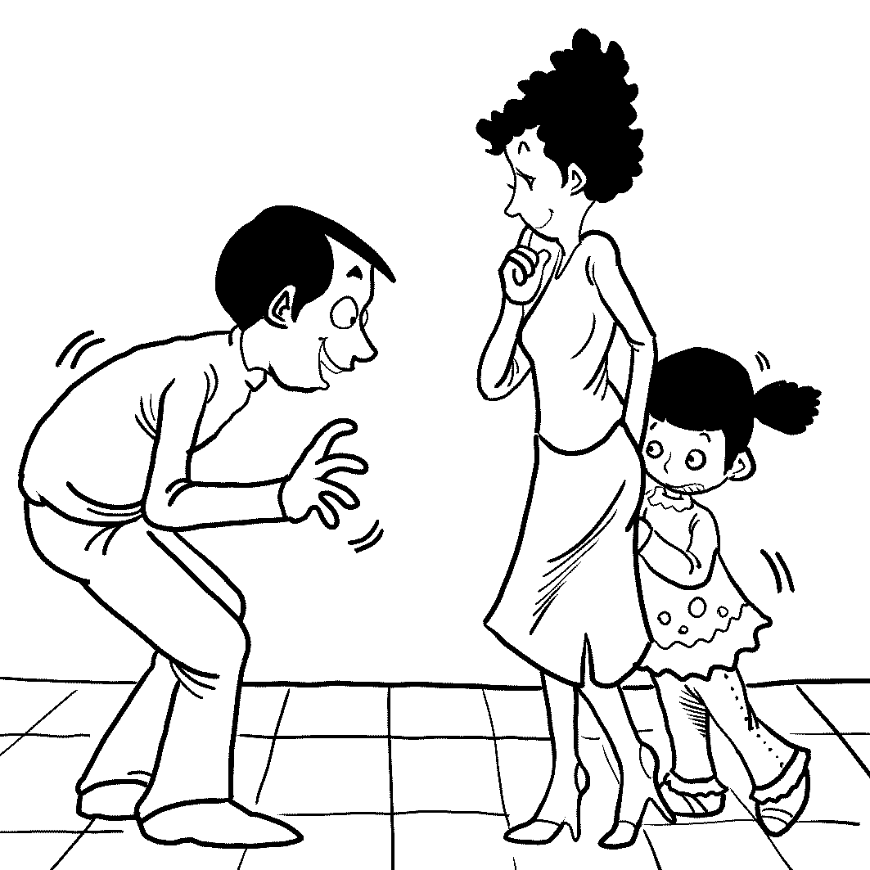

B. Best Response Questions
Listen to the question or statement and choose the best response.

3. (A) I saw her earlier. She's really beautiful and attractive.
(B) You're right. I've never seen anyone that tall before.
(C) What do you mean? I don't think she's all that smart.
(D) Well, she has a good job, so of course she's rich.

4. (A) I think our coach is going to be upset that we played so badly.
- Yeah, the other team was beaten badly and never had a chance!
- True. It was very exciting since we played in such a close game.
- Don't be upset. What is important is that we tried our best.

5. (A) You're so lucky she gets straight to the point.
(B) My mother also ignores my test results.
(C) She must have had something better to do.
(D) How long did she continue talking for?

6. (A) Who do you think would want to buy it, though?
- I doubt it. I think you are not allowed to set things on fire.
- Are you sure you could just leave it like that on the street?
(D) Thanks a lot! That's very generous of you.

C. Conversation Questions
Listen to each conversation and answer the question.
7. (A) The famous restaurants where she can try English food.
- The old buildings where she can learn about England's history.
- The many universities that England is well-known for.
(D) The downtown areas with all the different shops.

8. (A) She wants him to give her another idea.
(B) She feels he isn't making sense.
(C) She doesn't agree with him at all.
(D) She thinks his idea is a good one.

D. Short Talk Questions
Listen to the following paragraph and answer the questions.

9. (A) They spent a lot of time with the Time Traveler.
(B) They would work hard all day long.
(C) They ignored the Time Traveler, but still gave him food.
(D) They looked just like the Time Traveler's friends.

10. (A) He took other people to visit the future.
- He warned people about how the future might turn out.
- He broke the time machine so no one else could use it.
- He started thinking of other machines he could invent.

II. Vocabulary & Phrases (All+ & 指考單字) 13%

11. In 1999, soccer audiences booed and hissed when David Beckham came on the field and he was ____ in the media.
(A) worshiped (B) jeered (C) rendered (D) brewed
12. Dylan became a symbol for young people, who were revolting against traditional society, and because of this, he was ____ by the authorities.
(A) denounced (B) slumped (C) unlocked (D) fragmented
13. Many think the iPhone is a/an _____ device that will change the way people use their cell phones.
(A) absurd (B) federal (C) eloquent (D) ingenious
14. The development of the Internet ____ a new era in education, entertainment and communication.
(A) heralded (B) revolted (C) imprisoned (D) decayed
15. Like a living creature, civilizations are born, grow up, lose our vitality, decay, and eventually, they die. This process is ____ for all civilizations.
(A) inevitable (B) mischievous (C) controversial (D) victorious
16. People naturally tend to socialize with people they are ____ with and exclude people and ideas they disagree with.
(A) downward (B) legendary (C) compatible (D)accessible
17. That men are more ambitious and quarrelsome than women is a gender ____ .
(A) conquest (B) heritage (C) mythology (D) stereotype
18. In Taiwan, many religious groups have ____ activities that help people in need.
(A) masculine (B) charitable (C) primitive (D) genetic
19. Allen and Kim are at the supermarket to buy ____ to make a special pizza dinner.
(A) ingredients (B) capitalism (C) hospitality (D)diameters
20. In the 11th century, an Arabian doctor figured out how to extract ____ oils from plants, enabling people to make better perfumes.
(A) militant (B) biological (C) essential (D) operational
21. Micropolix, a ____ city, is teaching kids that money doesn’t grow on trees. There kids learn how the society works and the real value of money through games.
(A) miniature (B) lunar (C) relative (D) volcanic
22. Few people had the chance to surround themselves with ____ smells like Queen Elizabeth I, who had servants go ahead of her to spread beautiful scents.
(A) critical (B) heroic (C) splendid (D) tedious
23. When I forgot my password, I was unable to ____ my computer at work.
(A) shrink from (B) log on to (C) act out (D) leave an impression on

III. Cloze Test (All+ &指考單字) 22%
A. Hawaii is a miracle of a place, a chain of islands that __24__ one of the 50 American states. Pearl Harbor __25__ outside of the city of Honolulu and is Hawaii’s biggest harbor as well as a naval base, where American battleships came under a surprise attack by Japanese Forces on December 7, 1941. On that fateful day, many battleships were __26___, including the __26__ Arizona, the ship on which more than 1,100 seamen were killed. In the official memorial, the large marble wall with the names of those victims engraved on it is impressive, which makes people feel that they go on a __27__ to a sacred shrine.
24. (A) makes up (B) makes up for (C) is made of (D) is made from
25. (A) situates (B) lies (C) locates (D) lays
26. (A) sunken, sunk (B) sunk, sunken (C) sunk, sunk (D) sunken, sunken
27. (A) shipwreck (B) phenomenon (C) submarine (D) pilgrimage

B. What is the draw of toys? __28__, toys allow children to learn how the world works. Some toys help them learn basic coordination. Toys can even help children deal with painful situations. Doctors and nurses use toys to help child patients __29__. Toys do not have to be intricate to be fun because a child’s imagination can __30___. When it comes to __31__ fun with toys, children know that it’s all in the mind.

28. (A) Above all (B) On the other hand (C) Contrary to popular belief (D) For one thing
29. (A) hand (B) cope (C) misplace (D) reap
30. (A) go a long way (B) take up the habit (C) raise to a new level (D) get along
31. (A) have (B) had (C) have had (D) having

C. Sleepwalking is a disorder __32__ by actions that can be strange or dangerous. A sleepwalker is in non-dream stage of sleep, and will wake up with no memory. __33__, people have been acquitted of crimes after sleepwalking was used as a defense. The first example of this in America occurred in 1846, when a man was found __34__ of murder and arson because of sleepwalking at the time.
32. (A) characterizing (B) characterized (C) featuring (D) featured
33. (A) Surprisingly (B) Surprising (C) Basic (D) Basically
34. (A) guilty (B) guilt (C) not guilty (D) no guilt

D. Today, great perfumes are available at reasonable prices, and __35__ that we can thank perfumers, who create perfumes. Perfumers often compare the way __36__ a perfume releases its scents to a musical symphony with the top, middle and base notes. Each perfume is carefully __37__ and there are hundreds of different kinds. __38__ which perfume is best for you, go to a perfume store and smell what’s available. There is no right answer. Just remember that the way __39__ is part of how you present yourself to the world.
35. (A) so (B) x (C) in (D) for
36. (A) which (B) with (C) to (D) that
37. (A) crafted (B) beloved (C) celebrated (D) crushed
38. (A) To discover (B) Discovering (C) Discovered (D) Discover
39. (A) your smell (B) you smell (C) people smell (D) others’ smell

E. By the twelfth century, chess became widely known all over Central Europe __40__ a game of wits for scholar and military strategists. __41__ chess is a game that challenges the mind, it can help people learn. The chessboard can be used by teachers to __42__ lines, angles, and coordinates. The chess pieces, __43__, can give a history lesson. The king, queen, knight, bishop, rook, and pawn are examples of __44__ society. Next time you’re looking for something to do, find a friend and challenge him or her __45__ a game of chess. It’s still a great way to have fun while strengthening your mind in the process.
40. (A) for (B) as (C) of (D) with
41. (A) Besides (B) Unless (C) Since (D) Until
42. (A) demonstrate (B) dominate (C) reevaluate (D) relieve
43. (A) on the other hand (B) out of the ordinary (C) on the contrary (D) in the first place
44. (A) mellow (B) medieval (C) middle (D) modern-day
45. (A) for (B) on (C) with (D) to

IV. Vocabulary & expressions: 15%
46. You should ____ your attitude to school if you aspire to a prestigious college.
(A) adapt (B) adopt (C) adjust (D) enhance
47. Sam was nervous in the tennis match, but his ____ seemed very relaxed.
(A) opponent (B) participant (C) psychologist (D) professor
48. Tracy was so intelligent that she ____ her brother in school.
(A) outraged (B) outperformed (C) outnumbered (D) outgrew
49. The ____ of boys to girls is increasing so abnormally that there will be
an imbalance of population in the future.
(A) population (B) proportion (C) flexibility (D) complexity
50. The pope went back to the monastery on his annual ____.
(A) retirement (B) recreation (C) retreat (D) preparation
51. His friends and relatives ___ his wealth after they knew he had won the lottery.
(A) evoke (B) provoke (C) converse (D) covet
52. His behavior is ____ to his principles. I no longer trust him.
(A) contradictory (B) abstract (C) majestic (D) continuous
53. The ____ is someone who tells us what is happening in a book or film.
(A) professor (B) subject (C) detective (D) narrator
54. The teacher’s praise gave Jenny a great sense of ____.
(A) flattery (B) politeness (C) bias (D) satisfaction
55. Adam always has ____ excuses when his boss asks why he is late.
(A) romantic (B) advanced (C) numerous (D) superstitious
56. The educational reform ____ strong opposition.
(A) has an effect on (B) looks around (C) is faced with (D) dwells on
57. The party really ____ when everyone started to dance.
(A) came alive (B) came out (C) brought out (D) carried out
58. Not only ____ the sound of the poem, but we were moved by its meaning.
(A) we were impressed by(B) we enjoyed (C) did we enjoy (D) were we impressing
59. The referee tries to be fair; he hardly ____ in the game.
(A) jumps the gap (B) takes up (C) shuts up (D) takes sides
60. When I saw the cake, ____ that it was my girlfriend’s birthday.
(A) it happened to me (B) it occurred me (C) it came to me (D) it crossed my mind

V. Cloze Test: 20%

We often wonder why men and women think and feel so differently. According to scientists and researchers, men and women are different from each other because small differences in their brains __61__ them __61__ handle various data in different ways. Young girls usually learn to __62__ their first words and can make full sentences earlier than boys. Certain studies have further revealed that women speak in longer, more complicated sentences than men. __63__, men do better than women in tests that involve spatial ability. Unlike women, they __64__ to be good at dealing with abstract concepts of space. On the whole, the similarities __65__ the two sexes are more numerous than the differences.

61.(A) result; from (B) give; to (C) turn; on (D) lead; to
62.(A) say (B) tell (C) talk (D) open
63.(A) However (B) Therefore (C) Meanwhile (D) Otherwise
64.(A) attend (B) are likely (C) prefer (D) have
65.(A) in (B) between (C) among (D) with

Research __66__ that athletes who win bronze medals are happier than silver medalists. It is because silver medalists think that if they __67__ slightly better, they might have won a gold medal. __68__, if they’d performed slightly worse, they wouldn’t have won anything. Psychologists call this kind of behavior counter-factual thinking. To put it differently, lucky people can __69__ the impact of misfortune. They imagine what might have happened __70__ what actually happened.

66.(A) illustrates (B) originates (C) suggests (D) prescribes
67.(A) can perform (B) had performed (C) will perform (D) are performing
68.(A) On average (B) Without a doubt (C) In contrast (D) On the contrary
69.(A) inform (B) clear (C) deprive (D) ease
70.(A) as a result of (B) with regard to (C) native to (D) rather than

We can be “relay stations” of goodwill to help people who hate each other. We may achieve this goal __71__ giving a “secondhand compliment.” Try to listen for pleasant comments which one individual makes about another and __72__. This conduct will be very beneficial! On one hand, all people need to receive praise, so the recipient’s need for praise can be __73__ unexpectedly. On the other hand, the recipient is praised behind his back so he will see it __74__ something the speaker really means rather than as just politeness or even flattery. Knowing that some tiny sparks of goodwill __75__into the environment, those “goodwill messengers” will also become happy and have a sense of accomplishment.

71.(A) with (B) at (C) by (D) upon
72.(A) pass them out (B) pass them along (C) pass them over (D) pass them away
73.(A) paid (B) made (C) met (D) required
74.(A) as (B) like (C) such as (D) as to
75.(A) have released (B) are releasing (C) have been released(D) has been released

The Great Wall __76__ one of the very few man-made structures on the planet that can be seen from outer space because of its massive scale. In fact, this magnificent structure is __77__ of many short walls and thousands of towers. People used mostly with stone, but in some areas only dirt was used.
The Great Wall, __78__ at Shanhaiguan near the Yellow River and ending at Chiayuguan in the Gobi Desert, is about 2,400 kilometers long. The first walls were originally built back in the 3rd century B.C. __79__ keeping out invaders. Then, in the 15th century, new walls were built by the Ming emperors to keep out the Mongols. Today, tens of thousands of visitors __80__ to this unique site every day marvel at the construction skills of people who lived many centuries ago.
76.(A) is said that (B) is said to be (C) said that (D) said
77.(A) consisted (B) persisted (C) thought (D) made up
78.(A) to begin (B) begin (C) began (D) beginning
79.(A) by (B) through (C) in order to (D) with a view to
80.(A) drawn (B) captured (C) appealing (D) attracting

VI. 文意選填: 10%
(A) by (B) influential (C) benefit (D) playing
(E) without (AB) asked (AC) instance (AD) paying
(AE) lies (BC) reversed (BD) hostility (BE) instead
From my viewpoint, the power of positive thinking is much more __81__. Take our relationship with others for __82__. Everyone enjoys being admired or praised. If we have a negative attitude toward people and gossip behind their backs, __83__ will arise. Eventually, it will bounce back to ourselves. By contrast, if we think of others’ merits __84__ of shortcomings, we can make friends easily. Hence, we should practice __85__ a compliment to others directly __86__ hesitation. Also, we should be willing to offer necessary help when __87__. In the end, we are the ones who __88__ most. The gratitude will be __89__ back to us and thus help us win friendship and respect as well. In brief, the key to a successful relationship __90__ in the power of positive thinking.

VII. 選出錯誤的句子: 4%
91. (A) He conducted experiments examining whether thought can enhance good fortune.
- The stone building, linking by 3,000 steps, spread out over 18 square kilometers.
- Machu Picchu is the only famous ancient monument located in South America.
(D) The city’s mountainside location was likely chosen for its beauty.

92. (A) She said you are a good cook.
- Before my noted arrived, he had given up painting.
- His wife was the kindest woman he had ever known.
- I asked them to tell me how many photos were inside.
VIII. Reading Comprehension: 6%

The Consumers’ Foundation has released some warning facts and figures on the popular Taiwanese refreshment, pearl milk tea. Armed with the findings of a Taipei Medical University Hospital study conducted in 2006, the organization claims that drinking excessive amounts of pearl milk tea may cause adverse health effects and urges people to consider the risk involved in drinking too much of the popular treat.
The study cited by the Consumers’ Foundation found that a single 700ml cup of pearl milk tea contains 400 calories—the equivalent of about 300 grams of rice. The Consumers’ Foundation then made a survey of almost 7,000 people and found that roughly one out of six respondents claimed to drink one cup of pearl milk tea per day. In the same survey almost 3% of those questioned admitted to consuming three cups a day. At 400 calories per serving, that is a staggering 1,200 calories—over half of the recommended daily caloric intake for an adult. Drinking three cups of pearl milk tea in a day is the equivalent of eating almost one kilogram of rice but without the nutritional value since the majority of the calories in pearl milk tea comes from simple sugars. What’s more, the Consumers’ Foundation claims that if the yearly amount of sugar consumed island-wide were calculated in the form of standard sugar cubes piled on one another, they would equal the height of 545,000 Taipei 101 buildings.
Experts are concerned that consuming excessive sugary drinks can lead to obesity and tooth decay and increase the risk of suffering from chronic diseases, such as diabetes. Therefore, the authorities are advising people to think twice before reaching for a cup of pearl milk tea. They strongly suggest that thirsty people choose water for the sake of their health.

93. What does “adverse” mean in paragraph one?
(A) advanced (B) damaging (C) different (D) real

94. What is TRUE concerning the survey by the Consumers’ Foundation?
(A) Drinking three cups is like eating half a kilo of rice.
(B) Around 210 respondents drink three cups of pearl milk tea per day.
(C) More than two thousand respondents drink one pearl milk tea daily.
(D) The recommended daily caloric intake for an adult is 1,200 calories.

95. According to the article, which of the following is FALSE?
(A) The best drink for thirsty people is plain water.
(B) Drinking too much pearl milk tea can cause obesity.
(C) Eating too much rice doesn’t have nutritional value.
(D) Containing too much sugar is the problem with pearl milk tea.

台北市立松山高中九十七學年度第二學期高二英文科期末考答案

1- 5 D C A B D 6-10 C B D C B
11-15 B A D A A 16-20 C D B A C
21-25 A C B A B 26-30 B D D B A
31-35 D B A C D 36-40 D A A B B
41-45 C A A B D 46-50 C A B B C
51-55 D A D D C 56-60 C A C D D
61-65 D A A B B 66-70 C B C D D
71-75 C B C A C 76-80 B D D D A
81 B 86 E
82 AC 87 AB
83 BD 88 C
84 BE 89 BC
85 AD 90 AE

91-95 B A B B C

