台北市立松山高中九十八學年度第二學期高一英文科第一次期中考
第一部分：選擇題
聽力測驗
Part A
Look at the pictures below. For each, you will hear one or two questions and four possible answers, A to D. Write down the letter for the best answer (A, B, C, or D).

Questions 1-2 Questions 3-4
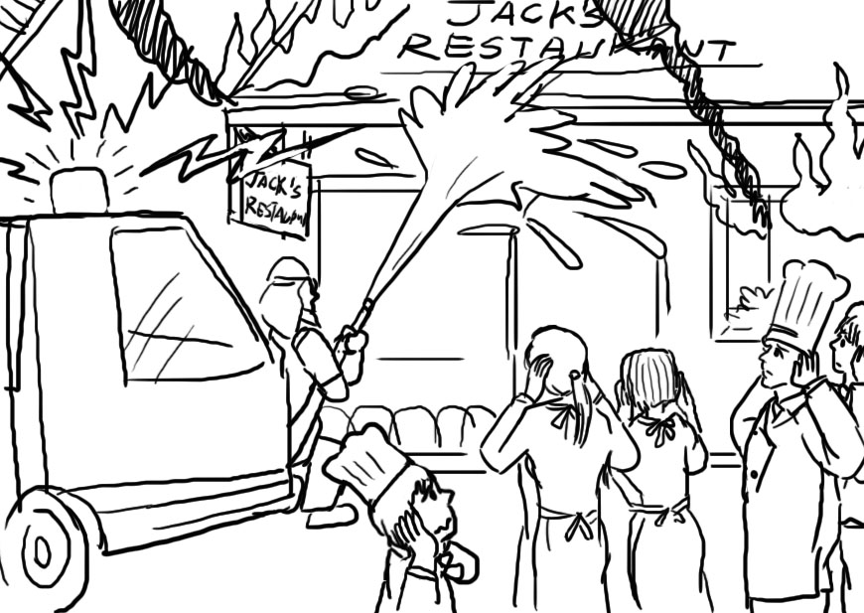
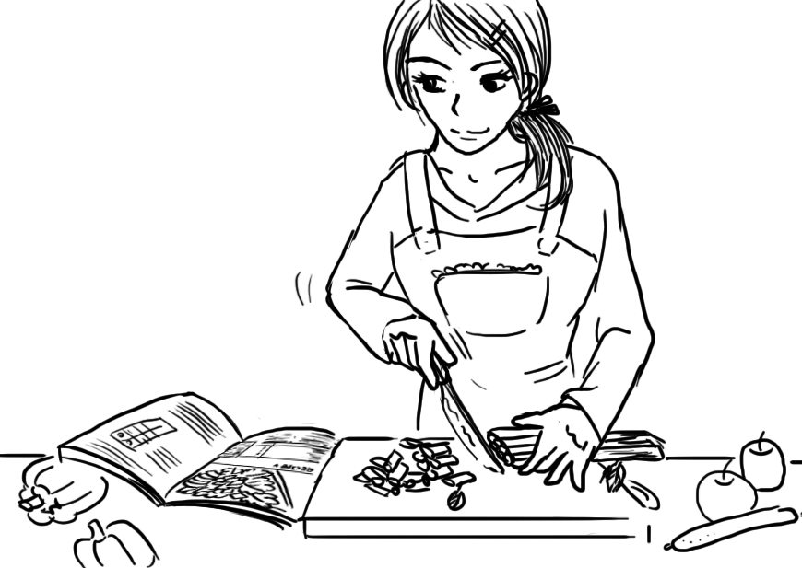

Part B
In part B, you will hear one or more questions or statements. Choose the best response or reply.
5. (A) Yes, we studied it in science class.
(B) Yes, I can play two musical instruments.
(C) No, I don’t know where it’s from.
(D) No, I don’t know my family history.
6. (A) She seems to be very strict.
(B) We have had two tests already!
(C) I think she will arrive next week.
(D) She is called Miss Jennings.
7. (A) She is just stressed about work.
(B) She has been studying for exams.
(C) She heard some good news this morning.
(D) She learned her father is very sick.
8. (A) Yes, he is one of my good friends.
(B) Yes, I’ll go and see him tomorrow.
(C) Yes, it is cat hair making me sneeze.
(D) Yes, he is angry about something.
Part C
In part C, you will hear one or more short conversations between a man and a woman, and then a question following each conversation. Choose the best answer to that question.
9. (A) That she needs some money.
(B) That he comes to help.
(C) That she needs his advice.
(D) That he could do the same.

10. (A) It would be a mistake.
(B) He hopes that will happen.
(C) Things aren’t that simple.
(D) There is something he can do.
11. (A) Help Julie feel a bit better.
(B) Try and avoid seeing Julie.
(C) Tell Julie to forget about it.
(D) Leave Julie alone.
12. (A) He can’t understand Bob.
(B) He thinks Bob is too smart.
(C) He complains that Bob shows off.
(D) He doesn’t find Bob’s jokes funny.

(4U) Cloze 18 %
(一) Though we may not notice it at first, perfume can have a big effect on us. For example, if a girl walks by wearing perfume, you are more likely to notice her than a girl that isn’t wearing any. Women often wear perfume with a fruity or floral scent. This is because these scents make a woman feel confident, __13__ others will think she smells sweet. Men, however, prefer to wear woody scents that remind others of a tree. These scents make women think of someone they can __14__.
Some people don’t like to follow the trends though. These people can try out some more__15__ scents to set them apart. Those who like being close with nature can wear dirt or even thunderstorm perfume. For something a bit more relaxing, people can try out the laundromat or bamboo scents. But, if you’d rather __16__ off your wild side, then gin and tonic or martini perfume will make sure the party goes where you do.
13. (A) which (B) that (C) where (D) while
14. (A) rely on (B) look up (C) fade away (D) focus on
15. (A) random (B) harsh (C) unusual (D) common
16. (A) to show (B) showing (C) showed (D) show

(二) A few centuries ago, Port Royal was one of the richest towns in the English colonies. But that didn’t mean it was a nice place to do business. Actually, Port Royal was home to many pirates who would rob ships traveling through the area. __17__, it was a center for buying and selling slaves. The people that lived there spent most of their free time drinking and gambling __18__ doing honest work. Taverns were __19__popular there that it is estimated there was one for every ten residents of the town. Port Royal even became known as the “Wickedest City on Earth.”
That all changed in 1692 when a massive earthquake hit. The earthquake caused a huge wave __20__ over the town and wash it into the sea. Around 2,000 people died and the town was completely destroyed. Some people believed that God caused the disaster as a punishment for the terrible things that people did there. There were __21__ to rebuild the town afterwards, but they were unsuccessful. Now, Port Royal is just a small fishing village.
17. (A) In addition (B) After all (C) Above all (D) In contrast
18. (A) in spite of (B) other than (C) thanks to (D) instead of
19. (A) very (B) too (C) so (D) much
20. (A) sweeps (B) to sweep (C) swept (D) sweeping
21. (A) attempts (B) concepts (C) spirits (D) districts

(三) Buddy Valastro is the Cake Boss. __22__ in his cake shop, Carlo’s Bakery, in New Jersey, Buddy makes unique and amazing cakes. Carlo’s Bakery has been open for nearly a hundred years, and it has been in the Valastro family the whole time. Buddy __23__ the business as Cake Boss when his father died several years ago, and he now works alongside his mother and two sisters. But, before his father passed away, Buddy made a promise__24__ he would make Carlo’s Bakery the most well-known bakery in America.
Making fantastic cakes is not an easy job. His customers come in with all sorts of strange requests. __25__ ,a group of firemen asked him to make a cake in the shape of a fire truck. Buddy wanted his cake to be memorable, so he went one step further. He included sirens and flashing lights on the cake, and also added a model of a burning building __26__ smoke coming out of the top!
22. (A) To work (B) When works (C) Working (D) Worked
23. (A) set off (B) came across (C) looked after (D) took over
24. (A) since (B) if (C) which (D) that
25. (A) For example (B) As usual (C) In fact (D) Without doubt
26. (A) by (B) with (C) of (D) for

(四) Susan is a beautiful woman with a loving and caring husband, Mark. Unfortunately, she had a tragic accident when she was 34 and became blind. Suddenly, she felt like all the joy had gone out of her life. Mark didn’t want to see her to be upset, so he did his best to __27__ her __27__. Every day, he stayed with her and helped her to __28__ living without sight. Eventually, she felt like she could manage to start working again.
Mark knew that if Susan was to make it, she would have to be able to get around __29__ her own. So, he taught her to take the bus. He walked her to the bus stop each day and then sat on the bus with her so that she would learn where to get on and off the bus. __30__ , she was able to take the bus alone.
27. (A) get – through (B) take – off (C) cheer – up (D) set – apart
28. (A) continue to (B) take on (C) stand out (D) adapt to
29. (A) with (B) in (C) at (D) on
30. (A) After a while (B) By the time (C) From time to time (D) Once in a while
(Focus On征服字彙) Vocabulary 15 %
31. What matters is not whether you have magic power, but whether you know how to _____ it.
(A) hire (B) exercise (C) pack (D) burst
32. You really need to learn to _____ you temper. You shouldn’t always be so emotional.
(A) pitch (B) link (C) govern (D) nod
33. People who have a _____ attitude toward things are hardly successful and happy.
(A) rapid (B) comfortable (C) favorite (D) negative
34. It’s an energy program _____ reducing our dependence on petroleum.
(A) knocked at (B) aimed at (C) shocked by (D) packed with
35. He likes to make a _____ of his extraordinary performance. He likes to show off.
(A) display (B) sample (C) crime (D) plain
36. What the criminal has done _____ a big problem in our society.
(A) deserts (B) arrests (C) detects (D) poses
37. Don’t bother your father. He is _____ over a way to help Johnny.
(A) greeting (B) puzzling (C) earning (D) electing
38. International companies are _____ up these days, which helps Taiwan become more and more
globalized.
(A) sliding (B) lowering (C) springing (D) dragging
39. Can you give me a(n) ____ number of people attending the party? I have to prepare enough food for them.
(A) dull (B) exact (C) rare (D) instant
40. As we dived deeply in the sea, the dangers _____.
(A) damaged (B) flooded (C) multiplied (D) combed
41. The poor little girl is _____ to colds. She often catches a cold.
(A) joint (B) naked (C) subject (D) royal
42. When I heard her poetic voice, it just _____ on me that she is my high school teacher.
(A) dawned (B) brushed (C) debated (D) begged
43. After continual questioning, the minister finally _____ that he is going to be the candidate.
(A) slipped (B) hid (C) confirmed (D) armed
44. There is a large _____ of Coke left in the bottle.
(A) quantity (B) pile (C) string (D) bundle
45. The farmers set a lot of _____ to catch birds which eat crops.
(A) mirrors (B) mosquitoes (C) traps (D) temples
(Textbook) Cloze: 20 %
Do you feel that you have a poor memory? If our brains were computers, we'd simply add a chip to upgrade our memory. __46__, the human brain is more complex than even the most advanced machine, so improving human memory __47__ slightly more effort.
Just like muscular strength, your ability to remember increases when you exercise your mind. Otherwise, depending on your memory to tackle challenges __48__ more difficult. Another way to exercise your brain is intensive and extensive reading. While reading, you are recognizing words and arranging them __49__ phrases, sentences and then ideas. Aside from that, understanding and being able to explain and teach others complex material __50__ important, too. Few things work as well as teaching.
Finally, positive mental feedback can set up an expectation of success. __51__ you are exercising your mind, dealing with challenges, __51__ explaining to your classmates, tell yourself that you want to learn what you need to remember, __52__ you can learn and remember it. A positive attitude helps improve your memory too.
46. (A) Instead (B) First (C) However (D) Besides
47. (A) makes (B) requires (C) solves (D) expresses
48. (A) becomes (B) become (C) to become (D) becoming
49. (A) on (B) with (C) into (D) for
50. (A) will be (B) to be (C) is (D) are
51. (A) Not only – but also (B) No matter – or (C) If – and (D) Whether – or
52. (A) even if (B) and that (C) but (D) and

To speakers of a language, certain words and expressions are chosen to create images in our minds. They make us see, hear, taste, touch and/or smell the world that it offers. __53__ way to do it is by using simile or metaphors. Animals seem to __54__ interesting features and therefore are used most often. For instance, if a person runs like a __55__, he gives people the impression of being good at running. When you call someone a chicken, you mean the person is a coward and doesn’t have courage to do something. If a teacher says, “The students are running to the playground like a __56__ of elephants, he or she probably means that they are making too much noise.
But if we compare two things and omit the word "like" or “as,” then we are using a(n) __57__. It goes a step further than the simile and __58__ asking us to picture one thing as being like another, we are asked to picture one thing as being another. So when you hear, “He was a lion in the fight,” it is not difficult to imagine what kind of person he is.
- (A) One (B) Another (C) The other (D) Still another
- (A) focus on (B) take on (C) give color to (D) move on to
- (A) crane (B) tortoise (C) lamb (D) cheetah
- (A) pack (B) herd (C) school (D) flock
- (A) vocabulary (B) expression (C) metaphor (D) simile
- (A) because of (B) except for (C) in addition to (D) instead of

When people are invited to a wedding, most of them will choose to dress themselves in red. Why not other colors? Living in a world of colors, we tend to __59___ the impact of colors on us for granted. Colorgenics, the study of how colors affect our lives, tells us how to be aware __60__ everything in our lives ___61___ to colors. On the one hand, there are many colors serving different functions in our lives. Pink, a color loved by many young girls, ___62__ make us calm and be very helpful in settling an argument. White can make things look lighter, contrasting with black. ___63___, colors may contain different meanings ___64___. Red envelopes are used in Taiwan and China, ____65____, while the Japanese use white ones in New Year. There are countless examples as long as you observe with your heart.
59. (A) make (B) taking (C) take (D) making
60. (A) of (B) that (C) X (D) to
61. (A) associating (B) related (C) connecting (D) link
62. (A) is said that (B) is said to (C) say that (D) say to
63. (A) As a result (B) Hence (C) On the other hand (D) In other words
64. (A) from a country to another country (B) from countries to countries
(C) from one country to one country (D) from country to country
65. (A) in addition (B) for instance (C) needless to say (D) believe it or not

篇章結構 5 %
The term “white elephants” comes from __66__ in Burma, Thailand, Laos and Cambodia. To possess a white elephant was considered __67__. It also means the kingdom was blessed with peace and prosperity. The tradition derives from __68__. The night before Buddha was born, his mother had a dream. In the dream __69__, a symbol of wisdom and purity.
Because the animals were considered sacred and laws protected them from labor, receiving a gift of a white elephant from a monarch was both a blessing and a curse: __70__, and a curse because the animal had to be retained and could not be put to much practical use.

(A) tales which associate a white elephant with the birth of Buddha
(B) the sacred white elephants kept by Southeast Asian monarchs
(C) a blessing because the animal was sacred and a sign of the monarch's favor
(D) a sign that the monarch governed the kingdom with justice and power
(E) a white elephant was presented to her with a lotus flower
閱讀測驗 5%
Alice’s Adventures in Wonderland is one of those distinctive tales that attracts both children
and adults. It was first published in 1865 and has always been popular until now. Both Oscar
Wilde, the playwright, and Queen Victoria were inclusive of the fans of the book. Released in
English alone firstly, the novel has been recognized as a global best-seller and then has been
Translated into 120 languages. This year, the eccentric famous director Tim Burton, who often
makes some different movie from other Hollywood directors, gives some extraordinary color to
Alice and her friends. His film keeps the spirit of the original story, but adds some flavor to make
it peculiar. Johnny Depp, the leading character of Pirates of the Carribean, stars as the Mad
Hatter, and Helena Bonham Carter plays the Red Queen, who could destroy Wonderland unless
Alice appears saving it. After several trials, an Australian actress Mia Wasikiwska won the role of
grown-up Alice in place of Lindsey Loham.
Actually, this isn’t the first time that Burton tries to make a film out of a classic story. He has
made many well-known movies like Batman, Sleepy Hollow, Sweeney Todd, and so on. He is
always considered a man of great talent and black humor. In order to present the imaginary
world perfectly and vividly to the audience, Tim combined live action and animation to create the
bizarre world of Wonderland. Whether you have seen this movie or not, it seems that this movie
has got all elements that would lead to success. If you really enjoy reading Alice in Wonderland or
are a big fan of Tim Burton, you’re undoubtedly encouraged to spend some time going to see this
movie.

71. According to the passage, which is not included in the factors that is likely to make this movie
successful?
(A) Great actors. (B) An extraordinary director.
(C) Outstanding setting. (D) The White Queen.
72. Which is NOT Tim Burton’s work?
(A) Alice in Wonderland. (B) Batman.
(C) Sweeney Todd. (D) Pirates of the Carribean.
73. What does the word “eccentric” in line 5 possibly mean?
(A) strange (B) normal (C) formal (D) accidental
74. Based on this passage, which sentence is true?
(A) Johnny Depp is regarded as a man of great talent.
(B) Alice in Wonderland is Tim Burton’s first movie out of a classic tale.
(C) Alice in Wonderland has only one version.
(D) Mia Wasikiwska made an effort to win the role of the adult Alice.
75. What is the best title for the reading?
(A) Enrich Your Life by Reading Books. (B) The Most Memorable Novel.
(C) What Makes Alice in Wonderland Worth Seeing. (D) The Relation Between Burton and Alice.
第二部分：非選擇題
文意字彙與詞類變化 15 %
- The future belongs to those who are d____t, not those who are lazy.
- There are many choices of valentine s day flowers, with red roses being perhaps the most popular because of their close a____n with love.
- The book was o____y published for children, but it later became extremely popular with the general public.
- Humor is best remedy that helps you stay better and keeps you healthy m____y as well as physically.
- John gave up the golden o____y to work in New York, but chose to stay in Taiwan developing his family-run business.
- The Internet provides access to a vast amount of i____n; it has almost everything you want to know.
- In Canada medical marihuana is legally prescribed by the doctors. It can help seriously ill medical patients relieve their s____g.
- Oftentimes the best part of a game is not winning, but what you learn in the p____s of playing it.
- I can see the r____e in her eyes. Tell her that if she doesn’t want to go out with us, she can just say no.
- This novel is very violent, so it’s not a_____e for children under the age of 12.
- Tourism has made the small town p______r. Now it’s always full of people.
- How parents behave has a great i______e on their children.
- The beauty of the Mt. Jade is beyond ____. (describe)
- My mother is very good at flower ____. (arrange)
- Friendliness is one of the major ____ of those people who live on this island. (character)
翻譯 (每格都不只一個字) 10 %
- 一提到(1)環境保護，世界上每一個人都應該減少(2)污染，養成少買，少需求的習慣(3)，而且盡可能地善用所取得的物資。
______________(1) environmental protection, all the citizens of the world should ______________(2) the amount of pollution, and ______________(3) buying less, needing less, and when they do get something they need, get it used if possible.
- 那些想成功的人，在面對挑戰(4)的時候絕對不能顯示出怯懦的樣子(5)。換句話說(6)，你越勇敢，就越可能成功(7)。
Those who want to succeed must ______________(5) when ______________(4) . ______________(6), the more courageous you are, ______________(7) you are to succeed.
- 根據中國文化傳統, 紅色代表(8)好運, 所以總統在春節期間發放(9)紅包給民眾。
According to the Chinese custom, red (8) good luck, so the president (9) red envelopes to people during the Chinese New Year.
4. 她的日記向我們證明(10)了她以前討厭這樣的一個生活。
Her diary (10) us that she used to hate such a life
台北市立松山高中九十八學年度第二學期高一英文科第一次期中考

答 案 卷

Class: No:_______ Name:_________________

Vocabulary and derivatives 文意字彙與詞類變化 15 %

1. | 2. | 3.
4. | 5. | 6.
7. | 8. | 9.
10. | 11. | 12.
13. | 14. | 15.

Translation 翻 譯 10% (一格不只一個字，全對才給分。)

(1). | (2).
(3). | (4).
(5). | (6).
(7). | (8).
(9). | (10).

