台北市立松山高中九十八學年度第二學期第一次段考高二英文試題
範圍：All+ (March) 4500字彙(p.p.292-359) 龍騰(四) L1~L4

Section One: All+
Listening (10%)

I. Picture Questions
Look at each picture and answer the question.

1. 2. 3.

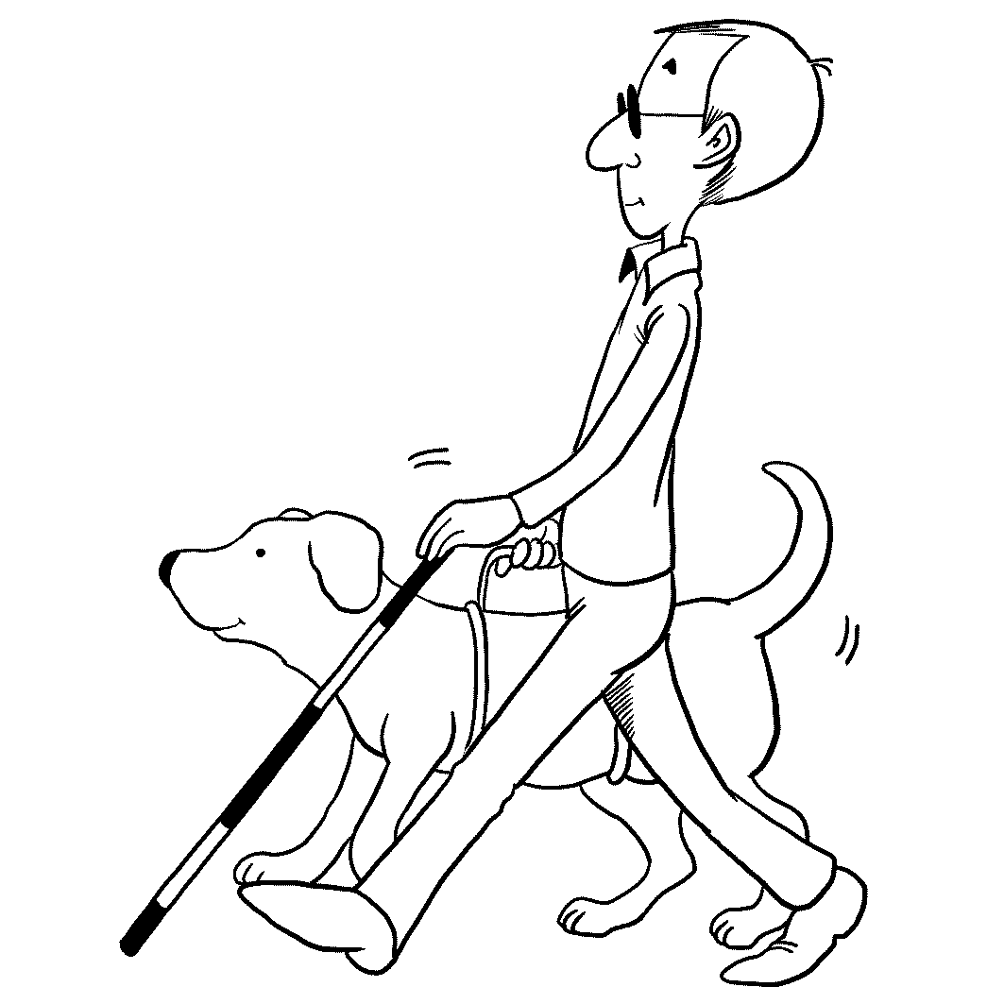
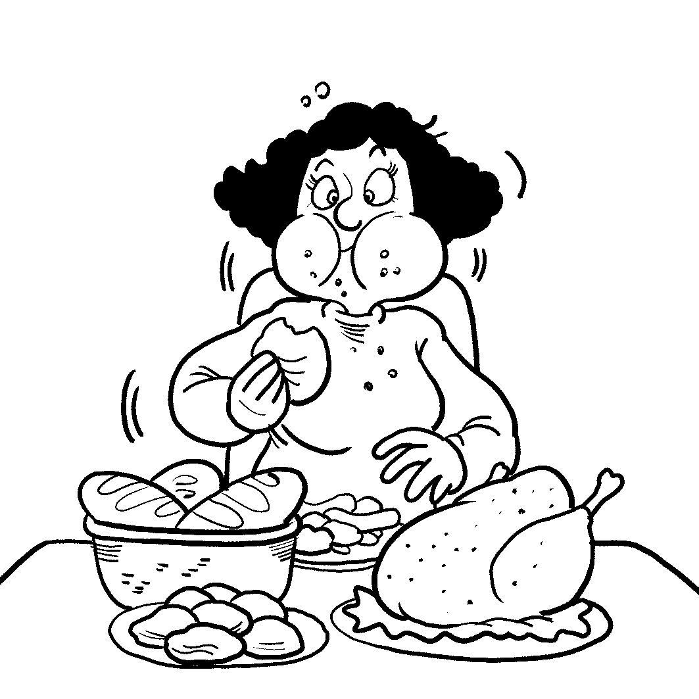
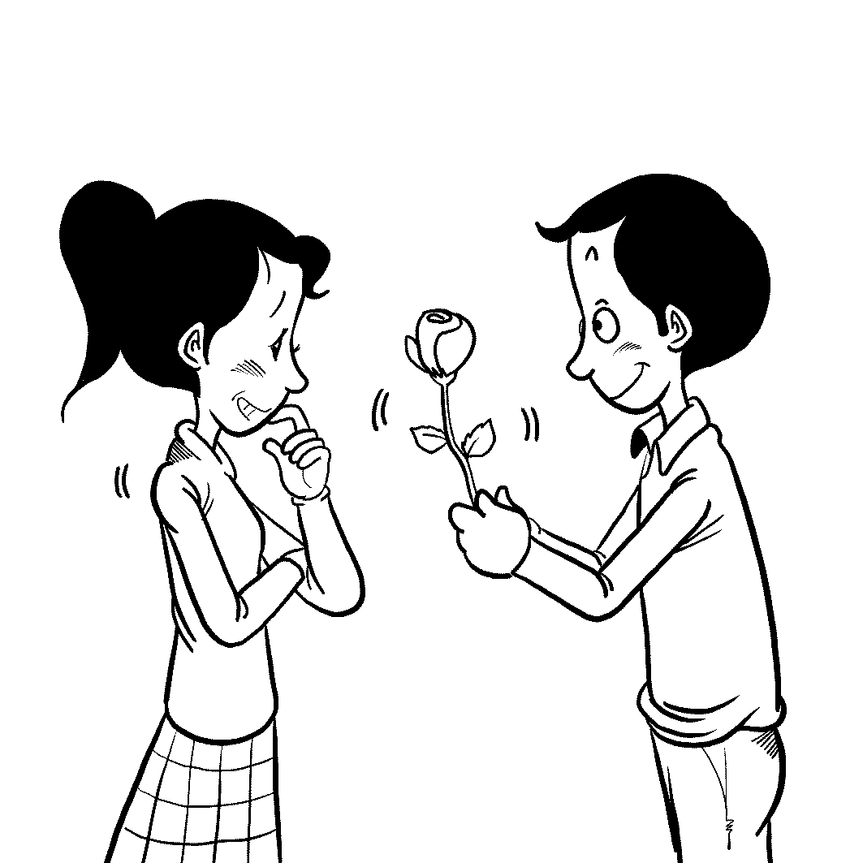

II. Conversation Questions
Listen to each conversation and answer the question.

4. (A) He can finish a lot of things.
(B) He is an artistic person.
(C) He works too hard.
(D) He is a little bit strange.

5. (A) Finish the project as soon as she can.
(B) Work on his part of the project too.
(C) Let him take over the project.
(D) Make a guess about when she’ll be done.

6. (A) It was a serious problem.
(B) It was a sad time for her.
(C) It was a victory for her.
(D) It was an easy thing to do.

7. (A) Brad and Angela will stay healthy when they’re old.
(B) Brad and Angela will stay married for a long time.
(C) Brad and Angela will have a good time.
(D) Brad and Angela will go on a nice vacation.

III. Short Talk Questions
Listen to the following paragraphs and answer the questions.

8. (A) They have found drugs and bombs.
(B) They have acted as guide dogs.
(C) They have smelled depression in people.
(D) They have stopped people from getting sick.

9. (A) It helps doctors find a cure for cancer.
(B) Any dog is able to find cancer.
(C) It is easy and does not hurt the patients.
(D) The dogs lift the patients’ moods.

10. (A) They will soon be found in hospitals.
(B) They are able to save lives in different ways.
(C) All working dogs are given red jackets to wear.
(D) Dogs can sniff out all illnesses in people.

Reading (15%)
I. Cloze Test
(a) Most people dream of winning the lottery. They imagine that the sudden riches will bring them happiness. However, this is not always the case. About one third of lottery winners end up in serious __(11)__ trouble, like going broke or owing money to creditors. But how does this happen? It seems that sudden windfalls can be disasters for people unprepared for them. Winning the lottery doesn't make you an instant millionaire. Often, winners receive their money over about 20 years. This is a problem if you start spending the money __(12)__ you have it! Lottery winners may forget about the taxes which they have to pay. And winning lots of money doesn't make you a financial expert - winners can end up making bad __(13)__ and losing their money. If you do win the lottery, stay calm. Wait about six months before making any big decisions or large purchases. __(14)__, devise a plan for spending the money wisely. After all, the money does not last forever!

11. (A) financial (B) improbable (C) intriguing (D) nonprofit
12. (A) as (B) until (C) before (D) after
13. (A) legacy (B) investments (C) luxuries (D) welfare
14. (A) To make matters worse (B) Without a care in the world
(C) In turn (D) Most importantly

(b) Food preservation is usually done with the help of chemicals. Some people, however, prefer naturally preserved food. Among all methods, the simplest is drying food. In 12,000 B.C., civilizations used the sun and the wind to do this. __(15)__, fans and heaters are used to turn grapes into raisins and fresh tomatoes into sun-dried ones. Then, there is curing. This is similar to drying, __(16)__ salt is used to remove the water from the food instead of heat and air. Curing is actually how we get ham and bacon from pork. It’s also why they taste saltier than normal pork. Another method is canning. This French invention was discovered after Napoleon offered money to anyone who could preserve food for his army. Food is first boiled in jars or cans. The heat kills the bacteria in the food, and as it cools, a(n) __(17)__ seal around the lid is created. Finally, there is fermentation. Here, bacteria are added to food. This turns milk into cheese and yogurt, cucumbers into pickles, and cabbage into kimchi. __(18)__ nothing like tasting the fruits of your own labor! So practice these different techniques to make your own delicious, chemical-free food.

15. (A) In fact (B) Besides (C) Nowadays (D) So far
16. (A) for (B) unless (C) or (D) so
17. (A) tangy (B) alert (C) vacuum (D) non-durable
18. (A) That's (B) It's (C) What's (D) There's

II. 文意選填 : 由(A)-(F) 選出最適合的選項，填入(19)-(21)空格中，使上下文意完整。
請忽略大小寫

(A) getting caught | (B) vulnerable to | (C) up to
(D) thanks to | (E) covering over | (F) easing its passage

Gabon is like the wild Africa that prospered before humans arrived on the continent. With dark rain forests __(19)__ three quarters of the land, and secret worlds scientists are only beginning to understand, Gabon is a treasure chest of natural beauty. However, the conservation of their habitats is under constant threat from humans. In 2002, Gabon's leaders established a series of national parks, each with its own treasures. Loango National Park lies on the coast. __(20)__ the wealth of food available for all the different species, this is a vibrant seaside community. Ivindo, in the east, holds some of the largest waterfalls in Africa. The dominant animal here is the forest elephant. This beast is smaller than the normal elephant, with straight tusks to stop it from __(21)__ in the thick foliage. Lope, in Gabon's center, is home to the largest group of mandrills ever recorded. With these and nine more national parks, Gabon's environmental plans continue to offer hope to this troubled continent.

III. 篇章結構: 由(A)-(D) 選出最適合的選項，填入(22)-(25)空格中，使上下文意完整。

Chopin's musical abilities and passion were apparent at an early age, and he was composing his first piano pieces at age seven. In 1831, Chopin settled in Paris because of the Russo-Polish War. __(22)__ Many of his future works, such as his mazurkas and polonaises, were highly patriotic. The mazurkas were Polish peasant folk dances, while the polonaises were danced by soldiers.
Besides his attachment to the Romantic Movement, Chopin was well-known for being the companion of Baroness Dudevant. __(23)__ He traveled to Majorca with her in order to improve his health. While on the island, he stayed in a French monastery, where he wrote a number of preludes. __(24)__ Chopin then moved to central France with the Baroness. This was the happiest time of his life, and he became very productive. During this period, he composed the "Polonaise Heroic" and the "Minute Waltz."
In 1849, shortly before he turned 40, Chopin died from his long struggle with tuberculosis. __(25)__ Despite dying at such a young age, Chopin is recognized as being one of the greatest composers in history. His compositions continue to move and delight listeners more than 150 years later.

(A) This wealthy French lady was a famous novelist who wrote under the name of George Sand.
(B) His body was buried in Paris, but his heart was removed and buried in Poland, as he had
wished.
(C) Unfortunately, the bad weather left him weak with tuberculosis.
(D) This conflict had a huge impact on Chopin’s music.
Section Two: Voc 4500 (15%)

26. The troops began to _____ from the northern region.
(A) wrap | (B) withdraw | (C) witness | (D) wreck

27. The UN _____ the two countries to sign the peace treaty as soon as possible.
(A) whipped | (B) supposed | (C) promoted | (D) urged
28. The ticket holders who followed the standard _____ will receive a full refund.
(A) procedures | (B) reservations | (C) proposals | (D) privileges

29. He is a typical hypocrite, _____ a man who does not practice what he preaches.
(A) oppositely (B) mutually (C) namely (D) critically

30. Mary has kept _____ with her key pal through e-mail for almost two years.
(A) cooperation (B) companion (C) correspondence (D) association

31. As time goes by, I have learned to _____ with tough problems on my own.
(A) cope | (B) interact | (C) concern | (D) quarrel

32. Is Germany one of the countries that _____ the European Union?
(A) pad | (B) constitute | (C) combine | (D) dodge

33. The _____ of the new uniforms to the soldiers was handled by the general.
(A) capacity | (()(B) elimination | (C) enclosure (D) distribution
34. The medicine is still undergoing the _____ stage. It is not in use now.
(A) adopted | (B) initial | (C) established | (D) experimental

35. Undoubtedly, many problems have _____ from the global recession.
(A) retreated | (B) bounced | (C) emerged | (D) mentioned

36. David is a man of honor; he will try everything to save the _____ of his company.
(A) estimation | (B) defense | (C) reputation | (D) disguise

37. Would you please send for someone to _____ the door so that it can close properly?
(A) investigate | (B) install | (C) insert | (D) mend

38. According to our _____, males do better than females in locating specific sites on the map.
(A) exception | (B) evaluation | (C) representation | (D) possession

39. We decide to postpone the trip until the weather is _____.
(A) favorite | (B) defensible | (C) considerable | (D) favorable

40. We had a narrow _____ from death when our car crashed.
(A) barrier | (B) escape | (C) errand | (D) command

Section Three: Textbook
I. Cloze Test (24%)
(A) Do you know why men and women are different in some aspects? Some studies show that sexual differences are caused by slight differences in our brains. It is these differences ___41___ cause both sexes to handle information they receive in slightly different ways. For instance, girls are more __42__ to learn to speak in full sentences earlier than boys. Women __43__ speak in more complicated sentences than men . Moreover, women are often __44__ as more articulate and eloquent than men. Nevertheless, when it __45__ concepts of spatial ability, men demonstrate more talent than women. The former can better picture objects’ shapes, positions, and proportions in their mind’s eye. Men are thought to be proficient at subjects which are __46__ more complicated and profound ideas. In other words, __47__ that boys seem to outperform girls in mathematical problems__48__ abstract concepts of spatial relationships. This may explain why boys tend to major in engineering __49__ girls in languages or communications. Accordingly, it can be concluded that the different characteristics of human brains __50__ different ways of cognition and choices of career.

41. (A) how (B) X (C) what (D) that
42. (A) probable (B) likely (C) possibly (D) possible
43. (A) prone to (B) tends to (C) were inclined to (D) are apt to
44. (A) thought (B) regard (C) referred to (D) looked to
45. (A) comes to (B) goes to (C) turns to (D) grows to
46. (A) irrelevant to (B) relating to (C) related to (D) contrary to
47. (A) it is apparent (B) it is obviously (C) evidently (D) obviously
48. (A) deal with (B) which deal with (C) dealt with (D) dealing
49. (A) whereas (B) however (C) nevertheless (D) even
50. (A) led to (B) result in (C) result from (D) contributes to

(B) In the seventh century, the printing press had not yet been invented, so monks had to make notes in the margins of the beautiful hand-lettered books. These notes were called “glosses,” __51__ comes the term “glossary.” Hence, __52__, monks can be called the earliest dictionary makers.
Over one thousand years later, in the eighteenth century, a lexicographer __53__ Samuel Johnson believed firmly that a dictionary should fix the pronunciation of words. But after eight years of working on the __54__ of his dictionary, which was finally published in 1755, he came to think __55__ impossible __55__ the language. He began then to promote his belief __56__ language constantly changed and dictionaries were out of date __57__ they were printed. Johnson’s dictionary was considered a __58__ in dictionary-making. He was the first person to put down on paper the words that actually __59__ the English language. Also, this dictionary set basic guidelines for the __60__ of dictionary-making. Among the subsequent lexicographers, the most famous was Noah Webster, a 19th century American, __61__ dictionary included many new words native __62__ America. He recorded the words of everyday conversation he heard people using. He followed Johnson’s theory--the spoken words form a language. Webster had a great __63__ modern dictionary-making. His belief has been followed by almost all dictionary-makers today. They deem that the role of dictionaries is to describe how educated people use the language rather than __64__ rules for its use.

51. (A) which (B) from which (C) in which (D) in that
52. (A) in one sense (B) in the process (C) in proportion (D) in theory
53. (A) who called (B) who is called (C) called (D) was named
54. (A) composition (B) complication (C) compliment (D) compilation
55. (A) that, for fixing (B) to be, in (C) it, to fix (D) as, to fix
56. (A) that (B) which (C) of (D) in
57. (A) as long as (B) the moment (C) no sooner (D) despite
58. (A) definition (B) discovery (C) landmark (D) departure
59. (A) consist of (B) make up (C) are composed of (D) comprises
60. (A) pursuit (B) theory (C) practice (D) craft
61. (A) which (B) who (C) what (D) whose
62. (A) for (B) in (C) to (D) from
63. (A) influence on (B) translation into (C) bias toward (D) affect
64. (A) transcribe (B) inscribe (C) prescribe (D) subscribe

II. Matching (6%)
- In ancient Rome, there were numerous fighters
- If he were to win the lottery,
- He seems
- He has no choice
- Only after he has his own children
- The truth-finding committee is

- to be handsome when he was young.
- will he realize how much kids can mean to a parent.
- he would have traveled around the world with his wife.
- killed in the arena.
- to have been rich when he was in America.
- he will know how hard it is to be a father.
- but to work overtime to support his family.
- made up of ten members.
- consisted of the representatives from ten departments.
J. he would donate some money to the charities.

III. Reading Comprehension (6%)
Andy works part-time at a restaurant and sometimes has to work during the lunchtime rush. One day, a large group of business people walked into the restaurant and sat in the area Andy was serving. He was very nervous about serving such a big crowd of people and checked twice to make sure that he had his pencil and notepad before he went to ask the people for their orders.
“Good afternoon, may I bring you something to drink?”
A woman sitting at the head of the table answered, “I think we’ll have two bottles of wine, one red and one white, and we’re ready to order.”
Andy started writing down orders for salads, pasta, sandwiches, and some appetizers—food you eat before the main course—for everyone to share. He gave them suggestions on the restaurant’s specials and helped those people who didn’t eat meat to pick vegetarian meals. He took the orders to the kitchen and brought the wine and some water.
“This must be a very stressful job,” said the woman at the head of the table.
“Sometimes,” he said, “but it’s a good break for studying!”
“What are you studying?” another man at the table asked.
“Computers,” Andy answered. “I’m interested in starting an Internet site where you can order special foods straight from your computer and have them delivered.”
The people at the table seemed very interested in Andy. He wanted to talk to them more, but he had to take more orders first. After the people had finished eating and Andy had served them coffee, the woman asked for the bill. As she was paying, she gave Andy her business card.
“I own an Internet delivery company. I would like to give you an interview. Are you interested?”
“Absolutely!” said Andy.
He thanked the woman and all the other people at the table. He carefully put the card away and finished serving the lunch rush. This was the best tip he had ever received! With a little luck, this might be the last luncheon rush hour he ever had to serve.

71. Before Andy took the orders to the kitchen, he had to make sure that _____.
(A) he had his pencil and laptop
(B) he had written down the customers’ suggestions
(C) he had his necktie on
(D) he had answered his customers’ questions on today’s specials

72. Andy dreamed of _____ in the future.
(A) opening a restaurant of his own (B) opening a computer company of his own
(C) starting an Internet food service (D) starting an Internet server business

73. “The best tip” Andy had ever received referred to _____.
(A) a job interview at an Internet delivery company
(B) a name card from a rich female customer
(C) a free luncheon treated by his customers
(D) a big amount of money left on the table he served

請將以下的答案寫在答案卷上

IV. Vocabulary & Derivatives (16%)
1. Joseph’s parents r_______ed him for his efforts with a new computer.
2. Children under five have free a_______n to the amusement park. That is, they don’t have to pay.
3. In 2009, Charles Kuen Kao was awarded the Nobel Physics Prize in r_______n of his achievements concerning the transmission of light in fibers for optical communication.
4. After seeing the doctor, you have to go to the pharmacy to have the p_______n filled.
5. You’d better avoid a c_______n with your supervisor in the company, or you might be fired.
6. Ask your tour guide to r_______d the best places to eat and to stay if you want to have a wonderful trip.
7. At the end of the program we will have an e_______e interview with President Barack Obama.
8. The lecture of professor Goldwater was very i_______e and helpful. That’s why his classroom was always crammed with students.
9. As Rachel was a little under the weather today, she left the office early and h_______led a taxi to take her home.
10. A free shuttle bus runs between the airport t_______l and the train station.
11. Ashley s_______ed all over the living room walls in crayon though her mom constantly reminded her not to do so.
12. Sherman’s parents stood there b_______ming proudly as he went up to receive the prize.
13. P_______ls, such as doctors, teachers and architects, make important contributions to the well-being of society as a whole.
14. Zeus, Athena, Cupid, Psyche and Narcissus are all characters from Greek m_______y.
15. She's always b_______ting about how successful her husband is.
16. Sharon has been interested in learning languages. So it stands to reason that she made up her mind to s_______e in linguistics.

V. Idioms & Phrases (8%)
請根據上下文及下面中文提示, 填入適合的片語, 使上下文意完整。 每格至少兩字。

1.雖然 ,儘管 2. 讓(某人)嚇一跳 3.在…找(東西) 4. 提出
5.更不用說 6. 遵守諾言 7. 謀生 8. 未必

Stepping out of Ray-Fang Station, I strolled around the night market, enjoying the peaceful atmosphere of the lovely small town. Suddenly, my eye fell on a vendor--Yes, that was Paul—a student of mine ten years ago, while I was teaching in a nearby senior high school. 1 Paul appeared so tall and strong, the innocence in his eyes remained the same as before. I stood right in front of him for a while. I was trying to 2 . “Noodles,” I ordered as the other customers, 3 in my pocket for some coins. Then his eyes sparkled-- “Mr. Wang, my English teacher!” Exclaimed Paul. For the next few minutes, we chatted and laughed a lot, till Paul himself finally 4 the issue of his financial troubles. His parents used to be factory workers. With a humble salary, the parents could hardly support the family, 5 the schooling of the three children. As the eldest son in the family, Paul promised to help take care of his brothers. So, after Paul’s graduation from senior high school, he decided to quit his studies. He 6 and started to work as a food vendor in the night market. Day by day, his food became popular and now he 7 by selling noodles. With Paul’s support, two of his brothers managed to go through college. For Paul, the best place to learn is 8 limited to academic schools. In fact, he has learned and achieved so much from the night market—a real social community college for him.

台北市立松山高中九十八學年度第二學期第一次段考高二英文試題

Class:___________ Name:_______________ No:______

答案卷

IV. Vocabulary:16%

1. | 2. | 3. | 4.
5. | 6. | 7. | 8.
9. | 10. | 11. | 12.
13. | 14. | 15. | 16.

V. Idioms & Phrases: 8% 每格至少兩字

1 | 2
3 | 4
5 | 6
7 | 8

台北市立松山高中九十八學年度第二學期第一次段考高二英文試題

答案卷

IV. Vocabulary:16%

1.  rewarded | 2.  admission | 3.  recognition | 4.  prescription
5.  confrontation | 6.  recommend | 7.  exclusive | 8.  informative
9.  hailed | 10.  terminal | 11.  scribbled | 12.  beaming
13.  Professionals | 14.  mythology | 15.  boasting | 16.  specialize

V. Idioms & Phrases: 8% 每格至少兩字

1  Despite } the fact that  In spite of | 2  catch him by surprise
3  fishing around /and fished around | 4  brought up
5  not to mention /say | 6  kept his word /promise
7  makes /is making } a (good) living  earns/ is earning | 8  not necessarily /always

1-10 BBAAD /CBACB 11-20 ACBDC /ACDED 21-30 ADACB /BDACC

31-40 ABDDC /CDBDB 41-50 DBDCA /CABAB 51-60 BACDC /ABCBD

61-70 DCACD /JEGBH 71-73 DCA

