台北市松山高中九十八學年度第二學期第二次段考高二英文試題

Section One : All+ Magazine (April 2010)
Listening (10%)

Part 1. Picture Questions
Look at each picture and answer the question.
1. 2. 3.
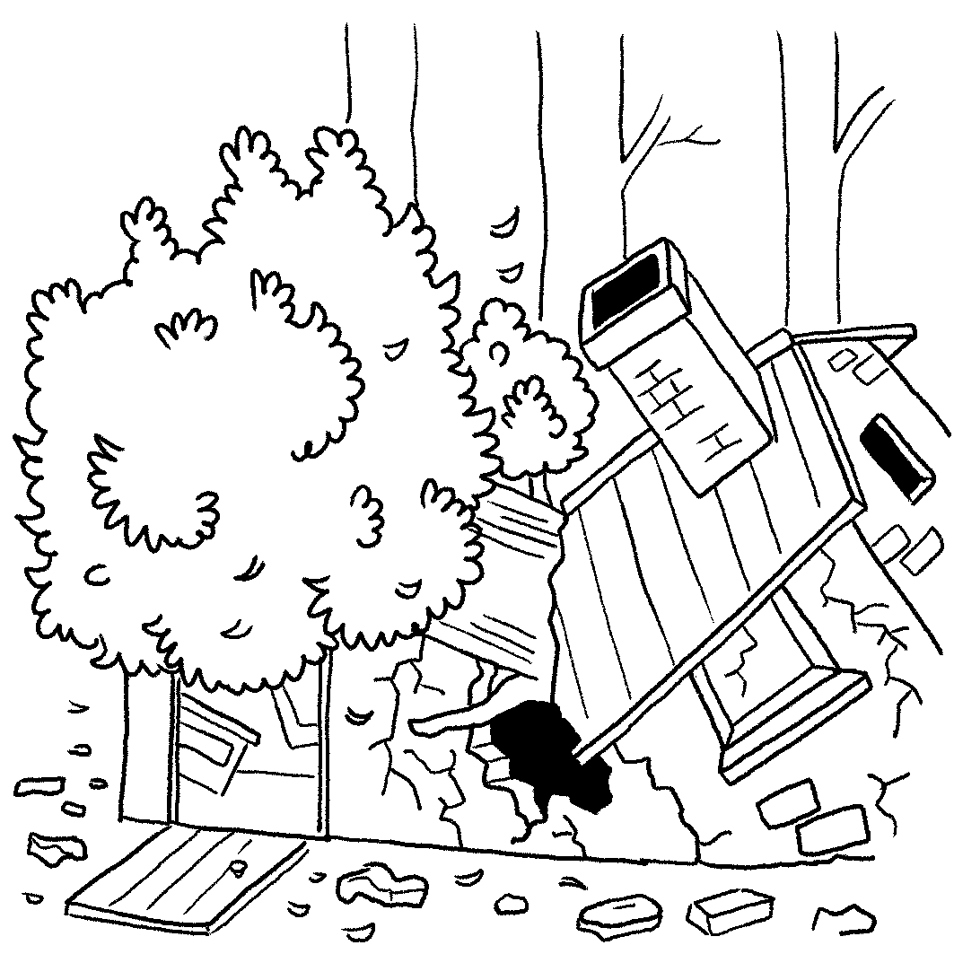
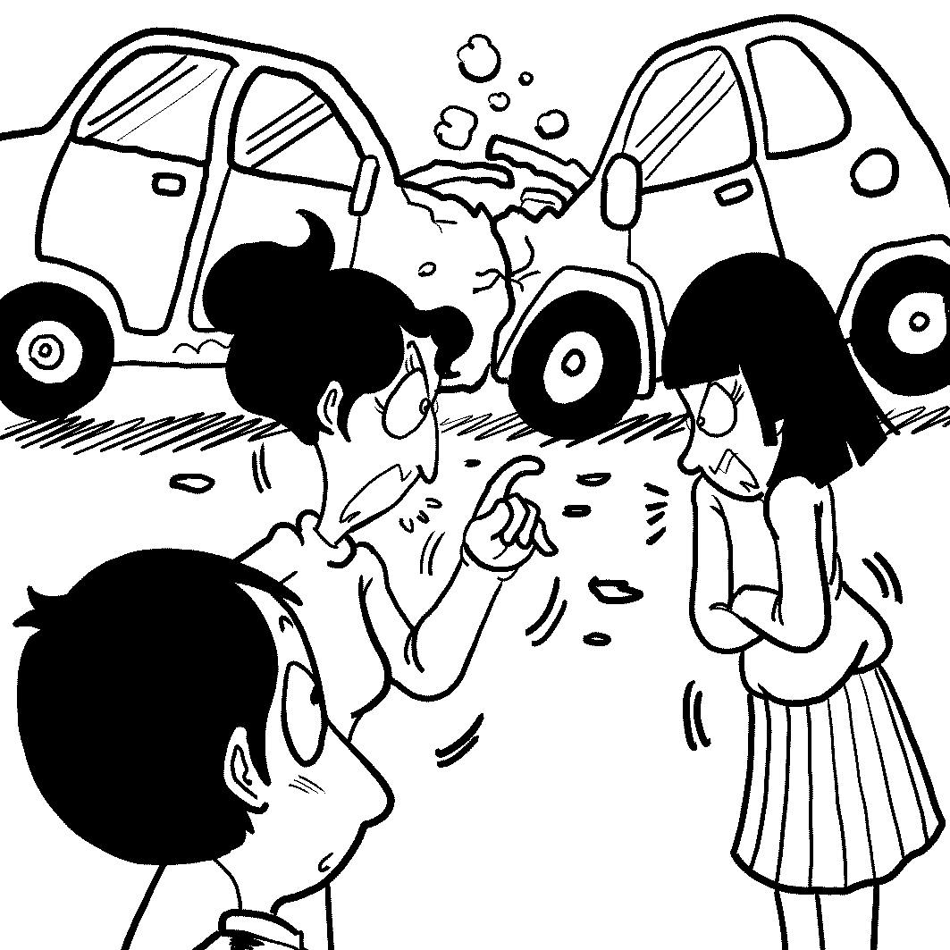
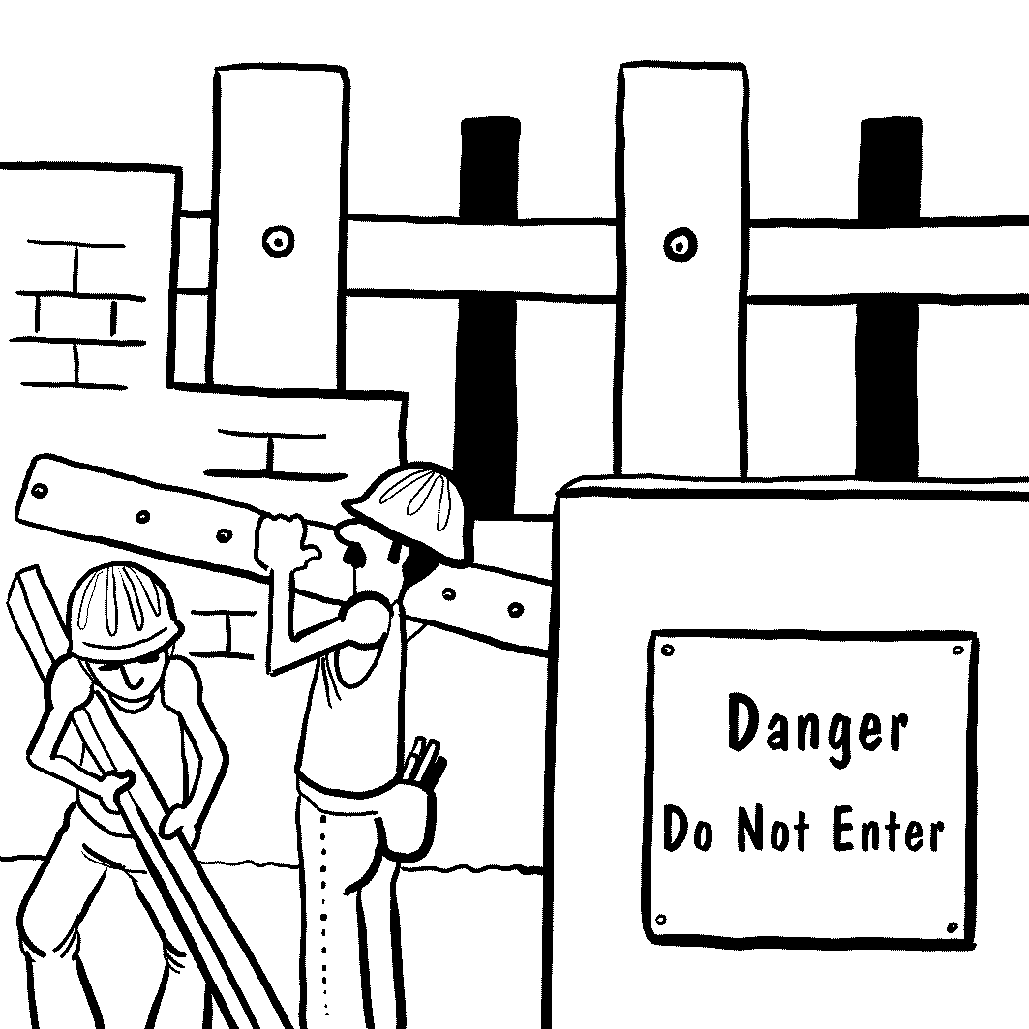

Part 2. Conversation Questions
Listen to each conversation and answer the question.

4. (A) It’s a lot of hard work.
(B) It doesn’t pay very well.
(C) The work hours are quite short.
(D) Her coworkers are friendly.

5. (A) She makes energy sources that don't run out.
(B) She sells traditional sources of energy.
(C) She encourages people not to use up energy.
(D) She searches for old forms of energy, like oil.

6. (A) It was so boring that she almost fell asleep.
(B) She had trouble understanding parts of its plot.
(C) Most of it was too violent for her to watch.
(D) She couldn’t stop laughing because it was so funny.

7. (A) It gets its battery life from the sun.
(B) It has lots of nice gems inside it.
(C) You plug it in at night to charge it.
(D) It works from the motion of the arm.

Part 3. Short Talk Questions
Listen to the following paragraph and answer the questions.
8. (A) Hakka culture and Taiwan’s natural beauty.
(B) The coming of spring in Taiwan.
(C) The planting of new trees in the forests.
(D) Peace and friendship between people.

9. (A) Traditional food and dancing.
(B) Bicycle rides.
(C) Arts and crafts fairs.
(D) Snowflakes.

10. (A) At the beginning of April.
(B) Over the whole of April and May.
(C) When the trees blossom in April or May.
(D) At the very end of May.

Reading (15%)
I. Cloze Test
(a) In 1970, U.S. Senator Gaylord Nelson got fed up with the disregard for the environment in the United States. Taking action, he decided to organize a countrywide event that would 11 a diverse audience. On April 22, members of the two rival political parties marched together with 20 million other Americans to demand a 12 environment. It was the first Earth Day, and the birth of a movement. By 1990, Earth Day became a global event. Since then, the Earth Day Network has been expanded to include more environmental groups in different countries. Earth Day 2010 promises to be the biggest yet, 13 the Green Generation. This is a new generation who 14 renewable energy, responsible consumption, and the creation of a green economy. To be part of this generation requires a new way of thinking about the world and about the way we live our lives.
11. (A) attach to | (B) adhere to | (C) appeal to | (D) apply to
12. (A) substantial | (B) sustainable | (C) superficial | (D) sensational
13. (A) focuses on | (B) that focuses on | (C) focused on | (D) focusing on
14. (A) commits to | (B) is committed to | (C) devotes to | (D) is devoting to

(b) Typically, most travelers choose hotels based on three 15 : comfort, location and price. However, some people are more interested in a unique experience and prefer to live in unusual or weird hotels. Those wanting a different style of vacation can 16 their childhood fantasies of living in a tree house by renting a room in the Ariau Amazon Towers. 17 the rain forest canopy of the wild Amazon region of Brazil, it is the largest treetop hotel in the world. In addition to being surrounded by natural beauty, visitors can do other adventurous things like swimming with rare pink dolphins. Another special type of 18 is the underwater hotel. One example is the Poseidon Undersea Resort, which will rest on the floor of a lagoon in Fiji. An elevator will transport guests to the plush suites below the surface. The popularity of these weird hotels is a sign that many travelers are truly searching for something different.
15. (A)facilities | (B) critics | (C) criteria | (D) molds
16. (A) overcome | (B) enforce | (C) restore | (D) fulfill
17. (A) Having located in | (B) Locating in | (C) Situated in | (D) Lied in
18. (A) accompaniment | (B) accommodation | (C) accomplishment | (D) application

II. Choice: Choose the best answer
- The angry coach _________ his players to fight harder.
(A) uttered (B) extended (C) proceeded (D) spurred
- Once exposed, soil and rocks are quickly _______ by wind and rain.
  - eroded (B) exploded (C) undertaken (D) invaded
- Hundreds of activists participated in the ________ to protest against the construction of a new power plant.
(A) calculation (B) inspiration (C) consumption (D) demonstration
- The notorious robber was taken into police ________ immediately after the robbery.
  - category (B) enforcement (C) compression (D) custody
- The general manager came up with a new marketing campaign in order to boost the _______of the company.
(A) imagery (B) destination (C) profile (D) procedure
- His business was _________ with $300 he'd managed to borrow from a friend.
  - gone into place (B) started from scratch
(C) waited in the wings (D) taking advantage of
- Mr. Wilson is very generous and kind-hearted. That is why he _________ many charitable activities.
  - hangs out with (B) ties with (C) takes revenge on (D) is involved in

Section Two: Voc 4500: Ch1-4 15%
26. What is the quickest ______ to Danshui station? I need to get there fast.
(A) occasion (B) skyscraper (C) route (D) brake
27. The Eiffel Tower is one of the most famous ______ in Paris.
(A) suburbs (B) landmarks (C) pubs (D) neighborhoods
28. I hope I can visit Taipei 101 _____ during my stay in Taipei.
(A) sometimes (B) other time (C) sometime (D) some times
29. The Ami are one of the aboriginal ______ in Taiwan.
(A) tribes (B) territories (C) studios (D) surroundings
30. Do you want me to put any ______ on your ice cream?
(A) nourish (B) landmark (C) syrup (D) vessel
31. Dolphins communicate with each other by producing high-_____ sounds.
(A) harbor (B) gallery (C) inn (D) frequency
32. The bag is expensive because it is made of genuine _____.
(A) parade (B) protein (C) lollipop (D) leather

33. After the party ended, we ______ and started to clean the house.
(A) made a journey (B) rolled up our sleeves
(C) had a close shave (D) hung by a thread
34. The witness said that he saw the defendant _____ the store that was later robbed.
(A) sneaking around (B) volunteering to (C) typing around (D) translating of
35. My skin is very _____ intense sunlight, so I have to carry an umbrella with me all the time.
(A) sensitive to (B) innocent of (C) intimate with (D) stingy with
36. The old man is very _____and refuses to listen to other people’s suggestions.
(A) passive (B) stubborn (C) noble (D) stingy
37. My mother is very _____ in her thinking; she doesn’t approve of boys having long hair.
(A) conscious (B) bold (C) conventional (D) broke
38. Mary is a _____ and runs a salon downtown.
(A) historian (B) hairdresser (C) governor (D) gangster
39. Scientists have proven that humans and chimpanzees have common _____.
(A) economists (B) founders (C) knights (D) ancestors
40. The recent election is said to be truly_____ the citizens’ wishes for peace in this country.
(A) professional in (B) fond of (C) representative of (D) technical in
Section III: Textbook ( L5-L8)
I. Cloze Test 22%
(A) Our personality traits have a lot to __41__ our birth order in the family. According to experts, first-borns tend to be more conservative and set higher standards for themselves since they often __42__ their parents’ values. Their constant __43__ to live up to their parents’ expectations makes them become high achievers. __44__ first borns, middle children are usually more sociable because they often have to look outside the family for praise. In this way, they learn valuable skills _45__ them for adult life. __46__, they often end up in leadership positions. As for the youngest children, their desire to get attention often helps them develop skills in __47__ their presence __47__. This is why the babies of the family have always been such charmers. On the other hand, when __48__ to describe the personality of only children, many people will respond negatively since they assume only children are spoiled brats. However, one research has found only children fare no worse than their peers with siblings __49__ personality development or achievement. In fact, they are likely to be __50__ , and successful. Lacking siblings, only children lose the immediate availability of others near their own age __51__ to interact socially. Therefore, they need to behave in an outgoing manner if they __52__ win friends since there is no guaranteed familial playmate.

41. (A) deal with (B) do with (C) cope with (D) do without
42. (A) disapprove of (B) impress (C) identify with (D) oppose
43. (A) effort (B) effect (C) affect (D) fact
44. (A) Compared with (B) Comparing (C) Contrasted (D) Contrasting
45. (A) prepared (B) that prepare (C) prepared for (D) preparing for
46. (A) As a result of (B) Nevertheless (C) Otherwise (D) Therefore
47. (A) making…fallen (B) having…feel (C) making…felt (D) having…fall
48. (A) asked (B) asking (C) to ask (D) to have ask
49. (A) in pursuit of (B) in terms of (C) in preference for (D) in order of
50. (A) motivating, high-achieving (B) motivated, high-achieved
(C) motivating, high-achieved (D) motivated, high-achieving
51. (A)who (B) whoever (C) with whom (D) no matter who
52. (A)are to (B) are meant to (C) are induced to (D) are up to

(B) Dr. Peale emphasizes the importance of living in a positive way and keeping a good relationship with others. Once two women in his church couldn’t get __53__ well. The longer the situation continued, ___54__. He knew if __55__ of them could be induced to say something nice about the other, perhaps the situation could be __56__. Therefore, he tried to pass good words on. __57__, it ended the church feud. Dr. Peale found __58__ meaningful to be a relay station for the little sparks of goodwill that might help jump the gap that __59__ people. The relayed friendly compliment was __60__ significant __60__ a direct one. __61__, when someone praises you directly, it may easily be seen as mere politeness. But if they compliment you behind your back, __62__ that they mean what they say.

53. (A) alone (B) rid of (C) over (D) along
54. (A) the worse and most unpleasant it would become
(B) it would become bad and more unpleasant
(C) the worse and more unpleasant it would become
(D) the worst and more unpleasant it would become
55. (A) neither (B) none (C) either (D) the other
56. (A) reversed (B) conversed (C) versed (D) advised
57. (A) Although the goodwill is feeble (B) Feeble as the goodwill was
(C) Feeble is the goodwill (D) Feeble was the goodwill
58. (A) that (B) X (C) what (D) it
59. (A) separate (B) quarantines (C) divides (D) segregate
60. (A) so…as to (B) much more…than (C) such…as (D) so…that
61. (A) In short (B) After all (C) Above all (D) In time
62. (A) chances are (B) it is likely to (C) it is by chance (D) it tends to

II.Matching 8%
63. Bill Gates is said to be
64. Since the turn of the 21st century,
65. Steve has five times
66. It can be challenging

- with neither a good guide nor the help from teachers.
- the number of CDs I have collected.
- richer than any person in the world.
- many people have started to learn Chinese.
- as many as my CDs.
AB. either go camping or go canoeing.
AC. the richest person in the world.

67. The ladies were chatting in the room with a plate of cookies
68. Some high school students find it hard
69. Yesterday, I tried to avoid talking to Mary
70. I paid special attention to the girl

- ,whom I had had an argument with last week.
- balancing on their knees.
- who is a teacher.
- balanced on their laps.
- who had her arms folded.
AB. to balance between work and play.

III. Reading comprehension (6%)
Music's interconnection with society can be seen throughout history. Every known culture on the earth has music. However, early music was not handed down from generation to generation or recorded. Hence, there is no official record of "prehistoric" music. Even so, there is evidence of prehistoric music from the findings of flutes carved from bones. The influence of music on society can be clearly seen from modern history. Music helped Thomas Jefferson write the Declaration of Independence. When he could not figure out the right wording for a certain part, he would play his violin to help him. The music helped him get the words from his brain onto the paper.
The power of music to affect memory is quite intriguing. According to The Center for New Discoveries in Learning, learning potential can be increased a minimum of five times by using the 60 beats per minute classical music. For instance, Mozart's music and baroque music, with a 60 beats per minute beat pattern, activate the left and right brain. The simultaneous left and right brain action maximizes learning and retention of information. Also, activities which engage both sides of the brain at the same time, such as playing an instrument or singing, cause the brain to be more capable of processing information.
Based on the above study, one simple way students can improve test scores is by listening to certain types of music such as Mozart's Sonata for Two Piano's in D Major before taking a test. This type of music releases neurons in the brain which help the body to relax. The effectiveness of Mozart's sonatas can be seen by the results from an IQ test performed on three groups of college students. The group who listened to a Mozart sonata before taking the test had the highest average scores. This finding provides hope for teachers and students.
71. What is the main idea of this article?
(A) the different roles of music in human history
(B) the positive influence of music on politicians
(C) the controversy over the influence of music on memory
- the impact of music on human brain
72. Which of the following statements is True?
(A) Mozart's Sonata decreases neurons in the brain which help the body to relax.
(B) learning potential can be increased two times by using the 60 beats per minute music.
- The left and right brains working at the same time minimize learning and retention of information.
(D) We find the evidence of prehistoric music in the flutes carved from bones.
73. According to the article, what can a student do if he wants to enhance his ability to process information?
(A) Avoid listening to rock music.
  - Read Thomas Jefferson’s biography.
  - Engage in activities such as playing instruments.
  - Compose a musical piece.
請將以下答案寫在答案卷上
IV. Vocabulary & Derivatives (16%)
1, Kevin is the top student in class and his parents take pride in him because of his excellent a________c performance.
2. Although Amy is handicapped, she is s____-s____t. She can take good care of herself and does not need to rely too much on others.
3. Most employers expect their employees to work e________y so that the productivity will increase.
4. The famous female dancer’s leg was so badly damaged in the car accident that the doctor had to amputate it. She had no choice but to receive an a________l leg after the amputation.
5. It is sheer c_______e that John and his wife were born on the same day.
6. Many deaf people have the feelings of i_________n and loneliness because they can not communicate with normal people in an effective way.
7. The lazy student was indifferent to the result of the exam and glanced c________y at the report card.
8. Charles Darwin was the o_______r of the theory of natural selection. He proposed the concept that natural selection was the basic mechanism of evolution.
9. Helen complained in_______y about her poor salary, but her colleagues seemed to be tired of her angry complaints.
10. Alice is a v________s woman, who has many admirable qualities such as kindness, thoughtfulness and generosity. That is why she is so popular with men.
11. Jim is an architect by o_________n. His job is to design houses and buildings for different customers.
12. As the Chinese saying goes, “Diligence can make up for lack of i________e.” Those who are not very clever can still achieve success if they work diligently.
13. Nancy is so kind and tolerant that she holds no g_______e against any of the people who have treated her unfairly.
14. The politician’s ________ (provoke) remarks caused an angry reaction from many in the audience.
15. Mr. Wilson is a successful entrepreneur and runs his business in a ________ (system) way.
16. These machines require constant _________ (maintain) so that they will be in good condition.
V. Translation (8%) 每格至少兩字
1. 雖然凱莉是獨生女但她既不羞怯也不自私。
Although Kelly is the only child in the family, she is n____________________.
2. 凱莉的父母親總是訓練凱莉要獨立，這樣的教養方式使凱莉受益很多。
Kelly’s parents always trained her to be independent and she b___________ such an upbringing.
3.自從凱莉的爸爸罹患失智症以來，凱莉擔負起照顧父親的責任。
Since Kelly’s father had demantia, she ____________ the responsibility of looking after him.
4.凱莉從未想過她必須接管父親高科技公司的營運。
________________ Kelly that she had to ______________ the running of her father’s
high-tech company.
5. 一開始公司的資深員工對凱莉懷有敵意，但她不因此感到沮喪。
At the beginning, the senior employees _______________ Kelly, but she did not feel upset about it.
6. 由於凱莉優異的領導力，她的公司達到成為全台灣最棒的高科技公司的目標。
Due to Kelly’s excellent leadership, her company ___________________ becoming the best high-tech company in Taiwan.
7. 凱莉結果成為台灣最具影響力的女性之一。
Kelly e______________ one of the most influential women in Taiwan.
台北市松山高中九十八學年度第二學期第二次段考高二試題
答案卷 Class: No: Name:

IV. Vocabulary & derivatives (16%)

1. academic | 2. self-sufficient | 3.efficiently
4.artificial | 5.coincidence | 6.isolation
7.casually | 8.originator | 9.indignantly
10.virtuous | 11.occupation | 12.intelligence
13.grudge | 14.provocative | 15.systematic
16.maintenance

V. Translation (8%)

1. neither timid/shy nor selfish | 2. benefited a lot from
3.has taken (on) | 4.It never occurred to/struck/hit
5.take over | 6. had/felt/showed hostility toward/to
7.reached/achieved the goal of  reaches/achieves the goal of | 8.ended up as/ended up becoming  ends up as/ ends up becoming

1-5 BCDAA 6-10 CAADC 11-15 CBDBC 16-20 DCBDA
21-25 DDCBD 26-30 CBCAC 31-35 DDBAA 36-40 BCBDC
41-45 BCAAB 46-50 DCABD 51-55 CADCC 56-60 ABDCB
61-65 B,A,AC,D,B 66-70 A,D,AB,A,E 71-73 DDC

