臺北市立松山高中99學年度第一學期高一第一次段考英文科試題
第一部分: Live Magazine，請將答案劃入答案卡
I. 聽力測驗: 10% (每題1 分)

Part 1: Picture Questions (2%)
Look at each picture and answer the question.
1. | 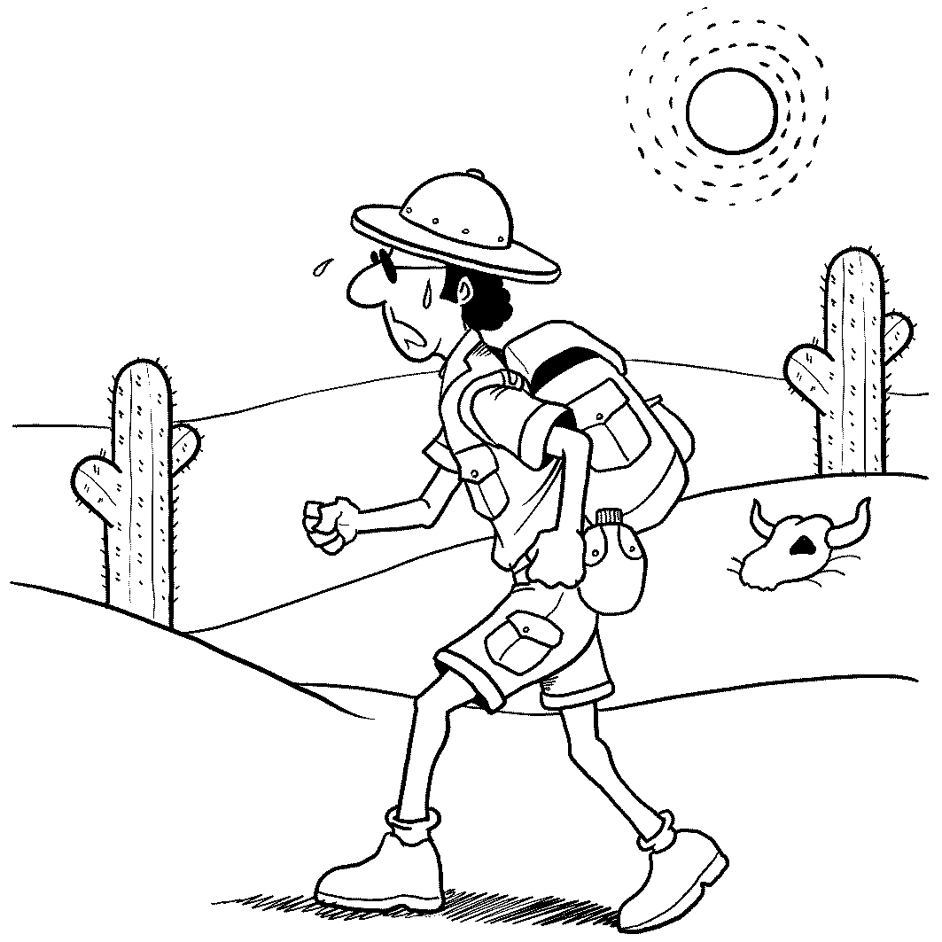 | 2. | 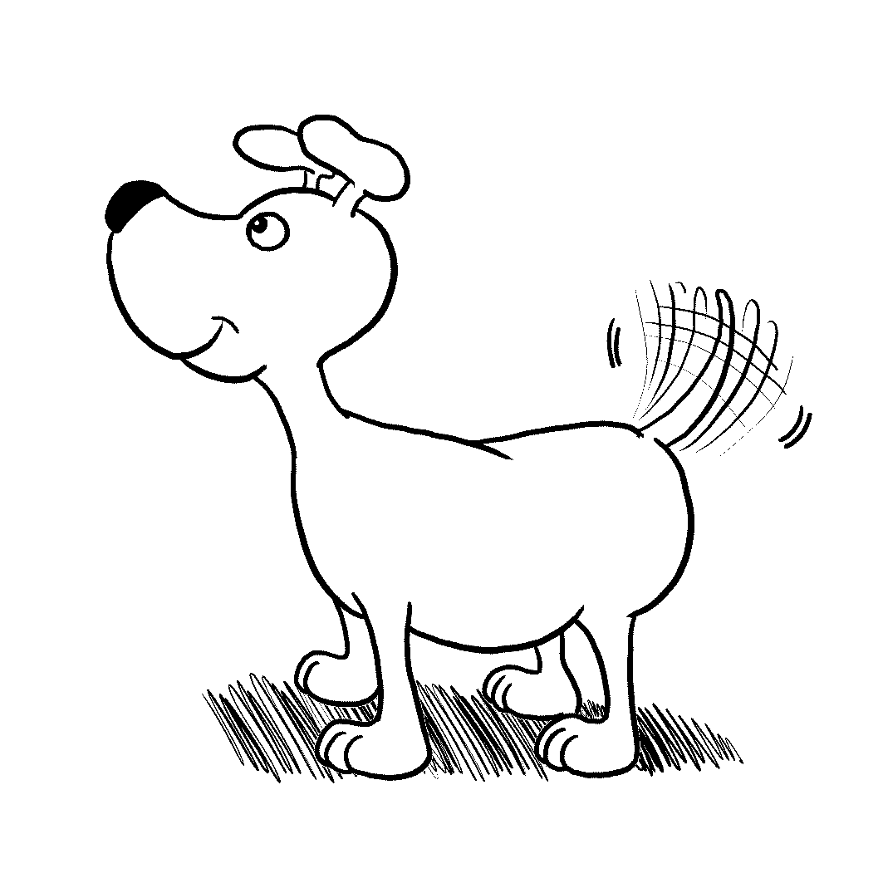

Part 2: Best Response Questions (3%)
Listen to the question or statement and choose the best response.

( ) 3. (A) Why doesn’t he want to see you?
(B) That sounds very dangerous.
(C) He wants you to speak to him.
(D) Is he annoying you again?

( ) 4. (A) They should work harder.
(B) They want you to do well in school.
(C) I know. They often buy you gifts.
(D) It’s great to spend time with family.

( ) 5. (A) Yes, you look nice with makeup on.
(B) No, those shoes look fine to me.
(C) Sure. Jewelry goes well with that dress.
(D) Yes, you should. It’s very cold outside.

Part 3: Conversation Questions (3%)
Listen to each conversation and answer the question.

( ) 6. (A) They are at her favorite Italian restaurant.
(B) There are many Italian restaurants around.
(C) The restaurant is close to their home.
(D) She can make Italian food at home.

( ) 7. (A) His mother doesn’t know that he hates cakes.
(B) His mother makes a different kind every year.
(C) Chocolate cake is one of his favorites.
(D) He has it every year on his birthday.

( ) 8. (A) To make him some food.
(B) To get out of his room.
(C) To be quiet in his room.
(D) To help him with his homework.

Part 4: Short Talk Questions (2%)
Listen to the following paragraphs and answer the questions.

( ) 9. (A) Bicycles.
(B) Electric cars.
(C) Cell phones.
(D) Scooters.

( ) 10. (A) Soon, there will be none left.
(B) They will be around for years to come.
(C) They can only be found in England.
(D) They will replace real libraries soon.

II. 詞彙: 10% (每題 1 分)
11. Jessica ________ that she saw the movie star George Clooney in the bookstore, but I
find it very hard to believe.
(A) pursued (B) claimed (C) insulted (D) forgave
12. The pilot made a (n) ________ landing in a field shortly after takeoff. It had to land
immediately because the engine was on fire.
(A) emergency (B) adventure (C) stress (D) challenge
13. It was my 18th birthday yesterday, and it was very ________ of my family to give me a
car as my birthday present.
(A) normal (B) courageous (C) social (D) generous
14. The audience was amazed when the famous magician ________ before their eyes in a
puff of smoke.
(A) promised (B) charged (C) vanished (D) squeezed
15. Julia Roberts’ ________ movie “Eat Pray Love” is a story that depicts a woman’s
journey to Italy, India and Bali, where she finally finds her happiness in life.
(A) recent (B) personal (C) average (D) royal
16. We ________ at the man who was wearing a funny hat. We couldn’t take our eyes off
him because he looked so strange.
(A) stuck (B) recognized (C) depended (D) stared
17. The oil spill in the gulf of Mexico (墨西哥灣漏油事件) has caused great ________ to
the environment and animals, leaving them no more clean home to live in.
(A) mess (B) weapon (C) harm (D) dust

18. Upon hearing that her house was shattered (破壞) by the typhoon, the old lady had
a (n) ________ of sadness on her face and quickly burst into tears.
(A) attraction (B) expression (C) education (D) addition
19. Jessica speaks not only English, her ________ language, but also French and German.
(A) realistic (B) perfect (C) amazing (D) native
20. I got a (n) ________ from my friend to bring her a souvenir from my journey to Europe.
(A) filled with | (B) nervously | (C) catch | (D) style
(E) still | (AB) offers | (AC) stand out
(A) method (B) essay (C) request (D) paradise
III. 文意選填: 7% (每題 1 分)
Interested in Art? The Taipei Fine Arts Museum now __21__ you a chance to feast your eyes on famous paintings ranging from Realism, Impressionism to Cubism.
One great example of Impressionism is Renoir’s Portrait of Mademoiselle Legrand (勒岡小姐畫像), which is one of the first paintings that can easily __22__ your eye at the exhibit. The eight-year-old girl holds her hands in front of her and __23__ looks off to the side. Perhaps she looked at her mother as she tried to stand __24__ for Renoir. The girl may be shy, but the black dress and the blue of her scarf __25__ strongly and look almost wet.
There are Postimpressionist works that have bold colors and geometric shapes on display as well. Miró’s Horse, Pipe, and Red Flower（馬、煙斗和紅花）is a great example of this __26__. It is __27__ so many bright colors and busy shapes that it looks like a party. Wherever your interest lies, this exhibition promises to satisfy and is definitely worth visiting!

IV. 綜合測驗: 9 % (每題 1分)
(A) Realizing the lack of education in a remote village in Pakistan, the Nobel Peace Prize nominee Greg Mortenson founded Central Asia Institute, which helped build up schools for the children in remote areas. __28__ education, Mortenson believes, is something that everyone should do his or her part to help with. He __29__ a great example for those in support of this basic human right.
However, Mortenson faced many difficulties as he tried to build schools in Afghanistan.
One of many was that he challenged the area’s belief that women should not be educated. Still, he believes that education is the only way to make a __30__ and long-lasting change. __31__ picking up weapons, the children are taking up pens. Although CAI and Mortenson have helped many children receive education over the years, there are still more than a million children who have no __32__ education. That’s why they started a campaign, Pennies for Peace, to seek the world’s continuous help for these children.
28. (A) To Promoting (B) Promoting (C) Promoted (D) Having promoted
29. (A) does (B) applies (C) sets (D) begins
30. (A) miserable (B) negative (C) precious (D) positive
31. (A) Instead of (B) Think of (C) In terms of (D) At the cost of
32. (A) success to (B) access in (C) access to (D) success in

(B) Italians not only love pasta, they also make the best of it. Now, Pasta even becomes a trademark of Italy. Real pasta is made from special flour and has a rough surface, which enables the sauce to stick to the noodles. Pasta tastes __33__, and its various shapes make it great fun to eat it, too!
__34__, it was not until the fifteenth century that the Italians started to eat pasta with sauce. Tomatoes reached Europe then and led to the creation of tomato sauce. In the twentieth century, a cream sauce __35__ the inventor Alfredo was born. __36__ this sauce, he created a dish of egg noodles, butter, and cheese for his pregnant wife. This famous dish was later known as Pasta Alfredo. Today, pasta’s fame travels far and wide and is eaten around the world. Surely, it will continue to enjoy its popularity for a long time.
33. (A) great (B) greatly (C) deliciously (D) better
34. (A) Therefore (B) In general (C) However (D) Despite
35. (A) named as (B) named for (C) named by (D) named after
36. (A) For (B) With (C) By (D) As

第二部份: Textbook
V. 克漏字 29% (每題 1 分)
(A) We can’t live without friends. However, friends won’t just come if you don’t ___37___. If you want to enjoy a close friendship, you have to make it __38___. Like a good chef, it takes you time and patience to develop a delicious friendship. Here are some tips. First of all, a warm smile is always welcome. It helps to make a good first impression. Besides, trust is also an essential element. In times of difficulties, you can always share __39__ on your mind with your friends. ___40___, having similar interests __41__ important. If so, you can spend more time __42__ the things you enjoy together. Furthermore, friendship also needs care. You can’t leave it alone, just __43__ you can’t leave soup on the stove without stirring it. Though having a friend __44__ you busy, it also makes you happy. A good friend, like a bowl of good soup, can be just __45__ when you feel down. Keeping old friendships and starting new ones can be a lot like making soup—it may take time , but it __46__.
37. (A) make any effort (B) take any effort (C) spare no effort (D) give some effort
38. (A) to happen (B) happen (C) to happening (D) happening
39. (A) the things are (B) the things which is (C) what are (D) what is
40. (A) However (B) Thus (C) Beside (D) In addition
41. (A) that is (B) are (C) is (D) which are
42. (A) talking or doing (B) talking or to do (C) on talking or doing (D) talk or doing
43. (A) like (B) for example (C) as (D) because
44. (A) lets (B) has (C) causes (D) keeps
45. (A) which you need (B) what you need (C) how you need it (D) that you need
46. (A) worths it (B) is worth (C) is worth it (D) worths

(B) On a quiet Saturday afternoon, my friend and I threw stones onto the roof of an old lady’s house because __47__. I found a stone and sent it for a ride. However, it slipped out of my hand and hit a small window of the lady’s house. We were afraid __48__, so we took to our heels right away. For the next few days, I was so worried about getting into trouble __49__ I didn’t think of the old lady and her broken window. However, when I was sure that I wasn’t in trouble, I started to feel sorry about __50__. I was determined to save the money I __51__ from delivering newspapers and __52__ it to the old lady. After I had the money ready, I walked to her house and slipped the envelope with the money under her door. The next day, I handed the old lady her paper, __53__ the warm smile __54__. She said to me, “I am proud of you.”
47. (A) it was boring (B) we were boring (C) it was bored (D) we were bored
48. (A) of catching (B) caught (C) that we are caught (D) of being caught
49. (A) , which (B) , therefore (C) that (D) but
50. (A) what I had done (B) the thing that has happened
(C) what was happening (D) what I did
51. (A) have made (B) made (C) making (D) make
52. (A) giving (B) to give (C) gave (D) given
53. (A) happily returning (B) and happily returning
(C) happily returned (D) and happily to return
54. (A) received from her (B) that given by her
(C) I received from her (D) being received from her

(C) Long time ago, in a town __55__ a lonely statue, __56__ was the Happy Prince. One day, a swallow saw the beautiful statue below when he was flying to a warmer place. He thought, “That looks like a perfect place to sleep.” After __57__ on the statue, the resting swallow felt a drop of water __58__ him. He asked the Happy Prince __59__. The Happy Prince looked down, __60__ to the swallow. He __61__ in the palace, where there was only happiness. After he died and was set up as a statue, he began to see all the misery down in the city. It made him sad. Since the Happy Prince __62__ move, he told the swallow to take the precious parts of his body to save those who were in need. He asked the swallow to give the jewel from one of his eyes to the poor girl who had lost her parents, and __63__ to the student who had no food to eat. The swallow kept helping the Happy Prince to give all the gold leaves on the statue to the people in need __64__ the swallow got really sick. Finally, the swallow __65__ by the Prince’s feet.
55. (A) standing (B) there were (C) stood (D) had
56. (A) which (B) that (C) and which (D) it
57. (A) landing (B) he landing (C) landed (D) he lands
58. (A) fell on (B) fallen on (C) felt on (D) fall on
59. (A) why was he crying (B) why he was crying (C) why he crying (D) why did he cry
60. (A) speaking (B) spoke (C) telling (D) told
61. (A) used to live (B) used to living (C) is used to live (D) is used to living
62. (A) was disable to (B) unable to (C) was unable to (D) disable to
63. (A) the other ones (B) the other (C) another (D) the others
64. (A) until (B) after (C) as long as (D) as soon as
65. (A) felt dead (B) fell died (C) fell deadly (D) fell dead

VI. Choice (Choose one INCORRECT不正確的 sentence): 8% (每題 2分)
66. (A) An English-speaking woman sitting next to Mike in the restaurant came to his rescue.
(B) The story written in English shows that knowledge is power.
(C) The student having learned Japanese for a month wants to move to Tokyo.
(D) The bear having rescued from the landslide got seriously hurt.
67. (A) Laura won’t answer you that question explained by the teacher just now.
(B)The tiger bit a man’s leg yesterday came from India.
(C) Anyone wanting to dance and to have fun is welcome to join our club.
(D) I heard my dog barking loudly when I was watching my brother playing with his toy.
68. (A) In front of the door laid a poor dog.
(B) At the desk sat the hard-working student.
(C) Maggie’s voice is similar to her sister’s.
(D) In the garden she stood with flowers in her hand.
69. (A) It’s hard to make myself understood in English.
(B) A man walked up to Jack, telling him that he would give him some magic beans.
(C) Bill didn’t delay to answer my questions.
(D) David ran across the road, chasing after the thief.

VII. 閱讀測驗: 6 % (每題 2分)
A teacher working in a senior high school in New York decided to do a class project to inspire her students to perform acts of kindness. First, she told each student the difference he made to her and the class, and then she presented each of them with a blue ribbon imprinted with gold letters which read, “Who I Am Makes a Difference”.
Afterwards, she gave each of her students three more ribbons and instructed them to go out and find someone else to honor. One of the boys in the class went to a junior executive in a nearby company and honored him for helping him with his career planning. The boy gave the junior executive a blue ribbon, then another two extra ribbons, asking him to find somebody to honor and also ask this other person to pass the ribbon forward.
Later that day the junior executive went to see his boss and told him that he deeply admired him for being a creative genius. The boss seemed surprised. The junior executive asked him to accept the gift of a blue ribbon and to find another person to honor. As the boss was driving home that night, he thought of his 14-year-old son.
When the boss came home, he told his son about the incredible thing that happened to him today and about the blue ribbon. He said to his son that he wanted to honor him and also apologized to him for not paying enough attention to him, for screaming at him at times for not getting good enough grades in school. In the end, the father told the son how important he was and that he did make a difference to him. Most of all, he loved him very much.
The startled boy started to cry and couldn’t seem to stop. His whole body shook. He looked up at his father and said through his tears, “I was planning on committing suicide tomorrow, Dad, because I didn't think you loved me. Now I don't need to.”
--Adapted from Chicken Soup for the Soul
70. What is the story mainly about?
(A) The importance of paying attention.
(B) The idea of spreading people’s acts of kindness.
(C) The art of presenting someone a gift.
(D) The way to express one’s opinion on making a difference.
71. According to the passage, the boss decided to tell his son that he loved him because
____________.
(A) He asked his son to pass the ribbon forward.
(B) The junior executive suggested that he tell his son.
(C) He was inspired by the blue ribbon that he received as a gift.
(D) His son was startled and couldn’t stop crying.
72. According to the passage, which of the following statements is TRUE?
(A) The teacher launched the class project in order to improve her students’ grades.
(B) The high school boy went to the junior executive because he wanted a job.
(C) The boss didn’t care for the project and refused to take the blue ribbon.
(D) The blue ribbon project saved the 14-year-old’s life and had a great influence on him.

第三部分: 字彙及片語，請作答於答案卷上
I. Vocabulary 15%
- The poor boy became an o_______n after both of his parents died in the fire.
- Although I did not win the game, I got the s_______n from trying my best.
- The coach gave the depressed player e_______t to continue the game.
- The businessman had correctly c_______ed that these machines would be a hit in the market.
- The boy was r_______ed to know that he had passed the exam.
- The teacher taught us the g______s history of our country and we felt proud of our land.
- A lot of kids in Africa are s______g because there is not enough food for them.
- The typhoon brought serious d_______n to the city; many roads and bridges could not be used again.
- The shop has a wide v_______y of candy; you’ll find a hundred kinds in there.
- C_______l differences sometimes make it hard for us to understand what people from different countries mean.
- The changing rules caused c_______n among the workers. They didn’t know which rules to follow.
- After the gangster made a t_______t to kill the lady, she quickly gave all her money to him.
- People with a c_______l record sometimes find it hard to get a job.
- Handing out red envelopes on Chinese New Year’s Eve has been a t_______n in Taiwan for many years.
- Martha’s father can’t think of any e_______n for her lies. She was an honest girl before. It’s hard for him to understand why she likes to tell lies now.

II. Translation: 6% (每格不只一字，錯一字全錯)
1.當提到修理車子，他是最厲害的了。
______1_______cars, he is second to none.
2.身為高一的學生，你應該下定決心用功讀書。
Being a freshman in the senior high school, you should m______2_____ study hard.
3.即使他在他的老師面前很害羞，他仍然盡最大的努力做好報告。
Even though he was very shy_____3______, he still tried his best to give a good report.
4.因為他的不誠實，我們不再相信他所說的話了。
A____4_______his dishonesty, we ____ 5______ believed _____6______.

臺北市立松山高級中學99學年第一學期高一英文科第一次期中考

ANSWER KEY:
- Vocabulary 15%
1  orphan | 2  satisfaction | 3  encouragement | 4  calculated
5  relieved | 6  glorious | 7  starving | 8  destruction
9  variety | 10  Cultural | 11  confusion | 12  threat
13  criminal | 14  tradition | 15  explanation

II. Translation 6%
1 When it comes to fixing/repairing | 2 make up your mind to
3 in his teacher’s presence | 4 As a result of
5 no longer /no more | 6 what he said

ANSWER KEY:
I. 聽力測驗: 10% (每題1 分)
1-5: DAABD 6-10: BDCCB
II. 詞彙: 10% (每題 1 分)
11-15: BADCA 16-20: DCBDC
III. 文意選填: 7% (每題 1 分)
21. AB 22. C 23. B 24. E 25. AC 26. D 27. A

IV. 綜合測驗: 9 % (每題 1分)
28-32: BCDAC 33-36: ACDB
V. 克漏字 29% (每題 1 分)
(A) 37-41: ABDDC 42-46: ACDBC
(B) 47-51: DDCAB 52-54: BAC
(C) 55-59: CAADB 60-65: AACBAD
VI. Choice: 8% (每題 2分)
66-69: DBAC
VII. 閱讀測驗: 6 % (每題 2分)
70-72: BCD

