台北市立松山高中九十九學年度第一學期高一英文科第二次期中考試題
第一部份: Live Magazine Oct.18 ~Nov.12, 2010 請將答案劃入答案卡
- 聽力測驗: 10% (每題1分)
Part 1. Picture Questions (2%)
Look at each picture and answer the question.

1. | 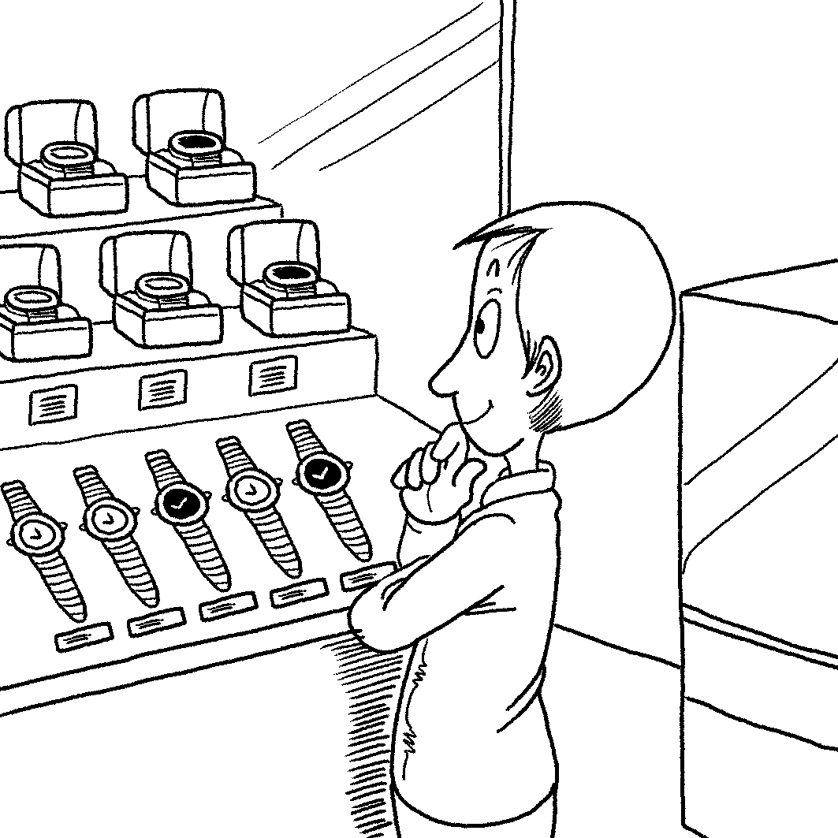 | 2. | 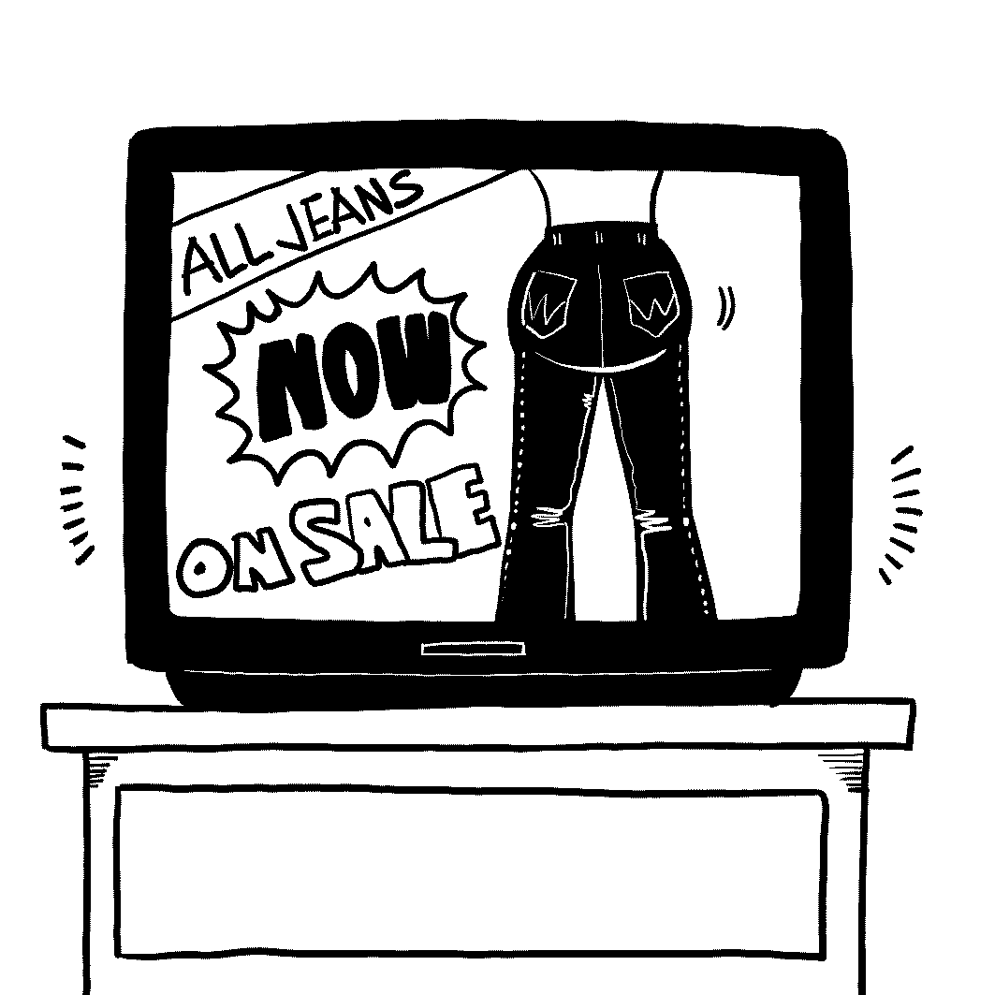

Part 2. Best Response Questions (3%)
Listen to the question or statement and choose the best response.
3. (A) Those are such cute pictures of her.
(B) She does love to read, doesn’t she?
(C) You shouldn’t buy her so many video games.
(D) She really has won many sports games.

4. (A) I hope you had a good time.
(B) Thanks for getting it for me.
(C) Can I have some, please?
(D) I’ll get a towel to clean it up.

5. (A) Just keep trying and you will.
(B) Don’t worry. It’s not expensive.
(C) I can drive you to the match.
- I also find it exciting to watch.

Part 3. Conversation Questions (3%)
Listen to each conversation and answer the question.

6. (A) Under the bed.
(B) On the bed.
(C) Next to the bed.
(D) Outside the room.
7. (A) He wanted to eat the doughnut.
(B) He told her she shouldn’t eat it.
(C) He will help the woman get some medicine.
(D) He thinks what happened is funny.

8. (A) Learning it isn’t easy to do.
(B) It takes a long time to learn.
(C) It is a lot of fun to learn.
- There is value in learning it.

Part 4: Short Talk Questions (2%)
Listen to the following paragraph and answer the questions.

9. (A) What money is made of.
(B) The value of money.
(C) The bacteria on money.
(D) The inventor of coins.

10. (A) Paper money is worth less than coins.
(B) The bills have fewer bacteria on them.
(C) It is no longer made from paper.
(D) Only the Chinese use paper money.

II. 詞彙:10% (每題1分)
11. With the coming of Christmas, window __________ designers rack their brains to make their store windows stand out.
(A) profile (B) display (C) factor (D) policy
12. The milk from Hokkaido’s cows is so delicious that all other milk pales in __________.
- progress (B) difference (C) phenomenon (D) comparison
13. A civil __________ focuses on the technical parts of the building; however, an architect cares more about the design.
(A) merchant (B) traveler (C) engineer (D) character
- The World Health __________ is an agency of the United Nations that helps to develop the international public health.
(A) Bacteria (B) Organization (C) Founder (D) Flavor
15. My mother is a very capable hostess; before the party, she double-checks all the _________ to make sure everyone’s need is filled.
(A) details (B) fireworks (C) honors (D) nerves

16. Australian scientists have discovered never-seen-before prehistoric sea __________ in the depths of the ocean below the Great Barrier Reef.
(A) journals (B) theories (C) creatures (D) submarines
17. Scientists fear that global temperature can vary quickly and cause _______ climate changes.
(A) charming (B) dramatic (C) ordinary (D) plenty
18. A super typhoon struck the northern Taiwan with heavy rain and winds. The winds were so powerful that people could ______ walk outside.
(A) holy (B) barely (C) costly (D) melancholy
19. The rescue team set off on a _____ to find the missing mountain climbers.
(A) passion (B) charm (C) quest (D) fate
20. The movie The Social Network, _____ from Ben Mezrich’s book, tells the story of the founders of Facebook.
(A) adept (B) adopted (C) accepted (D) adapted

III. 克漏字: 21% (每題1分)
(A) In the movie Charlie St. Cloud, the line between life and death blurs. The living __21___ not always gone, and the dead ___21__ not always alive. Teen idol Zac Efron ___22__ the multi-layered movie with charm and sensitivity. World famous ___23__ his excellent performance in the High School Musical series, Efron shows great depth with this new character.
21. (A) is (B) are (C) was (D) were
22. (A) tackles (B) resists (C) chills (D) founds
23. (A) by (B) as (C) to (D) for

(B) Time travel has been a popular idea in books and movies. As we know, time machines don’t exist in real life yet, but this doesn’t __24___ people __24___ dreaming up fantastic ways to travel through time. Scientist Stephen Hawking recently admitted that he believes time machine is possible __25___ we work out the practical parts. There are a few different theories about time travel. Some say that __26___ time travelers do will change the course of history. In The Time Machine, the hero travels to the past to save his fiancée, but she just dies in __27___ way. ___28__ , maybe changing the past would create a different world. In the Back to the Future movies, Marty McFly makes changes in the past, and his new present becomes a mess. He has to go back to set everything back to normal.
24. (A) put ... into (B) stop…from (C) warn… of (D) tow… away
25. (A) once (B) before (C) until (D) and
26. (A) the (B) what (C) nothing (D) some
27. (A) this (B) one (C) another (D) the other,
28. (A) That is to say (B) On the other hand (C) In addition (D) As a result
(C) The beauty of Hokkaido in summer and winter is often __29___. Summer flowers come into bloom and fill the air with the smell of lavender. Autumn comes earlier to Hokkaido than the rest of Japan. It __30__ maples fiery red, and other trees flash with gold. Lake Toya offers something warm. __31___ the watchful eye of a volcano, hot springs wait for you. While soaking in them, ___32__ night fall over the lake and fireworks light up the sky. Though every season is special in Hokkaido, ___33__ autumn’s colors and flavors may be the most special of all.
29. (A) talked (B) talked about (C) talking (D) talking about
30. (A) turns (B) sends (C) gives (D) causes
31. (A) With (B) From (C) Under (D) By
32. (A) watching (B) to watch (C) watched (D) watch
33. (A) but (B) yet (C) so (D) and

(D) Are food choices and personalities linked? Dr. Alan Hirsch ___34___ more than 18,000 people answer questions about their favorite foods. __35___ looking at the results, he found that food choices did ___36__ personality. People who choose nuts as a snack are often dependable, ___37__ potato chip lovers want to get ahead in life. People who enjoy spicy food love order and dislike ___38__ time. However, if your body is hot, it might push you toward peppers, too. Peppers help your body cool down. Thus, how __39___ if the food is from a person’s personality or body? For personality profiling, it is always best to be careful. Just like food, every person __40___ a lot of different flavors. You are __41___ you eat, but you are a lot more.
34. (A) gave (B) got (C) had (D) invited
35. (A) With (B) By (C) From (D) For
36.(A) figure (B) influence (C) adapt (D) handle
37. (A) however (B) whether (C) while (D) because
38. (A) wasting (B) to waste (C) control (D) controlling
39. (A) are we to know (B) we are to know (C) we did know (D) did we know
40. (A) is made from (B) is made up of (C) makes from (D) makes up
41. (A) who (B) whom (C) how (D) what

IV. 閱讀測驗 4% (每題1分)
Most American kids love Halloween treats, but a bucket of Halloween candy can be a dentist’s nightmare. Some parents try to get rid of half of the candy after their children go to bed, but dentists say parents also need to separate the good kinds of treats from the bad.
It is not exactly what a child eats that truly matters, but how much time it stays in his mouth. According to pediatric dentist Dr. Kaneta Lott, the most damaging stuff is something that is sticky or very hard and thus stays in the mouth for a long time. This is because we all have bacteria in our mouths. When we eat, the bacteria take our food as their food and produce an acid that destroys the surface of the teeth, causing cavities to form. The longer the food stays in the mouth, the more likely cavities will develop. Therefore, potato chips are worse than candy because they get stuck between teeth. For the same reason, raisins and crackers are not the best choice. Hard candies take a long time to consume and are also a bad choice for Halloween treats.
If children really love candy, dentists recommend that they eat chocolate instead. Unlike hard candies, chocolate dissolves quickly in the mouth. Besides, chocolate contains tannins, which help to kill some of the bacteria in the mouth. But no matter what a child eats, brushing after each meal is still the best way to fight cavities.

- What is the main purpose of this passage?
- To teach parents the meaning of Halloween candies for their children.
- To tell parents what sweets are less damaging to their children’s teeth.
- To point out the problems with Halloween celebrations.
- To discuss how cavities can be treated.
- According to the passage, which of the following is a better choice for Halloween treats?
- Raisins
- Chocolate
- Toffee apple
- Potato chips
- Why are hard candies especially bad for teeth?
- They contain too much sugar.
- They may break the child’s teeth.
- They help bacteria to produce tannins.
- They stay in the mouth for a long time.
- Which of the following is true about tannins?
- They destroy the surface of the teeth.
- They help chocolate to dissolve more quickly.
- They help to get rid of some bacteria in the mouth.
- They are produced when the bacteria digest the food.
第二部份: 三民版英文課本第一冊 L.5~8
V. 綜合測驗: 21%
The Chaldeans 46 the first to have practiced Western astrology. In 1930, a newspaper reported the life of Princess Margaret by astrology. Like Princess Margaret, everyone has a star sign ___47___ his or her birthday. If two people are born under the same signs, they ___48____ similar personality traits.
Fire-sign people usually 49 great leaders such as Napoleon and Churchill. But people born under earth signs have a tendency 50 plans before they take action. They follow their plans and are often successful in reaching their goals. On the other hand, air-sign people are eager _____51______ knowledge and always find things to learn in new experiences. Water-sign people are likely to be sensitive to the needs of others. They like to follow their hearts _____52_____ their minds. So, next time you are not quite sure of yourself, why not look at the sky and find new ways of looking at yourself?
46. (A) was said to be (B) are said to be (C) are said to have been (D) was said to have
47. (A) corresponded to (B) corresponding to (C) that corresponds with(D) corresponded with
48. (A) should share (B) would have shared(C) might have shared (D) might share
49. (A) do (B) make (C) be (D) work
50. (A) on making (B) to making (C) to make (D) by making
51. (A) for (B) with (C) to (D) on
52. (A) as well as (B) instead of (C) according to (D) based on

The custom of Halloween can ______53_______ back to long ago in Ireland. A man named Jack loved drinking with his friends and ______54______ them. Soon, no one wanted to make friends with him. One day, the Devil ____55____. Jack looked at the purse _____56______ by him earlier that day. It had a silver cross inside that would _____57_____ the Devil ____57_____ all his power. Jack quickly came up with an idea and ____58_____ the Devil ___58____ turning himself into a silver coin. And then Jack quickly put the coin in the purse. The Devil _____59____ Jack’s trick and gave his promise never to take Jack’s soul.
Years later, Jack died alone. His soul was not welcomed in Heaven, and couldn’t go down to Hell, either. Feeling sad and miserable, Jack walked around in the darkness forever.

53. (A) trace (B) date (C) be gone (D) be started
54. (A) to play jokes at (B) playing tricks with (C) to make fun of (D) playing tricks on
55. (A) showed up (B) made up (C) set out (D) turned down
56. (A) that stole (B) that had stolen (C) that had been stolen (D) which was stolen
57. (A) make; lost (B) let; lose (C) cause; to losing (D) have; to lose
58. (A) talked; out of (B) tricked; on (C) tricked; into (D) talked; to
59. (A) fell in (B) fell off (C) fell on (D) fell for

People invent things _____60______ their own needs. Later, the solutions ____61_____ their problems turn out to be great inventions and change our way of life. Working in a factory, Teng Hung-chi once wanted to wash his hands, but his hands were ____62_____ dirty that he didn’t want to touch the faucet. He thought, “If I could wash my hands without touching the faucet, it ______63_____ great. Then Teng worked hard to ____64____ his ideas ___64___ practice. Soon he invented a faucet ______65_______ by a built-in sensing device. The young inventor later sold the right to his invention for NT$ 1.5 million. Since then, Teng ______66______ many other things. Because of his many great inventions, Teng has become known as “Taiwan’s Edison.”
60. (A) to be filled (B) to meet (C) to satisfying (D) to be realized
61. (A) to (B) on (C) of (D) for
62. (A) very (B) such (C) more (D) so
63. (A) can be (B) will have been (C) would be (D) could have been
64. (A) make; from (B) turn; into (C) work; to (D) put; into
65. (A) to control (B) controlled (C) which controlled (D) controlling
66. (A) invented (B) has been invented (C) has invented (D) had invented

VI. 挑錯: 8% (以下每題有四個句子，請選出一個錯誤的句子。)
67. (A) Janet and Kevin used to be a couple, but they are divorced now.
(B) Two months after transferring to the new school, Paula is used to her new life.
(C) This knife is used to cutting fruit and vegetables.
(D) Wendy has got accustomed to taking the MRT to school every day.
68. (A) The book has been chosen as the Best Novel of the Year.
(B) I have never asked to do what I don’t want to do since I was a child.
(C) All the tickets had been sold out before the game began.
(D) All of the money that you gave me has been spent repairing my computer.
69. (A) It is essential for drivers to stay alert while they are driving.
(B) It is said that the “V” sign was first used by Winston Churchill.
(C) Two thousand people is said to have been hurt in the earthquake.
(D) It is important that people in a relationship give each other some personal space.
70. (A) If the typhoon didn’t come, we could go on a picnic.
(B) If the movie were not funny, it would not attract a lot of people.
(C) If the rumor turns out to be true, the employ will be laid off.
(D) If Andrew knew her phone number, he would have called her.

VII.文意字彙: 20% (請將答案填入答案卷)
- In ancient times, dragons s__________ed the Chinese emperors.
- The girl got lost and w____________red the streets for hours, looking for her mother.
- Peter is working with a piece of wood, trying to c__________e the shape of a monkey out of it.
- Grace left her country and i__________ed to German in 2009.
- Vicky is on vacation, so the company needs a r__________t for her until she returns.
- People in the past usually made p__________ns about the weather by watching the moon.
- The film Toys’ Story falls into the c__________y of animation.
- Mia showed great e__________m for HBL. She has never lost interest in it.
- The author used many interesting i__________ns in his storybook to attract children’s attention.
- Taiwan is s__________ed by the sea, so there is much seafood for us to choose from.
- Frank is a good m_________c. He knows almost everything about repairing broken machines.
- An answering machine is a d__________e for answering calls when people are not home.
- The boss met with a few r__________es of the workers to talk about a pay raise.
- The paintings are on e__________n right now. The artist is glad that her works are being shown to the public.
- Jack tried to c__________e his wife of his loyalty, but she didn’t believe him.
- Kenny learned about the g__________y of the island--- where the mountains are, and where the rivers meet the sea.
- Hot dogs and hamburgers are t__________l American food.
- After the big exam, I go to the movies for r__________n. This is how I rest and enjoy myself.
- When Paul was asked to c__________t on the event, he shook his head and said nothing.
- Although no one else liked the DVD that Sara had picked out, she felt satisfied with her s__________n.
台北市立松山高中99學年度第一學期高一英文科第二次期中考

VII. Vocabulary: 20%
1 | 2 | 3 | 4
5 | 6 | 7 | 8
9 | 10 | 11 | 12
13 | 14 | 15 | 16
17 | 18 | 19 | 20

VIII. Translation: 6%
1. 如果我現在會說流利的英文，我就不會害怕跟美國人說話了。反而，我會樂於與他們溝通。
(The fact is that I am not good at speaking English.)

_________________________________________________________________________________

2. 據說科學家們正在以不同的化學物質做實驗，以便能發明更好(用)的便利貼。

_________________________________________________________________________________

台北市立松山高中99學年度第一學期高一英文科第二次期中考
VII. Vocabulary: 20%
1  symbolized | 2  wandered | 3  carve | 4  immigrated
5  replacement | 6  predictions | 7  category | 8  enthusiasm
9  illustrations | 10  surrounded | 11  mechanic | 12  device
13  representatives | 14  exhibition | 15  convince | 16  geography
17  typical | 18  relaxation | 19  comment | 20  selection

VIII. Translation: 6% 每題三分
1. 如果我現在會說流利的英文，我就不會害怕跟美國人說話了。反而，我會樂於與他們溝通。
(The fact is that I am not good at speaking English.)
If I could speak English fluently now, / I would (might) not be afraid of talking to Americans. /
Instead, I would be willing to communicate with them.
I would enjoy (take pleasure in) communicating with them.
_________________________________________________________________________________

2. 據說科學家們正在以不同的化學物質做實驗，以便能發明更好(用)的便利貼。
It is said that scientists are experimenting/ with different chemicals, / so that they may (can) invent a better Post-it note. (in order to invent… / so as to invent…)
_________________________________________________________________________________
Answer key:
I. 聽力測驗: 10%
1~10 D D D D A / A B D D C

II. 詞彙: 10%
11~20 B D C B A / C B B C D

III. 克漏字: 21%
21~23 B A D
24~28 B A C C B
29~33 B A C D B
34~41 C B B C A A B D

IV. 閱讀測驗: 4%
42~45 B B D C

V. 綜合測驗: 21%
46~52 C B D B C A B
53~59 B D A C B C D
60~66 B A D C D B C

VI.挑錯: 8% (每題2分)
67~70 C B C D

