台北市松山高中九十二學年度第二學期高二英文科第一次期中考
以下部分請畫記於答案卡上
Time for Students : (March 1~20, 2004)
Part I. Listening Comprehension: 10%

A. Picture Description
- (B)
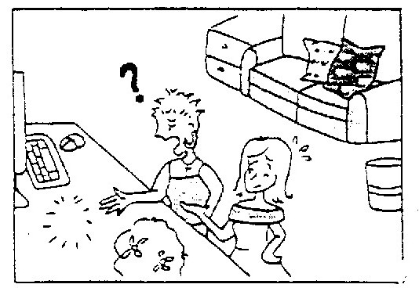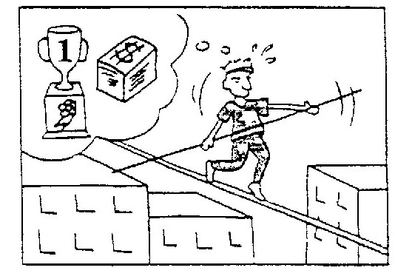

Part II. Word & phrases matching: 15%
A. aggressive B. mania C. distribution D. devastating
E. controversy AB. disaster AC. competitive AD. withstand
AE. diverse BC. motivation BD. construct BE. harmony
11. When it comes to baseball, Jack is the most ________ player in our class. He has a strong urge to win.
12. The program deals with subjects as _______ as pop music and ancient Greek drama.
13. The conference called for a more equitable _______ of wealth and power among nations.
14. The bridge is built to _______ an earthquake of 8.3 magnitude.
15. Men are considered more _______ than women. There is little doubt that It is rooted in biology.
16. With the approach of the presidential election, the ________ for politics swept over the whole country.
17. The Titanic is one of the most famous ________ stories in history.
18. She enjoyed the excitement of her work. Money was not her only_______.
19. There has been a huge _________ over where to put the city's new sports stadium and who should build it.
20. Large crowds of Spaniards staged a demonstration against the terrorist attack after the ________ train explosion.

A. line up with B. rely on C. fall apart D. for the sake of
E. tend to AB. cast a spell on AC. focus on AD. answer to
21. He moved to the seaside __________ his health. He thought the environment would be good for his health.
22. She's a witch, and she'll _________ you if she catches you.
23. Recent studies show that girls _______ be better at languages than boys.
24. Their marriage finally ________ because the husband had affairs with another woman.
25. Many working women ______ relatives to help take care of their children

Textbooks: (Far East English, Book Four, Lesson 1,2,4)
- Cloze test: 20%
(A) The Thai Water Festival is celebrated across the country in an unusual way. In the cities, people ___26___ the trucks filled with buckets of water and cruise the streets soaking everyone ___27___. In the countryside, children hide with buckets along the roadside ___28___ motorcyclists to come along. Once wet, the drivers will have to stop, and ___29___ stopping, they are sure to get a complete drenching! But no one cares about it because the Thais believe that the water will wash away the bad things of the past and bring good luck for the future. So, __30__they get, the better! The fun-loving street party is just one side of the Thai Water Festival. It has ___31___ a more serious side, ___32___ the fact that water symbolizes cleanliness, purity, and renewal. It also has __33___ with the traditional ceremonies ___34__ in people’s homes and at temples. Once the ceremonies are over, it is time __35____ the hoses and the buckets!

26. (A) from abroad (B) get aboard (C) on board (D) go abroad
27. (A) at first sight (B) comes into sight (C) out of sight (D) in sight
28. (A) to make sure (B) to be sure of (C) waiting for (D) go about dousing
29. (A) upon (B) as soon as (C) as well as (D) instead of
30. (A) wet (B) the wettest (C) the wetter (D) wetter
31. (A) so well as (B) as well (C) so far (D) as far as
32. (A) involves (B) to involve (C) involved in (D) which involves
33. (A) nothing to do (B) been done away (C) been connected (D) little to do
34. (A) taking place (B) taken place (C) holding (D) hold
35. (A) on (B) with (C) for (D) to

(B) To make efficient communication we can not __36__ without language. __37__verbal and written language, we use nonverbal language in __38__ interactions. Body language is the __39___ communication that __40___ on in everyday life. It tells you someone’s true feelings and ___41___ your words are being received. Your ability __42___ another person’s body language can cause the difference __43__ making a good impression and a very bad one. Some types of body language seem to be the same across the world, ___44___ smiling when we are happy and crying when we are sad. Still, many other forms of body language vary from one culture to __45___. In Japan, when parting from a friend, it is customary to give a bow, but in Taiwan, it is common to wave hands and say goodbye.
36. (A) make (B) take (C) get (D) do
37. (A) Beside (B) Except for (C) In addition (D) In addition to
38. (A) day by day (B) day-to-day (C) day and night (D) day after day
39. (A) unspoken (B) uncommon (C) universal (D) unusual
40. (A) happens (B) goes (C) makes (D) takes
41. (A) how nice (B) what well (C) how well (D) what good
42. (A) to express (B) of interrupting (C) to interpret (D) of explaining
43. (A) between (B) from (C) on (D) by
44. (A) for example (B) such as (C) likewise (D) whereas
45. (A) others (B) the other (C) the others (D) another

II. Matching: 5%
46. Taipei is a big city A. and my parents had me educated in the US.
47. To make myself easily understood B. he is proud of living here.
in English,
48. The policeman was alert enough C. so that he finally caught the robber.
49. Even if I don’t agree with you, D. whose population is over three million.
50. The older one gets, E. I have a conversational class with an American every week.
AB. but I firmly respect your right to speak.
AC. one will become more forgetful.
AD. I won’t stop you from speaking.
AE. to stop the old lady from being cheated.
BC. the wiser one is supposed to be.

III. Reading comprehension: 10%
(A)
Eyes are viewed as the most important nonverbal communication system. According to Mark Knapp, there are four major functions of eye communication. When talking with someone, we look at him or her as if saying that we are listening attentively. This is to monitor feedback. As a matter of fact, the listener gazes at the speaker more than the latter does at the former. If it is contrary to the circumstances, the conversational interaction becomes awkward. A second function is to signal a conversational turn. That is, after a speaker talks, his or her gaze falls on a listener to invite an answer . Therefore, the channel of the conversation has been switched and the other person is supposed to talk now.
Eye movement can reveal the relationship between two people. When direct eye contact between two people is held for many times, it is indicative of each other’s willingness to pursue friendship. Thus, we can clearly feel the two people are interested in each other. The final function is that we are capable of shortening the physical distance between us by making eye contact. We may catch someone’s eyes among the crowd, for instance. Soon we psychologically feel close though there is physical distance between us.
Sometimes we close our eyes to block some unpleasant sensation. True, eye avoidance can suggest lack of interest. But don’t forget that eye contact can speak loud consciously or unconsciously.

51. Which of the following descriptions is INCORRECT?
- The more two people exchange eye contact, the more they are interested in each other.
- To avoid an awkward conversational interaction, the speaker usually has to look at the listener more than the latter does at the former.
- Eye contact can help shorten the physical distance between us and other people.
- Eye contact can tell others that we are concerned about what others are talking.

52. When a speaker’s eye falls upon the listener, he or she may __________.
- ask for an awkward interaction.
- try to say he or she lacks interest.
- want to block some unpleasant sensation.
- be ready to give the speech turn to the other.
(B)
Argentina is a large country in the southern part of South America. It is rather famous for its annual Music Festival. The festival lasts ten days in January, during which each of Argentina’s 22 provinces is represented with a musical performance.
Thousands of Argentineans pack into the small town of Jesus Maria. In addition to dancing and singing performances, there are hundreds of booths set up to sell authentic Argentine food and crafts. Among the dishes that make people’s mouths water, asado, Spanish for barbecue, is the most tasty. In an asado, all parts of the cow are cooked. Some are deep-fried or rolled in salt and olive oil. Others are served in a bun. Still there are other delicacies such as cow tongue, blood sausage and intestines.
Excited people dance in the streets drinking wine while some others roar out songs. There are many people racing from one booth to another tasting a wide range of foods. On such warm winter nights at Jesus Maria, the people on the streets are all smiles. Delicious asado, together with singing and dancing, is impressive to every one who attends the festival.
53. Which of the following activities is not seen in the Music Festival?
- Making a musical performance.
- Drinking wine.
- Singing and dancing wildly.
- Holding a competition for the cow.
54. What is an asado?
- The activity in which people throw water at each other.
- Rolled or deep-fried buns.
- The way the cow are cooked.
- A Spanish custom that people set up booths to sell food and crafts.
55. Which of the following descriptions is CORRECT?
- Music Festival is held every year in Spain.
- Music Festival takes place every year in December in memory of Jesus Christ.
- The food sold during Music Festival is imported from other countries.
- Altogether Argentina is made up of 22 provinces.
以下部分請作答於答案卷上
IV. Vocabulary: 20%
1. The traffic in Taipei was c_______c this morning because some traffic lights
were out of order.
2. Our teacher suggested that we p_______y our minds by reading good books.
3. Measles is highly c______s. It will rapidly spread to the babies who aren’t given any vaccine.
4. My whole body was s______g wet when I was riding a bike home in the heavy rain.
5. To the Thais, s______ing perfumed water in the hands or over the heads of
their elders is a way to show their respect.
6. On New Year’s Eve, thousands of r______rs gathered in Times Square to celebrate the coming of the New Year.
7. The doctor asked the patient to s_______k out his tongue and checked if there was something wrong.
8. The president should take some action to m______n harmonious relations among different ethnic groups.
9. It’s our duty to teach the young to be r_______l of different people and different cultures.
10. The destructive power of natural disasters cannot be u________ed.
11. Most teenagers like to do the o_____te of what their parents want them to do. They claim that they are independent enough to decide what to do.
12. The fall of the Berlin Wall s_____ed the end of the cold war between East and West Germany.
13. The movie The Lord of the Rings was a_______ted from the trilogy novels by J.R.R. Tolkien.
14. During the presidential election, all the candidates are always a______ied by several bodyguards wherever they go.
15. Emily Dickson was a poet who had little c_____t with the outside world. Nearly nobody kept in touch with her.
16. When the teacher asked Jim why he was late for school, he just s_____ged his shoulders and said nothing.
17. She studies in Cambridge, which is a p_______s university across the world.
18. Factory workers are under p______e to work overtime during the high season.
19. Cindy told me her secret in a w______r lest someone should overhear it.
20. A man of h_____y will never take pride in his achievements.

V. Translation: 10%
1. 我的父母重視孩子培養良好的生活習慣， 因為他們認為良好的生活習慣是成功的基石。
My parents ____1___ the children’s cultivation of good living habits because they think of good living habits ____2___ of a successful life.

2. 生命的價值不在於長短， 而在於如何利用它。
The value of life ____3____ the length of days, ____4___ we make of them.

3. 昨晚若非他及時提醒， 我可能會被卡車碾過。
But for his warning in time, I ____5_____by that truck last night.

4. Bruce一見到女朋友， 就衝向前吻她的雙唇。
_____6____ his girlfriend, Bruce rushed forward and ___7____.

5. 即使無法像美國人一樣用英文流利的表達自己， 你也不需要覺得沮喪。
____8___ you can’t ____9____ ___10____ an American, you don’t need to feel discouraged.

VI. Reciting on General MacArthur’s Prayer for His Son: 10%
Build me a son, O Lord, who will be strong enough to know when he is weak, and ____1____ when he is afraid; one who will be proud and ____2____, and humble and ____3_____. Lead him, I pray, not ____4___, but under the stress and spur of difficulties and challenge. Here let him learn to _____5____; here let him learn ____6___. Build me a son whose heart ____7___, whose goal will be high; a son who will ____8___before he seeks to master other men, one who will learn to laugh, yet never ___9____; one who will ___10___, yet never forget the past.

