台北市立松山高級中學94學年度第一學期高二英文科第二次期中考
- Landmark and Smart Vocabulary
I Listening
Part A 3%
Look at the pictures below. For each, you will hear one or two questions and four possible answers, A to D. Write down the letter for the best answer (A, B, C, or D).

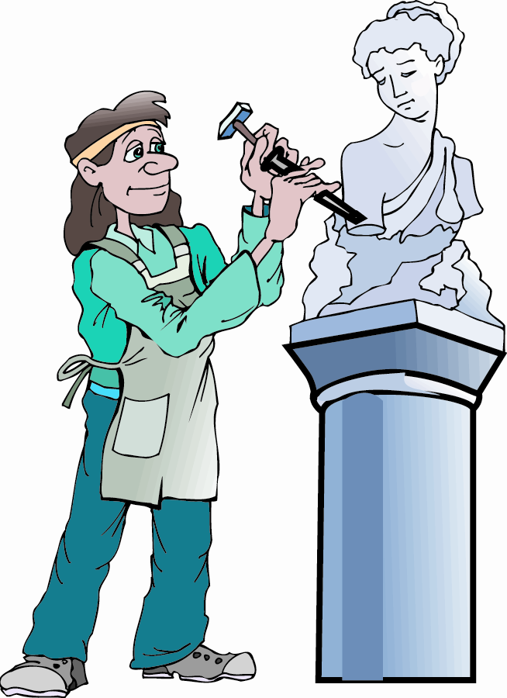
Questions 1~2 Question 3

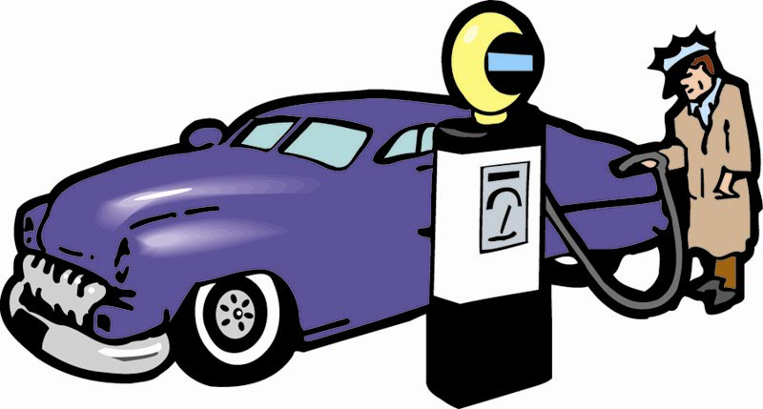

Part B 4%
In part B, you will hear several questions or statements. Choose the best response or reply.

4. (A) Where do you know her from?
(B) Then you should apologize.
(C) How much do you owe her?
(D) I can’t believe you forgot.

5. (A) No, I keep them in the refrigerator.
(B) Yes, I get sick whenever I eat them.
(C) No, they aren’t sent by ship.
(D) Yes, they help prevent them.

6. (A) Yes, only the rich people can afford it.
(B) Yes, its available to all citizens.
(C) No, religion is not taught to students.
(D) No, the equipment isn’t very advanced.

7. (A) Yes, we lost the game.
(B) Yes, we tied the other team.
(C) Yes, we missed the game.
(D) Yes, we beat the other team.

Part C 3%
In part C, you will hear one or more short conversations between a man and a woman, and then a question following each conversation. Choose the best answer to that question.

8. (A) That it’s a local competition.
(B) That it’s for college athletes.
(C) That it’s an international event.
(D) That it’s for professional athletes.

9. (A) That its fruit is very harmful to humans.
(B) That there is a person who lives in it now.
(C) That people think that it brings good luck.
(D) That there’s an old and popular story about it.

10. (A) To give the man a general outline of the report.
(B) To deliver the report to the boss herself.
(C) To write the report again in more detail.
(D) To make another copy of the report.

II Vocabulary (13%)
11. Traditionally, the superstitious regard seeing a black cat as an unfavorable ______.
(A. issue B. specie C. omen D. statue)
12. Being a tough person, Eugene is able to _____ all the sufferings.
(A. replace B. maintain C. dominate D. withstand)
13. Scientists think that human beings _____ from the apes.
(A. revolved B. evolved C. involved D. dissolved)
14. It’s a _____ business, from which we can gain a lot of money.
(A. profitable B. unconditional C. sensible D. gigantic)
15. I’m sorry for my complete _____ of it. I really don’t know about it at all.
(A. boundary B. ignorance C. fraction D. injustice)
16. The discovery will _____ the cause of cancer.
(A. shed light on B. catch on C. fix up D. wipe out)
17. Having worked so hard these days, I want to enjoy myself _____ this weekend.
(A. to and fro B. off the scale C. to the fullest D. up and around)
18. Business _____ all his time; therefore, he has little time to talk with his child.
(A. crashes B. eliminates C. absorbs D. conquers)
19. The Iraqi soldiers bombed the US headquarters in Bagdad in _____ for their attack.
(A. rescue B. revenge C. struggle D. exchange)
20. She usually browses the online auction to get good _____.
(A. bargains B. information C. charges D. budgets)
21. The company went _____ because it couldn’t pay off its debts.
(A. ruined B. wrecked C. bankrupt D. sunk)
22. I can see many kinds of clocks _____ in this shop.
(A. exported B. remain C. survive D. displayed)
23. _____ for money, I worked day and night at the cost of my health.
(A. Ambitious B. Desperate C. Tight D. Thorough)

III Cloze (11%)
1.
Biodiesel can be made from vegetable oil, oil from animal fat or __24___ cooking oil. Because of its ingredients, biodiesel is renewable. This reduces stress on crude oil supplies, and increases business for local farmers. Moreover, biodiesel can be used in any __25___ machine. Even better, its natural ingredients __26___ it to burn cleanly. Most importantly, it is environmentally friendly. __27___ crude oil supplies in __28___ and environmental issues increasing, new power sources are __29___ our future. Biodiesel is just one idea that is getting us back on the right track.
24.(A. recycle B. recycled C. recycling D. recyclable)
25.(A. powering-diesel B. diesel-powering
C. diesel-powered D. powered-diesel)
26.(A. make B. produce C. cause D. let)
27.(A. Because B. With C. By D. Although)
28.(A. decrease B. massive C. extinction D. decline)
29.(A. mapping out B. tied to C. resistant to D. hanging on to)

2.
Ang Lee didn’t have a chance to direct anything until he __30___ two scripts to a contest __31___ by the Taiwanese government. Not only __32___ the top prize in the contest, but he also took second place. That meant __33___ for his films, Pushing Hands and The Wedding Banquet.__34____ his first two films, Eat Drink Woman would complete what is jokingly known as “Father knows best” trilogy.
30.(A. submitted B. projected C. recommended D. operated)
31.(A. ran B. running C. run D. which runs)
32.(A. he took B. he did C. did he take D. did he do)
33.(A. to financing B. to finance C. financing D. being financed)
34.(A. Along with B. Apart from C. As well as D. In addition to)

B. Textbook
IV. Grammar (10%)
- Over 80 percent of the population in Taipei _________ between home and the office everyday.
(A) commute (B) commutes (C) commuting (D) to commute
- You had better __________ late for school again, or you will be punished.
(A) not be (B) not to be (C) not being (D) being not
- It is when we are lonely _______ we will realize the importance of our
family.
(A) on which (B) that (C) until (D) then
- His explanation makes me ___________ the present situation.
(A) understand (B) understanding (C) understood (D) to understand
- I cannot get along with Mary, for her opinion is always _______________
mine.
(A) differ from (B) different from (C) difference than (D) differ with
- I ___________ jogging every morning, but I don't now.
  - was used to go (B) used to going (C) used to go (D) am used to going
- The air in the room is not fresh; please keep the window __________.
(A) to close (B) closing (C) opened (D)open
- Even if we had tried our best, we still could not prevent the accident ______.
(A) not hapenning (B) from happening (C) to happen (D) not to happen
- Jason is the most diligent student _____________________________.
(A)whom I have ever seen (B) I ever see
(C) that I have ever seen (D) whom I ever see
- Cities ______ best recycling programs discovered two things are necessary
for success: convenience and education.
(A) having (B) of (C) which with (D) own

V. Cloze (15%)
1.
Mother Teresa, Sanit of the Gutters, died of a heart attack in Calcutta, (45) 87. Throughout her life, she did (46) she could do to help those in need. She founded the Missionaries of Charity, (47) more than 4,000 and (47) in more than 125 countries. Her spirit, which went beyond individual differences, won her the respect from people (48) all faiths and walks. (49) was described by a Hindu priest, Mother Teresa was considered (50) a Mother of us all.

- (A) age (B) at age of (C) aged (D) in
- (A) everything which (B) everything what (C) all (D) no matter what
- (A) numbering….working (B) number…work
(C) numbering….worked (D) numbering…work
- (A) with (B) of (C) in (D) from
- (A) As (B) When (C) Like (D) As if
- (A) being (B) to be as (C) as (D) X

2.
In Taiwan, Garbage is a big problem. Although (51) the garbage is buried under the ground in landfills, the landfills are quickly (52) , (53) makes recycling an immediate must. (54) people to do recycling, the program must be simple and convenient. (55) , running television commercials and putting up posters can help educate people about the importance of recycling. It is hoped that with everyone's effort the garbage problem in Taiwan can be solved.

- (A) a great number of (B) great deal of (C) much of (D) many
- (A) full of (B) filling up (C) filled up with (D) fill out
- (A) that (B) this (C) which (D) and which
- (A) Encourage (B) Encouraging (C) For encourage (D) To encourage
- (A) As a result (B) Hence (C) Moreover (D) However

3.
Nowadays, people can choose from many vehicles to travel to almost any place they wish. However, is there a vehicle that could take us back to (56) we were born? Actually, scientists (57) the possibility of time travel for many years. Some of them have (58) Einstein's Theory of Relativity (58) a basis for their arguments. Although time travel may still be a far-fetched dream, there is no reason why you can not let your imagination (59) . Go ahead and have a good trip!

- (A) the day which (B) in the time (C) the day when (D) where
- (A) had debated (B) have debating (C) are debating (D) have been debating
- (A) used…for (B) made….being (C) used….as (D) take….to be
- (A) go wildly (B) running wild (C) to go wild (D) run wild

VI. Discourse Structure 篇章結構 (5%)
(A) It did not remain dry, however.
(B) Shortly after the Columbia pictures were recorded, an American-Egyptian team dug along the banks of the ancient underground riverbeds.
(C) The whole idea seemed silly until satellites began circling the globe.
(D) The 10,000-year-old drawings near the town of Tassili show hunters stalking buffaloes, elephants, lions and antelopes.
(E) Amazingly, a giant river system was clearly etched on the photographs and radar screens recorded by Columbia.

For thousands of years, there have been stories and unconfirmed rumors about a huge, mysterious, waterless river system hidden beneath the barren, shifting dunes of the Sahara Desert. (60) . The space shuttle Columbia took pictures that allowed scientists to see below the surface of the desert. Since there was no moisture in the air to diffuse the images, the radar scans could penetrate deeper below the earth's surface than usual. (61) .
The pictures taken by Columbia helped explain early paintings found in the desert. (62) . Later paintings (4000 B.C.) depict cattle grazing, and finally, there are drawings showing Nile boats, camels, and bearded warriors with shields and spears.
Geologists believe the Sahara dried out during an ice age 2 million years ago. (63) . The region enjoyed brief rainy periods 200,000, 60,000, and 10,000 years ago. The presence of water drew animals and people, and soon civilizations developed. (64) . They found ancient tools and other artifacts probably used by Homo erectus, an early human who lived and hunted in the lush Sahara 200,000 years ago.

VII. Reading (6%)
There are at least 15 different types of avian influenza that routinely infect birds around the world. The current outbreak is caused by a strain known as H5N1, which is highly contagious among birds and rapidly fatal. Unlike many other strains of avian influenza, it can be transmitted to humans, causing severe illness and death.
Bird flu is not the same as SARS (severe acute respiratory syndrome). Although their symptoms are similar, SARS is caused by completely different viruses. Influenza viruses are also more contagious and cannot be as readily contained as SARS by isolating people who have the infection.
Influenza viruses are highly unstable and have the ability to mutate rapidly, potentially jumping from one animal species to another. Scientists fear the bird flu virus could evolve into a form that is easily spread between people, resulting in an extremely contagious and lethal disease. This could happen if someone already infected with the human flu virus catches the bird flu. The two viruses could recombine inside the victim body, producing a hybrid that could readily spread from person to person.
The resulting virus would probably be something humans have never been exposed to before. With no immune defenses, the infection could cause devastating illness, such as occurred in the 1918-19 Spanish flu pandemic, which killed an estimated 40 million to 50 million worldwide.

65. According to the passage, which of the following is true about avian flu?
- H5N1 is one of the strains of avian influenza.
- Avian flu can directly and easily spread from person to person.
- Avian flu can cause severe illness and death not only between people but among birds.
- H5N1 is as infectious as many other strains of avian influenza.
66. Compared with SARS, bird flu ___________ .
(A)has the same symptoms as SARS
- is caused by the same virus as SARS
(C)viruses are more contagious
(D)is more readily controlled by separating the infectious people.
67.According to the passage, what do scientists fear most about avian flu?
- There would be no sufficiency of vaccine if avian flu should become pandemic.
- There are no immune defenses, so human beings are vulnerable to avian flu.
- It can spread among people, if the bird flu virus mutates and combines with a human flu virus.
- The outbreak of avian flu caused by H5N1 is hard to control because the strain is a deadly virus.

VIII. Vocabulary (17%)
- _______________ Because the travel agency planned a very tight s________e, we only had little time to enjoy each scenic spot and were rushed throughout the whole travel.
- _______________ To maintain a safer traffic, all cars should give way to p____________rs.
- _______________ Famous for its romantic and cultural atmosphere, Paris attracts many f________n tourists from all over the world each year.
- _______________ To cut back on the amount of trash and to do better recycling, people have to s___________e garbage before dumping it.
- _______________ John plans to go into electronic i________y after he graduates from college.
- _______________ No matter who is elected the mayor, he/she should lead the city g___________t to serve all citizens.
- _______________ The underlying message of the film is that love t___________ds everything else; that is, love is on top of everything.
- _______________ Being such a diligent and consistent teacher, his d___________n to teaching has earned him the respect of his colleagues.
- _______________ Please accept my sincere c___________es on your cat's death.
- _______________ Mother Teresa was involved in a lot of c_________y work; that was why she was awarded the Nobel Peace Prize.
- _______________ My parents are very r____________s; they pray every night and go to church every week.
- _______________ Last week John went to see a fortune teller, and the fortune teller p__________ted that he would become rich in ten years.
- _______________ Mary is very interested in writing, and she hopes she can p___________h her work one day.
- _______________ Keith is such an arrogant person that he always i______es others' suggestion; he never pays attention to what people say.
- _______________ Since the completion of the MRT, this area has become more p___________s than it was before.
- _______________Despite numerous studies on dinosaurs, scientists still cannot make sure why dinosaurs d__________red thousands of years ago.
- _______________ As the Wangs always dump their garbage in public areas, they do not have a h___________s relationship with their neighbors.

IX. Blank Filling 4% (每格不只ㄧ字; 每格1分)
- 為了保持身體健康, 你應該儘可能的經常做運動
To keep you healthy, you should do exercise _____________________________.
- 只有奇蹟才能挽救他的生命
N_________________ a miracle can save her life.
- 如果我們都能盡ㄧ己之力, 我們就能有一個更乾淨的環境
If we can ___________________, we will have a cleaner environment.
- 你知道這艘船要開往哪裡嗎?
Do you know where the ship ______________________?

X.Translation (9%)
- 身為一個學生, 你應該把考上理想大學當作是最優先的事情. (………, ……make….)
- 事實上, 你有沒有從現在開始就努力用功是有很大差別的 (…, it…)
- 你越早開始,你達成目標的可能性就越大 (The……)

